def custom_bubble_sort(arr):
n = len(arr)
for i in range(n):
swapped = False
for j in range(0, n - i - 1):
if arr[j] > arr[j + 1]:
arr[j], arr[j + 1] = arr[j + 1], arr[j]
swapped = True
if not swapped:
break
return arr
S = input("Enter a string: ")
words = S.split(" ");
cnt = len(words)
print(f"Numer of words in sentence \"{S}\" is : {cnt}")
if cnt % 2 == 0:
print("Number of words is even, The sorting will be in Ascending direction")
print(f"The sorted string using bubble sort is: {custom_bubble_sort(words)} ")
sorted_string_sort_function = S.split()
sorted_string_sort_function.sort()
print(f"The sorted string using built-in sort function is {sorted_string_sort_function}")
else:
print("Number of words is odd, The sorting will be in Descending direction")
sorted_string = custom_bubble_sort(words)
sorted_string.reverse()
print(f"The sorted string using bubble sort in reverse is: {sorted_string} ")
sorted_string_sort_function = S.split()
sorted_string_sort_function.sort(reverse=True)
print(f"The sorted string using built-in sort function is {sorted_string_sort_function}")

Result
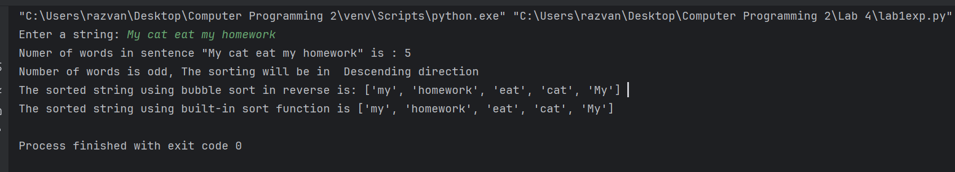

2
import re
S = input("Enter a string: ")
words = re.findall('^[a-z]+|[A-Z][^A-Z]*', S)
L = [element.lower() for element in words]
print(f"The number of elements is: {len(L)}")
print(f"The string after the split is and lower-case:{L} ")
L.reverse()
print(f"The string after the order change is :{L} ")

Result :

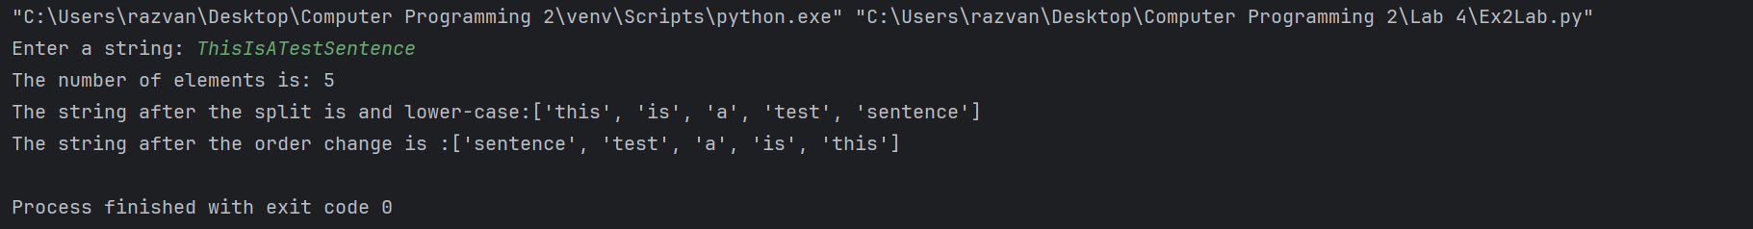
3
n = input("How many beers? : ")
beer_dictionary = {}
for i in range(int(n)):
name = input("Beer Name: ")
price = float(input("Beer price:"))
quality = int(input("Beer Quality (0-5):"))
beer_dictionary[name] = {
"Price": price,
"Quality": quality,
"Quality for Money": quality / price
}
sorted_beers = sorted(beer_dictionary.items(), key=lambda item: item[1]["Quality for Money"], reverse=True)
if sorted_beers:
print("\nBeers sorted by Quality for Money:")
for name, beer_info in sorted_beers:
print(f"{name}, Quality for Money: {beer_info['Quality for Money']}")
cheapest_beer = min(beer_dictionary.items(), key=lambda item: item[1]["Price"])
worst_beer = min(beer_dictionary.items(), key=lambda item: item[1]["Quality"])
print(f"\nThe Cheapest Beer is {cheapest_beer[0]}, Price: {cheapest_beer[1]['Price']}")
print(f"The Worst Beer is {worst_beer[0]}, Quality: {worst_beer[1]['Quality']}")
else:
print("No beers to display.")

