1

import numpy as np
sz = np.random.randint(low=5,high=10)
x=np.random.randint(low=0,high=100,size=sz )
y=np.random.randint(low=0,high=100,size=sz )

print('First Vector: ',x)
print('Second Vector: ',y)

first_sum= np.sum(x)
second_sum= np.sum(y)

print('First Vector summed:',first_sum)
print('Second Vector summed:',second_sum)

print(np.sum([x,y],axis=0));
print(np.sum([x,y],axis=1));

Result

First Vector: [56 72 83 7 57]
Second Vector: [85 19 68 72 6]
First Vector summed: 275
Second Vector summed: 250
[141 91 151 79 63]
[275 250]

import numpy as np
import math as mt
from matplotlib import pyplot as pt

cs,sn,tn= np.zeros(20),np.zeros(20),np.zeros(20)

x= np.linspace(-mt.pi,mt.pi,20);

for i in range (20):
cs[i]= mt.cos(x[i])
sn[i]=mt.sin(x[i])
tn[i]=cs[i]/sn[i]
figure,axis=pt.subplots(1,3);

axis[0].plot(x, sn,'r--')
axis[0].set_title("Sine Function")

axis[1].plot(x, cs,'g--')
axis[1].set_title("Cosine Function")

axis[2].plot(x, tn,'y--')
axis[2].set_title("Tangent Function")
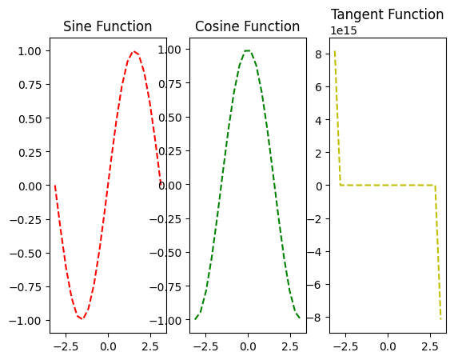
from operator import length_hint
import numpy as np
N=10
x= np.random.randint(-10,10,N);
print(x);

for i in range (N):
if x[i]%2==0:
print(x[i],": even")
else:
print(x[i]," odd")
if x[i]>=0:
print(" positive")
else:
print(" negative")

[-9 0 9 -6 6 -4 6 8 -9 -2]
-9 odd
negative
0 : even
positive
9 odd
positive
-6 : even
negative
6 : even
positive
-4 : even
negative
6 : even
positive
8 : even
positive
-9 odd
negative
-2 : even
Negative
import numpy as np
N=10
x= np.random.randint(high=100,low=0,size=N);
y= np.random.randint(high=100,low=0,size=N);
print(x)
print(y,'\n')

print(-np.sort([x,y],axis=0),'\n');
print(np.sort([x,y],axis=1));

for n in range(N):
for m in range (N-1-n):
if x[m]>x[m+1]:
x[m+1],x[m]=x[m],x[m+1]

print(x);
[12 57 79 8 70 82 54 78 91 33]
[61 93 82 52 86 52 80 76 85 50]

[[-12 -57 -79 -8 -70 -52 -54 -76 -85 -33]
[-61 -93 -82 -52 -86 -82 -80 -78 -91 -50]]

[[ 8 12 33 54 57 70 78 79 82 91]
[50 52 52 61 76 80 82 85 86 93]]
[ 8 12 33 54 57 70 78 79 82 91]

mport numpy as np
from matplotlib import pyplot as pt

F= np.zeros((20,20))

x= np.linspace(-2,2,20);
y= np.linspace(-1,3,20);

for i in range (20):
for k in range(20):
F[i][k]=(1-x[i])**2 +100*(y[k]-x[i]**2)**2

fig= pt.figure()
ax=pt.axes(projection='3d')
surface= ax.plot_surface(x,y,F,cmap=cm.autumn_r)
ax.set_title('Rosenbrock Function')
pt.show()

