Ex1
def hex_to_int(hex_value): # function to return decimal int value
try:
return int(hex_value, 16)
except ValueError:
raise ValueError("Invalid hex number: {}".format(hex_value))
def hex_calculator():
try:
first_operand = input("Enter the first operand (two hex digits): ").upper()
if not all(c in "0123456789ABCDEF" for c in first_operand): # check if the input is hexa characters
raise ValueError("Invalid hex number: {}".format(first_operand))
operation = input("Enter the operation (+, -, *, /): ")
if operation not in "+-*/":
raise ValueError("Invalid operation: {}".format(operation))
second_operand = input("Enter the second operand (two hex digits): ").upper()
if not all(c in "0123456789ABCDEF" for c in second_operand):
raise ValueError("Invalid hex number: {}".format(second_operand))
int_first = hex_to_int(first_operand)
int_second = hex_to_int(second_operand)
if operation == '+':
result = int_first + int_second
elif operation == '-':
result = int_first - int_second
elif operation == '*':
result = int_first * int_second
else:
if int_second == 0:
raise ZeroDivisionError("Division by zero is not allowed.")
result = int_first / int_second
if isinstance(result, int):
print("Result (Hex): {}".format(hex(result).upper()))
else:
print("Result (Hex): {}".format(result.hex().upper()))
print("Result (Decimal): {}".format(result))
except (ValueError, ZeroDivisionError) as e:
print("Error:", e)
hex_calculator()
if __name__ == "__main__": # call the function
hex_calculator()

Result
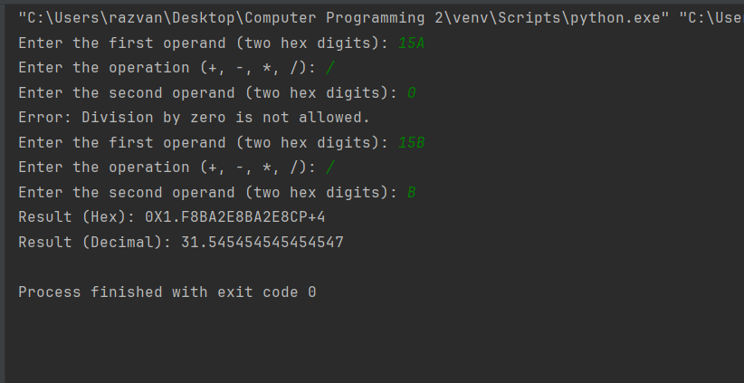

Ex2
import random
import re
def extract_words(input_file):
with open(input_file, 'r') as file:
text = file.read()
words = re.findall(r'\b[a-zA-Z]+\b', text)
return words
def create_word_dictionary(words): # function to create dictionary of unique words
word_set = set(word.lower() for word in words)
return list(word_set)
def generate_poem(word_dict, lines_per_strophe, words_per_line): # function to generate a poem from the dictionary
poem = []
for _ in range(lines_per_strophe):
line = ' '.join(random.choice(word_dict) for _ in range(words_per_line))
poem.append(line)
return poem
def save_poem(poem, output_file): # function to save the poem into a file
with open(output_file, 'w') as file:
for line in poem:
file.write(line + '\n')
if __name__ == "__main__":
input_file = "input.txt"
output_file = "output_poem.txt"
lines_per_strophe = int(input("Enter the number of lines per strophe: "))
words_per_line = int(input("Enter the number of words per line: "))
words = extract_words(input_file) # extract the words from the file
word_dict = create_word_dictionary(words) # create the dictionary
poem = generate_poem(word_dict, lines_per_strophe, words_per_line) # create the poem
save_poem(poem, output_file) # save the poem
print("Poem has been generated and saved to", output_file)

Input file :
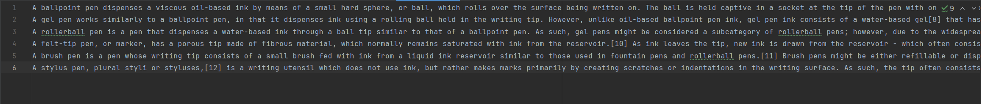

Result :
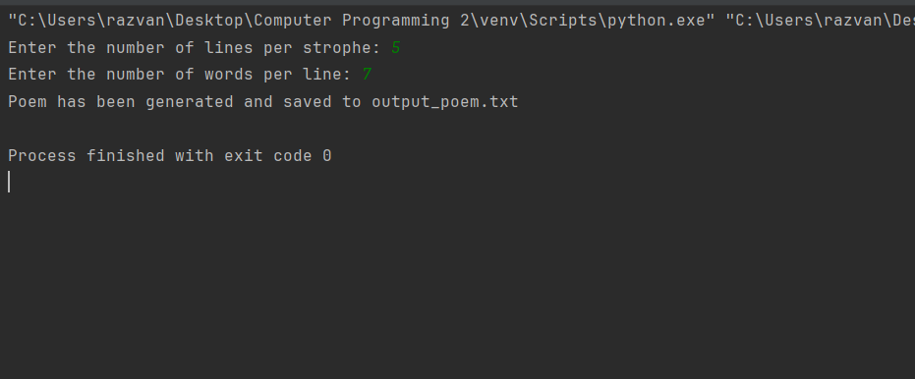
Output file :
