
Available online on: http://ejournal.undip.ac.id/index.php/teknik
TEKNIK, 46 (3), 2025, 270-278

Concrete Jacketing for Strength Enhancement of Square Columns in Corroded Reinforced Concrete Structures

Zahra Amalia 1,2*, Mahlil 1 , Adrian Ulza 1,2, Taufiq Saidi 1,Teuku Budi Aulia1, Cut Nella Asyifa 1,2

¹ Department of Civil Engineering, Faculty of Engineering, Universitas Syiah Kuala,
Jl. Syech Abdurrauf No.7, Kopelma Darussalam, Kec. Syiah Kuala, Kota Banda Aceh, Aceh 23111
² TDMRC, Tsunami and Disaster Mitigation Research Center
Jl. Hamzah Fansuri No.8, Kopelma Darussalam, Kecamatan Syiah Kuala Kota Banda Aceh, Aceh 23111

Submitted: May 19th, 2025; Revised: July 22nd, 2025; Accepted: July 29th, 2025; Available online: July 31st, 2025 DOI: 10.14710/teknik.v46i3.70449

Abstract
Buildings submerged during the 2004 Aceh tsunami have shown signs of structural degradation, particularly due to corrosion in column reinforcement, raising concerns about reduced seismic performance. This study aims to evaluate the effectiveness of the concrete jacketing method in retrofitting corroded square reinforced concrete columns. Specimens measuring 200 × 200 mm² in cross-section and 580 mm in height were subjected to accelerated corrosion targeting 20% mass loss, followed by axial and lateral loading tests. The results showed that corrosion reduced shear strength by 23.93% compared to non-corroded specimens. However, retrofitted corroded square reinforced concrete column demonstrated a 15.65% increase in strength when the stirrup reinforcement yielded. However, the shear capacity showed a slight decrease compared to the corroded columns without jacketing. This unexpected reduction is attributed to the absence of joint strengthening in the retrofit, which governed the overall shear resistance. These findings highlight the importance of including joint enhancement when applying concrete jacketing for comprehensive structural recovery.
Keywords: reinforcement corrosion; retrofitted square reinforced concrete column; concrete jacketing; lateral load; accelerated corrosion test

Introduction

Nearly two decades after the devastating earthquake and tsunami in Aceh, many existing buildings— particularly those located in inundated areas—are still showing signs of structural deterioration. The reinforcement bars within reinforced concrete (RC) columns have corroded, leading to reduced structural performance. This issue has been documented in various structures such as commercial buildings in Gampong Merduati (Habibie, Hasan, & Syarizal Fonna, 2023), the Aceh Provincial Youth and Sports Office (Laboratorium Forensik dan Struktur Bangunan, 2023), and several schools in Banda Aceh (Raihanda, 2022). Exposure to aggressive environmental conditions—such as coastal proximity, irregular climate patterns causing wet–dry

------------------------------------------------------------------
^{*)} corresponding author.
E-mail: zahra.amalia@usk.ac.id
cycles, and air pollution—accelerates corrosion in aging RC structures (Pusat Penelitian dan Pengembangan Prasarana Transportasi, 2001).
Recent earthquakes have further highlighted the vulnerability of aging structures, especially those built with inadequate seismic detailing and weakened by long-term corrosion from carbonation or chloride attack. Surface cracking, concrete spalling, and loss of confinement due to reinforcement corrosion are common and compromise structural safety (Amalia, Qiao, Nakamura, Miura, & Yamamoto, 2018; Ma, Che, & Gong, 2021; Tastani & Pantazopoulou, 2004). In many cases, these buildings require urgent retrofitting to ensure continued structural integrity.
Various advanced materials and methods have been proposed to strengthen deteriorated RC structures. Among them, fiber-reinforced polymers (FRP), both in the form of sheets and rods have shown significant potential due to their high strength-to-weight ratio,

corrosion resistance, and ease of application. Previous studies have demonstrated the effectiveness of FRP jacketing in improving flexural and shear performance of corroded RC elements, as well as enhancing ductility and energy dissipation under cyclic loading (Biskinis & Fardis, 2024; Jia et al., 2020; Karimipour & Edalati, 2021; Tianhao Lu, Peilong Li, Chuying Cui, Jiayu Wu, & Bing Fu, 2023). In addition to FRP, other advanced methods such as steel jacketing, strain-hardening cementitious composites and ultra-high-performance concrete have also been explored (Chong et al., 2024; Hassan, Baraghith, Atta, & El-Shafiey, 2021; Maciej Serda et al., 2022; Saeed & Hejazi, 2025; Weng, 2024). However, these solutions often require specialized materials, skilled labor, and advanced installation techniques, which may not be readily available in remote or resource-limited regions.
In contrast, retrofitting methods must be not only effective but also feasible within the limitations of local resources. In post-disaster and remote areas like Aceh, high-tech materials such as FRP are often difficult to procure or apply due to logistical, economic, and technical constraints. Therefore, concrete jacketing remains the most accessible, cost-effective, and practical solution for strengthening deteriorated RC columns in such contexts (Zhang, Zhao, Shen, Jin, & Ueda, 2014)
Concrete jacketing, widely applied in developing countries, involves removing deteriorated concrete, cleaning the corroded reinforcement, adding new longitudinal and transverse reinforcement, and casting a new concrete layer around the existing column. (Hyman, 2005) noted that this method has been used as an emergency repair for bridge piles in Florida. Although simple in concept, its effectiveness relies heavily on material quality, reinforcement detailing, and the bond between the old and new concrete.
Previous studies, such as (Ma et al., 2021) Ma, Che and Gong (2021), have examined the seismic performance of circular RC columns with 15% reinforcement corrosion retrofitted using concrete jacketing. Their findings indicated that increased corrosion levels and axial loading reduced ductility and hysteretic stability. (Ro, Kim, & Lee, 2023) also demonstrated that concrete jacketing significantly improves strength and stiffness, but its performance
retrofitting, cross-sectional losses exceeding 15% are often considered critical, requiring intervention.
Unlike previous studies that focused on circular columns or advanced materials, this study investigates the structural behavior of square RC columns with 20% reinforcement corrosion retrofitted using conventional concrete jacketing. This study lies in its practical application in remote post-tsunami regions, offering a low-tech yet effective solution where high-tech materials are inaccessible. This research specifically evaluates the effectiveness of jacketing in restoring column capacity and mitigating crack propagation in severely deteriorated columns.

Materials and Method
This research was conducted through an experimental approach. The study involved specimen of square reinforced concrete columns with a cross- sectional area of 200 × 200 mm², subjected to both axial and lateral loading. The details of the test specimens are illustrated in Figure 1. The specimens included corroded columns without any retrofitting and corroded columns that were retrofitted. The testing parameters for each specimen are summarized in Table 1. C-10: 20% corroded square RC column; C-10-R: retrofitted 20% corroded square RC column; C-N: non-corroded square RC column.
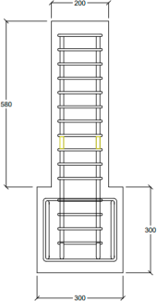
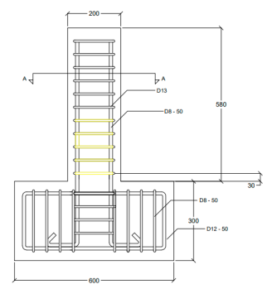
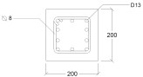
Section A-A
Front View Side View
Figure 1. Specimen’s configuration.

Tabel 1. Parameter of study.

depends on jacket reinforcement, compressive strength,

and bond quality.
However, further investigations are required to
Specimen Number of specimen
Corrosion level (%)
Concrete jacketing

evaluate the performance of concrete jacketing in columns with more severe corrosion levels, particularly
C-10 | 1 | 20 | No
C-10-R | 1 | 20 | Yes
C-N | 1 | - | No

in square columns where failure mechanisms may differ from circular ones. Although design standards such as (ACI 222R-01, 2001) and (ACI committee 562, 2019)
do not prescribe a strict corrosion threshold for

Tabel 2 . Concrete mix proportion.

Unit (kg/m³)

w/c | water | cement | coarse aggregate | fine aggregate
0,45 | 205,00 | 455,56 | 842,22 | 842,22
The concrete mix used in this study had a water- to-cement ratio (w/c) of 0.45, with a maximum aggregate size of 19 mm. The target compressive strength of the concrete was 26 MPa. Table 2 presents the concrete mix proportions per 1 m³. The test specimens were reinforced with D13 longitudinal bars, which have a yield strength of 465.6 MPa. The transverse reinforcement consisted of Ø8 stirrups spaced at 50 mm intervals, with a yield strength of 409.8 MPa. The specimens were cured by wrapping it completely with a wet cloth to maintain moisture for 1 week before conducting the corrosion test on the two specimens designated for corrosion.

Accelerated Corrosion Test And Concrete Retrofitting
The column specimens were submerged in a seawater tank during the accelerated corrosion test. The seawater was sourced from the Alue Naga coastal area in Banda Aceh (latitude 5.6034220, longitude 95.3475060). The corrosion test setup is shown in Figure 2. The seawater acted as an electrolyte, providing chloride ions (Cl⁻) necessary for the electrochemical corrosion process. The reinforcement bars were connected to a direct current (DC) power source, while a copper plate was submerged in the seawater solution. The reinforcement bars and the copper plate served as
the anode and cathode, respectively. Throughout the test, a constant current of 0.21 A was maintained. The targeted corrosion level was achieved based on mass loss, with a desired mass reduction of 20%. The estimated test duration, calculated using Faraday’s law, was 21 days.
After the corrosion test was completed, the concrete cover of specimen C-10-R was removed, and retrofitting was carried out as shown in Figure 3. A wire mesh was installed around the longitudinal reinforcement, and a bonding adhesive was applied to the surface of the existing concrete after chipping off the original cover. The concrete cover of the column was then recast using concrete with a compressive strength of 30 MPa.

Test Set-up
During the testing phase, the square RC column specimens were rigidly fixed to a steel reaction frame, as illustrated in Figure 4. The square RC columns were subjected to both axial and lateral loading. A constant axial compressive load of 100 kN was applied throughout the test, while the lateral load was gradually increased until the specimen reached its ultimate load capacity and experienced failure. All measuring instruments, including displacement transducers, strain gauges, and load cells, were connected to a data logger to record load variations throughout the test. The lateral deflection of the columns was measured using displacement transducers placed at heights of 100 mm,
300 mm, and 500 mm from the column base. The loading process was terminated once the lateral load began to decrease, indicating structural failure. Crack propagation was monitored during the test, and the final crack patterns were documented for each specimen.

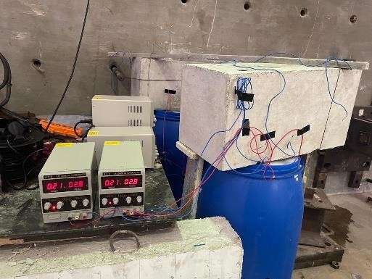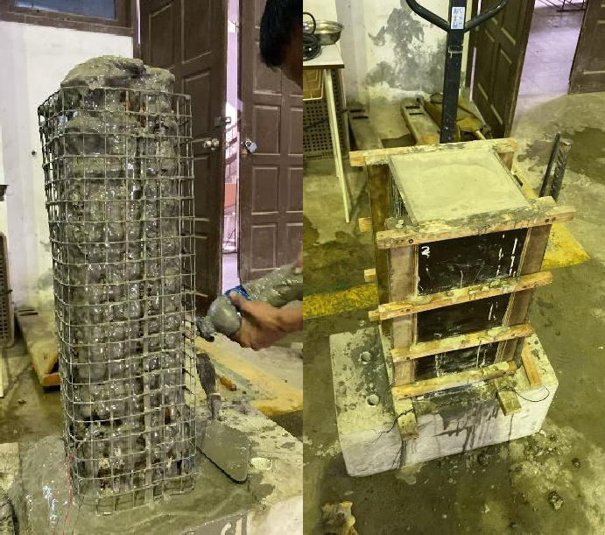
Figure 2. Accelerated corrosion test. Figure 3. Retrofitted specimen.

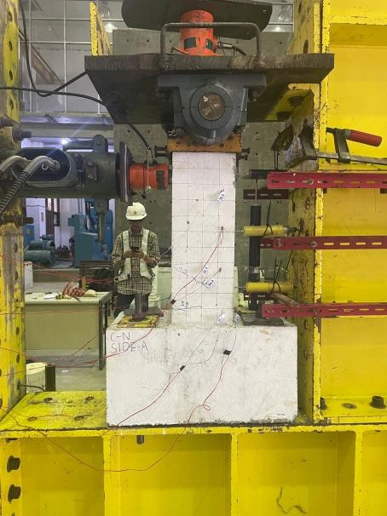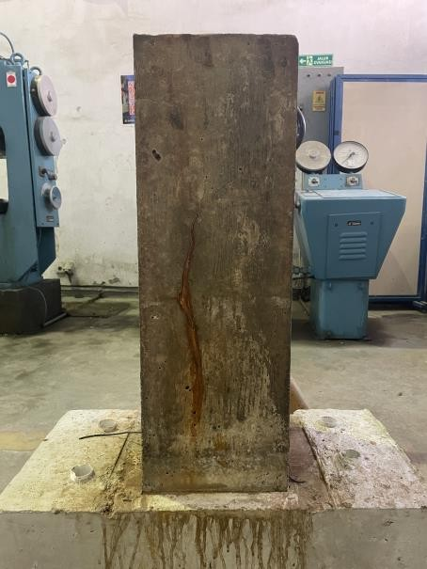
Figure 4. Test set-up. Figure 5. Condition of specimens after corrosion testing.

Results and Discussion
The results and discussion of this experimental study include the post-corrosion condition of the specimens, their maximum shear or lateral load capacity, the strain measured on the longitudinal reinforcement, and the crack patterns that developed during testing.

Actual Corrosion and Surface Crack Width
Figure 5 shows the condition of the test specimens after 21 days of accelerated corrosion testing. Cracks on the concrete surface are indicated by red lines. Corrosion in reinforced concrete is an electrochemical process. When the chloride ion concentration in the concrete exceeds a certain threshold, the protective oxide layer on the steel reinforcement is compromised. During the corrosion process, the corroded part of the reinforcement acts as the anode, while the surrounding uncorroded areas serve as the cathode. Electron flow from the anode to the cathode reacts with hydroxide ions (OH⁻), generating an electric current and forming Fe(OH)₂. The reddish or brown–orange color corrosion products result from subsequent reactions with oxygen and water penetrating the concrete. This phenomenon has also been described by (Amalia et al., 2018). It was observed through SEM, reported that corrosion products in brown–orange color penetrated along the full length of vertical cracks on the rebar surface, while smaller cracks (0.006–0.011 mm) showed minimal visible corrosion products. SEM images further revealed that corrosion products, often appearing white due to higher density, tended to fill the cracks rather than the surrounding concrete pores. In this study, several reddish or brown-orange corrosion
products were observed near the cracks shown in Figure
5. Such corrosion leads to a reduction in steel mass, which is quantified based on the mass loss relative to the wet surface area of the reinforcement.
Surface cracks on the concrete were observed as a result of reinforcement corrosion. The cracks followed the path of the reinforcement, in agreement with the findings reported in (Amalia et al., 2021).
Following the loading test, the reinforcing bars were extracted to measure the mass loss and assess the degree of corrosion. The corroded reinforcement bars were immersed in a 10% ammonium citrate solution for
24 hours to remove any attached corrosion products. These products were then cleaned using a wire brush. The condition of the corroded bars after cleaning is shown in Figure 6. Several instances of pitting corrosion (in red circle) were observed, indicating localized and severe metal degradation. Such conditions are typically observed in specimens exposed to accelerated corrosion with higher density. According to NACE (National Association of Corrosion Engineers (NACE), 2016), pitting corrosion may initiate from localized damage to the protective oxide layer, often due to low concentrations of dissolved oxygen. Although some non-uniform corrosion was present, especially in the form of pitting, it did not affect the validity of the experimental results. This is because the study did not focus on analyzing corrosion rate characteristics, but rather on evaluating the impact of the achieved corrosion levels on the load-bearing capacity of the columns.

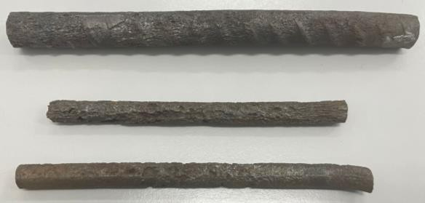
Sample of longitudinal rebar
Sample of stirrups

Figure 6. Condition of rebars after corrosion testing.
The stirrups exhibited more extensive corrosion damage compared to the longitudinal bars due to their proximity to the concrete surface. After cleaning, the bars were weighed again to determine the remaining mass. In this study, the measured corrosion percentage was 25% for the stirrups and 15% for the longitudinal reinforcement. The higher corrosion level in the stirrups is attributed to their location closer to the concrete surface. The surface crack widths observed on the specimens ranged from 0.15 mm to 0.70 mm. Figure 7 shows one of the test specimens with visible surface cracking.

Ultimate Shear Capacity of the Columns
Figure 8 presents the relationship between lateral load and deflection in the x-direction for the three column specimens which are the non-corroded specimen (C-N), the corroded specimen with 20% reinforcement mass loss (C-10), and the corroded specimen retrofitted with concrete jacketing (C-10-R). This figure illustrates the influence of corrosion and subsequent retrofitting on the lateral load capacity and deformation behavior of the columns. Based on the graph in Figure 8, the maximum shear load and horizontal deflection for each square RC column specimen were recorded as follows: 93.63 kN and 27.61 mm for specimen C-N, 71.22 kN and 29.33 mm for specimen C-10, and 70.53 kN and 28.2 mm for specimen C-10-R. These results indicate that corrosion in the reinforcement significantly reduces the shear capacity of the columns. The retrofitted corroded column (C-10-R) exhibited an increased deflection in the x-direction compared to the non-corroded specimen (C-N). In the y-direction, the deflections observed were
8.81 mm, 20.44 mm, and 12.13 mm for specimens C-N, C-10, and C-10-R, respectively, as illustrated in Figure
9. However, contrary to the expected enhancement, the retrofitted corroded square RC column exhibited a slight reduction in shear capacity compared to the corroded columns without jacketing. This reduction can be

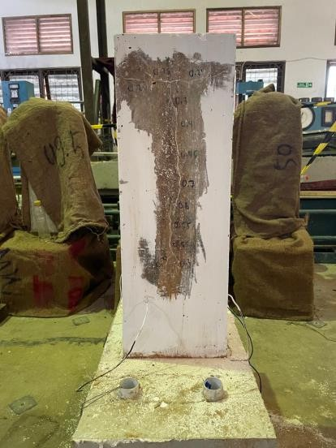
Figure 7. Surface cracks on columns after corrosion testing.
attributed to the absence of joint strengthening in the retrofit, which eventually became the failure point.
Among the three specimens with varying conditions, the highest ultimate shear capacity was recorded in the non-corroded specimen (C-N) at 93.63 kN. The corroded specimen without retrofitting (C-10) showed a 23.93% decrease in shear capacity and a 6.22% increase in x-direction deflection compared to C-
N. Corrosion products can debond the reinforcement from the surrounding concrete, reducing the bond strength and allowing greater relative movement between the steel and concrete, thus increasing column deflection.
This finding is consistent with that of (Kim, Yang, Noguchi, & Yoon, 2023), where a 10.5-21.5% mass loss resulted in a 17.9–26% reduction in the structural capacity of corroded beams. Similarly, (Zabihi-Samani, Shayanfar, Safiey, & Najari, 2018) reported that the moment capacity of corroded specimens decreased by 22% at corrosion levels of 20%. Furthermore, (Meda, Mostosi, Rinaldi, & Riva, 2014) conducted quasi-static tests on two rectangular RC columns, and found that a corrosion level of 20% led to reductions of 30% in ultimate load capacities.
The shear capacity of the retrofitted square RC column after corrosion (C-10-R) was 70.53 kN, representing a 24.66% reduction compared to the non- corroded specimen (C-N). The increase in shear capacity was not substantial, likely due to failure occurring at the column–foundation joint, as seen in the failure pattern images in Table 3. The retrofitting was limited to the column body and did not address the joint, which became the critical failure point.

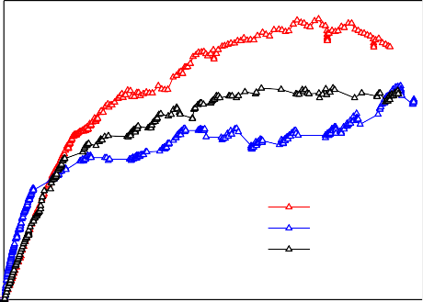
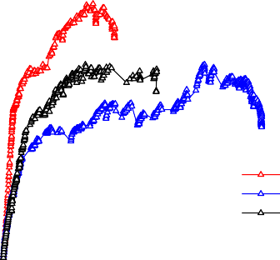
100
100

80

60

40

20
C-N C-10
C-10-R
80

60

40

20
C-N C-10
C-10-R

0 5 10 15 20 25 30
Lateral Load (kN)
Lateral Load (kN)
Deflection in x-direction (mm)
0 5 10 15 20 25 30
Deflection in y-direction (mm)

Figure 8. Lateral load–deflection relationship in x direction.
Although the retrofitted specimen (C-10-R) exhibited a slightly lower peak lateral load compared to the corroded specimen (C-10), its performance after the elastic phase was significantly better. As shown in the load–deflection realationship, C-10-R consistently carried higher lateral loads than C-10 in the post-elastic range. This indicates that the retrofitting improved the specimen's ductility and its ability to sustain loads under larger deformations, despite not substantially increasing the ultimate shear capacity. Nevertheless, from Figure 8 it can be calculated that the retrofitted square RC column exhibited a higher load at the yield point of the stirrup reinforcement. The stirrup yielded at 46.01 kN in the corroded specimen (C-10), whereas in the retrofitted corroded specimen (C-10-R), yielding occurred at 54.54 kN.
In this study, only one specimen was tested for each condition, non-corroded (C-N), corroded (C-10), and retrofitted corroded (C-10-R) square RC columns. This experimental design was chosen due to the considerable cost, time, and labor required for large-scale specimen fabrication, accelerated corrosion, and retrofitting processes. Similar single-specimen-per-condition approaches have been reported in previous studies investigating the effect of corrosion on RC members (Kim et al., 2023). While the number of specimens is limited, the primary aim of this work is to provide preliminary experimental evidence and identify structural response trends. These results will serve as a basis for future studies with larger sample sizes and numerical modelling to enhance the generality of the conclusions.
It is clear through this study that failure occurred at the column–foundation joint, which was not retrofitted in this study. This indicates that strengthening the
Figure 9. Lateral load–deflection relationship in y direction
column alone may not fully restore the structural capacity, and future work should consider retrofitting the joint region to achieve a more comprehensive improvement in seismic and corrosion resistance.

Strain and Lateral Load in the Columns
According to the graph in Figure 10, the maximum longitudinal reinforcement strain in the compression region was 0.01794 for specimen C-N and 0.00097 for specimen C-10-R. These findings suggest that the corroded reinforcement exhibited significantly smaller strain. The non-corroded specimen (C-N) exhibited a stable load response over a relatively large strain range before failure, reflecting well-developed plastic behavior. In contrast, the retrofitted corroded specimen (C-10-R) experienced a sudden load drop at a very small strain, suggesting premature failure and limited deformation capacity.
This behavior may be explained by the fact that retrofitting was applied only to the column body, while the column–foundation joint remained untreated and became the critical failure point. Additionally, the low strain reading could indicate strain localization, premature cracking near the joint, or an ineffective strain gauge position. The added stiffness from the jacketing may have also restricted strain development at the gauge location, causing stress redistribution to weaker unretrofitted regions. Overall, while the retrofitting improved load resistance in the post-elastic phase, it was insufficient in restoring the overall deformation capacity and failure resistance to the level of the original, uncorroded specimen. It is important to note that the strain data for the transverse reinforcement in the corroded specimen were not available due to strain gauge failure during loading. As a result, the assessment of confinement effectiveness in this specimen is limited.

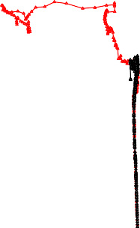
100
0
C-N
C-10-R
0

0

0
0
-0.02
-0.01
0
0.01 0.02

8
Shear Load (kN)

6

4

2

Strain
Figure 10. Load shear and strain relationsip.

Crack Patterns of the Columns
Table 4 presents the crack patterns and failure modes observed in the three column specimens. The failure mode of specimen C-N was classified as shear- flexure. Flexural cracks first appeared at a load of 4.3 tons on the tension side of the column. As the shear load increased, diagonal shear cracks developed along the sides subjected to shear forces. However, failure ultimately occurred due to the widening of the flexural cracks.
Tabel 3. Crack Patterns of the Columns.
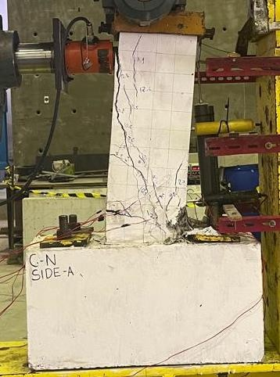

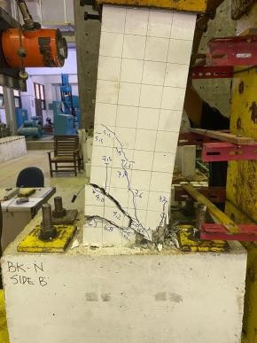
In specimen C-10, the initial flexural crack appeared at a load of 4.0 tons. Compared to C-N, this represents a 0.3-ton reduction in initial cracking load. Specimen C-10 experienced a flexural failure without the presence of shear cracks. Corroded square RC column tend to exhibit earlier flexural failure compared to the shear-flexure failure observed in non-degraded columns. This type of failure was accompanied by more significant deflections before reaching ultimate collapse.
For specimen C-10-R, the first crack appeared at a load of 5.5 tons. Compared to C-N, the initial cracking load increased by 1.2 tons. Shear cracks were observed but did not continue to grow or widen beyond a certain load. This behavior is attributed to the concentration of stress at the column–foundation joint, which eventually became the point of failure.

Conclusion
This study investigated the shear performance of square RC columns with 20% reinforcement corrosion retrofitted using concrete jacketing. The results showed that corrosion in reinforcement significantly reduced the shear capacity of the columns. Although concrete jacketing improved load yield and delayed initial cracking, the maximum shear capacity slightly decreased compared to the corroded columns without jacketing, mainly due to the absence of joint enhancement in the retrofit. Nevertheless, the retrofitted corroded square RC columns exhibited improved

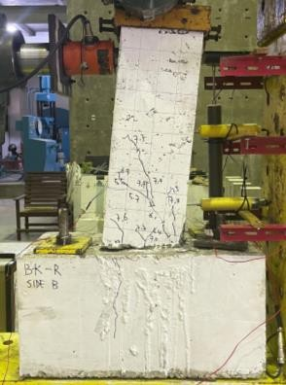

deformation performance, confirming that concrete jacketing can still serve as a viable, cost-effective, and practical strengthening method for deteriorated structures, particularly in remote post-disaster areas where advanced materials such as FRP are not readily accessible.
C-N | C-N
C-10 | C-10
C-10-R | C-10-R

Acknowledgement
This work was funded by Universitas Syiah Kuala and the Ministry of Higher Education, Science, and Technology of the Republic of Indonesia, Contract Number: 535/UN11.2.1/PG.01.03/SPK/PTNBH/2024,
dated May 3, 2024.

References
ACI 222R-01. (2001). Protection of Metals in Concrete Against Corrosion.
ACI committee 562. (2019). Code requirements for assessment, repair, and rehabilitation of existing concrete structures and commentary. In American Concrete Institute.
Amalia, Z., Qiao, D., Nakamura, H., Miura, T., & Yamamoto, Y. (2018). Development of simulation method of concrete cracking behavior and corrosion products movement due to rebar corrosion. Construction and Building Materials, 190, 560–572.
https://doi.org/10.1016/j.conbuildmat.2018.09.100 Amalia, Z., Saidi, T., Saidi, T., Aulia, T. B., Aulia, T. B., Mahlil, M., & Mahlil, M. (2021). Pengaruh Densitas Arus Terhadap Perilaku Retak Beton Bertulang Yang Mengalami Korosi Tulangan.
Teras Jurnal : Jurnal Teknik Sipil, 11(2), 351.
Engineering Structures, 228(111523). https://doi.org/https://doi.org/10.1016/j.engstruct.2 020.111523
Kim, H., Yang, S., Noguchi, T., & Yoon, S. (2023). An Assessment of the Structural Performance of Rebar-Corroded Reinforced Concrete Beam Members. Applied Sciences (Switzerland), 13(19). https://doi.org/10.3390/app131910927
Laboratorium Forensik dan Struktur Bangunan. (2023). Laporan hasil analisis forensik kekuatan dan keandalan struktur kantor dinas pemuda dan olahraga provinsi aceh. (November).
Ma, Y., Che, Y., & Gong, J. (2021). Behavior of corrosion damaged circular reinforced concrete columns under cyclic loading Behavior of corrosion damaged circular reinforced concrete columns under cyclic loading. Construction and Building Materials, 29(April 2012), 548–556. https://doi.org/10.1016/j.conbuildmat.2011.11.002 Maciej Serda, Becker, F. G., Cleary, M., Team, R. M.,

https://doi.org/10.29103/tj.v11i2.507
Holtermann, H., The, D., …
.فاطمی, ح. (2022)

Biskinis, D., & Fardis, M. N. (2024). Shear resistance of RC members with closed FRP jacket for Eurocode
8. Bulletin of Earthquake Engineering, 22(13),
6359–6377. https://doi.org/10.1007/s10518-024-
02000-0
Chong, X., Liu, H., Xie, L., Zhou, A., Huang, J., & Sha,
H. (2024). Experimental investigation of retrofitting seismically damaged reinforced- concrete frames using steel jacketing. Structures, 62(December 2023), 106243.
https://doi.org/10.1016/j.istruc.2024.106243 Habibie, M., Hasan, M., & Syarizal Fonna. (2023). Efek
Korosi Baja Tulangan Terhadap Kinerja Struktur Tipikal Pertokoan Di Banda Aceh. Al Qalam: Jurnal Ilmiah Keagamaan Dan Kemasyarakatan, 17(4), 2240–2252.
Hassan, A., Baraghith, A. T., Atta, A. M., & El-Shafiey,
T. F. (2021). Retrofitting of shear-damaged RC T- beams using U-shaped SHCC jacket. Engineering Structures, 245(December 2020), 112892.
https://doi.org/10.1016/j.engstruct.2021.112892 Hyman, A. E. (2005). Inspection , repair and
rehabilitation of concrete structures due to corrosion. 23, 309–337.
Jia, J., Zhao, L., Wu, S., Wang, X., Bai, Y., & Wei, Y. (2020). Experimental investigation on the seismic performance of low-level corroded and retrofitted reinforced concrete bridge columns with CFRP fabric. Engineering Structures, 209(110225). https://doi.org/https://doi.org/10.1016/j.engstruct.2 020.110225
Karimipour, A., & Edalati, M. (2021). Retrofitting of the corroded reinforced concrete columns with CFRP and GFRP fabrics under different corrosion levels.
Seismic Assessment, Repair and Retrofit of Existing Corroded Structures Using UHPC Jacketing. Uniwersytet Śląski, 7(1), 343–354. Retrieved from http://hdl.handle.net/10315/40964
Meda, A., Mostosi, S., Rinaldi, Z., & Riva, P. (2014). Experimental evaluation of the corrosion influence on the cyclic behaviour of RC columns. Engineering Structures, 76, 112–123.
National Association of Corrosion Engineers (NACE). (2016). International Measures of Prevention, Application, and Economics of Corrosion Technologies Study.
Pusat Penelitian dan Pengembangan Prasarana Transportasi. (2001). Laporan Akhir Pengaruh Lingkungan Korosif Beton Bertulang Jembatan.
Raihanda, B. (2022). Pengaruh Degradasi Penampang Kolom Bangunan Sekolah Akibat Genangan Tsunami Terhadap Beban Gempa. Universitas Syiah Kuala.
Ro, K. M., Kim, M. S., & Lee, Y. H. (2023). Improved Shear Strength Equation for Reinforced Concrete Columns Retrofitted with Hybrid Concrete Jackets. Materials, 16(3734).
Saeed, F. H., & Hejazi, F. (2025). A Comprehensive Review of Retrofitted Reinforced Concrete Members Utilizing Ultra-High-Performance Fiber- Reinforced Concrete. Materials, 18(5). https://doi.org/10.3390/ma18050945
Tastani, S. P. Ã., & Pantazopoulou, S. J. (2004). Experimental evaluation of FRP jackets in upgrading RC corroded columns with substandard detailing. 26, 817–829. https://doi.org/10.1016/j.engstruct.2004.02.003
Tianhao Lu, Peilong Li, Chuying Cui, Jiayu Wu, & Bing

Fu. (2023). Shear transferring mechanism of the FPR-to-concrete bonded joint with end U- jacketing: A theoretical study. Structures, 56(104991).
https://doi.org/https://doi.org/10.1016/j.istruc.2023
.104991
Weng, K. (2024). Seawater Seasand Concrete Beams and Frp-Strengthened Reinforced Concrete Beams. The Hong Kong Polytechnic University.
Zabihi-Samani, M., Shayanfar, M. A., Safiey, A., & Najari, A. (2018). Simulation of the Behavior of Corrosion Damaged Reinforced Concrete Beams with/without CFRP Retrofit. Civil Engineering Journal, 4(5), 958–970.
https://doi.org/10.28991/cej-0309148
Zhang, D. W., Zhao, Y. X., Shen, S. J., Jin, W. L., & Ueda, T. (2014). Analytical Model for Concrete Jacketed RC Columns with Precorrosion and Postcorrosion Damages Under Uniaxial Loading. 4th International Conference on the Durability of Concrete Structures, (July). https://doi.org/10.5703/1288284315394

