**EE323 Digital Signal Processing**

**Lab 3 - Frequency Analysis**

**23 Oct. ~ 1 Nov. 2019**

**3.1 Introduction**

In this experiment, we will use Fourier series and Fourier transforms to analyze continuous-time and discrete-time signals and systems. The Fourier representations of signals involve the decomposition of the signal in terms of complex exponential functions. These decompositions are very important in the analysis of linear time-invariant (LTI) systems, due to the property that the response of an LTI system to a complex exponential input is a complex exponential of the same frequency! Only the amplitude and phase of the input signal are changed. Therefore, studying the frequency response of an LTI system gives complete insight into its behavior.

In this experiment and others to follow, we will use the Simulink extension to Matlab. Simulink is an icon-driven dynamic simulation package that allows the user to represent a system or a process by a block diagram. Once the representation is completed, Simulink may be used to digitally simulate the behavior of the continuous or discrete-time system. Simulink inputs can be Matlab variables from the workspace, or waveforms or sequences generated by Simulink itself. These Simulink-generated inputs can represent continuous-time or discrete-time sources. The behavior of the simulated system can be monitored using Simulink's version of common lab instruments, such as scopes, spectrum analyzers and network analyzers.

**3.2 Background Exercises**

Inlab Report: Submit these background exercises with the lab report.

**3.2.1 Synthesis of Periodic Signals**

Each signal given below represents one period of a periodic signal with period *T*0.

1. Period $T_{0}=2$. For $t∈[0,2]$：

$s\left(t\right)=rect\left(t-\frac{1}{2}\right)$

2.Period $T_{0}=1$. For $t∈\left[-\frac{1}{2}，\frac{1}{2}\right]$：

$$s\left(t\right)=rect\left(2t\right)-\frac{1}{2}$$

For each of these two signals, do the following:

**i**: Compute the Fourier series expansion in the form

$$s\left(t\right)=a_{0}+\sum_{k=1}^{∞}{A_{k}}sin⁡(2πkf_{0}t+θ_{k})$$

Where $f_{0}=1/ T_{0}$.

Hint: You may want to use the following reference: Sec. 3.3 of “Signals and Systems”, Oppenheim and Willsky, 1997. Note that in the expression above, the function in the summation is sin $(2πkf_{0}t+θ_{k})$, rather than a complex sinusoid. The formulas in the above references must be modified to accommodate this. You can compute the cos/sin version of the Fourier series, then convert the coefficients.

**ii:** Sketch the signal on the interval $[0,T_{0}$].

**3.3 Getting Started with Simulink**

In this section, we will learn the basics of Simulink and build a simple system.

For help on "Simulink" see simulink.pdf. For the following sections download the file Lab3Utilities.zip.

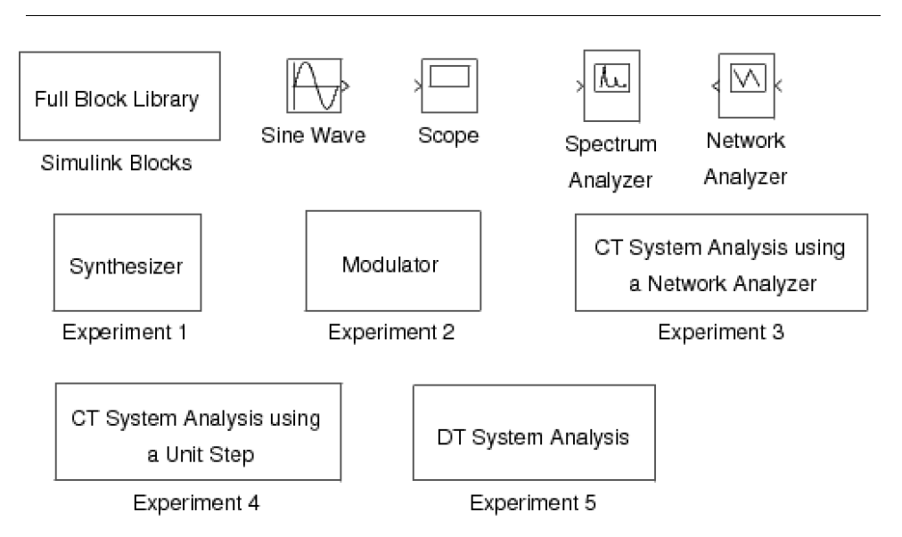

**Figure 3.1**: Simulink utilities for lab 3.



To get the library of Simulink functions for this laboratory, download the leLab3Utilities.zip. Once Matlab is started, type“Lab3” to bring up the library of Simulink components shown in Figure 3.1. This library contains a full library of Simulink blocks, a spectrum analyzer and network analyzer designed for this laboratory, a sine wave generator, a scope, and pre-design systems for each of the experiments that you will be running.

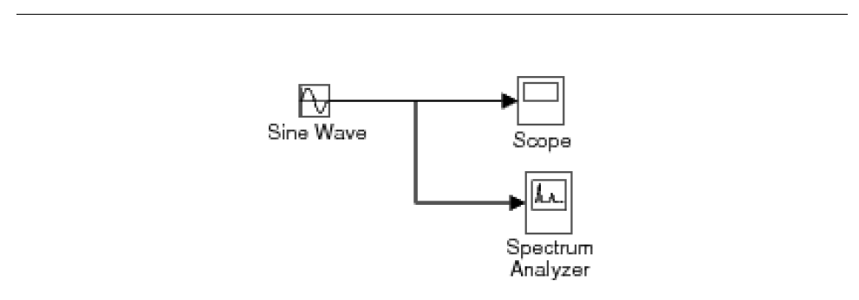

**Figure 3.2:** Simulink model for the introductory example.



In order to familiarize yourself with Simulink, you will first build the system shown in Figure 3.2. This system consists of a sine wave generator that feeds a scope and a spectrum analyzer.

1. Open a window for a new system by using the **New** option from the **File** pull-down menu, and select **Simulink** **Model**.

2. Drag the **Sine Wave**, **Scope**, and **Spectrum Analyzer** blocks from the **Lab3** window into the new window you created.

3. Now you need to connect these three blocks. With the left mouse button, click on the output of the **Sine Wave** and drag it to the input of the **Scope**. Now use the right button to click on the line you just created, and drag to the input of the **Spectrum Analyzer** block. Your system should now look like Figure 3.2.

4. Double click on the **Scope** block to make the plotting window for the scope appear.

5. Set the simulation parameters by selecting **Model Configuration Parameters** from the **Simulation** pull-down menu. Under the **Solver** tab, set the **Stop time** to 50, and the **Max step size** to 0.02. Then select **OK**. This will allow the **Spectrum Analyzer** to make a more accurate calculation.

6. Start the simulation by using the **Run** option from the **Simulation** pull-down menu. A standard Matlab figure window will pop up showing the output of the **Spectrum Analyzer**.

7. Change the frequency of the sine wave to **5*pi rad/sec** by double clicking on the **Sine Wave** icon and changing the number in the **Frequency** field. Restart the simulation. Observe the change in the waveform and its spectral density. If you want to change the time scaling in the plot generated by the spectrum analyzer, from the Matlab prompt use the **subplot(2,1,1)** and **axis()** commands.

8. When you are done, close the system window you created by using the **Close** option from the **File** pull-down menu.

**3.4 Continuous-Time Frequency Analysis**

For help on the following topics see the corresponding files: simulink.pdf or printing.pdf.

In this section, we will study the use and properties of the continuous-time Fourier transform with Simulink. The Simulink package is especially useful for continuous-time systems because it allows the simulation of their behavior on a digital computer.

**3.4.1 Synthesis of Periodic Signals**

Double click the icon labeled **Synthesizer** in Lab3 window to bring up a model as shown in Figure 3.3. This system may be used to synthesize periodic signals by adding together the harmonic components of a Fourier series expansion. Each Sin Wave block can be set to a specific frequency, amplitude and phase. The initial settings of the **Sin Wave** blocks are set to generate the Fourier series expansion

$$x（t）=0+\sum_{\begin{aligned}k=1 \\ k odd\end{aligned}}^{13}{\frac{4}{kπ}}\sin\left(2πkt\right)$$

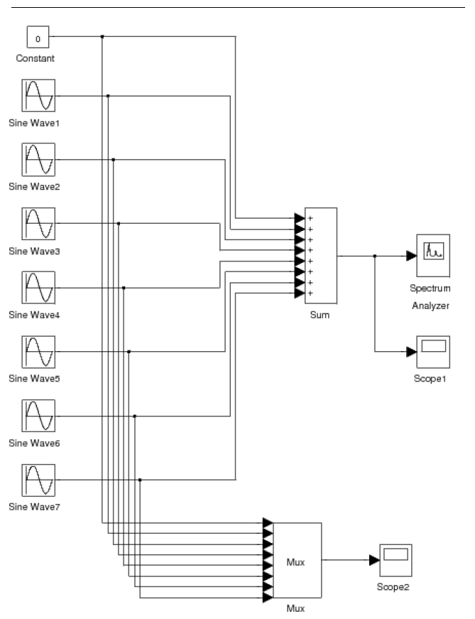

**Figure 3.3**: Simulink model for the synthesizer experiment.



These are the first 8 terms in the Fourier series of the periodic square wave shown in Figure 3.4.

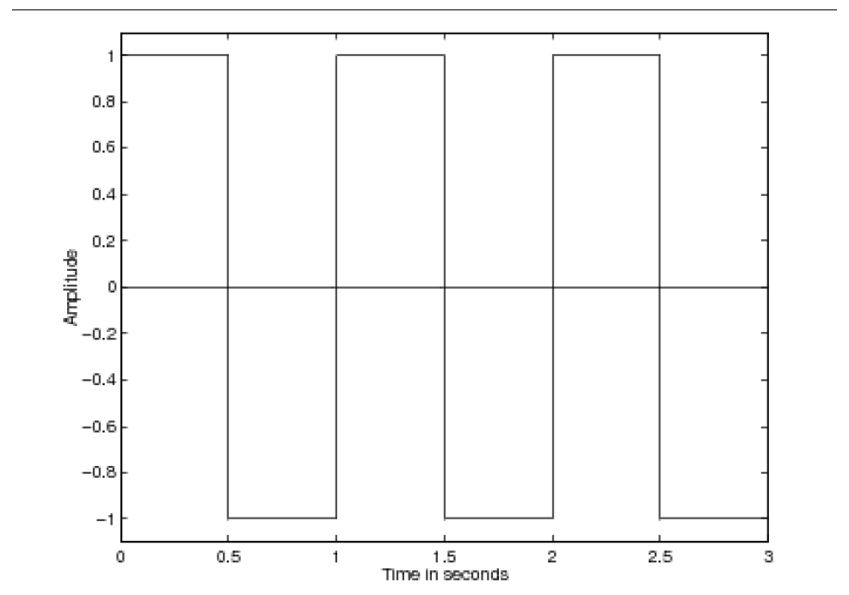

**Figure 3.4**: The desired waveform for the synthesizer experiment.



Run the model by selecting **Run** under the **Simulation** menu. A graph will pop up that shows the synthesized square wave signal and its spectrum. This is the output of the **Spectrum Analyzer**. After the simulation runs for a while, the **Spectrum Analyzer** element will update the plot of the spectral energy and the incoming waveform. Notice that the energy is concentrated in peaks corresponding to the individual sine waves. Print the output of the **Spectrum Analyzer**.

You may have a closer look at the synthesized signal by double clicking on the **Scope1** icon. You can also see a plot of all the individual sine waves by double clicking on the **Scope2** icon.

Synthesize the two periodic waveforms defined in the "Synthesis of Periodic Signals" (Section 3.2.1: Synthesis of Periodic Signals) section of the background exercises. Do this by setting the frequency, amplitude, and phase of each sine wave generator to the proper values. For each case, print the output of the **Spectrum Analyzer**.

Inlab Report: Hand in plots of the **Spectrum Analyzer** output for each of the three synthesized waveforms. For each case, comment on how the synthesized waveform differs from the desired signal, and on the structure of the spectral density.

**3.4.2 Modulation Property**

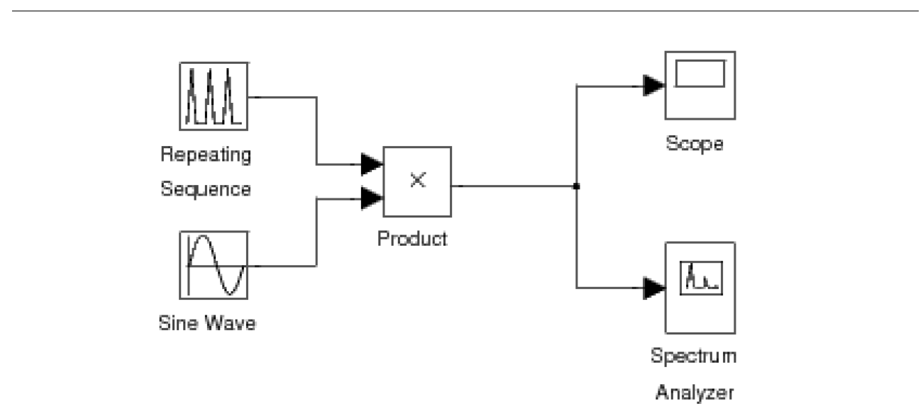

**Figure 3.5**: Simulink model for the modulation experiment.



Double click the icon labeled **Modulator** in Lab3 window to bring up a system as shown in Figure 3.5. This system modulates a triangular pulse signal with a sine wave. You can control the duration and duty cycle of the triangular envelope and the frequency of the modulating sine wave. The system also contains a spectrum analyzer which plots the modulated signal and its spectrum.

Generate the following signals by adjusting the **Time values** and **Output values** of the **Repeating Sequence** block and the **Frequency** of the **Sine Wave**. The **Time values** vector contains entries spanning one period of the repeating signal. The **Output values** vector contains the values of the repeating signal at the times specified in the **Time values** vector. Note that the **Repeating Sequence** block does NOT create a discrete time signal. It creates a continuous time signal by connecting the output values with line segments.

Print the output of the **Spectrum Analyzer** for each signal.

1. Triangular pulse duration of 1 sec; period of 2 sec; modulating frequency of 10 Hz (initial settings of the experiment).

2. Triangular pulse duration of 1 sec; period of 2 sec; modulating frequency of 15 Hz.

3. Triangular pulse duration of 1 sec; period of 3 sec; modulating frequency of 10 Hz.

4. Triangular pulse duration of 1 sec; period of 6 sec; modulating frequency of 10 Hz.

Notice that the spectrum of the modulated signal consists of a comb of impulses in the frequency domain, arranged around a center frequency.

Inlab Report: Hand in plots of the output of the **Spectrum Analyzer** for each signal. Answer following questions: 1) What effect does changing the modulating frequency have on the spectral density? 2) Why does the spectrum have a comb structure and what is the spectral distance between impulses? Why? 3) What would happen to the spectral density if the period of the triangle pulse were to increase toward infinity? (in the limit)

**3.5 Discrete-Time Frequency Analysis**

In this section of the laboratory, we will study the use of the discrete-time Fourier transform.

**3.5.1 Discrete-Time Fourier Transform**

The DTFT (Discrete-Time Fourier Transform) is the Fourier representation used for finite energy discrete-time signals. For a discrete-time signal, $x(n)$, we denote the DTFT as the function ${X(e}^{jω})$ given by the expression

$$X\left(e^{jω}\right)=\sum_{n=-∞}^{∞}{x[n]e^{-jωn}}$$

Since $X\left(e^{jω}\right)$ is a periodic function of $ω$ with a period of $2π$, we need only to compute $X\left(e^{jω}\right)$ for $-π<ω<π$.

Write a Matlab function X=DTFT(x, n0, dw) that computes the DTFT of the discrete-time signal **x**. Here **n0** is the time index corresponding to the 1st element of the **x** vector, and **dw** is the spacing between the samples of the Matlab vector **X**. For example, if **x** is a vector of length **N**, then its DTFT is computed by

$$X(ω)=\sum_{n=1}^{N}{x[n]e^{-jω(n+n0-1)}}$$

Where $ω$ is a vector of values formed by **w=(pi:dw:pi)** .

Hint: In Matlab, *j* or *i* is defined as $\sqrt{-1}$. However, you may also compute this value using the Matlab expression i=sqrt(1).

For the following signals use your DTFT function to

**i**: Compute $X\left(e^{jω}\right)$

**ii**: Plot the magnitude and the phase of $X\left(e^{jω}\right)$ in a single plot using the subplot command.

Hint : Use the abs() and angle() commands.

1.

$$x\left(n\right)=δ(n)$$

2.

$$x\left(n\right)=δ(n-5)$$

3.

$$x(n)={\left(0.5\right)}^{n}u(n)$$

Inlab Report: Hand in a printout of your Matlab function. Also hand in plots of the DTFT's magnitude and phase for each of the three signals.

**3.6 Exercises:**

1. Use the program developed in Section 3.5 to verify the DTFT of example 3 in the Lecture 4 on Slide 11.

(a) Let *N*=2, for sequence *x*[*n*] = 1 for $-N≤n≤N$, compute and plot the DTFT of the sequence *x*[*n*].

(b) Pad 5 zeros to each side of the sequence *x*[*n*]. Compute and plot the DTFT of the resultant sequence.

(c) Let *N*=7, for sequence *y*[*n*] = 1 for $-N≤n≤N$, compute and plot the DTFT of the sequence *y*[*n*].

You may plot several figures in a single plot (not in several subplots) by using different legends.

Describe your observations, comments on the observation.

Question: will padding zeros increase the frequency resolution?

2. Verify at least one symmetry property of DTFT from each table on Slide 172 and 173 of Lecture 4, respectively. Specifically, create a pair of sequences with symmetric properties from each table, compute the DTFT using the program developed in Section 3.5, observe the results, and comment on the observations. Submit the sequences, and the corresponding DTFT’s magnitude and phase plots to show the symmetric properties.

3. (a) Sample a continuous signal $x(t)=\sin\left(8πt+0.3π\right)+\cos\left(2πt+0.2π\right)$ at Nyquist rate, twice of Nyquist rate, 16 times of Nyquist rate and half Nyquist rate, respectively. The sampled signals are denoted as $x_{k}\left[n\right]$ for *k* = 1, 2, 3, 4, respectively.

(b) Plot $x_{k}\left[n\right]$ in a duration of 2 seconds (from 0 to 2 second).

(c) Using the program developed in Section 3.5 to plot the Fourier spectrums of $x_{k}$ in the range from $-π to π$. Explain the waveforms that you obtain as much as possible, for example the number, magnitude, and width of the peaks, the ripples, etc. How may you get sharper peaks and smaller ripples in the plots of the Fourier spectrum for a sequence sampled at a particular rate?

(d) Using what sampling rate, you can get only one peak, and two peaks in the range from $-π to π$, respectively? Explain the reasons.

4. Refer to the example on Slide 42 of Lecture Notes L4, write a program (or make use of the program developed in Section 3.5) to show the Gibbs phenomena. Describe your observation.