Infosys Springboard Virtual Internship 6.0 Completion Report

Team Details
Team 2
Start date : 25-Nov-25

Names:
S.No | Name
1 | S Jayanth (Project Coordinator)
2 | Akkurthy Kavya(Technical Lead)
3 | Dibya Patra(Developer Core module)
4 | Mounika(Developer supporting module)
5 | Swetha Palley(Tester and Quality Anlyst)

Internship Duration: 12 weeks

1.Project Title:

SMART HOME ENERGY MANAGEMENT SYSTEM

2.Project Objective:

- Provide secure and role-based access control using JWT authentication to manage Owners, Admins, Guests, and time-limited Maintenance Workers safely.
- Monitor and manage energy consumption efficiently by tracking real-time and historical energy usage of smart home devices.
- Enable intelligent device control and automation to allow users to remotely manage devices, schedule operations, and reduce unnecessary power usage.
- Deliver clear and actionable energy insights through dashboards and reports that help users understand usage patterns and optimize energy consumption.
- Support scalable and reliable system architecture with a clean, layered backend design ensuring security, performance, and future expansion.

3.Project Description:

The Smart Home Energy Management System (SHEMS) is a REST-based web application developed using Java 21 and Spring Boot, designed to provide secure control and monitoring of smart home energy usage.
The system follows a layered architecture consisting of Controller, Service, Repository, and Model layers to ensure modularity and maintainability. JWT-based authentication and Spring Security are used to enforce role-based access control for Owners, Admins, Guests, and time-limited Maintenance Workers.
Smart devices are associated with home owners and can be remotely controlled, scheduled, and automated through secured APIs. Real-time and historical energy consumption data is collected and persisted in a MySQL database using Spring Data JPA.
Analytical components aggregate usage data to generate insights such as consumption trends and peak usage periods.
Automated scheduling and rule-based execution reduce energy wastage by controlling devices based on predefined conditions.
The system is designed to be scalable, secure, and extensible for future enhancements such as advanced analytics and IoT integration.

3.Timeline Overview:

Week | Activities Planned | Activities Completed
Week1 | Project kickoff, requirement gathering, defining problem statement, and reviewing existing smart home energy management systems. | Conducted project initiation meeting, finalized project scope and objectives, identified user roles, and analyzed existing energy management solutions.
Week2 | System architecture design, technology stack finalization, and database schema planning. | Designed layered architecture (Controller, Service, Repository, Model), finalized Spring Boot, MySQL, JWT-based security, and prepared initial entity models.
Week3 | Authentication and role management module development. | Implemented JWT-based authentication flow, role-based access control, forgot-password mechanism with time-bound tokens, and maintenance worker access.
Week4 | Secure API development and backend validation. | Secured REST APIs using Spring Security, integrated JWT filters, tested role-based authorization, and validated backend request flows.
Week5 | Device management module design and implementation. | Developed APIs to add, update, remove, and control smart devices, linked devices to owners, and enforced access restrictions for guests and maintenance users.
Week6 | Energy consumption tracking and data storage implementation. | Implemented real-time and historical energy usage logging per device, optimized database queries, and validated data persistence using JPA.
Week7 | Analytics and reporting module development. | Built energy consumption aggregation logic, generated reports by date range, and prepared data structures for dashboard visualization.
Week8 | Scheduling and automation feature implementation. | Developed time-based scheduling and rule-based automation for device control to reduce unnecessary energy consumption.
Week9 | Frontend dashboard integration and system testing. | Integrated frontend with secured backend APIs, displayed energy analytics and device controls, and performed end-to-end system testing.
Week  10 | Final documentation, presentation preparation, and project demonstration. | Completed technical documentation, prepared presentation slides, and delivered final demo showcasing full system functionality.

5a.Key Milestones

Milestone | Decription | Date Acheived
Project Kickoff | Initial project briefing, requirement analysis, objective finalization, and study of existing smart home energy management solutions and technologies.
Team Formation | Forming a team accordingly with multiple sessions of discussions and presentations
Prototype / First Draft | Completion of core backend setup including layered architecture, JWT-based authentication, role management, and initial device management functionality.
Mid-Term Review | Review of system architecture, security implementation, device control features, energy tracking logic, and discussion of improvements for analytics and automation.

5b.Project Execution Details:

- The Smart Home Energy Management System (SHEMS) is a modular backend-driven development approach. The project began with requirement analysis, system design, and finalization of core technologies including Java 21, Spring Boot, Spring Security, JWT authentication, Spring Data JPA, MySQL, and JavaMailSender.
- A clean four-layer architecture (Controller, Service, Repository, and Model) was adopted to ensure separation of concerns, scalability, and maintainability. Initial development focused on implementing secure user authentication, role-based authorization (Owner, Admin, Guest, Maintenance Worker), and time-bound access control for maintenance users using JWT and Spring Security filters.
- The authentication module included secure signup, login, and password recovery mechanisms, with password reset links implemented using single-use, time-bound tokens delivered via email. Role-based access control was enforced both at the API level and method level, ensuring that users could access only permitted system functionalities.
- Smart devices were linked to owners and managed through secured REST APIs, enabling device registration, status control (ON/OFF), and access restriction based on user roles. Maintenance worker access was dynamically validated using custom end-time expiration logic to ensure automatic revocation without manual intervention.
- Energy consumption data was collected per device and persisted in a MySQL database, supporting both real-time monitoring and historical usage analysis. The system was tested through controller, service, and security-level validation to ensure correctness, performance, and security.
- Final integration involved connecting dynamic frontend dashboards with secured backend APIs, followed by comprehensive documentation and a live demonstration showcasing secure access, device control, energy analytics.

6.Snapshots / Screenshots
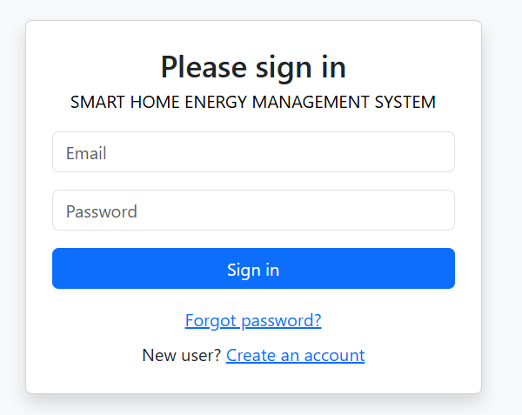

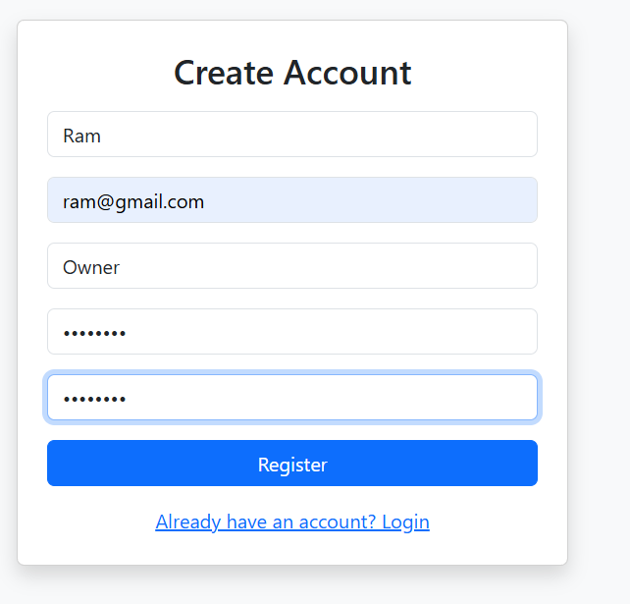

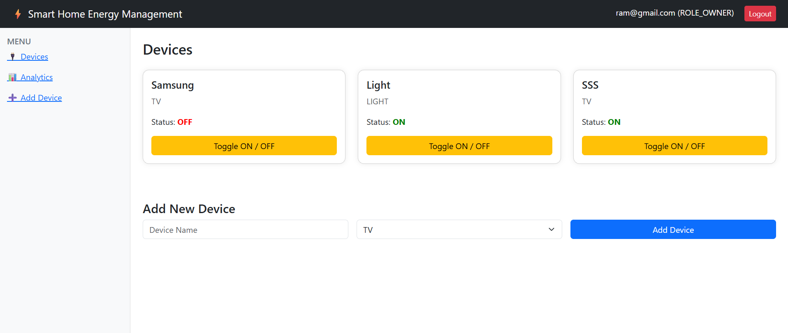
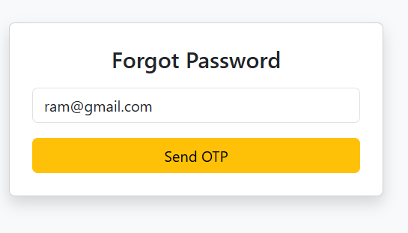

7. Learnings & Skills Acquired
- Backend Architecture & Layered Design – Gained practical experience in designing and implementing a clean four-layer architecture (Controller, Service, Repository, Model) using Spring Boot for scalable and maintainable backend development.
- Authentication & Authorization with Spring Security – Learned to implement JWT-based authentication, role-based access control, and secure API endpoints using Spring Security, including handling time-bound access for maintenance users.
- REST API Development – Strengthened skills in designing and building RESTful APIs for user management, device control, energy tracking, and automation with proper request validation and error handling.
- Database Design & ORM – Acquired experience in modeling relational database schemas and managing entity relationships using MySQL and Spring Data JPA for efficient data persistence and retrieval.

8.Challenges Faced

Challenge 1: Secure Role-Based Access Control
Problem:
Managing multiple user roles (Owner, Admin, Guest, Maintenance Worker) with different access levels and time-bound permissions increased system complexity.
Solution:
Implemented JWT-based authentication with Spring Security and enforced role-based authorization at both API and method levels, along with automatic expiry checks for maintenance worker access.
Challenge 2: Secure Password Recovery
Problem:
Preventing misuse or replay attacks during password reset operations.
Solution:
Implemented single-use, time-bound password reset tokens with a 15-minute expiry and secure email-based delivery using JavaMailSender.

9. Testimonals from team:
As part of the Smart Home Energy Management System (SHEMS) project, the team worked collaboratively following a structured, industry-oriented development process. Team members actively explored backend technologies such as Spring Boot, Spring Security, JWT authentication, and database design while adapting to real-world software engineering practices. Despite academic responsibilities and time constraints, the team maintained effective coordination through regular discussions, milestone tracking, and proactive communication. Challenges related to security implementation, role-based access, and system integration were addressed through collaborative problem-solving and shared technical documentation. This collective effort strengthened teamwork, improved technical proficiency, and ensured the successful delivery of a secure, scalable, and functional smart home energy management solution.

10.Conclusion:
The Smart Home Energy Management System (SHEMS) project successfully combined secure system design, role-based access control, and intelligent energy monitoring into a scalable web application. Through effective teamwork and structured development practices, the project achieved its objectives while providing valuable hands-on experience with real-world backend architectures and security concepts. Overall, the project strengthened both technical expertise and collaborative skills, preparing the team for future industry-level software development challenges.
11.Acknowledgement:
We sincerely thank our mentor for the continuous guidance, technical support, and encouragement provided throughout the development of the Smart Home Energy Management System (SHEMS). Your insights into system design, backend integration, and energy management concepts were instrumental in overcoming challenges and improving the quality of our work.
We are grateful for your patience, motivation, and valuable feedback, which helped our team successfully complete the project and gain meaningful technical and practical experience.

