Infosys Springboard Virtual Internship 6.0 Completion Report

Team Details
Team 2
Start date: 25-Nov-25

Intern Name:
S Jayanth

Internship Duration: 12 weeks

1.Project Title:

SMART HOME ENERGY MANAGEMENT SYSTEM

2.Project Objective:

- Provide secure and role-based access control using JWT authentication to manage Owners, Admins, Guests, and time-limited Maintenance Workers safely.
- Monitor and manage energy consumption efficiently by tracking real-time and historical energy usage of smart home devices.
- Enable intelligent device control and automation to allow users to remotely manage devices, schedule operations, and reduce unnecessary power usage.
- Deliver clear and actionable energy insights through dashboards and reports that help users understand usage patterns and optimize energy consumption.
- Support scalable and reliable system architecture with a clean, layered backend design ensuring security, performance, and future expansion.

3.Project Description:

The Smart Home Energy Management System (SHEMS) is a full-stack web application developed using Java 21 and Spring Boot to monitor, control, and optimize household energy usage. The system follows a structured MVC layered architecture consisting of Controller, Service, Repository, and Entity layers to ensure modularity and maintainability.
It integrates Thymeleaf-based dashboards with backend services to provide an interactive and user-friendly interface. Secure authentication is implemented using Spring Security with OTP-based email verification, login, and password recovery features.
Role-based access control is enforced for Admin, Owner, Guest, Child, and Maintenance users, where each role has a dedicated dashboard and limited permissions. Users can register and manage smart devices, control their ON/OFF states, and monitor their operational status remotely.
Energy consumption data is recorded for each device and stored in a MySQL database using Spring Data JPA. The system maintains both real-time and historical usage logs for tracking and analysis.
Analytics modules generate consumption trends, summaries, and visual insights displayed through charts and reports. Scheduling and automation features allow users to set time-based rules to operate devices efficiently and reduce energy wastage.
Additional services such as email notifications and basic billing estimation enhance usability. Overall, SHEMS provides a secure, scalable, and efficient solution for smart home energy management.

3.Timeline Overview:

Week | Activities Planned | Activities Completed
Week1 | Project kickoff, requirement gathering, defining problem statement, and reviewing existing smart home energy management systems. | Conducted project initiation meeting, finalized project scope and objectives, identified user roles, and analyzed existing energy management solutions.
Week2 | System architecture design, technology stack finalization, and database schema planning. | Designed layered architecture (Controller, Service, Repository, Model), finalized Spring Boot, MySQL, JWT-based security, and prepared initial entity models.
Week3 | Authentication and role management module development. | Implemented JWT-based authentication flow, role-based access control, forgot-password mechanism with time-bound tokens, and maintenance worker access.
Week4 | Secure API development and backend validation. | Secured REST APIs using Spring Security, integrated JWT filters, tested role-based authorization, and validated backend request flows.
Week5 | Device management module design and implementation. | Developed APIs to add, update, remove, and control smart devices, linked devices to owners, and enforced access restrictions for guests and maintenance users.
Week6 | Energy consumption tracking and data storage implementation. | Implemented real-time and historical energy usage logging per device, optimized database queries, and validated data persistence using JPA.
Week7 | Analytics and reporting module development. | Built energy consumption aggregation logic, generated reports by date range, and prepared data structures for dashboard visualization.
Week8 | Scheduling and automation feature implementation. | Developed time-based scheduling and rule-based automation for device control to reduce unnecessary energy consumption.
Week9 | Frontend dashboard integration and system testing. | Integrated frontend with secured backend APIs, displayed energy analytics and device controls, and performed end-to-end system testing.
Week  10 | Final documentation, presentation preparation, and project demonstration. | Completed technical documentation, prepared presentation slides, and delivered final demo showcasing full system functionality.

5a. Key Milestones

Milestone | Description | Date Achieved
Project Kickoff | Initial project briefing, requirement analysis, objective finalization, and study of existing smart home energy management solutions and technologies. | 2-12-25
Team Formation | Forming a team accordingly with multiple sessions of discussions and presentations | 11-12-25
Prototype / First Draft | Completion of core backend setup including layered architecture, JWT-based authentication, role management, and initial device management functionality. | 22-12-25
Mid-Term Review | Review of system architecture, security implementation, device control features, energy tracking logic, and discussion of improvements for analytics and automation. | 2-1-26
Final Project Demo | Demonstrated complete system workflow with secure login, role-based access, device management, energy monitoring, and automation features to mentors and evaluators. | 21-1-26
Project Presentation | Prepared documentation and slides explaining architecture, technologies, implementation, challenges, and outcomes, and presented the project to the review panel. | 11-2-26

5b. Project Execution Details:

The Smart Home Energy Management System (SHEMS) was implemented as a full-stack Spring Boot web application following the MVC architecture with Controller, Service, Repository, and Entity layers. The system integrates backend services with Thymeleaf-based frontend dashboards to provide an interactive and secure user experience.
The development began with project setup using Java 21, Spring Boot, Spring Security, Spring Data JPA, MySQL, and Maven. A modular layered structure was created to separate business logic, database operations, and presentation components for better maintainability and scalability.
The authentication and security module was developed first using Spring Security and a CustomUserDetailsService. Users register through the system with email verification and OTP-based authentication. The OTPService generates and validates one-time passwords, while the EmailService sends verification and password recovery emails. Secure login, registration, forgot-password, and OTP verification flows were implemented through dedicated Thymeleaf pages.
Role-based access control was enforced for multiple user types including Admin, Owner/User, Guest, Child, and Maintenance/Electrician. Each role is redirected to a specific dashboard with restricted permissions. Authorization checks are applied at both controller and service levels to ensure secure access to features.
Device management functionality was implemented using DeviceController and DeviceService. Users can add, update, remove, and control smart appliances. Devices are linked to specific users, ensuring ownership-based control. Maintenance users have limited operational access.
Energy monitoring was implemented through the EnergyTrackingService and UsageLog entity. The system records real-time and historical energy consumption for each device and stores the data in MySQL. This enables tracking of usage patterns and historical analysis.
Analytics and reporting features were developed using AnalyticsService and ReportController. Aggregated data is processed to generate consumption summaries, trends, and insights, which are displayed in dashboards using charts and visual components through JavaScript and charts.js.
Automation capabilities were introduced through the SchedulerService and Schedule entity. Users can create time-based schedules to automatically switch devices ON/OFF, reducing unnecessary power consumption and enabling smart energy optimization.
Additional system enhancements include:
- Email notifications and alerts
- BillingService for energy usage cost estimation
- NotificationService for system messages
- Multiple dashboards customized for each role
- Static resources (CSS/JS) for responsive UI design
The system was tested at controller, service, and database levels. Integration testing ensured smooth interaction between frontend dashboards and backend APIs. Final deployment validated secure login, device control, energy logging, analytics visualization, and automation features working together as a complete smart home solution.
Overall, the implementation demonstrates a secure, scalable, and user-friendly smart energy management platform combining authentication, device control, monitoring, analytics, and scheduling in a unified system.

6. Snapshots / Screenshots

Login page:

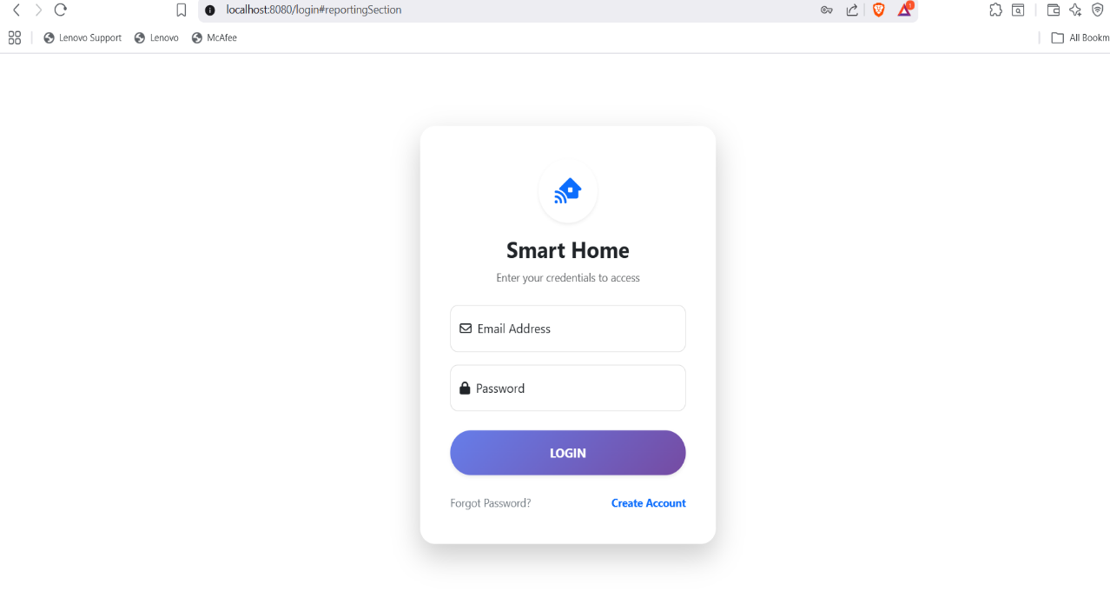

Admin/Owner : 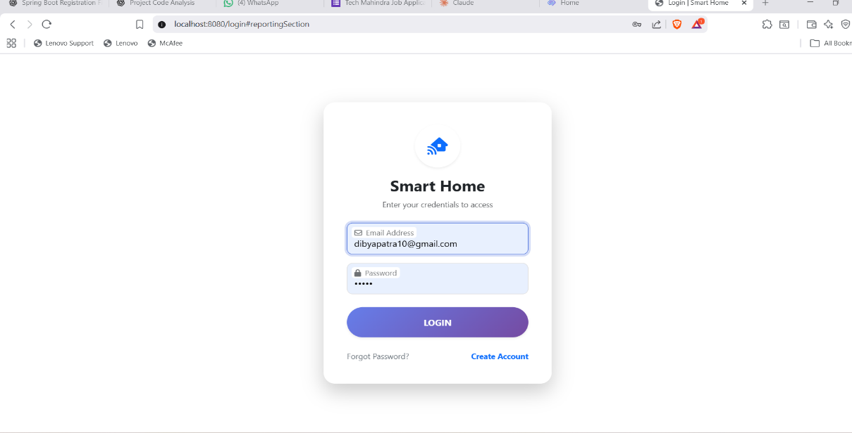

Owner Dashboard : 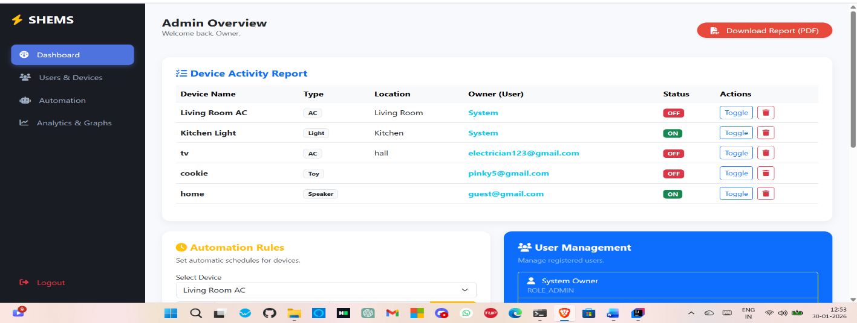

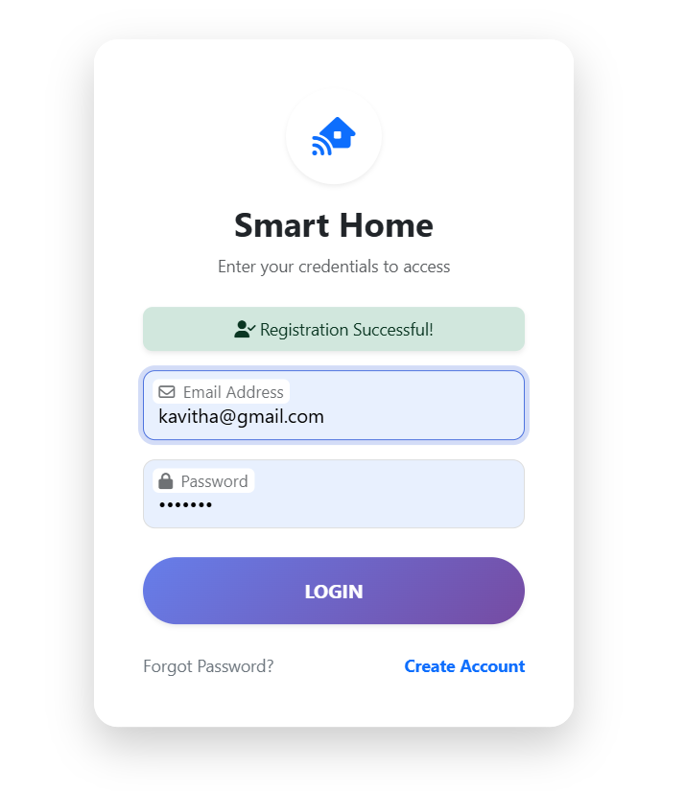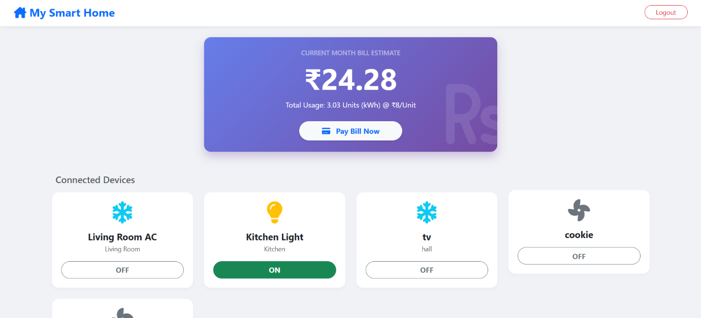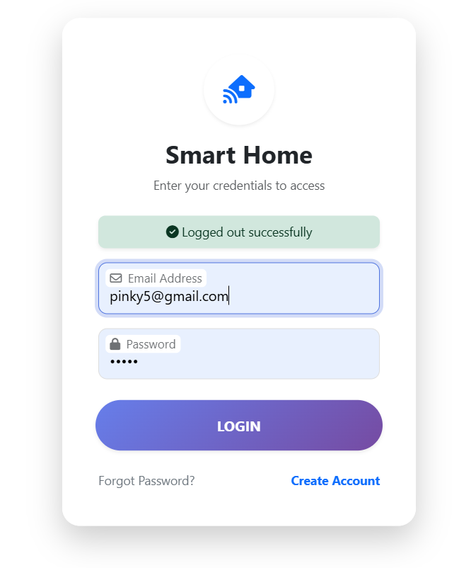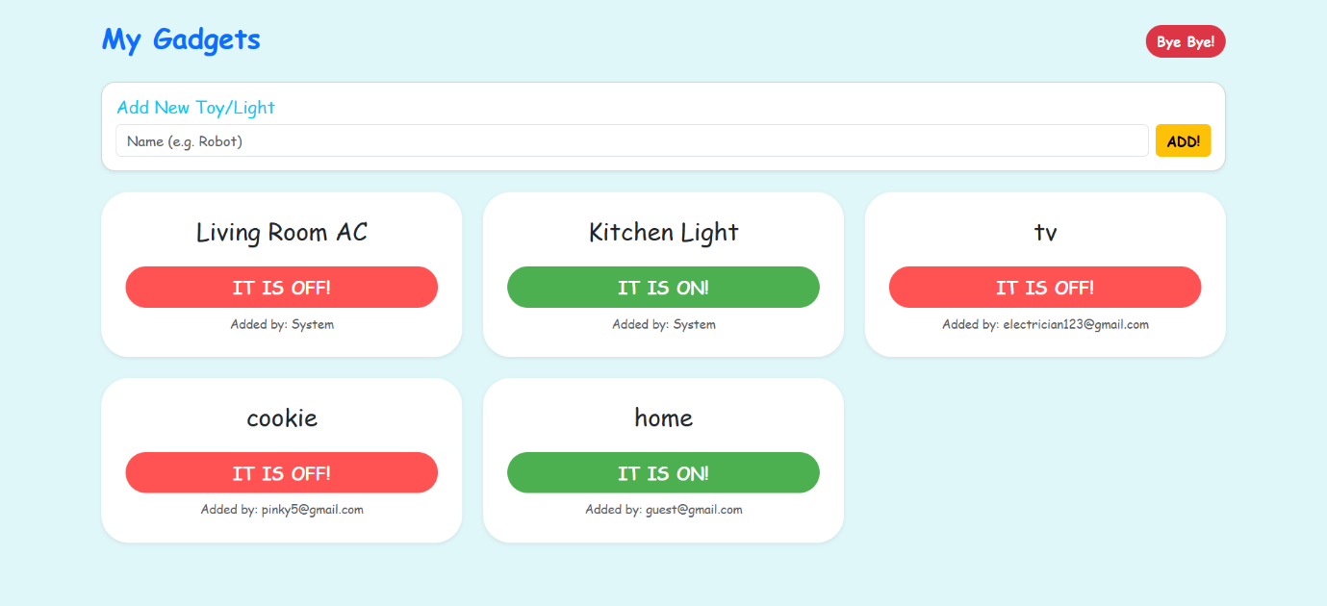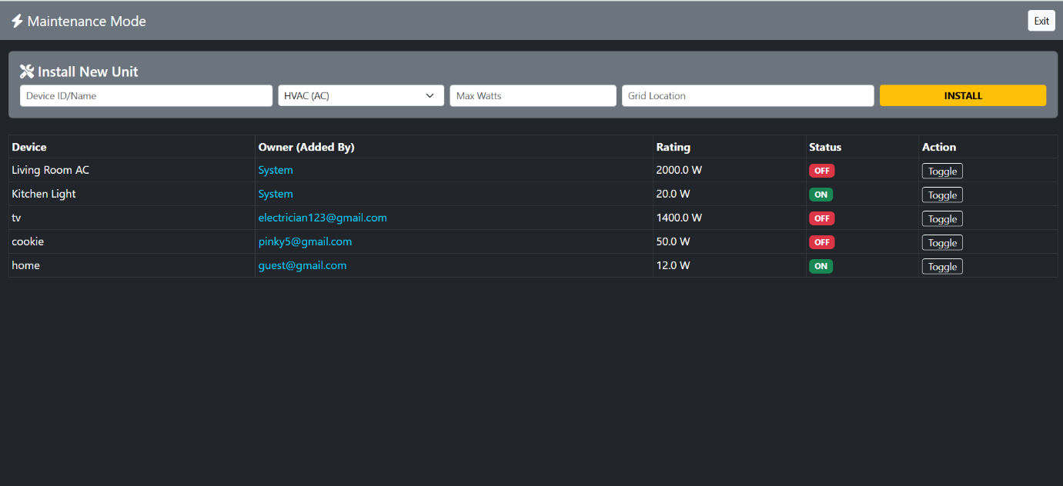

7. Learnings & Skills Acquired

Spring Boot & MVC Architecture – Gained hands-on experience designing a full-stack web application using Spring Boot with a layered MVC architecture (Controller, Service, Repository, Entity) for scalable and maintainable development.
Authentication & Security Implementation – Implemented secure login and registration using Spring Security, OTP-based email verification, password recovery, and role-based access control for multiple user types.
RESTful Services & Backend Logic – Developed controllers and business services for device management, energy tracking, scheduling, analytics, and reporting with proper validation and exception handling.
Database Design & Persistence – Designed relational schemas and managed entity relationships using MySQL and Spring Data JPA for efficient storage and retrieval of energy and device data.
Frontend Integration – Built dynamic dashboards using Thymeleaf, HTML, CSS, JavaScript, and charts to visualize energy consumption and enable real-time device control.
Automation & Scheduling – Implemented time-based scheduling and rule-driven automation to optimize appliance usage and reduce energy wastage.
Testing & Debugging – Performed unit testing, integration testing, and security validation to ensure reliability, performance, and smooth frontend–backend communication.
Team Collaboration & Project Management – Improved teamwork, task planning, documentation, and milestone tracking through collaborative development and regular reviews.

8.Challenges Faced

Challenge 1: Secure Role-Based Access Control
Problem:
Managing multiple user roles (Owner, Admin, Guest, Maintenance Worker) with different access levels and time-bound permissions increased system complexity.
Solution:
Implemented JWT-based authentication with Spring Security and enforced role-based authorization at both API and method levels, along with automatic expiry checks for maintenance worker access.
Challenge 2: Secure Password Recovery
Problem:
Preventing misuse or replay attacks during password reset operations.
Solution:
Implemented single-use, time-bound password reset tokens with a 15-minute expiry and secure email-based delivery using JavaMailSender.
Challenge 3: Real-Time Energy Data Tracking
Problem:
Capturing and storing energy consumption data for multiple devices in real time caused frequent database writes and increased system load. This made it difficult to efficiently maintain accurate logs without affecting performance.
Solution:
Designed an optimized UsageLog entity and implemented batch-based persistence using Spring Data JPA. Efficient queries and indexed tables were used to reduce database overhead, ensuring fast storage and retrieval of both real-time and historical energy data.
Challenge 4: Frontend–Backend Integration for Multiple Dashboards
Problem:
Different user roles such as Admin, Owner, Guest, and Maintenance required separate dashboards with different permissions and features. Managing dynamic data rendering and secure page access for each role was complex.
Solution:
Implemented Thymeleaf-based dynamic templates with Spring MVC controllers and enforced role-based authorization using Spring Security. Each role was redirected to a dedicated dashboard, ensuring secure navigation and proper feature visibility.
Challenge 5: Device Scheduling and Automation Logic
Problem:
Automatically turning devices ON/OFF at scheduled times required reliable execution without manual intervention. Handling overlapping schedules and ensuring consistent device states was challenging.
Solution:
Developed a scheduling module using a Schedule entity and backend service logic to trigger time-based operations. Validations were added to avoid conflicts, and automated checks ensured accurate device state updates, improving energy efficiency.

9. Testimonals from team:
As the Team Leader and Project Coordinator for the Smart Home Energy Management System (SHEMS), I was responsible for overseeing the overall planning, execution, and coordination of the project. I guided the team in following a structured, industry-oriented development process, ensuring clear task allocation, milestone tracking, and timely delivery. I actively participated in backend design, security implementation using Spring Boot, Spring Security, and JWT authentication, and supported system integration and debugging. By facilitating regular discussions, resolving technical challenges, and maintaining documentation, I ensured effective collaboration and successful completion of a secure, scalable, and functional smart home energy management solution.
10.Conclusion:
The Smart Home Energy Management System (SHEMS) project successfully combined secure system design, role-based access control, and intelligent energy monitoring into a scalable web application. Through effective teamwork and structured development practices, the project achieved its objectives while providing valuable hands-on experience with real-world backend architectures and security concepts. Overall, the project strengthened both technical expertise and collaborative skills, preparing the team for future industry-level software development challenges.
11.Acknowledgement:
I would like to acknowledge the guidance and support that contributed significantly to my role in the development of the Smart Home Energy Management System (SHEMS). Through continuous mentoring, technical discussions, and constructive feedback, I was able to strengthen my understanding of system architecture, backend integration, and energy management concepts.
This guidance, along with consistent self-effort and team coordination, enabled me to overcome technical challenges, improve implementation quality, and successfully fulfill my responsibilities as Team Leader and Project Coordinator. The experience provided valuable practical exposure and enhanced my technical, leadership, and problem-solving skills.

