**2020**

**1.a)** **Define signal ,system and signal processing.**

**Signal**

**A signal is a function that conveys information about the behavior or characteristics of a physical system. It is typically a time-dependent variable.**

* **Examples:**
  + **Electrical voltage varying over time (e.g., audio signal)**
  + **Temperature measured every hour (discrete-time signal)**
  + **Images (2D signals)**

**System**

**A system is a device or process that takes one or more signals as input, performs some operation on them, and produces output signals.**

* **Examples:**
  + **An audio amplifier (input: microphone signal, output: louder signal)**
  + **A filter that removes noise from an image**
  + **A communication channel**

**Signal Processing**

**Signal processing is the analysis, manipulation, and transformation of signals to extract useful information, improve quality, or enable transmission and storage.**

* **Types:**
  + **Analog signal processing (continuous signals, e.g., in circuits)**
  + **Digital signal processing (DSP) (discrete signals, e.g., using computers or microcontrollers)**
* **Examples:**
  + **Noise reduction in audio recordings**
  + **Image enhancement in medical scans**
  + **Data compression (e.g., MP3, JPEG)**

**1.b)** **Differentiate between digital and analog signal.**

| **Aspect** | **Analog Signal** | **Digital Signal** |
| --- | --- | --- |
| **Definition** | **Continuous signal that varies smoothly over time** | **Discrete signal with specific values at intervals** |
| **Representation** | **Represented by a continuous waveform** | **Represented by binary values (0s and 1s)** |
| **Values** | **Infinite possible values within a range** | **Finite number of values (e.g., 0 and 1)** |
| **Examples** | **Sound waves, light intensity, temperature** | **Computer data, digital audio, digital video** |
| **Susceptibility to Noise** | **More affected by noise and distortion** | **Less affected by noise due to discrete nature** |
| **Storage and Transmission** | **Difficult to store without degradation** | **Easy to store, compress, and transmit** |
| **Accuracy** | **Can be very precise, but degrades over time** | **Accuracy depends on sampling rate and resolution** |
| **Devices** | **Analog tape recorder, vinyl player** | **Computers, smartphones, digital cameras** |

**1.c)** **Explain the basic elements of a Digital Signal Processing system.**

**1. Analog Input Signal**

* **The real-world signal, such as sound, temperature, or pressure.**
* **It is continuous in time and amplitude.**

**🔹 2. Anti-Aliasing Filter**

* **A low-pass analog filter used before sampling.**
* **Purpose: Removes high-frequency components that could cause aliasing when the signal is digitized.**

**🔹 3. Sampler (ADC - Analog to Digital Converter)**

* **Converts analog signal to a digital signal by taking samples at regular intervals.**
* **Outputs a discrete-time, discrete-amplitude signal (digital signal).**
* **Sampling rate must meet the Nyquist criterion to avoid information loss.**

**🔹 4. Digital Signal Processor**

* **The core processing unit (could be software or hardware).**
* **Performs various operations like:**
  + **Filtering (e.g., noise reduction)**
  + **Compression**
  + **Modulation/Demodulation**
  + **Feature extraction (e.g., in speech or image recognition)**

**🔹 5. Digital to Analog Converter (DAC)**

* **Converts the processed digital signal back to analog form if required for real-world output.**
* **Output is continuous in time and amplitude.**

**🔹 6. Reconstruction Filter**

* **A low-pass filter applied after DAC.**
* **Smooths out the stepped analog signal from the DAC to recreate a continuous waveform.**

**🔹 7. Output Signal**

* **Final analog signal, such as audio played through a speaker or a visual display.**

**2. a) Define discrete time signal. How do you convert an analog signal into digital form? Explain with example.**

**Definition:  
A discrete-time signal is a signal defined only at discrete points in time. It is obtained by sampling a continuous-time signal at uniform intervals.**

**Conversion of Analog Signal to Digital:**

1. **Sampling: Convert the continuous-time signal x(t)x(t)x(t) to a discrete-time signal x[n]x[n]x[n] by sampling at intervals of Ts​ seconds:  
   x[n]=x(nTs)**
2. **Quantization: Approximate the amplitude of the sampled signal to a finite set of levels.**
3. **Encoding: Convert the quantized values into binary format.**

**Example:  
Let x(t)=sin(2πt ) sampled at Ts=1 second:**

**x[n]=sin(2πn)**

**2. b) Consider the analog signal x(t)=5sin(200πt)x(t)**

**The is signal can be rewritten as:**

**x(t)=5sin(2π⋅100t)**

**So, the signal has a frequency f=100 Hz**

**i. Minimum sampling rate to avoid aliasing:**

**According to Nyquist Theorem, the minimum sampling rate should be:**

**fs≥2f=2×100=200 Hz**

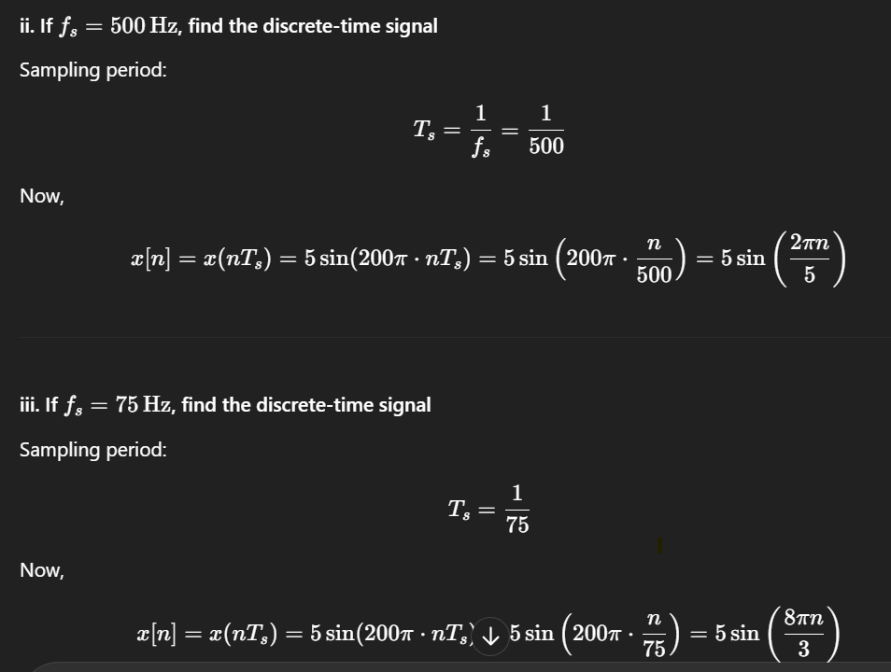

**2. c) Define Sampling Theorem**

**Sampling Theorem (Nyquist-Shannon Theorem):  
A continuous-time signal can be completely represented in its samples and reconstructed from them if it is band-limited and the sampling frequency fsf_sfs​ is at least twice the maximum frequency present in the signal.**

**fs​≥2fmax​**

**3.b)** **Differentiate between energy signal and power signal.**

