

**Final Year Project Report**

**Title: Smart Automated Classroom Attendance System Using Face Recognition**

**Submitted by**

Muhammad Ahmed (13460) (Team Leader)

Faiq Ali Siddiqui (14020)

Syeda Aliza Ali (13550)

Maryam Rehan (13541)

**Instructor**

**Dr. Aarij Mahmood Hussaan**

**Supervisor**

**Dr. Affan Alim**

**Project Description**

**Abstract**:

The project aims to develop an automated attendance system for classrooms using camera equipped with facial recognition technology. Traditional attendance tracking methods often suffer from inefficiencies, such as manual recording errors and time-consuming processes. By leveraging cameras and advanced facial recognition algorithms, this system offers a more accurate, efficient, and convenient way to monitor student attendance in educational settings. The system logs attendance in real-time, provides notifications of anomalies.

**Introduction**:

In today's fast-paced educational environment, efficient management of classroom attendance poses a significant challenge for educators and administrators alike. Traditional methods of attendance taking, such as manual roll calls or paper-based sign-in sheets, are time-consuming, prone to errors, and often lack real-time insights into student attendance patterns. To address these challenges and streamline the attendance tracking process, we propose the "Smart Automated Classroom Attendance System."

The Smart Automated Classroom Attendance System (SACAS) leverages cutting-edge technology, including Machine learning/Deep learning, based on biometric recognition and computer vision, to revolutionize the way attendance is managed in educational institutions. By harnessing the power of advanced algorithms and sensor technology, the system offers a seamless and efficient solution for tracking student attendance in real-time. Essentially, a database will be integrated to the system for recording the attendance and other in out of the activities of students. The flow diagram of the complete proposed system is shown in Figure -1.

Essentially, the system comprises six primary implementation modules: (i) Creation of the database using registration, (ii) Developing the Machine learning model using available class database, (iii) Detection and recognition of the faces, (iv) Design of the database for attendance records, (v) Integration of the camera, and (vi) User interface development for image registration. Ultimately, each module within the proposed models will be harmoniously integrated to function as a cohesive product. The experiment will be tested on two different senior of dataset (i) already available face dataset like FERET, or Georgia tech, and other is our classroom student’s dataset. **You Only Look Once (YOLO)**: YOLO is another fast and accurate object detection algorithm. It divides the input image into a grid and predicts bounding boxes and class probabilities directly from the grid cells, resulting in real-time performance. **ResNet**: Residual Networks (ResNet) are a family of CNN architectures featuring residual connections, which allow for the training of very deep networks. ResNet variants are commonly used for face detection and recognition tasks due to their excellent performance and scalability. Therefore, both deep learning techniques will be used in our proposed framework of SACAS. The attendance record will be maintained in MySQL database. A smart attendance database will be designed in MySQL where the attendance activity will be maintained.

**Benefits:**

**Increased Efficiency:**

* Automates the attendance marking process, saving time for educators and students alike by eliminating manual roll calls.

**Enhanced Accuracy:**

* Reduces errors associated with traditional attendance methods, ensuring that attendance records are precise and reliable.

**Reduced Burden:**

* Automates repetitive tasks, freeing up faculty to focus on more critical activities such as student engagement and instructional quality.

**Improved Student Accountability:**

* By providing a transparent and tamper-proof attendance record, the system encourages students to attend classes regularly, knowing their presence is accurately tracked.

**Improved Data Management:**

* Centralized storage of attendance records makes it easy to access, manage, and analyze data for reporting and decision-making purposes.

**Functional Requirements:**

* **Camera Integration:**

The system shall integrate with cameras installed in the classroom to capture real-time footage of the students present in the class.

* **Face Recognition:**

The system shall employ facial recognition algorithms to accurately identify students who is present in the classroom.

* **Attendance Logging:**

The system shall automatically log the attendance of each student based on their presence in the classroom captured by cameras.

* **User Interface:**

The system shall have a user-friendly interface for teachers/administrators to view attendance records, monitor real-time attendance, and manage the system.

* **Attendance Marking:**

The system shall mark attendance when the faculty clicks a button on the website to open the camera.

Attendance shall be marked for all students present in the classroom at that moment.

* **Data Export:**

The system should allow for the export of attendance data in various formats (e.g., CSV, Excel) for further analysis or record-keeping.

**Non-Functional Requirements:**

* **Accuracy**:

The facial recognition algorithm shall achieve a minimum accuracy rate of 90% in identifying students present in the classroom.

* **Maintainability:**

The system shall be designed in a modular fashion to facilitate easy updates and maintenance, with a target of less than 2 hours for minor updates and 8 hours for major updates.

* **Interoperability**:

The system shall be capable of exporting data in formats such as CSV and Excel to ensure compatibility with various data analysis tools.

* **Auditability**:

The system shall maintain detailed logs of attendance records, including timestamps of when students were recognized and logged, ensuring all data is stored for a minimum of one academic year.

* **Data Integrity**:

The system shall ensure that all attendance data is accurately captured, stored, and retrieved without any corruption or loss, with a data integrity rate of 99.9%.

* **Website Response Time:**

The system's response time for all events triggered by buttons on the website shall be optimized to ensure minimal delay, with a target response time of less than 4 seconds per event.

**Required Diagrams:**

The required diagrams that illustrate our project are as follows:

**Use Case Diagram:**

Illustrates the interactions between users (students, faculty, IT) and the system for various functionalities such as automatic attendance marking, managing student information, and viewing attendance data.

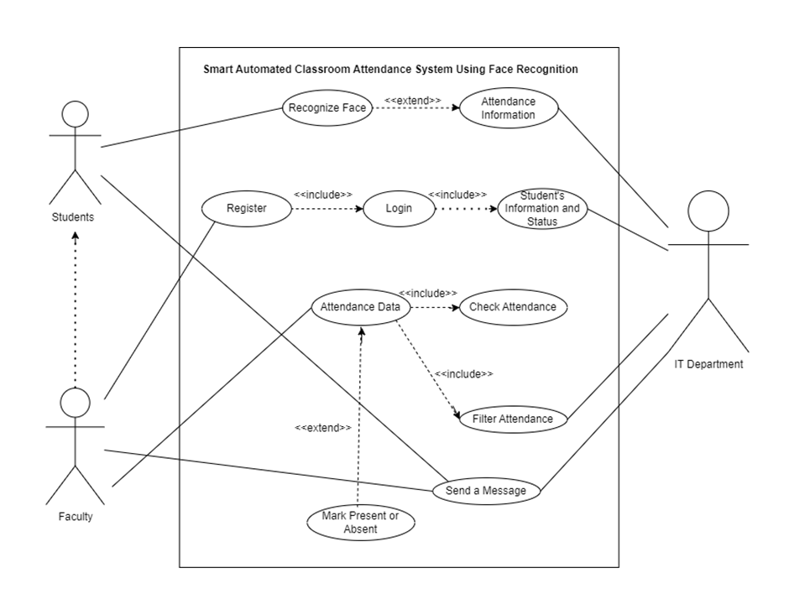

**Use Case Narratives:**

Provides detailed descriptions for each use case, including pre-conditions, post-conditions, and the normal flow of events for actions like student attendance marking, faculty managing information, and filtering attendance data.

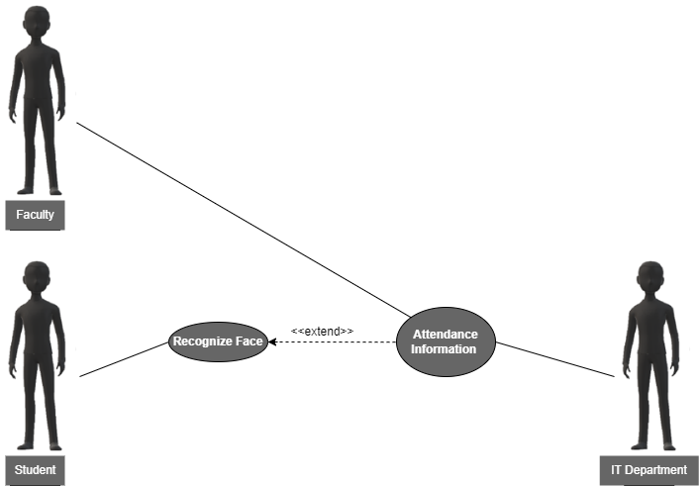

|  |  |  |
| --- | --- | --- |
| **Use Case Name:** | Automatic Attendance Marking (UC-1) | |
| **ID:** | UC-1 | |
| **Actors Involved:** | * Student * IT * Faculty | |
| **Brief Description** | It describes the automatic process of marking a student's attendance using facial recognition technology. | |
| **Pre-Conditions** | * Student registered with face image data * Classroom camera operational * Attendance system software working. | |
| **Post-Conditions** | Student attendance recorded with timestamp.  Faculty manages records. | |
| **Normal Flow of Events:** | **Actor Action** | **System Response** |
| **Student’s Action:**   1. Enters the classroom and the student does not need to take any specific actions beyond being present within the camera's view for facial recognition to occur. | 1. Face Recognition 2. Attendance Marking |

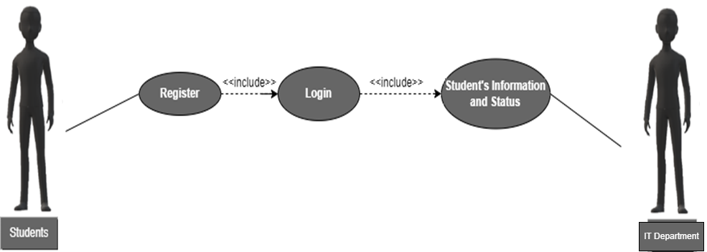

|  |  |  |
| --- | --- | --- |
| **Use Case Name:** | Faculty Manages Student Information (UC-2) | |
| **ID:** | UC-2 | |
| **Actors Involved:** | • Faculty  • IT (Indirect) | |
| **Brief Description** | It describes the process of a faculty member registering, logging in, and managing student information within the attendance system. | |
| **Pre-Conditions** | • The faculty member has internet access and a device to access the system.  • The attendance system software is operational. | |
| **Post-Conditions** | • The faculty member is successfully registered and logged in to the system.  • The faculty member can view and manage student information and status (e.g., attendance records).  • (Indirect) IT retains control over overall system management and security. | |
| **Normal Flow of Events:** | **Actor Action** | **System Response** |
| **1. Faculty:**   * Registers on system page. * Logs in with username/password * Manages student info on faculty dashboard: views lists, individual details, attendance (if permitted), updates (if permitted).  1. **IT(Indirect):**  * IT maintains security, defines permissions. | 1. System creates faculty account securely.  2. Displays student info based on access level.  3. Grants access to a system with valid login.  4. Prompts retry or recovery for invalid credentials. |

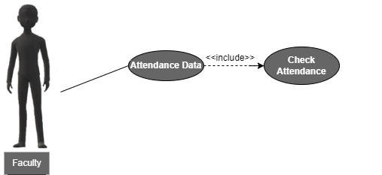

|  |  |  |
| --- | --- | --- |
| **Use Case Name:** | Faculty Checks Attendance (UC-3) | |
| **ID:** | UC-3 | |
| **Actors Involved:** | • Faculty | |
| **Brief Description** | This use case describes the process of a faculty member using the system to view and check student attendance data. | |
| **Pre-Conditions** | • The faculty member is successfully logged in to the system.  • The attendance system has captured student attendance data (e.g., through face recognition). | |
| **Post-Conditions** | • The faculty member has viewed and analyzed student attendance information for a specific class session or timeframe. | |
| **Normal Flow of Events:** | **Actor Action** | **System Response** |
| **Faculty:**  Accesses the attendance data section of the system.  Selects options to view and analyze attendance data for a specific class session, date range, or student. | 1. System displays attendance options.  2. Faculty filter class/date/student.  3. System retrieves attendance info: student list, status (present/absent/late), timestamps. Format depends on system design. |

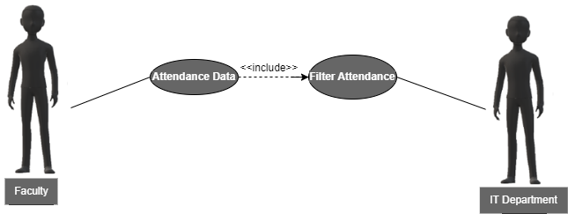­

|  |  |  |
| --- | --- | --- |
| **Use Case Name:** | Faculty Filters Attendance Data (UC-4) | |
| **ID:** | UC-4 | |
| **Actors Involved:** | • Faculty  • IT (Indirect) | |
| **Brief Description** | This use case describes the process of a faculty member using the system to filter and view specific student attendance data. | |
| **Pre-Conditions** | • The faculty member is successfully logged in to the system.  • The attendance system has captured student attendance data. | |
| **Post-Conditions** | • The faculty member has viewed and analyzed student attendance information based on applied filters (e.g., date range, specific student). | |
| **Normal Flow of Events:** | **Actor Action** | **System Response** |
| **Faculty:**  Accesses the attendance data section of the system.  Selects options to view and analyze attendance data for a specific class session, date range, or student. | 1. System displays attendance options.  2. Faculty filters class/date/student.  3. System retrieves attendance info: student list, status (present/absent/late), timestamps. Format depends on system design. |

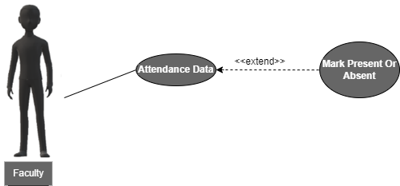

|  |  |  |
| --- | --- | --- |
| **Use Case Name:** | Faculty Initiates And Checks For Students Attendance(UC-5) | |
| **ID:** | UC-5 | |
| **Actors Involved:** | • Faculty | |
| **Brief Description** | This use case describes the process of a faculty member using the system to mark student attendance during a class session. | |
| **Pre-Conditions** | • The faculty member is successfully logged in to the system.  • The face recognition system is operational. | |
| **Post-Conditions** | • The faculty member also have option to mark (present or absent), if student’s were present in the class.  • The system stores the attendance data for each student. | |
| **Normal Flow of Events:** | **Actor Action** | **System Response** |
| **Faculty Actions:**  • Accesses attendance marking section.  • Selects method to mark attendance:   * Manual selection: Selects attendance status(present/absent) for each student. | 1**. Facial Recognition:**   * Successful recognition marks student "present" with date/time. * Unsuccessful recognition prompts manual selection or retry.   **Manual Selection:**   * Stores faculty's selections for each student's status with date/time. |

**Machine Learning Pipeline**

Outlines the steps involved in the machine learning model development and deployment for facial recognition, including data collection, training, validation, and real-time prediction.

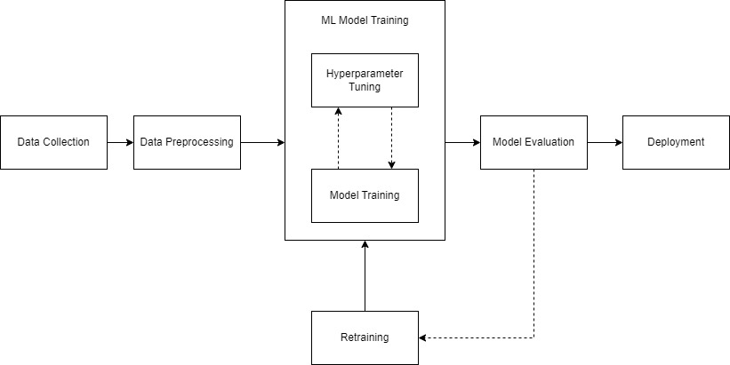

**ERD Diagram**

Displays the entity-relationship diagram showing the database structure, including entities like students, attendance records, and their relationships.

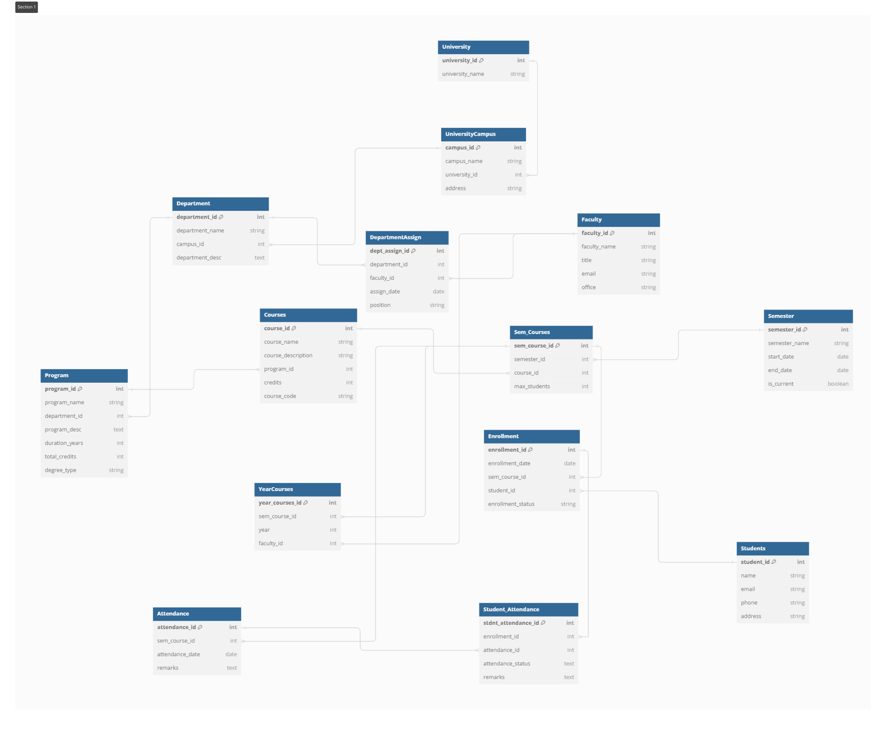

**State Diagram**

Depicts the different states the system can be in and transitions between these states based on events such as user actions or system processes.

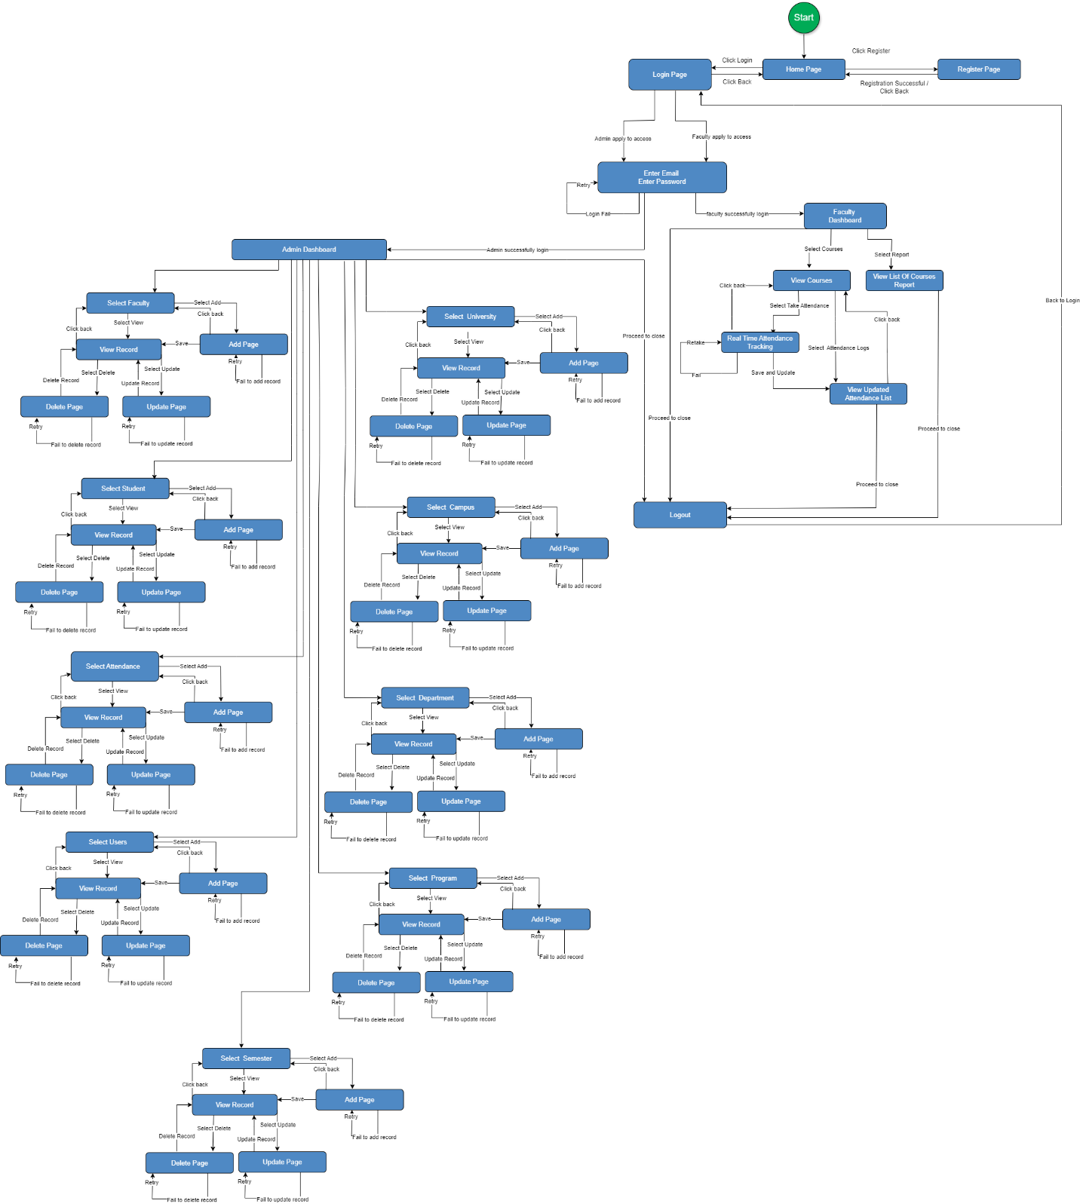

**Prototype:**

Visual representation of the system's user interface, including pages for home, registration, login, admin dashboard, and faculty dashboard.

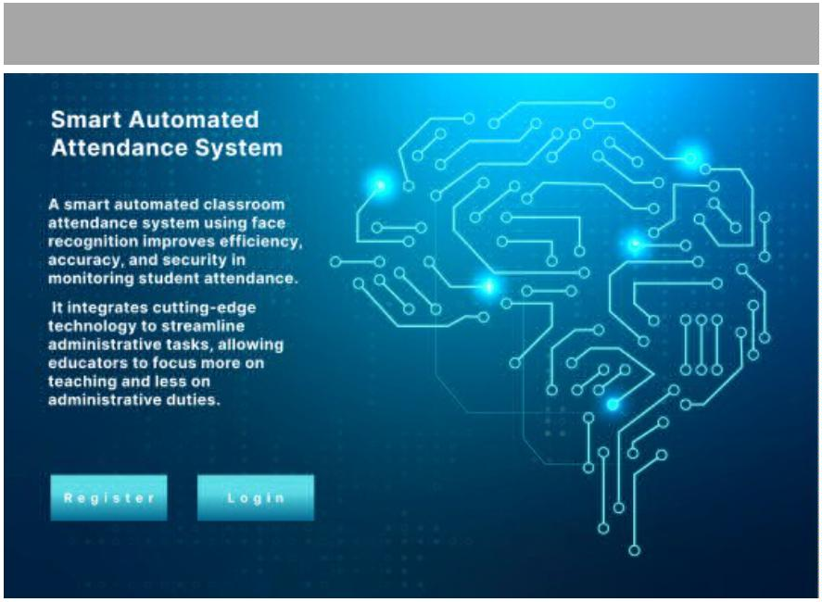

Home Page

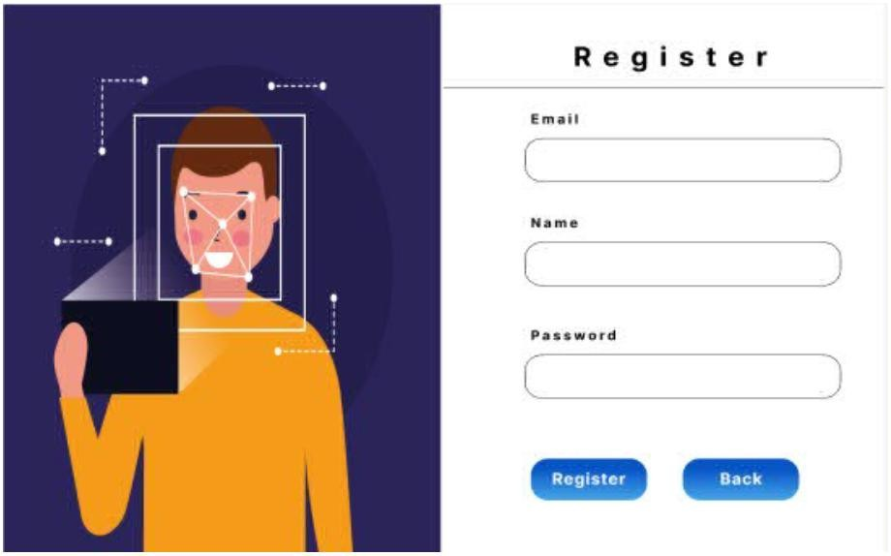

Register

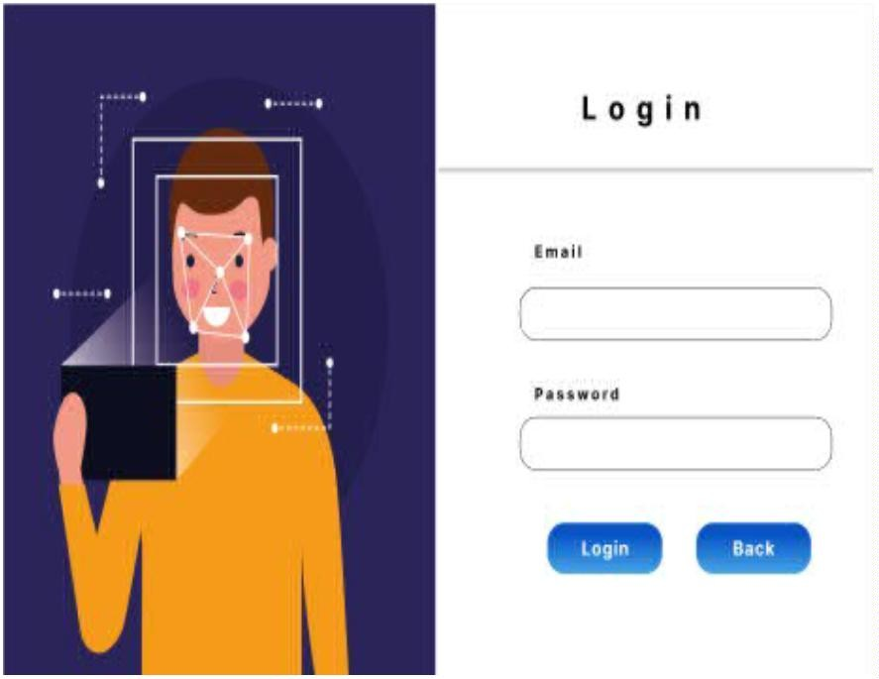



Login

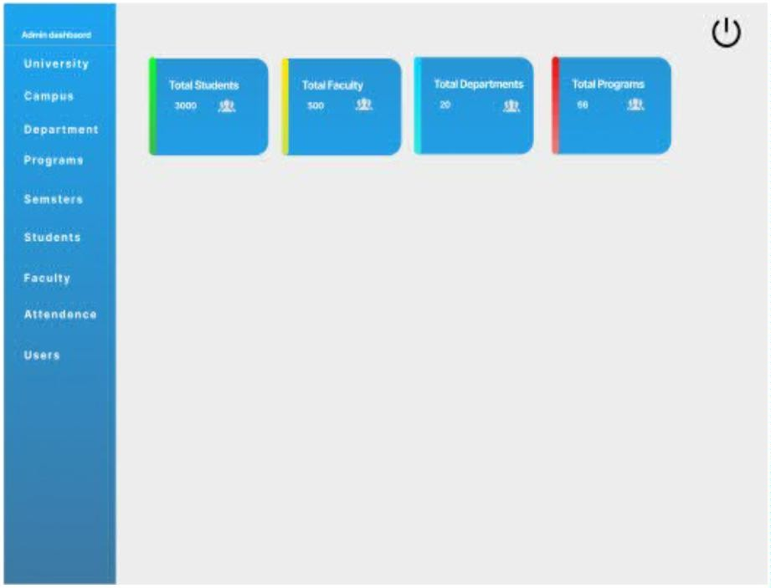



Admin Dashboard

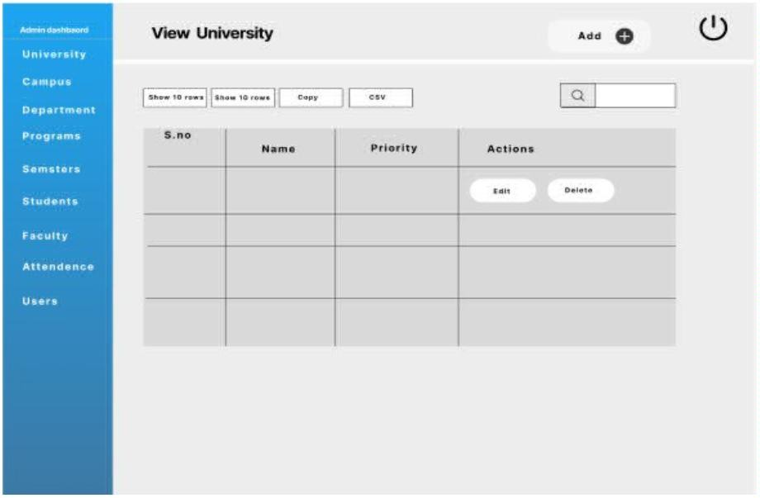

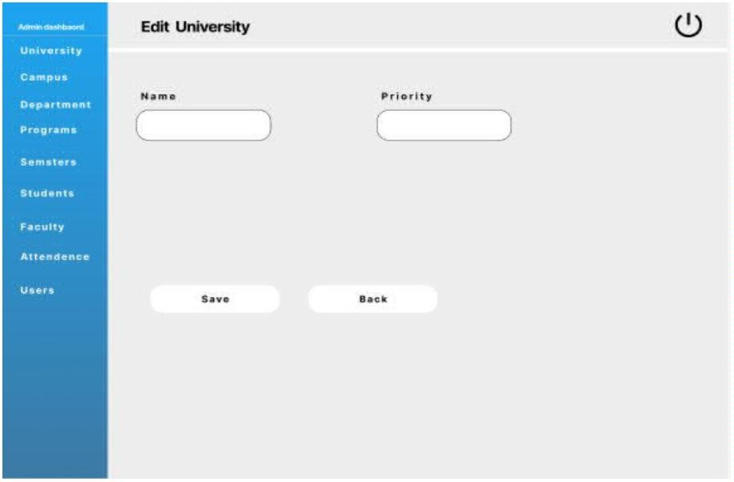

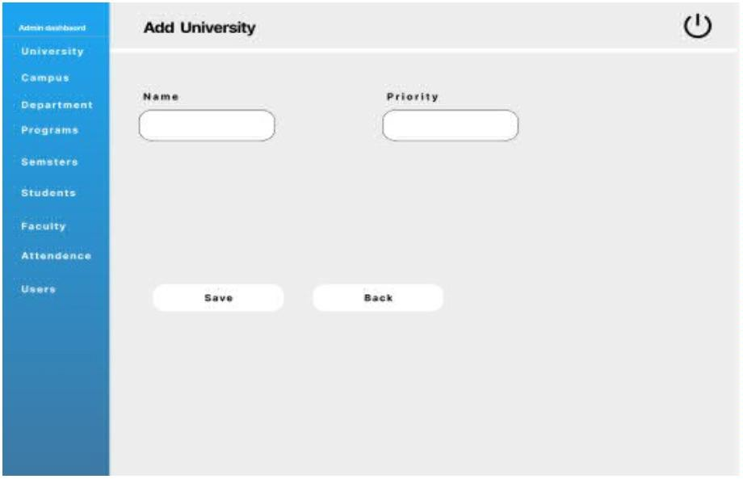



Faculty Dashboard

