Page Object Model (POM) Framework Implementation
Selenium WebDriver + TestNG | Eclipse Java Project
This guide shows how to create a basic Selenium automation framework in Eclipse as a normal Java Project (not Maven), using Page Object Model (POM) and TestNG.

1. Requirements
- Eclipse IDE for Java Developers
- JDK 17 or JDK 21
- Google Chrome
- Selenium Java client library
- TestNG Eclipse plugin

2. Create the Java Project in Eclipse
1. Open Eclipse.
2. Go to File → New → Java Project.
3. Project name: SeleniumPOMFramework.
4. Select the installed JDK.
5. Click Finish.
Expected project structure:
SeleniumPOMFramework
└── src
├── base
├── pages
├── tests
└── utils

3. Add Selenium JAR Files
Download the Selenium Java client ZIP from the official Selenium website. Extract it. In Eclipse, right-click the project → Build Path → Configure Build Path → Libraries → Classpath → Add External JARs. Add the Selenium Java client JAR and all JAR files from the extracted selenium-java/lib folder. Click Apply and Close.
Important: Selenium 4 includes Selenium Manager, so for normal Chrome automation you generally do not need to manually download chromedriver.exe.

4. Install TestNG in Eclipse
1. Go to Help → Eclipse Marketplace.
2. Search for TestNG.
3. Install TestNG for Eclipse.
4. Restart Eclipse when asked.
5. After restarting, right-click a test class and verify that Run As → TestNG Test is available.

5. Create Packages
Right-click src → New → Package. Create these four packages:
- base
- pages
- tests
- utils
Final structure:
src
├── base
│ └── BaseTest.java
├── pages
│ ├── LoginPage.java
│ └── HomePage.java
├── tests
│ └── LoginTest.java
└── utils
└── DriverManager.java

6. Create DriverManager.java
Right-click utils → New → Class → DriverManager.
package utils;
import org.openqa.selenium.WebDriver;
import org.openqa.selenium.chrome.ChromeDriver;
public class DriverManager {
private static WebDriver driver;
public static void createDriver() {
driver = new ChromeDriver();
driver.manage().window().maximize();
}
public static WebDriver getDriver() {
return driver;
}
public static void quitDriver() {
if (driver != null) {
driver.quit();
driver = null;
}
}
}

7. Create BaseTest.java
Right-click base → New → Class → BaseTest.
package base;
import org.testng.annotations.AfterMethod;
import org.testng.annotations.BeforeMethod;
import utils.DriverManager;
public class BaseTest {
@BeforeMethod
public void setUp() {
DriverManager.createDriver();
}
@AfterMethod
public void tearDown() {
DriverManager.quitDriver();
}
}

8. Create LoginPage.java
This is the main POM idea: locators and page actions are kept inside the page class. The test class should not directly use Selenium locators.
package pages;
import org.openqa.selenium.By;
import org.openqa.selenium.WebDriver;
public class LoginPage {
private WebDriver driver;
private By username = By.id("username");
private By password = By.id("password");
private By loginButton = By.id("login");
public LoginPage(WebDriver driver) {
this.driver = driver;
}
public void enterUsername(String usernameValue) {
driver.findElement(username).sendKeys(usernameValue);
}
public void enterPassword(String passwordValue) {
driver.findElement(password).sendKeys(passwordValue);
}
public void clickLogin() {
driver.findElement(loginButton).click();
}
public void login(String usernameValue, String passwordValue) {
enterUsername(usernameValue);
enterPassword(passwordValue);
clickLogin();
}
}

9. Create HomePage.java
package pages;
import org.openqa.selenium.By;
import org.openqa.selenium.WebDriver;
public class HomePage {
private WebDriver driver;
private By homeTitle = By.tagName("h1");
public HomePage(WebDriver driver) {
this.driver = driver;
}
public String getHomeTitle() {
return driver.findElement(homeTitle).getText();
}
}

10. Create LoginTest.java
Right-click tests → New → Class → LoginTest.
For a simple demonstration, the test below uses a practice page. The locator values in LoginPage.java must match the actual page you test.

package tests;

import org.testng.Assert;
import org.testng.annotations.Test;
import base.BaseTest;
import pages.LoginPage;
import pages.HomePage;
import utils.DriverManager;

public class LoginTest extends BaseTest {

@Test
public void validLoginTest() throws
InterruptedException {

DriverManager.getDriver().get(
"https://the-internet.herokuapp.com/login"
);

LoginPage loginPage = new LoginPage(DriverManager.getDriver());

loginPage.enterUsername("tomsmith");
loginPage.enterPassword("SuperSecretPassword!");
loginPage.clickLogin();

HomePage homePage = new HomePage(DriverManager.getDriver());

String title = homePage.getHomeTitle();

Assert.assertEquals(title, "Secure Area");
Thread.sleep(30000);
}
}

11. Correct LoginPage.java for the Demonstration Site
package pages;
import org.openqa.selenium.By;
import org.openqa.selenium.WebDriver;
public class LoginPage {
private WebDriver driver;
private By username = By.id("username");
private By password = By.id("password");
private By loginButton = By.cssSelector("button[type='submit']");
public LoginPage(WebDriver driver) {
this.driver = driver;
}
public void enterUsername(String usernameValue) {
driver.findElement(username).sendKeys(usernameValue);
}
public void enterPassword(String passwordValue) {
driver.findElement(password).sendKeys(passwordValue);
}
public void clickLogin() {
driver.findElement(loginButton).click();
}
public void login(String usernameValue, String passwordValue) {
enterUsername(usernameValue);
enterPassword(passwordValue);
clickLogin();
}
}

12. Correct HomePage.java for the Demonstration Site
package pages;
import org.openqa.selenium.By;
import org.openqa.selenium.WebDriver;
public class HomePage {
private WebDriver driver;
private By homeTitle = By.cssSelector("div.example h2");
public HomePage(WebDriver driver) {
this.driver = driver;
}
public String getHomeTitle() {
return driver.findElement(homeTitle).getText();
}
}

13. Run the Test
1. Save all Java files using Ctrl + S.
2. Right-click LoginTest.java.
3. Select Run As → TestNG Test.
4. Chrome should open automatically.
5. The test opens the login page, enters credentials, clicks Login, reads the Secure Area heading, and performs a TestNG assertion.
6. If the assertion passes, TestNG shows the test as PASSED.
OUTPUT
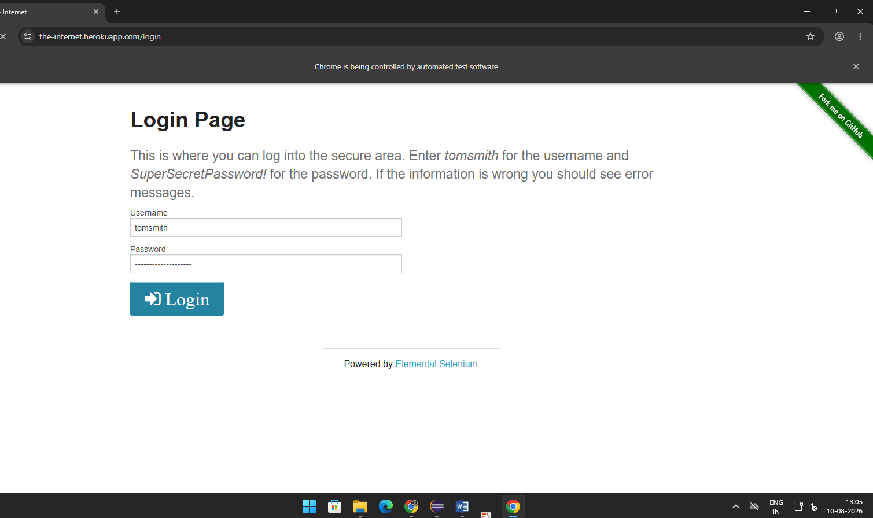

How POM Works
LoginTest
↓
BaseTest
↓
DriverManager
↓
LoginPage
↓
Selenium WebDriver
↓
Chrome Browser
The important principle is separation of responsibility: BaseTest controls test setup/cleanup, DriverManager manages WebDriver, Page classes contain locators and page actions, and Test classes contain the actual test scenarios and assertions.

Page Object Model is a design pattern used in Selenium automation where each web page is represented by a separate Java class. The class contains the page's locators and reusable actions. TestNG is used to organize and execute test cases, while Selenium WebDriver performs browser automation. This structure reduces code duplication and makes the framework easier to maintain.

