- Open Any browser search www.makemytrip.com copy the link, open selenium IDE
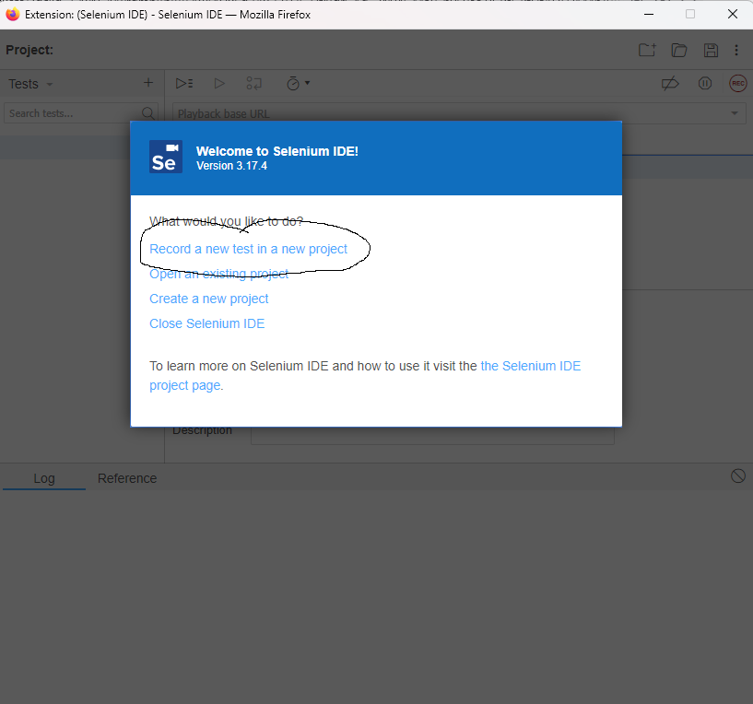
Select “Record a new test in a new project”.
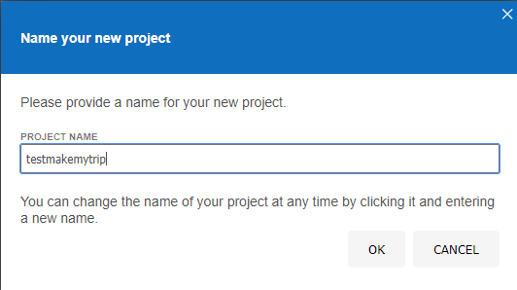
Then paste the link of the website:
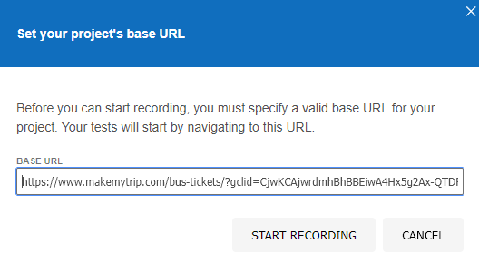
Tap on start recording.
Maximize the new tab
Then right click anywhere in the windows
Select Selenium IDE> Verify> Title
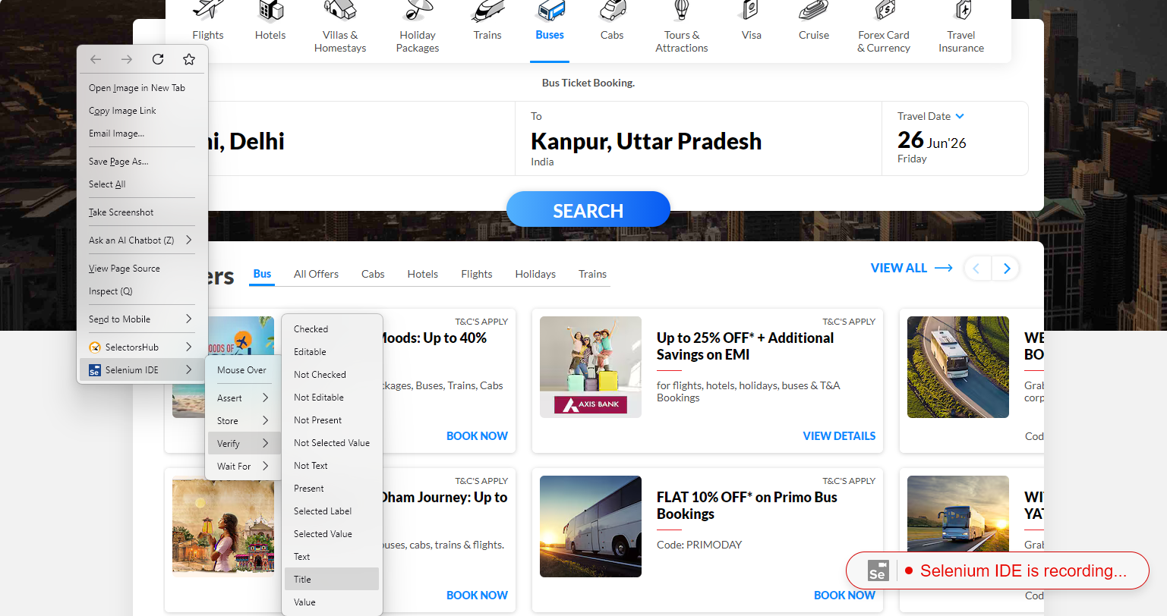
Then fill the boxes “from to where” tap on search.

Select any one bus right click on it, select Selenium IDE>Assert>Text
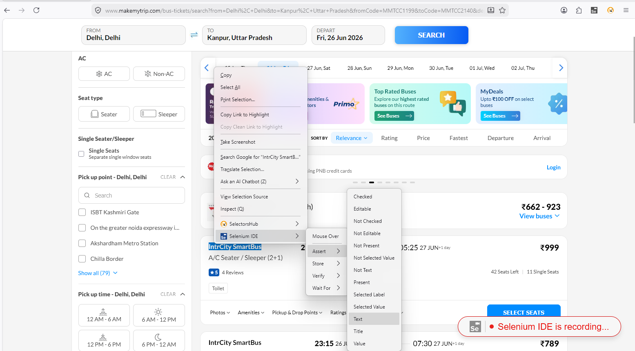
Then Select Price right click on it select Selenium IDE>Store>Text
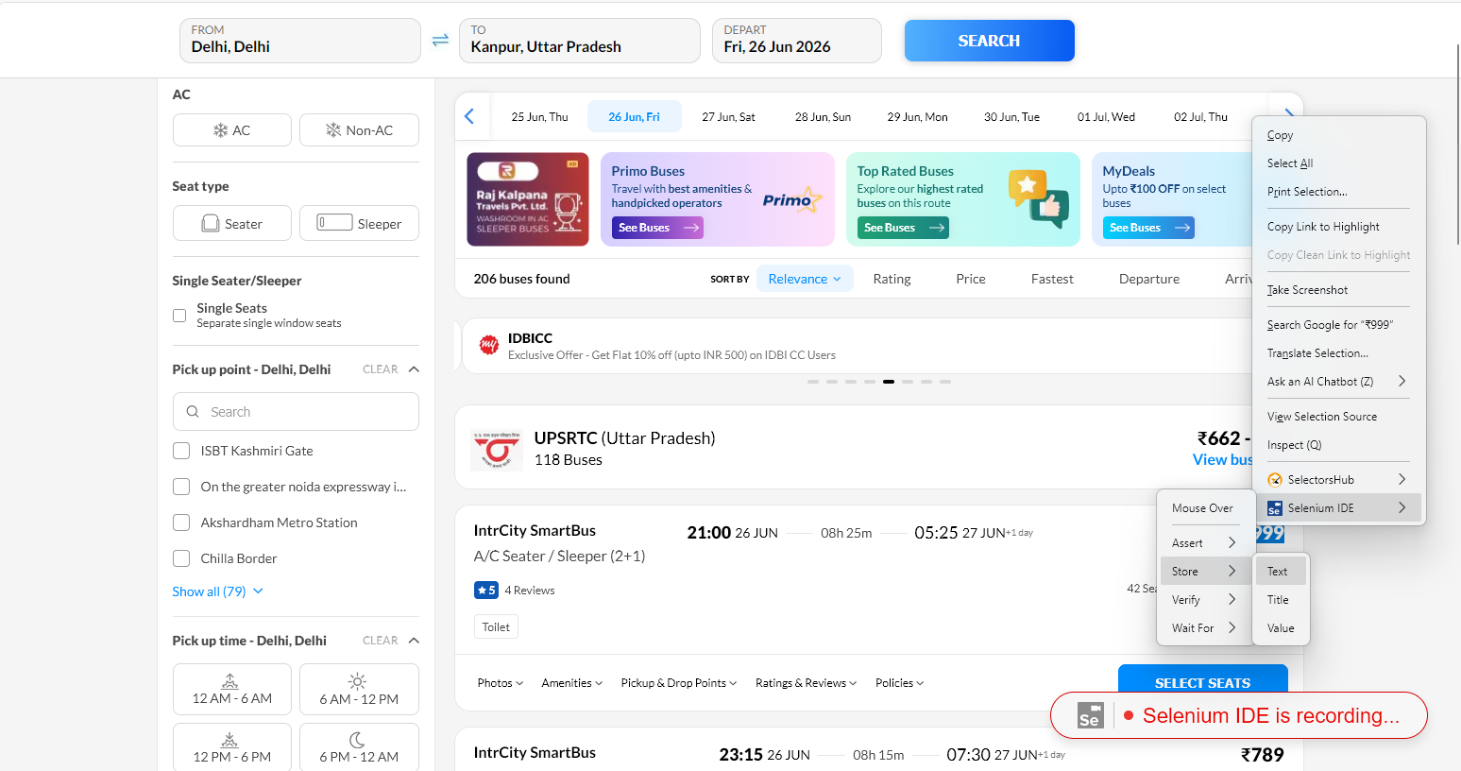
Enter the variable name “price” then click ok.
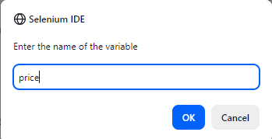

Then select the next step in IDE
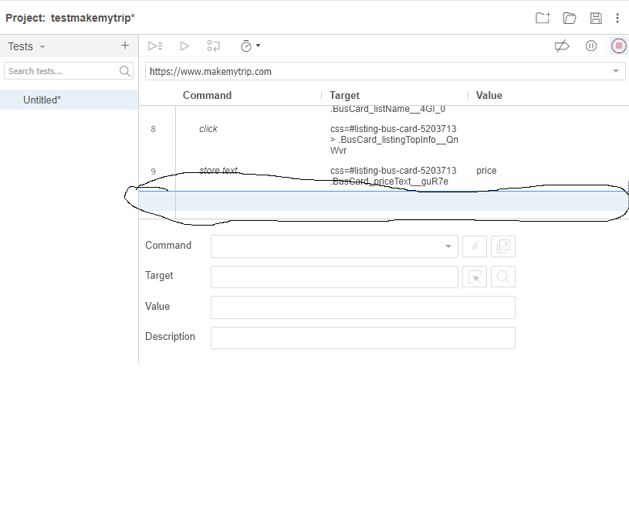
On command write “echo” in target write “${price}”
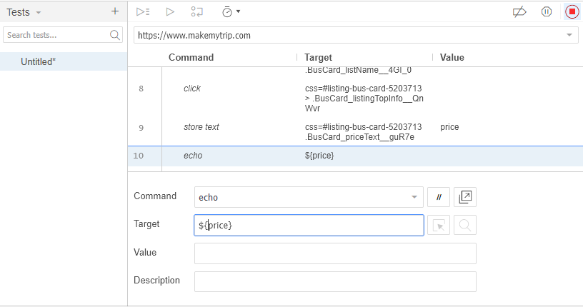
Click stop recording in right top corner
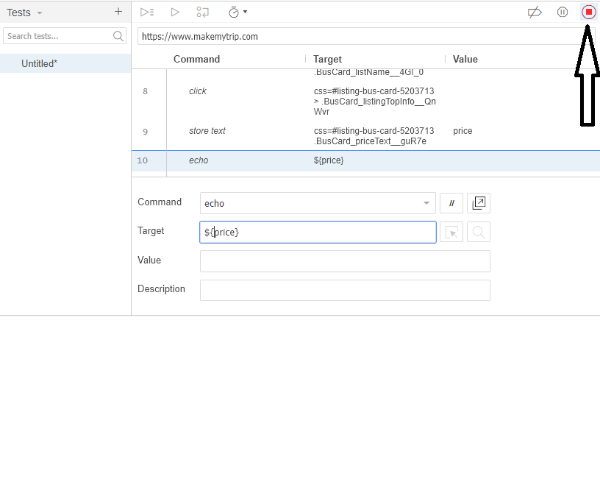
Then write the test name
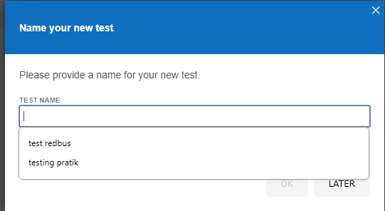

Select Ok

Then Select the echo tab and select Run current Test
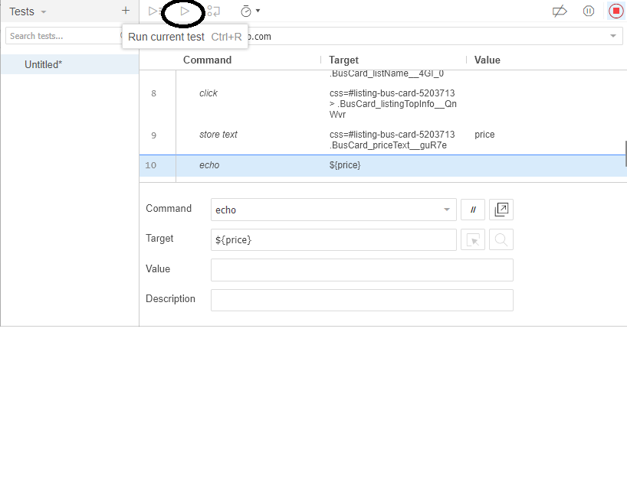

Then open Selenium IDE Look in Log down left tab
The price should come same as shown in the website


