nPractical no.4
Selenium Server (Grid) Configuration and Remote Execution Tool: Selenium Server (Grid) Install and configure Selenium Server in Hub-Node architecture. Execute a test script on multiple browsers using Remote WebDriver and compare cross-browser results

Step 1: Check Java
Open Command Prompt.
Command: java -version
Verify Java 17 is installed.
Screenshot: Paste your screenshot here.

Step 2: Install JDK 17
Download Windows x64 Installer, install it, and verify Java 17.
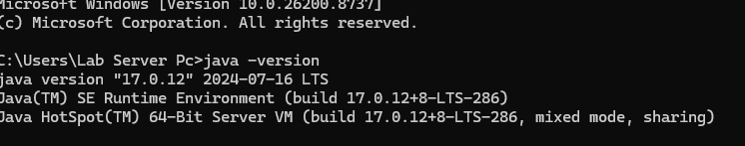

Step 3: Download Selenium Server
Download selenium-server-4.44.0.jar and save it in C:\SeleniumGrid.

Step 4: Open CMD
Command: cd C:\SeleniumGrid
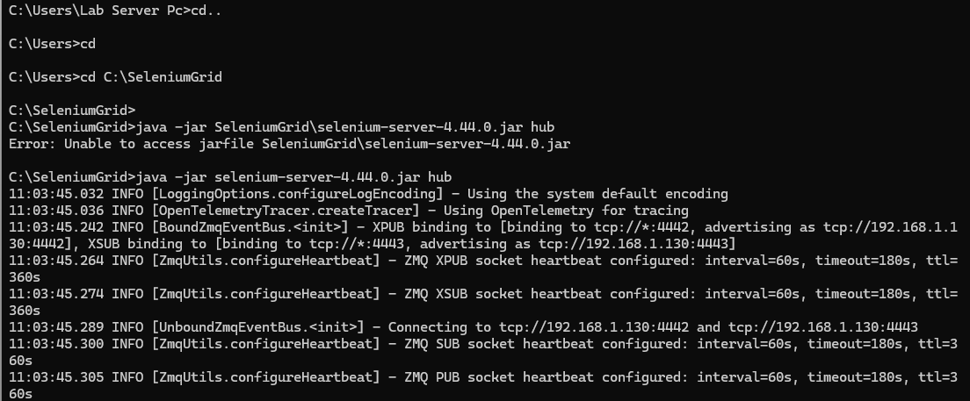

Step 5: Start Selenium Grid open another command prompt
Command: java -jar selenium-server-4.44.0.jar hub
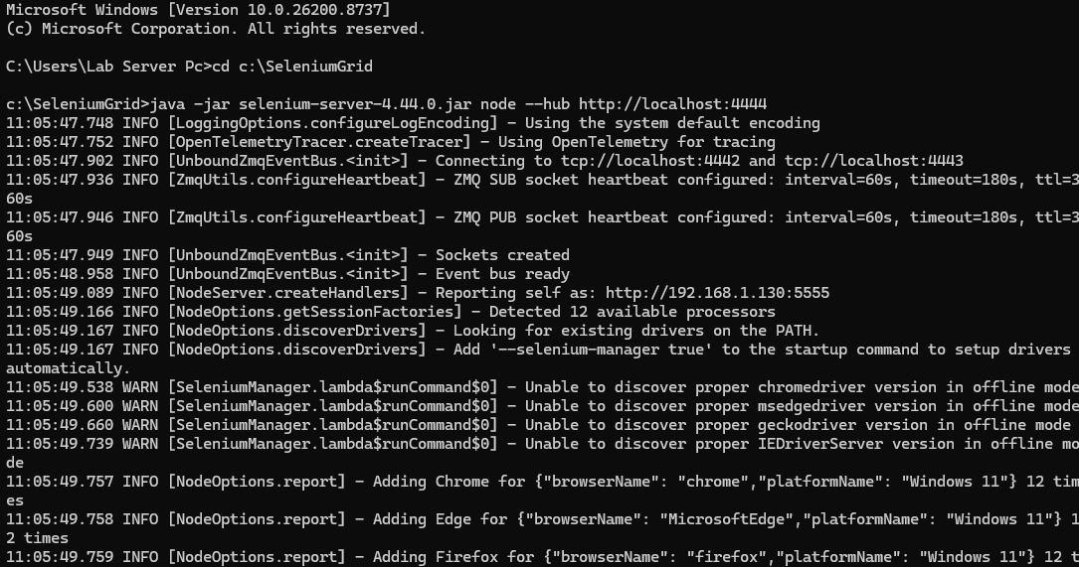

Step 6: Open Dashboard

Step 7: Verify Browsers
Ensure browser icons (Chrome/Edge) are visible.
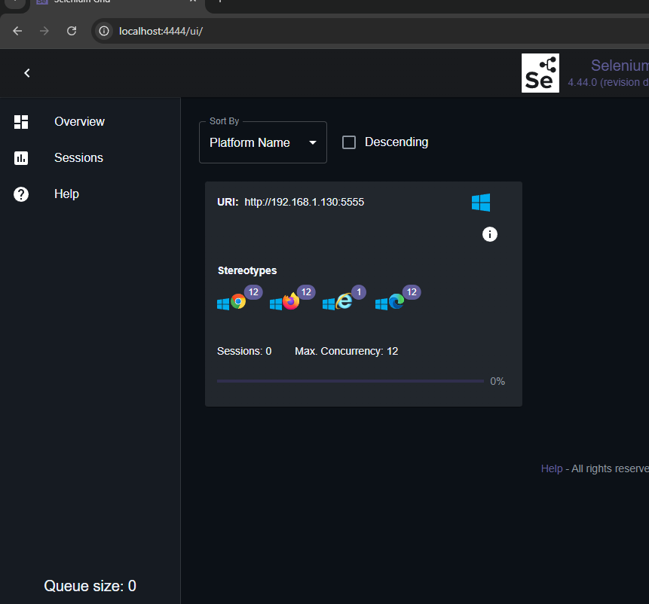
Screenshot: Paste your screenshot here.

Step 8: Install Eclipse
Install Eclipse IDE for Java Developers.

Step 9: Create Project
Create Java project SeleniumGridDemo.

Step 10: Add Selenium Libraries
Configure Selenium libraries or Maven.

Step 11: Write Code
Create RemoteTest.java using RemoteWebDriver.
import java.net.URL;
import org.openqa.selenium.WebDriver;
import org.openqa.selenium.chrome.ChromeOptions;
import org.openqa.selenium.remote.RemoteWebDriver;
public class RemoteTest {
public static void main(String[] args) throws Exception {
URL url = new URL("http://localhost:4444");
ChromeOptions options = new ChromeOptions();
WebDriver driver = new RemoteWebDriver(url, options);
driver.get("https://www.google.com");
System.out.println(driver.getTitle());
driver.quit();
}
}

Step 12: Run
Run as Java Application and verify Google opens.

