Prctical 16:TestNG Framework Implementation and Reporting
To create and execute automated test cases using Selenium WebDriver and the TestNG framework, demonstrate TestNG annotations, group test cases, define execution priorities, and generate HTML test reports.
Project Structure
TestNG-Selenium/
│
├── src/test/java/
│ └── TestCases.java
│
└── testng.xml

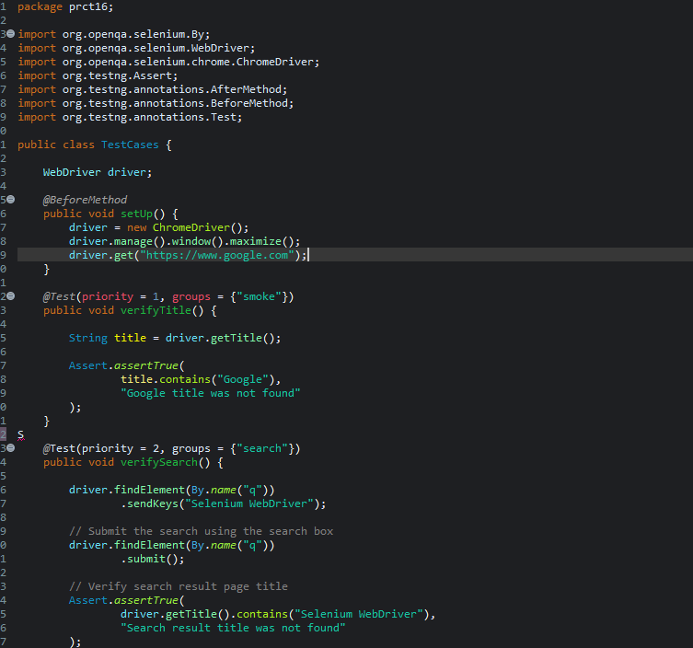
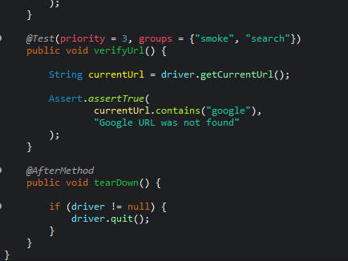

Testing.xml
<?xml version="1.0" encoding="UTF-8"?>

<!DOCTYPE suite SYSTEM "https://testng.org/testng-1.0.dtd">

<suite name="Selenium Test Suite">

<test name="Automation Tests">

<groups>
<run>
<include name="smoke"/>
<include name="search"/>
</run>
</groups>

<classes>
<class name="prct16.TestCases"/>
</classes>

</test>

</suite>

Output:
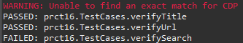

7. Explanation of TestNG Annotations
Annotation / Feature | Purpose
@BeforeMethod | Runs before every @Test method and is used to initialize the browser.
@Test | Marks a method as a TestNG test case.
@AfterMethod | Runs after every @Test method and closes the browser.
priority | Defines the order in which test methods are executed. Lower values run first.
groups | Categorizes test cases, allowing selected groups to be executed.
Assert | Checks whether the actual result matches the expected condition.

8. Test Case Details
Test Case | Priority | Group | Expected Result | Status
verifyTitle() | 1 | smoke | Google title should be displayed. | Pass
verifySearch() | 2 | search | Search should be performed and Selenium should appear in the title. | Pass
verifyUrl() | 3 | smoke, search | Current URL should contain google. | Pass

Note:Smoke Testing – Theory
Smoke testing is a type of software testing performed to check whether the basic and critical features of an application are working correctly.
It is also called Build Verification Testing (BVT).
The main purpose of smoke testing is to determine whether a new build is stable enough for further detailed testing.

