Continuous Integration using Jenkins
Tool: Jenkins + Selenium WebDriver Configure Jenkins to execute Selenium automation scripts automatically. Generate build reports and analyze test execution history.

package seleniumtest;

import org.openqa.selenium.WebDriver;
import org.openqa.selenium.chrome.ChromeDriver;
import org.testng.Assert;
import org.testng.annotations.BeforeMethod;
import org.testng.annotations.Test;

public class GoogleTset {

WebDriver driver;

@BeforeMethod
public void setUp() {
driver = new ChromeDriver();
driver.manage().window().maximize();
}

@Test
public void googleTest() {

driver.get("https://www.google.com");

String title = driver.getTitle();

System.out.println("Title: " + title);

Assert.assertTrue(
title.contains("Google"),
"Title does not contain Google"
);

// Keep browser open
try {
Thread.sleep(10000);
} catch (InterruptedException e) {
e.printStackTrace();
}
}
}

<?xml version="1.0" encoding="UTF-8"?>

<suite name="Selenium Test Suite">

<test name="Google Test">

<classes>
<class name="seleniumtest.GoogleTset"/>
</classes>

</test>

</suite>

Add required libraries using build path
*Testing and selenium libraries
Download Jenkins from official website.Login with Jenkins.
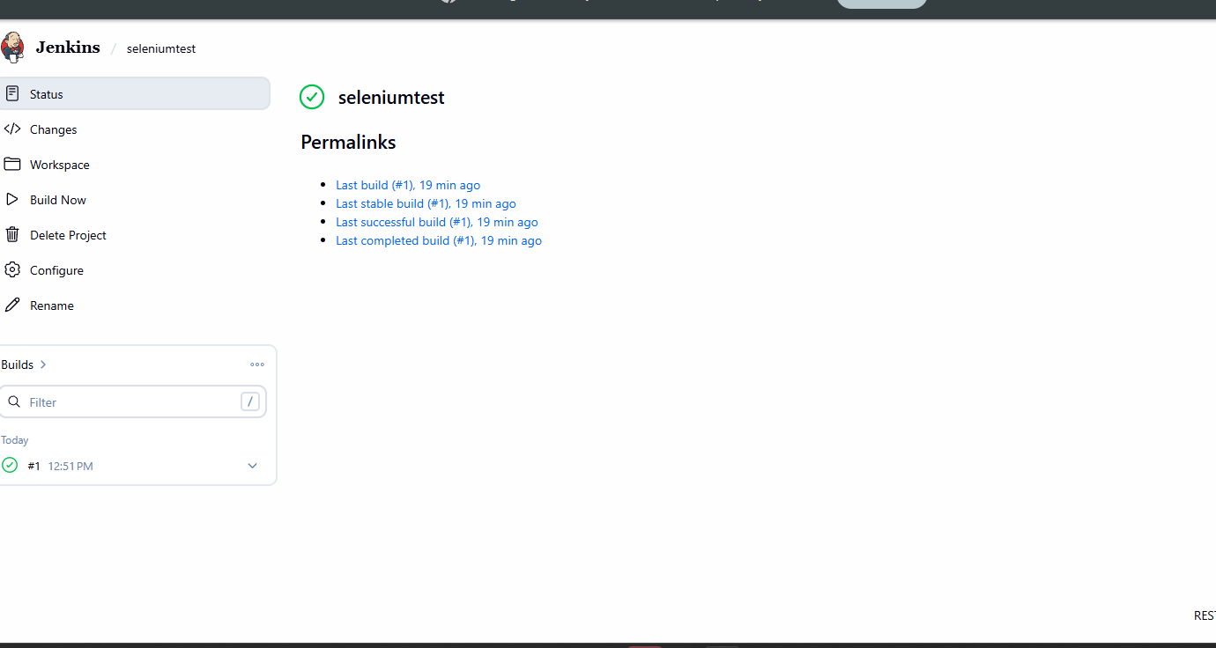

In project explorer test-output must be shown when you run testng.xml run as Testng


