SmartCare v0.4 - Domain Implementation Workbook
Week 7 student resource

1. UML-to-Code Trace
UML element | Python element | Implemented? | Notes
Patient | Class patient | Yes | Core domain class representing patient
Atributes:  Unique Id  Name  Date of Birth  Contact  Address | #Hints  id: int  first_name: str  last_name: str  date_of_birth: date  contact: str  address: str  medical: str | Yes | Hints for atrributes
Practitioner | class Practitioner: | Yes | Holds all data for the doctor
Attributes:  Unique Id  Name  Specialty | id: int  first_name: str  last_name: str  specialty: str | Yes | All attributes a doctor must possess
Appointment | class Appointment: | Yes | Connects patient with practitioner for visit
Attributes  Date  Time  Day | class Appointment:  SLOT_MINUTES: ClassVar[int] = 20  _all: ClassVar[list[Appointment]] = []  def __init__(  self,  patient: Patient,  practitioner: Practitioner,  date: dt.date,  time: dt.time,  double_booked: bool = False,  ) -> None:  self.patient = patient  self.practitioner = practitioner  self.date = date  self.time = time  self.double_booked = double_booked  self._status = AppointmentStatus.SCHEDULED  self._check_conflicts()  Appointment._all.append(self) | Yes | All attributes that an appointment must have with duration
Status | class AppointmentStatus(Enum):  SCHEDULED = "scheduled"  COMPLETED = "completed"  CANCELLED = "cancelled" | Yes | Status confirms the appointment and ability to modify
Medical form | N/A | No | Was not implemented can be implemented in a future version

2. Domain Invariants
Class | Invariant / rule | How protected
Patient | Birthdate can not be in the future | Raise value error to sync with calendar to not allow patiewnts birthdate past currect date
Practitioner | Must have first,last name and specialty | Using if raise value error
Appointment | a practitioner can only have one time and patient at a time and cannot conflict with other appointments making sure no duplicates | Created a check conflict functionm
 | each patient has allocated time of 20 minutes unless double booked appointment | 20 minute slots in the code with would link with the calendar.  Freezing and locking out booked timeslots

3. Composition / Inheritance Decisions
Relationship | Decision | Rationale
Patient appointment | Composition | A patients need to book an an appointment to see pratcitioner
Practitioner and appointment | composition | It links the practitioner to the patient and allocating a specific time

4. AI Pair-Programming Record
AI contribution | Conforms? | Decision | Reason | Verification
Appoinment status | Partly as Ai helped with valuess | A ccpeted | So we kept there hints to specify the the paremters especially when it comes to string and integers | Rus transitions through all sets testing all works
20-minute slot; double_booked=True gives 40 minutes | Unconfirmed. "Double booked" was ambiguous | Accept | can't mean two patients at once, because a practitioner sees one patient at a time | 9:00 ended 9:20. Double-booked 10:00 ended 10:40
AI helped with validation |  | Accepted |  | AI helped create the rules to make the program work efficiently and effectily for example making sure birthdate is nor past current date.

5. Updated UML
Insert updated UML only if implementation revealed a justified design change. Explain every change.
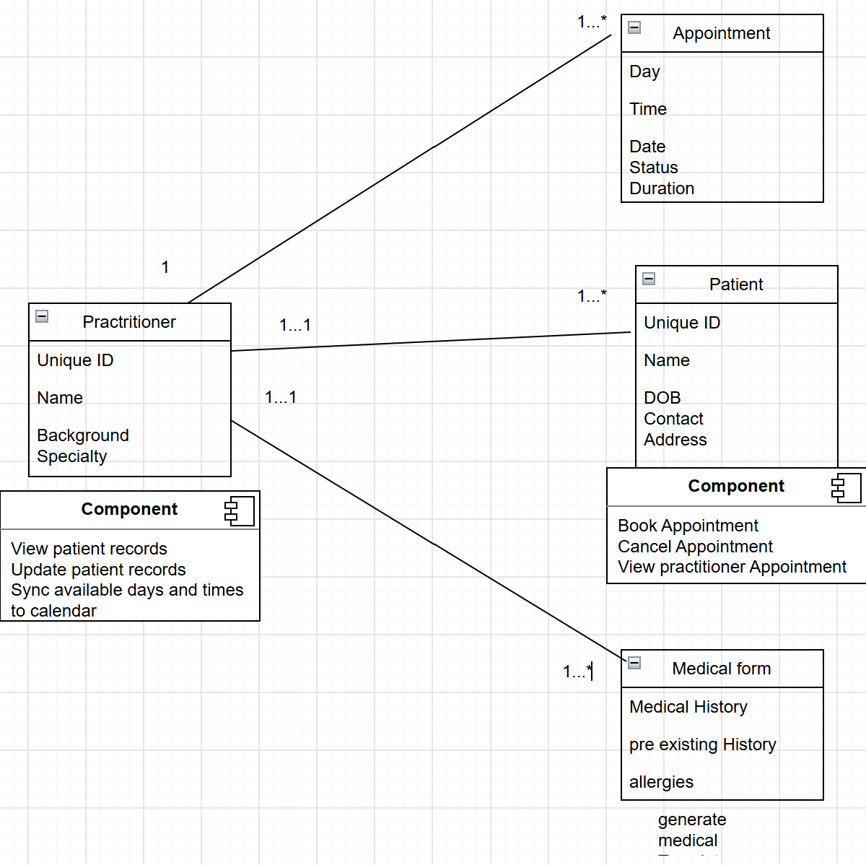
I updated my original version with Specialty created a duration for appointment so the eliminate conflicts and keep practitioners on track with schedule.

