FOUNDIT
Campus Lost and Found Directory with 64 Bit Perceptual Image Hashing
WEB TECHNOLOGY PROJECT REPORT, V SEM.
BTech (Computer Science & Engineering)
FLEXICORE-3131
SUBMITTED TO
SCHOOL OF COMPUTER ENGINEERING, M.I.T., MANIPAL
By
Soukaryo Chandra
Reg. No: 240953644 | Roll No: 54
Under the guidance of: Roshan David
November, 2026

Team Details and Work Split
Sl. | Name and registration | Modules / Pages designed | Signature
1 | Soukaryo Chandra 240953644 Roll 54 | 1. Public landing page, authentication and Student Portal. 2. Campus Security Admin Console and database maintenance.
This is an individual project. Soukaryo Chandra is responsible for both modules, including interface design, implementation, integration and report preparation.

Source Code
https://github.com/s-chandra-a/FoundIt
GitHub repository supplied by the author. The report is based on the attached draft, code excerpts and screenshots.

1. Project Overview
FoundIt is a full-stack, cross-platform web application built using React 19 [1], Tailwind CSS v4 [2], Framer Motion, Node.js (Express) [3], and Google Firebase (Authentication and Cloud Firestore) [4] to modernize university lost-and-found operations. In large university campuses, students frequently misplace essential personal and academic belongings such as laptops, graphing calculators, university ID cards, laboratory journals, and insulated water bottles. Traditional recovery channels rely on unorganized physical drop-boxes, fragmented messaging groups, or paper registers that lack visual search capabilities and structured ownership verification. FoundIt unifies the entire recovery lifecycle into a clean, role-separated web portal where students can browse verified found items, file lost item reports, and execute automated 64-bit Perceptual Difference Hash (dHash) [5] visual similarity searches.
The architecture enforces strict role-based access control (RBAC) across two distinct authentication modes: a University Student Portal restricted exclusively to verified academic email domains (.edu and .ac.*), and a Administrator Campus Security Admin Console provisioned with a dedicated administrator account (admin@foundit.edu). Students who find items on campus drop them off anonymously at designated campus security desks, where administrators log the item along with its submission desk location and generate its 64-bit hexadecimal visual fingerprint using the HTML5 Canvas 2D API [6]. When a student claim is verified and approved by an administrator, the item automatically transitions out of the active Found Directory into a dedicated Resolved History Archive, ensuring the public directory remains clutter-free while retaining full auditability and one-click CSV export for campus security record keeping.

1.1 Purpose of the Website
The primary purpose of FoundIt is to eliminate the inefficiency, false claims, and manual overhead of traditional university lost-and-found desks by introducing deterministic computer-vision image hashing and structured claim verification. Instead of scrolling through hundreds of text-only notices, students can upload a reference photo of their lost belonging and immediately rank all active found items by bitwise visual similarity percentage using a 64-bit luminance gradient hash (dHash) [5]. Furthermore, by enforcing anonymous campus drop-offs for found items and requiring verifiable proof of ownership (such as serial numbers, etchings, or lock-screen details) before Campus Security approves a claim, the platform safeguards student privacy and prevents unauthorized item collection.

1.2 Objectives
- Role-Separated Campus Access: Provide two isolated login modes— Student Mode (restricted to university-issued .edu and .ac.* email addresses) and Admin Mode (pre-configured administrator Campus Security account)—using Firebase Email/Password Authentication [4].
- 64-Bit Perceptual Image Hashing (dHash) Search Engine: Compute a 16-character hexadecimal fingerprint from a 9×8 grayscale luminance gradient matrix for every uploaded item image [5, 6] and rank candidate matches by bitwise Hamming distance similarity percentage.
- Anonymous Found Item Drop-Off Logging: Enable administrators to log found items turned in anonymously at campus collection desks (Student Union Room 104, Main Library Desk, Engineering Hall Reception, etc.) and automatically correlate their image hashes against active student lost reports.
- Student Lost Item Reporting & Claim Tracking: Allow students to file structured Lost Item Reports, submit ownership claims with supporting proof, and monitor real-time verification status updates and pickup instructions.
- Resolved History Archive & Unresolve Restoration: Automatically remove approved/resolved items from the active Found Directory and archive them in the Admin Resolved History tab, complete with an Unresolve & Restore to Found Directory action if an item must be returned to active circulation.
- Database Maintenance & Client-Side CSV Export: Provide administrators with full catalog search, inline status management, 1-click demo catalog seeding, and client-side Export to CSV download for institutional record keeping [7].

1.3 Target Users
- University Students, Researchers, and Faculty: Primary users who sign in with their university-provided email addresses to search the active Found Directory, run perceptual image hash comparisons, file lost item reports, and track ownership claims.
- Campus Security & Lost-and-Found Administrators: Administrative staff who log anonymous found item drop-offs, evaluate student ownership claims, issue pickup instructions, manage the Resolved History archive, and export audit logs to CSV.
- Users with Special & Accessibility Needs (Accessibility Considerations [8]):
- Screen-Reader & Assistive Technology Users: Semantic HTML5 landmarks ( <header> , <aside> , <main> , <nav> , <footer> ), descriptive aria-label attributes on icon controls, and structured form labels.
- Color-Blind & Low-Vision Users: High-contrast daylight surfaces ( #F8FAFC background with #0F172A ink exceeding 14:1 contrast ratio) and dual-encoded status badges that pair color with explicit icons and text labels (e.g., Checkmark + "Resolved · Approved for Pickup").
- Mobile-Only Campus Users: Fully responsive viewport architecture with a collapsible mobile navigation drawer and touch-friendly action targets for students walking between lecture halls.

1.4 Site Map
The website follows a hierarchical, role-aware Single-Page Application (SPA) architecture where all views are designed and implemented by Soukaryo Chandra (Reg. No: 240953644):
Area | Pages and navigation | Contributor
Public | Landing page → Student / Admin authentication | Soukaryo Chandra
Student Portal | Found Directory ↔ Image Hash Search ↔ Report Lost Item ↔ My Claims and Status | Soukaryo Chandra
Admin Console | Log Found Item ↔ Claim Verification ↔ Resolved History ↔ Database Maintenance | Soukaryo Chandra

1.5 Tools and Technologies
Item | Details
HTML version | HTML5 (Semantic Landmarks, HTML5 <canvas> 2D API for Perceptual Hashing, and FileReader API) [6]
CSS framework and version | Tailwind CSS v4.1 (@tailwindcss/vite) with custom typography variables and responsive grid utilities [2]
JavaScript / TypeScript & Libraries | TypeScript 5.8, React 19.0 (Functional Components & Hooks) [1], Motion (Framer Motion v12 for micro-interactions), Lucide React Icons
Data source (static / JSON / API) | Google Cloud Firestore (NoSQL real-time document database with firestore.rules RBAC) [4], Firebase Authentication (Email/Password), and Node.js Express REST API (/api/hash-compare, /api/state) exchanging JSON payloads [3]
IDE and Environment used | Visual Studio Code, Node.js v22 LTS Runtime, Vite 6.2 Build System, tsx TypeScript execution engine, ESLint with @firebase/rules-unit-testing
Accessibility Guidelines for Users with Disabilities | W3C WCAG 2.1 Level AA [8]: High-contrast daylight palette (>14:1 primary text contrast), keyboard-navigable forms and modals, password reveal toggle buttons, non-color-dependent status badges, and responsive touch targets
Testing tools (Lighthouse, WAVE etc.) | Google Chrome DevTools & Lighthouse (Performance, Accessibility, and Best Practices auditing), TypeScript Compiler (tsc --noEmit), and Firebase Rules Linter (npx eslint firestore.rules)

1.6 Common Design Followed by the Team
To ensure visual cohesion, high scannability, and consistent presentation across all public and authenticated views, a unified design system was established and strictly followed across every component:
- Semantic Layout & Sticky Navigation Shell: Every authenticated page shares a fixed left vertical sidebar ( 256px width on desktop, collapsible drawer on mobile) paired with a pinned top workspace header ( fixed top-0 left-0 right-0 md:left-64 z-40 ). The header displays a 3-level breadcrumb trail ( FoundIt / Portal Mode / Active View ) where the third breadcrumb on desktop is an interactive dropdown menu for rapid view switching even when scrolled deep down long directory pages.
- Daylight Colour Palette: The interface uses a cool alabaster background canvas ( #F8FAFC ), white elevated cards ( #FFFFFF ) with subtle 1px solid #E2E8F0 borders, deep slate ink ( #0F172A ) for primary headings, academic cobalt blue ( #1D4ED8 ) for primary student actions, teal ( #0D9488 ) for perceptual hash and admin intake highlights, emerald green ( #15803D ) for verified/resolved states, and amber ( #B45309 ) for pending claims.
- Tri-Font Typographic Hierarchy: Headings use Plus Jakarta Sans ( 600/700 weights) for headings; body copy and form inputs use Public Sans for readability; and all 16-character hexadecimal image hashes, Hamming distances, match percentages, and KPI counters use JetBrains Mono with font-variant-numeric: tabular-nums so numerical columns align vertically.
- Common Footer & Dense Tactile Feedback: Both the public landing page and the authenticated workspace feature a unified footer crediting the developer ( Soukaryo Chandra, Reg. No: 240953644, School of Computer Engineering, M.I.T., Manipal ) alongside a floating bottom-right Toast Notification Stack and in-page confirmation banners that provide immediate visual feedback after every click, hash computation, status change, or CSV export.

2. Student 1: Soukaryo Chandra (Reg. No: 240953644)
Modules / Pages: Module 1: Public Landing Page, University Authentication (.edu Domain Verification) & Student Portal (Found Directory, 64-Bit Perceptual Image Hash Search, Report Lost Item & My Claims Status) Module 2: Campus Security Admin Console (Log Anonymous Found Item Drop-Offs, Claim Verification, Resolved History Archive with Unresolve Action & Database Maintenance with CSV Export)

2.1 Module Description

Module 1: Public Landing Page, University Authentication & Student Portal
Purpose: Module 1 serves as the public entry point and the complete student-facing workspace of the FoundIt platform. It educates visitors on how 64-bit perceptual image hashing works, enforces university email authentication, and empowers students to search active found items, run visual similarity queries, report lost items, and track ownership claims.
- Main Sections & Features:
- Landing Page & Interactive Perceptual Hash Inspector (LandingPage.tsx): Features a 12-column hero split with an interactive hardware preset switcher that computes real-time 64-bit dHash fingerprints on HTML5 canvases, displaying a 64-cell bitwise comparison matrix, Hamming distance, and match percentage alongside a 4-column Campus KPI strip and Role Breakdown cards.
- Campus Authentication Modal (AuthModal.tsx): Provides dedicated tabs for Student Portal (.edu) and Admin Console sign-in/registration, interactive password visibility toggle buttons, and 1-click demo credential population.
- Found Directory Tab (StudentDashboard.tsx): Displays only active, unresolved found items (excluding status === 'resolved' items) in a 3-column responsive card grid with instant keyword/hash filtering, category pills, 1-click hash copying, and a modal to submit ownership claims.
- Perceptual Image Hash Search Tab: Allows students to upload a photograph of their lost item (or select an existing lost report) and click Compare Image Hashes to rank all active found items by bitwise match percentage.
- Report Lost Item Tab & My Claims Tab: Enables students to file new lost item reports (with an informational banner explaining the anonymous campus drop-box policy for found items) and monitor real-time approval status and pickup instructions for their submitted claims.
- Dynamic Input, Processing, and Output:
- Input: Student credentials ( .edu email & password), uploaded lost item image file (JPEG/PNG/WebP), search keywords, category selection, lost item metadata (title, location, date, description), and ownership claim proof description.
- Processing: Client-side HTML5 <canvas> downscales uploaded images to a 9×8 pixel grid, converts RGB pixels to grayscale luminance ( Y = 0.299R + 0.587G + 0.114B ), compares adjacent horizontal pixels to pack a 64-bit hexadecimal hash [5, 6], and computes bitwise XOR Hamming distance against active catalog hashes via both client-side computation and the Express /api/hash-compare endpoint.
- Output: Ranked visual match cards displaying exact similarity percentage (e.g., 98.4% Match ), 64-bit gradient matrix visualization, persisted Firestore documents in items and claims , and animated toast notifications.

Module 2: Campus Security Admin Console & Database Maintenance
Purpose: Module 2 provides Campus Security administrators with a high-privilege moderation and inventory management suite to log anonymous found item drop-offs, verify student ownership claims, manage the Resolved History archive, and export records to CSV.
- Main Sections & Features:
- Log Found Item Tab (Anonymous Drop-Off Intake — AdminDashboard.tsx): Allows admins to record newly found items turned in anonymously at designated campus collection desks ( CAMPUS_DROP_LOCATIONS ) with photo upload or hardware preset generation. As soon as an image hash is generated, the panel automatically scans and displays matching student Lost Item Reports (≥65% similarity).
- Claim Verification Tab: Displays all pending student ownership claims alongside the student's proof description, item thumbnail, and hash match percentage. Admins can enter custom pickup instructions and click Approve & Mark Resolved or Reject Claim .
- Resolved History Archive Tab: Houses all resolved items that have been removed from the active Found Directory. Includes a dedicated Unresolve & Restore to Found Directory button on every card that resets the item's status to approved (and any linked claim back to pending ), returning it to active student circulation.
- Database Maintenance Tab & CSV Export: Features a searchable data table of active records filterable by All, Found, or Lost, inline status dropdown selectors, permanent record deletion, 1-click demo catalog seeding, and an Export to CSV button.
- Dynamic Input, Processing, and Output:
- Input: Anonymous found item details (title, category, campus drop-off desk location, bin note, photo), claim moderation decisions (Approve/Reject + Admin Pickup Notes), Unresolve commands, and CSV export triggers.
- Processing: Updates Cloud Firestore items and claims collections, synchronizes state with the Express backend ( /api/state ), and serializes all items and claims into RFC-4180 escaped CSV rows prefixed with a UTF-8 Byte Order Mark ( \uFEFF ) [7].
- Output: Real-time removal of resolved items from the student Found Directory, immediate placement into Resolved History, persistent confirmation banners with quick-navigation links, and instant browser download of foundit-campus-records-YYYY-MM-DD.csv .

2.2 Design of the Module
The application employs a dual-tier communication architecture combining Google Cloud Firestore real-time WebSockets (onSnapshot) [4] with a Node.js Express REST API [3] exchanging JSON payloads:
- Image Hash Search Request Lifecycle (POST /api/hash-compare): When a student clicks "Compare Image Hashes & Rank Matches" , the frontend serializes the 16-character query hexadecimal hash and an array of active found item hashes into a JSON payload and dispatches an asynchronous fetch('/api/hash-compare', { method: 'POST', headers: { 'Content-Type': 'application/json' }, body: JSON.stringify(...) }) request. The Express backend parses the JSON body, converts each 16-character hex string into a 64-bit binary vector, computes the Hamming distance (number of differing bits out of 64) and similarity percentage ((64 - differingBits) / 64) * 100 , sorts the results in descending order of match percentage, and returns a structured JSON response that React renders as ranked similarity cards.
- Database Persistence & Claim Resolution Lifecycle (Cloud Firestore & /api/state): When a student files a Lost Report or raises a Claim, or when an Admin logs an anonymous Found Item, approves a claim, or clicks "Unresolve & Restore to Found Directory" , the React frontend invokes Firebase SDK methods ( setDoc , updateDoc , deleteDoc ) against the Cloud Firestore database ( ai-studio-45e58299-be20-4f3e-b98c-078e1363afac ) and mirrors the snapshot to POST /api/state . Real-time onSnapshot listeners immediately push state diffs to connected clients.
- Client-Side Validation:
- University Email Domain Enforcement: The isUniversityEmail(email) validator verifies that student sign-in and registration emails end with accredited academic suffixes ( .edu , .edu.* , .ac.* ) before invoking Firebase Auth.
- Schema & Image Compression Validation: Form handlers validate required fields, enforce character length bounds defined in BLUEPRINT_CONSTRAINTS (titles 2–120 chars, descriptions 4–1000 chars, proof 5–1000 chars), and compress uploaded item photos on an HTML5 canvas to JPEG quality 0.78 (max 420×315px , <90KB) to reduce stored image size.
- Server-Side & Security Rules Validation:
- Express API Validation: The Node.js /api/hash-compare route validates that queryHash is a non-empty string and sanitizes hexadecimal characters before bitwise evaluation.
- Firestore Security Rules (firestore.rules): Enforces server-side schema and role validation at the database engine level—verifying that students can only create type == 'lost' reports under their own request.auth.uid , while only authenticated administrators ( isAdmin() ) can create type == 'found' anonymous drop-off items, approve/reject claims, or unresolve archived items.

2.3 Development of the Module (Code Snippets)

Snippet 1: 64-Bit Perceptual Difference Hash (dHash) & Bitwise Hamming Distance (src/utils/imageHash.ts)
export async function computePerceptualHash(imageSrc: string): Promise<ComputedImageHash> {
return new Promise((resolve, reject) => {
const img = new Image();
img.crossOrigin = 'anonymous';
img.onload = () => {
// 1. Downscale image to 9x8 pixels on HTML5 Canvas for 64 horizontal gradient
comparisons
const hashCanvas = document.createElement('canvas');
hashCanvas.width = 9;
hashCanvas.height = 8;
const hashCtx = hashCanvas.getContext('2d')!;
hashCtx.fillStyle = '#F8FAFC';
hashCtx.fillRect(0, 0, 9, 8);
hashCtx.drawImage(img, 0, 0, 9, 8);

const imgData = hashCtx.getImageData(0, 0, 9, 8).data;
const gray: number[][] = [];
for (let y = 0; y < 8; y++) {
const row: number[] = [];
for (let x = 0; x < 9; x++) {
const idx = (y * 9 + x) * 4;
const lum = Math.round(0.299 * imgData[idx] + 0.587 * imgData[idx + 1] + 0.114 *
imgData[idx + 2]);
row.push(lum);
}
gray.push(row);
}

// 2. Compute 64 gradient bits (left neighbor >= right neighbor) & pack into 16-hex
string
const bits: number[] = [];
for (let y = 0; y < 8; y++) {
for (let x = 0; x < 8; x++) {
bits.push(gray[y][x] >= gray[y][x + 1] ? 1 : 0);
}
}
let hashHex = '';
for (let i = 0; i < 64; i += 4) {
const nibble = (bits[i] << 3) | (bits[i + 1] << 2) | (bits[i + 2] << 1) | bits[i + 3];
hashHex += nibble.toString(16);
}
resolve({ hashHex, bits, luminanceGrid: [], previewDataUrl:
hashCanvas.toDataURL('image/jpeg', 0.78) });
};
img.onerror = () => reject(new Error('Failed to load image'));
img.src = imageSrc;
});
}

Snippet 2: Express Backend Perceptual Hash Comparison Endpoint (server.ts)
app.post('/api/hash-compare', (req, res) => {
const { queryHash, candidates } = req.body as {
queryHash?: string;
candidates?: Array<{ id: string; imageHash: string }>;
};

if (!queryHash || typeof queryHash !== 'string' || !Array.isArray(candidates)) {
res.status(400).json({ error: 'Invalid payload: queryHash and candidates array required.'
});
return;
}

const results = candidates
.map((candidate) => {
const metrics = computeHammingMetrics(queryHash, candidate.imageHash || '');
return { id: candidate.id, imageHash: candidate.imageHash, ...metrics };
})
.sort((a, b) => b.matchPercentage - a.matchPercentage);

res.json({ queryHash, totalCompared: results.length, results });
});

Snippet 3: Admin Unresolve Workflow & Client-Side CSV Export (src/App.tsx & src/components/AdminDashboard.tsx)
// Restore a Resolved Item from Admin Resolved History back to the Active Found Directory
const handleUnresolveItem = async (itemId: string) => {
if (!userProfile) return;
const linkedApprovedClaims = claims.filter((c) => c.itemId === itemId && c.status ===
'approved');

await updateDoc(doc(db, 'items', itemId), {
status: 'approved',
updatedAt: serverTimestamp(),
});

for (const clm of linkedApprovedClaims) {
await updateDoc(doc(db, 'claims', clm.id), {
status: 'pending',
adminNotes: 'Unresolved by Admin — returned to active Found Directory.',
updatedAt: serverTimestamp(),
});
}
};

// Client-Side Export of Items & Claims to UTF-8 CSV Spreadsheet
const handleExportToCSV = () => {
const escapeCsvCell = (val: unknown) => `"${String(val ?? '').replace(/"/g, '""')}"`;
const rows: string[] = [
['Record Type','ID','Directory Type','Title','Category','Status','Location','Date','64-Bit
dHash','Reporter / Claimant','Description / Proof','Linked Item ID','Match Score (%)','Admin
Notes']
.map(escapeCsvCell).join(',')
];
items.forEach((item) => rows.push(['ITEM', item.id, item.type.toUpperCase(), item.title,
item.category, item.status, item.location, item.dateOccurred, item.imageHash,
item.reporterName, item.description, '', '', ''].map(escapeCsvCell).join(',')));
claims.forEach((claim) => rows.push(['CLAIM', claim.id, 'OWNERSHIP_CLAIM', claim.itemTitle,
'', claim.status, '', '', '', claim.claimantName, claim.proofDescription, claim.itemId,
claim.matchScore, claim.adminNotes].map(escapeCsvCell).join(',')));

const blob = new Blob(['\uFEFF' + rows.join('\r\n')], { type: 'text/csv;charset=utf-8;' });
const link = document.createElement('a');
link.href = URL.createObjectURL(blob);
link.setAttribute('download', `foundit-campus-records-${new
Date().toISOString().split('T')[0]}.csv`);
link.click();
};

Snippet 4: Cloud Firestore Role-Based Security Rules (firestore.rules)
match /items/{itemId} {
allow read: if isSignedIn();
allow create: if isSignedIn()
&& isValidCampusItem(incoming())
&& itemId == incoming().id
&& (
(incoming().reporterId == request.auth.uid && incoming().type == 'lost'
&& (incoming().status == 'pending_approval' || incoming().status ==
'approved'))
|| isAdmin()
);
allow update: if isSignedIn()
&& isValidCampusItem(incoming())
&& itemId == incoming().id
&& (isAdmin() || (existing().status == 'approved' && incoming().status ==
'claimed'));
allow delete: if isAdmin() || (isSignedIn() && existing().reporterId == request.auth.uid);
}

2.4 Results
The ten supplied screenshots document the public, student and administrator interfaces. The following functionality index links the required features to the relevant evidence.
No. | Functionality | Evidence
1 | Student and administrator authentication | Figure 2.2
2 | Browse, search and filter found items | Figure 2.3
3 | Photo-based perceptual hash search | Figure 2.4
4 | Submit a lost item report | Figure 2.5
5 | Track ownership claims and pickup status | Figure 2.6
6 | Log anonymous found-item drop-offs | Figure 2.7
7 | Verify and approve or reject claims | Figure 2.8
8 | Archive resolved items and restore them | Figure 2.9
9 | Maintain records and export CSV | Figure 2.10
Image similarity is a screening aid, not proof of ownership. Security staff must check the claimant’s supporting details. dHash compares image gradients and may be affected by changes in angle, crop, lighting or background.
The screenshots and excerpts are evidence supplied with the draft. No independent runtime test, security audit or accessibility certification is claimed in this report.

Figure 2.1: Public Landing Page & Interactive 64-Bit Perceptual Hash Inspector
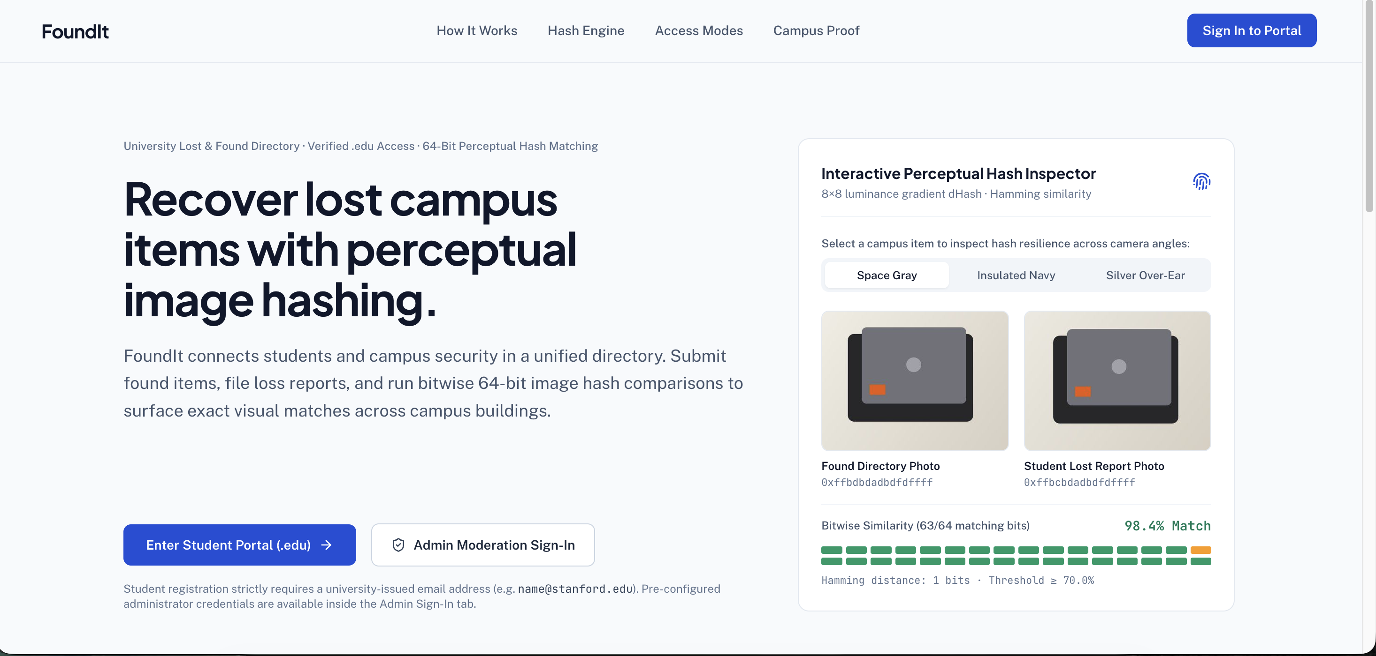
Displays the hero value proposition, role-separated entry buttons, and live 64-bit dHash comparison showing 98.4% bitwise similarity (63/64 matching bits, Hamming distance: 1 bit) across camera angles.
Figure 2.2: FoundIt Campus Authentication Modal (.edu University Domain Policy)
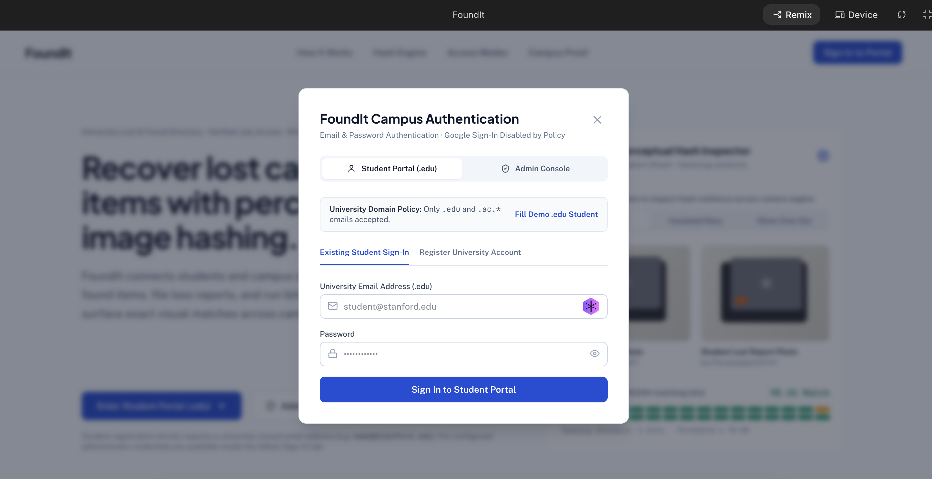
Role-separated Email & Password authentication modal enforcing the .edu / .ac.* university email policy for students, password visibility toggle, and 1-click demo credential population.

Figure 2.3: Student Portal — Active Found Directory & Sticky Breadcrumb Navigation
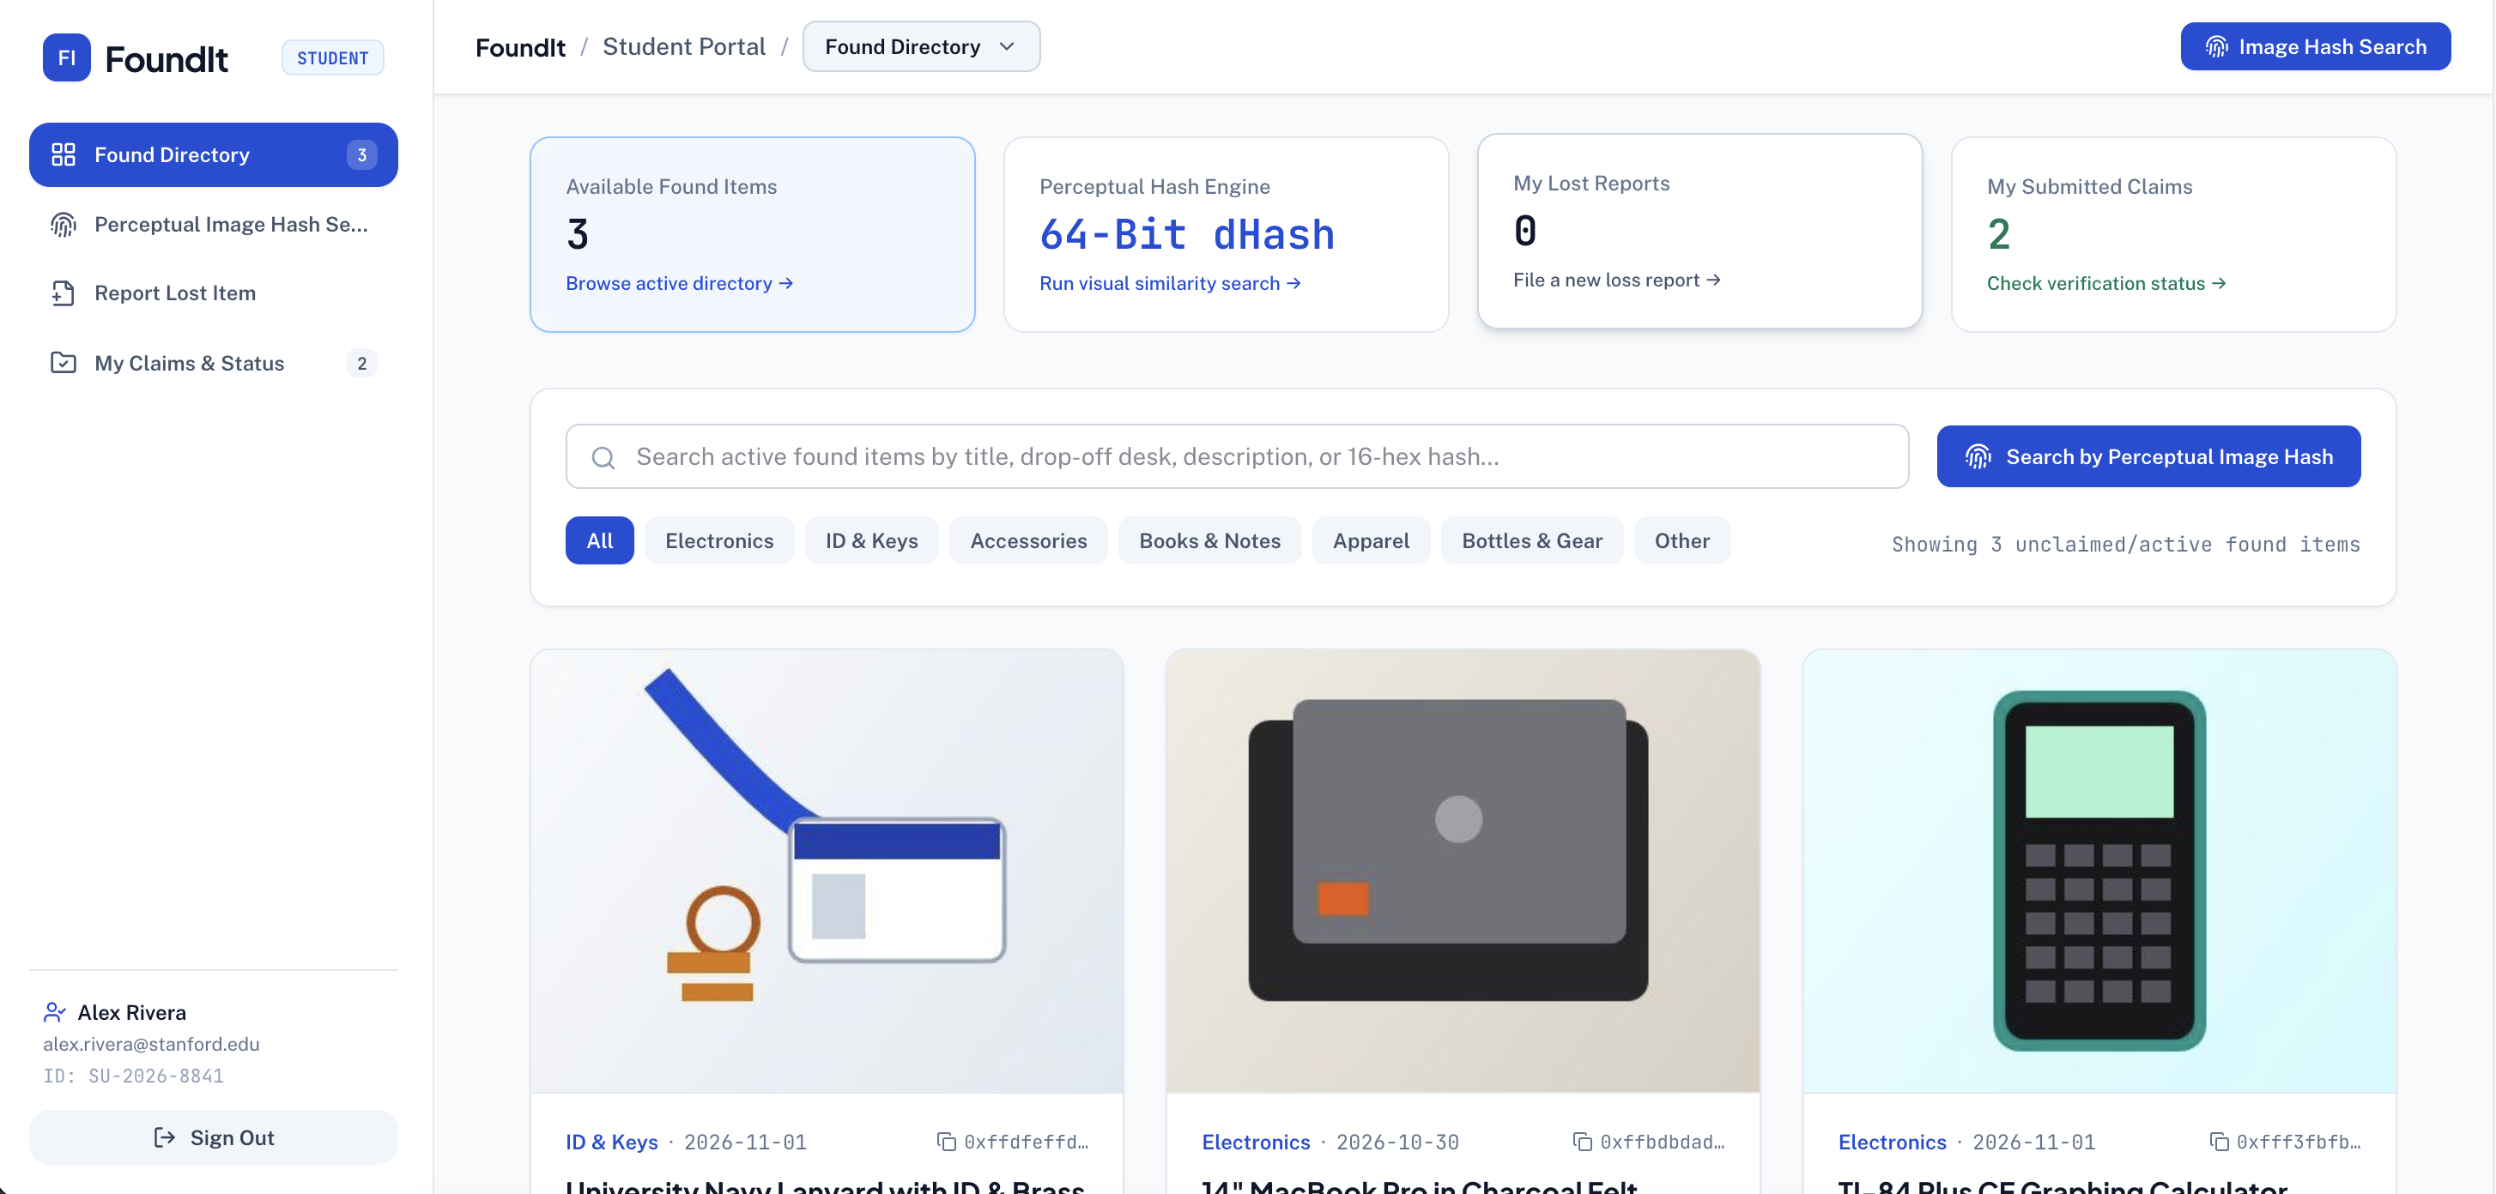
Displays active unclaimed found items across campus buildings with real-time search, category filter buttons, KPI summary cards, and 16-character hexadecimal dHash badges.
Figure 2.4: Student Portal — Perceptual Image Hash Search (64-Bit dHash Engine)
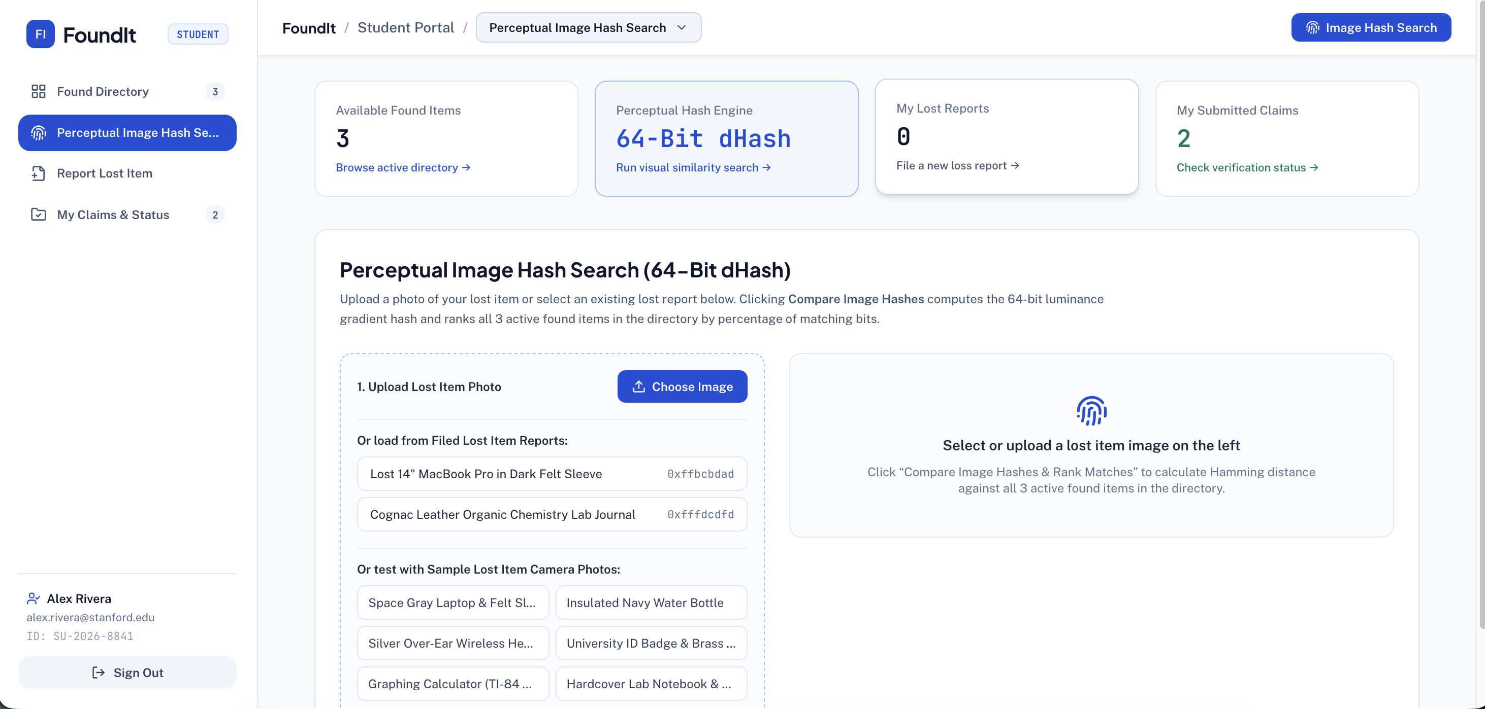
Interactive visual similarity search workspace where students upload a photo of their lost item or select an existing lost report to rank all active found items by bitwise Hamming similarity percentage.

Figure 2.5: Student Portal — File a Campus Lost Item Report
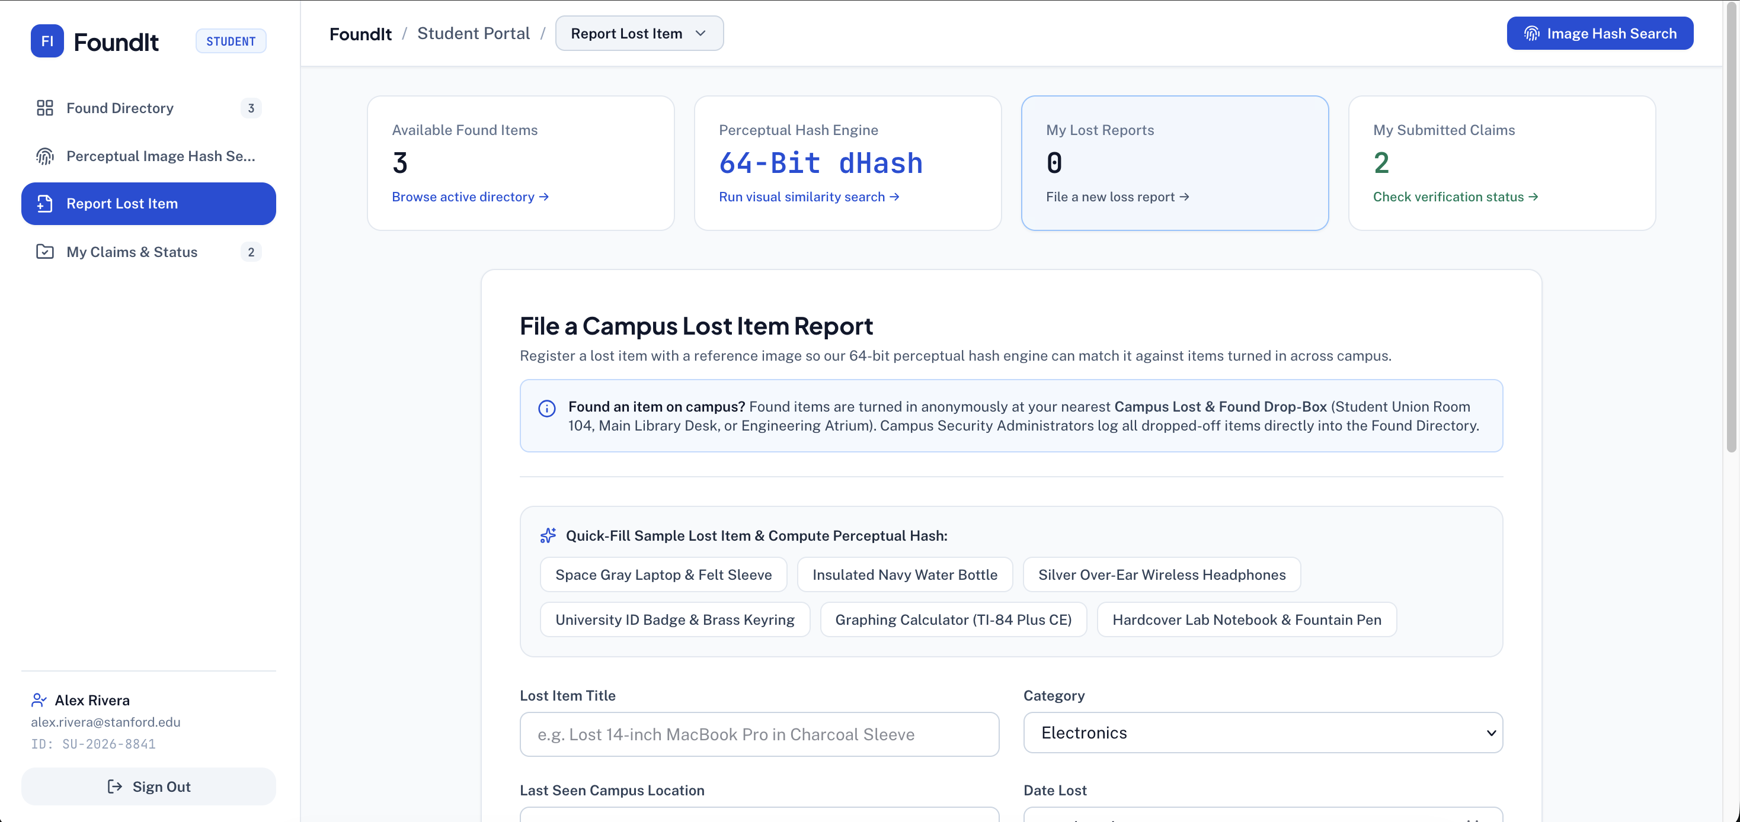
Dedicated student loss reporting form with anonymous found drop-box policy notice, quick-fill hardware preset buttons, and client-side HTML5 Canvas 64-bit perceptual hash generation.
Figure 2.6: Student Portal — My Ownership Claims & Verification Status
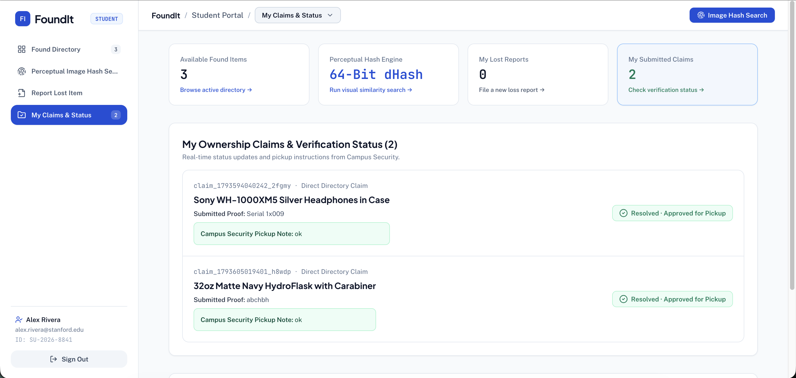
Real-time claim tracking view displaying submitted proof of ownership, verification status badges (Resolved · Approved for Pickup), and Campus Security pickup instructions.

Figure 2.7: Admin Console — Log New Found Item into Directory (Anonymous Campus Drop-Off Intake)
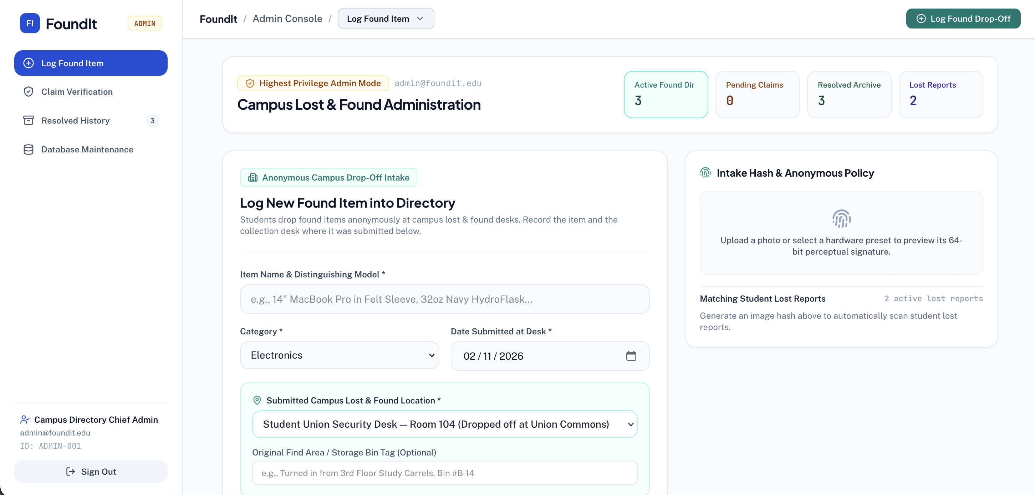
High-privilege administrator form for logging anonymous found items turned in at designated campus security desks, complete with automatic perceptual hash correlation against active student lost reports.
Figure 2.8: Admin Console — Claim Verification Queue
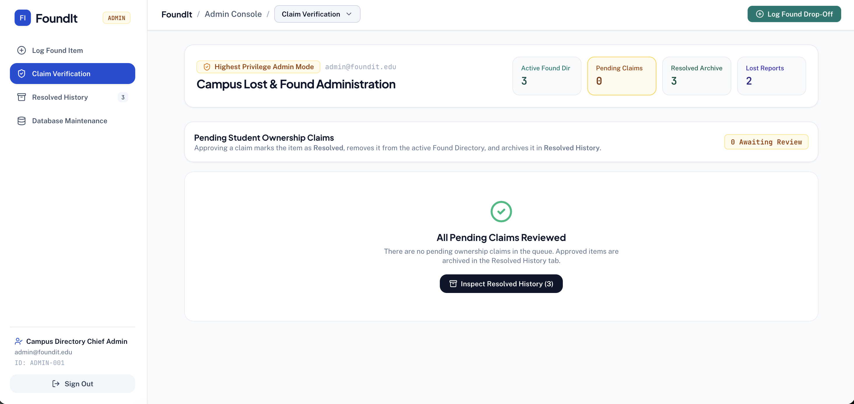
Administrator claim moderation panel where pending student claims are evaluated against proof descriptions and perceptual hash match scores before being approved and moved to Resolved History.

Figure 2.9: Admin Console — Resolved History Archive & Unresolve Action
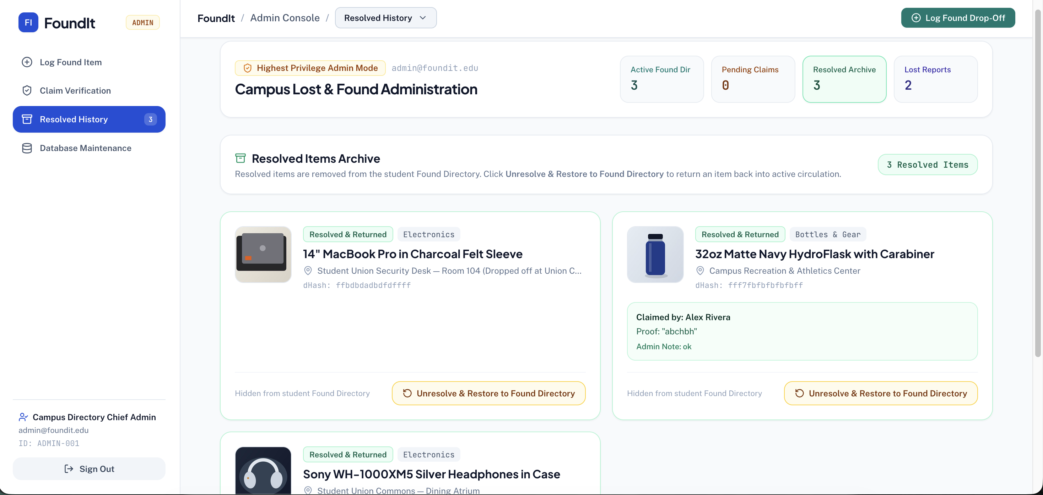
Dedicated Resolved Items Archive housing items removed from the active Found Directory, equipped with an "Unresolve & Restore to Found Directory" button to return items to active circulation if needed.
Figure 2.10: Admin Console — Database Maintenance & Client-Side Export to CSV
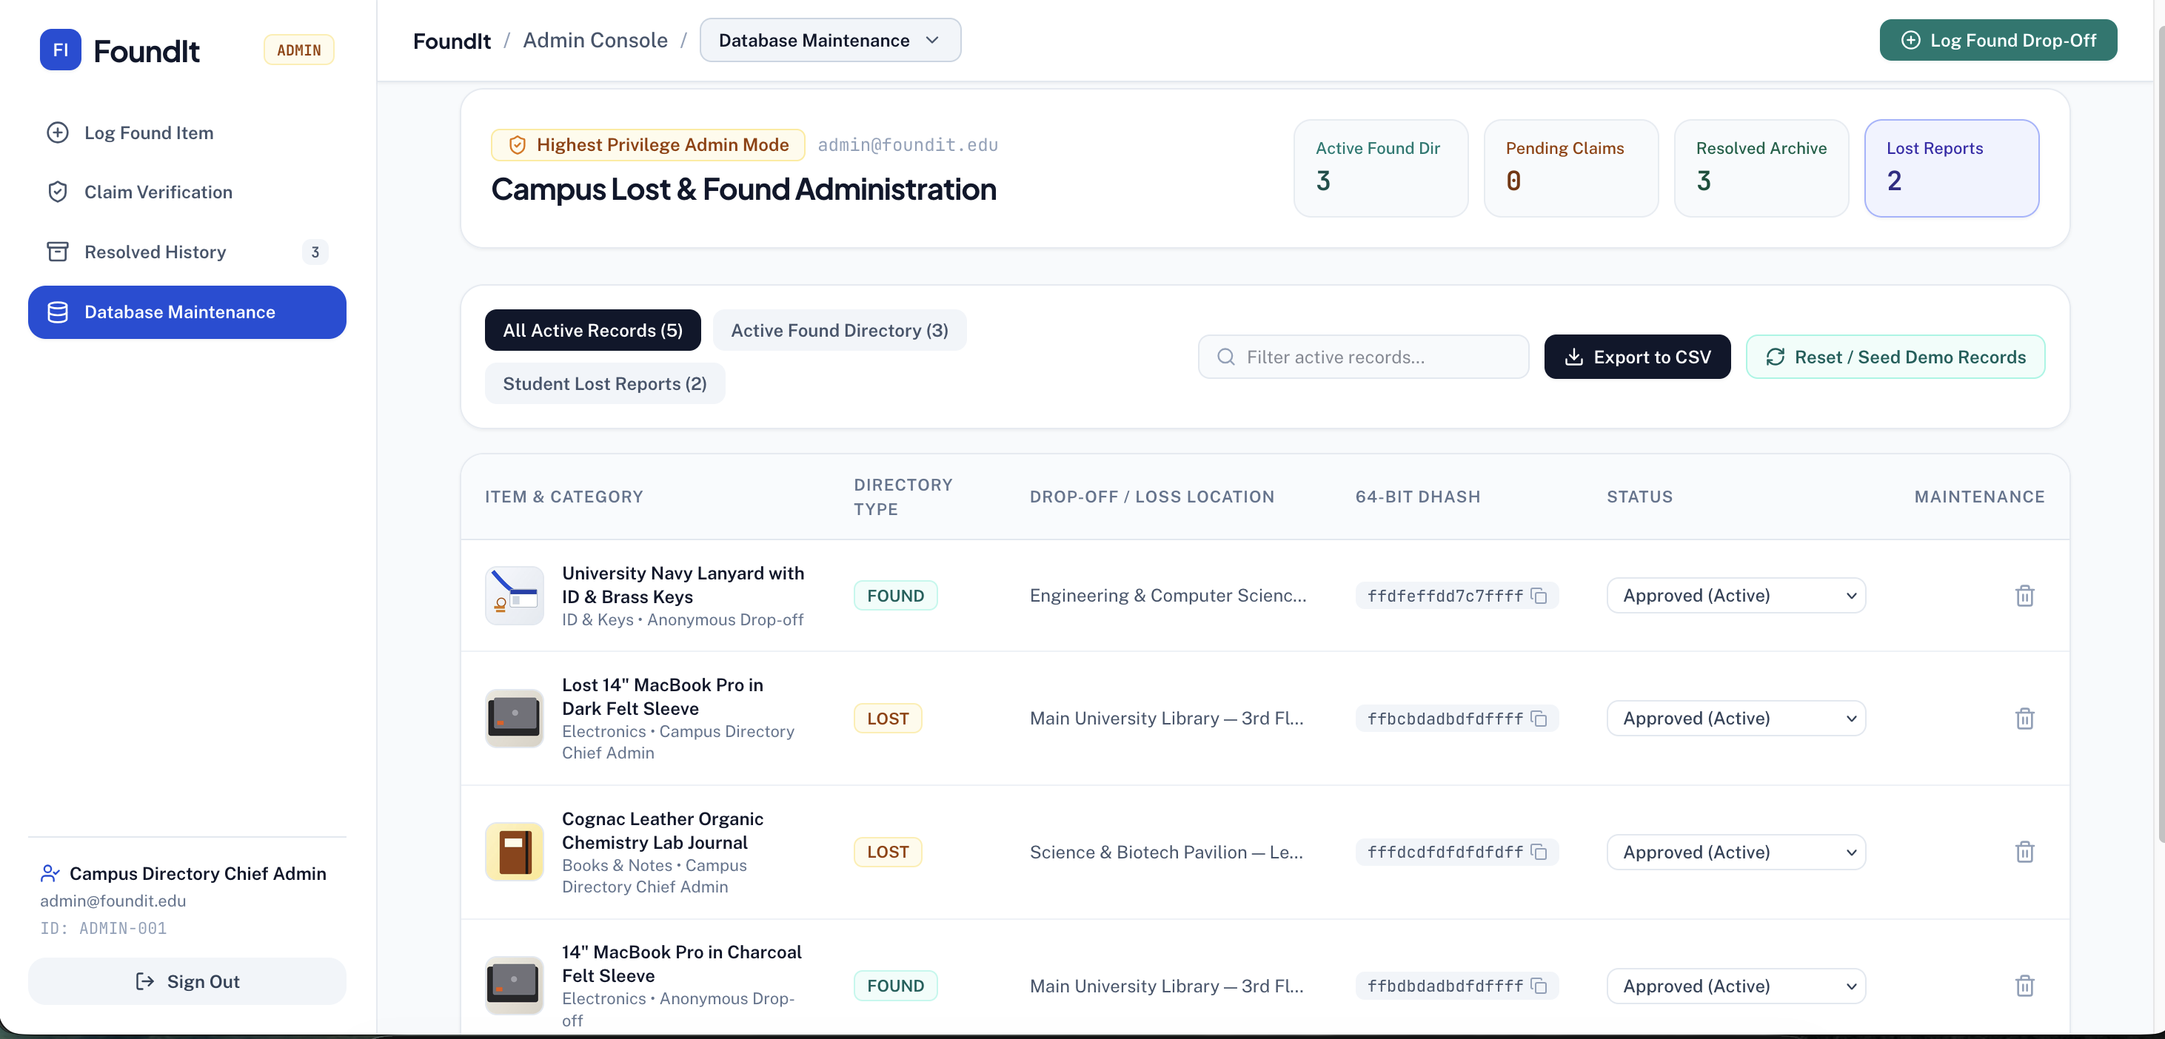
Comprehensive database management table featuring directory type filters, search bar, 1-click Export to CSV for record keeping, Reset / Seed Demo Records, inline status controls, and record deletion.

3. Conclusion and Future Scope
I developed FoundIt as a campus lost-and-found application with separate student and security-administrator workflows. The project combines a React and TypeScript interface, an Express API and Firebase services. Its core functions cover directory browsing, image-hash search, lost reports, ownership claims, found-item intake, claim verification, archival restoration and CSV export. The implementation demonstrates form handling, image processing, database updates and role-aware interface design. The complete design and development contribution belongs to Soukaryo Chandra.
Future work includes more robust image matching using multiple photos and colour features, email or push notifications for potential matches, and QR-based collection after ownership verification. Additional testing should evaluate access-control rules, concurrent claim updates, keyboard navigation and image-matching accuracy on real campus data.

4. Reference
[1] React 19 Official Documentation — Meta Open Source. "React Reference Overview: Hooks, Components, and State Lifecycle." Available at: https://react.dev/reference/react (Cited in Sections 1, 1.5, 2.1).
[2] Tailwind CSS v4.0 Documentation — Tailwind Labs Inc. "Styling with Utility Classes, Responsive Design, and Theme Variables." Available at: https://tailwindcss.com/docs (Cited in Sections 1, 1.5).
[3] Express.js 4.x API Reference — OpenJS Foundation. "Routing, Middleware, and JSON Request Processing in Node.js." Available at: https://expressjs.com/en/4x/api.html (Cited in Sections 1, 1.5, 2.2).
[4] Google Firebase Documentation — Google LLC. "Firebase Authentication & Cloud Firestore Security Rules and Real-Time Listeners." Available at: https://firebase.google.com/docs/firestore (Cited in Sections 1, 1.2, 1.5, 2.2).
[5] Krawetz, N. (2013) — The Hacker Factor Blog. "Kind of Like That: Perceptual Image Hashing and the Difference Hash (dHash) Algorithm." Available at: https://www.hackerfactor.com/blog/index.php?/archives/529-Kind-of-Like-That.html (Cited in Sections 1, 1.1, 1.2, 2.1).
[6] MDN Web Docs: HTML5 Canvas 2D Context API — Mozilla Corporation. "CanvasRenderingContext2D.drawImage() and getImageData() Pixel Manipulation." Available at: https://developer.mozilla.org/en-US/docs/Web/API/CanvasRenderingContext2D (Cited in Sections 1, 1.5, 2.1).
[7] Shafranovich, Y. (2005) — IETF RFC 4180. "Common Format and MIME Type for Comma-Separated Values (CSV) Files." Internet Engineering Task Force. Available at: https://datatracker.ietf.org/doc/html/rfc4180 (Cited in Sections 1.2, 2.1).
[8] W3C Web Content Accessibility Guidelines (WCAG) 2.1 — World Wide Web Consortium. "Contrast (Minimum), Keyboard Accessible, and Use of Color." Available at: https://www.w3.org/TR/WCAG21/ (Cited in Sections 1.3, 1.5).
[9] TypeScript 5.8 Handbook — Microsoft Corporation. "Everyday Types, Interfaces, and Strict Type Checking." Available at: https://www.typescriptlang.org/docs/handbook/intro.html (Cited in Section 1.5).
[10] Vite 6 Guide — Evan You & Vite Contributors. "Next Generation Frontend Tooling and Server Middleware Mode." Available at: https://vite.dev/guide/ (Cited in Section 1.5).
[11] FoundIt source code repository. Soukaryo Chandra. https://github.com/s-chandra-a/FoundIt

