**Project Overview – Technical Design Document**

**Game Concept**

Turn based role playing game. The player plays the role of 3 characters. They start off in a town, which will be the central hub for the game. Their purpose is to climb a tower consisting of 15 floors. Each floor is procedurally generated and changes if/when the player revisits the floor. At the top of the tower, floor 15, lies the player's goal.

**Technical Goals**

* 3D graphics
* Menu based game
* Turn based battle system
* Procedurally generated maps
* A.I.
* User Friendly Interface

**Third Party Tools**

**FMOD**

FMOD is an audio library developed by Firelight Technologies for 2D and 3D sound and music. It comes with a free usage license for non-commercial projects.

<http://www.fmod.org/>

**Blender**

Blender is a free and open source 3D animation suite developed by Neo Geo Studio and Not a Number Technologies. It comes with a free usage license for any purpose.

<http://www.blender.org/>

**GIMP**

Gimp is a free and open source raster editor. It comes with a free usage license for any purpose.

<http://www.gimp.org/>

**3DS MAX**

3DS Max is a 3D modeling software developed by Autodesk. For this project, we will be using the Student license which allows free use for educational purposes.

<http://usa.autodesk.com/adsk/servlet/pc/index?siteID=123112&id=18270111>

**GitHub**

GitHub is an application used for collaborating with others through each person's repository.

[https://github.com](https://github.com/)

**DirectX9**

DirectX9 is a graphics library using the Windows OS.

**Game Play**

**Game structures/Game objects**

* 7 housing structures – Item shop, Weapon Shop, Armor Shop, Tavern, Rune/Gem Shop, Inn, Tuturial Building
* 1 Tower Structure
* 4 character models – hero, heroine, mage, final boss
* 2 boss models
* 9 enemy models
* 4 room types – 1 pathway, 2 pathways, 3 pathways, 4 pathways
* 4 corridor types – corridor, turn, t-section, 4-way cross
* Textures/Descriptions – character, boss, enemy, town, shop, weapons, armor

**Player Actions**

The player starts in town. They are able to move from shop to shop or to the tower. The player can also access the menu, where they'll be able to change equipment, check their status, etc. Once the player moves to the tower, they'll enter the first floor of the tower. Each floor, except floors 5, 10, and 15, will be procedurally generated. Other than those 3 floors that remain the same, the other floors will change upon revisiting. While in the tower, the player is able to move about, access the menu, and engage in battles with monsters. Battles are not randomly generated, so the player will be able to avoid battles if they like. The number of monster battles on a given floor will be randomly generated however. Accessing the menu will be the same as in town. The player may advance to the next floor by finding the staircase generated in one of the rooms. There is no way for the player to descend a floor. The player may exit the tower either by use of an item or after all 3 characters are defeated in a battle. In battle, the player has a selection of actions to choose from. The battle ends when either all enemies are wiped out or all characters are defeated. Every 5th floor will contain a boss monster. After defeating the boss, the player will be able to return to this floor without having to climb the previous floor.

**Victory Conditions**

The game ends when the player defeats the boss on floor 15. The is no Game Over. If all 3 of the player's characters are defeated, they are returned to town.

**Code Overview**

Coding will begin in wWinMain. wWinMain will be responsible for creating the game object, the window, initializing both the game and window, initializing the global timer, initializing DirectX, handling the message loop, and shutting down all objects that need to be shutdown. See Dependency Chart.

**User Interface**

**Game Menu**

**StartUp Menu:**

The startup menu will consist of a 2D menu and a Texture background. The following choices will be available:

* New Game
* Continue
* Options
* Quit

New Game will start the player with a fresh file. Load Game will allow the player to continue from where the last left off if there is a save file available. The Options selction will take the player to the options menu. The credits selection will show the credits. Quit will quit the game and close the window.

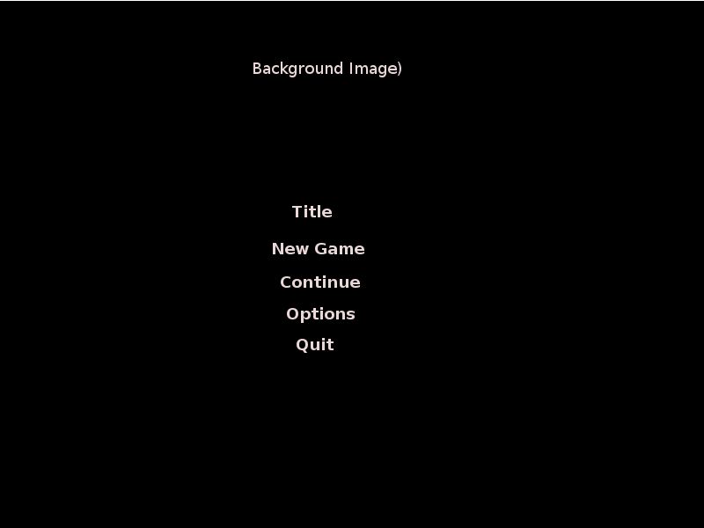

**Options Menu:**

The options menu will consist of a 2D menu and a texture background. The following choices will be available:

* Credits
* Sound – adjust slider
* Screen – Fullscreen/Window
* Controls – Keyboard/Controller
* Back

The sound slider will adjust the volume of the sound and music being played. Both the Sound Test and BGM Test will allow the player to listen to the games sounds and music. Change Controls will take the player to the next screen, where they can switch from keyboard to controller or vice versa, and change the button layout. Back will take the player to the previous screen.

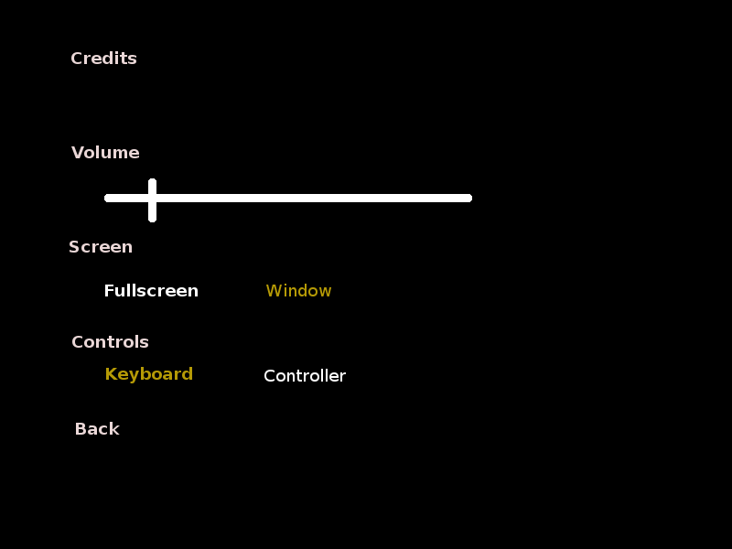

**Battle Menu:**

The battle menu will consist of a 2D menu. The following choices will be available:

* Attack – allows the character to attack a target.
* Skill – allows the character to use a skill.
* Defend – The character takes reduced damage til their next turn
* Escape – Allows the party to run from the battle.
* Item – Allows the character to use an item.

**Item Shop Menu:**

* Buy – Displays buyable items
* Sell – Displays sellable items
* Exit – Exits the Shop

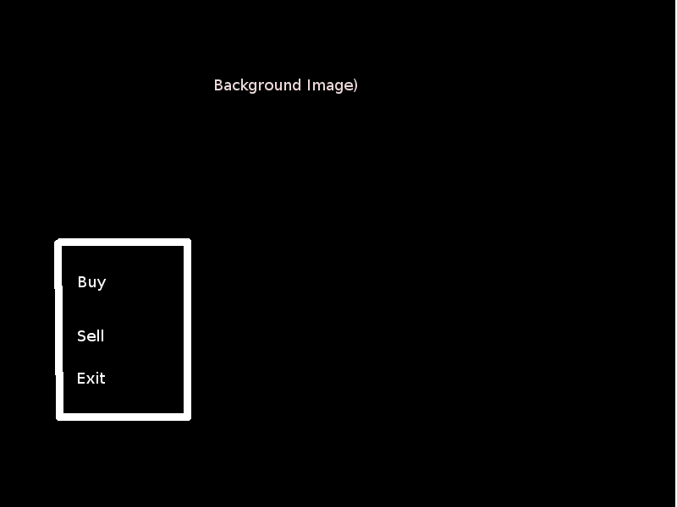

**Item Shop Buy/Sell Menu:**

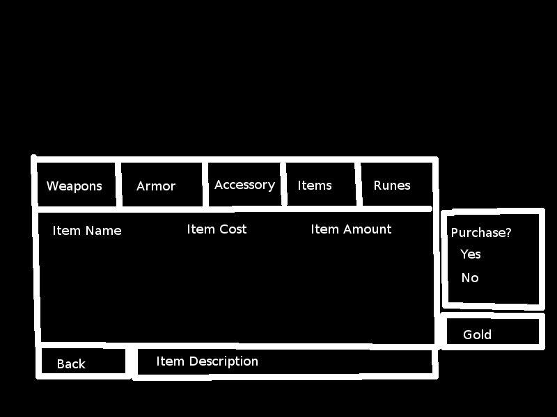

**In-Game Controls:**

**Navigating Menus**

**Keyboard Input:**

* W – Move cursor Up
* S – Move cursor Down
* A – Move cursor Left
* D- Move cursor Right
* Left Mouse Button – Confirm
* Right Mouse Button - Cancel

**Controller Input:**

* Directional pad Up – Move cursor Up
* Dpad Down – Move cursor Down
* Dpad Left – Move cursor Left
* Dpad Right – Move cursor Right
* A button – Confirm
* B button - Cancel

**Navigating Town/Tower**

**Keyboard Input:**

* W – Move forward
* S – Move backward
* A – Move left
* D – Move right
* H – Access Menu
* F – Interact with objects

**Controller Input:**

* Dpad Up – Move forward
* Dpad Down – Move backwards
* Dpad Left – Move left
* Dpad Right – Move right
* Y button – Access Menu
* A button – Interact