Viewing Options and Transformations
Memo for RiCPP, Andreas Pidde, 29th May 2008
RenderMan® is a registered trademark of Pixar.
Contents
1 Correlations Between the Various Screen Description Options of the RenderMan Interface 2
1.1 Physical Display Description 2
1.1.1 RiDisplay(RtToken name, RtToken type, RtToken mode, …): Selects the physical output device. 2
1.2 Display Channel Description 2
1.2.1 RiDisplayChannel(RtToken channel, …): User defined mode (Arbitrary Output Variables AOV) of a display. 2
1.2.2 RiFormat(RtFloat xres, RtFloat yres, RtFloat pixelaspect): Sets the dimension of the frame (“raster” space). 3
1.2.3 RiFrameAspectRatio(RtFloat aspect): Sets the frame aspect ratio of the frame. 3
1.2.4 RiCropWindow(RtFloat xmin, RtFloat xmax, RtFloat ymin, RtFloat ymax): Sets the coordinates of the crop window, using normalized display coordinates (“NDC” space) 3
1.3 The Screen Coordinates of the Image 4
1.3.1 RiScreenWindow(RtFloat left, RtFloat right, RtFloat top, RtFloat bottom): Sets the screen window coordinates of the image (“screen” space) 4
1.4 The Camera to Screen Projection 4
1.4.1 RiProjection(RtToken name, …): Appends a projection matrix to the current transformation matrix to get the camera to screen projection. 4
1.4.2 RiClipping(RtFloat hither, RtFloat yon): Sets the clipping planes (“camera” space). 5
1.5 Important Modes for the Viewing 5
1.5.1 RiWorldBegin(RtVoid): Set up the whole viewing 5
1.5.2 RiWorldEnd(RtVoid): Ending the world block 6
1.5.3 RiFrameBegin(RtInt frameNo), RiFrameEnd(): Frame blocks 7
2 Spaces 8
2.1 Overview 8
2.2 The Raster Space 8
2.3 The NDC Mapped to Raster Space 10
2.4 The Screen Coordinates Mapped to NDC 11
2.5 The Camera Coordinates Projected to the Screen Coordinates 11
2.6 The World Coordinates Transformed to Camera Space 12
2.7 The Local Coordinates Transformed to World Space 13
3 Sample Application RiGLApp 14
4 Implementation of RiTransformPoints and RiCoordSysTransform 21
5 Orientation of Coordinate Systems and Primitives 22
6 Literature 23

Correlations Between the Various Screen Description Options of the RenderMan Interface

Physical Display Description

RiDisplay(RtToken name, RtToken type, RtToken mode, …): Selects the physical output device.
name: Gives the literal name of the output device.
type: The type of the output device like “framebuffer” and “file”.
mode: The channels: “rgbaz”, “rgba”, “rgbz”, “rgb”, “a”, “z”. User defined channels can be specified by using the RiDisplayChannel command. Channels can be separated by a comma, like “rgb,z”.

The parameter list can contain an optional parameter “origin” [RtInt, RtInt] for the output device coordinates, that’s an additional offset from the upper left corner of the physical output device to the upper left corner of the frame. The default value is [0, 0] – the upper left corner of the display matches the upper left corner of the frame. A special display can have standard values for width, height and pixel aspect ratio, that can be used by RiCPP as default values, if RiFormat is not called. If the pixelaspect value of RiFormat is less than zero the standard pixel aspect ratio of the output device is used (1.0 for square pixels is taken, if the current ratio is not known). If an origin is given, the default values for width and height are less than this origin, so that the images fits to the lower right corner if RiFormat is not called.
Multiple displays (secondary displays) can be chosen, if a “+” sign is the first character in name. The primary display is used for the default values of RiFormat. Secondary displays can be used for arbitrary output variables (AOV, see also RiDisplayChannel).

Display Channel Description

RiDisplayChannel(RtToken channel, …): User defined mode (Arbitrary Output Variables AOV) of a display.
The inline definition of a display channel with optional parameters like filters. The channels can be values that are present to the renderer, like “varying normal N”. The data can be provided by surface shaders, that use the channel variables as output – in a way like you provide the surface color Cs by surface shaders. The name without the type definition can then be used as part of mode in RiDisplay. If you don't use the optional parameters for a special channel – like a quantization, you can alternatively simply RiDeclare the display channels and use RiQuantize for quantization. Parameters can also go to the parameter list of a secondary display. The RiDisplayChannel parameters binding is stronger than that of RiDisplay.

RiFormat(RtFloat xres, RtFloat yres, RtFloat pixelaspect): Sets the dimension of the frame (“raster” space).
xres: Width of the output window, measured in pixels.
yres: Height of the output window, measured in pixels.
pixelaspect: Pixel aspect ratio (pixelwidth/pixelheight) of the output device. A negative value can be used to get the current ratio from the physical display description (see RiDisplay).

The default values match the size and pixel ratio of the physical display. If the output device is a file or the dimensions are not known by the renderer, the defaults are somewhat implementation dependent: The values width 512 and height 384 can be found in the RI 3.1 specs and the default for the pixel aspect ratio is 1.0. That's a frame aspect ratio of 4/3.

RiFrameAspectRatio(RtFloat aspect): Sets the frame aspect ratio of the frame.
aspect: The aspect ratio of the final image. aspect > 0.0.

The default value is: aspect = (pixelaspect * xres / yres). aspect will match the values of RiFormat. If you choose a frame aspect ratio that does not match the display coordinates, the image coordinates will be smaller on either the bottom or the right side – but the image will not be distorted. The unused pixels will be left blank while rendering. The frame aspect ratio is the ratio that will appear at the final physical image, provided that the pixel aspect ratio (pixelaspect in RiFormat) is chosen correctly to match the one of the display. If you choose aspect = 16.0/9.0 for example, you’ll get a 16.0/9.0 output.

RiCropWindow(RtFloat xmin, RtFloat xmax, RtFloat ymin, RtFloat ymax): Sets the coordinates of the crop window, using normalized display coordinates (“NDC” space)
xmin: Minimal x coordinate (left edge)
xmax: Maximal x coordinate (right edge)
ymin: Minimal y coordinate (bottom edge)
ymax: Maximal x coordinate (top edge)

0.0 <= xmin <= xmax <= 1.0 and 0.0 <= ymin <= xmax <= 1.0

Two crop windows have the property, that the images will fit together seamlessly at their x-edges if xmin_{i} = xmax_{i-1} and at their y-edges if ymin_{i} = ymax_{i-1}. Therefore, you can render images in stripes or tiles and fit them together afterwards. A crop window contains the coordinates of the half open intervals [xmin, xmax) and [ymin, ymax). The coordinates are given in NDC (normalized display coordinates). NDC ranges from 0.0 to 1.0 in two dimensions and there are mappings to the raster space as well as to the screen window. Like in raster space and unlike screen space, the origin is located at the upper left corner of the frame, positive x axis is to the right and positive y axis is down.

The Screen Coordinates of the Image

RiScreenWindow(RtFloat left, RtFloat right, RtFloat top, RtFloat bottom): Sets the screen window coordinates of the image (“screen” space)
left: The coordinates for the left edge of the image.
right: The coordinates for the right edge of the image.
top: The coordinates for the top edge of the image.
bottom: The coordinates for the bottom edge of the image.

left <= right and bottom <= top

RiScreenWindow is used to set up the screen coordinates for the extension of the front view (on the viewing plane) explicitly. If the coordinates do not correspond with the frame aspect ratio, distortion will occur. The screen coordinates are given in camera space. The distance of the screen window from camera position defaults to 1.0 unit. It can be different for perspective projections with a field of view ("fov”) with a value not equal 90 degree.
The default values for the screen coordinates are chosen in a way that the range -1.0 and 1.0 matches the smaller side, either left to right or bottom to top. The other range is calculated in a way that there it matches the frame aspect ratio.

If the image is physically wider than high (frame aspect ratio >= 1):

left = -frameaspect
right = frameaspect
top = 1.0
bottom = -1.0

If the image is physically higher than wide (frame aspect ratio < 1):

left = -1.0
right = -1.0
top = 1.0 / frameaspect
bottom = -1.0 / frameaspect

The Camera to Screen Projection

RiProjection(RtToken name, …): Appends a projection matrix to the current transformation matrix to get the camera to screen projection.
name: Type of the projection: “orthographic” (default), “perspective”, “null”.

The parameter list can contain an optional “fov” [RtFloat] parameter (> 0, < 180.0) for the field of view of the “perspective” projection. The field of view will be used to calculate the distance of the viewing plane to the camera. If the fov is set by the user, the viewing plane is moved appropriately in z, in a way that fov matches the -1 to 1 square in screen coordinates: distance = 1 / tan(fov/2). The default is 90 degree for fov, that's a distance of 1 unit. The screen window (RiScreenWindow) is than positioned on that plane. The angle of the rays from viewing point through the edges of the screen window may be another angle than the one given by fov. The near and far clipping plane are used for the front and far side of the viewing volume (frustum) and are projected to z = 0.0 and z = 1.0 appropriately.
The orthographic projection simply uses the screen coordinates for viewing. The near clipping plane is projected to z = 0.0, the far clipping plane is projected to the distance 1.0. You can use the “null” projection to use the CTM as projection matrix. The default projection is “orthographic”. The CTM is reseted to identity for camera placement after work is done.

RiClipping(RtFloat hither, RtFloat yon): Sets the clipping planes (“camera” space).
hither: Near clipping plane (default RI_EPSILON)
yon: Far clipping plane (default RI_INFINITY)

The near clipping plane must be in front of the viewing point and hither < yon. The default values are RI_EPSILON for the near (hither) and RI_INFINITY for the far (yon) clipping plane. If possible, you should take more reasonable values. Put the near clipping farer away relaxes the problem of the maximum eye splits in REYES, a nearer far clipping plane may result in a better resolution for depth values.

Important Modes for the Viewing

RiWorldBegin(RtVoid): Set up the whole viewing
Since options can be written in any order, the ranges for raster space and screen window can be calculated late at RiWorldBegin. Because the set up of the viewing matrices are deferred to RiWorldBegin, RiTransformPoints can be called reliably only within a world block. RiWorldBegin also stores the CTM for world to camera transformation and begins a new attribute and transformation block with a reseted CTM. World blocks can not be nested.

// Pseudo code to get the display options in RiWorldBegin

origin_{out} = {0, 0};
xres_{out} = 512;
yres_{out} = 384;
pixelaspect_{out} = 1.0;

if ( RiDisplay has been called ) {
if ( display got standard xres ) {
xres_{out} = xres_of_display;
}
if ( display got standard yres ) {
yres_{out} = yres_of_display;
}
if ( display got standard pixel aspect ratio ) {
pixelaspect_{out} = pixel_aspect_ratio_of_display;
}
if ( origin parameter is available ) {
origin_{out} = origin_of_display;
}
}

if ( RiFrame has been called ) {
xres_{out} = xres_of_RiFrame;
yres_{out} = yres_of_RiFrame;
if ( pixelaspect_of_RiFrame > 0 ) {
pixelaspect_{out} = pixelaspect_of_RiFrame;
}
}

frameaspect_{out} = (RtFloat)xres_{out} * pixelaspect_{out} / (RtFloat)yres_{out};

if ( RiFrameAspect has been called ) {
frameaspect_{out} = frameaspect_of_RiFrameAspect;
// If the frame aspect do not match the current output frame,
// either the bottom or the right side of the frame is not rendered,
// so that the output frame has the aspect ratio wanted. However,
// there will be no visible distortion.
Set xres_{out} and yres_{out} according to frameaspect_{out} and pixelaspect_{out};
}

// Here the matrix that transforms from NDC to display device raster coordinates can be build
Build NDCToRaster_{out} and its inverse;

if ( frameaspect_{out} >= 1.0 ) {
left_{out} = -frameaspect_{out};
right_{out} = frameaspect_{out};
bottom_{out} = -1.0;
top_{out} = 1.0;
} else {
left_{out} = -1.0;
right_{out} = 1.0;
bottom_{out} = -1.0/frameaspect_{out};
top_{out} = 1.0/frameaspect_{out};
}

if ( RiScreenWindow has been called ) {
left_{out} = left_of_RiScreenWindow;
right_{out} = right_of_RiScreenWindow;
top_{out} = top_of_RiScreenWindow;
bottom_{out} = bottom_of_RiScreenWindow;
}

// Here the matrix that transforms from screen coordinates to NDC can be build
Build screenToNDC_{out} and its inverse;

projection_{out} = “orthographic”;
viewingPlaneDistance_{out} = 1.0;
projCTM = identity;

if ( RiProjection has been called ) {
projection_{out} = projection_of_RiProjection;
projCTM = CTM stored by RiProjection;
if ( projection_of_RiProjection is “perspective” ) {
fov = 90.0;
if ( fov is set by RiProjection ) {
fov = fov of RiProjection;
}
Set viewingPlaneDistance_{out} appropriately to fov: 1/tan(fov/2);
Calculate prespectiveProjectionMatrix;
cameraToScreen_{out} = prespectiveProjectionMatrix ×
projCTM;
} else if ( projection_of_RiProjection is “orthographic” ) {
Calculate ortographicProjectionMatrix;
cameraToScreen_{out} = ortographicProjectionMatrix × projCTM;
} else {
cameraToScreen_{out} = projCTM;
}
} else {
Calculate ortographicProjectionMatrix;
cameraToScreen_{out} = ortographicProjectionMatrix;
}

Set cropwindow_{out} to {0,0}, {1, 1};

if ( RiCropWindow has been called ) {
cropwindow_{out} = cropwindow_of_RiCropWindow;
}

worldToCamera_{out} = CTM;
Reset CTM;

RiWorldEnd(RtVoid): Ending the world block
RiWorldEnd marks the end of the world block. The camera transformation matrix that was valid before RiWorldBegin was called is restored with the transformation and attribute block.

RiFrameBegin(RtInt frameNo), RiFrameEnd(): Frame blocks
frameNo: Frame number

The optional frame block opens a new option, attribute and transformation block, encloses world blocks and can be used for the scope of the viewing matrices. Frame blocks can not be nested.

Spaces

Overview
There are six major spaces used by the RenderMan interface, and five special matrices transform from one space to another.
- 2D Raster space (“raster”, RI_RASTER), pixel coordinates. The origin is the upper left corner and has the x,y coordinates (0, 0). x grows to the right, y grows downwards. The raster space can be mapped to the device space of a concrete physical output device.
- The matrix tagged with “raster” (RI_RASTER) maps from NDC to raster space.
- 2D normalized display coordinates (“NDC”, RI_NDC). Also has its origin (0, 0) at the upper left corner, x grows to the right, y grows downwards. (1, 1) are the coordinates of the lower right corner, that is mapped to the lower right corner of the raster that matches the frame aspect ratio.
- The matrix tagged with “NDC” (RI_NDC) maps from screen coordinates to NDC.
- 2D screen coordinates (“screen”, RI_SCREEN), contains the viewport, bound by the RiScreenWindow coordinates. X grows to the right, y grows upwards.
- The matrix tagged with “screen” (RI_SCREEN) projects from camera space to screen space.
- 3D camera coordinates (“camera”, RI_CAMERA), default orientation is left handed. Coordinate system has its origin at the viewpoint. x grows to the left, y grows upwards and z grows into the depth.
- The matrix tagged with “camera” (RI_CAMERA) transforms from world coordinates to camera coordinates.
- 3D world coordinates (“world”, RI_WORLD), default orientation is left handed. Reference coordinates, space where the primitives are placed in.
- The matrix tagged with “world” (RI_WORLD) contains the current transformation matrix (CTM) that transforms from local object coordinates to world coordinates.
- 3D local object coordinates “current” (RI_CURRENT), default orientation is left handed. Local coordinates of the current system (world or camera). In the world block the RI_CURRENT matrix is the same as the matrix tagged with RI_WORLD.
For the primitives further coordinates like parametric coordinates (u, v) and texture coordinates (s, t) can be used.
A 3D point of the local coordinates system in a world block can be transformed to raster space by the following transformation pipeline:
raster coordinates = point × RI_CURRENT × RI_CAMERA × RI_SCREEN × RI_NDC × RI_RASTER
After RiWorldBegin the camera is placed and the composite matrix RI_CAMERA × RI_SCREEN × RI_NDC × RI_RASTER is fixed until RiWorldEnd. RiCPP stores each matrix with its inverse to transform to the opposite direction. Also different matrices to transform the normal vectors must be maintained (M⁻¹)^{T}. However, since the inverse matrix is already stored, the transposed matrix can be calculated on the fly.

The Raster Space
The raster space is an internal representation of a 2D pixel plane, bounded by width and height. The width and height are calculated by using the frame aspect ratio and pixel aspect ratio. Parts of it can be mapped directly to a physical device specified by RiDisplay. Although two dimensional, RiCPP maintains a z coordinate ranging from 0.0 to 1.0 with depth information for each pixel. The layout can be visualized by the following diagram:
Figure 1: The raster space frame
0,0
width
height
a single pixel
A pixel at (x, y) in raster space is a small rectangle of half open intervals: horizontal [x, x+1) and vertical [y, y+1), having 0 <= x < width and 0 <= y < height. Because the coordinates are at the boundary of a pixel, crop windows with the same crop coordinates of adjacent edges fit seamlessly (see also RiCropWindow). A pixel rectangle is mapped to a single pixel at the physical output device, optionally with an offset given by the origin of the device coordinates. This mapping can be done in the OpenGL renderer by the function calls:

glViewport(origin.x, origin.y, xres-origin.x, yres-origin.y);
glOrtho(0, xres-origin.x, yres-origin.y, 0, 0.0, -1.0);

There are several aspects that influence the mapping of the raster coordinates to the physical display coordinates. The RiFormat can be used to give a width and a height. The whole raster can be translated by the origin given by the RiDisplay command. The frame aspect ratio can cause that either portions of the bottom or the right are not filled. A crop window RiCropWindow can be used to render only a part of the raster. Because the crop window is given in NDC it always lies inside the frame. And finally, the bounds of the output device can cut portions away. The pixel aspect ratio does not influence the mapping directly, because it is used to set up the default coordinates of the screen windows (together with the frame aspect ratio). The device mapping used for the OpenGL renderer takes this into account and to draw the visible rectangle only.

glViewport(
origin.x + cropwindow_raster_left, // x
origin.y + cropwindow_raster_top, // y
min(cropwindow_raster_width,
display_xres – origin.x – cropwindow_raster_left), // width
min(cropwindow_raster_height,
display_yres – origin.y – cropwindow_raster_top) // height
);
glOrtho(
cropwindow_raster_left, // left
cropwindow_raster_left +
min(cropwindow_raster_width,
display_xres – origin.x – cropwindow_raster_left), // right
cropwindow_raster_top +
min(cropwindow_raster_height,
display_yres – origin.y – cropwindow_raster_top), // bottom
cropwindow_raster_top, // top
0.0, // near
-1.0 // far
);

The defaults of RenderMan are chosen in a way that no distortion occurs and the whole space of a physical display is used. A more general example of the raster to device mapping is shown in the next diagram (see also Figure 8.6 in Upstill, Steve: The RenderMan Companion).

Figure 2: Raster to device mapping
Surface of the physical display device
origin in device coordinates
Screen window (frame)
Interior of the frame with aspect
Crop window
Rendered pixels
You can use origin and the width and height of RiDisplay and RiFormat for the OpenGL draft renderer to render sub windows of a given window. Because of the raster to device mapping the world blocks can be mapped to different OpenGL viewports within a single redraw routine of your application.

The NDC Mapped to Raster Space
Figure 3: Window with three frames as subwindows
Window
Frame 1
Frame 2
Frame 3
The normalized display coordinates NDC can be used for clipping and are mapped directly to the raster coordinates by a scaling matrix. width and height are the sizes of the frame with the correct aspect ratio. The z coordinates are used for the depth information in the range [0, 1].
Matrix 2.1: NDC to Raster matrix
The NDC form a rectangle with the coordinates (0,0) for the upper left and (1,1) for the lower right.

The Screen Coordinates Mapped to NDC
The screen coordinates are given by the extension of the screen window. They are mapped to the NDC by moving the top (tp) left (lft) of the screen window to the left bottom, scaling by the inverse of the width and the negative inverse of the height to get NDC. The z coordinates range from 0 to 1 are used for depth information.
Matrix 2.2: Screen to NDC

The Camera Coordinates Projected to the Screen Coordinates
The camera space is the 3D space as seen from the viewpoint of the camera. The coordinates are “projected” to screen space by the camera to screen matrix – it is not a real projection, because screen space still maintains the z coordinate. The projection matrix is premultiplied to the current matrix that was valid when RiProjection was called – if RiProjection is not called the orthographic projection is taken as projection matrix. The RI_NULL projection does nothing (identity matrix as projection matrix) – the transformation matrix (TM_{preproj}) that was valid when RiProjection was called is used as projection matrix. An RI_ORTHOGRAPHIC projection projects the viewing volume given by the screen window, near and far clipping plane, just by moving the near clipping plane to z = 0 and scaling the z coordinates appropriately.
Figure 4: Perspective Projection
1
1
top
fov/2
tan(fov/2)
1/tan(fov/2)
y
z
½ screenht
viewplane
proj for default fov=90°
The RI_PERSPECTIVE projection does the perspective projection (the plane at z = 1 is translated to z = 0 while projecting, x, y coordinates on the view plane at z = 1/tan(fov/2) are not changed) by using first the homogeneous perspective matrix (same as RiPerspective). To get the proper screen coordinates the near clipping plane (by perspective matrix projected values hither_{proj} = (0 0 hither 1) × M_{proj}) is moved to z = 0 and z is scaled appropriate so that the (projected yonder_{proj} = (0 0 yonder 1) × M_{proj}) far clipping plane becomes z = 1. The division of the homogeneous component is applied very late after the whole view matrix has been multiplied to the positions.
Matrix 2.3: Orthographic, camera to screen

Matrix 2.4: Perspective, camera to screen

The World Coordinates Transformed to Camera Space
The world coordinates are lying in the 3D reference space where the primitives are placed. The world coordinates are transformed to the camera space by the world to camera matrix – this is the matrix that was CTM when RiWorldBegin was called. The CTM can be manipulated by various RenderMan calls: RiTranslate, RiScale, RiRotate, RiSkew, RiTransform and RiConcatTransform. There is also a RiPerspective, but this is in general not useful for world to camera or local to world transformation.
Matrix 2.5: Translation

Matrix 2.6: Scaling

Matrix 2.7: Rotation, about vector (x y z) by angle a

Matrix 2.8: Skew vector (x₁ y₁ z₁) towards (x₂ y₂ z₂) by angle a

The Local Coordinates Transformed to World Space
The local coordinates are in the space that is current, when a primitive is defined by an interface call. The coordinates are transformed to the world space by the current transformation matrix CTM. Transformation blocks can be used to nest object coordinates.

Sample Application RiGLApp
RiGLApp for MacOS is a small throw away application I've created to test the viewing pipeline of RiCPP. It can be used to visualize the impact of the various parameters to the viewing. A green polygonal square is shown on a white ground. The white ground visualizes the rendered area, a square is used to visualize possible distortion. The values of the parameters are shown in the HUD. You can change the settings by first activating the group and then edit the values. The corresponding RMan interface routine is called only when it's group is activated. If nothing is set, the display shows the rendering using default values.
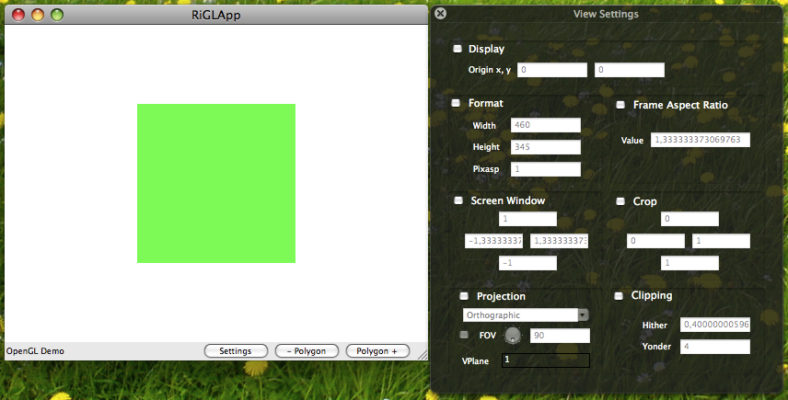Screenshot 3.1: Frame with default values
The clipping values are not the default values but have more reasonable values. The hither and yonder clipping plane can be changed independently from the view plane.
The physical pixel aspect is 1.0 for the display. If you change the size of the window, the default values for the parameters are changed appropriately. Using the standard values, the whole viewing area is used by the output and no distortion occurs (the frame aspect and screen window coordinates change appropriately).
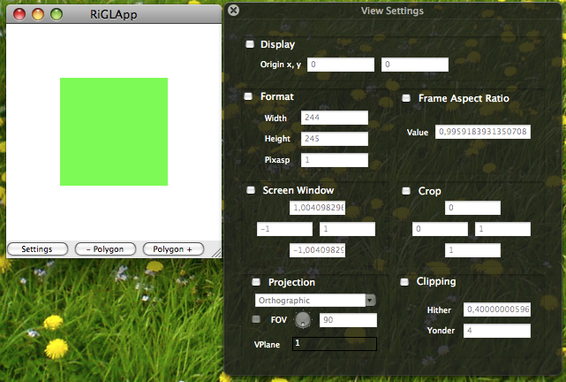Screenshot 3.2: Frame with default values and different size
If the pixel aspect ratio is changed, say to 2.0 - which means that pixels at the physical output device are twice as wide as high - at a display with square pixels the frame appears twice as heigh as on a display with wide pixels. Frame aspect ratio and screen coordinates are changed appropriately.
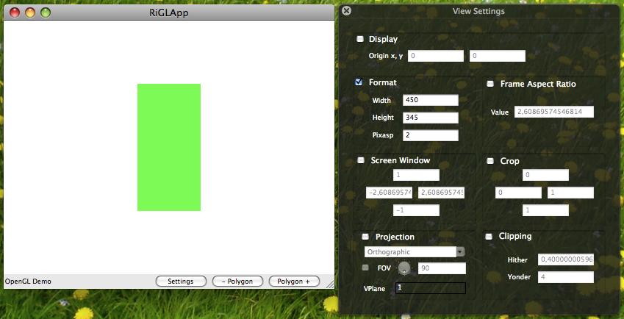Screenshot 3.3: Frame with pixel value of 2.0
The origin can be used to move the frame. The default frame width and height is changed so that the lower right corner of the frame fits to the lower right of the display. If the frame format is set, these values are taken as they are.
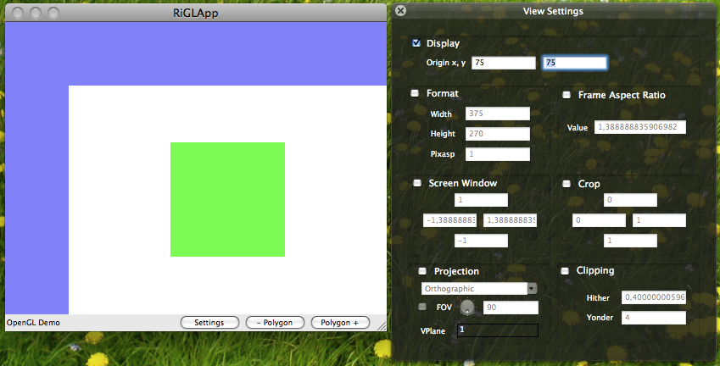Screenshot 3.4: Origin set to (75, 75)
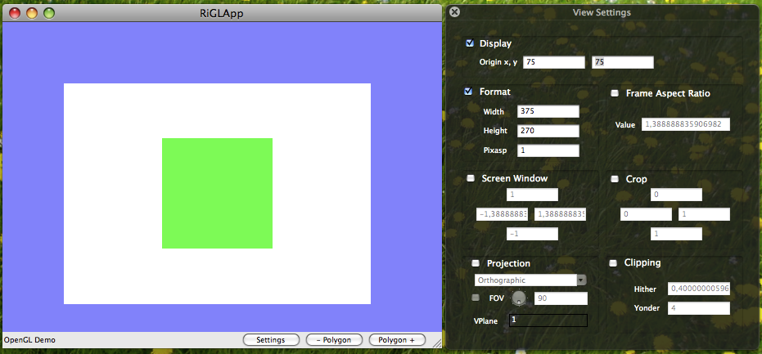Screenshot 3.5: Origin set, fixed format
The frame aspect ratio can be used to set a fixed aspect ratio of the frame. Pixels on the right or bottom can be left blank if the frame with the given aspect ratio does not fit into the display, but no distortion occurs.
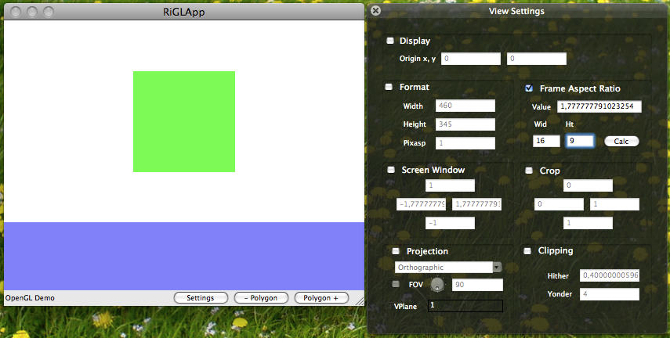Screenshot 3.6: Frame aspect of 16/9, bottom left blank
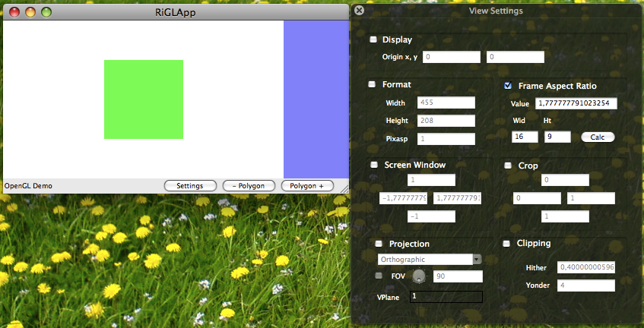Screenshot 3.7: Frame aspect of 16/9, right left blank
If the screen window coordinates are fixed and the ratio of the screen window does not match the frame aspect ratio, distortion occurs.
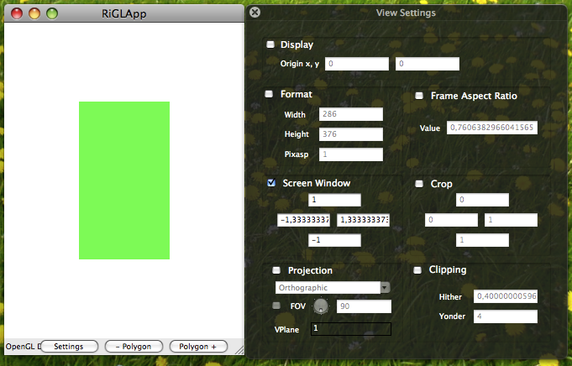Screenshot 3.8: Fixed screen coordinates do not match frame aspect ratio
The crop window coordinates are set in NDC. If the left coordinate has the same value as the right of another otherwise equal frame (or the top coordinate of one frame is the same as the bottom of another frame), the frames will fit seamlessly at the cropped edge and fit within the frame coordinates.
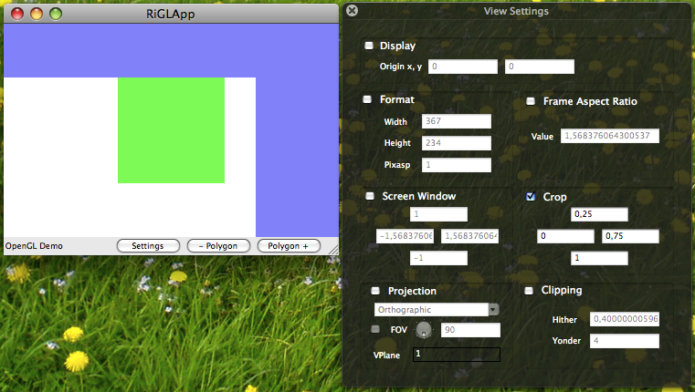Screenshot 3.9: Crop window
The field of view (fov) angle of the perspective projection can be used to move the viewing plane nearer and farer away from the view point. The fov angle is used to calculate a 1 by 1 square on the view plane – so if fov is smaller the view plane is moved away (looks like seen through a tele objective), if it is larger, the view plane is moved nearer to the view point (looks like seen through a wide angle objective). The screen window visible on the frame lies on that view plane. The default value is 90 degree, the view plane is 1 unit away from the eye point. Coordinates on the view plane are not changed by the projection.
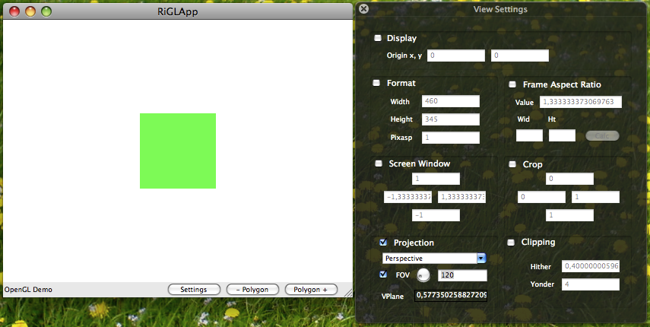Screenshot 3.10: Wide angle, zoom out, fov of 120 degree
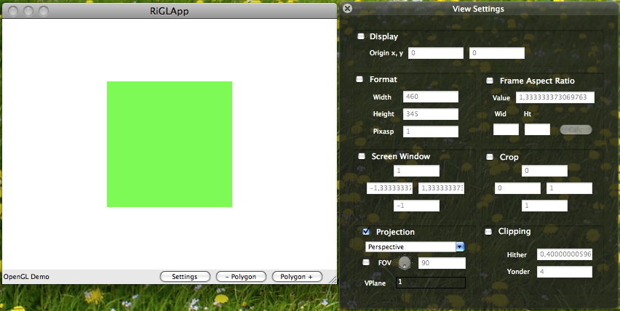Screenshot 3.11: Perspective projection 90 degree fov
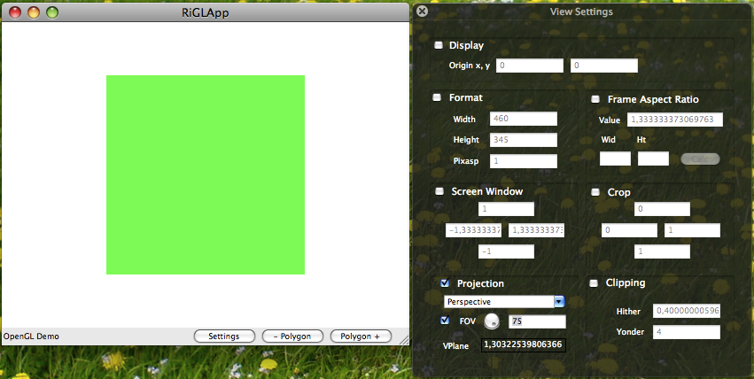Screenshot 3.12: Small angle, zoom in, fov of 75 degree
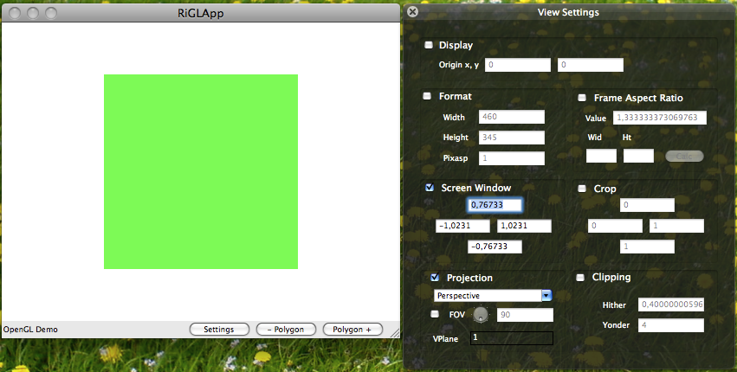Screenshot 3.13: Screen window made smaller, same as fov 75 (top' = tan(fov/2) top)
The square polygon of the sample is 1 unit away from the camera and lies on the view plane if the fov has the value of 90. So the square looks the same at 90 degree perspective and orthographic projection for the same screen window. Shrinking the screen window appropriately and letting the fov unchanged can have the same effect as making the fov smaller. Enlarging the screen window has the same effect as making the fov bigger. Changing the screen window is more general as changing the fov, because the viewpoint can be moved out of the center. To avoid distortion the screen coordinates have to match the frame aspect ratio.

Implementation of RiTransformPoints and RiCoordSysTransform
RiTransformPoints can be used to transform points from one named space given by it's matrix to another. The division by the homogeneous coordinate is applied if necessary. The main spaces can be accessed via their names: RI_CURRENT (current space, when call is applied), RI_WORLD, RI_CAMERA, RI_SCREEN, RI_NDC, RI_RASTER. The implementation first builds a composite matrix that transforms from one space to the other, then applies the matrix to the given positions (1 as homogeneous coordinate) and doing the homogeneous division finally. Therefore, vectors can in general not be transformed using RiTransformPoints.
The composite matrix is build by using the appropriate matrices (or inverse matrices) that transfer from one space to another. RiTransformPoints can be used within world blocks only, because RiWorldBegin sets up the spaces.
Figure 5: Spaces
Current
World
Camera
Screen
NDC
Raster
From
To
RI_CURRENT ==
RI_WORLD
RI_CAMERA
RI_Screen
RI_NDC
RI_RASTER
„To“
„From“
In the last figure, space “To” was marked by RiCoordinateSystem(“To”) in camera space, “From” was marked in world space. To transform from “From” to “To”, a matrix: “From” × RI_CAMERA × InverseMatrix(“To”) is used.
In RiCoordSysTransform a composite matrix is build and premultiplied. You start always in the current coordinates system. Say, you issue a RiCoordinateSystem(“To”). A matrix is build to transforms from “To” to the current coordinate system ( “To” × InverseMatrix(RI_CAMERA) × InverseMatrix(RI_CURRENT)) and is premultiplied to the CTM (that results CTM = “To” × InverseMatrix(RI_CAMERA)). You can use coordinates local to “To” after this call. If the coordinate system you want to change to lies in the same space as the current coordinate system, the stored transformation matrix of the destination system is just used as new transformation matrix. If RiCoordinateSystem transforms to the space of the current coordinate system (like RiCoordinateSystem(RI_WORLD) in a world block), the identity matrix is used as new CTM. Transformations to the same coordinate system RiCoordinateSystem(RI_CURRENT) has no effect.

Orientation of Coordinate Systems and Primitives
The distinction between the current orientation (the orientation of primitives, the default is left handed, clockwise winding, but it can be changed by RiOrientation) and the orientation (or handedness) of the current coordinate system (initially the left handed camera coordinate system is taken, but it can be swapped by negative scalings, i.e. a negative determinant of the corresponding transformation matrix) must be considered. If the camera coordinate system is RH, the world coordinate system must also be initially marked as RH.
The current orientation can be used to define whereto the normals of surface positions point. Normals are calculated using a left hand rule, opposite normals are calculated by a right hand rule. Normals can either point to the outside RiOrientation(RI_OUTSIDE) direction (the current orientation is set to match the orientation of the current coordinate system, that's the initial state) or to the inside RiOrientation(RI_INSIDE) (the current orientation is set to the opposite of the orientation of the current coordinate system) of a surface or solid (mind the solid operation RI_DIFFERENCE, the orientation of the surface that is subtracted must be flipped). If you know the winding of a surface (say a polygon), you can set the current orientation either explicitly to be left handed RI_LH or to be right handed RI_RH. The handedness of the current orientation can be flipped by calling RiReverseOrientation. The system maintains the orientation of the current coordinate system. Whenever the orientation of the coordinate system flips by a transformation, the current orientation is flipped also (it's normal will point to the opposite direction): If the current orientation and the orientation of the current coordinate system are of opposite handedness, the normal of a surface must point to the opposite direction as specified with RiOrientation.

 | Coordinate systems orientation is LH | Coordinate systems orientation is RH
Current orientation is LH | Normals taken as current normals | Opposite normals taken as current normals
Current orientation is RH | Opposite normals taken as current normals | Normals taken as current normals

The current normals have impact to surface culling (if RiSides(1) is set, surfaces having their current normals point away from the camera will be culled) and shading.

Literature
- Pixar Animation Studios, Pixar's RenderMan User's Manual https://renderman.pixar.com/forum/docs/RfM_1.0/RenderMan_Manual/users_guide/index.php
- Pixar Animation Studios, PhotoRealistic RenderMan Application Note #10, The Viewing Transformation https://renderman.pixar.com/forum/docs/RfM_1.0/RenderMan_Manual/AppNotes/appnote.10.php
- Upstill, Steve: The RenderMan Companion, Addison-Wesley Professional, 1990, ISBN 978-0201508680
- Apodaca, Anthony A.; Gritz, Larry: Advanced RenderMan, Morgan Kaufmann, 1999, ISBN 978-1558606180
- Raghavachary, Saty: Rendering for Beginners, Focal Press, 2004, ISBN 978-0240519357

RiCPP makes use of two additional optional parameters "dispxres" (display x-resolution), "dispyres" (display y-resolution), and "pixelaspect" (pixel aspect ratio of the display). These parameters can be used for RiDisplay to set the current physical sizes of the display. The OpenGL renderer needs to know the current sizes of a visual.
The aspect ratio is the width divided by the height of a rectangle.

