Triangulation of Polygons
Memo for RiCPP, Andreas Pidde, 23th April 2008

There are four interface functions included in the RenderMan interface to describe polygons: RiPolygon (single simple, planar convex polygon), RiGeneralPolygon (single planar polygon with holes, maybe concave), RiPointsPolygons (polyhedra consisting of simple, planar, convex polygons), and RiPointsGeneralPolygons (polyhedra, consisting of planar polygons with holes). Polygons generated by RiPointsGeneralPolygons are in the most general form. They can be seen as a collection of polygons generated by a number of RiGeneralPolygon calls using shared vertices.
Because the triangulation of polygons is needed by some parts of the framework, a functionability for the triangulation of RiGeneralPolygon primitives is included in RiCPP. This triangulation can be used by all polygon interface functions, albeit simple convex polygons may be triangulated in an easier straight forward way.
The “P” parameters are used for position information in object space. All positions are assumed to lie within the same plane and no self intersecting edges or degenerated vertices are considered (only simple polygons are allowed). As given by the RenderMan RiGeneralPolygon interface call, one polygonal outline having a number of holes can be handled. The implementation of RiPointsGeneralPolygons can use the triangulation by multiple calls. The “facevarying” parameters have to be considered because they have a different layout than the “varying” parameters. These different indices are managed by introducing a further indirection for vertex numbers serving as output. The first indirection contains the indices for “facevarying” parameters. The “varying” parameters can be accessed by using these indices for indirect vertex indices (as indices for the vertices parameter of the RiPointsGeneralPolygons and RiPointsPolygons call). Btw. the array for vertex indices of RiPointsGeneralPolygons has the same layout as “facevarying” parameters. Because of this, for a possible OpenGL output, the RiPoints(General)Polygons varying parameters need to be copied (and get duplicated) later by RiCPP, if a polygon contains also “facevarying” variables.
The orientation of the current coordinate system and the current orientation need to be considered for the winding and the normal vector of a polygon. If looking from the camera onto the polygon and the current orientation is left handed, polygons having a clockwise winding are rendered with a normal pointing towards the camera (see also the RiSpec on RiPolygon).
The triangulation is done by using an ear clipping algorithm (see David Eberly, Triangulation by Ear Clipping, 2008 in http://www.geometrictools.com/). There were a small number of steps needed to be done:
- Build a double linked list of vertex indices
- Extract the 2D coordinates of the 3D positions
- Get the orientation of the outer polygon (border)
- Get the orientation of the holes, need to be the opposite of the border, swap as needed
- Integrate the holes into the border by adding bridge edges from the border to the hole and back to the border.
- Triangulate by ear clipping (clip most pointed vertices first, ...as an heuristic)

Implementation
CTriangulatedPolygon is used as container for a triangulated polygon, it can use a CEarClipper object for the triangulation. The classes can be found in the polygon.h.cpp files of the ricontext module. Testpoly is a simple test program with PostScript output.
To initialize the triangulation a container and a triangulation strategy are needed, this can be achived by:
// Initializing the triangulation
CEarClipper earClipper;
CTriangulatedPolygon poly(earClipper);

The calling of the triangulation is straight forward and the container can be reused. The resulting indices of the triangles can be found in CTriangulatedPolygon::triangles(), and the size of this vector is always a multiple of three. The triangles have always the same winding as the outer polygon has.
void poly(CTriangulatedPolygon &poly)
{
RtFloat p[] = {
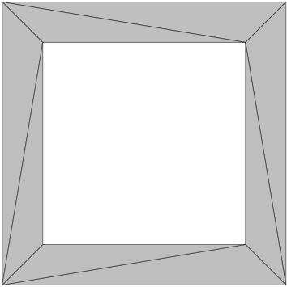Figure 1: Triangulated polygon
// outer
1, 1, 0, // 0
1, 8, 0, // 1
8, 8, 0, // 2
8, 1, 0, // 3

// inner (hole)
2, 2, 0, // 4
2, 7, 0, // 5
7, 7, 0, // 6
7, 2, 0, // 7
};

RtInt loops[] = {
4, 4
};

RtInt verts[] = {
3, 2, 1, 0,
4, 5, 6, 7
};

poly.triangulate(sizeof(loops)/sizeof(loops[0]), loops, verts, p);
// The result is in poly.triangles(), size is always a multiple of 3

// Positions can be extracted by
const std::vector<unsigned long> &triangles = poly.triangles();
std::vector<unsigned long>::const_iterator iter = triangles.begin();

float x[3], y[3], z[3];
while ( iter != triangles.end() ) {
// First position of the triangle
x[0] = p[verts[*iter]*3];
y[0] = p[verts[*iter]*3+1];
z[0] = p[verts[*iter]*3+2];
++iter;

// Second position
x[1] = p[verts[*iter]*3];
y[1] = p[verts[*iter]*3+1];
z[1] = p[verts[*iter]*3+2];
++iter;

// Third position
x[2] = p[verts[*iter]*3];
y[2] = p[verts[*iter]*3+1];
z[2] = p[verts[*iter]*3+2];
++iter;

// Do something with the triangle
}
}

Samples
The following two samples are copied out of the test program.

RtFloat p[] = {
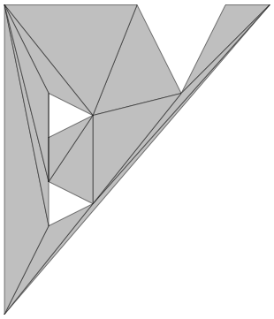Figure 2: Concave polygon with holes
// outer
1, 1, 0, // 0
1, 8, 0, // 1
4, 8, 0, // 2
5, 6, 0, // 3
6, 8, 0, // 4
7, 8, 0, // 5

// inner (hole)
2, 5, 0, // 6
2, 6, 0, // 7
3, 5.5, 0, // 8

// inner (hole)
2, 3, 0, // 9
2, 4, 0, // 10
3, 3.5, 0 // 11
};

RtInt loops[] = {
6,
3,
3
};

RtInt verts[] = {
0, 1, 2, 3, 4, 5,
6, 7, 8,
9, 10, 11,
};

The data for next sample is copied from Joseph O'Rourke's Computational Geometry in C.
RtFloat p[] = {
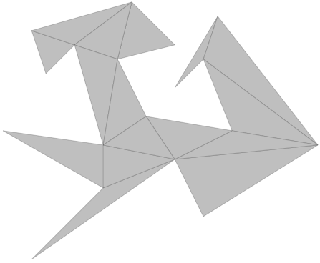Figure 3: O'Rourke's polygon
// outer
0, 0, 0, // 0
10, 7, 0, // 1
12, 3, 0, // 2
20, 8, 0, // 3
13, 17, 0, // 4
10, 12, 0, // 5
12, 14, 0, // 6
14, 9, 0, // 7
8, 10, 0, // 8
6, 14, 0, // 9
10, 15, 0, // 10
7, 18, 0, // 11
0, 16, 0, // 12
1, 13, 0, // 13
3, 15, 0, // 14
5, 8, 0, // 15
-2, 9, 0, // 16
5, 5, 0 // 17
};

RtInt loops[] = {
18
};

RtInt verts[] = {
0, 1, 2, 3, 4,
5, 6, 7, 8, 9,
10, 11, 12, 13, 14,
15, 16, 17
};

