Execution was done with CMD, execute the server program first, then the client

Execute the server program with command: java saulsa2p1server

Execute the client program with command: java saulsa2p1client

Output of server program:

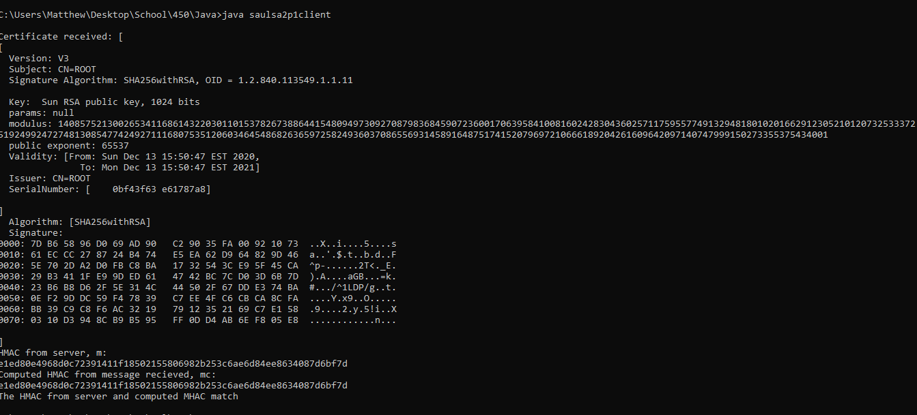

Output of client program:

