

Pneumonia Detection Using Machine Learning and Deep Learning

Annex with full metrics + confusion matrices

Epitech Paris

Group 29

Confusion Matrix - Logistic Regression

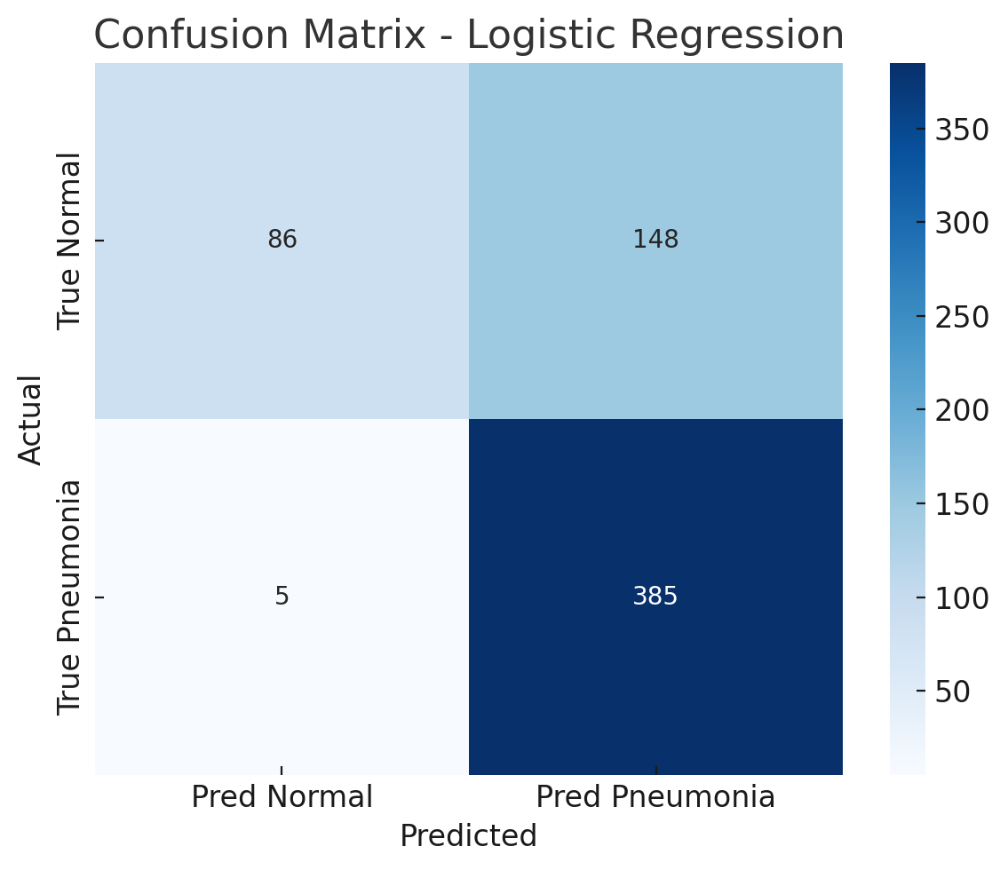

Confusion Matrix - SVM (PCA)

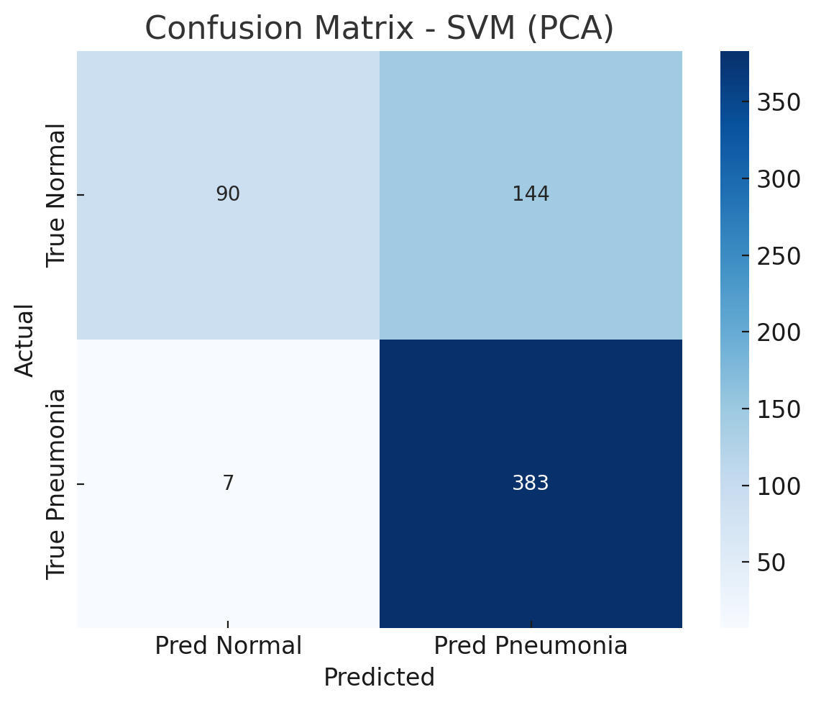

Confusion Matrix – CNN

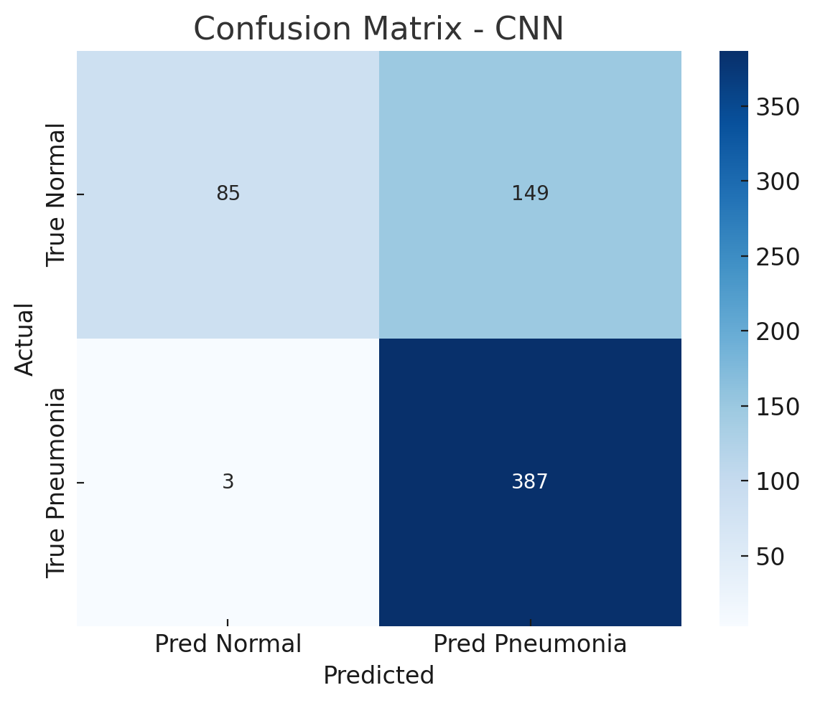

🧾 Annex
In this annex, we detail the performance metrics of all tested models with a focus on confusion matrices, which reveal how models behave on true vs. predicted classes. This is especially critical in medical diagnosis, where false negatives (missed pneumonia cases) must be minimized.

🔹 Logistic Regression (Tuned via GridSearch + Cross-Validation)
The logistic regression model, after being fine-tuned with a grid search over the regularization parameter C, showed strong recall for pneumonia cases. On the test set:
- It correctly classified 385 pneumonia images and only missed 5 (false negatives), which is excellent in terms of medical safety.
- However, it misclassified 148 normal images as pneumonia, leading to a relatively high number of false positives.
- This behavior reflects a conservative model that prefers to err on the side of caution predicting pneumonia more often, even at the cost of mistakenly flagging healthy cases.
Such a tendency is generally acceptable in medical applications, where catching every potential pneumonia case is often prioritized.

🔹 Support Vector Machine (SVM) with PCA
After applying Principal Component Analysis (PCA) to reduce the feature dimensionality from 16,384 to 100 components, a linear SVM model was trained.
- On the test set, the SVM correctly identified 383 pneumonia cases and misclassified 7, showing only slightly more false negatives than logistic regression.
- It improved a bit in classifying normal cases compared to logistic regression, reducing false positives from 148 to 144.
This version of SVM offered a more balanced trade-off between sensitivity and specificity, benefiting from the dimensionality reduction that helped avoid overfitting.

🔹 Convolutional Neural Network (CNN)
The CNN was the most advanced model used and achieved the strongest performance overall:
- It correctly classified 387 pneumonia cases and made only 3 false negatives, which is the lowest miss rate across all models.
- It also misclassified 149 normal cases as pneumonia, similar to logistic regression.
The CNN demonstrated excellent discrimination ability with a high AUC score and the best F1 score. Its architecture allowed it to capture complex spatial patterns in X-ray images, which classical models could not.

💡 Interpretation
These confusion matrix results highlight key trade-offs:
- Logistic Regression: prioritizes recall (low false negatives), but with more false positives.
- SVM + PCA: offers a slightly more balanced classification, performing well under reduced feature space.
- CNN: delivers the best recall and overall performance, especially suitable for deployment in a clinical setting.

In high-risk domains like medicine, minimizing false negatives (missed pneumonia cases) is critical. Hence, even if CNN and logistic regression produce more false alarms, their medical value remains high.



