

🩺 Final Report
Pneumonia Detection Using Machine Learning and Deep Learning

Epitech Paris

Group 29

1. Introduction
This project focuses on automating pneumonia detection from chest X-ray images using both classical machine learning and deep learning techniques. The goal is to evaluate various approaches, understand their strengths, and build a system that is both performant and interpretable, a key concern in medical AI.
The dataset is structured into three parts:
- train/ → used for training models
- val/ → used initially for tuning, but replaced by cross-validation
- test/ → held out for final evaluation
Each subset contains two classes:
- NORMAL (healthy patients)
- PNEUMONIA (infected patients)

2. Dataset Overview
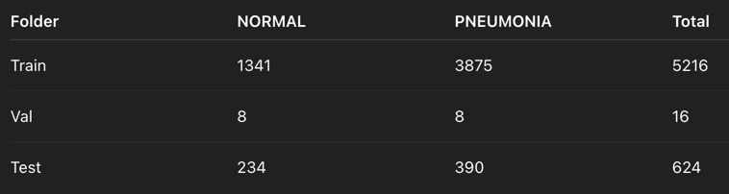
⚠️ Imbalance Warning:
The dataset has many more pneumonia cases than normal, which could lead to biased models. This is mitigated by:
- Using F1 Score and AUC instead of just accuracy
- Leveraging class weights or resampling where needed
⚠️ Validation Set Note:
Due to the tiny size of the validation set, it was not used for tuning. Instead, we employed cross-validation, which better stabilizes evaluation and hyperparameter tuning.

3. Preprocessing Pipeline
To make data ML-ready:
- 🧪 Grayscale: All images were converted to grayscale to simplify computation
- 📏 Resize: Resized to 128×128 pixels for uniformity
- 📉 Normalization: Pixel values scaled to range [0,1]
- 📦 Structured into:
  - X_train, y_train
  - X_val, y_val
  - X_test, y_test
For classical ML, images were flattened to 1D vectors (16,384 features).
For CNN, they retained their 3D shape: (128, 128, 1).

4. Core ML Concepts Applied
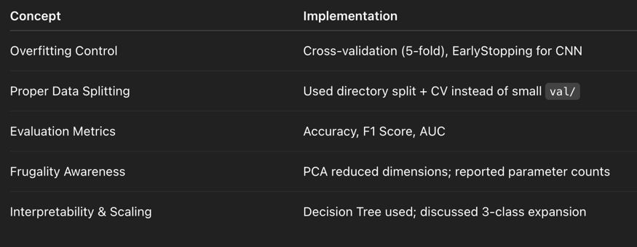

5. Classical Machine Learning Models

🔹 Logistic Regression (Baseline)
- Flattened images to 16,384 features
- Used GridSearchCV with StratifiedKFold(n_splits=5)
- Scoring metric: F1 Score
- Class weights = 'balanced' to handle imbalance
Best Parameters: C = 1
Performance on Test Set:
- Accuracy: 75.5%
- F1 Score: 83.4%
- AUC Score: 90.4%

🔹 Decision Tree
- max_depth=10
- Simple and interpretable
Performance:
- Accuracy: 71.9%
- F1 Score: 81.0%
- AUC Score: 53.9%

🔹 SVM with PCA
To avoid overfitting and accelerate training:
- Used PCA to reduce from 16,384 → 100 components
- Explained ~95% of variance
- Used linear SVM with C=1
Test Performance:
- Accuracy: 73.5%
- F1 Score: 82.3%
- AUC Score: 88.8%

6. PCA – Dimensionality Reduction Justification

Why PCA?
- ✅ End-to-End Result: Improved F1 and AUC, reduced training time
- ✅ Variance Explained: First 100 components captured ~95% variance
- ✅ Frugality: From 16,384 → 100 features → reduced model complexity

Model Complexity Notes

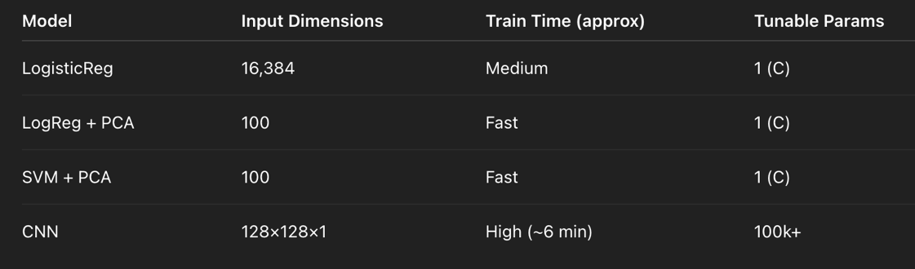

7. Deep Learning – Convolutional Neural Network (CNN)

📐 Architecture
Conv2D(32) → MaxPool → Conv2D(64) → MaxPool → Flatten → Dense(128) → Dropout → Output(2)
- Activation: ReLU
- Output: Softmax (2 classes)
- Optimizer: Adam
- Loss: Categorical Crossentropy
- EarlyStopping (patience=3)

🧪 Evaluation (Test Set)
- Accuracy: 80.4%
- F1 Score: 86.3%
- AUC Score: 93.1%
✅ Best performing model overall
✅ Balanced recall/precision, critical in healthcare
✅ EarlyStopping controlled overfitting

8. SOM – Self-Organizing Map Visualization
To interpret representations, we used:
- PCA (→ 50 components)
- MiniSom (10×10 grid)
- Color-coded markers:
  - 🔵 Circle = NORMAL
  - 🔴 Square = PNEUMONIA

Results
- Clear class separation
- Confirms models are learning separable features
- Adds interpretability to PCA+ML pipeline

9. Simulated 3-Class Classification (Bonus)
Although dataset is binary, we explored how to scale to 3 classes:
- Modified CNN to output 3 neurons (softmax)
- Adjusted loss to categorical crossentropy
- Used macro F1 and 3×3 confusion matrix
- Suggested datasets: COVIDx, ChestX-ray14

10. Model Comparison Summary
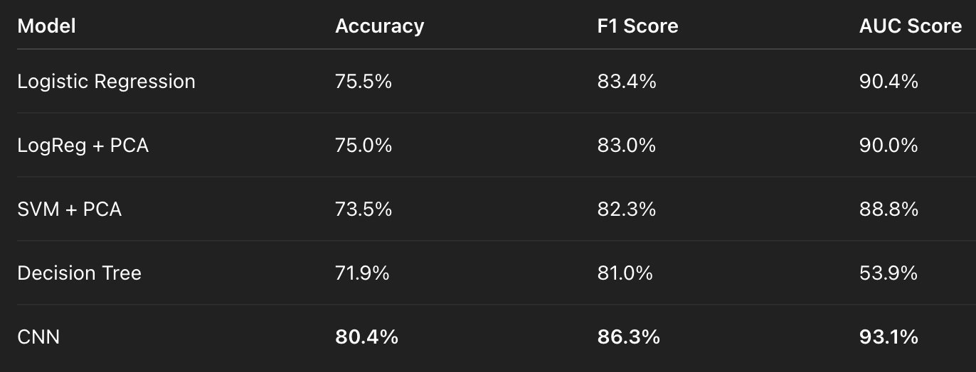

11. Conclusion
This project demonstrated the full pipeline for AI-based medical image classification. We:
- Built strong baselines with Logistic Regression and SVM
- Applied PCA for dimensionality reduction and frugality
- Trained a robust CNN showing superior performance
- Visualized high-dimensional features via SOM
- Simulated expansion to multi-class diagnosis
- Applied cross-validation, tuning, and interpretable methods throughout
✅ The CNN is recommended for deployment, while PCA-based models serve as lightweight, explainable alternatives, all rooted in sound ML principles.



