GrantMinded: A Grant Identification Prototype

Sarah Gothard
sg5941@g.rit.edu

Abstract— Nonprofit organizations face increasing difficulty identifying relevant funding opportunities as millions compete for grants across a fragmented and heterogeneous online ecosystem. Grant information is dispersed across thousands of websites with inconsistent structure and terminology, making systematic discovery resource-intensive and costly. This paper presents GrantMinded, an automated grant-identification system that integrates classical web-scraping techniques, logistic-regression filtering, keyword and cosine-similarity thresholds, and a final Support Vector Machine (SVM) relevance model. The system was tuned to the mission of the I-CONNECT Foundation as an applied case study. Results show that GrantMinded improves enrichment of mission-aligned opportunities by approximately 30×, reducing the effort required from roughly 36 pages reviewed per relevant opportunity to approximately two. These findings demonstrate that GrantMinded provides an effective, scalable approach for navigating the unstandardized grant landscape and reducing the operational burden of funding discovery for nonprofits.
Keywords—funding, web-scrape, efficiency, grants

Introduction
The nonprofit sector in the United States includes more than two million organizations competing for limited funding. For most of these organizations, grants are a core component of financial sustainability. Yet despite this dependence, finding grants is surprisingly difficult.

The process is time-consuming and often requires dedicated, costly staff effort. Grant information is dispersed across thousands of government portals, foundation websites, and corporate giving pages, each using different terminology and formatting. With no standardization, even basic patterned searches become challenging.

Paid tools such as GrantPortal or GrantStation may seem affordable, but they remain out of reach for many small and mid-sized nonprofits operating in an increasingly competitive funding climate.

Compounding the challenge, each funder has highly specific interests, making it difficult to quickly determine whether an opportunity is truly aligned with a nonprofit’s mission. This fragmented landscape turns the simple task of identifying funding into a laborious and expensive process.

These barriers highlight a clear gap: the need for open-source, intuitive tools for grant identification that can be tailored to a nonprofit’s specific mission. Addressing this gap has the potential to support entire communities while mitigating costs.

In response, we developed a prototype web-scraping and filtering pipeline to test whether an automated, mission-aware grant-seeking system could accelerate funding discovery. The pipeline conducts targeted website crawls or general web searches, applies lightweight machine-learning filters, and then scores pages using both mission-specific keyword matching and cosine similarity. A final relevance model filters remaining pages, producing a concise, searchable output that nonprofit staff can use to quickly identify high-quality opportunities [Fig. 1].

FIGURE 1 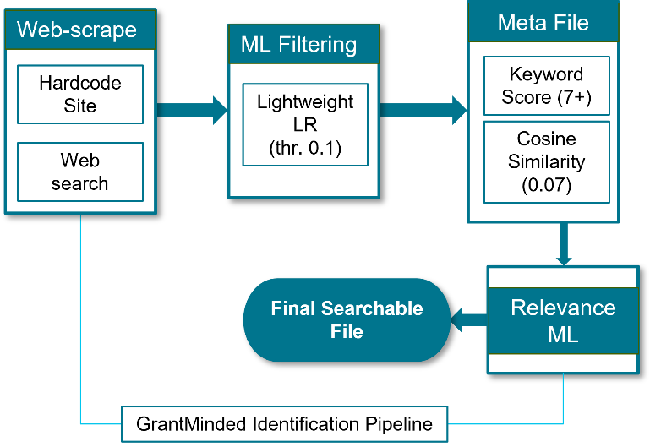

- GrantMinded Structure - The four stage filtering pipeline that internally drive the GrantMinded application. A webscraper (general or site specific) feeds a logistic regression filter whose output feeds a keyword score and cosine filter, which then feeds subset of pages into a SVM model filter. The final output is a searchable file to be used in easy grant discovery for nonprofts.

For this feasibility experiment, we tuned the system to the I-CONNECT Foundation mission, which reads:

“The I-CONNECT Foundation aims t0 serve the older population by connecting socially isolated older adults to our community; help enhance quality of life by providing social connections via technology; and promote brain health through meaningful conversations”.

PRIOR WORK
A. Nonprofit funding structures and strategy. Nonprofit sustainability depends on deliberate choices about funding models rather than ad-hoc grant chasing. Foster, Kim, and Christiansen identify ten distinct nonprofit funding models and argue that clarity around these models improves long-term viability and strategic focus [3]. Complementing this, Jegers integrates portfolio theory with nonprofit specifics and shows that diversification can sometimes increase, rather than reduce, risk when crowding effects exist among sources. This suggests that optimal funding portfolios vary by context and must account for each organization’s goals and the interactions among revenue streams [4].

B. Information retrieval for nonprofit matching and grant discovery. Traditional tools in this domain (e.g., IRS-990 explorers) are largely keyword-based and not mission-aware. ANGEL builds on the ColBERT retrieval model and incorporates enhancements such as syntax-aware local attention and pseudo-relevance feedback, trained on MSMARCO and evaluated on a curated nonprofit dataset. It relies on structured IRS-990 data and APIs to build a nonprofit search database, requiring technical expertise and infrastructure for use. While ANGEL demonstrates sizable gains over strong baselines (e.g., +0.14 MAP@10, +0.16 MRR@10), its implementation remains most accessible to research teams or well-resourced organizations [6].

In contrast, GrantMinded aims to make grant discovery more accessible to small and mid-sized nonprofits by scraping publicly available government, foundation, and corporate funding pages. This lowers barriers to entry, allowing nontechnical staff to benefit from automated retrieval, filtering, and ranking of live grant opportunities [6].

METHODOLOGY
Development of the GrantMinded application proceeded through four primary stages:
- Web scraping and corpus construction (stage 0)
- Grant/Not-Grant machine-learning filter (stage 1)
- Lightweight mission-relevance filter (stage 2)
- Final relevance machine-learning filter (stage 3)

Stages 0-2 were developed in parallel with the creation of two corpus datasets:

Initial corpus: A broad, unfiltered collection of webpages captured during early scraping. Each page was annotated with a keyword-based mission score and a cosine similarity score derived from predefined keyword weights and text embeddings based on I-CONNECT’s mission (described in mission-relevance and webscraper sections).

Final corpus: The refined and final dataset produced after applying Stages 0–2 (web scraping, grant detection, and lightweight relevance filtering).

Both corpus generations produced a meta-level CSV file containing the URL, a unique document identifier (also used as the filename in the text and HTML archives), the keyword score, the cosine similarity score, the list of matched keywords, a short content snippet, and several placeholder fields such as “relevance_label,” “grant_yesno,” and “label_exp” that were reserved for manual annotation and model labeling.

Manual labeling of grant status and mission relevance was conducted after each corpus was generated. Each corpus was capped at 1000 entries, and all 1000 entries were manually reviewed. Mission relevance was coded as 1 or 0, with 1 indicating relevance to the I-CONNECT Foundation mission and 0 indicating irrelevance. Grant status was coded as “grant” for true funding opportunities and “not a grant” for all other page types. For pages judged irrelevant or not grants, brief explanatory notes were added to the “label_exp” field, including descriptors such as “landing-page,” “relevance,” and “article.”

The Webscraper (Stage 0). The web-scraper was implemented in Python using standard web-scraping and data-processing libraries (BeautifulSoup, urllib, scikit-learn). The crawler followed hyperlinks to a predefined depth of 4 and operated using two complementary strategies:

Static-seed crawling: We crawled a set of known funding pages where I-CONNECT Foundation had previously identified successful or mission-aligned opportunities.

General web search crawling (Stage 0): We performed browser-style search queries through Google, Yahoo, and DuckDuckGo, using mission-aligned phrases such as: “aging nonprofit funding,” “community isolation grant 501(c)(3),” and “social isolation grant.”

All discovered URLs were retained in the initial corpus at a text file and html file.

Each scraped page was assigned a mission keyword score based on a weighted dictionary developed with I-CONNECT Foundation leadership. Terms aligned with I-CONNECT’s mission (e.g., aging, dementia, isolation, Alzheimer's) were weighted at 3 points. Additional domain terms such as telehealth were weighted at 2, while nonprofit-specific terms like “501(c)(3)” were assigned 3 points. Core grant-language terms (e.g., grant = 4, funding = 3) were included to anchor general funding context. The maximum possible keyword score was 24.

We also computed a cosine similarity score between the text of each scraped page and a reference mission text derived from the I-CONNECT Foundation mission statement and language from previously successful funders. To do this, page text and reference text were tokenized, lowercased, stripped of stopwords, and converted into TF-IDF vectors using a lightweight scikit-learn vectorizer. Cosine similarity was then calculated between these TF-IDF representations to produce an embedding-based measure of semantic alignment.

This version of the webscraper was then used to generate the initial corpus with an output of the text and html files and the meta CSV file. Importantly, no filtering occurred during creation of the initial corpus. All pages, regardless of relevance, were included so that empirical thresholding analyses could later determine optimal cut-points for keyword and cosine similarity filtering and grant identification modeling.

Grant Page Identifcation Filter (Stage 1): Using the initial unfiltered corpus and the manually assigned “grant_yesno” labels, we developed a classifier to determine whether a crawled page represented a true grant opportunity. Two classical machine-learning approaches were evaluated: Logistic Regression and Naïve Bayes. All page text was preprocessed through a lightweight natural-language pipeline that lowercased the text, tokenized it, removed English stopwords, and converted it into TF-IDF unigram vectors using scikit-learn. These vectors served as input features for both models.

Because true grants were rare in the initial corpus, we used a training and testing split that emphasized signal clarity during training while preserving real-world conditions during evaluation. We constructed a small, balanced training set consisting of 60 positive (grant) pages and 164 negative (not-grant) pages, for a total of 224 documents. This downsampling was necessary to prevent the model from being overwhelmed by the large number of irrelevant pages, which would obscure the linguistic patterns distinguishing grant opportunities. The remaining approximately 800 documents formed the test set and retained the natural class imbalance.

Training on the balanced subset provided a clean learning signal, while evaluating on the large, imbalanced test set allowed us to assess performance under realistic conditions in which true grants are rare. Using this setup, we trained lightweight classifiers for grant versus non-grant detection and compared the Naïve Bayes and Logistic Regression models using recall and F1 scores as the primary evaluation metrics.

The best-performing model was then integrated into the web-scraping pipeline as the first filtering layer, using its selected performance metrics and the optimally tuned decision threshold.

Keyword Score and Cosine Similarity Thresholding (Stage 2): Using the initial unfiltered corpus, we evaluated how well the keyword score and cosine similarity measures predicted mission relevance. We conducted Welch’s t-tests to compare the distributions of these features between relevant and irrelevant pages, and we fit two-parameter logistic regression models to assess their independent associations with the binary “is_relevant” label.

Based on these empirical analyses, we selected slightly conservative thresholds, relative to the observed group means, and integrated them into the web-scraping pipeline as a lightweight second-stage relevance filter.

With these layering techniques in place, we re-ran the improved GrantMinded application to generate the final corpus.

Relevance modeling (Stage 3): For the final stage of mission relevance modeling, we transformed the full corpus using TF-IDF vectorization. The vectorizer automatically tokenized each document, lowercased the text, removed English stopwords, and represented the content using both unigrams and bigrams. Including bigrams allowed the model to capture mission-relevant phrases such as “older adults” and “social isolation.” TF-IDF weighting downweighted terms that appeared frequently across documents, preventing common words such as grant or program from dominating the feature space simply due to frequency. The vocabulary was capped at the 5,000 most informative features, with no minimum document-frequency threshold, allowing rare but meaningful terms to remain if they contributed valuable signal. This produced a clean, high-dimensional representation of the text prior to machine learning.

Because most scraped funding pages are not aligned with the I-CONNECT Foundation mission, we intentionally preserved the natural class imbalance when constructing the relevance-modeling dataset. The training set contained 725 documents, of which only 20 were labeled as mission-aligned. The test set contained 288 documents, with only 8 relevant items. Maintaining this real-world imbalance avoided artificially inflating performance or creating a training environment that would not reflect deployment conditions. Preserving rarity ensured that models were forced to learn the subtle linguistic cues that distinguish truly mission-aligned opportunities from generic grant pages.

We evaluated three classical supervised-learning algorithms for relevance classification: Naïve Bayes, Logistic Regression, and Support Vector Machines; using their standard implementations in the scikit-learn library. Naïve Bayes and Logistic Regression served as strong, interpretable baselines commonly used in natural-language processing tasks, while SVMs were included for their strong performance in high-dimensional TF-IDF spaces and their ability to learn separating boundaries when positive examples are extremely rare.

Because mission-aligned grants represent a very small fraction of the corpus, we applied class_weight="balanced" to the Logistic Regression and SVM models. This weighting scheme increases the penalty for misclassifying relevant pages and prevents the models from collapsing into predicting “not relevant” for all documents. Using balanced weighting ensured that these classifiers remained sensitive to the rare positive cases the GrantMinded pipeline is designed to identify.

Model performance was assessed using five-fold stratified cross-validation. Stratification ensured that each fold preserved the same level of class imbalance as the full corpus. In each iteration, the model was trained on four folds and validated on the remaining fold, and performance metrics were averaged across all five cycles. Precision, recall, and F1 score served as the primary evaluation metrics, as they are more informative than accuracy in highly imbalanced settings. This cross-validated evaluation provided stable, realistic estimates of model performance and supported the selection of the best-performing algorithm for integration into the GrantMinded pipeline as the final relevance-filtering layer.

We saved two components for deployment in the GrantMinded application: the svm_vectorizer, which converts any new webpage into the TF-IDF feature space, and the trained svm_clf model, which classifies whether a page is relevant to the foundation.

This pair powers the mission-relevance stage of the GrantMinded pipeline, and is the driving and final filter in the application.

Beta Deployment: The optimized three-layer filtering system was integrated into the webscraper and used to generate a prototype searchable document intended for foundation-facing use. Beta testing occurred in two cycles. The first cycle applied the GrantMinded application to three websites that had historically provided mission-aligned grant opportunities for the I-CONNECT Foundation. The second cycle expanded deployment to include both general web searches and known “friendly” sites.

For both beta cycles, the output was capped at 300 candidate grant opportunities. The resulting document included source URLs, brief content snippets, keyword scores, and cosine-similarity values for each retained page. All entries produced during beta deployment were manually reviewed to assess mission relevance for the foundation.

Baseline Metrics: Baseline metrics were obtained from interviews and internal documentation provided by I-CONNECT Foundation leadership. These metrics characterized the foundation’s previous grant-discovery workflow, including typical search protocols, the approximate time spent on grant discovery in the prior year, and the number of mission-aligned opportunities identified as viable candidates for application. These baseline values were used as a reference point and compared to the outputs of the GrantMinded system using descriptive statistics to evaluate improvement in discovery efficiency and mission alignment.

The reported I-CONNECT Foundation funding strategies included dedicated staff time and a multimodal strategy that included solicitation campaigns, manual web searches, and network outreach.

Although this work accounted for only roughly 10% of the foundation’s budget, much of the true cost was hidden in volunteer staff time and executive networking behind the scenes. These traditional efforts identified only three grants relevant to the I-CONNECT mission in the year prior to this project.

We compared the number and rate of mission-aligned grants identified through the traditional workflow to those identified by the GrantMinded pipeline. This comparison used simple descriptive statistics with counts and proportion, and fold-change enrichment metrics to quantify the improvement in discovery efficiency.

RESULTS
Initial Corpus and Webscraper (Stage 0): Stage 0 of the web-scraping process produced an initial corpus of approximately 1,000 pages, accompanied by a metadata file containing keyword scores, matched keywords, cosine similarity values, and a primary key linking each page to its corresponding text and HTML files.

The most frequently occurring mission-specific term in this corpus was “aging,” although overall mission alignment was extremely low. The mean keyword score was 6.6 (SD=3.4) and the mean cosine similarity score was effectively zero, indicating that the initial scrape captured predominantly unrelated content, as expected for an unfiltered web crawl.

Manual labeling confirmed this noise: roughly 78% (775) of the pages were not grants at all, but instead resource pages, informational articles, or landing pages linking to external funding sources. Only about one percent (13) of the entire corpus represented genuinely mission-aligned funding opportunities. These distributions are summarized in Table 1.

TABLE 1
Relevance | Is Grant | Not Grant | Unsure | Grand Total
Not Relevant | 60 | 775 | 88 | 923
Relevant | 13 |  |  | 13
Duplicate |  |  | 64 | 64
Total | 73 | 775 | 152 | 1000
Tabel 1. Frequency of grant presence in this initial corpus, stratified by relevance to the I-CONNECT Foundation mission.

Grant Page Identifcation Filter (Stage 1): For the grant-detection stage of the GrantMinded pipeline, we evaluated two lightweight classifiers, Naïve Bayes and Logistic Regression, using the manually labeled initial corpus. The response variable was the binary “grant_yesno” label assigned to all 1,000 pages. Training and test splits followed the sampling strategy described in the Methods section.

Both models were evaluated across multiple decision thresholds, with performance assessed using precision, recall, and F1 score. Because missing a true grant is costly for the foundation, recall served as the primary criterion.

Naïve Bayes showed stable but moderate performance. At its best threshold, it achieved a recall of approximately 0.83 and an F1 score of about 0.69, indicating that it captured most true grants but produced a higher rate of false positives and had less stable precision across thresholds.

Logistic Regression performed substantially better. At a threshold of 0.1, it reached perfect recall, identifying every true grant in the test set, while maintaining strong precision at approximately 0.92 and an F1 score of 0.96. Even at higher thresholds, the model preserved a balanced precision–recall profile, with F1 scores remaining around 0.92.

Given the goal of maximizing recall in this stage, ensuring that no true grant is missed, Logistic Regression clearly outperformed Naïve Bayes [Fig. 2]. Its combination of perfect recall and high precision at lower thresholds made it the most
reliable classifier for integration into the GrantMinded pipeline. Accordingly, the Logistic Regression model with a tuned decision threshold of 0.1 was selected as the first-stage grant-identification filter.

FIGURE 2
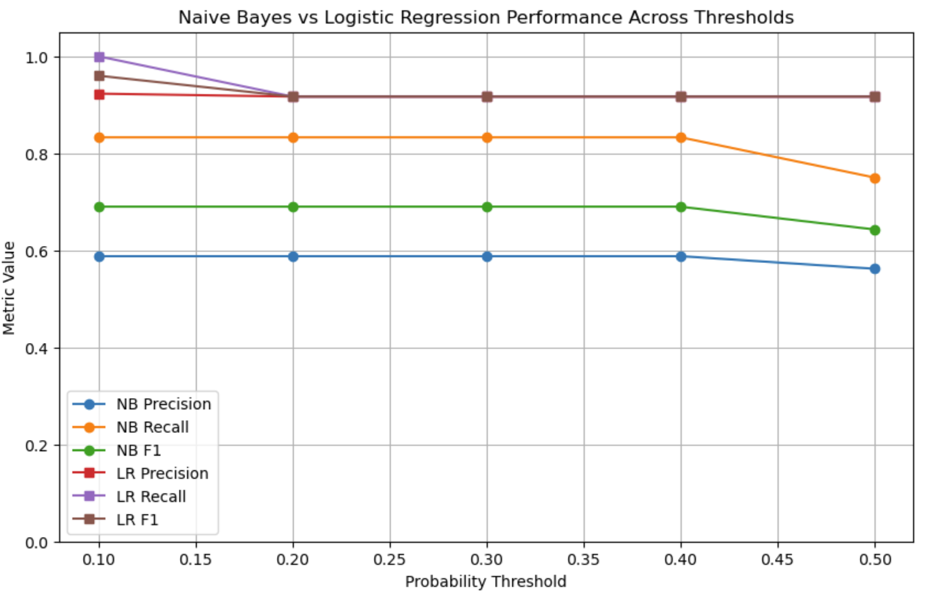
Figure 2: Precision, recall, and F1 score for Naïve Bayes and Logistic Regression models across all probability thresholds. Each line represents a performance metric plotted over the full threshold range used for tuning..

Keyword Score and Cosine Similarity Thresholding (Stage 2): Stage 2 evaluated how well the keyword score and cosine similarity metrics distinguished mission-aligned grants from irrelevant pages. Welch’s t-tests and two-parameter logistic regression models showed that both features were significant predictors of relevance (Tabel 2). Relevant grants had substantially higher keyword scores, and each one-point increase in keyword score increased the odds of relevance by approximately 22% (p = 0.016). Cosine similarity provided even stronger separation: relevant pages averaged 0.10 compared with 0.04 for non-relevant pages, a highly significant difference (p < 0.0001).

TABEL 2
Metric | Mean | SD | P-Value
Keyword |  |  | 0.016
Not Relevant t | 6.68 | 3.46
Relevant t | 9.02 | 3.54
Cosine Sim. |  |  | < 0.0001
Not Relevant t | 0.04 | 0.03
Relevant t | 0.1 | 0.06
Tabel 2: Mean values, standard deviations, and Welch’s t-test significance results for keyword scores and cosine similarity between relevant and non-relevant pages..

Based on the observed distributions, we selected conservative thresholds of 7 for keyword score and 0.07 for cosine similarity. These thresholds preserved the majority of relevant grants while filtering out much of the early noise in the corpus.

Together, the two metrics provided a reliable, computationally inexpensive triage mechanism, and were integrated into the GrantMinded pipeline as the second filtering layer.

Final Corpus turning: The grant-identification classifier and the keyword/cosine-similarity thresholds were integrated into the web-scraping tool as the first and second filtering layers. Using the lightweight Logistic Regression model as the initial pass, followed by the empirically derived keyword-score and cosine-similarity thresholds, we generated the final corpus for mission-relevance modeling. This corpus was iteratively refined across three major version updates and 18 substantial refactoring cycles.

The resulting dataset contained 1,013 new documents. Manual review of the full corpus showed that the updated pipeline identified 28 mission-aligned grants; an improvement from 13 in the first corpus iteration and from the 3 discovered through the I-CONNECT Foundation’s baseline processes (Table 3). Effectively, the refined pipeline more than doubled the number of relevant grants compared with the initial scrape and surfaced nearly nine times as many mission-aligned opportunities as the Foundation’s prior manual workflow.

Relevant documents were shorter on average (864 vs. roughly 1,140 tokens), had higher keyword scores, and exhibited greater cosine-similarity variability than non-relevant pages.

TABEL 3
Metric | Overall | Not Relevant | Relevant
N | 1013 | 985 | 28
Total Tokens | 1,149,718 | 1,125,526 | 24,192
Vocabulary Size | 22,345 | 22,186 | 2,690
Doc Length (mean) | 1135.0 | 1142.7 | 864.0
Keyword Score (mean(sd)) | 6.0(3.2) | 5.9 (3.1) | 8.2 (2.6)
Cosine Sim. (mean(sd)) | 0.1 (0.04) | 0.1 (0.04) | 0.1 (0.1)
Tabel 3: Summary of key corpus characteristics.

The statistical patterns in Table 3 further show that mission-aligned grants contain denser concentrations of mission-specific terminology and more distinctive linguistic structure than non-relevant pages. These differences support the effectiveness of the feature-based filtering used in earlier stages of the pipeline and confirm that relevant grants occupy a measurably distinct profile within the broader web corpus.

Relevance modeling (Stage 3): To classify which pages in the final corpus were mission-aligned for the I-CONNECT Foundation, we evaluated three supervised learning algorithms: Naïve Bayes, Logistic Regression, and Support Vector Machines (SVM). As noted in the methods section, Naïve Bayes and Logistic Regression served as strong baseline models for natural-language tasks, offering stable and interpretable performance. SVMs were included because of their strength in high-dimensional TF-IDF feature spaces and their robustness when positive examples are rare, conditions that match the highly imbalanced grant landscape.

All models were trained on TF-IDF representations of the full corpus using the naturally imbalanced class distribution (20 relevant documents in the training set, 8 in the test set).

Performance was evaluated using five-fold stratified cross-validation to preserve the rarity of relevant grants in each fold. Precision, recall, and F1 score served as the primary metrics, as accuracy is uninformative under such extreme imbalance.

Logistic Regression: For Logistic Regression, we conducted five-fold stratified cross-validation across four values of the regularization parameter C. As C increased, the model became more flexible, and both precision and F1 score improved steadily. The strongest performance was obtained with C = 10, which provided the best balance of precision and recall under the extreme class imbalance [Fig. 3].

FIGURE 3
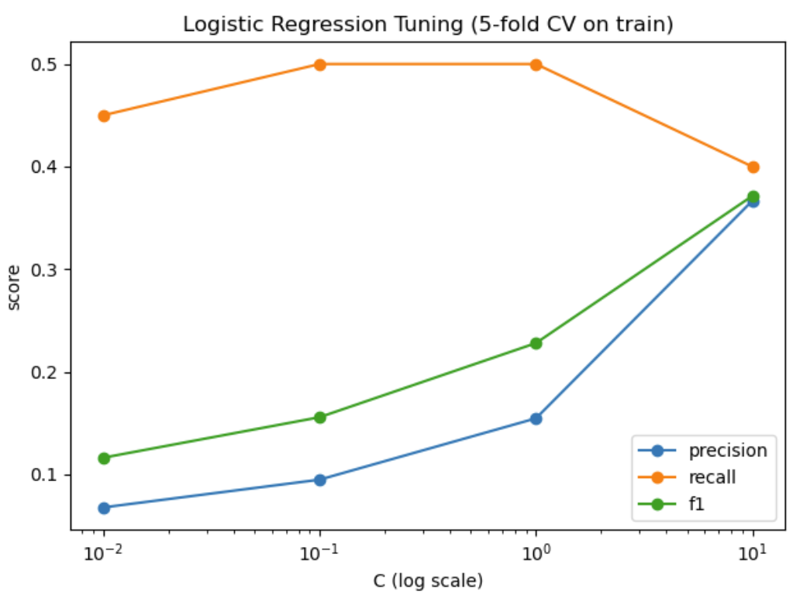
Figure 3: Shows the evaluation metrics across the C turning parameter.

After selecting the best Logistic Regression configuration (C = 10), we tuned the decision threshold on the held-out test set. Rather than using the default threshold of 0.5, we swept thresholds from 0.05 to 0.95 and selected the value that maximized the F1 score, which is critical in imbalanced settings where both precision and recall carry substantial weight. The optimal threshold was 0.85, indicating that the model requires relatively high confidence before predicting relevance. This threshold provided the best tradeoff between capturing rare mission-aligned grants and minimizing false-positive predictions [Fig. 4].

FIGURE 4
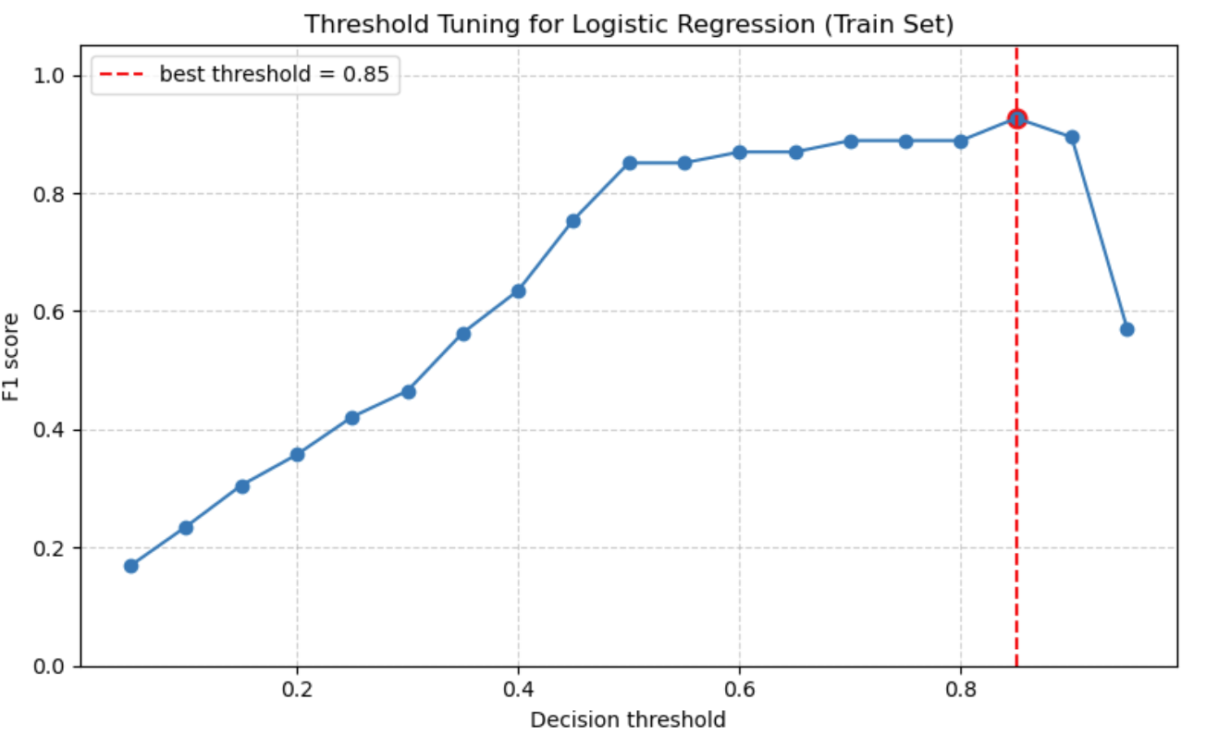
Figure 4: F1 score as a function of decision threshold for Logistic Regression, showing 0.85 as the optimal value.

The Logistic Regression model configured with C = 10 and a tuned decision threshold of 0.85 was carried forward into the Stage 3 model comparison and selection process.

Naïve Bayes: For Naïve Bayes, we evaluated smoothing parameters (alpha) of 0.1, 0.5, and 1.0 using five-fold stratified cross-validation. Only the smallest smoothing value, α = 0.1, produced any meaningful signal, achieving an F1 score of approximately 0.09 [Fig. 5]. Larger alphas collapsed to predicting all pages as not relevant, reflecting the challenges posed by the extreme class imbalance. Because α = 0.1 yielded the highest performance among the Naïve Bayes configurations, this version was carried forward for comparison against the other relevance models.

FIGURE 5
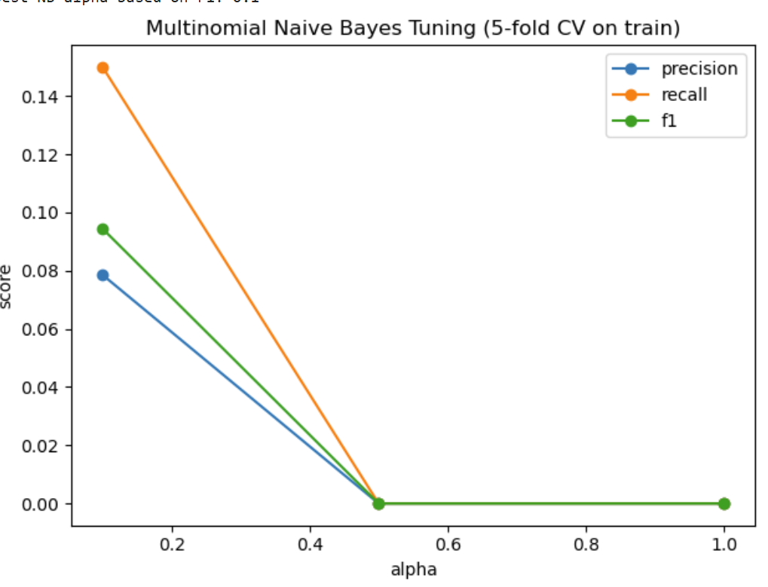
Figure 5: Shows the evaluation metrics across the alpha turning parameter

Naïve Bayes performed poorly in this setting. The combination of rare positive examples and a high-dimensional, sparse TF-IDF feature space is a known limitation for NB classifiers, which assume feature independence and tend to be dominated by the majority class in heavily imbalanced text problems.

Support Vector Machine: For the SVM relevance model, we evaluated four regularization values (C = 0.01, 0.1, 1, and 10) using five-fold stratified cross-validation. As C increased, the model became less regularized and more capable of separating the rare relevant pages from the surrounding noise. The strongest performance, measured by the highest cross-validated F1 score, was achieved with C = 10 [fig.6].

FIGURE 6
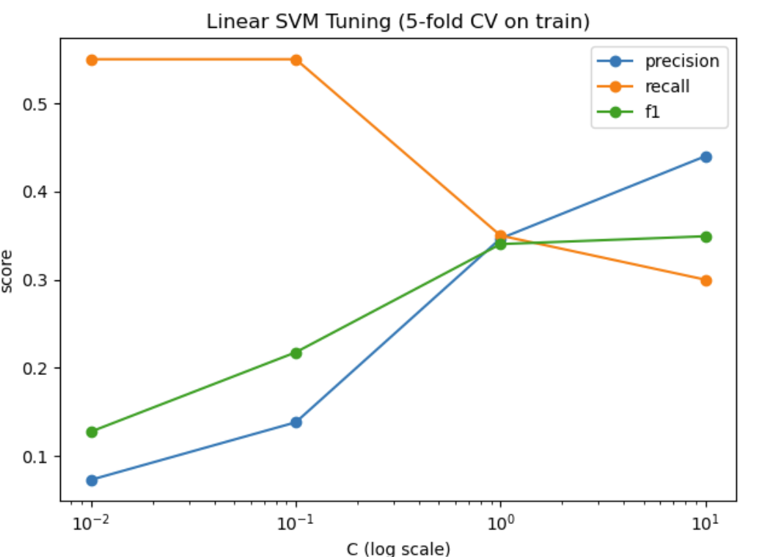
Figure 6: Shows the evaluation metrics across the C turning parameter.

On the final test set, the Linear SVM with C = 10 achieved a precision of 0.833, recall of 0.625, and an F1 score of 0.714, demonstrating strong performance given the sparse, highly imbalanced TF-IDF feature space. These results indicate that the SVM is well suited for identifying rare mission-aligned pages in a high-dimensional text environment.

Comparison and Model Selection: After tuning each classifier, we compared their final test-set performance using precision, recall, and F1 score to determine which model would serve as the Stage 3 relevance filter in the GrantMinded pipeline [fig. 7].

FIGURE 7
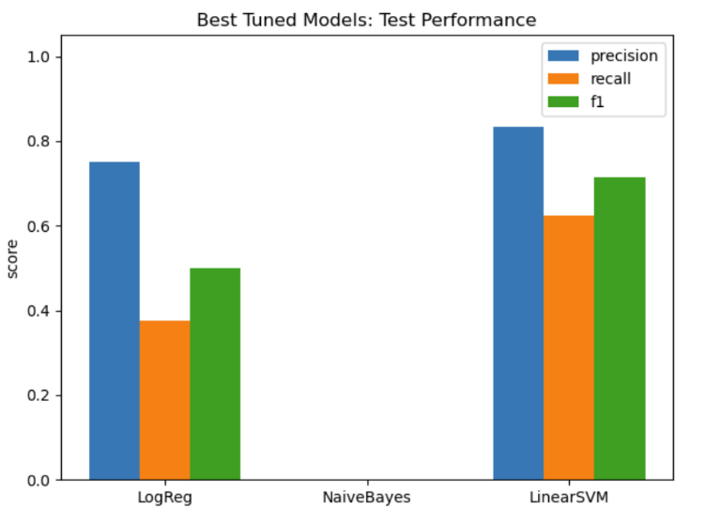
Figure 7: Model comparison of precision, recall, and F1 scores, illustrating the superior performance of the Linear SVM and the collapse of the Naïve Bayes classifier.

The tuned Logistic Regression model (C = 10, threshold = 0.85) achieved a precision of 0.75, recall of 0.375, and an F1 score of 0.50. The Naïve Bayes model, even at its best smoothing parameter, failed to identify any relevant pages and produced precision, recall, and F1 scores of 0.0.

The Linear SVM demonstrated the strongest overall performance. With C = 10, it achieved a precision of 0.833, recall of 0.625, and an F1 score of 0.714, indicating greater sensitivity to rare mission-aligned pages while maintaining strong precision.

Based on these results, the Linear SVM with C = 10 was selected as the final relevance classifier and integrated into GrantMinded as the third and most critical filtering layer.

Beta Testing Deployment: The final GrantMinded filter system was deployed in two cycles.

Cycle 1 (Targeted Funders): After assembling all tuned components of the GrantMinded prototype, we first tested the full three-layer pipeline on three major funder websites historically associated with mission-aligned opportunities for the I-CONNECT Foundation: AFAR, the Robert Wood Johnson Foundation (RWJF), and the Gates Foundation. For each website, the crawler conducted a breadth-first search to depth 3, visiting up to 15 pages per domain. All retrieved pages were processed through the complete pipeline: Logistic Regression grant detection, keyword and cosine filtering, and the final SVM relevance classifier.

Across all three sites, no pages passed all stages, resulting in 0 pages in the final discovery file. Review of the logs confirmed that the system rejected pages for appropriate reasons and that each filtering layer operated as intended.
Importantly, this outcome highlights a core strength of the pipeline: GrantMinded is selective. Even for well-known funding organizations, the system does not surface opportunities unless they are both grant-like and strongly aligned with the nonprofit’s specific mission. This behavior is desirable for a tool intended to minimize noise and highlight only high-value opportunities.

Cyle 2 (General Search and Targeted Sources): In the second beta cycle, we deployed the complete GrantMinded application, across both general web search results and the targeted seed websites developed in Stage 0.

Across all pages explored, 16 pages passed all three filtering layers and were included in the final discovery file. Manual review showed that 13 of the 16 pages were genuinely mission-aligned funding opportunities, yielding a final precision of 81.25%.

To contextualize this result, the original labeled corpus contained only 2.8% relevant pages. The beta deployment therefore produced roughly a 30-fold enrichment in mission-aligned grant hits compared to the raw web environment.

CONCLUSIONS AND FUTURE WORK
Conclusion: Across both beta demonstrations, the GrantMinded pipeline exhibited precisely the behavior intended for a mission-aware grant discovery system. On major funder websites such as AFAR and the Robert Wood Johnson Foundation, the system returned zero results, confirming that it does not produce false positives when no mission-aligned opportunities exist. In contrast, the broader web deployment surfaced 16 high-confidence pages, of which 13 were verified as truly relevant, yielding a precision of over 81% .

In practical terms, this means the I-CONNECT Foundation would move from needing to review around 36 pages to find one relevant opportunity to reviewing only one or two. This represents a substantial reduction in required staff effort and associated costs.

- Before GrantMinded: Approximately 36 pages needed to be reviewed to find one relevant opportunity.

- After GrantMinded: Only 1 to 2 pages need to be reviewed to find one relevant opportunity.

These results demonstrate that the integrated pipeline substantially increases the efficiency of grant discovery, elevates the density of mission-relevant results, and reduces the manual burden of identifying high-quality opportunities for the I-CONNECT Foundation.

Limitations: The primary limitation is that each layer of the GrantMinded filter application would need to be tuned and retrained for each nonprofit’s mission, as organizational priorities and domains differ widely. However, the multi-stage architecture is generalizable, and the retraining requirement reflects the tailored nature of mission alignment rather than a flaw in the pipeline itself. Additionally, the results suggest that this effort maybe more cost-effective in overhead reduction.

Future work: Looking ahead, the next phase of development will focus on automating model retraining so that new nonprofits can supply mission text or past awards and receive an immediately customized system. In parallel, a real-world pilot at the I-CONNECT Foundation would allow for a practical evaluation of time savings, cost reductions, and impact on grant application success.

In summary, this work demonstrates that GrantMinded and similar targeted search methods are not only feasible, but can be a transformative approach to nonprofits identify funding opportunities. Rather than relying on costly subscription services or labor-intensive review of irrelevant pages, the pipeline automatically surfaces grants that are both structurally grant-like and mission-aligned. With its high precision, significant reduction in staff burden, and the potential for low-cost broad deployment, GrantMinded represents a feasible and impactful approach to supporting small and mid-sized nonprofits in sustaining their work and strengthening their communities.

References
[1] USAFacts, “How many nonprofits are there in the U.S.?,” 2024. [Online]. Available: https://usafacts.org/articles/how-many-nonprofits-are-there-in-the-us/

[2] R. Auritt, “What percentage of a nonprofit budget should be for fundraising?,” BoardEffect, May 5, 2024. [Online]. Available: https://www.boardeffect.com/blog/what-percentage-of-a-nonprofit-budget-should-be-for-fundraising/

[3] M. Neumayr, U. Schneider, and M. Meyer, “Public funding and its impact on nonprofit advocacy,” Nonprofit and Voluntary Sector Quarterly, vol. 44, no. 2, pp. 297–318, Apr. 2015, doi: 10.1177/089976401351335.

[4] R. M. Silverman and K. L. Patterson, “The effects of perceived funding trends on non-profit advocacy: A national survey of non-profit advocacy organizations in the United States,” International Journal of Public Sector Management, vol. 24, no. 5, pp. 435–451, Jul. 2011, doi: 10.1108/09513551111147169.

[5] W. L. Foster, P. Kim, and B. Christiansen, “Ten nonprofit funding models,” Stanford Social Innovation Review, Spring 2009. [Online]. Available: https://ssir.org/pdf/2009SP_Feature_Foster_Kim_Christiansen.pdf

[6] M. Jegers, “Modeling non-profit organisations’ funding diversification,” Financial Accountability & Management, vol. 1, no. 1, pp. 1–20, 2024, doi: 10.1177/27533743241227622.

[7] H. Bi, Y. Cheng, J. Yu, and Y. Shen, “Government funding and nonprofit performance in service delivery and policy engagement: Exploring the mediating roles of private donations, volunteers, and network quality,” Journal of Chinese Governance, vol. 10, no. 2, pp. 165–194, Mar. 2025, doi: 10.1080/23812346.2025.2475417.

[8] S. Haq, A. Sharma, and P. Bhattacharyya, “ANGEL: Enterprise search system for the non-profit industry,” in Proc. Int. Conf. Computational Linguistics (COLING), IIT Bombay, India, 2021.

[9] C. D. Manning, H. Schütze, and P. Raghavan, Introduction to Information Retrieval, Draft, Apr. 1, 2009.

[10] G. James, D. Witten, T. Hastie, R. Tibshirani, and J. Taylor, An Introduction to Statistical Learning, Springer, 2021.

