This submission is original work and no part is plagiarized (signed) _______________(Date)___________



MECHANICAL ENGINEERING DEPARTMENT
Thapar University of Engineering and Technology, Patiala

Assignment - 1.

Dynamics for the Mangonel-No Drag

UTA016 Engineering Design Project-I

Assignment - 1.

Dynamics for the Mangonel-No Drag

The following assignment has been based on the lecture on projectile dynamics for the Mangonel -with No drag. Complete the following individually, copying will be dealt with severely.
Notes:
- Ensure on all graphs the curve is visible and sufficient resolution is provided so that the height and distance is determinable. The following chart is an example for 70 degrees at 22m/s.
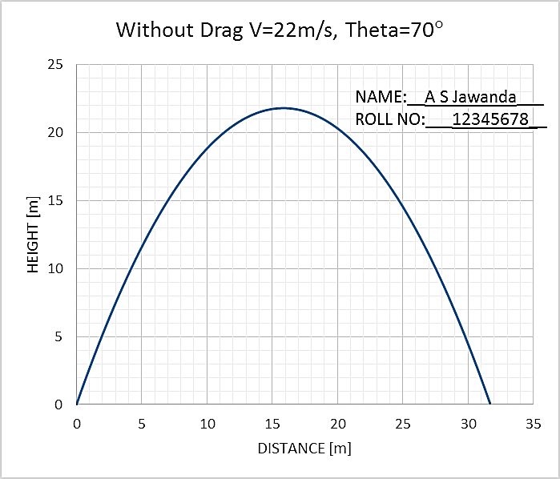
Note: Compulsory to Add Text box of Name and Roll No to every graph as shown.
- The excel graph and results for: One Launch angle in degrees, velocity in m/s have to be shown for evaluation on the same day. While the print of this word document with graphs (with Name and Roll No in text box) and hand written conclusion, name and roll number on every page, stapled together, is to be submitted in next Tutorial class (if it is a holiday, then as instructed).
- Do not leave this assignment until the last minute to find you have some IT issue.

Enjoy the assignment and try to think around the subject as much as possible and take from it any tips that you might use with your own Mangonel design.

Marking Scheme:
Tutorial 1 Total = 10 Marks
Evaluation at end of 2 Hours Tutorial 1= 5
Submission of Tutorial 1 print tagged in folder=5

Weightage Assignment 1 (10 Marks) + Assignment 2 (10 Marks) = 10% for both.

TUTORIAL CLASS EVALUATION [5 Marks]
Only Q1e below evaluated at the end of 2 Hours of tutorial class on computer.
One Marks each for:
- Excel sheet formulation,
- Layout,
- Graph series,
- Graph clarity and
- Graph format, as given in note.
NOTE: Compulsory to Add Text box of Name and Roll No to every graph as shown.

- Using the Excel spread sheet that you have developed to model the dynamics of a “missile” cast by the Mangonel, copy and paste graphs for the following into this document
  - No drag: Launch angle 25 degrees, velocity 15m/s
<Insert Graph>
  - No drag: Launch angle 35 degrees, velocity 15m/s
<Insert Graph>
  - No drag: Launch angle 45 degrees, velocity 15m/s
<Insert Graph>
  - No drag: Launch angle 65 degrees, velocity 15m/s
<Insert Graph>
  - No drag: Launch angle 75 degrees, velocity 15m/s
<Insert Graph>

- Plot a combined graph for No drag: Launch velocity 25m/s for angle varying from 20 degrees to 80 degrees in step of 5 degrees.

- Plot a combined graph for No drag: Angle 30 degrees and launch velocity varying from 10m/s to 60 m/s in step of 10 m/s.

- For the combined graphs in Q1, Q2 and Q3comment on the effect of angle of launch and velocity on the horizontal distance travelled. [5 Marks]
(HANDWRITTEN ONLY)

END

