|  |  |
| --- | --- |
| 341312304 | שרה גריפית |
| 207223066 | טל שמיר |

2.1: Diagram of FSM

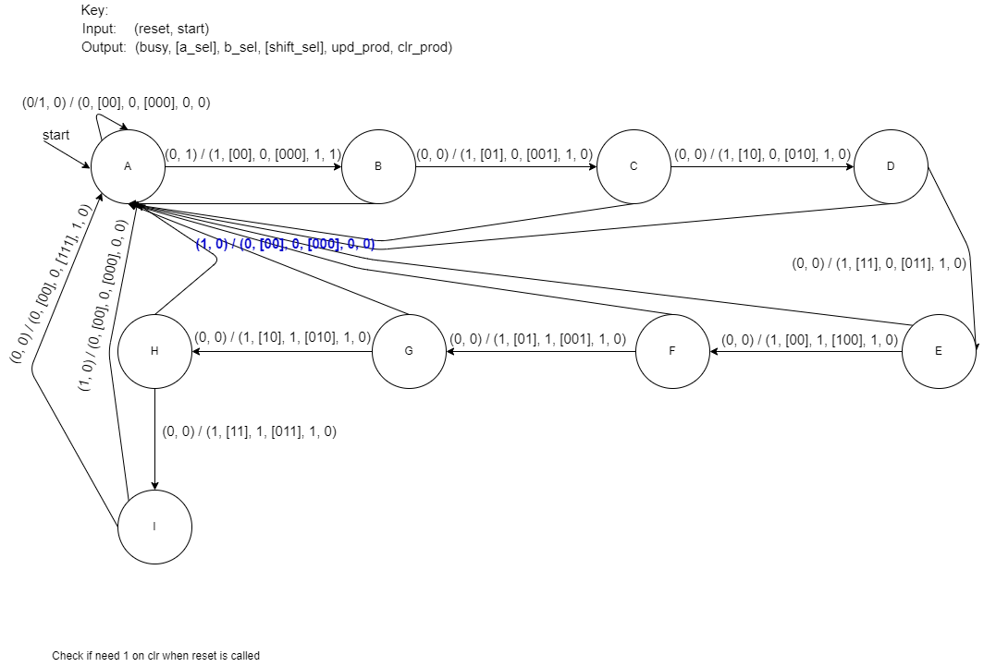The following is a diagram of the FSM we will implement: UPDATE PHOTO!!!!

Each multiplication takes 9 clock cycles.

2.2: