Ein Bild, das Logo enthält.

Gitcon Driver V1.0

Firmware Reference Manual - [EN]

Generated with Doxygen 1.9.5

Author Simon Grundner

1 Data Structure Index 4

1.1 Data Structures 4

2 File Index 5

2.1 File List 5

3 Data Structure Documentation 6

3.1 gitcon_context_t Struct Reference 6

3.1.1 Detailed Description 6

3.1.2 Field Documentation 6

3.1.2.1 midi_handle 6

3.1.2.2 midi_queue 6

3.1.2.3 sampler 7

3.2 i2s_sampler_t Struct Reference 7

3.2.1 Detailed Description 7

3.2.2 Field Documentation 7

3.2.2.1 buffer 7

3.2.2.2 buffer_pos 8

3.2.2.3 buffer_size 8

3.2.2.4 dma_queue 8

3.2.2.5 dsp_queue 8

3.3 midi_config_t Struct Reference 9

3.3.1 Detailed Description 9

3.3.2 Field Documentation 9

3.3.2.1 baudrate 9

3.3.2.2 rx_io 9

3.3.2.3 tx_io 9

3.3.2.4 uart_num 9

3.4 midi_context_t Struct Reference 10

3.4.1 Detailed Description 10

3.4.2 Field Documentation 10

3.4.2.1 cfg 10

3.5 midi_message_t Struct Reference 10

3.5.1 Detailed Description 10

3.5.2 Field Documentation 11

3.5.2.1 channel 11

3.5.2.2 param1 11

3.5.2.3 param2 11

3.5.2.4 status 11

4 Structural Diagram 12

5 File Documentation 13

5.1 config.h File Reference 13

5.1.1 Detailed Description 14

5.1.2 Macro Definition Documentation 14

5.1.2.1 ADC_RES 14

5.1.2.2 ADC_RES_BITS 14

5.1.2.3 AUDIO_BUFFER_SIZE 14

5.1.2.4 DMA_CHAN 14

5.1.2.5 F_SAMPLE_HZ 14

5.1.2.6 FFT_SIZE 14

5.1.2.7 FFT_WINDOW_SIZE 15

5.1.2.8 INTERNAL_ADC_CHANNEL 15

5.1.2.9 INTERNAL_ADC_IO 15

5.1.2.10 INTERNAL_ADC_UNIT 15

5.1.2.11 MIDI_BAUD 15

5.1.2.12 MIDI_RX 15

5.1.2.13 MIDI_TX 15

5.1.2.14 MIDI_UART 15

5.1.2.15 SPI_CS 15

5.1.2.16 SPI_DEV 16

5.1.2.17 SPI_MISO 16

5.1.2.18 SPI_MOSI 16

5.1.2.19 SPI_SCLK 16

5.2 config.h 17

5.3 i2s_sampler.c File Reference 18

5.3.1 Macro Definition Documentation 18

5.3.1.1 READER_TIMEOUT_MS 18

5.3.1.2 READER_TIMEOUT_TICKS 18

5.3.1.3 RESAMPLE_DENOMINATOR 18

5.3.2 Function Documentation 18

5.3.2.1 i2s_sampler_start() 18

5.3.2.2 i2s_sampler_stop() 19

5.4 i2s_sampler.c 20

5.5 i2s_sampler.h File Reference 23

5.5.1 Detailed Description 23

5.5.2 Function Documentation 23

5.5.2.1 i2s_sampler_start() 23

5.5.2.2 i2s_sampler_stop() 24

5.6 i2s_sampler.h 25

5.7 midi.c File Reference 26

5.8 midi.c 27

5.9 midi.h File Reference 30

5.10 midi.h 31

5.11 midi_utils.c File Reference 33

5.12 midi_utils.c 34

5.13 gitcon.c File Reference 35

5.14 gitcon.c 36

5.15 gitcon.h File Reference 42

5.16 gitcon.h 43

5.17 main.c File Reference 44

5.18 main.c 45

5.19 test_fft.c File Reference 47

5.20 test_fft.c 47

5.21 test_midi.c File Reference 47

5.22 test_midi.c 47

6 Index 48

# Data Structure Index

## Data Structures

Here are the data structures with brief descriptions:

gitcon_context_t

Driver passing parameters 6

i2s_sampler_t

Sampler Data 7

midi_config_t

MIDI Bus configuration 9

midi_context_t

MIDI configuration wrapper 10

midi_message_t

MIDI message data 10

# File Index

## File List

Here is a list of all documented files with brief descriptions:

MTAP-MIDI-Guitar-Converter/firmware/Gitcon_Driver/include/config.h

Gitcon Driver Configuration and Pin-Out File and dependencies 13

MTAP-MIDI-Guitar-Converter/firmware/Gitcon_Driver/lib/audio/i2s_sampler.c

I2S Sampler Driver Source for ESP32 18

MTAP-MIDI-Guitar-Converter/firmware/Gitcon_Driver/lib/audio/i2s_sampler.h

I2S Sampler Driver for ESP32 22

MTAP-MIDI-Guitar-Converter/firmware/Gitcon_Driver/lib/midi/midi.c

MIDI Driver Source for ESP32 22

MTAP-MIDI-Guitar-Converter/firmware/Gitcon_Driver/lib/midi/midi.h

MIDI UART Driver for ESP32 22

MTAP-MIDI-Guitar-Converter/firmware/Gitcon_Driver/lib/midi/midi_utils.c

MIDI Message Utilities 22

MTAP-MIDI-Guitar-Converter/firmware/Gitcon_Driver/src/gitcon.c

Gitcon Driver Source 22

MTAP-MIDI-Guitar-Converter/firmware/Gitcon_Driver/src/gitcon.h

Gitcon Driver 22

MTAP-MIDI-Guitar-Converter/firmware/Gitcon_Driver/src/main.c

Main File for Gitcon Project 22

MTAP-MIDI-Guitar-Converter/firmware/Gitcon_Driver/test/test_fft/test_fft.c

Unit Test for FFT 22

MTAP-MIDI-Guitar-Converter/firmware/Gitcon_Driver/test/test_midi/test_midi.c

Unit Test for MIDI Driver 22

# Data Structure Documentation

## gitcon_context_t Struct Reference

Driver passing parameters.

#include <gitcon.h>

Data Fields

* i2s_sampler_t *sampler
* midi_handle_t midi_handle
* QueueHandle_t midi_queue

### Detailed Description

This data structure is passed around to all tasks to reconfigure driver parameters as needed.

Parameters

|  |  |
| --- | --- |
| sampler | I2S Sampler Handler |
| midi_handle | MIDI Driver Context (MIDI over UART) |
| midi_queue | MIDI Queue Handler |

* Definition at line 25 of file gitcon.h.

### Field Documentation

#### midi_handle

midi_handle_t midi_handle

MIDI driver context containing UART bus- and pin configuration.

* Definition at line 32 of file gitcon.h.

#### midi_queue

QueueHandle_t midi_queue

MIDI-Messages are queued here to be written onto the UART bus by the MIDI driver.

* Definition at line 33 of file gitcon.h.

#### sampler

i2s_sampler_t* sampler

Audio sampling parameters

* Definition at line 30 of file gitcon.h.

## i2s_sampler_t Struct Reference

Sampler Data.

#include <i2s_sampler.h>

Data Fields

* QueueHandle_t dma_queue
* QueueHandle_t dma_queue
* QueueHandle_t dsp_queue
* size_t ∗ buffer
* size_t buffer_pos
* size_t buffer_size

### Detailed Description

This struct contains the relevant data to sample audio correctly.

Parameters

|  |  |
| --- | --- |
| dma_queue | Samples are sent to this queue by the DMA |
| dsp_queue | Sampling result is sent to this queue |
| buffer | Buffer to store samples in |
| buffer_pos | Current position in buffer |
| buffer_size | Size of the buffer in samples |

* Definition at line 20 of file i2s_sampler.h.

### Field Documentation

#### buffer

size_t∗ buffer

The buffer stores sampled audio data with a size of 16 bit per sample due to the ADC resolution of 12 bit.

* Definition at line 24 of file i2s_sampler.h.

#### buffer_pos

size_t buffer_pos

To append incoming data correctly, a buffer position variable stores the index of where the DMA Controller left off.

* Definition at line 25 of file i2s_sampler.h.

#### buffer_size

size_t buffer_size

Stores the size of the buffer in Samples. This configuration is usually set during the initialization phase and not changed afterwards.

* Definition at line 26 of file i2s_sampler.h.

#### dma_queue

QueueHandle_t dma_queue

Raw data sent by the Direct-Memory-Access-Controller is read from a queue by the sampler.

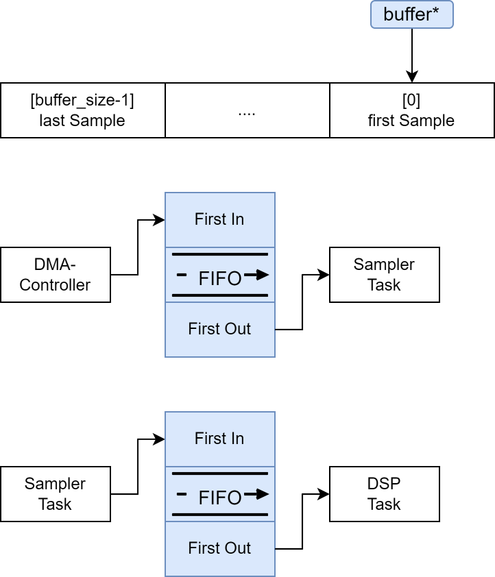

* Definition at line 22 of file i2s_sampler.h.

#### dsp_queue

QueueHandle_t dsp_queue

The buffer is sent into a queue for further processing.

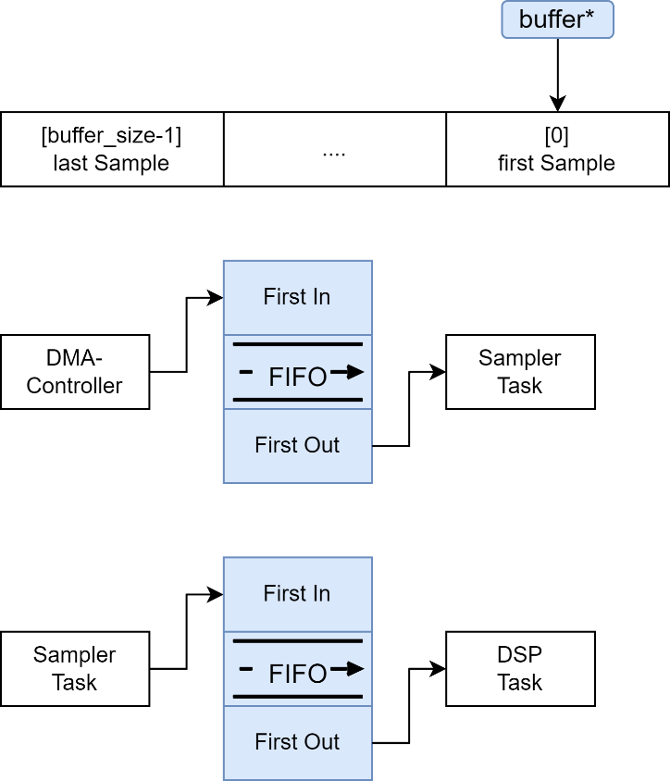

* Definition at line 23 of file i2s_sampler.h.

## midi_config_t Struct Reference

MIDI UART Configuration

#include <midi.h>

Data Fields

* uart_port_t uart_num
* uint baudrate
* gpio_num_t rx_io
* gpio_num_t tx_io

### Detailed Description

UART Driver Configuration for MIDI transmission

Parameters

|  |  |
| --- | --- |
| uart_num | UART Port |
| Baudrate | UART Baudrate |
| rx_io | UART RX Pin |
| tx_io | UART TX Pin |

* Definition at line 76 of file midi.h.

### Field Documentation

#### baudrate

uint baudrate

Baud rate configuration for UART

* Definition at line 79 of file midi.h.

#### rx_io

gpio_num_t rx_io

Receive GPIO pin number.

* Definition at line 80 of file midi.h.

#### tx_io

gpio_num_t tx_io

Transmit GPIO pin number.

* Definition at line 81 of file midi.h.

#### uart_num

uart_port_t uart_num

UART port id of the ESP32

* Definition at line 78 of file midi.h.

## midi_context_t Struct Reference

Wrapper for midi_config_t

Data Fields

* midi_config_t cfg

### Detailed Description

gitcon_context_t references the wrapper struct.

Parameters:

|  |  |
| --- | --- |
| cfg | MIDI Config |

* Definition at line 24 of file midi.c.

### Field Documentation

#### cfg

midi_config_t cfg

* Definition at line 26 of file midi.c.

## midi_message_t Struct Reference

MIDI Message data.

#include <midi.h>

Data Fields

* uint8_t param1
* midi_status_t status
* uint8_t channel
* uint8_t param2

### Detailed Description

MIDI Message Data Struct

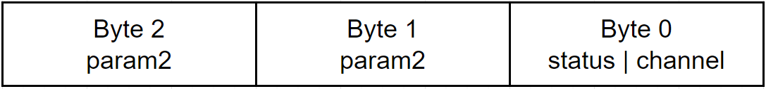

Parameters

|  |  |
| --- | --- |
| status | MIDI Status Byte |
| channel | MIDI Channel |
| param1 | MIDI Parameter 1 |
| param2 | MIDI Parameter 2 |

* Definition at line 60 of file midi.h.

### Field Documentation

#### channel

uint8_t channel

Addresses a specific Channel on the MIDI-receiver side.

* Definition at line 64 of file midi.h.

#### param1

uint8_t param1

Different functions depending on the status.

* Definition at line 62 of file midi.h.

#### param2

uint8_t param2

Different functions depending on the status.

* Definition at line 65 of file midi.h.

#### status

midi_status_t status

* Definition at line 63 of file midi.h.

# Structural Diagram

Ein Bild, das Diagramm enthält.

The Structural Flowchart Diagram above describes the **initialization setup** (in red), as well as the **repetitive** **process tasks** (in yellow). Once the firmware has been reset, an initialization is executed and all initial parameters are loaded into the driver parameter handler, which serves as a central data struct. When fully booted up and the real-time operating system has started, a continuous stream of data is sampled and processed, until a MIDI note is ready to be sent onto the UART bus.

# File Documentation

## config.h File Reference



Macros



### Detailed Description

Gitcon Driver Configuration and Pin-Out File and dependencies.

|  |  |  |  |
| --- | --- | --- | --- |
| Author | Version | Date | Copyright |
| @s-grundner | 0.1 | 2022-12-24 | Copyright (c) 2022 |

* Definition in file config.h.

### Macro Definition Documentation

#### ADC_RES

#define ADC_RES (1 << ADC_RES_BITS)

ADC Resolution ($2^{n}$)

* Definition at line 50 of file config.h.

#### ADC_RES_BITS

#define ADC_RES_BITS 12

ADC Resolution in bit

* Definition at line 49 of file config.h.

#### AUDIO_BUFFER_SIZE

#define AUDIO_BUFFER_SIZE 512

Maximum number of samples stored in the audio buffer.

* Definition at line 55 of file config.h.

#### DMA_CHAN

#define DMA_CHAN 1

Direct memory access channel

* Definition at line 48 of file config.h.

#### F_SAMPLE_HZ

#define F_SAMPLE_HZ 15000

Sample rate at which the sampler reads audio data.

* Definition at line 56 of file config.h.

#### FFT_SIZE

#define FFT_SIZE (AUDIO_BUFFER_SIZE ∗ FFT_WINDOW_SIZE)

Number of samples the Fast Fourier Transform can process.

* Definition at line 58 of file config.h.

#### FFT_WINDOW_SIZE

#define FFT_WINDOW_SIZE 4

Factor by which the Fast Fourier Transform buffer is larger than the audio buffer.

* Definition at line 57 of file config.h.

#### INTERNAL_ADC_CHANNEL

#define INTERNAL_ADC_CHANNEL (ADC_CHANNEL_5)

Internal ADC channel. Corresponds to a hardware GPIO on the ESP32 chip.

* Definition at line 52 of file config.h.

#### INTERNAL_ADC_IO

#define INTERNAL_ADC_IO (GPIO_NUM_33)

Internal Analog Digital Converter GPIO Pin number.

* Definition at line 53 of file config.h.

#### INTERNAL_ADC_UNIT

#define INTERNAL_ADC_UNIT (ADC_UNIT_1)

Internal Analog Digital Converter unit.

* Definition at line 51 of file config.h.

#### MIDI_BAUD

#define MIDI_BAUD (115200)

Baud rate of the MIDI UART driver.

* Definition at line 44 of file config.h.

#### MIDI_RX

#define MIDI_RX (GPIO_NUM_27)

MIDI Driver receive GPIO.

* Definition at line 46 of file config.h.

#### MIDI_TX

#define MIDI_TX (GPIO_NUM_26)

MIDI Driver receive GPIO.

* Definition at line 45 of file config.h.

#### MIDI_UART

#define MIDI_UART (UART_NUM_1)

* Definition at line 43 of file config.h.

#### SPI_CS

#define SPI_CS (GPIO_NUM_5)

* Definition at line 40 of file config.h.

#### SPI_DEV

#define SPI_DEV (VSPI_HOST)

* Definition at line 41 of file config.h.

#### SPI_MISO

#define SPI_MISO (GPIO_NUM_19)

* Definition at line 38 of file config.h.

#### SPI_MOSI

#define SPI_MOSI (GPIO_NUM_23)

* Definition at line 37 of file config.h.

#### SPI_SCLK

#define SPI_SCLK (GPIO_NUM_18)

* Definition at line 39 of file config.h.

## config.h



## i2s_sampler.c File Reference

#include "i2s_sampler.h"

Macros



Functions

* static void IRAM_ATTR sampler_task(void *arg)
  + *Sampler Task for I2S*
* i2s_sampler_t ∗i2s_sampler_start (adc_channel_t adc1_channel, QueueHandle_t recv_queue, size_t buffer_size, size_t f_sample)
  + *Starts a sampler Task that samples from the given ADC1 channel and sends the samples to the given Queue.*
* esp_err_t i2s_sampler_stop (i2s_sampler_t ∗sampler)
  + *Deletes sampler Task, frees memory, and uninstalls ADC as well as i2s driver.*

### Detailed Description

I2S Sampler Driver Source for ESP32

|  |  |  |  |
| --- | --- | --- | --- |
| Author | Version | Date | Copyright |
| @s-grundner | 0.1 | 2022-12-24 | Copyright (c) 2022 |

* Definition in file i2s_sampler.c.

### Macro Definition Documentation

#### READER_TIMEOUT_MS

#define READER_TIMEOUT_MS 10

Time in milliseconds for the I2S reader to timeout.

* Definition at line 16 of file i2s_sampler.c.

#### READER_TIMEOUT_TICKS

#define READER_TIMEOUT_TICKS (READER_TIMEOUT_MS / portTICK_PERIOD_MS)

Converts milliseconds into RTOS ticks.

* Definition at line 17 of file i2s_sampler.c.

#### RESAMPLE_DENOMINATOR

#define RESAMPLE_DENOMINATOR 2

Buffer divider for double buffering.

* Definition at line 15 of file i2s_sampler.c.

### Function Documentation

#### sampler_task()



This is a RTOS Task, which accepts data from the DMA Controller.

This function is executed in IRAM, due to its direct communication with the DMA-Controller

Parameters

|  |  |
| --- | --- |
| arg | Takes in i2s_sampler_t * as datatype. |

* Definition at line 27 of file i2s_sampler.c.

#### i2s_sampler_start()



Starts a sampler Task that samples from the given ADC1 Channel and sends the samples to the given Queue.

Parameters

|  |  |
| --- | --- |
| adc1_channel | ADC1 Channel to use (Only ADC1 Channels are supported) |
| recv_queue | Queue to send samples to |
| buffer_size | Size of the buffer in samples |
| f_sample | Sample rate at which the sampler samples the audio |

Returns

i2s_sampler_t∗ Sampler context or NULL if failed.

* Definition at line 53 of file i2s_sampler.c.

#### i2s_sampler_stop()



Deletes sampler Task, frees memory, and uninstalls ADC as well as I2S driver.

Parameters

|  |  |
| --- | --- |
| sampler | Sampler to stop. |

Returns

ESP_OK if successful

* Definition at line 92 of file i2s_sampler.c.

## i2s_sampler.c







## i2s_sampler.h File Reference

I2S audio sampler for ESP32.



Data Structures

* struct i2s_sampler_t
  + *Sampler Data.*

Functions

* i2s_sampler_t ∗i2s_sampler_start (adc_channel_t adc1_channel, QueueHandle_t recv_queue, size_t buffer_size, size_t f_sample)
  + *Starts a sampler Task that samples from the given ADC1 channel and sends the samples to the given Queue.*
* esp_err_t i2s_sampler_stop (i2s_sampler_t ∗sampler)
  + *Deletes sampler Task, frees memory and uninstalls ADC as well as i2s driver.*

### Detailed Description

I2S audio sampler for ESP32.

|  |  |  |  |
| --- | --- | --- | --- |
| Author | Version | Date | Copyright |
| @s-grundner | 0.1 | 2022-12-24 | Copyright (c) 2022 |

* Definition in file i2s_sampler.h.

### Function Documentation

#### i2s_sampler_start()



Starts a sampler Task that samples from the given ADC1 Channel and sends the samples to the given Queue.

Parameters

|  |  |
| --- | --- |
| adc1_channel | ADC1 Channel to use (Only ADC1 Channels are supported) |
| recv_queue | Queue to send samples to |
| buffer_size | Size of the buffer in samples |
| f_sample | Sample rate |

Returns

i2s_sampler_t∗ Sampler context or NULL if failed.

* Definition at line 53 of file i2s_sampler.c.

#### i2s_sampler_stop()



Deletes sampler Task, frees memory, and uninstalls ADC as well as I2S driver.

Parameters

|  |  |
| --- | --- |
| sampler | Sampler to stop. |

Returns

ESP_OK if successful

* Definition at line 92 of file i2s_sampler.c.

## i2s_sampler.h





## midi.c File Reference

## midi.c









## midi.h File Reference

## midi.h







## midi_utils.c File Reference

## midi_utils.c





## gitcon.c File Reference

## gitcon.c















## gitcon.h File Reference

## gitcon.h



## main.c File Reference

## main.c







## test_fft.c File Reference

## test_fft.c

## test_midi.c File Reference

## test_midi.c

# Index