CUDA optimization and correctness audit
  - 60 real CLI cases • 12 kernel families • NVIDIA GeForce RTX 2080 Ti
Prepared 29 October 2026 from the 28 October evaluation evidence. Synthetic representative CUDA workloads written for this evaluation; not NVIDIA source code or an assessment of NVIDIA engineering standards.

Measured outcome
Attempted 60 CLI cases: 5 confirmed improvements, 0 inconclusive, 45 unchanged, 0 confirmed regressions and 10 failures. The independent harness recorded 300 successful CPU-reference comparisons.
All-60 correctness was NOT established. Only 50 of 60 cases have the complete six-check baseline/output CPU validation and independent timing record. The remaining 10 cases failed the source guard before independent validation; no independent speedup is claimed for them. The saved-buffer audit independently passed 50/60 case records and 300/300 available buffer comparisons.
Largest confirmed measured gain: matmul_640, 1.585× (36.9% lower kernel latency). Its 95% bootstrap interval is 1.538–1.619×.
Descriptive geometric mean of measured speedup ratios across 50 cases: 1.029×. This includes unchanged outputs and timing noise; it is not a general expected speedup or an independent-sample statistical claim.
The correctness audit found gaps in the CLI verification layer despite passing existing tests. Performance conclusions here rely on the additional independent harness checks; see the audit findings and their limits below.
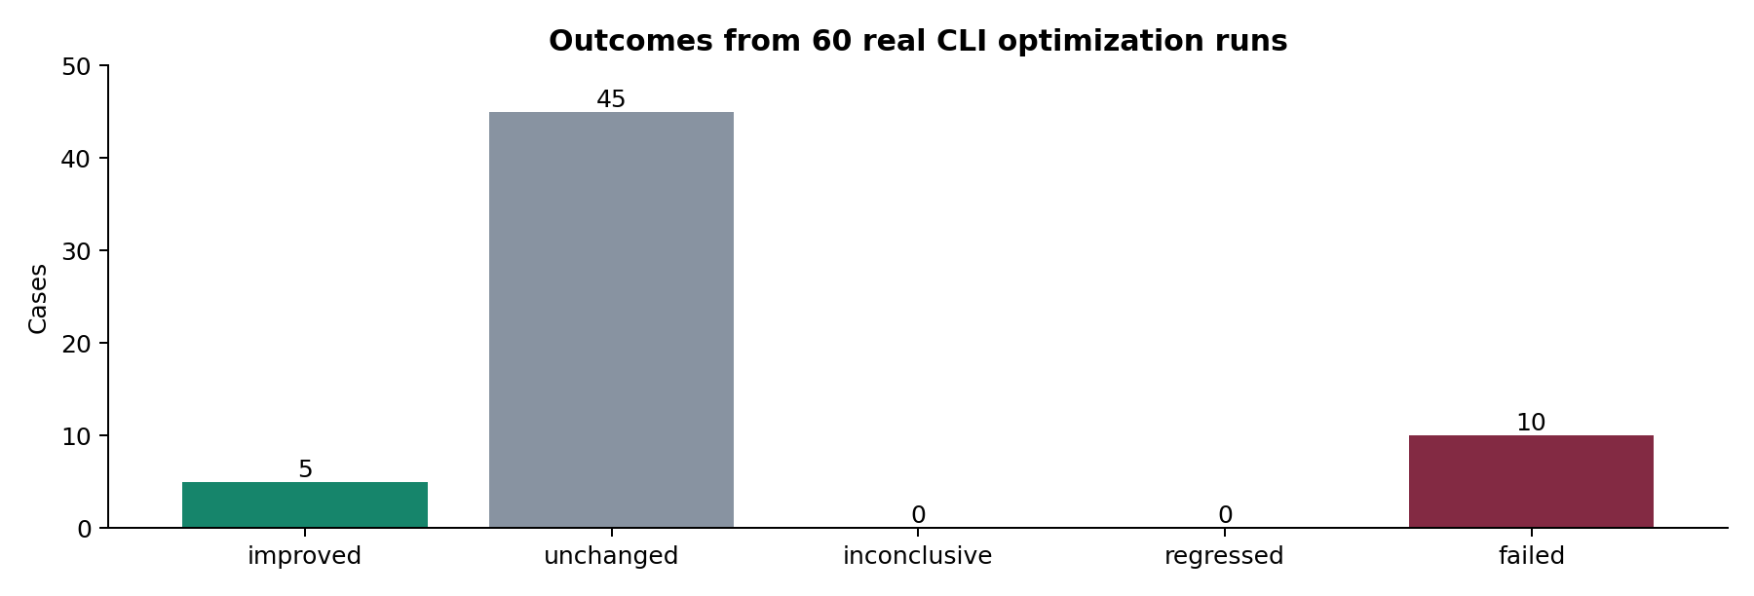
Figure 1. Unchanged source is never counted as an optimization, regardless of timing noise.

Scope and execution environment
Two specialist agents handled benchmark construction/execution and independent verification auditing. The primary agent assembled the evidence and report. Existing repository changes were retained.
Item | Value
GPU | NVIDIA GeForce RTX 2080 Ti, 11 GB; Windows WDDM; sm_75
Compiler | CUDA nvcc 13.2, V13.2.51; Windows MSVC toolchain
Driver | 616.92 (nvidia-smi at start of evaluation)
Repository HEAD | 3b61030fa0140f4290357f1a7959fedf5d6a72ab, working tree modified before evaluation
Optimizer | Actual cuda_opt_agent.cli.app optimize invocation per case; max_iter=18
Generation | Built-in transformation search; no authenticated LLM generation
Profiling | GPU hardware-counter access unavailable; no profiler-derived efficiency claims

Workload design
Each baseline is a straightforward functional implementation with ordinary untuned choices: direct global-memory access, serial work within a thread, or missing tiling/vectorization. No artificial sleeps or deliberately serial whole-vector kernel is used. Some simple pointwise kernels may already be close to practical efficiency. The 60 cases are 12 algorithms at five sizes, not 60 independent algorithms.
Family | Sizes (N) | Baseline design
matmul | 96, 192, 320, 448, 640 | Direct one-thread-per-output GEMM; no shared-memory tiling.
matmul_transposed_b | 96, 192, 320, 448, 640 | Pairwise row dot products; each thread walks two rows.
matvec | 192, 384, 640, 896, 1280 | One thread per matrix row; serial dot accumulation.
row_sum | 192, 384, 640, 896, 1280 | One thread per row; serial reduction with strided inter-thread reads.
row_dot | 192, 384, 640, 896, 1280 | Batched row dot products; serial reduction per thread.
row_max | 192, 384, 640, 896, 1280 | One thread per row; serial maximum reduction.
transpose | 192, 384, 640, 896, 1280 | Direct global-memory transpose without a shared-memory tile.
stencil9 | 8192, 32768, 131072, 524288, 2097152 | Periodic nine-point 1D stencil with direct loads and modulo indexing.
conv3x3 | 192, 384, 640, 896, 1280 | Zero-padded 3x3 box convolution with direct neighborhood loads.
saxpy | 8192, 32768, 131072, 524288, 2097152 | Scalar pointwise SAXPY; no explicit vectorized loads.
poly5 | 8192, 32768, 131072, 524288, 2097152 | Pointwise degree-five polynomial using a short Horner loop.
row_softmax | 192, 384, 640, 896, 1280 | Numerically stable softmax; serial max/sum/output passes per row.

Measurement and verification protocol
For each case the real CLI receives a complete host-runnable CUDA translation unit and writes its selected source. The independent harness recompiles baseline and selected output. Both versions are checked against a NumPy float64 CPU oracle at (N, seed 0), (N+3, seed 1), and (N−1, seed 7), including sizes not divisible by the usual block/tile size. Checks require the expected output length, finite float32 values and elementwise agreement with rtol=1e−4 and atol=1e−5.
Inputs use deterministic uint32 hashing to generate signed dyadic values. The suite checks the host contract and kernel signature, records SHA-256 source hashes and rejects nonfinite or nonpositive timing samples. The independent auditor re-reads saved output buffers with separately expressed CPU oracles and checks source integrity and timing arithmetic. These checks reduce trust in candidate-controlled output.
An explicitly reviewed exception permits pragma-unroll annotations in the host harness; other host or signature changes are rejected. The exact CLI-produced source is compiled and timed. Host launch-loop unrolling can affect launch pacing within a CUDA-event interval, so such gains describe the complete CLI-produced implementation, not strictly device-kernel instruction changes. The ten saved failed cases remain failed even where their host edits appear to be pragma-only: no recovery execution or independent validation was completed for those cases.
Timing uses 12 samples per version, alternating baseline/output order; each sample performs 5 warmup launches and times 30 launches with CUDA events. Reported speedup is mean baseline milliseconds divided by mean selected-output milliseconds. Intervals are percentile 95% bootstrap intervals from 10,000 independent resamples of the 12 timings per version (seed 42). A changed source is classified improved only when the lower bound exceeds 1.01; regressed when the upper bound is below 0.99; otherwise inconclusive.
These are kernel timings, not application end-to-end latency. Windows display activity, clock changes and launch scheduling can affect results. Intervals are per case, not adjusted for 60 comparisons, and do not establish generalization to other GPUs. A CLI-selected variant can fail to improve under independent measurement; every such outcome is retained.

Optimization graphs
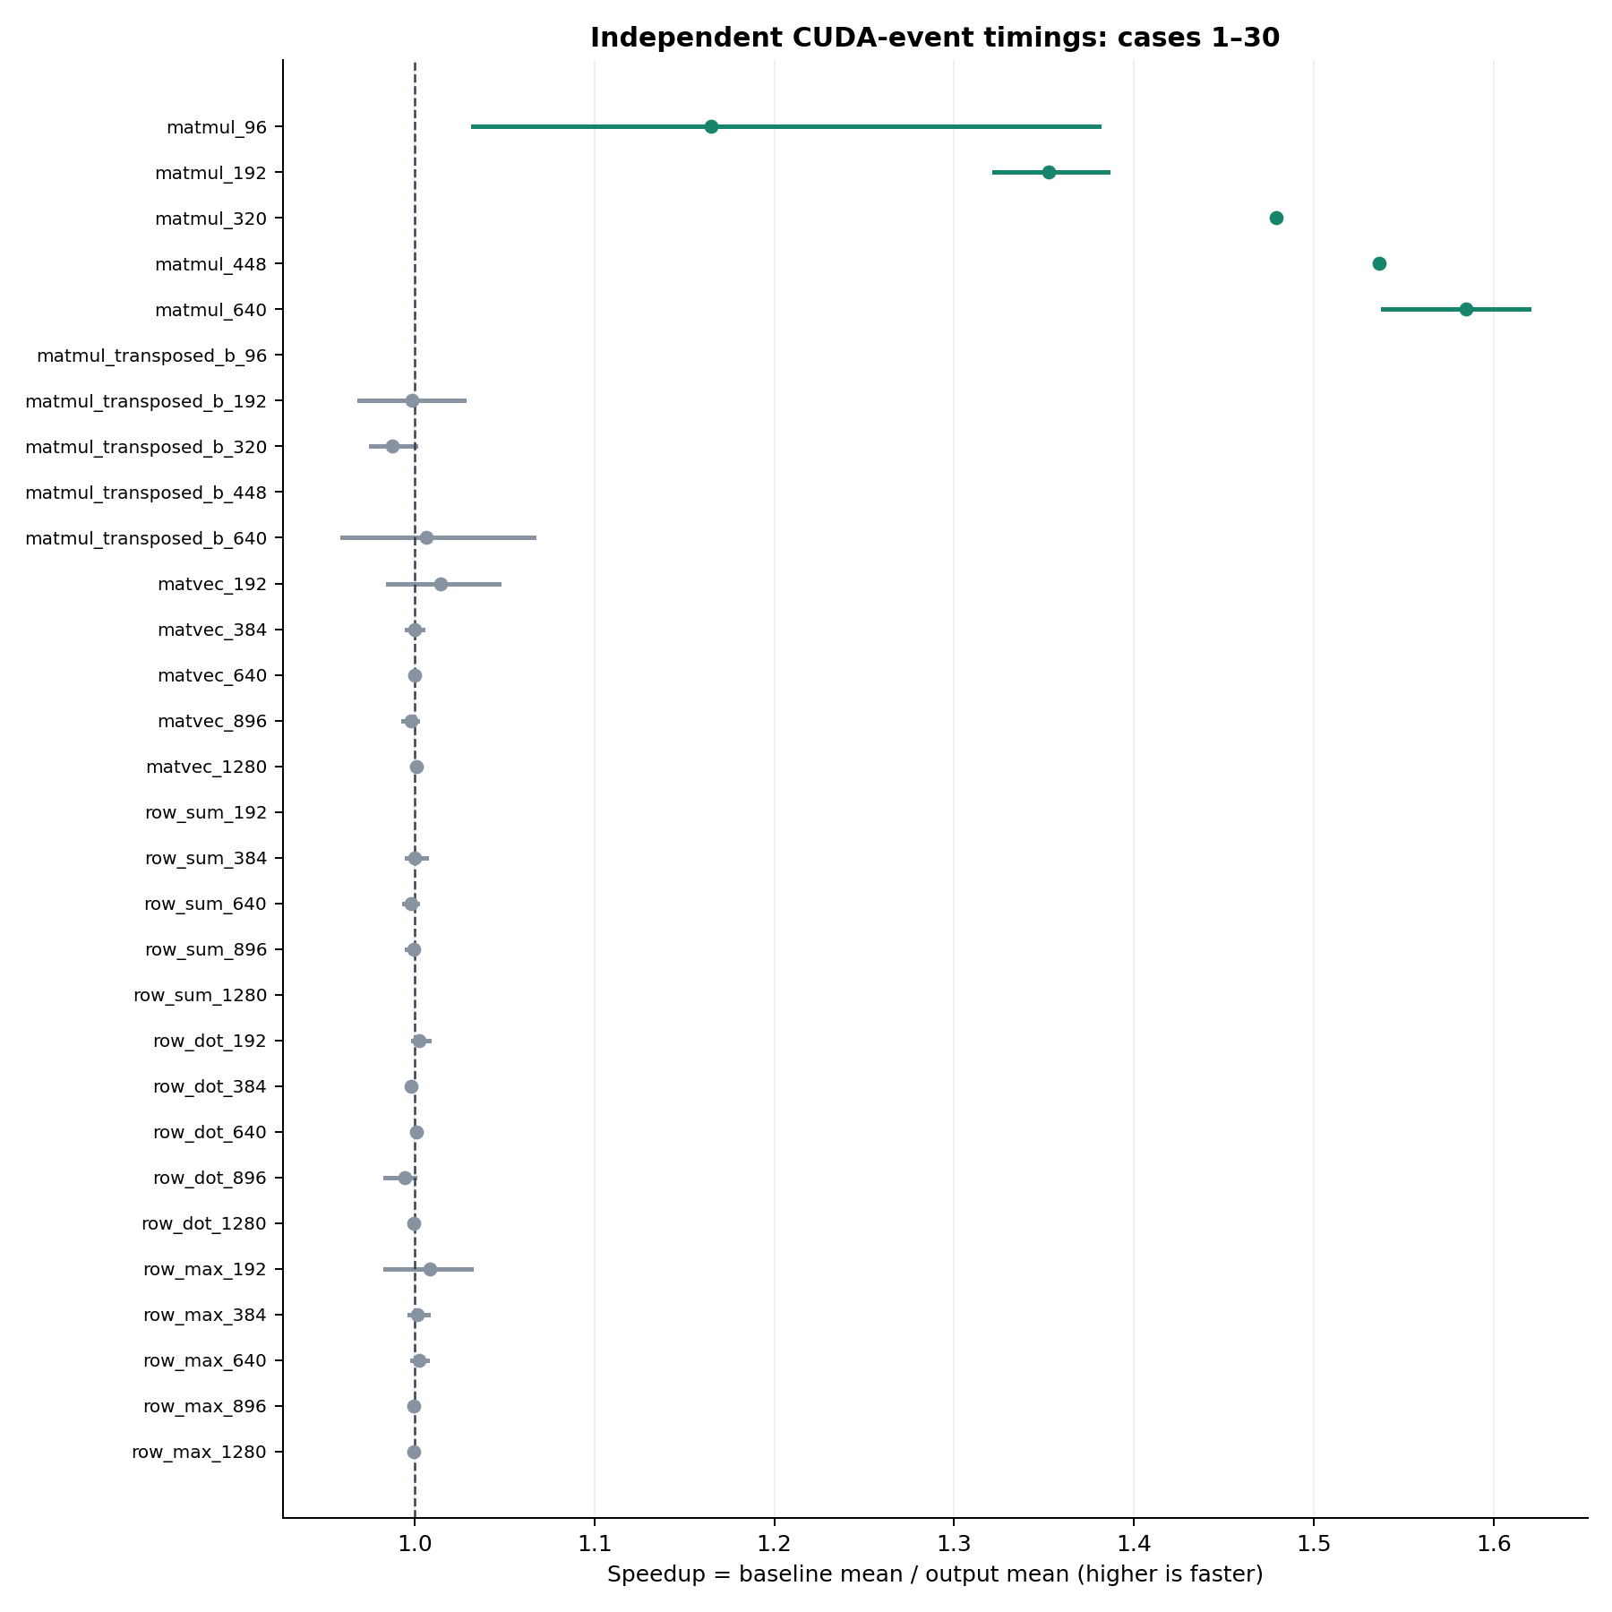
Figure 2. Measured speedup with 95% bootstrap intervals, first 30 cases. Green: improved; grey: unchanged; amber: inconclusive; red: regressed.

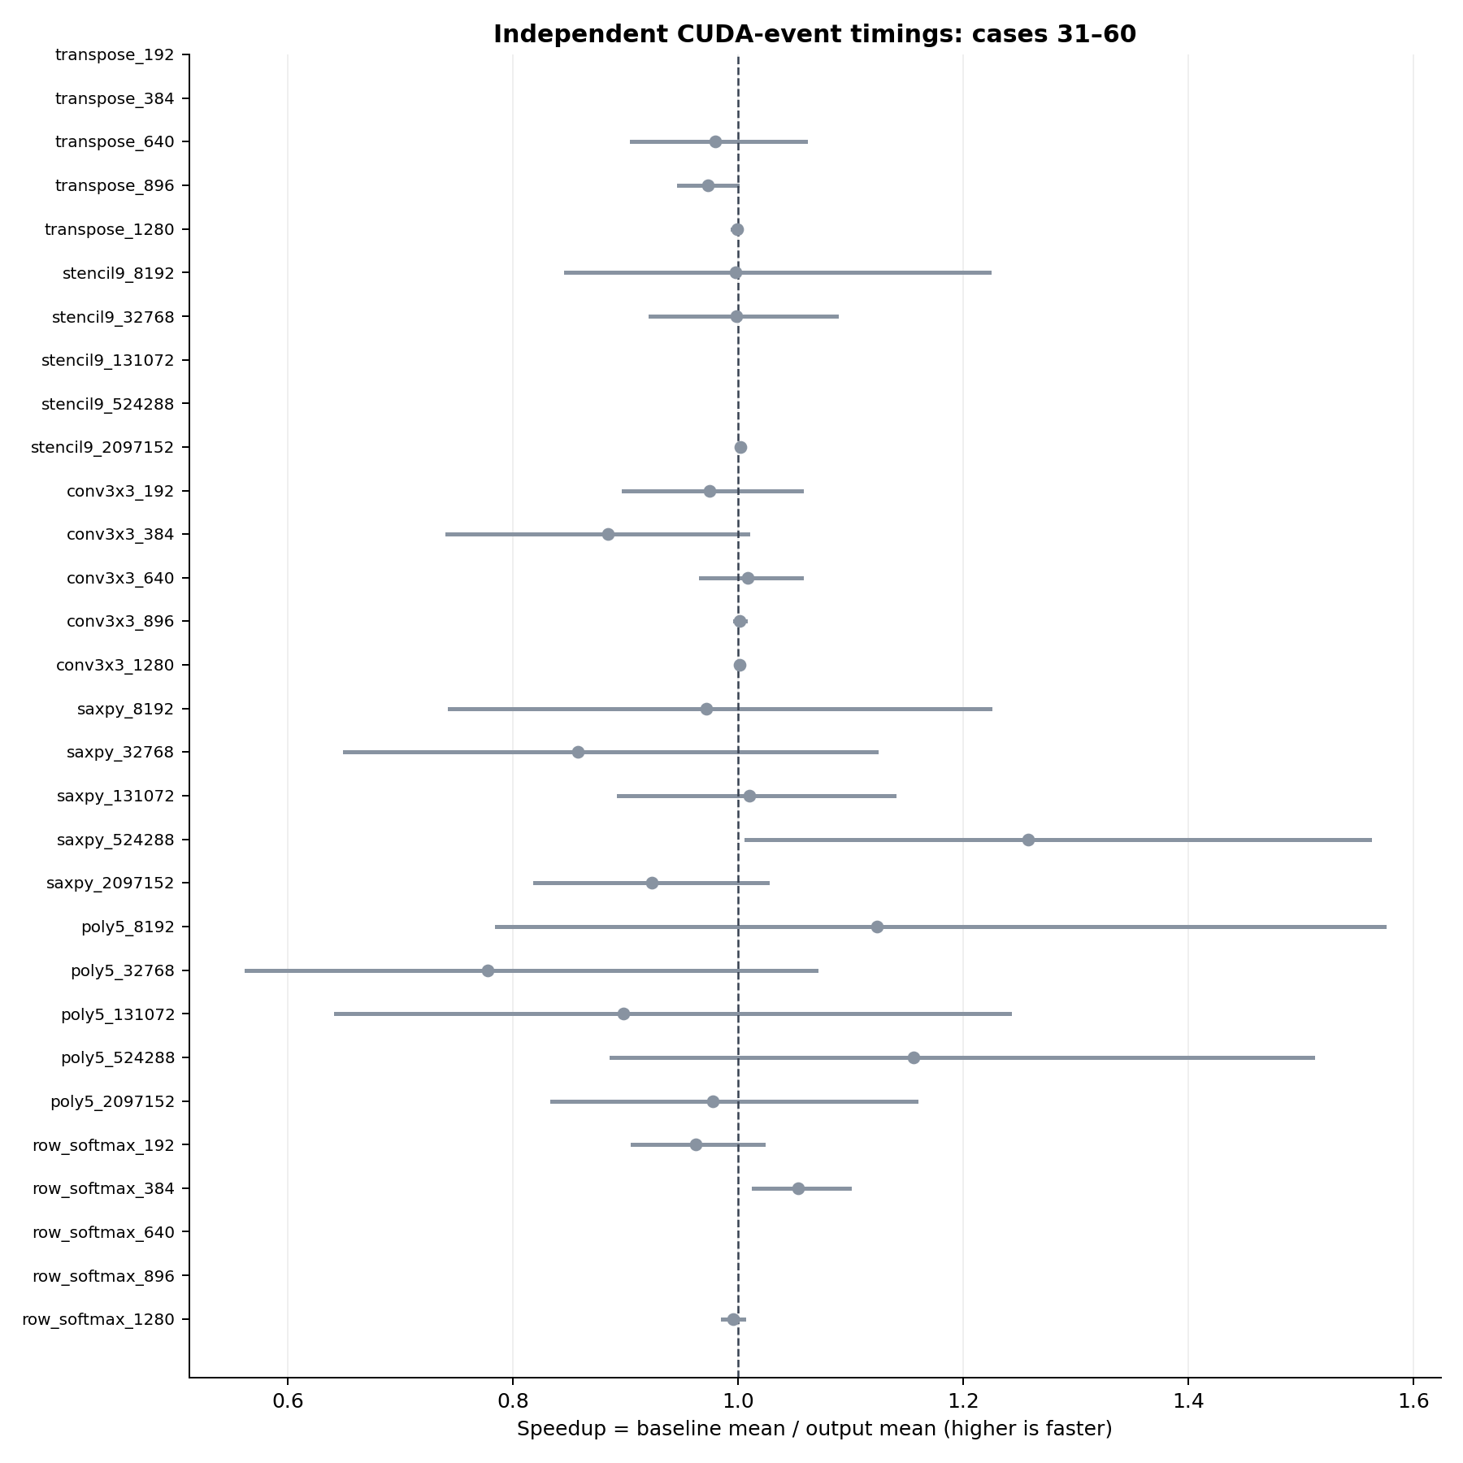
Figure 3. Remaining 30 cases, using the same classification and timing method.
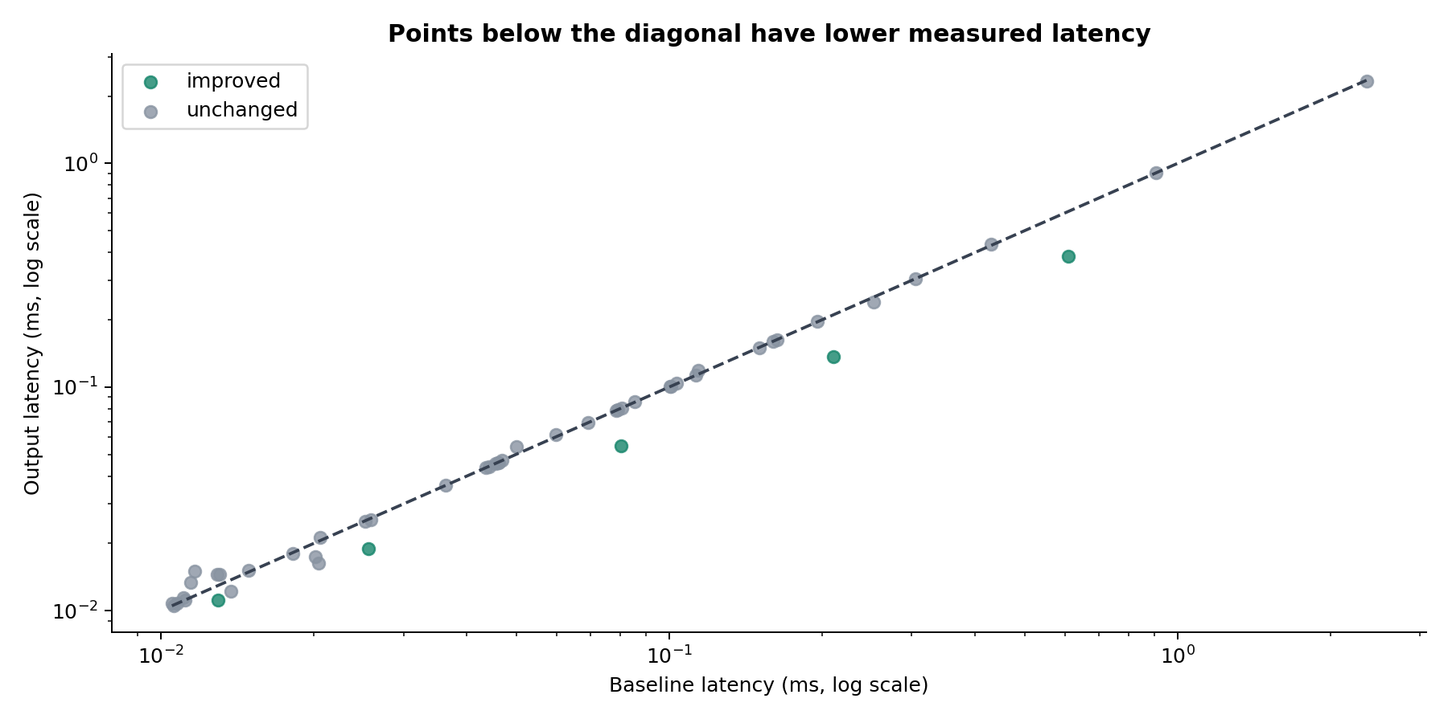
Figure 4. Baseline versus selected-output kernel latency. A point below the diagonal alone does not establish a confirmed improvement.

All 60 case results
Case | Outcome | Base ms | Out ms | × | 95% interval
matmul_96 | improved | 0.012928 | 0.011099 | 1.165 | 1.032–1.380
matmul_192 | improved | 0.025583 | 0.018913 | 1.353 | 1.322–1.386
matmul_320 | improved | 0.080396 | 0.054346 | 1.479 | 1.477–1.481
matmul_448 | improved | 0.210329 | 0.136911 | 1.536 | 1.534–1.539
matmul_640 | improved | 0.608971 | 0.384301 | 1.585 | 1.538–1.619
matmul_transposed_b_96 | failed | — | — | — | —
matmul_transposed_b_192 | unchanged | 0.112894 | 0.113082 | 0.998 | 0.969–1.028
matmul_transposed_b_320 | unchanged | 0.429727 | 0.435062 | 0.988 | 0.976–1.000
matmul_transposed_b_448 | failed | — | — | — | —
matmul_transposed_b_640 | unchanged | 2.354513 | 2.339910 | 1.006 | 0.960–1.066
matvec_192 | unchanged | 0.025903 | 0.025538 | 1.014 | 0.985–1.047
matvec_384 | unchanged | 0.046909 | 0.046902 | 1.000 | 0.995–1.005
matvec_640 | unchanged | 0.080718 | 0.080738 | 1.000 | 0.998–1.002
matvec_896 | unchanged | 0.103526 | 0.103724 | 0.998 | 0.994–1.001
matvec_1280 | unchanged | 0.163124 | 0.162966 | 1.001 | 0.999–1.003
row_sum_192 | failed | — | — | — | —
row_sum_384 | unchanged | 0.046041 | 0.046038 | 1.000 | 0.996–1.007
row_sum_640 | unchanged | 0.078584 | 0.078737 | 0.998 | 0.994–1.002
row_sum_896 | unchanged | 0.100486 | 0.100561 | 0.999 | 0.996–1.002
row_sum_1280 | failed | — | — | — | —
row_dot_192 | unchanged | 0.044277 | 0.044168 | 1.002 | 0.999–1.008
row_dot_384 | unchanged | 0.085603 | 0.085764 | 0.998 | 0.996–1.000
row_dot_640 | unchanged | 0.150173 | 0.150046 | 1.001 | 0.999–1.003
row_dot_896 | unchanged | 0.195852 | 0.196965 | 0.994 | 0.984–1.000
row_dot_1280 | unchanged | 0.305096 | 0.305298 | 0.999 | 0.998–1.000
row_max_192 | unchanged | 0.025264 | 0.025056 | 1.008 | 0.983–1.031
row_max_384 | unchanged | 0.046111 | 0.046044 | 1.001 | 0.997–1.007
row_max_640 | unchanged | 0.079238 | 0.079055 | 1.002 | 0.999–1.007
row_max_896 | unchanged | 0.100781 | 0.100819 | 1.000 | 0.998–1.001
row_max_1280 | unchanged | 0.160171 | 0.160245 | 1.000 | 0.998–1.001
transpose_192 | failed | — | — | — | —
transpose_384 | failed | — | — | — | —
transpose_640 | unchanged | 0.014875 | 0.015186 | 0.980 | 0.905–1.060
transpose_896 | unchanged | 0.020591 | 0.021162 | 0.973 | 0.948–0.999
transpose_1280 | unchanged | 0.045445 | 0.045497 | 0.999 | 0.995–1.002
stencil9_8192 | unchanged | 0.011150 | 0.011179 | 0.997 | 0.847–1.223
stencil9_32768 | unchanged | 0.010767 | 0.010784 | 0.998 | 0.922–1.088
stencil9_131072 | failed | — | — | — | —
stencil9_524288 | failed | — | — | — | —
stencil9_2097152 | unchanged | 0.043602 | 0.043500 | 1.002 | 1.000–1.005
conv3x3_192 | unchanged | 0.010508 | 0.010777 | 0.975 | 0.898–1.056
conv3x3_384 | unchanged | 0.012886 | 0.014571 | 0.884 | 0.741–1.009
conv3x3_640 | unchanged | 0.018186 | 0.018026 | 1.009 | 0.967–1.056
conv3x3_896 | unchanged | 0.036282 | 0.036245 | 1.001 | 0.997–1.006
conv3x3_1280 | unchanged | 0.069345 | 0.069269 | 1.001 | 0.999–1.003
saxpy_8192 | unchanged | 0.011070 | 0.011395 | 0.972 | 0.744–1.224
saxpy_32768 | unchanged | 0.011447 | 0.013343 | 0.858 | 0.651–1.122
saxpy_131072 | unchanged | 0.010612 | 0.010509 | 1.010 | 0.894–1.139
saxpy_524288 | unchanged | 0.020448 | 0.016264 | 1.257 | 1.007–1.561
saxpy_2097152 | unchanged | 0.049976 | 0.054102 | 0.924 | 0.819–1.026
poly5_8192 | unchanged | 0.013717 | 0.012208 | 1.124 | 0.786–1.574
poly5_32768 | unchanged | 0.011641 | 0.014964 | 0.778 | 0.563–1.069
poly5_131072 | unchanged | 0.013021 | 0.014492 | 0.898 | 0.643–1.241
poly5_524288 | unchanged | 0.020112 | 0.017398 | 1.156 | 0.887–1.510
poly5_2097152 | unchanged | 0.059843 | 0.061224 | 0.977 | 0.835–1.158
row_softmax_192 | unchanged | 0.114227 | 0.118704 | 0.962 | 0.906–1.023
row_softmax_384 | unchanged | 0.252705 | 0.239872 | 1.053 | 1.014–1.099
row_softmax_640 | failed | — | — | — | —
row_softmax_896 | failed | — | — | — | —
row_softmax_1280 | unchanged | 0.907619 | 0.911543 | 0.996 | 0.987–1.005

Failed cases and missing evidence
Each case below exited the CLI with code 0 but was rejected by the suite host/signature guard. A source export or successful CLI exit does not establish correctness or speedup. The saved-buffer auditor identifies host unroll-pragma edits for these ten records, but this narrow exception does not supply the missing output buffers or timings. These are validation failures, not demonstrated numerical mismatches. Their CLI-reported speedups are excluded from the performance charts and aggregates.
Failed case | Selected variant | Recorded failure
matmul_transposed_b_96 | input_i4_loop_unrolling | Candidate changed host harness or kernel signature
matmul_transposed_b_448 | input_i6_loop_unrolling | Candidate changed host harness or kernel signature
row_sum_192 | input_i4_loop_unrolling | Candidate changed host harness or kernel signature
row_sum_1280 | input_i7_loop_unrolling | Candidate changed host harness or kernel signature
transpose_192 | input_i6_loop_unrolling | Candidate changed host harness or kernel signature
transpose_384 | input_i6_loop_unrolling | Candidate changed host harness or kernel signature
stencil9_131072 | input_i6_loop_unrolling | Candidate changed host harness or kernel signature
stencil9_524288 | input_i6_loop_unrolling | Candidate changed host harness or kernel signature
row_softmax_640 | input_i7_loop_unrolling | Candidate changed host harness or kernel signature
row_softmax_896 | input_i5_loop_unrolling | Candidate changed host harness or kernel signature

Results by kernel family
Family | Improved | Unchanged | Uncertain | Regressed | Failed
matmul | 5 | 0 | 0 | 0 | 0
matmul_transposed_b | 0 | 3 | 0 | 0 | 2
matvec | 0 | 5 | 0 | 0 | 0
row_sum | 0 | 3 | 0 | 0 | 2
row_dot | 0 | 5 | 0 | 0 | 0
row_max | 0 | 5 | 0 | 0 | 0
transpose | 0 | 3 | 0 | 0 | 2
stencil9 | 0 | 3 | 0 | 0 | 2
conv3x3 | 0 | 5 | 0 | 0 | 0
saxpy | 0 | 5 | 0 | 0 | 0
poly5 | 0 | 5 | 0 | 0 | 0
row_softmax | 0 | 3 | 0 | 0 | 2

Selected transformations
Case | CLI-selected variant | Independent outcome
matmul_96 | input_i9_shared_memory_tiling | improved
matmul_192 | input_i9_shared_memory_tiling | improved
matmul_320 | input_i9_shared_memory_tiling | improved
matmul_448 | input_i9_shared_memory_tiling | improved
matmul_640 | input_i9_shared_memory_tiling | improved

Independent correctness audit

Verification and correctness audit
Existing tests: 114/114 passed; adversarial probes: 11/25 meet expectations, 14 reveal gaps.

Findings

V01 — HIGH: Floating correctness comparison accepts NaN and some infinity mismatches
Evidence: cuda_opt_agent/correctness/file_runner.py:308-314; probes nan_candidate, nan_baseline, both_nan, inf_baseline_finite_candidate, opposite_infinities, both_inf all accepted.
Impact: A broken numeric output can be marked correct and proceed to benchmarking. NaN > tolerance is false; infinite baseline also makes the allowed error infinite.
Recommendation: Reject nonfinite baseline and candidate values for this finite-output contract, or implement an explicit NaN/Inf policy. Validate finite nonnegative tolerances. Add regression tests.

V02 — HIGH: CUDA-event timing accepts invalid values and trusts candidate-controlled stdout
Evidence: cuda_opt_agent/benchmark/timer.py:129-140; nan, inf, -1, and 0 accepted by CudaEventTimer in probes.
Impact: Invalid or fabricated elapsed times can contaminate timing statistics. A generated host harness can print a favorable constant while computing correct output.
Recommendation: Require finite strictly positive samples and trusted timing instrumentation. Freeze host harness or compile kernel-only edits into an immutable harness.

V03 — MEDIUM: Benchmark timeout does not terminate the subprocess
Evidence: cuda_opt_agent/benchmark/timer.py:68-69 and 118-119; HostTimer_kills_timeout and CudaEventTimer_kills_timeout probes observe no kill call.
Impact: A timed-out executable can remain active, consume GPU resources, and distort later measurements. Probe uses mocked subprocesses, not an intentionally hung GPU.
Recommendation: Kill and await the child on timeout/cancellation, and handle process trees when required. File correctness runner already kills its timed-out process.

V04 — HIGH: CLI source export can select an iteration with no successful validation
Evidence: cuda_opt_agent/cli/commands/optimize.py:120-130 and 97-117; failed_baseline_not_emitted probe receives the failed baseline iteration.
Impact: A source file can be emitted despite failed compilation or absent correctness/timing evidence. File existence and CLI success alone do not establish optimized correctness.
Recommendation: Filter export candidates by successful compilation, passed correctness, valid benchmark, and absence of errors; fail export when none qualify.

V05 — LOW: Runnable-source preflight is lexical rather than semantic
Evidence: cuda_opt_agent/cli/commands/optimize.py:133-165; comment_only_contract_rejected probe passes comment-only source through preflight.
Impact: Comments can satisfy the entrypoint/main/output checks. Compilation normally catches invalid source later; this is not by itself a correctness bypass.
Recommendation: Describe this check as a heuristic or use parsed source; retain compilation and executable output checks as authoritative gates.

V06 — MEDIUM: Baseline equivalence is not an independent correctness oracle
Evidence: cuda_opt_agent/agents/coordinator.py:329-336 checks baseline against itself; file_runner.py:128-175 compares variant with baseline. both_wrong_same_value probe demonstrates agreement accepted as designed.
Impact: Matching baseline mistakes and fixed-input specialization can pass. This is an architectural limitation rather than an unexpected unit-test failure.
Recommendation: Provide a trusted CPU/library oracle and multiple shapes/seeds, including boundary dimensions; distinguish equivalence from semantic correctness.

Methodology and limitations
- The audit reviews the working tree used by this suite; existing user changes are preserved and production code is not patched.
- 114 pre-existing correctness, benchmark, and CLI tests passed. The 25 additional adversarial probes use mocked subprocess output, exercising real comparator/timer/selector code without GPU activity; 11 meet expectations and 14 reveal gaps. These are not 14 distinct defects.
- 60 requested benchmark cases comprise 12 synthetic representative families at five sizes each, not 60 independent algorithms or NVIDIA-authored source.
- Suite harness independently checks finite outputs, exact byte counts, and NumPy float64 references at (N,0), (N+3,1), and (N-1,7), for baseline and selected source. Input data use deterministic uint32 hashing and dyadic values.
- Suite harness requires host and signature preservation except explicitly allowed full-line unroll pragmas; finite positive timing samples are mandatory. Exact CLI output is compiled, without silently reconstructing the host. Auditor separately re-reads saved buffers using its own oracle expressions, checks host main under the same narrow pragma exception, timing divisor, hashes, and timing arithmetic.
- Loop-unroll transforms can insert pragmas on host input/warmup/launch loops as well as the device kernel. These edits preserve work counts, but host launch pacing within the CUDA-event interval can change. Reported speedup therefore measures the complete CLI-produced implementation, not exclusively device instruction changes. Ten saved source-guard failures remain unvalidated; identifying pragma-only host changes does not replace missing correctness buffers and timings.
- An initial harness divisor error (30 launches divided by 60) was found during review and corrected to 30 before any completed result. The interrupted preliminary optimizer log is preserved.
- Independent timings comprise 12 alternating process samples per version, each containing five warmups and 30 CUDA-event-timed launches. Confidence intervals are bootstrap intervals from this local sample, not cross-device guarantees.
- No compute-sanitizer/racecheck evidence is included; numerical checks do not prove absence of all memory errors, races, or errors on all inputs.
- The desktop GPU, WDDM scheduling, fixed run order, short kernels, and multiple related comparisons limit inference. No multiplicity correction is applied to per-case confidence intervals.

Saved-result independent review
{
"cases_checked": 60,
"cases_passed": 50,
"host_unroll_pragma_cases": 10,
"buffer_checks": 300,
"buffer_checks_passed": 300
}
Re-run from repository root: .venv/Scripts/python.exe workspace/suite60_20261028/audit/verify_saved_results.py, then build_audit.py.

Reproduction and evidence
From the repository root, run .venv\Scripts\python.exe -m workspace.suite60_20261028.run_suite. The runner resumes saved completed cases; use a separate output directory for a fresh repeat. Build this report with python workspace/suite60_20261028/build_report.py.
The suite directory contains manifest.json, results.json, results.csv, run_suite.py, audit/ and figures/. Each case preserves input.cu, output.cu, command.json, config.yaml, optimize.log and result.json; compiled binaries and correctness buffers exist where execution reached those stages. Audit files preserve existing test output and adversarial probe evidence. Source and result SHA-256 hashes are recorded in evidence_sha256.json.

