

**Software Design Document -**

**UML Diagrams**

**for**

**Python Onboarding**

**For Incoming Students**

**(POFIS)**

**Version 0.1**

**Prepared by**

**Group Name: Saab**

|  |  |  |
| --- | --- | --- |
| **Rebecca Daniel** | **11585986** | **rebecca.daniel@wsu.edu** |
| **Andrew Cornish** | **11571297** | **andrew.cornish@wsu.edu** |
| **Samuel Dunn** | **11453733** | **samuel.i.dunn@wsu.edu** |
| **Abdi Vicenciodelmoral** | **11554779** | **a.vicenciodelmoral@wsu.edu** |

**Date:** **11/08/2019**

Contents

1 Activity Diagrams 1

1.1 New User 1

1.2 Registered User 2

2 Structural Modeling 3

2.1 Current Class Diagram 3

3 Behavorial Modeling 4

3.1 Sequence Diagram 4

**1 Activity Diagrams**

Section one provides current activity diagrams for complex use case scenarios.

**1.1 New user**

The activity diagram (figure 1) models the scenario of a new or unregistered user interacting with the POFIS system.

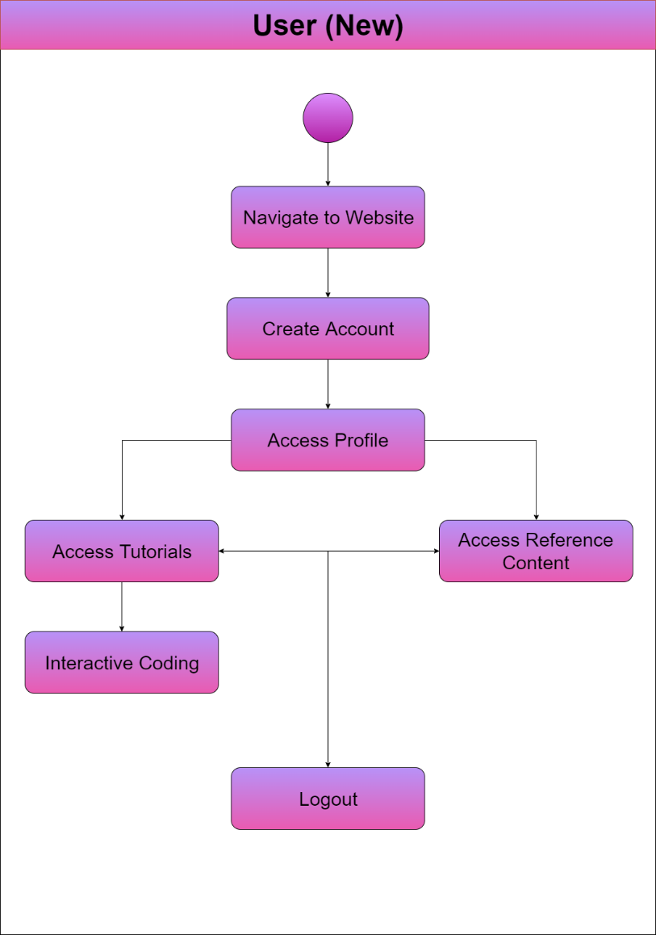

Figure 1: New User diagram

**1.2 Registered User**

The activity diagram (figure 2) models the scenario of a registered user interacting with the POFIS system.

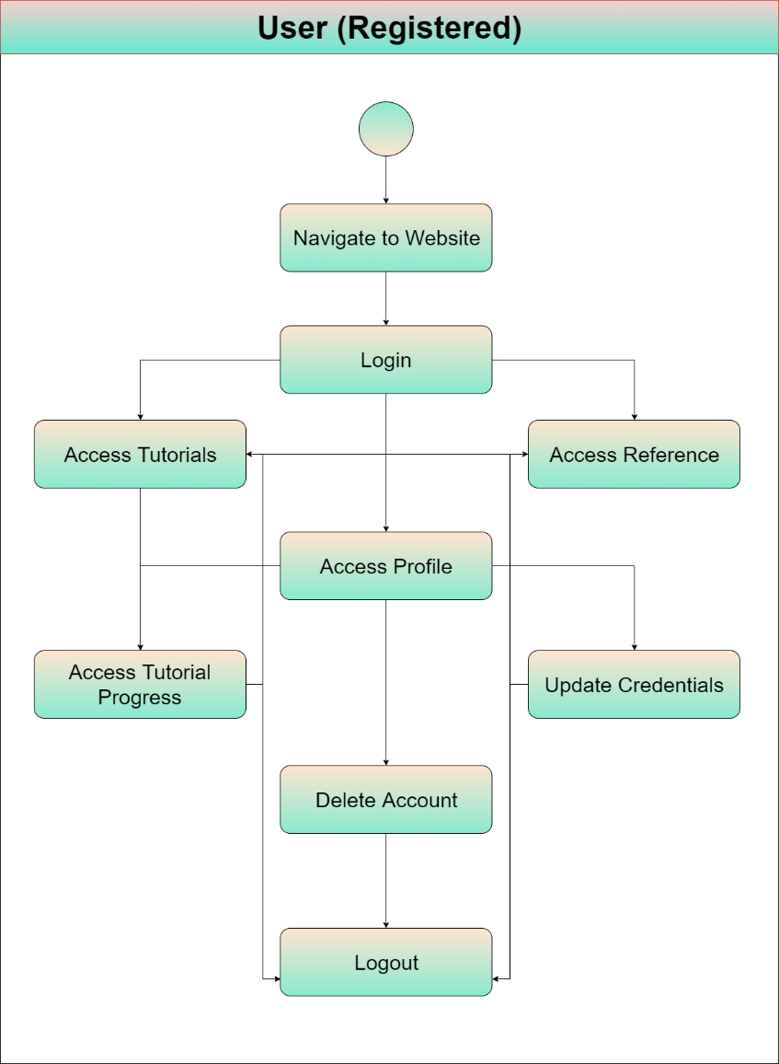

Figure 2: Registered User diagram

**2 Structural Modeling**

Section two provides the current class diagram for the system.

**2.1 Current Class Diagram**

The class diagram (figure 3) models the current structure of the POFIS system. It is expected that this structure may need to be modified during the process of coding.

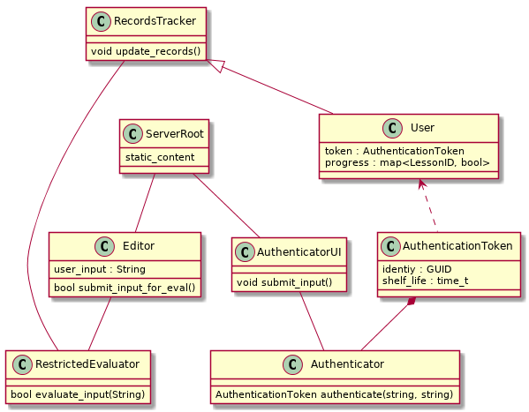

Figure 3: Class diagram

**3 Behavioral Modeling**

Section three provides the current state diagram for the POFIS system.

**3.1 Current Behavioral Diagram**

The state diagram (figure 4) represents the current structure of the POFIS system. It is expected that the structure may change during the process.

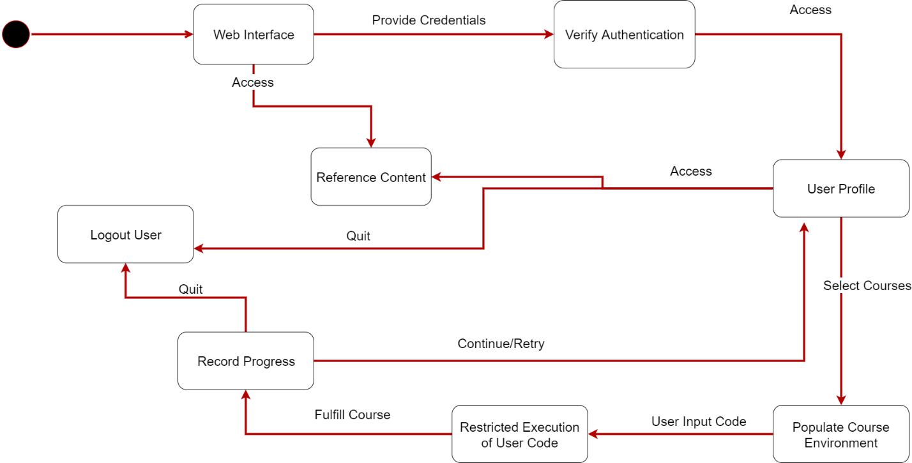

Figure 4: Behavioral diagram