15/12/2023
Data Visualization Project
Semin Islamovic BSHDS2
x22434792
National college of ireland

Introduction

Data source background:

The data sources that were chosen for this project is the COVID-19 and its impact on students’ dataset [1] and the students stress responses dataset [2]. These datasets were obtained from the public online dataset website called Kaggle. The first dataset is a survey student response that was conducted in India that contains real-world data showcasing the effects of the global pandemic on various aspects of health, stress, rating, and time spent on different platforms. The second dataset shows the stress levels on different variables pre and post COVID-19 in different countries. To create visualisations for this project, it is crucial to understand the background of the data source. These pandemic impact datasets offer a comprehensive view of the consequences of the pandemic on students which allows us to create insightful visual representations that can demonstrate the key factors at play.

Data Characteristics:

The nature of these datasets is mixed with quantitative and qualitative data. First dataset is comprised of 19 variables and contains a total of 1182 records. Variable examples include Time spent in online class/social media/fitness/sleep, change in weight, ratings, preferred medium and health issues. This dataset was downloaded as a CSV file and is a total file size of 142KB. The second dataset is comprised of 15 variables holds a total of 40 records. Variable example of this dataset includes stress levels before the pandemic and then after. This dataset was also downloaded as a CSV file and is a total file size of 3KB. The relevance and importance of these datasets lie in its ability to provide us with a perspective on the severe consequences of the global health crisis. Below is a visually presented summary table of the obtained datasets.
CRITERIA: | DATASET 1: | DATASET 2:
Source | Kaggle | Kaggle
File Name | “Covid-19 Student response survey” | “Students stress responses”
Size | 142KB | 3KB
File Format | CSV | CSV
Number of Instances | 1182 | 40
Number of Attributes | 19 | 15
File Type | Structured | Structured

Objectives:

Target audience:

Our main target audience encircle academic administrators, students/teachers, and the public that may be interested or concerned with the physical and mental well-being of students during this challenging period. We aim to provide accessible and user-friendly insights for public awareness with many unique visualisations. Academic administrators can use these visualisations to improve educational strategies needs during this situation. Educators will also gain a greater understanding of student’s experiences, which enables for more needed student support. The public will also be informed of these student challenges that they had to come up against. Another audience that can benefit from these insights into the hard challenges faced by students would be educational policymakers.

Information Aim:

Our main aim is to highlight the impact of the COVID-19 pandemic on students mental/physical well-being and their academic experiences. We aim to burrow into aspects such as the unique changes in health, stress, learning methods, fitness, and variation in access to academic resources. By the effective use of visualisations, we pursue to enrich a comprehensive understanding of the tough challenges faced by students during this pandemic period. We hope to aim to reveal the drastic change in stress levels pre pandemic and post pandemic. Additionally, we also aim to identify any trends and correlations that may reveal future educational methods.

Narrative Direction:
The narrative will start off by first examining the change in learning modalities that was forced to be brought in by the pandemic, including online learning. We’ll also explore the mental health aspect by investigating the patterns and trends in stress and anxiety pre and post pandemic among these students. The narrative will then switch to the physical health aspect, exploring the effect on fitness levels and weight change during this period of online learning. The narrative will also then turn to variation in resources, mentioning issues such as the remote divide and academic support. We will also explore the connections between preferred medium for online learning and time spent on sleep, social media, and self-study. Finally, we aim to reveal the difficult interplay between these various variables and their significant impact on the students’ academic performance and experiences. This narrative direction hopes to contribute to better support to students in hard and challenging periods of crisis such as this COVID-19 global pandemic.

Design Process:

Ideation:

During the ideation stage, I deeply engaged in brainstorming periods to identify the key dimensions and various aspects related to the topic of the impact of COVID-19 on students. I firstly considered the variables of the student experience during this global virus, including academic aspects, mental health, physical health, and resource challenges. I came up with some research questions such as How have the learning modalities changed? What are the drastic changes in mental and physical health among the students? What are the overall thoughts on remote learning from the students?
During brainstorming, educators and online experts together created a range of ideas and hypotheses to be carried out. These ideas were then sketched out, which formed the basis for potential visualisations that could help us effectively display the information of the datasets. I then explored different visualisation methods which are appropriate for each aspect. For example, line charts were considered to showcase the trends in preferred learning modalities and heatmaps for showcasing stress levels before and after pandemic.
Data Processing:
Firstly, we carried out the process of selecting and obtaining relevant datasets. This involved matching the available data with our brainstormed ideas and exploring how to translate this data into clear and user-friendly visualisations. Data cleaning was an essential step to undertake to avoid any null values or outliers in our selected datasets. This ensured that our visualisations would come out as reliable and accurate. The next major step we had to undertake was data transformation. This involved converting data into a format that is appropriate for our visualisations. One example includes for the preferred learning modalities, we transformed categorical values into numerical representations. The final step we carried out was structuring the data into suitable representation techniques. Demographic data was planned for pie charts or bar charts and other variables such as learning modalities was originally organised for line charts.

Iterations:

Slight adjustments were made to the visualisations such as colour schemes, detailed labelling, and overall clear and tidy layout of the visualisation. This iteration hoped to improve the effectiveness of the visualisations in communicating the insights about the impact of the COVID-19 pandemic on students. Some specific focused areas during the iteration process included introducing user-friendly features, simplifying, and adjusting the presentation of complex data information. These improvements would ensure that the final product of the visualisation was clear, user-friendly, and accessible to an audience of all skills and non-skills of visualisations. The iteration process then continued until the visualisations achieved a steady balance between user expectations and simplicity.

Design choices:

Techniques and Layout:

In choosing the suitable visualisation techniques and layouts for this project on the impact of COVID-19 on students, careful and observed consideration was given to effectively convey the compact and heavy information while making sure the clarity is steady. The first technique I used was the word cloud. This was chosen to visualise what students miss the most during their time in lockdown. This allows us to easily identify the key words and phrases which were most frequently mentioned by the students.
The next technique used was the Pie chart. This was utilised to clearly show the most popular preferred modes of social media that was used during this pandemic. Each slice of the pie shows how popular the social media platform is by the size. The next technique used was a Bar-chart to represent the different student online class experiences. This was ideal as it is simple to identify which rating was most popular and least popular.

Styling:

Clear styling and labels were applied to these visualisations to further enhance the visual representation and user-friendliness of the selected visualisations. The colour background for the word cloud was selected as black. This was carefully chosen to align with the theme of stand-out, promoting a visually appealing cloud of colourful words. Clear and neat labels showing the name and values was utilized in most of the visualisations allowing the audience to notice the information provided straight away at first glance.

Interactivity features:

To engage with the audience and broaden the exploration of the selected data, some interactive features were applied into specific visualisations. Dropdown filters were applied to the health issue scatter plot. The dropdown menu on the right-hand side of the plot allowed users to select their own desired viewing choices and what they wanted to know specifically.

Colour choices:

The colour choices were aimed to overall enhance the visual representation while making sure it is effective. The Blue-Red colour gradient was applied to the Bar-chart to represent blue as the most popular to red being the least popular to differentiate it clearly and logically. This then aids the user to quickly interpret popularity among online class experiences. As mentioned before, a black background was used for the word cloud as I found it the best option to make the multi coloured words stand out better to the viewing audience. Pie-chart also similarly uses a multi colour palette with a white separator border to make it look more visually appealing.

Development of Design:

Each of the visualisations that I have shown-cased in the below section have been created in the software Tableau.

Static Visualisations:

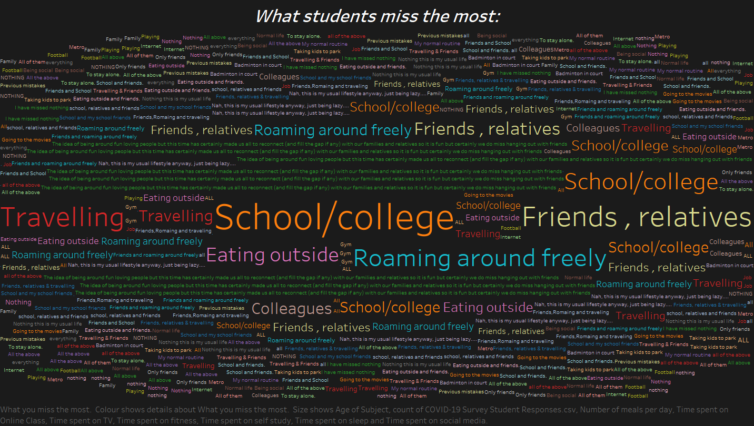
The first visualisation created was the word cloud which shows all words and sentences on what students miss the most during their period in lockdown. This word cloud clearly represents most popular answers by size allowing for a quick and brief first glance idea. As shown in the word cloud, we can easily identify that school/college, friends, relatives, travelling, eating outside and roaming outside were the most common answers given by the students.

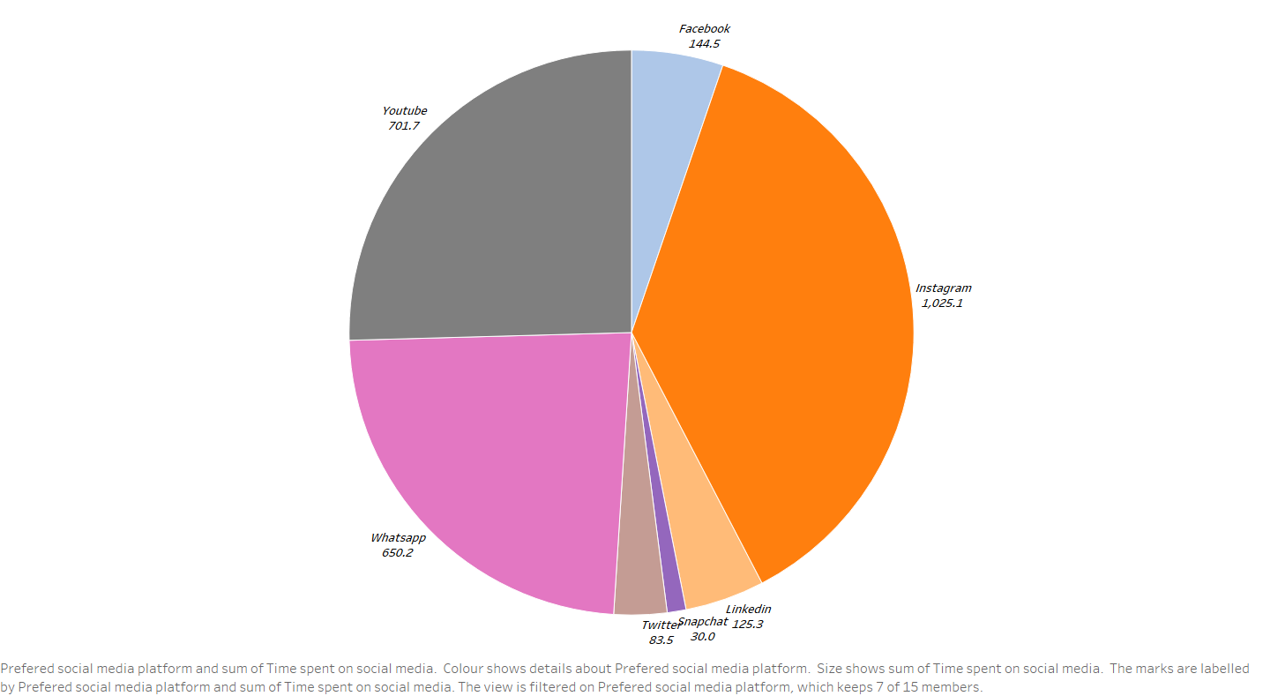
The next visualisation created was the Pie-chart. This visualisation main aim to represent the most preferred social media platform during the period of the pandemic. Each slice of the pie clearly represent a specific social media platform which a label showing the name and value. Three of the biggest slices are clearly as shown above Instagram, WhatsApp and YouTube. We can conclude that these were the most used social media platforms in Delhi.
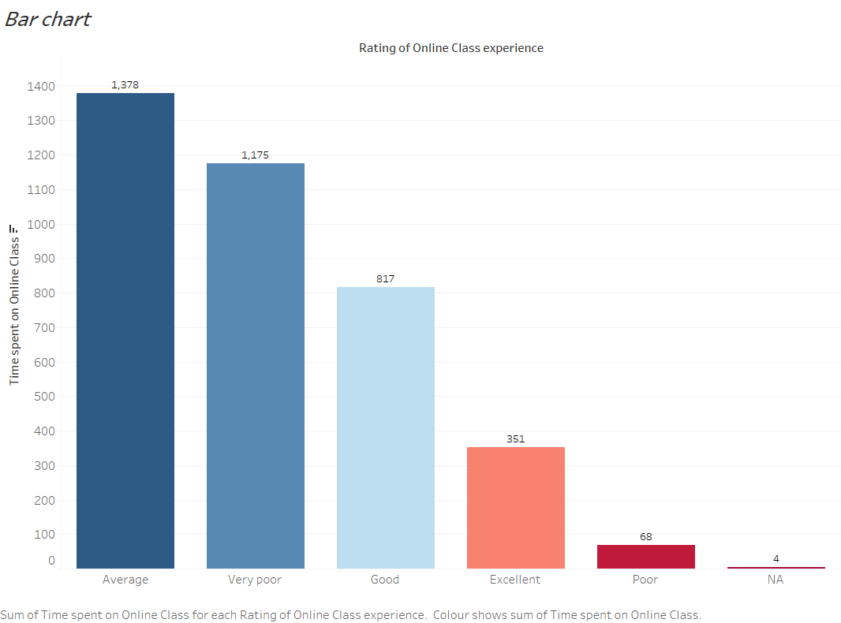

A Bar-chart was then created to show the rating of online class by students. We arranged the bars in descending order to make the most and least popular ratings stand out to easily identify. In this case, average, very poor and good were the highest. We can say that online class may need slight improvements overall to improve the ratings to better and excellent.
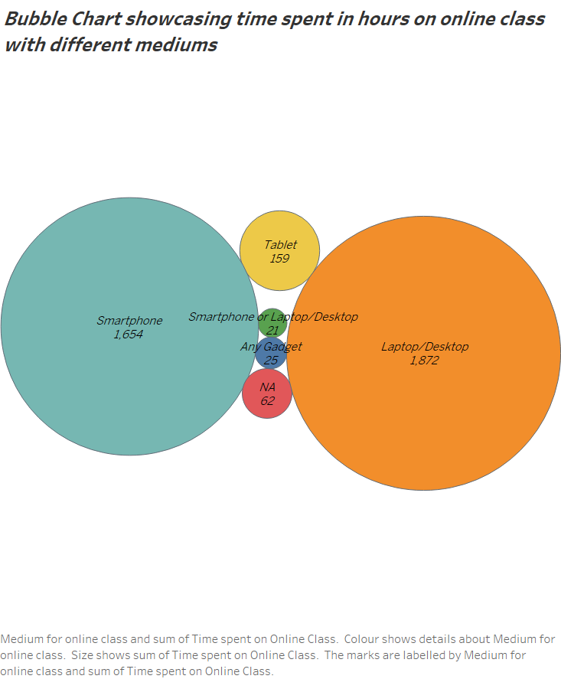
The last but not least static visualisation created was the bubble chart showing the most preferred medium during lockdown. The bubble size shows the popularity by number of the medium. By looking at the visualisation we can see that smartphone and laptops are by far the most popular medium used. There Is a very huge gap in numbers between them and the rest of the types.

Interactive Visualisations:

The link to the Public Tableau server where I created my interactive visualisations can be found here:
https://public.tableau.com/app/profile/semin.islamovic/viz/InteractiveVisualisationsProjectSeminIslamovic/Dashboard1?publish=yes
The first interactive visualisation I created was the scatter plot showing the health issues on students during lockdown. Judging by the plot, we can see that less time spent on fitness and more time on online class/social media leads to an increase in overall weight. The interactivity feature lets you choose different optionality on what you what to figure out first. The other two visualisations are consisted of a tree map and bubble chart. Tree map shows health issues with different stress busters while the bubble chart demonstrates change in weight depending on time spent on watching TV. Both visualizations include hover interactive features to allow the user to view the information provided when hovered above a certain sector.

Conclusion:

Reflection on Objective:

Our main aim was to create visualisations that effectively show the multifaceted impact of the global pandemic on students’ lives. Through the mixture of both static and interactive visualisations, we provided a holistic view of various experiences, ranging from online class experiences to health and overall well-being.

Insights and patterns:

Each visualisation revealed different insights and patterns. For example, the Bar-chart showcasing the popularity of each online class ratings highlighting that improvements need to be made for future online class engagement.

Challenges and Feedback:

The journey in completing this project was not without challenges. Trying to first find the right and appropriate dataset for creating visualisations was the hardest task in my opinion. Making sure the data was accurate and relevant posed some hurdles also. Data processing and data cleaning was a bit time consuming but is an essential factor for analysis. Feedback received during the project development was key to improving visualisations. The dropdown filter was deemed to be intuitive which offered a more focused lens on specific aspects of health issues.

Potential Expansions:

Without a doubt, further explorations could be addressed. Any future projects could look into deeper demographic analysis. An analysis of open-ended responses could also be incorporated. Finally, I also think the exploration of online education beyond the pandemic could also be vital and beneficial.

References:

[1] ‘COVID-19 and its Impact on Students’. Accessed: Dec. 03, 2023. [Online]. Available: https://www.kaggle.com/datasets/kunal28chaturvedi/covid19-and-its-impact-on-students
[2] ‘Find Open Datasets and Machine Learning Projects | Kaggle’. Accessed: Dec. 06, 2023. [Online]. Available: https://www.kaggle.com/datasets

