**METRICS COMPARISON**

MAE:

🖥️ SYSTEM INFORMATION

==================================================

OS: Linux 6.1.123+

Processor: x86_64

CPU Cores: 4 physical, 8 logical

RAM: 51.0 GB

GPU: Tesla T4

GPU Memory: 14.7 GB

Library versions:

NumPy: 2.0.2

PyTorch: 2.8.0+cu126

TensorFlow: 2.19.0

Scikit-learn: 1.6.1

Numba: 0.60.0

🚀 COMPREHENSIVE BENCHMARK OF MAE IMPLEMENTATIONS

================================================================================

📊 Data size: 1,000 elements

--------------------------------------------------

NumPy: 0.011ms ± 0.002ms

NumPy Manual: 0.006ms ± 0.001ms

Sklearn: 0.326ms ± 0.036ms

Numba Basic: 0.001ms ± 0.001ms

Numba Parallel: 0.021ms ± 0.005ms

Numba Vector: 0.001ms ± 0.001ms

PyTorch CPU: 0.015ms ± 0.001ms

PyTorch GPU: 0.104ms ± 0.055ms

TensorFlow CPU: 0.208ms ± 0.025ms

TensorFlow GPU: 0.449ms ± 0.034ms

🏆 Best result: Numba Basic (0.001ms)

📊 Data size: 10,000 elements

--------------------------------------------------

NumPy: 0.016ms ± 0.002ms

NumPy Manual: 0.012ms ± 0.002ms

Sklearn: 0.338ms ± 0.035ms

Numba Basic: 0.004ms ± 0.001ms

Numba Parallel: 0.022ms ± 0.006ms

Numba Vector: 0.006ms ± 0.002ms

PyTorch CPU: 0.022ms ± 0.005ms

PyTorch GPU: 0.123ms ± 0.012ms

TensorFlow CPU: 0.227ms ± 0.023ms

TensorFlow GPU: 0.432ms ± 0.026ms

🏆 Best result: Numba Basic (0.004ms)

📊 Data size: 100,000 elements

--------------------------------------------------

NumPy: 0.108ms ± 0.009ms

NumPy Manual: 0.101ms ± 0.007ms

Sklearn: 0.576ms ± 0.041ms

Numba Basic: 0.040ms ± 0.005ms

Numba Parallel: 0.030ms ± 0.006ms

Numba Vector: 0.073ms ± 0.008ms

PyTorch CPU: 0.069ms ± 0.009ms

PyTorch GPU: 0.376ms ± 0.021ms

TensorFlow CPU: 0.432ms ± 0.031ms

TensorFlow GPU: 0.445ms ± 0.051ms

🏆 Best result: Numba Parallel (0.030ms)

📊 Data size: 1,000,000 elements

--------------------------------------------------

NumPy: 1.109ms ± 0.047ms

NumPy Manual: 1.086ms ± 0.033ms

Sklearn: 2.111ms ± 0.122ms

Numba Basic: 0.659ms ± 0.041ms

Numba Parallel: 0.106ms ± 0.008ms

Numba Vector: 0.899ms ± 0.042ms

PyTorch CPU: 0.416ms ± 0.132ms

PyTorch GPU: 1.910ms ± 0.072ms

TensorFlow CPU: 0.928ms ± 0.090ms

TensorFlow GPU: 0.449ms ± 0.024ms

🏆 Best result: Numba Parallel (0.106ms)

📊 Data size: 10,000,000 elements

--------------------------------------------------

NumPy: 27.470ms ± 0.541ms

NumPy Manual: 27.866ms ± 0.702ms

Sklearn: 37.403ms ± 1.054ms

Numba Basic: 24.796ms ± 0.861ms

Numba Parallel: 1.422ms ± 0.064ms

Numba Vector: 46.790ms ± 1.163ms

PyTorch CPU: 16.942ms ± 0.560ms

PyTorch GPU: 18.147ms ± 0.399ms

TensorFlow CPU: 14.432ms ± 0.421ms

TensorFlow GPU: 1.194ms ± 0.043ms

🏆 Best result: TensorFlow GPU (1.194ms)

📊 Data size: 100,000,000 elements

--------------------------------------------------

NumPy: 301.358ms ± 3.435ms

NumPy Manual: 304.851ms ± 5.414ms

Sklearn: 385.735ms ± 5.066ms

Numba Basic: 278.911ms ± 4.477ms

Numba Parallel: 17.138ms ± 1.229ms

Numba Vector: 478.399ms ± 5.638ms

PyTorch CPU: 170.574ms ± 16.395ms

PyTorch GPU: 180.120ms ± 1.385ms

TensorFlow CPU: 132.954ms ± 8.879ms

TensorFlow GPU: 9.908ms ± 0.107ms

🏆 Best result: TensorFlow GPU (9.908ms)

================================================================================

📈 DETAILED PERFORMANCE ANALYSIS

================================================================================

🔍 Data type analysis (size: 1,000,000)

--------------------------------------------------

Data type: <class 'numpy.float32'>

NumPy: 1.122ms

Numba: 0.685ms (speedup: 1.64x)

Data type: <class 'numpy.float64'>

NumPy: 2.198ms

Numba: 1.388ms (speedup: 1.58x)

⚡ Numba compilation overhead analysis

--------------------------------------------------

Compilation time: 0.018ms

Execution time: 0.004ms

Compilation overhead: 4.3x

🖥️ GPU analysis

--------------------------------------------------

Size 1,000,000: CPU 0.420ms, GPU 1.948ms (speedup: 0.22x)

Size 10,000,000: CPU 18.207ms, GPU 18.000ms (speedup: 1.01x)

Size 100,000,000: CPU 180.752ms, GPU 180.911ms (speedup: 1.00x)

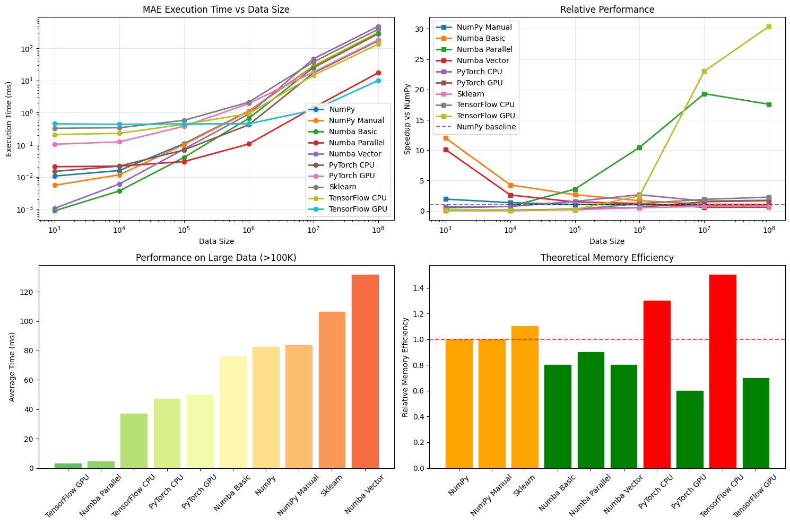

========================================================================

🎯 FINAL RECOMMENDATIONS

========================================================================

📊 GENERAL MAE PERFORMANCE RECOMMENDATIONS:

🥇 FOR MAXIMUM SPEED:

• Numba (jit) - best choice for CPU computations

• PyTorch GPU - for very large arrays with GPU

• Parallel Numba - for multi-core systems

⚖️ FOR SPEED/SIMPLICITY BALANCE:

• Sklearn - optimized C implementation

• NumPy - simplicity and reliability

• PyTorch CPU - if already using PyTorch

🔄 FOR DIFFERENT DATA SIZES:

• < 10K elements: Sklearn or NumPy

• 10K - 1M elements: Numba

• > 1M elements: Numba Parallel or PyTorch GPU

⚠️ AVOID:

• TensorFlow for simple computations (large overhead)

• GPU for small data (transfer overhead)

• First Numba call in production (compile overhead)

💡 OPTIMIZATIONS:

• Use float32 instead of float64 when possible

• Pre-compile Numba functions in advance

• Batching for GPU operations

• Avoid copying data between devices

RMSE:

🖥️ SYSTEM INFORMATION

==================================================

OS: Linux 6.1.123+

Processor: x86_64

CPU Cores: 4 physical, 8 logical

RAM: 51.0 GB

GPU: Tesla T4

GPU Memory: 14.7 GB

Library versions:

NumPy: 2.0.2

PyTorch: 2.8.0+cu126

TensorFlow: 2.19.0

Scikit-learn: 1.6.1

Numba: 0.60.0

🚀 COMPREHENSIVE BENCHMARK OF RMSE IMPLEMENTATIONS

================================================================================

📊 Data size: 1,000 elements

--------------------------------------------------

NumPy: 0.011ms ± 0.002ms

NumPy Manual: 0.007ms ± 0.002ms

Sklearn: 0.299ms ± 0.022ms

Numba Basic: 0.001ms ± 0.001ms

Numba Parallel: 0.023ms ± 0.009ms

Numba Vector: 0.001ms ± 0.001ms

PyTorch CPU: 0.021ms ± 0.005ms

PyTorch GPU: 0.106ms ± 0.012ms

TensorFlow CPU: 0.240ms ± 0.029ms

TensorFlow GPU: 0.517ms ± 0.038ms

🏆 Best result: Numba Basic (0.001ms)

📊 Data size: 10,000 elements

--------------------------------------------------

NumPy: 0.019ms ± 0.005ms

NumPy Manual: 0.013ms ± 0.002ms

Sklearn: 0.333ms ± 0.031ms

Numba Basic: 0.004ms ± 0.002ms

Numba Parallel: 0.022ms ± 0.005ms

Numba Vector: 0.007ms ± 0.002ms

PyTorch CPU: 0.024ms ± 0.003ms

PyTorch GPU: 0.135ms ± 0.012ms

TensorFlow CPU: 0.278ms ± 0.040ms

TensorFlow GPU: 0.498ms ± 0.039ms

🏆 Best result: Numba Basic (0.004ms)

📊 Data size: 100,000 elements

--------------------------------------------------

NumPy: 0.096ms ± 0.009ms

NumPy Manual: 0.086ms ± 0.006ms

Sklearn: 0.516ms ± 0.062ms

Numba Basic: 0.046ms ± 0.006ms

Numba Parallel: 0.029ms ± 0.005ms

Numba Vector: 0.070ms ± 0.007ms

PyTorch CPU: 0.056ms ± 0.008ms

PyTorch GPU: 0.439ms ± 0.060ms

TensorFlow CPU: 0.469ms ± 0.032ms

TensorFlow GPU: 0.495ms ± 0.027ms

🏆 Best result: Numba Parallel (0.029ms)

📊 Data size: 1,000,000 elements

--------------------------------------------------

NumPy: 0.940ms ± 0.031ms

NumPy Manual: 0.934ms ± 0.034ms

Sklearn: 1.901ms ± 0.105ms

Numba Basic: 0.664ms ± 0.038ms

Numba Parallel: 0.119ms ± 0.115ms

Numba Vector: 0.897ms ± 0.040ms

PyTorch CPU: 0.549ms ± 0.066ms

PyTorch GPU: 1.946ms ± 0.069ms

TensorFlow CPU: 0.994ms ± 0.070ms

TensorFlow GPU: 0.538ms ± 0.048ms

🏆 Best result: Numba Parallel (0.119ms)

📊 Data size: 10,000,000 elements

--------------------------------------------------

NumPy: 18.608ms ± 0.624ms

NumPy Manual: 18.734ms ± 0.630ms

Sklearn: 28.217ms ± 3.118ms

Numba Basic: 24.562ms ± 1.029ms

Numba Parallel: 1.430ms ± 0.111ms

Numba Vector: 47.034ms ± 1.266ms

PyTorch CPU: 16.964ms ± 0.544ms

PyTorch GPU: 18.033ms ± 0.288ms

TensorFlow CPU: 14.052ms ± 0.435ms

TensorFlow GPU: 1.179ms ± 0.028ms

🏆 Best result: TensorFlow GPU (1.179ms)

📊 Data size: 100,000,000 elements

--------------------------------------------------

NumPy: 219.488ms ± 3.191ms

NumPy Manual: 221.008ms ± 3.178ms

Sklearn: 292.445ms ± 4.823ms

Numba Basic: 276.341ms ± 3.893ms

Numba Parallel: 16.743ms ± 1.191ms

Numba Vector: 488.089ms ± 5.303ms

PyTorch CPU: 171.081ms ± 12.821ms

PyTorch GPU: 180.125ms ± 1.574ms

TensorFlow CPU: 134.450ms ± 6.335ms

TensorFlow GPU: 9.910ms ± 0.108ms

🏆 Best result: TensorFlow GPU (9.910ms)

================================================================================

📈 DETAILED PERFORMANCE ANALYSIS

================================================================================

🔍 Data type analysis (size: 1,000,000)

--------------------------------------------------

Data type: <class 'numpy.float32'>

NumPy: 0.975ms

Numba: 0.690ms (speedup: 1.41x)

Data type: <class 'numpy.float64'>

NumPy: 1.741ms

Numba: 1.401ms (speedup: 1.24x)

⚡ Numba compilation overhead analysis

--------------------------------------------------

Compilation time: 0.018ms

Execution time: 0.005ms

Compilation overhead: 3.3x

🖥️ GPU analysis

--------------------------------------------------

Size 1,000,000: CPU 0.334ms, GPU 1.955ms (speedup: 0.17x)

Size 10,000,000: CPU 17.369ms, GPU 17.838ms (speedup: 0.97x)

Size 100,000,000: CPU 169.475ms, GPU 180.857ms (speedup: 0.94x)

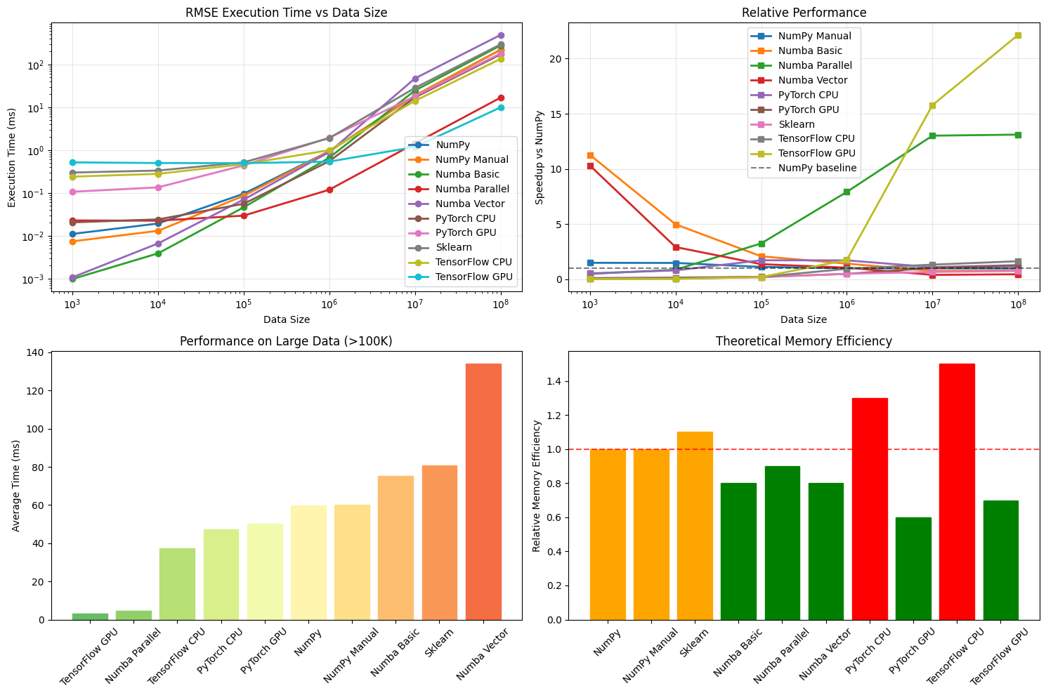

================================================================================

🎯 FINAL RECOMMENDATIONS

================================================================================

📊 GENERAL RMSE PERFORMANCE RECOMMENDATIONS:

🥇 FOR MAXIMUM SPEED:

• Numba (jit) - best choice for CPU computations

• PyTorch GPU - for very large arrays with GPU

• Parallel Numba - for multi-core systems

⚖️ FOR SPEED/SIMPLICITY BALANCE:

• Sklearn - optimized C implementation

• NumPy - simplicity and reliability

• PyTorch CPU - if already using PyTorch

🔄 FOR DIFFERENT DATA SIZES:

• < 10K elements: Sklearn or NumPy

• 10K - 1M elements: Numba

• > 1M elements: Numba Parallel or PyTorch GPU

⚠️ AVOID:

• TensorFlow for simple computations (large overhead)

• GPU for small data (transfer overhead)

• First Numba call in production (compile overhead)

💡 OPTIMIZATIONS:

• Use float32 instead of float64 when possible

• Pre-compile Numba functions in advance

• Batching for GPU operations

• Avoid copying data between devices

R2:

🖥️ SYSTEM INFORMATION

==================================================

OS: Linux 6.1.123+

Processor: x86_64

CPU Cores: 4 physical, 8 logical

RAM: 51.0 GB

GPU: Tesla T4

GPU Memory: 14.7 GB

Library versions:

NumPy: 2.0.2

PyTorch: 2.8.0+cu126

TensorFlow: 2.19.0

Scikit-learn: 1.6.1

Numba: 0.60.0

🚀 COMPREHENSIVE BENCHMARK OF R² SCORE IMPLEMENTATIONS

================================================================================

📊 Data size: 1,000 elements

--------------------------------------------------

NumPy: 0.022ms ± 0.003ms → R²: 0.992513

NumPy Manual: 0.782ms ± 0.045ms → R²: 0.992513

NumPy Optimized: 0.018ms ± 0.003ms → R²: 0.992513

Sklearn: 0.489ms ± 0.068ms → R²: 0.992513

Numba Basic: 0.001ms ± 0.001ms → R²: 0.992513

Numba Parallel: 0.021ms ± 0.004ms → R²: 0.992513

Numba Vector: 0.002ms ± 0.001ms → R²: 0.992513

PyTorch CPU: 0.047ms ± 0.008ms → R²: 0.992513

PyTorch GPU: 0.177ms ± 0.031ms → R²: 0.992513

TensorFlow CPU: 0.629ms ± 0.060ms → R²: 0.992513

TensorFlow GPU: 1.093ms ± 0.106ms → R²: 0.992513

🏆 Best result: Numba Basic (0.001ms)

📊 Data size: 10,000 elements

--------------------------------------------------

NumPy: 0.038ms ± 0.007ms → R²: 0.992169

NumPy Manual: 7.570ms ± 0.135ms → R²: 0.992169

NumPy Optimized: 0.028ms ± 0.002ms → R²: 0.992169

Sklearn: 0.460ms ± 0.042ms → R²: 0.992169

Numba Basic: 0.006ms ± 0.001ms → R²: 0.992169

Numba Parallel: 0.025ms ± 0.006ms → R²: 0.992169

Numba Vector: 0.012ms ± 0.003ms → R²: 0.992169

PyTorch CPU: 0.053ms ± 0.009ms → R²: 0.992169

PyTorch GPU: 0.197ms ± 0.015ms → R²: 0.992169

TensorFlow CPU: 0.773ms ± 0.137ms → R²: 0.992169

TensorFlow GPU: 1.103ms ± 0.098ms → R²: 0.992169

🏆 Best result: Numba Basic (0.006ms)

📊 Data size: 100,000 elements

--------------------------------------------------

NumPy: 0.191ms ± 0.020ms → R²: 0.992265

NumPy Manual: 78.107ms ± 1.490ms → R²: 0.992265

NumPy Optimized: 0.194ms ± 0.017ms → R²: 0.992265

Sklearn: 0.789ms ± 0.058ms → R²: 0.992265

Numba Basic: 0.044ms ± 0.005ms → R²: 0.992265

Numba Parallel: 0.050ms ± 0.008ms → R²: 0.992265

Numba Vector: 0.123ms ± 0.013ms → R²: 0.992265

PyTorch CPU: 0.169ms ± 0.024ms → R²: 0.992265

PyTorch GPU: 0.451ms ± 0.022ms → R²: 0.992265

TensorFlow CPU: 1.082ms ± 0.119ms → R²: 0.992265

TensorFlow GPU: 1.086ms ± 0.055ms → R²: 0.992265

🏆 Best result: Numba Basic (0.044ms)

📊 Data size: 1,000,000 elements

--------------------------------------------------

NumPy: 2.024ms ± 0.075ms → R²: 0.992255

NumPy Manual: 757.147ms ± 9.112ms → R²: 0.992255

NumPy Optimized: 2.068ms ± 0.094ms → R²: 0.992255

Sklearn: 3.837ms ± 0.130ms → R²: 0.992255

Numba Basic: 0.544ms ± 0.038ms → R²: 0.992255

Numba Parallel: 0.329ms ± 0.021ms → R²: 0.992255

Numba Vector: 1.644ms ± 0.079ms → R²: 0.992255

PyTorch CPU: 0.716ms ± 0.179ms → R²: 0.992255

PyTorch GPU: 2.028ms ± 0.044ms → R²: 0.992255

TensorFlow CPU: 2.420ms ± 0.405ms → R²: 0.992255

TensorFlow GPU: 1.102ms ± 0.056ms → R²: 0.992255

🏆 Best result: Numba Parallel (0.329ms)

📊 Data size: 10,000,000 elements

--------------------------------------------------

NumPy: 36.613ms ± 0.937ms → R²: 0.992258

NumPy Manual: 7609.530ms ± 39.284ms → R²: 0.992296

NumPy Optimized: 36.748ms ± 0.768ms → R²: 0.992258

Sklearn: 70.461ms ± 1.481ms → R²: 0.992258

Numba Basic: 9.115ms ± 0.383ms → R²: 0.992258

Numba Parallel: 4.525ms ± 0.330ms → R²: 0.992258

Numba Vector: 75.774ms ± 1.208ms → R²: 0.992264

PyTorch CPU: 37.771ms ± 2.657ms → R²: 0.992258

PyTorch GPU: 19.113ms ± 0.298ms → R²: 0.992258

TensorFlow CPU: 29.304ms ± 0.809ms → R²: 0.992258

TensorFlow GPU: 2.173ms ± 0.043ms → R²: 0.992258

🏆 Best result: TensorFlow GPU (2.173ms)

================================================================================

📈 DETAILED PERFORMANCE ANALYSIS

================================================================================

🔍 Data type analysis (size: 1,000,000)

--------------------------------------------------

Data type: <class 'numpy.float32'>

NumPy: 2.195ms → R²: 0.992255

Numba: 0.620ms (speedup: 3.54x) → R²: 0.992255

Data type: <class 'numpy.float64'>

NumPy: 3.663ms → R²: 0.992255

Numba: 0.999ms (speedup: 3.67x) → R²: 0.992255

⚡ Numba compilation overhead analysis

--------------------------------------------------

Compilation time: 0.028ms

Execution time: 0.019ms

Compilation overhead: 1.5x

🖥️ GPU analysis

--------------------------------------------------

Size 1,000,000: CPU 1.143ms, GPU 2.026ms (speedup: 0.56x)

CPU R²: 0.992255, GPU R²: 0.992255

Size 10,000,000: CPU 34.904ms, GPU 19.219ms (speedup: 1.82x)

CPU R²: 0.992258, GPU R²: 0.992258

