The S²-Flow Conjecture Holds for All Goldberg Snarks
  - Analytic reduction, exact interval certificate, and reproducible full-graph verification
21 July 2026
Abstract
We prove that every Goldberg snark Gₖ, for odd k ≥ 5, admits an S²-flow. The cyclic block shift has twelve free edge orbits. The fundamental rotation by 2π/k is shown to be impossible for k ≥ 7, explaining the failure of the initial numerical continuation. A non-fundamental representation of index (k−1)/2, with rotation angle π−π/k, reduces the twelve-vector equivariant system to a single scalar equation H(s,x)=0. Exact rational interval arithmetic proves a uniform sign change and strict monotonicity on a parameter rectangle containing every Goldberg parameter. This yields a unique real-analytic scalar branch and an explicit unit-vector flow on the complete infinite family. The accompanying repository independently verifies the exact interval certificate and performs full-graph numerical checks.
Keywords: Goldberg snark; unit vector flow; S²-flow; equivariant construction; interval arithmetic; cubic graph.

1. Result and scope
An S²-flow on an oriented graph is a map from oriented edges to unit vectors in R³ such that the signed sum of incident edge vectors is zero at every vertex. The universal conjecture asserts that every bridgeless cubic graph admits such a flow [4,5]. This report proves the conjecture for the complete infinite family of Goldberg snarks, not for all bridgeless cubic graphs.
Main Theorem. For every odd integer k ≥ 5, the Goldberg snark Gₖ admits an S²-flow.

2. Goldberg graph and the corrected orbit structure
For every block index t modulo k, let Bₜ be induced by vertices v₁ᵗ,…,v₈ᵗ. The nine internal edges are
v₁v₂, v₁v₇, v₂v₈, v₃v₄, v₃v₈, v₄v₇, v₅v₆, v₆v₇, v₆v₈,
and consecutive blocks are joined by
v₂ᵗv₁ᵗ⁺¹, v₄ᵗv₃ᵗ⁺¹, v₅ᵗv₅ᵗ⁺¹,
with block superscripts read modulo k. This is the standard eight-vertex Goldberg link construction [1–3]. For odd k ≥ 5 these graphs form the Goldberg snark family.
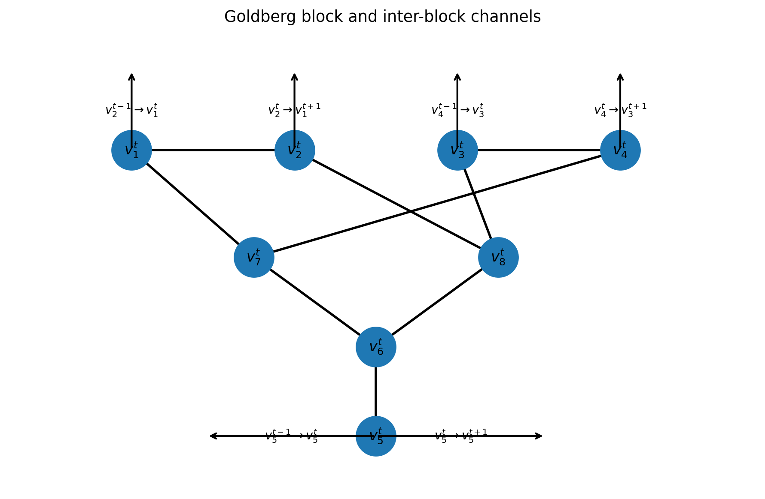
Figure 1. The eight-vertex Goldberg block and its three incoming and three outgoing channels.
Correction to the supplied exploratory code. The cyclic shift t↦t+1 has exactly twelve edge orbits, all of size k. The apparent decomposition into twelve ordinary orbits and three singleton seam orbits was an orbit-canonicalization bug: a seam edge and its shifted non-seam edge belong to the same orbit.

3. Why the fundamental generator fails
Let R be the rotation used to represent one block shift, and orient the channel r from v₅ᵗ to v₅ᵗ⁺¹. The Kirchhoff equation at v₅ reduces to
g + r − R⁻¹r = 0.
Because g must be a unit vector, every equivariant solution must satisfy
||(R⁻¹−I)r|| = 1.
If R has the fundamental angle 2π/k, the operator norm of R⁻¹−I is 2 sin(π/k). For k ≥ 7,
2 sin(π/k) < 1,
so the required unit chord cannot exist. This is a rigorous structural obstruction, not a local-minimum problem. It explains why G₅ was solvable while the same ansatz failed at G₇.

4. Correct cyclic representation
For odd k define
ℓ = (k−1)/2, φ = 2πℓ/k = π−π/k, R = R_z(φ).
Then Rᵏ=I. Put
u = φ/2, x = cot u = tan(π/(2k)).
For k ≥ 5, 0 < x ≤ tan(π/10) < 13/40. The exact inequality follows from tan²(π/10)=1−2√5/5 and direct rational comparison. The complete proof therefore only needs the compact rational domain 0≤x≤13/40.

5. The reduced 36-equation system
Orient the twelve representative edge orbits as a,b,c,d,e,f,g,h,i,p,q,r in the order listed in Table 1. Dividing the Kirchhoff equations in block t by Rᵗ gives eight representative vector equations:
a+b−R⁻¹p=0, −a+c+p=0, d+e−R⁻¹q=0, −d+f+q=0
g+r−R⁻¹r=0, −g+h+i=0, b+f+h=0, c+e+i=0
Together with twelve unit-norm equations, this is the square 36×36 equivariant system. A global rotation about the z-axis gives one gauge direction in the unrestricted numerical formulation. The analytic reduction below fixes that gauge automatically.
Template | Oriented representative | Role
a | v₁ᵗ→v₂ᵗ | first local channel
b | v₁ᵗ→v₇ᵗ | first local channel
c | v₂ᵗ→v₈ᵗ | first local channel
d | v₃ᵗ→v₄ᵗ | second local channel
e | v₃ᵗ→v₈ᵗ | second local channel
f | v₄ᵗ→v₇ᵗ | second local channel
g | v₅ᵗ→v₆ᵗ | central channel
h | v₆ᵗ→v₇ᵗ | central closure
i | v₆ᵗ→v₈ᵗ | central closure
p | v₂ᵗ→v₁ᵗ⁺¹ | inter-block
q | v₄ᵗ→v₃ᵗ⁺¹ | inter-block
r | v₅ᵗ→v₅ᵗ⁺¹ | inter-block
Table 1. Orientation and order of the twelve free edge-orbit templates.

6. Scalar reduction

6.1 Local two-vertex channel
For a scalar y define
z_y=√(1−y²(1+x²)), δ_y=√(3−4y²), λ_y=1−y²,
A_y=(δ_y z_y−yx)/(2λ_y), D_y=(z_y+δ_y yx)/(2λ_y),
B_y=A_y+yx, C_y=D_y−z_y.
Let W_y=(−yx,z_y) in the xz-plane and let J be the quarter-turn in that plane. Since ||W_y||²=λ_y and δ_y²=4λ_y−1, the vector
U_y=(W_y−δ_y JW_y)/(2λ_y)
has unit norm and satisfies U_y·W_y=1/2. Its coordinates are (A_y,D_y). Consequently the four vectors generated by one local channel are all unit vectors and satisfy its two Kirchhoff equations. This proves the local identities algebraically, without numerical optimization.

6.2 Final scalar equation
Set t=1/2−s and define
H(s,x)=(B_t−B_s)²+(C_s−C_t)²−3/4.
The first term controls the horizontal component of the two central closure vectors; the second controls their vertical component. Therefore H(s,x)=0 is exactly the remaining unit-norm condition. All other equations are identities once t=1/2−s.

7. Exact existence, uniqueness, and regularity
The repository contains a decisive certificate computed entirely with integers, exact rational intervals, and outward dyadic square-root bounds. No floating-point arithmetic is used for the following inequalities. The proof covers x∈[0,13/40] and s∈[2/3,21/25].
Certified statement | Exact sign | Conservative decimal bound
H(2/3,x) | strictly negative | < -0.281883
H(21/25,x) | strictly positive | > 0.058561
∂H/∂s | strictly positive | > 1.220892
The endpoint signs are certified on sixteen exact x-subintervals. Strict monotonicity is certified on a 32×32 subdivision of the (s,x)-rectangle at 112 dyadic bits. The stored JSON certificate contains every rational enclosure and is independently recomputed by the verifier.
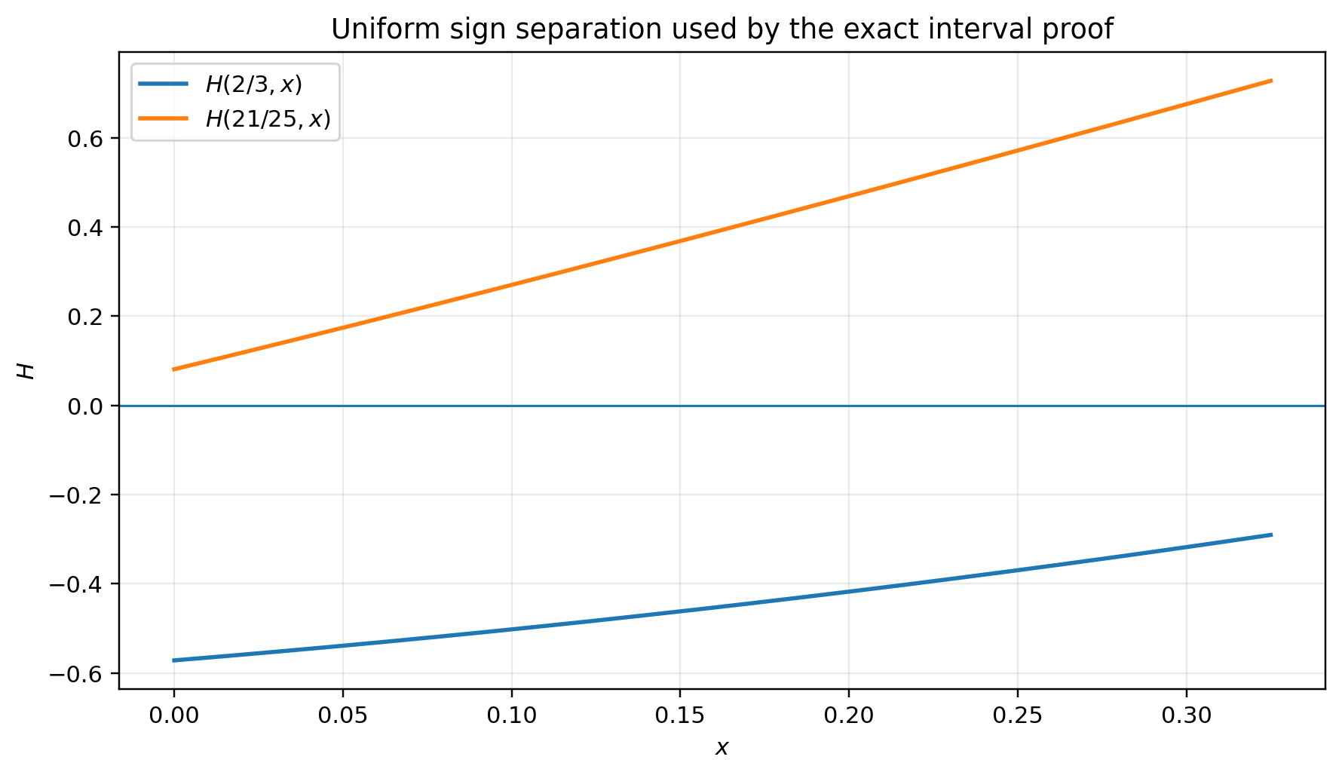
Figure 2. Floating-point visualization of the sign separation that is proved by exact interval arithmetic.
By the intermediate value theorem, for every x in the domain there exists a root s(x)∈(2/3,21/25). Since ∂H/∂s>0, the root is unique. The radicands remain strictly positive on the rectangle, so H is real analytic; the implicit function theorem therefore gives a unique real-analytic branch s(x).
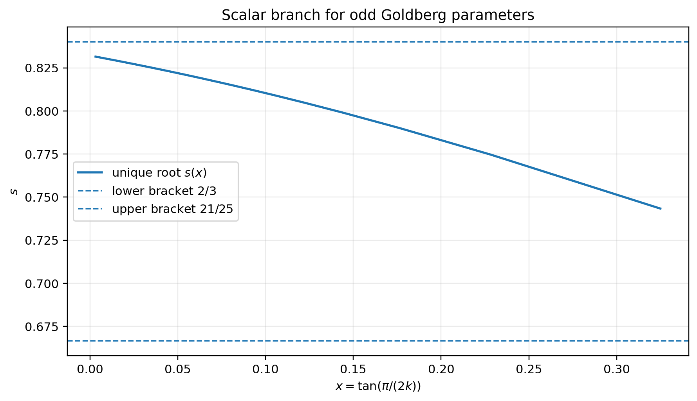
Figure 3. The unique scalar branch sampled at odd Goldberg parameters k=5,…,501.

8. Explicit twelve-template construction
For the unique root s=s(x), put t=1/2−s and define
a=( A_s, 0, D_s), b=(−B_s, s, −C_s), c=( B_s, s, C_s),
d=( A_t, 0, D_t), e=(−B_t, t, −C_t), f=( B_t, t, C_t),
g=(0,−1,0),
h=(B_s−B_t,−1/2,C_s−C_t),
i=(B_t−B_s,−1/2,C_t−C_s),
p=(−sx,−s,z_s), q=(−tx,−t,z_t),
r=(x/2,1/2,√(3−x²)/2).

9. Verification of the construction

9.1 Unit norms
The local-channel lemma gives unit norm for a,b,c,p and d,e,f,q. The vector r is unit by direct calculation. The identity R⁻¹r−r=(0,−1,0) gives the unit vector g. Finally, H(s,x)=0 gives ||h||=||i||=1.

9.2 Kirchhoff equations
- The local-channel identities give a+b=R⁻¹p, c=a−p, d+e=R⁻¹q, and f=d−q.
- The selected r gives g+r=R⁻¹r.
- The definitions give h+i=g.
- Because s+t=1/2, direct componentwise addition gives b+f+h=0 and c+e+i=0.
Thus all eight representative vertex equations hold. For every block shift j, assign Rʲ times the corresponding template to the shifted edge. Orthogonality preserves norms and the representative equations. Since Rᵏ=I, the assignment is consistent at the seam. This completes the proof of the Main Theorem.

10. Reproducibility and independent checks
The exact theorem does not depend on numerical experiments. The experiments provide regression protection for graph indexing, orbit expansion, orientation signs, and implementation errors.
Check | Observed result
Odd parameters | 499 values, k=5,…,1001
Full graph expansions | 149 graphs, k=5,…,301
Worst reduced Kirchhoff residual | 3.036e-16
Worst reduced norm residual | 2.220e-15
Worst full Kirchhoff residual | 7.196e-14
Worst full norm residual | 3.708e-14
Independent large instance | G₁₀₀₁: 8,008 vertices and 12,012 edges
Automated tests | 10 tests passed

10.1 Commands
python -m pip install -r requirements-dev.txt
python -m pip install -e .
python scripts/run_interval_proof.py
python scripts/verify_interval_certificate.py
python scripts/run_numerical_sweep.py --max-k 1001 --full-max-k 301
python scripts/verify_one.py 1001
python -m pytest

11. What has and has not been proved
Proved | Every Goldberg snark Gₖ with odd k≥5 has an explicit Zₖ-equivariant S²-flow; the scalar solution is unique and real analytic in the continuous parameter x.
Not proved | The universal S²-flow conjecture for all bridgeless cubic graphs. The result is a strong infinite-family theorem, not a universal proof.

Appendix A. Proof-certificate configuration
- Certificate schema: goldberg-s2-interval-certificate-v1
- Dyadic precision: 112 bits
- Endpoint partition: 16 x-boxes
- Derivative partition: 32×32 boxes
- Arithmetic: Python integers, fractions.Fraction, integer square root, and outward dyadic enclosures
- Certificate SHA-256: 0a55c601b8e1ea62c350a97da2cbb883cf8448e38f5f96918ba7c19206bfdf93

References
[1] M. K. Goldberg, “Construction of Class 2 Graphs with Maximum Vertex Degree 3,” Journal of Combinatorial Theory, Series B 31 (1981), 282–291.
[2] C. Fiori and B. Ruini, “Infinite Classes of Dihedral Snarks,” Mediterranean Journal of Mathematics 5 (2008), 199–210. DOI: 10.1007/s00009-008-0144-3.
[3] X. Zhang, Y. Wang, and S. Zhang, “Feedback Numbers of Goldberg Snark, Twisted Goldberg Snarks and Related Graphs,” ITM Web of Conferences 25 (2019), 01012. DOI: 10.1051/itmconf/20192501012.
[4] D. Mattiolo et al., “On d-Dimensional Nowhere-Zero r-Flows on a Graph,” arXiv:2304.14231, 2023.
[5] H. Houdrouge et al., “2-Dimensional Unit Vector Flows,” arXiv:2602.21526, 2026.

