Rigorous Equivariance Addendum for Flower-Snark S²-Flows
Exact exclusion of the strict order-2n ansatz, complete all-generator diagnostics, and independently verifiable dyadic Newton-Kantorovich certificates for J5-J41

Reproducibility package revision - 19 July 2026

1. Executive summary and corrected status
This revision removes the three material caveats identified in the first equivariance addendum. The strict one-block ansatz is now excluded by a complete analytic proof for every odd flower parameter, the exact finite-range existence theorem is backed by the actual machine-readable certificates and an independent verifier, and the asymmetry test now covers every cyclic generator.
Earlier caveat | Resolution | Proof status | Reproducible artifact
Strict Z_2n nonexistence was inferred from local optimisation. | A structural contradiction is proved for both det(Q)=+1 and det(Q)=-1. | Exact theorem for all odd n >= 5. | strict_ansatz_exact.py
The claimed rational certificates were absent. | Nineteen dyadic certificates for J5-J41 and a separate integer-only verifier are included. | Exact computer-assisted theorem for the finite range. | certificates/*.npz and verify_exact_certificates.py
Only one generator was evaluated in the supplied code. | All exponents coprime to 2n are tested; the averaging pullback is corrected. | Validated numerical diagnostic over 38 generators. | equivariance_all_generators.py

Important correction. The earlier group-average implementation used the wrong matrix power in row-vector convention. After correction, the stored certificates remain strongly non-equivariant, but the J5 averaged norm deficit is approximately 0.60 rather than 0.99. The scientific conclusion survives; the previous numerical value does not.

2. Exact exclusion of the strict order-2n ansatz
Theorem 1 (strict one-block equivariance is impossible). For every odd n >= 5, no unit S²-flow on the flower snark J_n is equivariant under the full one-block automorphism sigma of order 2n through a single matrix Q in O(3).

2.1 Canonical reduction
Orient the four edge types as A_i: c_i -> t_i, B_i: t_i -> t_(i+1), C_j: c_(j mod n) -> w_j, and D_j: w_j -> w_(j+1). Reorientation changes only signs and therefore does not affect existence. Strict equivariance gives four unit templates a, b, c, d such that
A_i = Q^i a, B_i = Q^i b, C_j = Q^j c, D_j = Q^j d.
Kirchhoff's law at t_i, w_j, and c_i reduces exactly to
a = (I - Q^(-1)) b, c = (I - Q^(-1)) d, a + (I + Q^n)c = 0.
Orbit closure adds
Q^n a = a, Q^n b = b, Q^(2n)c = c, Q^(2n)d = d,
with |a|=|b|=|c|=|d|=1.

2.2 Proper orthogonal case
Assume det(Q)=+1. Then Q is a rotation. The equation a=(I-Q^(-1))b and |a|=1 show that b is not fixed by Q. Since Q^n b=b, Q^n cannot be a nontrivial rotation, whose fixed space is only its axis; otherwise b would lie on that axis and a would vanish. Hence Q^n=I. The hub equation becomes a+2c=0, which is impossible because both vectors have unit norm.

2.3 Improper orthogonal case
Assume det(Q)=-1. Orthogonally decompose R^3=P direct-sum L so that Q is a planar rotation through theta on P and multiplication by -1 on L. Because n is odd and Q^n b=b, the L-component of b is zero. A nonzero planar fixed vector of Q^n also forces n theta to be a multiple of 2 pi.
lambda = 4 sin^2(theta/2).
For a planar vector u, |(I-Q^(-1))u|^2=lambda |u|^2. Applying this to a=(I-Q^(-1))b and the unit norms yields lambda=1. Now Q^n is +I on P and -I on L. The hub equation forces
|c_P|^2 = 1/4, |c_L|^2 = 3/4.
Since c=(I-Q^(-1))d, one has c_L=2d_L. Therefore |d_L|^2=3/16 and |d_P|^2=13/16. Consequently
|c|^2 = lambda |d_P|^2 + 4|d_L|^2 = 13/16 + 12/16 = 25/16,
contradicting |c|=1. Both determinant cases are impossible, completing the proof. The accompanying SymPy script verifies the only scalar arithmetic step exactly: 25/16 - 1 = 9/16.

3. All-generator equivariance diagnostic
For each J_n in {5,7,9,11,13}, every exponent r coprime to 2n is evaluated. The transported automorphism tau_r=sigma^r is lifted to the oriented edge list, including orientation signs. A proper rotation R_r is fitted by orthogonal Procrustes analysis.
epsilon_r = max_e | s_e x_(tau_r(e)) - R_r x_e |.
The corrected cyclic diagnostic average is
xbar_e = (1/(2n)) sum_(k=0)^(2n-1) R_r^(-k) [s_e^(k) x_(tau_r^k(e))].
In the row-vector implementation, the pullback is right multiplication by R_r^k. The complete pipeline is validated on synthetically planted equivariant data: the worst rotation recovery error is 1.43e-15, the worst equivariance residual is 1.27e-15, and the worst averaging reconstruction error is 6.21e-15.
Graph | Generators | Residual min | Residual max | Norm deficit max | Kirchhoff max
J5 | 4 | 1.852 | 1.998 | 0.600 | 3.33e-16
J7 | 6 | 1.808 | 1.984 | 0.974 | 6.11e-16
J9 | 6 | 1.947 | 1.999 | 0.985 | 5.00e-16
J11 | 10 | 1.802 | 1.989 | 0.990 | 3.89e-16
J13 | 12 | 1.948 | 1.993 | 0.982 | 5.83e-16
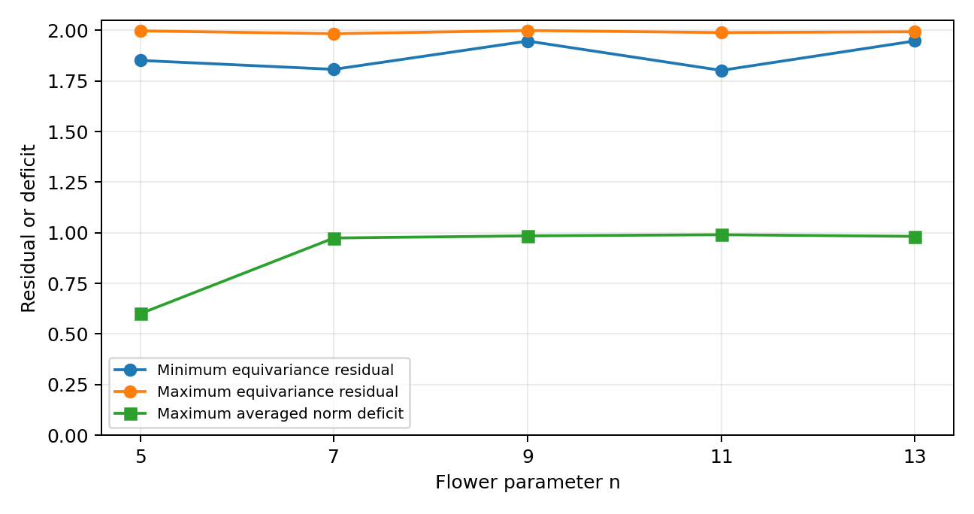
Figure 1. Diagnostics over all 38 cyclic generators.
Conclusion. Every stored certificate is far from every tested equivariant representation, with even the best generator giving a maximum edge residual between 1.802 and 1.948. This is a statement about the particular generic Newton certificates, not about the existence of a separate Z_n-symmetric branch.

4. Complete exact certificates for J5-J41
Theorem 2 (finite certified flower family). For every odd n with 5 <= n <= 41, the flower snark J_n admits an exact S²-flow.

4.1 Rational polynomial system
Let B be the oriented incidence matrix and let Z be an integer fundamental-cycle basis of ker(B), with q=m-v+1=2n+1 columns. Every three-dimensional flow is X=ZY for a q by 3 coefficient matrix Y. The 6n unit equations are
f_e(Y) = |(ZY)_e|^2 - 1 = 0, e=1,...,6n.
Three linear gauge equations place one selected edge on the x-axis and a second nonparallel edge in the xy-plane. Thus the system has 6n+3 equations in 3q=6n+3 variables and entirely integer coefficients.

4.2 Exact Newton-Kantorovich inequality
The certificate stores dyadic rational approximations y0 and A to a solution and the inverse Jacobian. Using the infinity norm, the verifier computes exactly
alpha = |A F(y0)|, beta = |I - A J(y0)|, |A(J(y)-J(y0))| <= L |y-y0|.
For r=10^(-8), it verifies the radii polynomial and contraction inequalities
p(r) = alpha + (beta - 1)r + Lr^2 < 0, beta + Lr < 1.
Banach's fixed-point theorem then gives a unique exact root in the closed infinity-norm ball of radius r. Because BZ=0 exactly and all norm equations vanish at the root, the resulting object is an exact S²-flow. All decisive products and inequalities are recomputed with arbitrary-precision integers by the independent verifier; SciPy is not imported by that verifier.
J_n | Dimension | alpha | beta | L | p(r) | Contraction
J5 | 33 | 4.27e-13 | 3.77e-11 | 5.94e+02 | -1.00e-08 | 5.94e-06
J7 | 45 | 3.74e-13 | 6.05e-11 | 1.73e+03 | -1.00e-08 | 1.73e-05
J9 | 57 | 4.47e-13 | 1.02e-10 | 4.34e+03 | -1.00e-08 | 4.34e-05
J11 | 69 | 4.49e-13 | 2.41e-10 | 9.18e+03 | -1.00e-08 | 9.18e-05
J13 | 81 | 4.45e-13 | 1.86e-10 | 1.70e+04 | -1.00e-08 | 1.70e-04
J15 | 93 | 4.41e-13 | 4.01e-10 | 2.89e+04 | -1.00e-08 | 2.89e-04
J17 | 105 | 4.50e-13 | 7.84e-10 | 4.61e+04 | -9.99e-09 | 4.61e-04
J19 | 117 | 4.47e-13 | 1.26e-09 | 6.98e+04 | -9.99e-09 | 6.98e-04
J21 | 129 | 4.42e-13 | 9.49e-10 | 1.01e+05 | -9.99e-09 | 1.01e-03
J23 | 141 | 4.36e-13 | 1.51e-09 | 1.43e+05 | -9.99e-09 | 1.43e-03
J25 | 153 | 4.53e-13 | 3.73e-09 | 1.95e+05 | -9.98e-09 | 1.95e-03
J27 | 165 | 4.62e-13 | 4.99e-09 | 2.61e+05 | -9.97e-09 | 2.61e-03
J29 | 177 | 4.62e-13 | 5.16e-09 | 3.42e+05 | -9.97e-09 | 3.42e-03
J31 | 189 | 4.56e-13 | 5.67e-09 | 4.40e+05 | -9.96e-09 | 4.40e-03
J33 | 201 | 4.50e-13 | 4.12e-09 | 5.59e+05 | -9.94e-09 | 5.59e-03
J35 | 213 | 4.51e-13 | 5.52e-09 | 6.99e+05 | -9.93e-09 | 6.99e-03
J37 | 225 | 4.50e-13 | 7.26e-09 | 8.64e+05 | -9.91e-09 | 8.64e-03
J39 | 237 | 4.62e-13 | 1.03e-08 | 1.06e+06 | -9.89e-09 | 1.06e-02
J41 | 249 | 4.56e-13 | 8.80e-09 | 1.28e+06 | -9.87e-09 | 1.28e-02
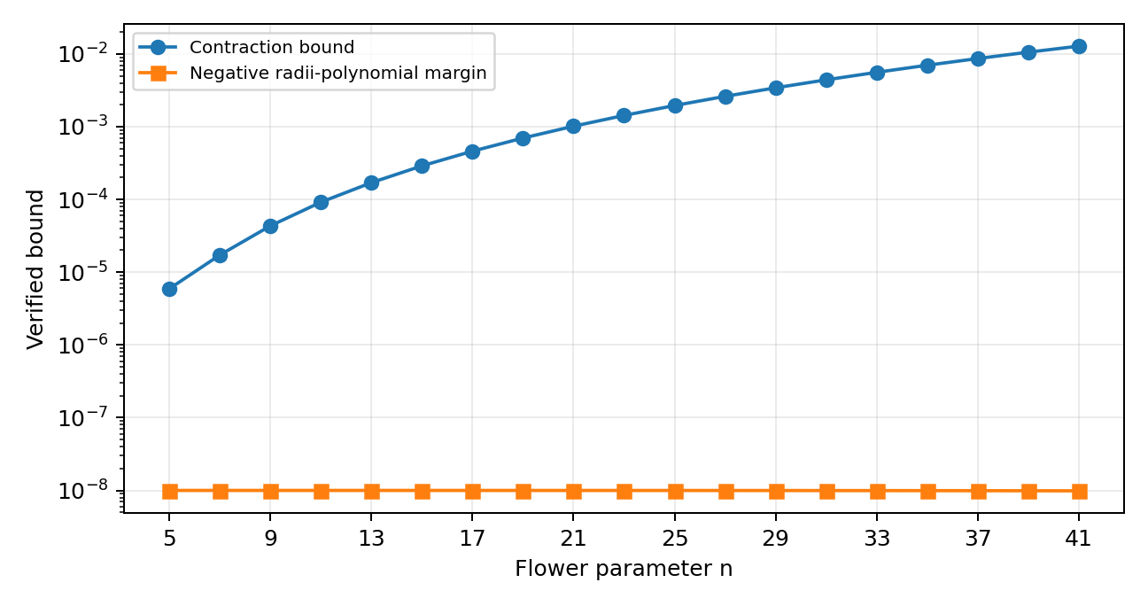
Figure 2. Exact certificate margins for all nineteen flower snarks.
The earlier value r=10^(-6) is not retained. The present verifier uses a deliberately conservative global infinity-norm Lipschitz bound, for which r=10^(-8) succeeds uniformly through J41. This is a change in certificate radius, not a weakening of the existence theorem.

5. Reproducibility map
Artifact | Purpose
scripts/strict_ansatz_exact.py | Exact symbolic audit of the all-n strict-ansatz contradiction.
scripts/equivariance_all_generators.py | All 38 generators, corrected averaging, and synthetic validation.
scripts/zn_ansatz.py | Rebuilds the six-template k=1 numerical branch from J5 through J41.
scripts/exact_rational_certificates.py | Builds dyadic Newton-Kantorovich certificates.
scripts/verify_exact_certificates.py | Independent arbitrary-integer verification of every certificate.
scripts/verify_all.py | Runs the full exact, numerical, and regression test suite.
certificates/*.npz | Nineteen complete certificates, including inverse-Jacobian data.
results/*.json and *.csv | Machine-readable outputs used in this report.
Complete verification command:
python -m pip install -r requirements.txt
python scripts/verify_all.py

6. Remaining all-n problem
The finite theorem through J41 and the exact exclusion of the strict Z_2n ansatz do not yet prove the existence of a Z_n-equivariant S²-flow for every odd n. The remaining target is a uniform existence theorem for the reduced six-template system F(z,theta)=0 over theta in (0,2pi/5], where theta=2pi/n. The most direct rigorous routes are interval continuation with a finite Kantorovich mesh plus derivative bounds, or a symbolic parametrisation of the observed k=1 branch. No statement in this document treats the numerical smoothness evidence as an all-n proof.

