Remote sensing of plant health in a warmed boreal peatland

Keenan Ganz[1], Jeffrey Warren[2], Jen Peters2, Misha Krassovski2

August 2, 2021

# 1 ABSTRACT

Boreal peatlands comprise a high-latitude carbon sink that stores roughly a third of the Earth’s terrestrial carbon. A climate-induced reduction in net primary productivity may transform boreal peatlands into a carbon source, accelerating climate change. The future of boreal peatlands is further clouded by a low diversity in tree species; the loss of a few species could have catastrophic effects on ecosystem function. To project how boreal peatland forests will respond to climate change, we collected multispectral drone imagery at the SPRUCE experiment in northern Minnesota. This experiment consists of ten open-top enclosures with above- and below-ground warming, with -enriched air. We studied two dominant tree species: black spruce (*Picea mariana*) and American larch (*Larix laricina*). We developed a semi-automated image processing workflow to align images from different perspectives and assign image regions to particular trees. For each tree, we measured three spectral indices of plant health: excess greenness, green chromatic coordinate, and normalized difference vegetation index. We performed general additive modeling and mixed-effects modeling to identify nonlinear relationships with temperature and to determine the magnitude of random effects, respectively. We found that spectral proxies of plant health improved with increasing temperature under ambient , but worsened with increasing temperature under elevated . The decline in plant health under elevated was more pronounced in larch than in spruce, suggesting that larch is more vulnerable to a warming climate. However, mixed-effects modeling showed that random effects were at least as large as the temperature effect, indicating ample variation in plant health, independent of experimental treatment. Future efforts will focus on (1) modeling plant nutrient status, (2) integrating hyperspectral imagery into the workflow, and (3) determining seasonal changes in spectral indices. Accomplishing these objectives will improve understanding of the role boreal peatlands play in the global climate system.

# 2 INTRODUCTION

Boreal peatlands comprise a high-latitude carbon sink that stores roughly a third of the Earth’s terrestrial carbon1. Climate change may transform boreal peatlands into a carbon source via a reduction in net primary productivity. The future of boreal peatlands is further clouded by low biodiversity; loss of a few tree species may have a catastrophic effect on ecosystem function.

Remote sensing enables rapid, non-destructive sampling of the spectral properties of plants2. At large spatial scale, satellites enable monitoring of plant health throughout the year. At fine spatial scale, drones outfitted with consumer cameras have been employed to similar effect. The remote sensing community has developed a staggering array of plant health indices. That is, for each pixel of an image the intensity of different wavelengths of light are combined in an expression to produce a quantitative measure of plant health.

We hypothesize that the use of drone imagery in an experimentally warmed and -enriched boreal peatland will enable rapid, non-destructive sampling of particular trees. Our goal to repeatedly measure the same tree is analagous to the use of static phenocameras to monitor plant phenology throughout the year3,4. However, a drone platform implies additional challenges. First, minor shifts in perspective require images to be aligned prior to processing. Second, non-vegetation pixels must be excluded from analysis. Finally, imagery from different sensors must be combined into a single workflow to enable efficient processing.

# 3 METHODS

## 3.1 Site description

The Spruce and Peatland Responses Under Changing Environments (SPRUCE) experiment is a climate manipulation experiment located in a peat bog in the US Forest Service’s Marcell Experimental Forest (47.5055202 N, 93.4539644 W)5. There are 10 enclosed plots heated at +0, +2.25, +4.5, +6.75, or +9C. Each temperature treatment consists of a plot at ambient and another at 900 ppm .The canopy is dominated by two main tree species: American larch (*Larix laricina*) and black spruce (*Picea mariana*). The understory consists of evergreen shrubs and *Sphagnum spp.* moss.

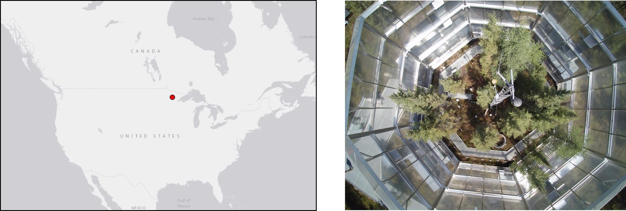

Figure 3.1: Left: location of the SPRUCE experiment (red dot) within North America. Right: top-down view of a SPRUCE enclosure.

## 3.2 Image acquisition

Drone images were captured on May 18th and 19th, 2021. Sky conditions were partly cloudy and the majority of images were captured in full sun. We captured 3-band red, green, and blue (RGB) images and 3-band red, green, and near-infrared images (RGN). RGB images were captured with two cameras (CGO3 and E10Tv, YUNEEC International, Jiangsu, China) at high (approx. 300 feet) and low altitude (approx. 100 feet). RGN images were captured with an RGB camera fitted with a filter that encodes near-infrared intensity in the blue channel (Survey 3, MAPIR Inc., San Diego, USA). We calibrated RGN images using vendor-supplied ground calibration targets and software.

## 3.3 Spectral indices

We identified three spectral indices of plant health that are resistant to differences in illumination. Two indices were calculated from RGB images: excess greenness (EXG; Eq. 3.1) and green chromatic coordinate (GCC; Eq. 3.2).

(3.1)

(3.2)

EXG and GCC have been used to monitor overall plant vigor and water stress, respectively6,7. We also calculated the normalized difference vegetation index (NDVI; Eq. 3.3) from the red and near-infrared bands of RGN images.

(3.3)

NDVI values range from -1 to 1. NDVI values greater than zero indicate green vegetation, with larger values indicating greater vigor. This index is of particular interest due to its use in near sensing studies8 as well as in studies using satellite imagery9.

## 3.4 Image alignment

Capture of images with a drone-mounted sensor enables rapid sampling at the cost of inconsistent position and perspective relative to the image target. To align images together for more efficient processing, we manually created masks that linked image regions of interest (ROIs) to numbered trees within the site. We aligned images with the panorama stitching software Hugin (<http://hugin.sourceforge.net/>). In short, Hugin reprojects images such that common features correspond to the same image coordinates. We applied this procedure to sets of images taken at the same altitude and of the same plot.

## 3.5 Image masking

Following alignment, ROIs consisted of vegetation and background pixels for a particular tree or group of trees. In RGB images, we calculated the distribution of EXG and found a bimodal distribution of vegetation (v) and background (b) pixels. We fit a Gaussian mixture to a probability density estimate of the EXG distribution and derived two measurements from the fit (Eq. 3.4; : density, : peak height, : Gaussian function, : peak center, : peak width).

(3.4)

The first measurement was the mean EXG value of the vegetation peak (). Second, we calculated the 90th percentile of GCC () in pixels where .

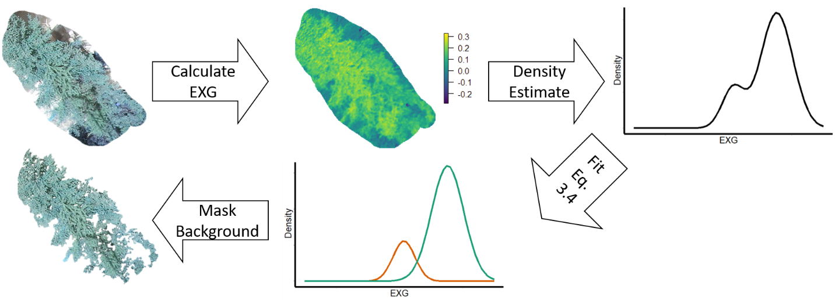

Figure 3.2: Schematic of the images processing workflow to calculate and . Excess greenness images formed a bimodal histogram consisting of a vegetation and background peak. was calculated as the mean of the vegetation peak, while was calculated as the 90th percentile of GCC in pixels where

In NDVI images, a fit analogous to Eq. 3.4 was not useful since background pixels had similar values to vegetation pixels. Instead, green vegetation widened a single prominent peak in the distribution of NDVI values. Therefore, we estimated the 90th percentile of the central NDVI peak, denoted , as the mean of the NDVI peak plus 1.282 standard deviations.

## 3.6 Foliar chemistry

Spectral indices are an especially useful monitoring tool if they are strongly correlated to plant water stress or nutrient status. Samples of tree needles were collected on July 12th, 2021 and frozen until processing on July 17th, 2021. We measured leaf mass per unit area, chlorophyll concentration, and carotenoid concentration. Pigments were extracted in dimethyl sulfoxide and measured by absorbance at 480, 649, and 665 nm.10 We measured leaf area by imaging needles in an office scanner and identifying needle pixels with a variant of the isodata algorithm of Ridler and Calvard implemented in ImageJ (<https://imagej.nih.gov/ij/>)11.

## 3.7 Statistical analysis

Our goal was to establish the relationship between spectral indices, plot treatment, and foliar chemistry. We report correlation between the three spectral indices and foliar chemistry. We expected the relationship between temperature and spectral indices to be nonlinear, so we employed general additive models12,13. General additive models allow for complex nonlinear relationships, but do not support interaction terms. Therefore, to account for the effect of we fit distinct temperature vs. spectral index models for each combination of atmosphere and tree species.

We ensured model parsimony by producing simple linear regression models alongside each general additive model. The model which had the lowest second-order Akaike information criterion14 was carried through to the next step in the workflow. The second-order Akaike information criterion is preferable for small sample sizes, but is equivalent to the original Akaike information criterion for sufficiently large sample sizes.

To determine the consistency of the image processing workflow, we fitted random effects to the residuals of the general additive model fit for each atmosphere-species pair. Random effects refer to changes in a given spectral index independent of experimental treatment.15 For example, if a particular tree is anomalously green, this model would fit a large random effect to measurements of that tree. Large random effects do not necessarily imply a poor model fit or erroneous measurement; they identify particular measurements which deviate from the general additive model fit.

We used ROI number and image acquisition order as random effects. Both random effect groups were nested within plot number. That is, the first image captured in plot 4 is a distinct random effect group from the first image captured in plot 8. If the image alignment process does not systematically affect spectral measurements, we expect that the random effects from image acquisition number would be smaller than those due to ROI number.

To determine whether the difference between random effect groups was significant, we log-transformed the effect magnitude estimates and performed two-sample t-tests. The alternative hypothesis was that the mean transformed ROI effect magnitude was larger than that for image acquisition order. We tested the normality of the transformed random effect estimates with a Shapiro-Wilk test. When both random effect groups were not significantly different from normal, we used a Welch two-sample t-test due to unequal variances. Otherwise, we used a Wilcoxon rank sum test, which assumes neither normality nor equal variances.

# 4 RESULTS

## 4.1 Random effects

Before comparing spectral indices with temperature and foliar chemistry, we must verify that the random effects due to the imagery acquisition process are small in comparison to effects due to variation in the tree canopy. We show a complete random effect estimate in Figure 4.1 for the fit to vs. temperature in black spruce under a carbon rich atmosphere. From visual inspection, it is clear that random effects due to image capture order are smaller than those due to variation among trees.

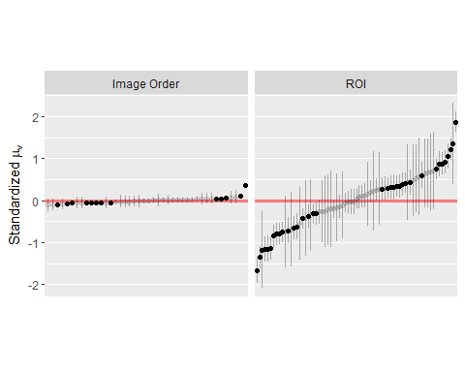

Figure 4.1: Simulated random effect estimates in the residuals of a general additive model fit to vs. temperature in black spruce under a carbon rich atmosphere. Vertical lines show the 95% confidence interval of the random effect. Bolded points have zero outside of the 95% confidence interval.

This observation holds across all combinations of atmosphere, species, and spectral index (Table 4.1). In all cases, we rejected the null hypothesis (). Furthermore, in all but one case random effects due to ROI had a higher proportion of significantly nonzero effects than those due to image acquisition order.

Table 4.1: Random effect magnitudes, grouped by spectral index and atmosphere. Magnitudes are reported as the mean absolute value, followed by the percentage of random effects with zero outside of the 95% confidence interval. All data are standardized for consistent units. The final two columns indicate the difference in means test and the significance of the test results (*: , **: , ***:

| Atmosphere | Species | Index | Image Order | ROI | Test | Significance |
| --- | --- | --- | --- | --- | --- | --- |
| 900 ppm | Larch |  | 0.116 (19) | 0.599 (45) | Wilcoxon | *** |
|  |  |  | 0.039 (14) | 0.670 (35) | Wilcoxon | *** |
|  |  |  | 0.067 (32) | 0.665 (29) | Welch | ** |
|  | Spruce |  | 0.051 (31) | 0.537 (49) | Wilcoxon | *** |
|  |  |  | 0.039 (31) | 0.471 (46) | Wilcoxon | *** |
|  |  |  | 0.037 (27) | 0.644 (47) | Wilcoxon | *** |
| Ambient | Larch |  | 0.186 (24) | 0.665 (38) | Welch | *** |
|  |  |  | 0.150 (16) | 0.708 (44) | Wilcoxon | *** |
|  |  |  | 0.177 (26) | 0.836 (75) | Wilcoxon | *** |
|  | Spruce |  | 0.056 (22) | 0.508 (45) | Wilcoxon | *** |
|  |  |  | 0.061 (22) | 0.485 (54) | Wilcoxon | *** |
|  |  |  | 0.107 (26) | 0.631 (54) | Wilcoxon | *** |

## 4.2 Spectral indices vs. temperature and

All general additive model fits between spectral indices and temperature, grouped by species, were statistically significant (). Furthermore, all general additive models had a lower second-order Akaike information criterion than their equivalent linear model. The fit results are summarized in Figure 4.2. Under ambient atmosphere, greenness increased with temperature until about +4.5C, after which increasing temperature resulted in a decrease in greenness. Under a -enriched atmosphere, greenness followed an inverted curve as compared to the ambient atmosphere. That is, greenness was highest at temperature extremes and reached a minimum at roughly +4.5C.

From visual inspection of the fit, larch appears to show greater interaction with than spruce. The effect is more pronounced in the models for and than in . However, this observation is difficult to quantify because general additive models do not support interaction terms.

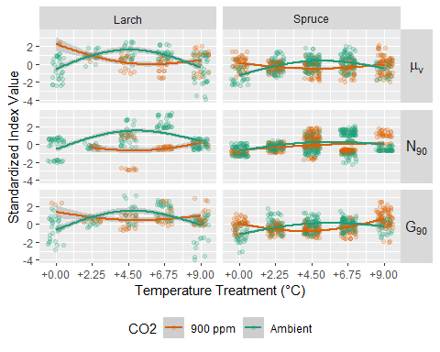

Figure 4.2: Scatterplots and general additive model fits of spectral indices vs. temperature in a carbon rich and ambient atmosphere. In all models shown, . Shaded regions indicate the 95% confidence interval of the model. No data were available for in larch at +0C. For display purposes, data points have 0.5 units of horizontal noise.

## 4.3 Correlation between spectral indices and foliar chemistry

Both greenness-based spectral indices correlated significantly with chlorophyll content and leaf mass per unit area (Table 4.2). However, did not significantly correlate with any foliar property. Similarly, carotenoid content was not significantly correlated with any of the spectral indices.

Table 4.2: Pearson’s r between spectral indices and foliar properties. Asterisks denote significance as in Table 4.1. Spectral indices were only derived from ROIs that contained a single tree.

| Index | Chl. a (g/cm) | Chl. b (g/cm) | Chl. total (g/cm) | Carotenoids (g/cm) | Leaf mass per area (g/cm) |
| --- | --- | --- | --- | --- | --- |
|  | 0.601*** | 0.580*** | 0.599*** | 0.273 | -0.578*** |
|  | 0.478*** | 0.495*** | 0.487*** | -0.019 | -0.538*** |
|  | 0.244 | 0.248 | 0.248 | 0.030 | -0.221 |

We hypothesized that significant correlations between spectral indices and foliar chemistry may be attributed to differences between species instead. For example, leaf mass per unit area differs in spruce and larch as does . Therefore, a significant correlation between leaf mass per unit area and may simply reflect the relative position of two clusters in data space (Figure 4.3).

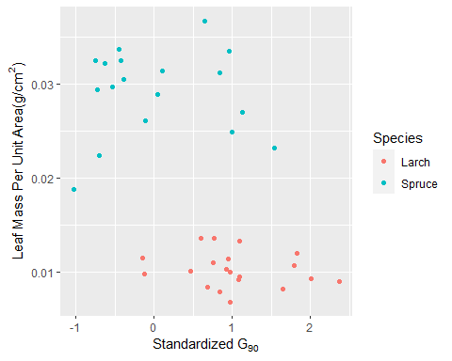

Figure 4.3: Scatterplot of vs. leaf mass per unit area, colored by tree species. Although the bulk correlation between the two variables is significant, the correlation within a particular species is insignificant.

We recalculated intraspecific correlations to determine if significance levels observed in interspecific correlations remain. To our surprise, all significant correlations at the interspecific level became insignificant at the intraspecific level.

Table 4.3: Pearson’s r between spectral indices and foliar properties, grouped by species. Asterisks denote significance as in Table 4.1 (no significant correlations were present). Spectral indices were only derived from ROIs that contained a single tree.

| Species | Index | Chl. a (g/cm) | Chl. b (g/cm) | Chl. total (g/cm) | Leaf mass per area (g/cm) |
| --- | --- | --- | --- | --- | --- |
| Larch |  | 0.2492 | 0.2038 | 0.2388 | -0.1570 |
|  |  | 0.0982 | 0.0993 | 0.1001 | -0.2148 |
| Spruce |  | 0.351 | 0.277 | 0.339 | -0.087 |
|  |  | -0.069 | -0.123 | -0.085 | 0.227 |

# 5 CONCLUSIONS

## 5.1 Image acquisition random effects

Across multiple cameras and a variety of image captures, random effects due to the image capture process are significantly smaller than those due to variation in spectral indices among individual trees. This supports the use of drone image capture as a reproducible, consistent whole-plot sampling method. Some of the largest random effects due to image capture were for images where infrastructure obstructed the camera or for images taken in low light conditions. In the future, images should ideally be captured under no cloud cover. Or, cameras should be calibrated for use under overcast conditions before being flown.

## 5.2 Spectral indices vs. temperature

We observed a consistent trend in greenness vs. temperature using two greenness indices and two tree species. This suggests a common temperature response to photosynthesis. Under a low carbon atmosphere, slightly higher temperatures may increase reaction rates until water loss prevents photosynthesis at high temperatures. Under a carbon-enriched atmosphere, the carbon fertilization effect may shift the increase in greenness to a lower thermal optimum. That is, extra carbon increases photosynthesis such that any increase in temperature reduces greenness via water loss.

## 5.3 Spectral indices vs. foliar chemistry

Unsurprisingly, the spectral indices related to the intensity of green light were most strongly correlated with green pigments. On the other hand, the NDVI-based index was not strongly correlated with any foliar characteristic. Separting background from vegetation pixels in RGN images was much more difficult than in the RGB image. Our estimate of 90th percentile NDVI may be insufficient to determine plant health with this index.

Moreover, significant correlations at the interspecies level became entirely insignificant at the intraspecies level. Interspecies correlations most likely identified differences between species instead of true relationships between indices and foliar chemistry. This does not, however, detract from the use of spectral indices for monitoring plant health. The indices used here are most likely to be useful in a region with high biodiversity where interspecies correlation is of interest.

## 5.4 Future work

In this study, we have shown how drone imagery can be used to assess the health of trees in a warmed and environment. However, we have only considered one point in time and a limited scope of spectral measurements. The utility of our methods will be better characterized by (1) modeling plant nutrient status, (2) integrating hyperspectral imagery into the workflow, and (3) determining seasonal changes in spectral indices. Accomplishing these objectives will also improve understanding of the role boreal peatlands play in the global climate system.

# 6 ACKNOWLEDGEMENTS

This work was supported in part by the U.S. Department of Energy, Office of Science, Office of Workforce Development for Teachers and Scientists (WDTS), and Office of Biological and Environmental Research under the Science Undergraduate Laboratory Internship program.

# 7 REFERENCES

1 Y. Pan, R.A. Birdsey, J. Fang, R. Houghton, P.E. Kauppi, W.A. Kurz, O.L. Phillips, A. Shvidenko, S.L. Lewis, J.G. Canadell, P. Ciais, R.B. Jackson, S.W. Pacala, A.D. McGuire, S. Piao, A. Rautiainen, S. Sitch, and D. Hayes, Science **333**, 988 (2011).

2 J. Cavender-Bares, J.A. Gamon, and P.A. Townsend, editors, *Remote Sensing of Plant Biodiversity* (Springer International Publishing, Cham, 2020).

3 L. Wingate, J. Ogée, E. Cremonese, G. Filippa, T. Mizunuma, M. Migliavacca, C. Moisy, M. Wilkinson, C. Moureaux, G. Wohlfahrt, A. Hammerle, L. Hörtnagl, C. Gimeno, A. Porcar-Castell, M. Galvagno, T. Nakaji, J. Morison, O. Kolle, A. Knohl, W. Kutsch, P. Kolari, E. Nikinmaa, A. Ibrom, B. Gielen, W. Eugster, M. Balzarolo, D. Papale, K. Klumpp, B. Köstner, T. Grünwald, R. Joffre, J.-M. Ourcival, M. Hellstrom, A. Lindroth, C. George, B. Longdoz, B. Genty, J. Levula, B. Heinesch, M. Sprintsin, D. Yakir, T. Manise, D. Guyon, H. Ahrends, A. Plaza-Aguilar, J.H. Guan, and J. Grace, Biogeosciences **12**, 5995 (2015).

4 K.N. Nasahara and S. Nagai, Ecological Research **30**, 211 (2015).

5 P.J. Hanson, J.S. Riggs, W.R. Nettles, J.R. Phillips, M.B. Krassovski, L.A. Hook, L. Gu, A.D. Richardson, D.M. Aubrecht, D.M. Ricciuto, J.M. Warren, and C. Barbier, Biogeosciences **14**, 861 (2017).

6 L. Zhang, H. Zhang, W. Han, Y. Niu, J.L. Chávez, and W. Ma, Agricultural Water Management **251**, 106866 (2021).

7 A.M. Reid, W.K. Chapman, C.E. Prescott, and W. Nijland, Forest Ecology and Management **374**, 146 (2016).

8 H.C. Stimson, D.D. Breshears, S.L. Ustin, and S.C. Kefauver, Remote Sensing of Environment **96**, 108 (2005).

9 I.H. Myers-Smith, J.T. Kerby, G.K. Phoenix, J.W. Bjerke, H.E. Epstein, J.J. Assmann, C. John, L. Andreu-Hayles, S. Angers-Blondin, P.S.A. Beck, L.T. Berner, U.S. Bhatt, A.D. Bjorkman, D. Blok, A. Bryn, C.T. Christiansen, J.H.C. Cornelissen, A.M. Cunliffe, S.C. Elmendorf, B.C. Forbes, S.J. Goetz, R.D. Hollister, R. de Jong, M.M. Loranty, M. Macias-Fauria, K. Maseyk, S. Normand, J. Olofsson, T.C. Parker, F.-J.W. Parmentier, E. Post, G. Schaepman-Strub, F. Stordal, P.F. Sullivan, H.J.D. Thomas, H. Tømmervik, R. Treharne, C.E. Tweedie, D.A. Walker, M. Wilmking, and S. Wipf, Nature Climate Change **10**, 106 (2020).

10 A.R. Wellburn, Journal of Plant Physiology **144**, 307 (1994).

11 T. Ridler and S. Calvard, IEEE Transactions on Systems, Man, and Cybernetics **8**, 630 (1978).

12 S.N. Wood, *Generalized Additive Models: An Introduction with r*, 2nd ed. (Chapman; Hall/CRC, 2017).

13 S. Wood, (2021).

14 C.M. Hurvich and C.-L. Tsai, Biometrika **76**, 297 (1989).

15 D. Bates, M. Mächler, B. Bolker, and S. Walker, Journal of Statistical Software **67**, 1 (2015).

1. Department of Earth and Environmental Sciences, Rensselaer Polytechnic Institute, Troy, NY 12180
2. Environmental Sciences Division, Oak Ridge National Laboratory, Oak Ridge, TN 37830