Platform Detail:
Libraries are targetted to .NET Standard 1.4
Executables are targetted to .NET Framework 4.6.1
Unit tests are targetted to .NET Framework 4.6.1

Libraries Used:
Nunit
Moq

Folder Structure
===========
\ReadMe.doc
\GlobalRightsManagement\ GlobalRightsManagement.sln
\GlobalRightsManagement\Executable

Solution Structure:

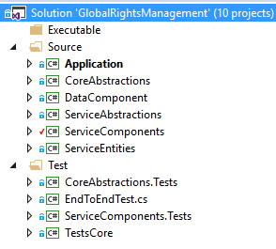

NOTE:
1. Source and Tests are Solution Folders hence it is not visible in. disk.
2. VS 2017 is used for this solution and project file.

Default TestData File(s) and location
./Executable/TestData/MusicContract.txt
./Executable/TestData/PartnerContract.txt

Running application from Command line

Option 1. > Application.exe
This will load the test data from default Test data locations

Options 2. > Application.exe <musiccontract-file-path> <partner-file-path>

Sample Screenshot:

Initial Screen (Default Test Data)

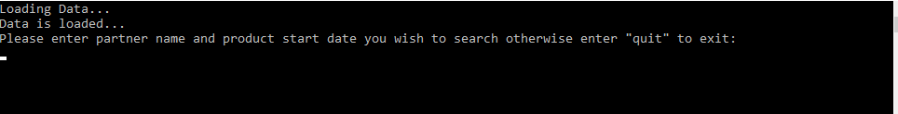
Input (Sample from Requirement Document)

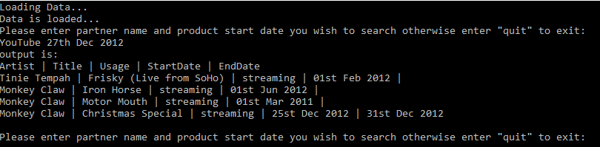
>quit (Exit from the screen)

