Task Manager

Shawn Mitchell

WGU Student ID# 000750926

Western Governors University

Bachelor of Science, Software Development

Course Mentor: Dave Huff

Table of Contents

Capstone Introduction 3

Business Opportunity 3

Existing Market Gaps 4

Development Lifecycle 4

Deliverables 5

Implementation 6

Requirements Verification 6

Programming Environment 6

Development Costs 7

Human Resources 7

Project Deliverables and Timeline 7

Conclusions 9

Appendix A - Diagrams 10

Appendix B - Unit Test Plan and Results 14

Appendix C - References 16

# Capstone Introduction

The success of on demand services such as ride sharing, AirBnB, and Uber-Eats demonstrate that the market is shifting toward a self-employment model, also known as the gig economy. In this model, a parent company serves as a focal point for customers and matches them with available local contractors who can fulfill the customers' needs. The second annual self-employment report published by Fresh Books Cloud Accounting states,

"Climbing the corporate ladder is no longer the American dream. Over the last few years a significant mindset shift has taken place, and with it has emerged a workforce which values flexibility over stability." (Cosgrave and Moulton, 2018).

The trend towards self-employment is creating a need for planning and resource management tools. With companies like Uber, these tools are provided, however for those who choose not to use a parent company for customer referral these tools will need to be procured.

# Business Opportunity

A look at the software products in the dispatch and project management field shows that many of these products require a large investment up front. Some examples are:

AyaNova from $159.00 for 1 license to $3950.00 for 50 licenses per year. (ayanova.com, n.d).

HCSS Dispatcher $6,700.00 one-time cost. (capterra.com, n.d).

SAWIN Service Automation $9,999.00 one-time cost. (capterra.com, n.d).

These are systems that may be more comprehensive and complicated than many small businesses need. The biggest opportunities are at the low end of the market, where the entry-level entrepreneurs would look to invest in a management system.

# Existing Market Gaps

Startup companies or the self employed might find the previous offerings to be cost prohibitive. Kinetic Creations is looking to position this product as a low-cost entry-level solution geared toward small businesses with a need to manage tasks, inventory and employees. This would include customer site technicians such as plumbers, electricians and IT companies.

# Development Lifecycle

An iterative development methodology was used in the application development. The iterative methodology produces a series of software builds where features are gradually implemented. The illustration below shows the iterative process phases:

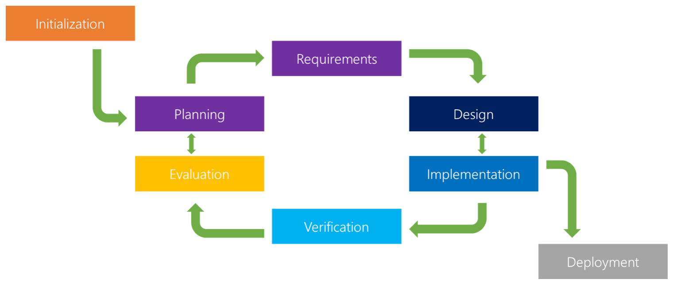

Source: cleverism.com

This process was determined to be ideal for this project as each successive user interface screen depended on the previous screen being completed. In each iteration the requirements for the UI screen were determined, then a layout was designed to fit the requirements. During the implementation phase the code was developed to interact with the database and have the UI elements display or accept data as needed. The verification phases included testing the database interactions and UI elements. During each evaluation phase the unit was checked against the user interface flowchart (Appendix A, Figure 1) to ensure the workflow specifications were being met.

# Deliverables

The primary goal of the project is to create a mobile application that allows a service professional to manage tasks and inventory. This will be met with the following deliverables:

* Design a database that will store the data.
* Create a PHP class that will interface with the database.
* Design the menu systems for team, task and inventory management.
* Create any additional classes needed to support the application
* Implement a function that allows for the exchange of inventory

# Implementation

The project will be developed using a variety of technologies including a PHP web server, SQL database, and Java. While the web server will currently be locally hosted, the commercial version of the Task Manager application will move the web server to a cloud service to facilitate database growth and availability. The anticipated outcome of this project will be a commercially viable product that fits in the low cost end of the market.

# Requirements Verification

Due to the success of on demand services and the gig economy, Kinetic Creations is looking for a product to position as a low-cost entry-level solution geared toward small businesses with a need to manage tasks, inventory and employees. These requirements will be fulfilled with the Task Manager product.

# Programming Environment

The database was designed using the MySQL workbench modeling tool to create the tables, attributes and relations. The forward engineering tool was then used to auto generate the SQL code used to create the database on the MAMP web server. The PHP server interface was created using the Visual Studio SDK. The application was developed using Java in the Android Studio SDK.

# Development Costs

There are no costs related to this project at the moment; all development software is either a free or community version, and the web server is hosted on existing equipment at Kinetic Creations.

# Human Resources

This project was conceived, designed and developed for Kinetic Creations entirely by the author.

# Project Deliverables and Timeline

|  |  |  |  |  |  |
| --- | --- | --- | --- | --- | --- |
| Deliverable | Expected Duration | Start | End | Actual Duration | Dependencies |
| UI Flowchart | 1 Day | April 11 | April 11 | 1 Day | None |
| Database EER | 1/2 Day | April 12 | April 12 | 1 Day | None |
| Database Class | 1 Day | April13 | April 13 | 1 Day | Database EER |
| Object Classes | 1 Day | April 14 | April 14 | 1 Day | UI Flowchart |
| User Interface | 1 Day | April 15 | May 7 | 22 Days | UI Flowchart |
| UI: Login | 1 Day | April 15 | April 15 | 1 Day | UI Flowchart, Object Classes, Database Class |
| UI: Task List | 1 Day | April 16 | April 16 | 1 Day | UI: Login |
| UI: Add Task | 1 Day | April 17 | April 17 | 1/2 Day | UI: Task List |
| UI :Add Customer | 1 Day | April 17 | April 17 | 1/2 Day | UI: Add Task |
| UI: Task Details | 1 Day | April 18 | April 19 | 2 Days | UI: Task List |
| UI : Add Parts to Task | 1 Day | April 19 | April 21 | 3 Days | UI: Task Details |
| UI: Order Parts | 1 Day | April 21 | April 25 | 4 Days | UI: Task Details |
| UI: Inventory List | 1 Day | April 25 | April 28 | 3 Days | UI: Task List |
| UI : Receive Orders | 1 Day | April 28 | April 30 | 2 Days | UI: Inventory List |
| UI : Edit Customer | 1 Day | April 30 | May 4 | 5 Days | UI: Add Task |
| UI: Reports | 1 Day | May 7 | May 7 | 1 Day | UI: Task List |
| Design and implement web server | 5 Days | May 8 | May 23 | 15 days | Knowledge of how to implement |
| Add web server interface class | 2 Days | May 24 | May 26 | 2 Days | Web server |
| Adapt UI elements to use the web server interface | 5 Days | May 27 | June 4 | 8 Days | Web server interface class |
| Test and debug | 3 Days | June 5 | June 14 | 11Days | Functional Application |

# Appendix C - References

Cosgrave, D., & Moulton, C. (2018). Second Annual Self Employment Report. Retrieved from <http://www.freshbooks.com/fbstaticprod-uploads/public-website-assets/_themes/freshbooks/brand-assets/2018selfemploymentreport.pdf>

Martin. (2018, July). 7 Basic Software Development Life Cycle (SDLC) Methodologies: Which one is best? Retrieved from <https://www.cleverism.com/software-development-life-cycle-sdlc-methodologies/>

[ayanova.com price guide]. (n.d.). Retrieved from <https://www.ayanova.com/purchase_AyaNova_online.htm>

[Capterra HCSS-Dispatcher review]. (n.d.). Retrieved from <https://www.capterra.com/p/147712/HCSS-Dispatcher/>

[Capterra SAWIN review]. (n.d.). Retrieved from <https://www.capterra.com/p/24370/SAWIN/>