EmbedResearchGaps: embedding-driven identification of research gaps in author-keyword space
Sebastian Matysik ^{a,*}, Joanna Wiśniewska ^{b}, Paweł Karol Frankowski ^{c,d}
ª Doctoral School, Institute of Management, University of Szczecin, Cukrowa 8, 71-004 Szczecin, Poland
^{b} Institute of Management, University of Szczecin, Cukrowa 8, 71-004 Szczecin, Poland
^{c} Faculty of Computer Science and Telecommunications, Maritime University of Szczecin, Wały Chrobrego 1-2, 70-500 Szczecin, Poland
^{d} Faculty of Electrical Engineering, West Pomeranian University of Technology in Szczecin, Sikorskiego 37, 70-313 Szczecin, Poland
* Corresponding author. E-mail address: sebastian.matysik@usz.edu.pl

Abstract
EmbedResearchGaps identifies candidate research gaps in the author-keyword space of a screened literature corpus. It implements two published procedures: clustering author keywords and flagging each cluster's periphery, or clustering articles first and then mining each cluster's keyword sub-space for emerging concepts, unrealised conceptual combinations and cross-cluster concepts. It adds seven embedding backends, a five-provider annotation panel, blinded expert sheets and a consensus mode pooling candidates across k-means seeds and corpus sizes. In two Scopus case studies candidate sets were sensitive to both and the ranking added no reliable novelty enrichment over lexical filtering, so the software reports support explicitly and treats candidates as hypotheses for expert screening.

Keywords
research gaps; semantic embeddings; keyword clustering; literature review; bibliometrics; reproducibility

Metadata
Table 1. Code metadata.
Nr | Code metadata description | Metadata
C1 | Current code version | v1.0.0
C2 | Permanent link to code/repository used for this code version | https://github.com/s-matysik/EmbedResearchGaps/releases/tag/v1.0.0
C3 | Legal code license | MIT License
C4 | Code versioning system used | git
C5 | Software code languages, tools and services used | Python (>= 3.10); numpy, pandas, scipy, scikit-learn, matplotlib, networkx, kneed, typer; optional sentence-transformers, krippendorff, openpyxl; optional HTTP access to the OpenAI, Nomic, Jina and Cohere embedding endpoints and to the OpenAI, Anthropic, Google, DeepSeek and xAI chat endpoints
C6 | Compilation requirements, operating environments and dependencies | Pure Python 3.10 or newer, no compilation: pip install embedresearchgaps (or pip install -e . from the repository). Runs fully offline with the built-in tfidf-svd backend; remote backends read API keys from named environment variables
C7 | If available, link to developer documentation/manual | https://github.com/s-matysik/EmbedResearchGaps#readme
C8 | Support email for questions | sebastian.matysik@usz.edu.pl

1. Motivation and significance
Formulating a research gap is the step of a systematic literature review that has resisted automation most stubbornly. It is normally done by expert reading [1], and the categories a gap can fall into have been formalised for systematic reviews [2] without the identification itself becoming mechanical; the organisational-research literature argues further that gap-spotting is a weak way of constructing a research question when it is not disciplined by evidence [3]. Reporting standards specify how a review must be documented [4] but not how its research agenda is arrived at. Screening, by contrast, has been automated repeatedly, by active-learning frameworks [5] and by embedding-based ranking: EmbedSLR ranks candidate articles by the cosine distance between an embedded research question and embedded titles and abstracts, and validates the resulting set bibliometrically [6], with a multi-model consensus procedure added in version 2.0 [7]. Once a reviewer holds a screened corpus, the question changes from which papers belong here to what do these papers not talk about, and the usual answer is an unaided reading of discussion sections.
Author keywords are an attractive substrate for that second question. They are assigned by the authors themselves, they are short enough to embed without truncation, and their co-occurrence structure underpins a large bibliometric literature with established tooling — VOSviewer [8], bibliometrix [9] and CiteSpace [10] — and established reporting conventions [11]. That tooling visualises structure and leaves the reading to the analyst; work that detects emerging topics does so from citation and term-burst signals rather than from a semantic space [12]. Substituting contextual sentence embeddings [13,14] for term co-occurrence makes the semantic neighbourhood of a keyword computable, and embedding-based clustering separates short texts more coherently than bag-of-words representations [15].
Two procedures for turning that structure into candidate gaps were introduced recently. The first clusters the author keywords of a screened corpus and treats the semantic periphery of each keyword cluster as the interesting region, on the argument that a term far from its own cluster centroid is attached to the field only loosely [16]. The second clusters the articles first, labels each cluster, and then mines a keyword sub-space inside every cluster with three detectors: rare and lexically salient terms (emerging concepts), pairs of established terms that never co-occur (conceptual combinations), and terms established elsewhere in the corpus but absent from this cluster (cross-cluster concepts) [17]. Both were validated with a panel of large language models annotating keywords against a calibrated rubric — a design supported by evidence that language models match or exceed human coders on well-defined annotation tasks [18–20] — and the second additionally against two human experts [17].
Neither procedure was released as software. Both existed as notebooks in which model choice, thresholds and API credentials were interleaved with the analysis, which makes a published run impossible to repeat and a new corpus expensive to analyse. EmbedResearchGaps turns them into one library with a single configuration object, interchangeable embedding backends, and a validation layer that is part of the package rather than an appendix to it. It also adds what the prototypes lacked: a measurement of how far a candidate list survives re-initialisation of the clustering it rests on.
The intended user is a reviewer who has already screened a corpus — with EmbedSLR, a database query, or by hand — and wants a ranked, auditable list of directions the corpus leaves open. The workflow is: export from Scopus or Web of Science, load, state the research problem in one or two sentences, choose a backend, run one or both modes, and read the candidate table. Every candidate carries its source articles, the metric values behind its score, and a one-line rationale.

2. Software description

2.1. Software architecture
Fig. 1 shows the architecture. A shared front end loads a bibliographic export, resolves the Scopus and Web of Science column conventions, normalises author keywords, embeds the texts with the selected backend and — when a research problem is supplied — ranks the records by cosine distance to it and truncates the corpus to the N nearest. Two modes then operate on that analysis corpus, and a shared back end handles consensus, validation and output.
The package holds twelve top-level modules and a validation subpackage of five: config (dataclasses carrying every threshold, weight and seed), corpus, text (keyword normalisation, the methodological-term filter, corpus-level TF-IDF salience), encoders, clustering (semantic ranking, k-selection, k-means with per-cluster centroid distances), keywords, gaps (the four detectors and three scoring formulae), results, pipelines, consensus, viz and cli; the subpackage holds the annotation protocol, the annotator backends, the agreement metrics, the study runner and the expert sheets. Runs are deterministic: one RunConfig fixes every threshold, weight and seed, and PipelineResult.save() writes it next to the tables, so a published result can be regenerated from the artefacts alone.

2.2. Software functionalities
Two operating modes. keywords_first embeds and clusters the unique author keywords of the analysis corpus, then flags keywords whose distance from their own cluster centroid exceeds a cluster-specific percentile (95 by default); because the threshold is computed inside each cluster, clusters of different semantic density are judged on their own scale. articles_first clusters the articles, labels each cluster from its most frequent non-core keywords, builds a keyword sub-space inside every cluster, and applies the three detectors, each with its own composite score. Both modes share the filters that remove terms peripheral for uninteresting reasons: a frequency ceiling, a token-count rule, a methodological blocklist of some fifty phrases and acronyms, and a core-domain filter dropping the terms that define the field itself.
Seven embedding backends. tfidf-svd is offline, deterministic and needs no credentials; sbert runs any sentence-transformers checkpoint locally; openai, nomic, jina and cohere call hosted endpoints; precomputed accepts user-supplied vectors, which is how a published run is repeated without re-embedding. All conform to one contract that validates the returned row count and rejects non-finite vectors, so a silent misalignment between a keyword and its embedding cannot occur. API keys are read from named environment variables and never enter a configuration object, a result file or a log.
Database-agnostic input. load_csv resolves canonical fields through an alias table covering the Scopus CSV export, the Scopus Search API and both Web of Science export flavours — two-letter field tags and spelled-out headers — so none needs a column map; any other export is accommodated by passing one. Web of Science Keywords Plus is deliberately not treated as author keywords, because those terms are assigned by the database rather than the authors; a user who wants them must ask explicitly. The test suite loads all three flavours and asserts they yield an identical corpus.
Stability-aware consensus. consensus_gaps repeats a mode across k-means seeds and, optionally, across analysis-corpus sizes, and reports for every candidate the fraction of runs that produced it, together with the pairwise overlap of the candidate sets, decomposed into the overlap attributable to the seed alone and the overlap across corpus sizes. Filtering on that support turns a single-run list into a ranking whose reproducibility is measured rather than assumed; Section 3 shows why this is necessary. A partition whose silhouette [21] falls below 0.10 additionally raises a LOW_CLUSTER_SEPARATION warning naming the measured value.
Validation. The validation subpackage implements the annotation protocol of the source papers: a keyword is labelled GAP, EXPLORED, LOW IMPORTANCE, METHOD or NOISE and given a Novelty Score from 1 to 10 against a rubric supplied verbatim in the prompt. Six chat providers are registered and called at temperature 0 where the model accepts it; the study of Section 3.3 uses five. CallableAnnotator wraps any local function, and a failing annotator is recorded rather than allowed to abort the study. The module computes label rates, Novelty distributions, Fleiss' kappa, Krippendorff's alpha, pairwise agreement, and the comparison between the candidate set and a control set with a Welch t-test, a Mann-Whitney U test, Cohen's d and a permutation test on the difference of means. selected_and_control_keywords builds a control set disjoint from the candidates, and compare_keyword_sets refuses parametric p-values when the two arms share a keyword, because a two-sample statistic on nested samples has no defined null distribution. Blinded expert sheets — rows shuffled, gap types and scores withheld — are written as a workbook and read back into a Spearman concordance against the panel.
Figures and diagnostics. Seven figures are produced head-lessly, and every run returns the diagnostics a methods section needs: cluster sizes and quality indices, the k-selection trace, the TF-IDF match-type breakdown, core-domain terms, deduplication counts and the encoder descriptions.
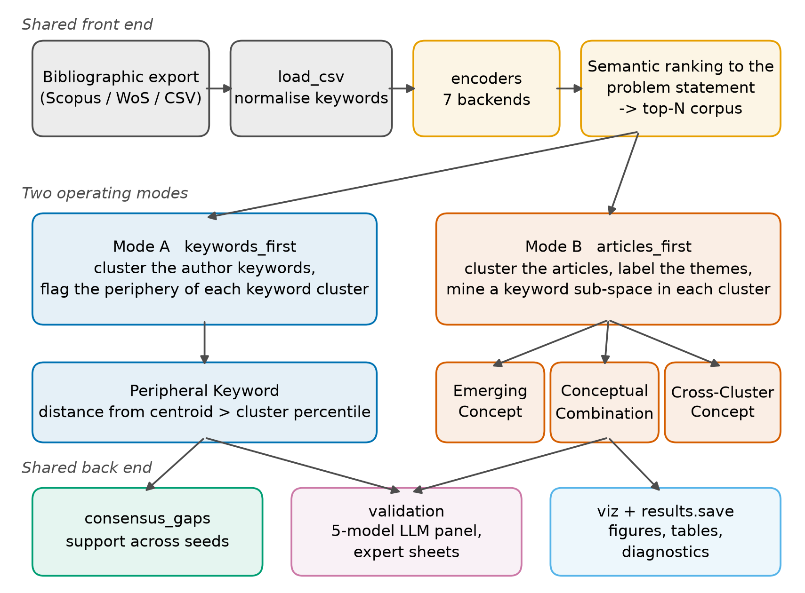
Fig. 1. Software architecture: a shared front end prepares the analysis corpus, two modes mine it, and a shared back end measures stability, validates candidates and writes outputs.

3. Illustrative examples
Two corpora were retrieved from Scopus, restricted to English-language journal articles in the business, economics and decision-science subject areas, and analysed with text-embedding-3-large, N = 50 and otherwise default settings. The management corpus holds 493 records matching dynamic capabilit and digital transformation, analysed against "How do dynamic capabilities enable the digital transformation of established firms?"; the economics and finance corpus holds 487 records matching fintech or financial technology together with financial inclusion, credit risk or bank lending*, analysed against "How does fintech credit affect financial inclusion and credit risk in banking systems?". A third corpus of 290 records on gamification in marketing served as a conformance check against the topic of the source publications. Queries, corpora, every reported table and the regeneration scripts are deposited with the release [22].

3.1. What the modes return
On the management corpus, k-selection chose k = 6 for both modes by the elbow rule, because the best silhouette over the candidate range (0.041 for the article space, 0.065 for the keyword space) fell below the 0.25 floor. From the 146 unique author keywords, Mode B returned 27 candidate entries covering 26 distinct keywords — 18 emerging concepts, 7 cross-cluster concepts and 2 conceptual combinations — and Mode A returned 6 peripheral keywords, 4.1 % of its keyword space (Fig. 2). The highest-ranked candidates are single-study terms such as Agrifood businesses, Automotive industry and DT vision, and the sole high-ranked combination pairs Dynamic capabilities with Industry 4.0: two established terms of the same cluster that never co-occur in one record.
On the economics and finance corpus (168 unique author keywords, k = 6 for both modes), Mode B returned 27 entries (16 emerging, 7 cross-cluster and 4 combinations) and Mode A returned 4, 2.4 % of its keyword space. Fig. 3 shows the type distribution and the twelve highest-ranked candidates, headed by South Asia, Soft information and Regulatory resources, with Credit risk × Financial inclusion as the strongest combination. Fig. 4 shows that the six article clusters of each corpus overlap thematically without collapsing into one another.
The type distribution is dominated by emerging concepts in every corpus, reproducing the pattern reported for the articles-first procedure [17]. The candidates are a mixture of genuine research directions, contextual scope terms (South Asia, Sub-Saharan Africa) and — in one management record — two personal names that a metadata error had placed in the author-keyword field, neither of them the article's author. The panel labelled those names NOISE with a Novelty Score of 1, which is what a validation layer exists to produce: the pipeline surfaces what the metadata contains, and the layer above catches what should not have been there.
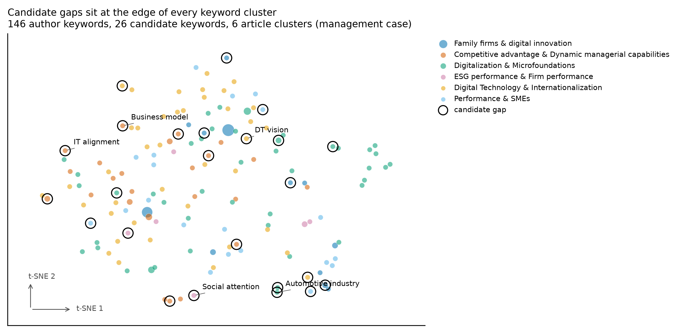
Fig. 2. Author-keyword space of the management corpus: t-SNE projection of all 146 author-keyword embeddings. Colour is the article cluster a keyword is most often assigned to, marker area is document frequency, and outlines mark the 26 distinct Mode B candidates; the highest-scoring are labelled where labels do not collide.
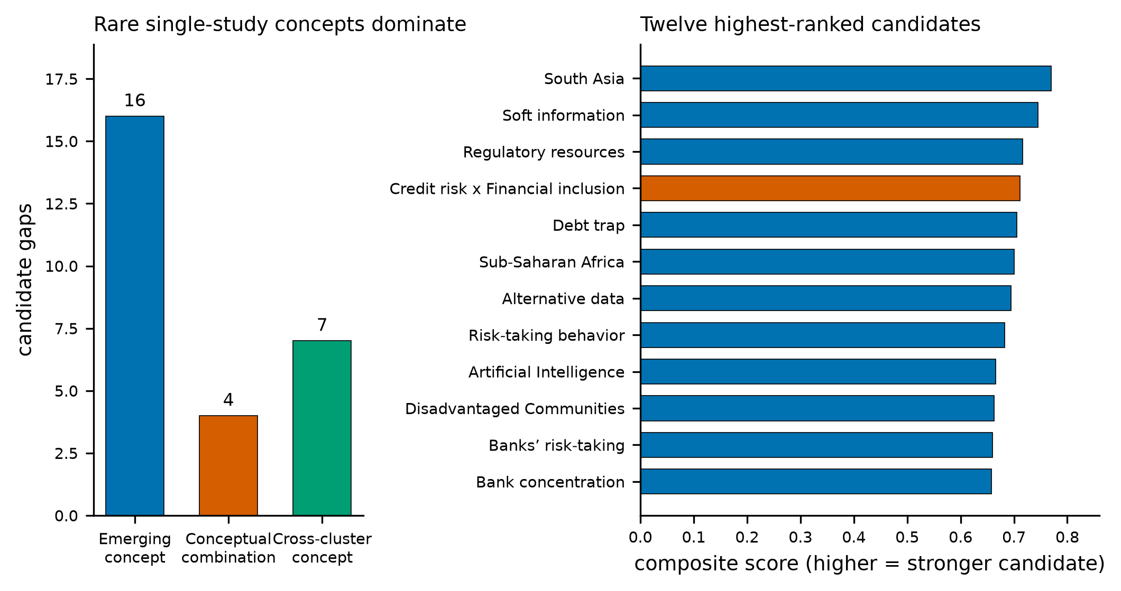
Fig. 3. Economics and finance corpus, Mode B. Left: candidate entries per type. Right: the twelve highest-ranked candidates, coloured by type; scores are comparable within a type, not across types.
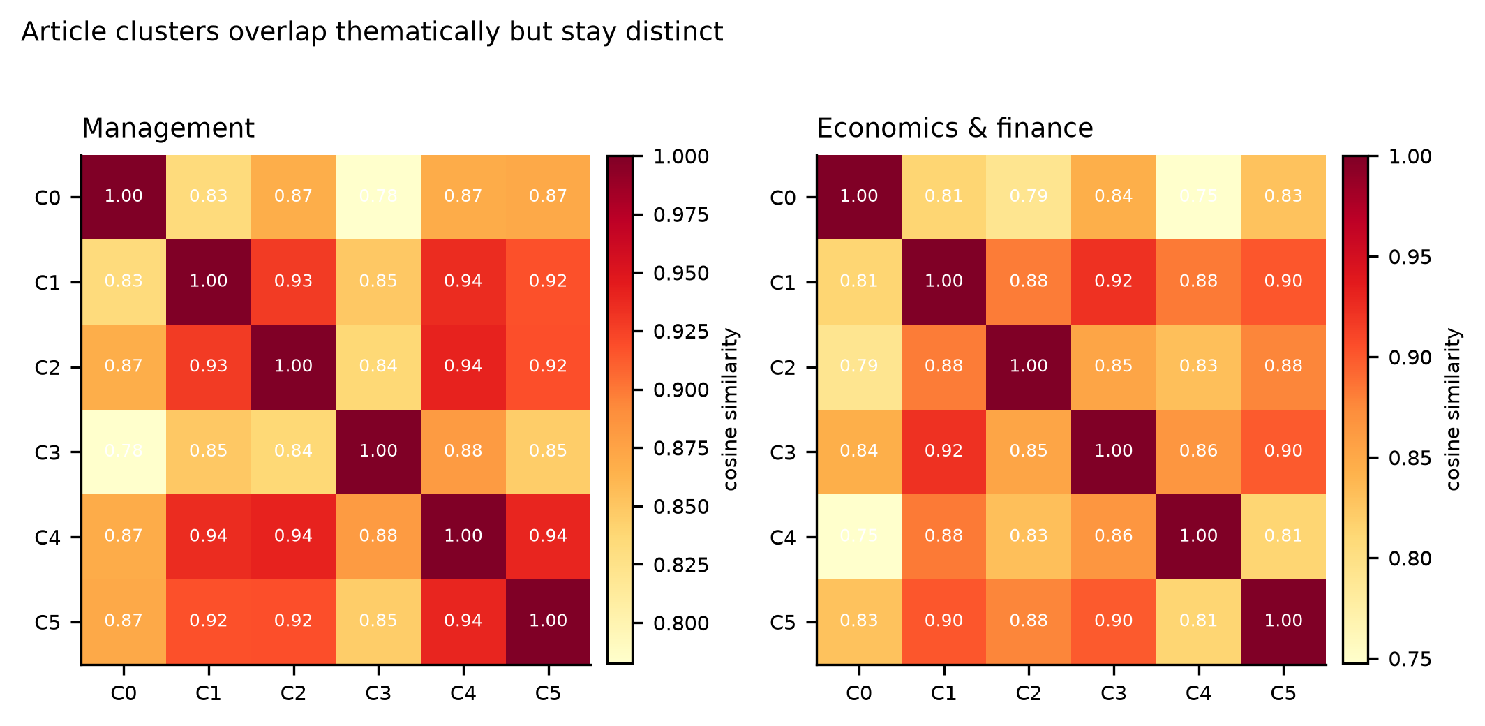
Fig. 4. Pairwise cosine similarity of the six article-cluster centroids in each case study — the inter-cluster overlap measure of the source procedure.

3.2. How stable the candidate lists are
Fig. 5 quantifies stability. Re-running a mode with five k-means seeds and nothing else changed, the candidate sets overlap by a mean pairwise Jaccard index of 0.44 (Mode B) and 0.14 (Mode A) on the management corpus, and 0.38 and 0.15 on the economics and finance corpus; the worst Mode A seed pair shares no candidate at all. Changing the corpus size from N = 50 to N = 30, 100 or 150 leaves overlaps of 0.09 to 0.31 against the N = 50 reference for Mode B and 0.00 to 0.38 for Mode A — the zero being the economics and finance corpus at N = 150, whose eight candidates have nothing in common with the four found at N = 50. Because N is as arbitrary as the seed, consensus_gaps pools over both: across five seeds and four sizes, twenty runs per mode, the mean pairwise overlap is 0.23 and 0.19 for Mode B on the two corpora, and the decomposition separates the sources — 0.45 and 0.39 between runs sharing a size, against 0.18 and 0.14 between runs that do not. The corpus size moves the candidate list more than the seed does.
Pooling is what makes a list reportable. Of 161 distinct candidates produced across the twenty management Mode B runs, 12 reach majority support and 2 are unanimous; for economics and finance the figures are 166, 11 and 2. Mode A pools to 50 and 37 candidates with 2 and 1 at majority support and none unanimous — a quantitative statement that its single-run output should not be read as a ranking at all. High support is not validity, though: the two personal names left in the management keyword field by a metadata error reach support of 0.85 and 0.75, because a data defect is perfectly reproducible, which is why the package ships the validation layer as well.
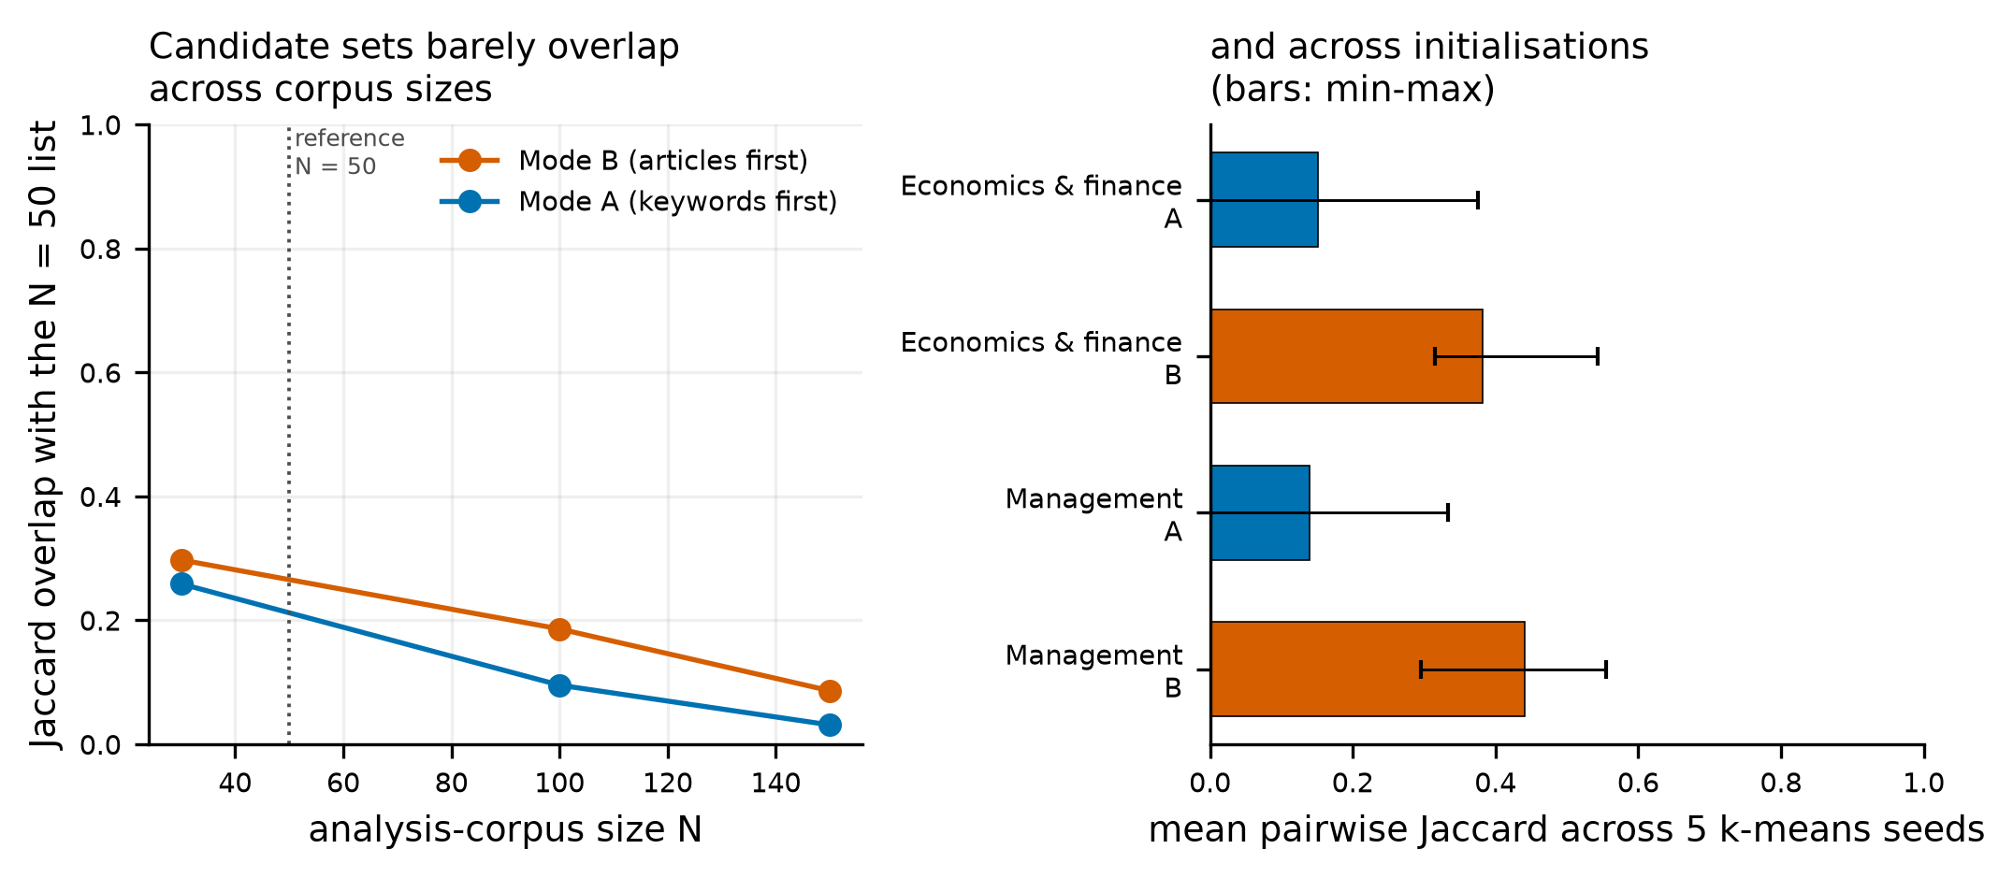
Fig. 5. Stability of the candidate list. Left: Jaccard overlap with the N = 50 candidate list when the analysis corpus is resized, shown separately for the two modes and averaged over the two case studies. Right: mean pairwise Jaccard overlap across five k-means seeds with everything else held fixed; whiskers span the minimum and maximum seed pair.

3.3. What the panel says
Five providers (GPT-4o, Claude Sonnet 4.6, DeepSeek V4 Pro, Grok 4.5 and Gemini 2.5 Flash) annotated every candidate and every author keyword of the analysis corpus at temperature 0 — between 758 and 990 judgements per corpus and mode. The control arm is the keyword population minus the candidates: the arms must be disjoint, or the candidates contribute to both and no two-sample statistic has a defined null distribution. Inter-annotator reliability on the candidate sets was moderate (Fleiss' κ 0.45–0.70; Krippendorff's α on the Novelty Score 0.38–0.85). Holding two models out and correlating their mean Novelty Score against that of the remaining three gave Spearman ρ between 0.64 and 0.83 on the Mode B candidate sets; on Mode A the coefficient rests on four to six keywords and is uninterpretable. This is a model-against-model check exercising the same concordance code path as an expert study, not a substitute for one.
Against that control (Fig. 6, left) the six comparisons point in different directions. Mode B candidates are labelled GAP more often than control keywords on the economics and finance corpus (+12.7 pp, mean Novelty Score +12.5 %, Welch p = 0.032, Mann-Whitney p = 0.014, permutation p = 0.046, d = 0.21) and less often on management (−1.2 pp) and gamification (−9.1 pp); Mode A is negative on all three (−8.0, −9.3, −3.5 pp). One nominally significant result out of six pre-planned comparisons is what chance produces: under Holm correction across the six, nothing survives (smallest adjusted p = 0.19). We therefore read the panel as showing no reliable novelty enrichment, with a single corpus-and-mode combination worth re-testing on an independent corpus rather than a demonstrated effect.
The panel is not the only evidence on this method, and the earlier evidence is more favourable. The AMCIS study validated its candidates against two human experts as well as the panel: an associate professor and a full professor, each with more than twenty years in the field of the corpus, independently scored the sixteen candidates the pipeline produced. Three of them — social commerce, time poverty and psychological distance — were labelled GAP unanimously by all five models and corroborated as gaps by at least one expert, and expert mean Novelty Scores correlated with the panel's at Spearman ρ = 0.61 (p = 0.012, n = 16) [17]. That study also found the spread of expert opinion wider than the spread across models, and described its expert arm as a pilot to be replaced by a larger calibrated study. A sixteen-keyword pilot on one marketing corpus and a panel study on three corpora in two other domains are different measurements, and the disagreement between them is what that larger study is needed to resolve. We did not repeat it — an expert study is a study of people, not of software — so the package ships the instrument instead, and the blinded sheets for all three corpora are in the supplementary material.
A filter-eligible comparison locates where what little signal there is comes from. The eligible pool is every keyword that passes all filters but that the ranking did not select; the remaining keywords fail at least one filter. Comparing the pool against those failing keywords isolates the filters, and comparing the candidates against the pool isolates the ranking applied on top of them (Fig. 6, right). The filters raise the GAP rate by 7.8 pp on management and 10.6 pp on economics and finance, and mean novelty by 8.3 % and 9.2 % (permutation p = 0.149 and 0.069) — consistent in sign and size on both corpora. The ranking then moves the GAP rate by −6.1 pp and +6.8 pp and novelty by −8.4 % and +8.6 % (permutation p = 0.192 and 0.150) — inconsistent in sign. On these corpora the filters carry whatever enrichment exists, and the periphery criterion adds nothing the panel can detect.
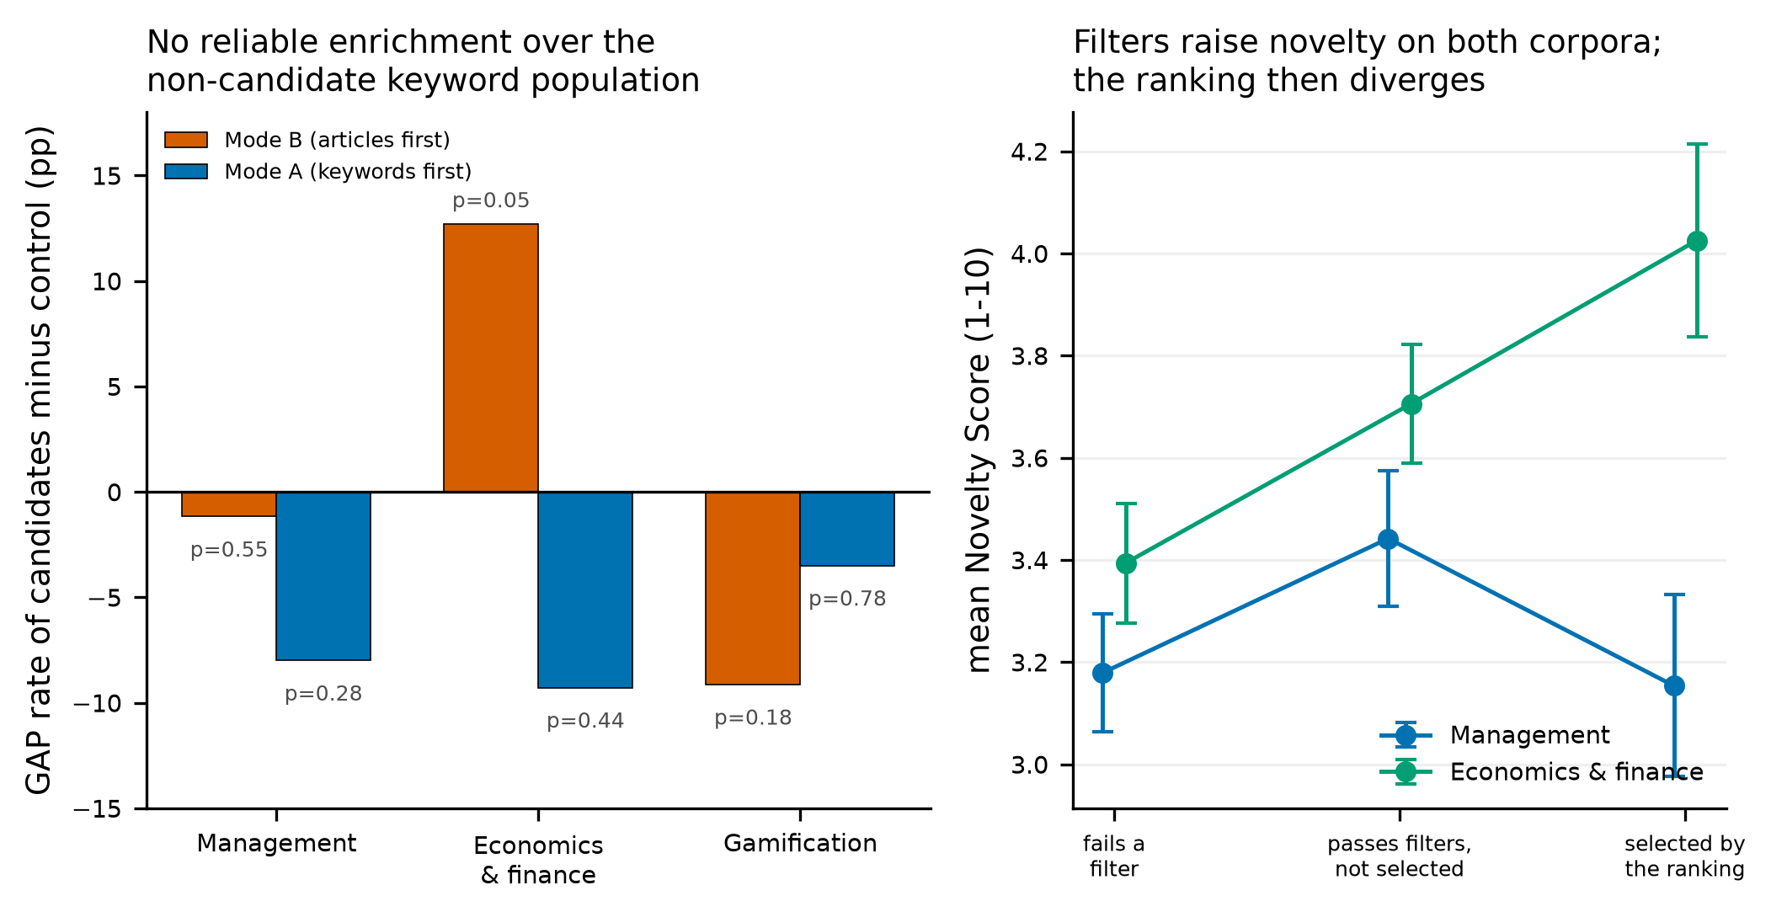
Fig. 6. Panel validation, five providers at temperature 0. Left: GAP rate of the candidate set minus that of the disjoint control set, in percentage points, annotated with the permutation p-value of the Novelty Score test. Right: mean Novelty Score across the three arms that separate the contribution of the filters from that of the ranking; whiskers are standard errors.

4. Impact
The immediate impact is that two published procedures become executable. A reviewer who wants to apply either now installs a package, writes ten lines, and obtains a candidate table with a rationale and source articles for every row, instead of transcribing a notebook and re-entering credentials. The precomputed backend plus the saved RunConfig make a published run repeatable at zero embedding cost, which turns a gap list into evidence a reviewer can be asked about.
The methodological impact is the measurement the prototypes did not report. Because EmbedResearchGaps makes both the seed and the corpus size explicit parameters and pools across them, the instability documented in Section 3.2 becomes visible and reportable rather than hidden behind a default, and the LOW_CLUSTER_SEPARATION warning tells a user when their partition is too weak to read a single-run ranking off. Any future work that ranks candidates from a k-means partition of an author-keyword space now has both a baseline to beat and an instrument that measures whether it beat it. The filter-eligible comparison of Section 3.3 is the same kind of instrument for effect attribution: it distinguishes "our filters are sensible" from "our ranking works", and it is available to anyone extending either procedure.
Because the ranking adds no detectable enrichment over the filters and the lists move with the initialisation, a candidate table from this package is a generator of hypotheses for expert screening, not an inventory of established omissions. The software is built for that use: every candidate carries a rationale, its source articles and its support across runs, and the validation subpackage and the expert sheets give the screening step instruments too.
EmbedResearchGaps is complementary to EmbedSLR [6,7] rather than incremental: EmbedSLR decides which articles enter a review by ranking document-level embeddings against inclusion criteria, whereas EmbedResearchGaps takes an already-screened corpus and mines the author-keyword space of the accepted articles for what they do not discuss, returning typed candidates with stability support. It is likewise not a bibliometric mapping tool: VOSviewer and bibliometrix visualise co-occurrence structure and leave interpretation to the reader, whereas EmbedResearchGaps applies explicit, parameterised criteria to produce a ranked, auditable list with a measured reproducibility — and reports when that reproducibility is poor. The validation subpackage is reusable on its own, on any keyword list whatever produced it.

5. Conclusions
EmbedResearchGaps implements, tests and documents two embedding-based procedures for identifying candidate research gaps in author-keyword space, with interchangeable embedding backends, a five-provider validation panel, expert sheets, and cross-process determinism enforced by the test suite (315 tests, 93 % statement coverage).
Applied to two new Scopus corpora, the software reproduces the mechanics and the candidate-type distribution of the published procedures, and shows two limits users should plan around: candidate lists are sensitive both to the k-means initialisation and to the corpus size, and the semantic ranking adds no reliable novelty enrichment beyond the lexical and frequency filters. We therefore recommend running the articles-first mode through consensus_gaps across at least five seeds and several corpus sizes, reporting support with every candidate, and treating the output as hypotheses for expert screening rather than a ranking to be read off. Work in progress extends consensus across embedding models and replaces k-means with a density-based partition whose stability does not depend on an initialisation.

Declaration of generative AI and AI-assisted technologies in the manuscript preparation process
During the preparation of this work the authors used Claude (Anthropic) in order to assist with implementing and testing the software, running the reported analyses and drafting and editing the manuscript. After using this tool, the authors reviewed and edited the content as needed and take full responsibility for the content of the published article. No AI tool is listed as an author. The figures are data visualisations produced by the package's own plotting code from the deposited result tables; no primary observed or experimental image was created or altered with AI tools.

CRediT authorship contribution statement
Sebastian Matysik: Conceptualization, Methodology, Software, Validation, Formal analysis, Data curation, Visualization, Writing – original draft, Writing – review and editing. Joanna Wiśniewska: Conceptualization, Methodology, Validation, Supervision, Writing – review and editing. Paweł Karol Frankowski: Conceptualization, Methodology, Software, Validation, Writing – review and editing.

Declaration of competing interest
The authors declare that they have no known competing financial interests or personal relationships that could have appeared to influence the work reported in this paper.

Funding
This research did not receive any specific grant from funding agencies in the public, commercial, or not-for-profit sectors.

Data availability
The three corpora, all candidate and validation tables, the figure sources and the scripts that regenerate every reported number are deposited in the software release [22], under data/ and paper/; the panel's annotation judgements are included in full. The corpora are Scopus records retrieved through the Scopus Search API, and data/README.md gives the queries and retrieval dates, so a reader with Scopus access can re-retrieve them.

Acknowledgements
The authors thank the two anonymous domain experts who took part in the expert validation of the antecedent study [17].

References
[1] Westgate MJ, Barton PS, Pierson JC, Lindenmayer DB. Text analysis tools for identification of emerging topics and research gaps in conservation science. Conserv Biol 2015;29:1606-14. https://doi.org/10.1111/cobi.12605.
[2] Robinson KA, Saldanha IJ, McKoy NA. Development of a framework to identify research gaps from systematic reviews. J Clin Epidemiol 2011;64:1325-30. https://doi.org/10.1016/j.jclinepi.2011.06.009.
[3] Sandberg J, Alvesson M. Ways of constructing research questions: gap-spotting or problematization? Organization 2011;18:23-44. https://doi.org/10.1177/1350508410372151.
[4] Page MJ, McKenzie JE, Bossuyt PM, Boutron I, Hoffmann TC, Mulrow CD, et al. The PRISMA 2020 statement: an updated guideline for reporting systematic reviews. BMJ 2021;372:n71. https://doi.org/10.1136/bmj.n71.
[5] van de Schoot R, de Bruin J, Schram R, Zahedi P, de Boer J, Weijdema F, et al. An open source machine learning framework for efficient and transparent systematic reviews. Nat Mach Intell 2021;3:125-33. https://doi.org/10.1038/s42256-020-00287-7.
[6] Matysik S, Wiśniewska J, Frankowski PK. EmbedSLR: an open-source python framework for efficient embedding-based screening and bibliometric validation in systematic literature review. SoftwareX 2025;32:102416. https://doi.org/10.1016/j.softx.2025.102416.
[7] Matysik S, Wiśniewska J, Frankowski PK. Version 2.0 - EmbedSLR: an open-source python framework for efficient embedding-based screening and bibliometric validation in systematic literature review. SoftwareX 2026;34:102563. https://doi.org/10.1016/j.softx.2026.102563.
[8] van Eck NJ, Waltman L. Software survey: VOSviewer, a computer program for bibliometric mapping. Scientometrics 2010;84:523-38. https://doi.org/10.1007/s11192-009-0146-3.
[9] Aria M, Cuccurullo C. bibliometrix: an R-tool for comprehensive science mapping analysis. J Informetr 2017;11:959-75. https://doi.org/10.1016/j.joi.2017.08.007.
[10] Chen C. CiteSpace II: detecting and visualizing emerging trends and transient patterns in scientific literature. J Am Soc Inf Sci Technol 2006;57:359-77. https://doi.org/10.1002/asi.20317.
[11] Donthu N, Kumar S, Mukherjee D, Pandey N, Lim WM. How to conduct a bibliometric analysis: an overview and guidelines. J Bus Res 2021;133:285-96. https://doi.org/10.1016/j.jbusres.2021.04.070.
[12] Small H, Boyack KW, Klavans R. Identifying emerging topics in science and technology. Res Policy 2014;43:1450-67. https://doi.org/10.1016/j.respol.2014.02.005.
[13] Devlin J, Chang MW, Lee K, Toutanova K. BERT: pre-training of deep bidirectional transformers for language understanding. In: Proceedings of NAACL-HLT 2019. Minneapolis: Association for Computational Linguistics; 2019, p. 4171-86. https://doi.org/10.18653/v1/N19-1423.
[14] Reimers N, Gurevych I. Sentence-BERT: sentence embeddings using Siamese BERT-networks. In: Proceedings of EMNLP-IJCNLP 2019. Hong Kong: Association for Computational Linguistics; 2019, p. 3980-90. https://doi.org/10.18653/v1/D19-1410.
[15] Petukhova A, Matos-Carvalho JP, Fachada N. Text clustering with large language model embeddings. Int J Cogn Comput Eng 2025;6:100-8. https://doi.org/10.1016/j.ijcce.2024.11.004.
[16] Frankowski PK, Wiśniewska J, Matysik S. Automated identification of research gaps using keyword clustering and an embedding model. In: PACIS 2026 Proceedings, paper 7. https://aisel.aisnet.org/pacis2026/adv_theory/adv_theory/7 [accessed 13 September 2026].
[17] Frankowski PK, Wiśniewska J, Matysik S. Semantic periphery detection in academic keyword space: an embedding-driven framework for automated research gap identification. In: AMCIS 2026 Proceedings, paper 7. https://aisel.aisnet.org/amcis2026/ai_aiaa/ai_aiaa/7 [accessed 13 September 2026].
[18] Gilardi F, Alizadeh M, Kubli M. ChatGPT outperforms crowd workers for text-annotation tasks. Proc Natl Acad Sci U S A 2023;120:e2305016120. https://doi.org/10.1073/pnas.2305016120.
[19] Törnberg P. Large language models outperform expert coders and supervised classifiers at annotating political social media messages. Soc Sci Comput Rev 2024;43:1181-95. https://doi.org/10.1177/08944393241286471.
[20] Heseltine M, Clemm von Hohenberg B. Large language models as a substitute for human experts in annotating political text. Res Polit 2024;11. https://doi.org/10.1177/20531680241236239.
[21] Rousseeuw PJ. Silhouettes: a graphical aid to the interpretation and validation of cluster analysis. J Comput Appl Math 1987;20:53-65. https://doi.org/10.1016/0377-0427(87)90125-7.
[22] Matysik S, Wiśniewska J, Frankowski PK. EmbedResearchGaps. Version 1.0.0 [software]. GitHub; 2026. https://github.com/s-matysik/EmbedResearchGaps/releases/tag/v1.0.0.

