Marked copy. Yellow background marks text new or changed relative to the submitted version; text removed from a revised sentence follows it in grey strike-through in square brackets. A clean copy without marking is supplied separately.

EmbedResearchGaps: embedding-based shortlisting and stability assessment of candidate research gaps in author-keyword space
anonymized for review

Abstract
Literature screening is increasingly automated, but experts must still identify what screened corpora leave unexplored. EmbedResearchGaps implements two published methods for finding candidate gaps from author keywords: cluster-periphery detection, and article-cluster mining for emerging concepts, cross-cluster concepts and unrealized combinations. It adds seven embedding backends, five-model annotation, blinded expert sheets and a consensus layer, with 407 tests at 93% coverage. On three Scopus corpora candidate lists moved with every analysis choice: Jaccard overlap was 0.14-0.44 across seeds and 0.00-0.23 across backends, and no silhouette exceeded 0.07. Against a disjoint control the ranking showed no reliable novelty enrichment (largest contrast +13.0 pp, 95% CI -5.6 to 30.4) and no advantage over a random draw of equally rare keywords.

Keywords
research gaps; semantic embeddings; keyword clustering; literature review; bibliometrics; reproducibility

Metadata
Table 1. Code metadata.
Nr | Code metadata description | Metadata
C1 | Current code version | v1.1.0
C2 | Permanent link to code/repository used for this code version | anonymized for review
C3 | Legal code license | MIT License
C4 | Code versioning system used | git
C5 | Software code languages, tools and services used | Python (>= 3.10); numpy, pandas, scipy, scikit-learn, matplotlib, networkx, kneed, requests, typer
C6 | Compilation requirements, operating environments and dependencies | Pure Python 3.10 or newer, no compilation: pip install embedresearchgaps
C7 | If available, link to developer documentation/manual | anonymized for review
C8 | Support email for questions | anonymized for review

Motivation and significance
A reviewer who has finished screening faces a question no tool answers: which of the roughly 150 author keywords in an accepted corpus point to underexplored directions? Screening is automated repeatedly, through active learning [1] and embedding-based ranking as in EmbedSLR [2,3], and reporting standards specify documentation [4]; moving from a screened corpus to a shortlist still rests on unaided reading [5]. Gap categories are formalized [6], yet identification stays non-mechanical, and gap-spotting is criticized as a weak basis for research questions without problematization [7].
Neighbouring traditions infer links, themes or summaries: literature-based discovery connects disjoint literatures from Swanson's ABC paradigm onward [8,9]; link prediction forecasts co-occurring term pairs [10]; topic models and their embedding-based successors summarize a corpus into themes [11]; language models increasingly interpret literature [12]. The task here is narrower: rank the author keywords of a screened corpus so an expert reads fewer. No ranking can identify what a field has not yet asked, which needs interpretation, not classification against ground truth.
Two recent procedures generate such shortlists: one clusters author keywords and flags peripheral terms [13]; the other clusters articles, then searches each cluster's keyword subspace for emerging concepts, untested combinations of established terms, and concepts present elsewhere but absent from that cluster [14]. Both were evaluated by a multi-model panel against a calibrated rubric and by two experts in a pilot [13,14]. That design rests on evidence that models annotate some text tasks reliably [15-17] — political-text and crowd-work coding, which does not establish validity for gap assessment — and model annotators carry position, verbosity and self-preference biases [18]. Neither study released software or tested whether candidates persist on a rerun.
This paper turns that work into a reusable tool and asks three questions. Can the procedures be reproduced under configuration control? How far do candidate lists move with the seed, the corpus size and the backend? Does the ranking enrich the shortlist beyond its own filters and beyond a random draw of equally rare keywords? The third is the hypothesis tested, with the filters and a rarity-matched selection as baselines. Packaging also lets the second procedure's positive result be re-examined: it reported the GAP rate rising from 38.1% for the keyword population to 77.5% for the candidates, a comparison whose control contains them (Section 3.5).
Author keywords suit shortlisting: author-assigned, short, and long used in bibliometric work that visualizes co-occurrence while leaving interpretation to analysts [19-22]. Emerging-topic research relies on citation and term bursts rather than semantic spaces [23], whereas sentence embeddings [24,25] make keyword neighborhoods computable and separate short texts better than bag-of-words [26].

Software description

Software architecture
A shared front end loads a bibliographic export, normalizes author keywords, deduplicates records, embeds texts and selects the analysis corpus by proximity to the research problem. Two modes mine it; a shared back end measures stability, supports assessment and writes tables, figures and the run configuration (Fig. 1).
Thirteen top-level modules and a five-module validation subpackage divide the work: config, corpus, text, keywords, encoders, clustering, gaps, external, consensus, results, pipelines, viz and a command-line interface. The 407 tests enforce cross-process determinism and pin the parameters quoted here to the code; precomputed preserves published vectors, so a deposited run regenerates without a hosted endpoint.
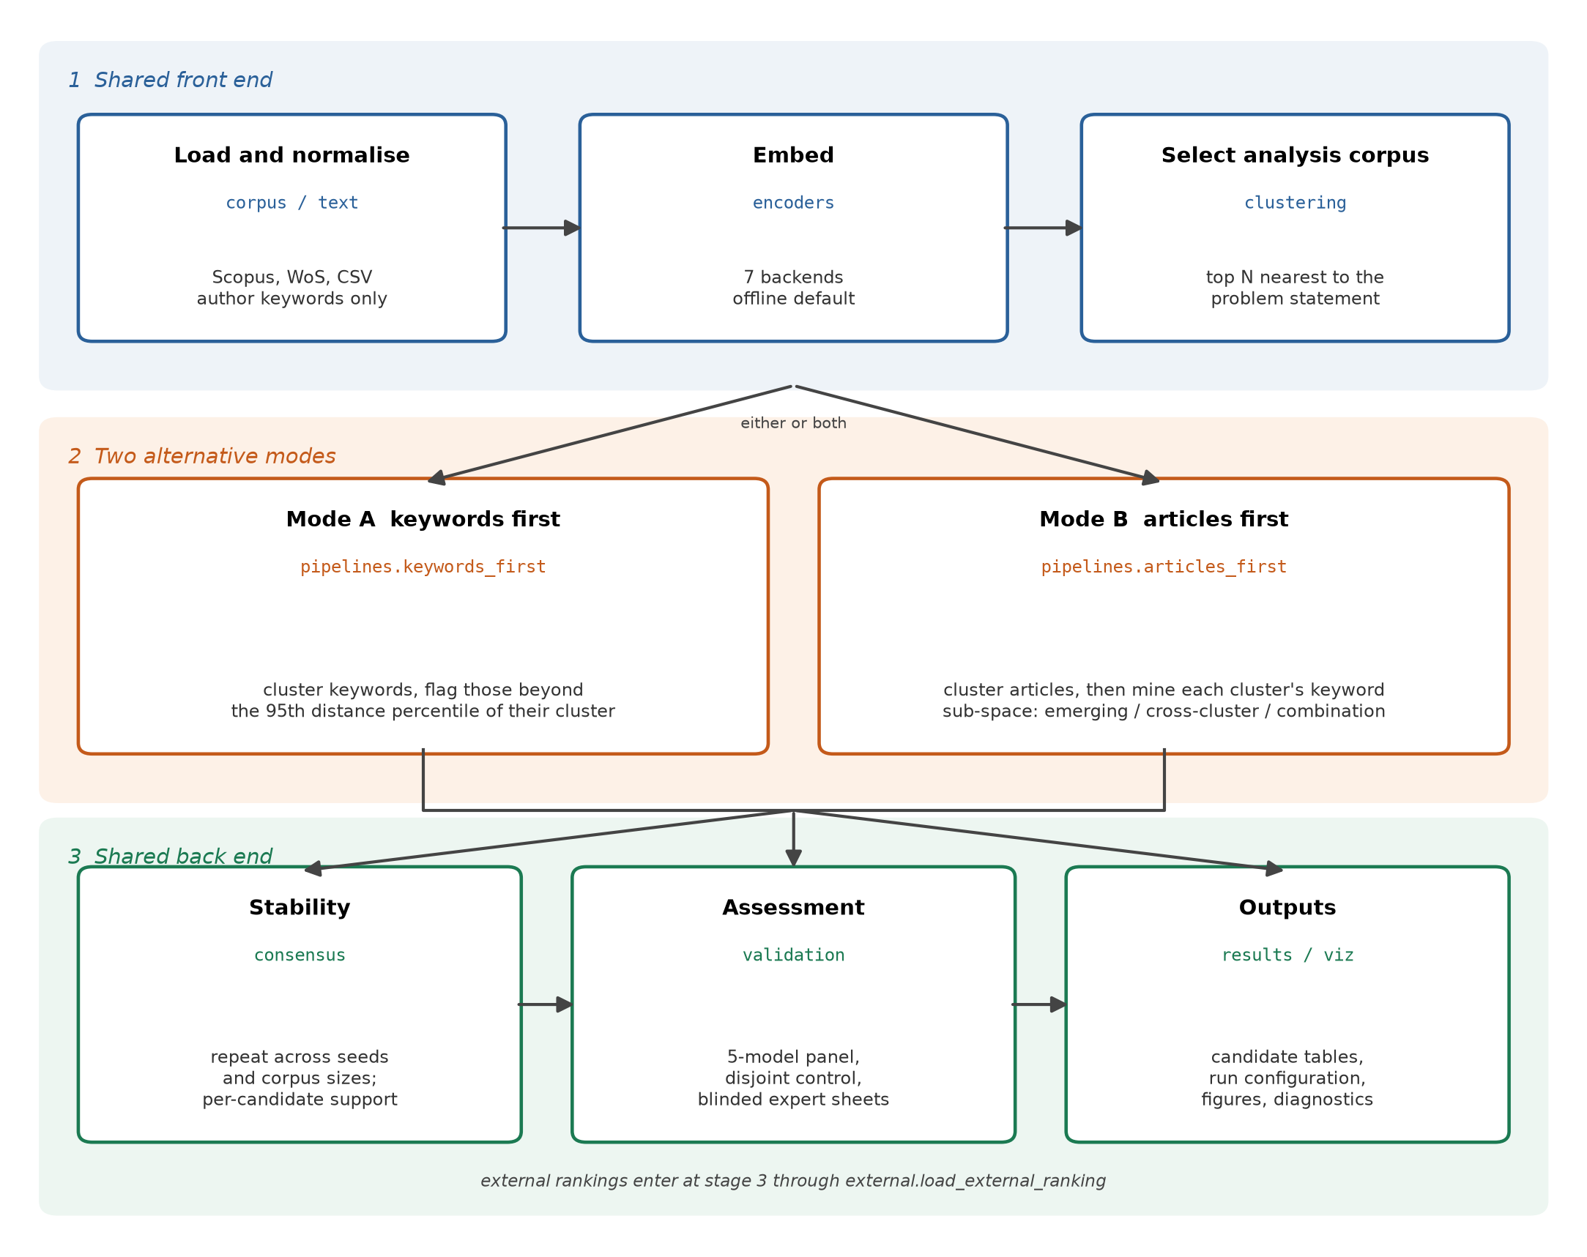
Fig. 1. Software architecture. Stage 1 prepares the analysis corpus, stage 2 applies either mining mode, stage 3 measures stability, assesses candidates and writes outputs; each component names its module. [figure regenerated]

Software functionalities
Two operating modes. keywords_first (Mode A) clusters the unique author keywords and flags one whose cosine distance from its cluster centroid exceeds the 95th percentile within that cluster, so clusters of different density are judged on their own scale. articles_first (Mode B) clusters the articles, labels each cluster from its frequent non-core keywords, builds a keyword sub-space per cluster and applies three detectors: emerging concept, document frequency at or below a ceiling c (here the default c = 1, one article); conceptual combination, two established keywords with cosine similarity in (0.25, 0.65), peaking at 0.45, carried by no common article; cross-cluster concept, a keyword frequent elsewhere but absent from the cluster under test. Each candidate carries a composite score, a weighted sum of min-max-normalized components (emerging: 0.25 distance from the sub-cluster centroid, 0.15 centrality, 0.30 TF-IDF salience, 0.30 rarity; no recency term). Weights and thresholds reproduce the source procedures [13,14] untuned, so they are defaults, not optima; S10b rescores each candidate set under equal and leave-one-out weightings, moving the order (Kendall tau 0.39-0.87) but not the membership, which the filters decide. Normalization is within one run's candidate set, so scores order candidates within a run but not across runs, and consensus pools membership rather than scores.
Shared filters remove terms peripheral for non-substantive reasons: the frequency ceiling, a two-token rule, a blocklist of 56 methodological phrases fixed before analysis, a TF-IDF floor of 0.005, and a core-domain filter dropping terms in over half the records. The ceiling was held at 1 for every corpus size, so the size sensitivity of Section 3.2 is no artefact of a moving threshold; the source procedure's proportional rule is available but unused. Every parameter of the reported runs is in S10; S10b-S10c vary the weights and the ceiling.
Seven embedding backends. tfidf-svd is offline and deterministic, sbert runs any sentence-transformers checkpoint locally, openai, nomic, jina and cohere call hosted endpoints, and precomputed accepts user vectors; Section 3.6 evaluates three, the other hosted backends being covered only by recorded-transport tests. One contract validates vector counts and rejects non-finite values, and precomputed keys vectors by text, not row position, so a stale mapping raises instead of misaligning. API keys come from environment variables and never enter a configuration object, result file or log. load_csv resolves canonical fields through an alias table covering the Scopus CSV export, the Scopus Search API and both Web of Science export flavors; Keywords Plus is excluded as database-generated.
Stability-aware consensus. consensus_gaps repeats a mode across seeds and, optionally, corpus sizes, reporting per candidate the fraction of runs producing it and, per run pair, the candidate-set overlap by source of variation. A partition whose silhouette [27] falls below 0.10 raises LOW_CLUSTER_SEPARATION; that threshold, the k-selection acceptance threshold (0.25) and the periphery percentile are RunConfig parameters, so their effect on the list can be read directly.
Candidate assessment. The validation subpackage implements the source protocol verbatim: each keyword receives a label (GAP, EXPLORED, LOW IMPORTANCE, METHOD or NOISE) and a Novelty Score from 1 to 10. The prompt carries the keyword, the research problem and the rubric but not the corpus, so scores reflect general knowledge rather than novelty within the analyzed articles; Section 3.3 tests how far they track rarity instead. Seven annotator backends are registered, six hosted chat endpoints at temperature 0 and CallableAnnotator for local functions; since temperature 0 does not guarantee reproducibility across model revisions, raw judgments, model identifiers and access dates are deposited. The module computes label rates, agreement coefficients and candidate-control comparisons: selected_and_control_keywords builds a control disjoint from the candidates and compare_keyword_sets withholds parametric p-values when arms share a keyword. Blinded expert sheets are exported and read back for Spearman correlation (S9). load_external_ranking reads a candidate list produced elsewhere into the same result object, so another tool's ranking can be scored against the same control (Section 3.4).
A minimal run, from export to expert sheet:
from embedresearchgaps import RunConfig, EncoderConfig, articles_first, load_csv
from embedresearchgaps.consensus import consensus_gaps
from embedresearchgaps.validation import build_expert_sheet

config = RunConfig(
top_n_articles=50,
problem_description="How does fintech credit affect financial inclusion?",
article_encoder=EncoderConfig(name="tfidf-svd"), # offline, no credentials
)
corpus = load_csv("scopus.csv")
result = articles_first(corpus, config) # typed, scored candidates
written = result.save("results/finance") # tables, diagnostics, config
consensus = consensus_gaps(corpus, "articles_first", config, seeds=(42, 7, 123, 2024, 99))
shortlist = consensus.gaps.query("support >= 0.5") # candidates in most runs
build_expert_sheet(result, config.problem_description).to_excel("experts.xlsx")

print(sorted(written), len(result.gaps), len(shortlist))
# ['articles', 'centroid_similarity', 'config', 'gaps', 'keywords', 'summary'] 26 23

Seven figures are produced headlessly, and every run returns the diagnostics a methods section needs: cluster sizes and quality indices [28,29], the k-selection trace [30], the TF-IDF match breakdown and per-cluster years.

Illustrative examples
Two Scopus corpora were retrieved: 493 records on dynamic capabilities and digital transformation, 487 on fintech credit, financial inclusion and bank lending; a third of 290 on gamification in marketing shares its topic, not its retrieval, with [14]. Queries, dates, problem statements, identifiers, all tables and the regeneration scripts are deposited (S1, [31]). Selecting the N articles nearest the problem statement plays the role screening plays; N = 50 here.
Table 2. Runs in this section. Keywords: distinct author keywords. E/X/C/P: emerging, cross-cluster, combination, peripheral candidates. Seed J: mean pairwise Jaccard over five seeds, hosted backend. RBO: rank-biased overlap over five seeds, offline backend. Support: candidates at majority support of the pooled total over twenty runs. Last column: keyword-level GAP-rate difference vs the disjoint control.
Corpus | Mode | Keywords | k | Silhouette | Candidates (distinct) | E/X/C/P | Seed J | RBO | Support >= 0.5 | GAP rate vs control (pp, 95% CI)
Management | B | 146 | 6 | 0.033 | 27 (26) | 18/7/2/0 | 0.44 | 0.34 | 12/161 | -1.2 [-17, 15]
Management | A | 146 | 6 | 0.051 | 6 (6) | 0/0/0/6 | 0.14 | 0.10 | 2/50 | -8.0 [-37, 24]
Economics & finance | B | 168 | 6 | 0.055 | 27 (25) | 16/7/4/0 | 0.38 | 0.27 | 11/166 | +13.0 [-6, 30]
Economics & finance | A | 168 | 6 | 0.051 | 4 (4) | 0/0/0/4 | 0.15 | 0.14 | 1/37 | -9.3 [-35, 28]
Gamification | B | 172 | 6 | 0.017 | 28 (26) | 18/7/3/0 | 0.32 | 0.38 | n/a | -9.1 [-24, 6]
Gamification | A | 172 | 8 | 0.069 | 6 (6) | 0/0/0/6 | 0.19 | 0.03 | n/a | -3.5 [-33, 28]

3.1 Candidate outputs of the two modes
k-selection maximises silhouette, falling back to the elbow criterion [30] below the 0.25 threshold: k = 6 in five runs, k = 8 in gamification Mode A. Mode B returned 27 entries over 26 distinct keywords in management and 27 over 25 in economics and finance, of which 24 enter the panel study; Mode A returned 6 and 4 peripheral keywords (Table 2, Figs. 2 and 3). Emerging concepts dominate, partly by definition: 54-62% of Mode B and every Mode A candidate occurs in one record; all are multi-token. Every partition falls below the 0.10 silhouette threshold and raises LOW_CLUSTER_SEPARATION; centroid similarities run 0.75 to 0.94 (Fig. 4). Distance concentration depresses silhouette even where structure exists, so these runs exercise the pipeline under weak separation. Candidates mix research directions, scope terms and, in one record, two personal names mis-entered as keywords, labelled NOISE at Novelty 1.
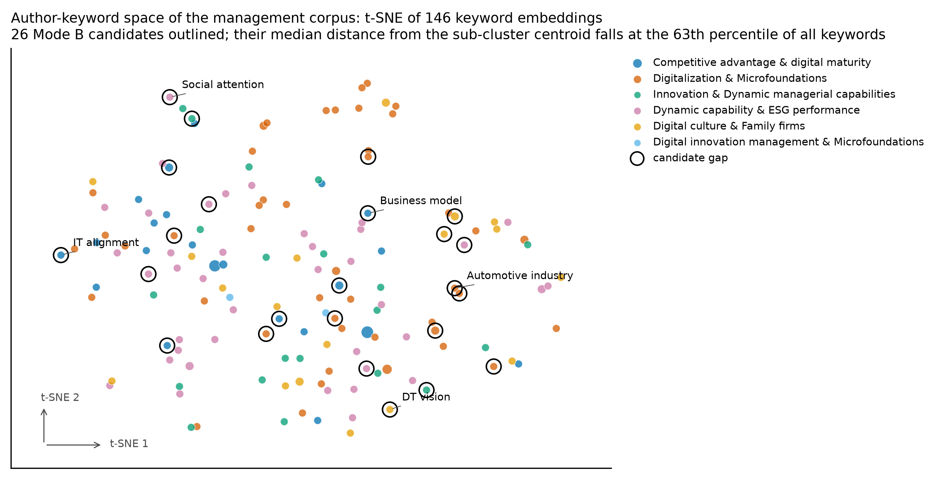
Fig. 2. Author-keyword space of the management corpus: t-SNE [32] projection of keyword embeddings, colored by dominant article cluster, marker area proportional to the square root of document frequency, Mode B candidates outlined. [figure regenerated]
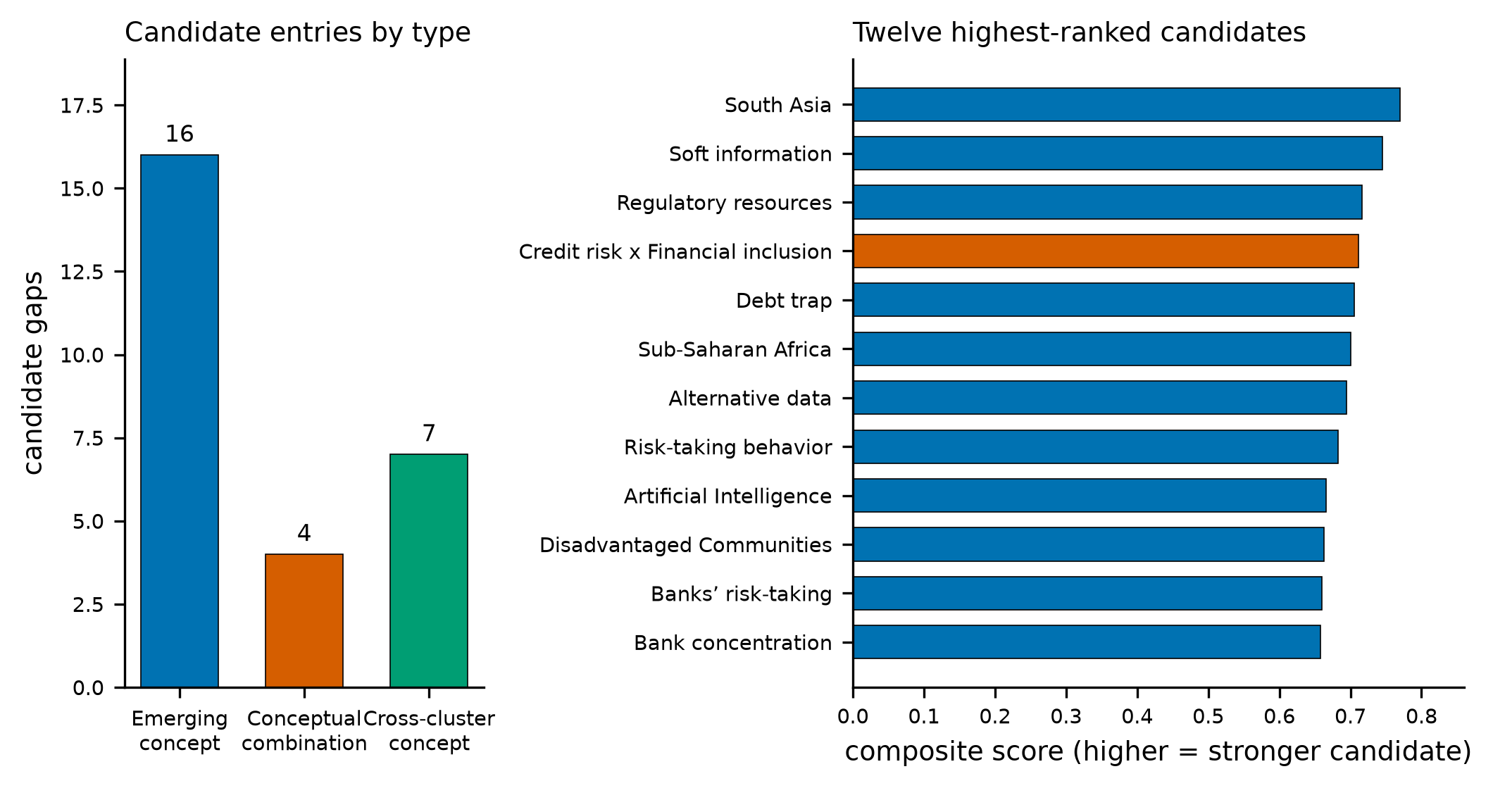
Fig. 3. Economics and finance corpus, Mode B: candidate types (left) and the twelve highest-ranked candidates with composite scores (right); the other corpora are in supplementary S16. [removed: their (right). ] [figure regenerated]
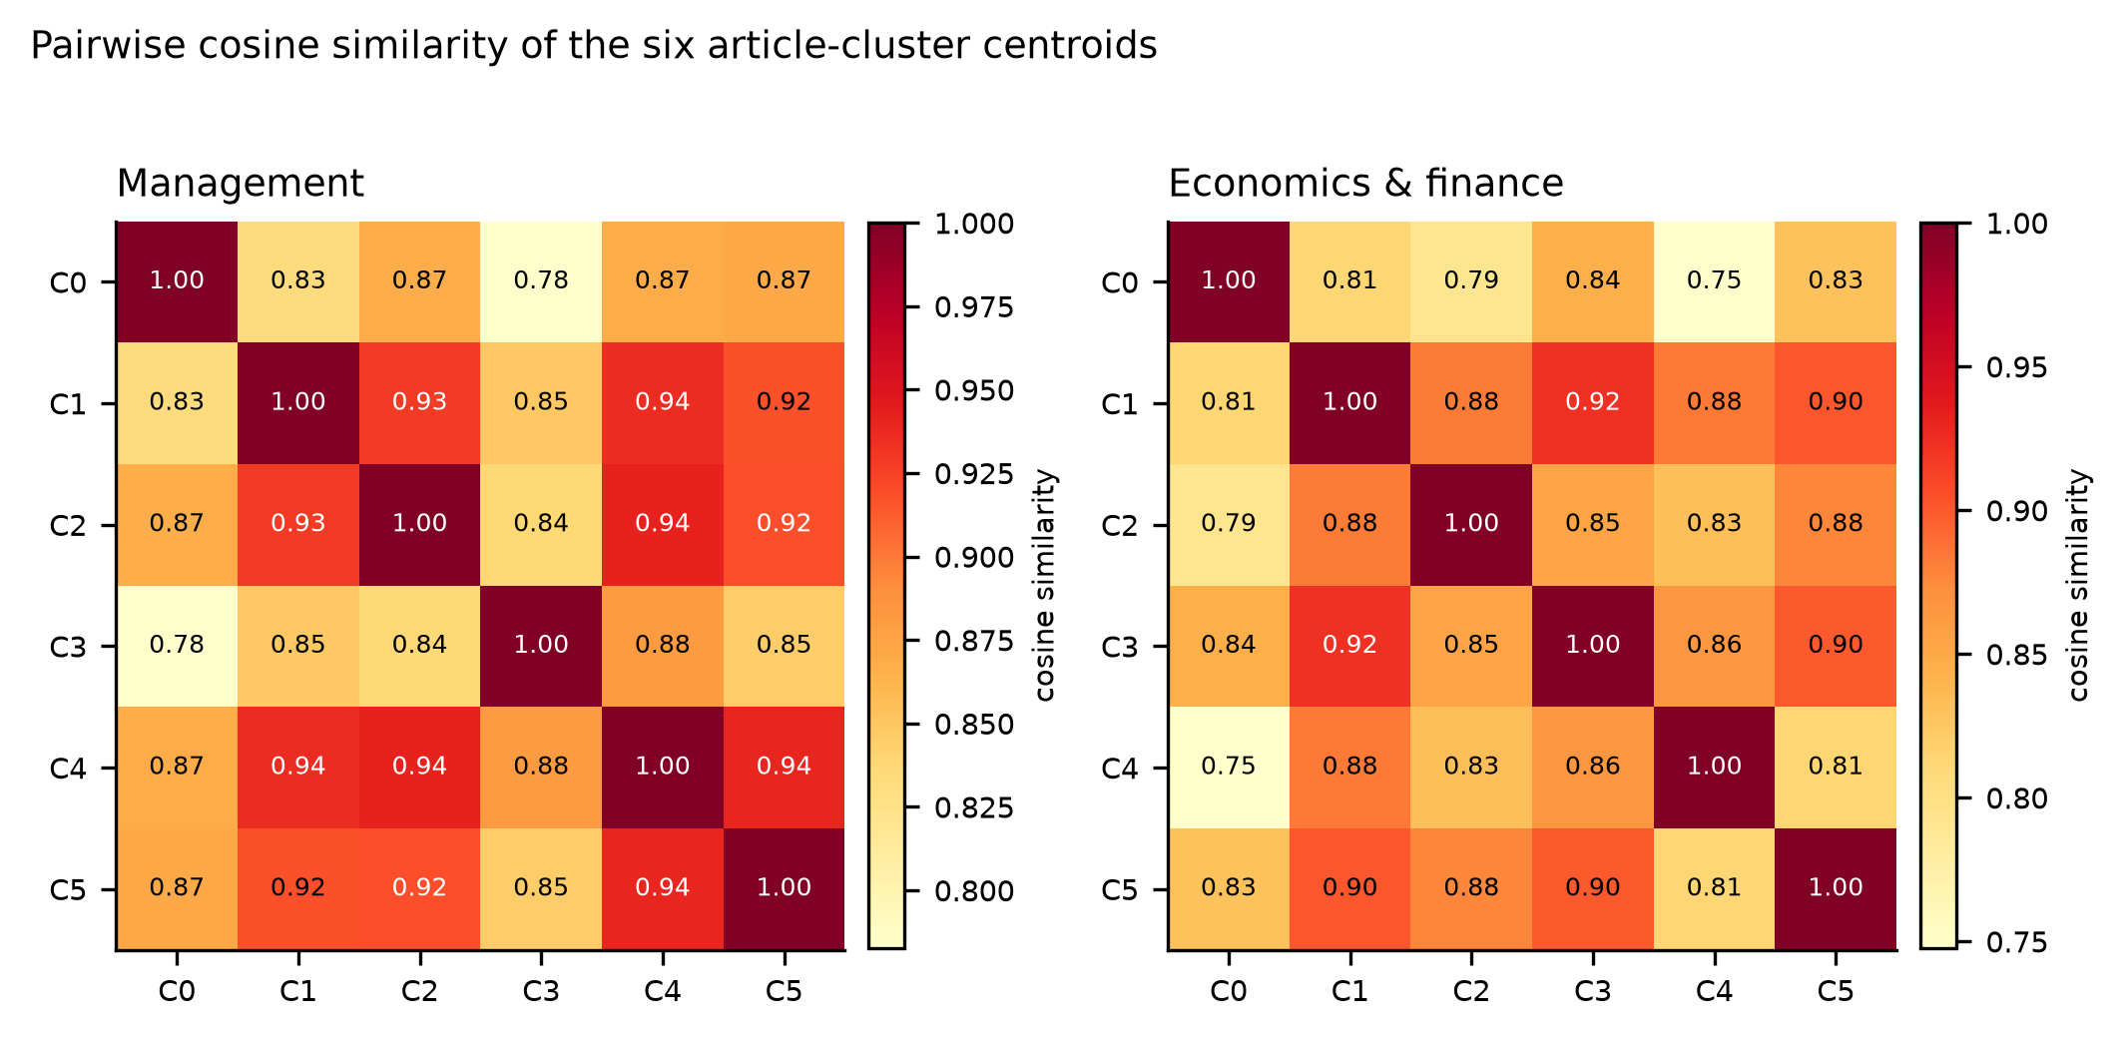
Fig. 4. Pairwise cosine similarity of the six article-cluster centroids, management (left) and economics and finance (right). [figure regenerated]

3.2 Candidate-list stability
Across five k-means seeds, mean pairwise Jaccard overlap was 0.44 (Mode B) and 0.14 (Mode A) in management, 0.38 and 0.15 in economics and finance (Fig. 5); the least stable Mode A pair shared nothing. Resizing gave 0.09-0.31 and 0.00-0.38, partly because k was re-selected each run, from 4 to 9. Pooling five seeds and four sizes, mean overlap was 0.23 and 0.19, decomposing into 0.45 and 0.39 within a size and 0.18 and 0.14 across sizes (S6b); the 0.14 above is across seeds at N = 50, not the 0.288 of that table, which pools all same-size pairs.
Because the output is a reading order, set overlap is not sufficient. Measured offline, rank-biased overlap (p = 0.9) across five seeds is 0.27-0.38 for Mode B and 0.03-0.14 for Mode A (S6c): about half a Mode B top-10 recurs under another seed, Mode A orderings rarely. Mode A lists hold fewer than ten items, so their top-10 overlap is bounded by length and not comparable with Mode B's. These rank measures and the Jaccard figures come from different backends, not one experiment.
Consensus support makes this explicit (Table 2): of 161 distinct candidates over twenty management Mode B runs, 12 reach majority support, 2 are unanimous. Support is not validity: the two metadata-error names reach 0.85 and 0.75.
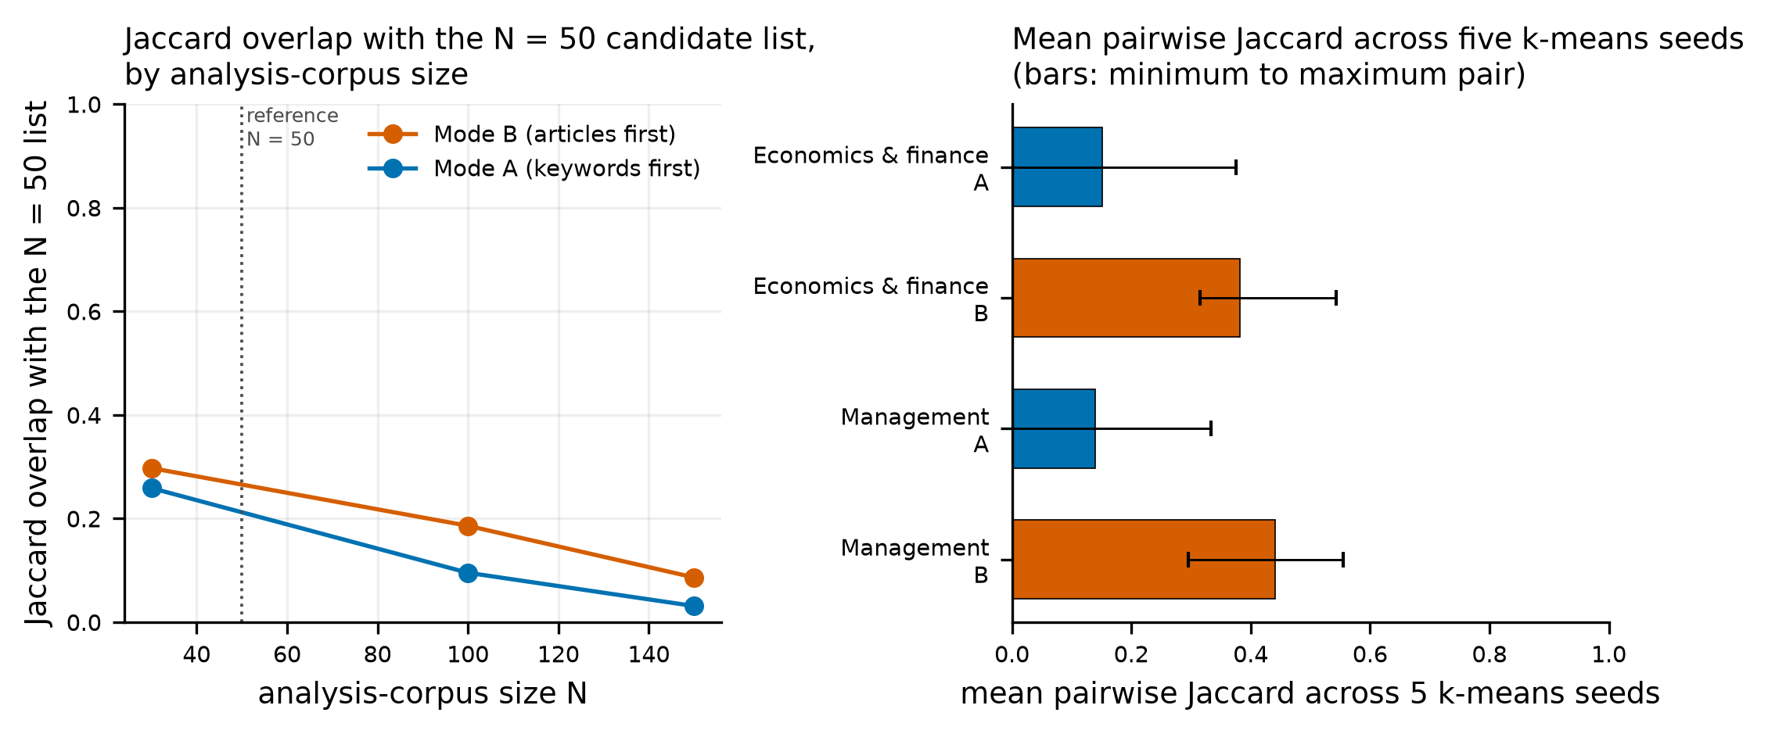
Fig. 5. Stability of the candidate list. Left: Jaccard overlap with the N = 50 list when the corpus is resized. Right: mean pairwise overlap across five k-means seeds; whiskers span the extreme pairs. [figure regenerated]

3.3 Multi-model annotation results
Five providers (GPT-4o, Claude Sonnet 4.6, DeepSeek V4 Pro, Grok 4.5, Gemini 2.5 Flash; identifiers and access dates in S8) assessed every author keyword of each analysis corpus at temperature 0 against one rubric. The unit of analysis is the keyword: its five judgments are aggregated before arms are compared, and S3 repeats everything at the judgment level. The control is the keyword population minus the candidates. Ordinal Krippendorff's alpha [33] on the Novelty Score is 0.53-0.67 (95% CI 0.45-0.74); Fleiss' kappa [34] on the labels, as the source studies report, is 0.45-0.70. Combinations are scored through their constituent terms, the panel rating keywords, not pairs.
Effect directions were inconsistent across the six comparisons (Fig. 6, left; Table 2). The largest is economics and finance, where 24 Mode B candidates scored 4.03 against 3.58 for 144 controls: 0.46 points on the Novelty Score (95% CI -0.33 to 1.24) and 13.0 pp in GAP rate (95% CI -5.6 to 30.4, permutation p = 0.14). Main-text intervals are percentile bootstraps over keywords, 10 000 resamples; S14's Welch intervals and the cluster bootstrap are sensitivity checks. The other five differences are negative, -1.2 to -9.3 pp; no interval excludes zero, and Holm adjustment [35] leaves the smallest adjusted p at 0.87 (GAP rate) and 1.00 (Novelty). The GAP rate is the mean over keywords of the share of five judgments labelling it GAP, not the share of keywords with a GAP majority. The design is not powerful: with 24-26 candidates against 120-146 controls in Mode B, and 4-6 against 140-166 in Mode A, the minimal detectable difference at 80% power is 22-26 pp and 49-54 pp. Equivalence testing against a 10 pp margin also fails to reject (smallest TOST p = 0.15). That margin is our usability assumption, two to three items on a 25-item shortlist, fixed during revision before these tests but after the original results were known, so the analysis is exploratory. Because keywords are nested within article clusters, the intervals were recomputed by resampling the six clusters with replacement, 4 000 draws (S14b): no conclusion changes, and economics and finance Mode B runs from -2 to 35 pp, itself imprecise at six clusters. The data neither demonstrate enrichment nor establish its absence: effects below roughly 20 pp are unresolvable here.
Two checks bear on what the panel measures. Over all annotated keywords the mean Novelty Score correlates weakly and negatively with document frequency (rho = -0.05, -0.03, -0.23): a weak monotonic association, not evidence that judgments are independent of rarity or valid as novelty measurement. Nor can they certify a gap in the analyzed corpus, because the prompt omits it. Re-annotating the same keywords with corpus evidence attached raises every GAP rate and Novelty mean, never lowering a label, and reverses the contrast in one corpus (S18): absolute rates are a property of the prompt, so only contrasts against a control are reported. The prefilters remove the methodological, core-domain and single-token terms the rubric labels METHOD, NOISE or LOW IMPORTANCE, so part of any filter-stage difference reflects agreement between filters and rubric rather than independent evidence. Decomposing by stage locates what separation exists (Fig. 6, right): the filter contrast is positive in both corpora, 7.9 pp (95% CI -5.2 to 21.0) and 10.5 pp (-2.5 to 23.6), while the ranking contrast changes sign (-6.3 and +7.2 pp).
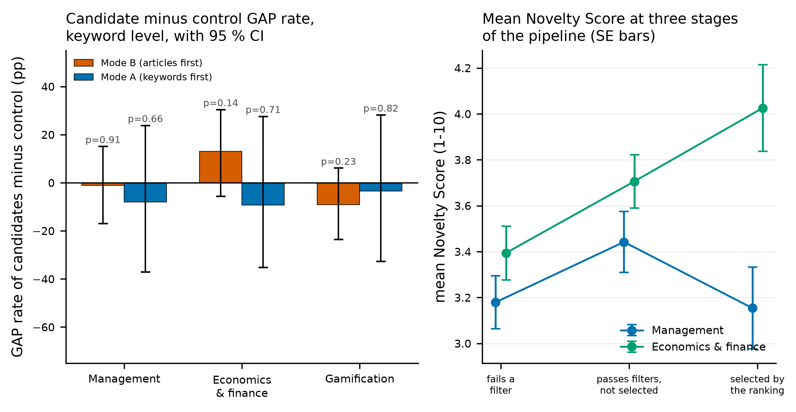
Fig. 6. Panel assessment, five providers at temperature 0, keyword as the unit. Left: GAP rate of candidates minus the disjoint control, 95% bootstrap intervals and permutation p-values. Right: mean Novelty Score at three stages (fails a filter; passes, not selected; selected), with standard errors. [removed: control. the filter-eligible decomposition - passes filters, selected by the ranking). ] [figure regenerated]

3.4 Comparison with simpler shortlists
Because the panel annotated every keyword, any shortlist of the same size can be scored on the same judgments. Three alternatives: a random draw of k keywords, a draw from the rare multi-token stratum the filters admit, and the k most frequent terms. Mode B candidates reached GAP rates of 46.2%, 65.0% and 35.4% across the three corpora, against 47.2%, 53.7% and 43.1% for unrestricted random selection and 49.2%, 59.9% and 48.1% for the rarity-matched draw (95% intervals 36-62, 46-74, 37-59 pp), sitting at its 31st, 75th and 1st percentile and below its mean in five of six comparisons. The most frequent keywords do clearly worse (42.3%, 49.2%, 26.2%), so the ceiling carries signal, but the ranking is not shown to improve on a random choice among the rare keywords it admits (S10c varies that ceiling). A rarity-ordered shortlist of the same size, read back through load_external_ranking, reaches 50.0%, 65.8% and 58.5% against its own disjoint control's 46.5%, 51.7% and 40.4%, with a Jaccard overlap of at most 0.06 against our candidates (S17); that control is defined against itself, so the two sets of rates are not interchangeable.

3.5 Expert comparison and re-evaluation of the antecedent study
In the pilot of [13,14], two experts assessed sixteen gamification candidates; their mean Novelty Scores correlated with the panel at rho = 0.61 (p = 0.012, n = 16); S8b sets out that comparison and its limits. Expert opinion was more widely spread than model opinion: a reference signal, not a gold standard (S8b).
In [14] candidates were compared with the full keyword population, which contains them. The nesting shrinks rather than inflates the contrast — at our candidate share it scales the disjoint-control estimate by about 0.86 (S8b) — so the reference group cannot alone explain the larger published effect. Corpora, candidate lists and model versions also differ; separating them needs a replication on that retrieval.

3.6 Backend sensitivity and computational cost
The runs above use text-embedding-3-large; repeating all six with tfidf-svd and with a local checkpoint (all-mpnet-base-v2) gives supplementary S12. Re-embedding the same corpus at the same endpoint months later returned 27 management candidates sharing 16 with the deposited 26: a hosted backend is not a fixed input over time, hence replay through precomputed. Separation is weak throughout: no silhouette exceeds 0.07, the maximum being 0.070. Backend choice moved membership more than cluster quality: against the text-embedding-3-large sets, tfidf-svd overlaps by a mean Jaccard of 0.14 in Mode B and 0.00 in Mode A, all-mpnet-base-v2 by 0.18 and 0.07 — below the 0.38-0.44 seed overlap within one backend.
We recommend the local checkpoint by default: no credentials, no network, 1,900 texts in under four minutes on eight cores. The two transformer backends' silhouette ranges overlap (0.036-0.070 against 0.017-0.069), so neither separates clusters demonstrably better, and substantive use calls for sensitivity analysis across at least two. That is cheap: Mode B on management takes 7.0 s at N = 50 and 14.3 s at N = 493 offline, peaking near 300 MiB (S13). Scalability beyond about 500 records was not tested.

Impact
The contribution is not a better ranking but a way to find out what a ranking is worth. Two procedures that existed only as notebooks are now a tested package in which every threshold, weight and seed is a declared parameter, runs reproduce across processes, and published results regenerate from deposited vectors.
The audit is the second contribution. Candidate lists are not stable: they move with the seed, the corpus size and the backend, by amounts large relative to the lists. The source studies reported one run each, so a reader could not tell whether a candidate would survive a rerun — as holds for single-run shortlists generally. Hence a procedure: run a mode across several seeds and sizes, report per-candidate support, and treat support as an instability screen, not a validity criterion; it catches artifacts of one initialization but cannot show a stable candidate marks a real gap, as the two stable metadata errors prove.
The third contribution is the assessment layer: a disjoint control, a declared unit of analysis, deposited judgments, blinded expert sheets and the refusal to report parametric p-values on overlapping arms, reusable for any ranking through load_external_ranking (Section 3.4). The evaluation sets expectations: on three corpora the ranking showed no reliable enrichment over a disjoint control and no advantage over a random draw from the rare keywords its filters admit, most measurable separation coming from the filters. What is demonstrated is narrower than a benefit to a reviewer: a reproducible shortlist with recorded provenance and sensitivity analyses over seeds, sizes and backends. Whether that saves time needs a user study, not reported here.
The package complements rather than extends EmbedSLR [2,3] and is not a bibliometric mapping tool (S15). Unlike embedding-based topic models such as BERTopic, which, like co-occurrence maps, require manual cluster inspection before a gap can be named [11], it turns that inspection into a ranked, typed shortlist with supporting articles and stability measures. Adjacent tools cover earlier steps — cluster selection [36], metadata enrichment [37], screening [38,39] — but none ranks underexplored directions from a screened corpus.
For practitioners, it reduces roughly 150 author keywords to about 25 typed, scored and sourced candidates with support values, in seconds and without credentials. For methodologists, it is an instrument for studying keyword-based gap detection and re-examining published claims: the antecedent result rests on a control containing the candidates, and the correction ships in the package, not in a comment on it.

Conclusions
EmbedResearchGaps implements two published research-gap procedures as a tested, configurable Python package and applies them to three Scopus corpora. The procedures reproduce; their outputs are strongly sensitive to the seed, the corpus size and the backend; and the ranking cannot be shown to add novelty beyond its own filters or a rarity-matched random draw.
The limits matter. The evidence is three English-language Scopus corpora of 493, 487 and 290 records in business and management, one problem statement each; neither the instability nor the null result is established beyond them. The panel is five models applied to a rubric, with ordinal agreement of 0.53-0.67 and no corpus in the prompt, which S18 shows inflates every rate: a proxy for expert judgment, not a measurement of novelty, and the one expert comparison is a sixteen-keyword pilot. Arms of 24-26 candidates cannot resolve differences below roughly 20 pp, and combinations are scored through their constituent terms.
Those limits define the work the package supports: a calibrated expert study on the sheets it exports, replication of the antecedent study on its retrieval, and a clustering whose stability does not depend on an initialization. We recommend reporting per-candidate support with every published candidate list, and treating any single-run shortlist, from this package or another, as one draw from an uncharacterized distribution.

Data availability
The corpora, all candidate and validation tables, the panel's raw judgments, figure sources and regeneration scripts are deposited with the release [31], together with supplementary sections S1-S17. Scopus records are redistributed as the bibliographic fields needed for reproduction plus record identifiers, within the terms permitted for research use; readers with Scopus access can re-retrieve full records from the queries and dates in S1.

Declaration of competing interest and generative AI
The authors declare no competing interests. GPT-4o, Claude Sonnet 4.6, DeepSeek V4 Pro, Grok 4.5 and Gemini 2.5 Flash were used as annotators in the study of Section 3.3, and a large language model assisted with code refactoring and language editing. Prompts, model identifiers and access dates are in supplementary S8 and raw judgments are deposited. The authors reviewed and edited all content and take full responsibility for it.

References
[1] van de Schoot R, de Bruin J, Schram R, Zahedi P, de Boer J, Weijdema F, et al. An open source machine learning framework for efficient and transparent systematic reviews. Nat Mach Intell 2021;3:125-33. https://doi.org/10.1038/s42256-020-00287-7.
[2] anonymized for review
[3] anonymized for review
[4] Page MJ, McKenzie JE, Bossuyt PM, Boutron I, Hoffmann TC, Mulrow CD, et al. The PRISMA 2020 statement: an updated guideline for reporting systematic reviews. BMJ 2021;372:n71. https://doi.org/10.1136/bmj.n71.
[5] Westgate MJ, Barton PS, Pierson JC, Lindenmayer DB. Text analysis tools for identification of emerging topics and research gaps in conservation science. Conserv Biol 2015;29:1606-14. https://doi.org/10.1111/cobi.12605.
[6] Robinson KA, Saldanha IJ, McKoy NA. Development of a framework to identify research gaps from systematic reviews. J Clin Epidemiol 2011;64:1325-30. https://doi.org/10.1016/j.jclinepi.2011.06.009.
[7] Sandberg J, Alvesson M. Ways of constructing research questions: gap-spotting or problematization? Organization 2011;18:23-44. https://doi.org/10.1177/1350508410372151.
[8] Swanson DR. Fish Oil, Raynaud's Syndrome, and Undiscovered Public Knowledge. Perspect Biol Med 1986;30:7-18. https://doi.org/10.1353/pbm.1986.0087.
[9] Sebastian Y, Siew EG, Orimaye SO. Emerging approaches in literature-based discovery: techniques and performance review. The Knowledge Engineering Review 2017;32. https://doi.org/10.1017/s0269888917000042.
[10] Rindflesch T, Hristovski D, Kastrin A. Link Prediction on a Network of Co-occurring MeSH Terms: Towards Literature-based Discovery. Methods Inf Med 2016;55:340-346. https://doi.org/10.3414/me15-01-0108.
[11] Wang Z, Chen J, Chen J, Chen H. Identifying interdisciplinary topics and their evolution based on BERTopic. Scientometrics 2023;129:7359-7384. https://doi.org/10.1007/s11192-023-04776-5.
[12] Ding L, Lawson C, Shapira P. Rise of Generative Artificial Intelligence in Science. Scientometrics 2025;130:5093-5114. https://doi.org/10.1007/s11192-025-05413-z.
[13] anonymized for review
[14] anonymized for review
[15] Gilardi F, Alizadeh M, Kubli M. ChatGPT outperforms crowd workers for text-annotation tasks. Proc Natl Acad Sci U S A 2023;120:e2305016120. https://doi.org/10.1073/pnas.2305016120.
[16] Törnberg P. Large language models outperform expert coders and supervised classifiers at annotating political social media messages. Soc Sci Comput Rev 2024;43:1181-95. https://doi.org/10.1177/08944393241286471.
[17] Heseltine M, Clemm von Hohenberg B. Large language models as a substitute for human experts in annotating political text. Res Polit 2024;11. https://doi.org/10.1177/20531680241236239.
[18] Zheng L, Chiang WL, Sheng Y, Zhuang S, Wu Z, Zhuang Y, et al. Judging LLM-as-a-judge with MT-Bench and Chatbot Arena. In: Advances in Neural Information Processing Systems 36 (NeurIPS 2023). https://doi.org/10.48550/arXiv.2306.05685.
[19] van Eck NJ, Waltman L. Software survey: VOSviewer, a computer program for bibliometric mapping. Scientometrics 2010;84:523-38. https://doi.org/10.1007/s11192-009-0146-3.
[20] Aria M, Cuccurullo C. bibliometrix: an R-tool for comprehensive science mapping analysis. J Informetr 2017;11:959-75. https://doi.org/10.1016/j.joi.2017.08.007.
[21] Chen C. CiteSpace II: detecting and visualizing emerging trends and transient patterns in scientific literature. J Am Soc Inf Sci Technol 2006;57:359-77. https://doi.org/10.1002/asi.20317.
[22] Donthu N, Kumar S, Mukherjee D, Pandey N, Lim WM. How to conduct a bibliometric analysis: an overview and guidelines. J Bus Res 2021;133:285-96. https://doi.org/10.1016/j.jbusres.2021.04.070.
[23] Small H, Boyack KW, Klavans R. Identifying emerging topics in science and technology. Res Policy 2014;43:1450-67. https://doi.org/10.1016/j.respol.2014.02.005.
[24] Devlin J, Chang MW, Lee K, Toutanova K. BERT: pre-training of deep bidirectional transformers for language understanding. In: Proceedings of NAACL-HLT 2019. Minneapolis: Association for Computational Linguistics; 2019, p. 4171-86. https://doi.org/10.18653/v1/N19-1423.
[25] Reimers N, Gurevych I. Sentence-BERT: sentence embeddings using Siamese BERT-networks. In: Proceedings of EMNLP-IJCNLP 2019. Hong Kong: Association for Computational Linguistics; 2019, p. 3980-90. https://doi.org/10.18653/v1/D19-1410.
[26] Petukhova A, Matos-Carvalho JP, Fachada N. Text clustering with large language model embeddings. Int J Cogn Comput Eng 2025;6:100-8. https://doi.org/10.1016/j.ijcce.2024.11.004.
[27] Rousseeuw PJ. Silhouettes: a graphical aid to the interpretation and validation of cluster analysis. J Comput Appl Math 1987;20:53-65. https://doi.org/10.1016/0377-0427(87)90125-7.
[28] Davies DL, Bouldin DW. A Cluster Separation Measure. IEEE Trans. Pattern Anal. Mach. Intell. 1979;PAMI-1:224-227. https://doi.org/10.1109/tpami.1979.4766909.
[29] Caliński T, Harabasz J. A dendrite method for cluster analysis. Communications in Statistics 1974;3:1-27. https://doi.org/10.1080/03610927408827101.
[30] Satopaa V, Albrecht J, Irwin D, Raghavan B. Finding a "Kneedle" in a Haystack: Detecting Knee Points in System Behavior. 2011 31st International Conference on Distributed Computing Systems Workshops 2011;:166-171. https://doi.org/10.1109/icdcsw.2011.20.
[31] anonymized for review. EmbedResearchGaps. Version 1.1.0 [software]; 2026. Repository and release archive anonymized for review.
[32] van der Maaten L, Hinton G. Visualizing data using t-SNE. J Mach Learn Res 2008;9:2579-605.
[33] Hayes AF, Krippendorff K. Answering the Call for a Standard Reliability Measure for Coding Data. Communication Methods and Measures 2007;1:77-89. https://doi.org/10.1080/19312450709336664.
[34] Fleiss JL. Measuring nominal scale agreement among many raters.. Psychological Bulletin 1971;76:378-382. https://doi.org/10.1037/h0031619.
[35] Holm S. A simple sequentially rejective multiple test procedure. Scand J Stat 1979;6:65-70.
[36] Chien T, Chen L, Chou W. ClusterChoice: a web-based tool for interpretable clustering and algorithm comparison in bibliometric networks. SoftwareX 2026;35:102794. https://doi.org/10.1016/j.softx.2026.102794.
[37] Wei LK. OneCLick: streamlined metadata enrichment using machine-inferred keywords from OpenAlex. SoftwareX 2025;31:102353. https://doi.org/10.1016/j.softx.2025.102353.
[38] Haindl P. ReviQ: a systematic literature review workbench. SoftwareX 2026;35:102814. https://doi.org/10.1016/j.softx.2026.102814.
[39] Cavalcante EMdS, Silva dos Santos MD, Araújo MDR, Teodoro IPdO, Azevedo AT, Barros THdS, Silva RFd, Coelho RD. BiblioSelect: a graphical tool for paper screening and bibliometric analysis in review workflows. SoftwareX 2026;35:102932. https://doi.org/10.1016/j.softx.2026.102932.

