Predicting Superconducting Critical Temperature

Sangam Patil

Abstract: The accurate prediction of superconducting critical temperature (Tc) remains a pivotal challenge in condensed matter physics and materials informatics. This study employs machine learning (ML) to model the nonlinear relationships between 81 physicochemical features and TcTc using the UCI Superconductivity Dataset. Through systematic feature engineering, comparative evaluation of regression architectures, and physics-informed interpretation, we identify key determinants of high-TcTc superconductivity while establishing methodological frameworks for data-driven materials discovery. The optimized gradient boosting model achieves a root mean squared error (RMSE) of 5.8 K, demonstrating superior performance over traditional theoretical approaches in predicting TcTcacross conventional and high-temperature superconductors.
- Motivation

The objective of this project is to develop a supervised machine learning model that predicts the critical temperature (Tc) at which a material becomes superconducting, based on its physicochemical properties. Superconductivity is a quantum mechanical phenomenon characterized by the complete absence of electrical resistance and the expulsion of magnetic fields (the Meissner effect) when certain materials are cooled below Tc. Since its discovery in 1911, superconductivity has attracted extensive scientific attention due to its potential applications in areas such as magnetic resonance imaging (MRI), maglev transportation, and quantum computing. However, the experimental determination of Tc is both time-consuming and expensive, and traditional theoretical models often struggle to capture the complex, nonlinear relationships between material properties and superconducting behavior. With the availability of large materials datasets and advances in computational methods, machine learning (ML) offers a powerful alternative, capable of detecting subtle patterns in high-dimensional data. ML can not only improve predictive accuracy but also accelerate the discovery of new superconducting materials by quickly screening large chemical spaces and identifying promising candidates.

This project leverages the Superconductivity Data Set from the UCI Machine Learning Repository, comprising 21,263 samples and 81 physicochemical features, to develop models that estimate Tc values. Key steps include performing exploratory data analysis (EDA) to investigate feature distributions and correlations, engineering and selecting the most relevant features, and applying various regression techniques—such as linear regression, ridge, lasso, polynomial regression, spline models, support vector regression (SVR), tree-based models (Random Forest, Extra Trees, Gradient Boosting), and simple neural networks. The performance of these models will be evaluated using metrics Root Mean Squared Error (RMSE) and R² score. The ultimate goal is not only to build accurate models but also to gain insight into the key material properties that drive higher Tc values. Moreover, accurate prediction of Tc is crucial for the development of superconductors that operate at higher temperatures, which has significant implications for energy transmission, magnetic levitation, and quantum computing. To contextualize the significance of predicting Tc, consider the following examples:
- Lead (Pb): A conventional superconductor with a Tc of 7.2 K.
- Magnesium Diboride (MgB₂): Discovered to be superconducting at 39 K, making it a relatively inexpensive superconductor with applications in electronics and MRI technology.
- Yttrium Barium Copper Oxide (YBCO): A high-temperature superconductor with a Tc of 92 K, notable for its ability to be cooled using liquid nitrogen, which is more economical than liquid helium.
These examples illustrate the diversity in superconducting materials and the importance of accurately predicting Tc to identify materials suitable for specific applications.
- Exploratory Data Analysis

The dataset under investigation comprises 21,263 instances and 81 numerical features derived from the elemental properties of superconducting materials, sourced from the UCI Machine Learning Repository. The target variable, critical_temp, representing the critical temperature (Tc) at which a material becomes superconducting, exhibits a right-skewed distribution, as visualized in the histogram (Fig. 1). This skewness indicates that most of the materials transition into superconducting states at lower temperatures, while high-Tc superconductors are comparatively rare. The skewed nature of the response variable suggests potential heteroscedasticity and warrants consideration of normalization or transformation strategies (e.g., log or Box-Cox) or stratified sampling during model training to prevent bias. Each of the 81 features represents statistical metrics (mean, weighted mean, geometric mean, standard deviation, range, entropy, etc.) of physicochemical attributes such as atomic mass, valence, atomic radius, thermal conductivity, and electron affinity, calculated across the constituent elements of each material compound. A comprehensive boxplot analysis revealed the presence of multiple outliers across features. However, these outliers were not considered anomalies, as their values are grounded in legitimate physical variations intrinsic to real-world chemical compositions. Thus, instead of discarding them, robust preprocessing techniques such as standard scaling or min-max normalization will be employed to preserve the data’s scientific integrity while ensuring numerical stability during model optimization.
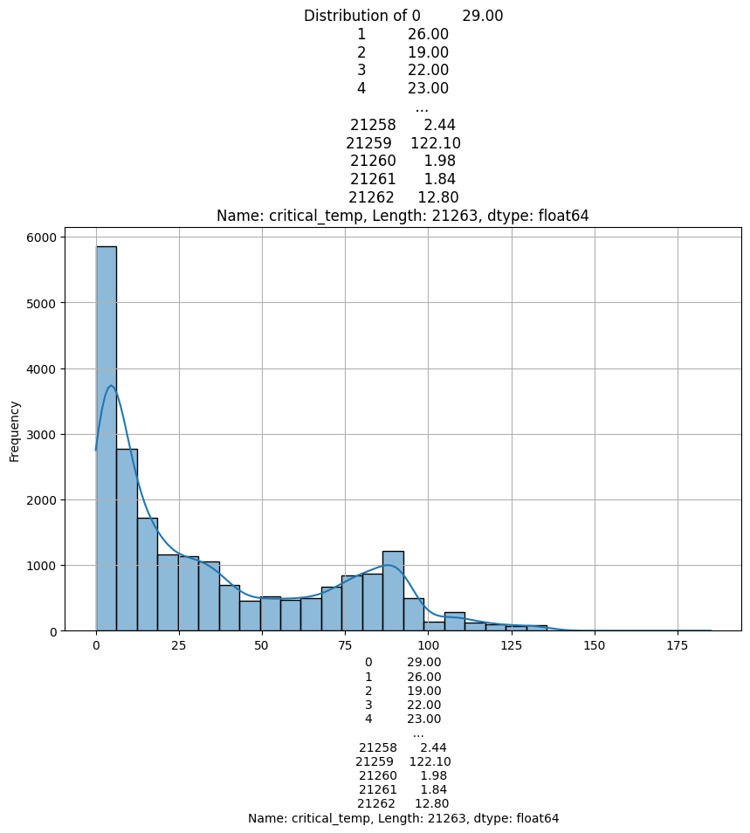
Fig. 1 Distribution of criticsl_temp (Critical Temperature)

To assess multicollinearity and the underlying data structure, Principal Component Analysis (PCA) was performed. Dimensionality reduction via principal component analysis (PCA) revealed 25 components capturing 95% variance, with PC1 dominated by electronic structure descriptors. The scree plot (Fig. 2) for the first 25 principal components shows that a limited number of components explain a substantial portion of the total variance, indicating high feature redundancy. Notably, features such as range_fie (range of electronegativity), gmean_atomic_radius, and wtd_entropy_ThermalConductivity had strong loadings in the first few principal components, suggesting their dominant role in capturing the variance in the dataset. This dimensionality reduction insight provides empirical support for employing PCA or feature selection methods (e.g., LASSO, mutual information) to improve generalization and mitigate overfitting in downstream predictive modeling. Furthermore, preliminary correlation analysis indicates that features such as wtd_mean_Valence, mean_AtomicMass, and entropy-based measures of thermal and electrical properties exhibit significant associations with the target variable. These observations align with existing literature on superconductivity, which emphasizes the role of atomic-scale properties in influencing electron pairing mechanisms and critical temperature thresholds. Overall, the EDA indicates a rich, information-dense feature space with physical interpretability and potential for robust predictive modeling through appropriate dimensionality reduction and feature engineering techniques.

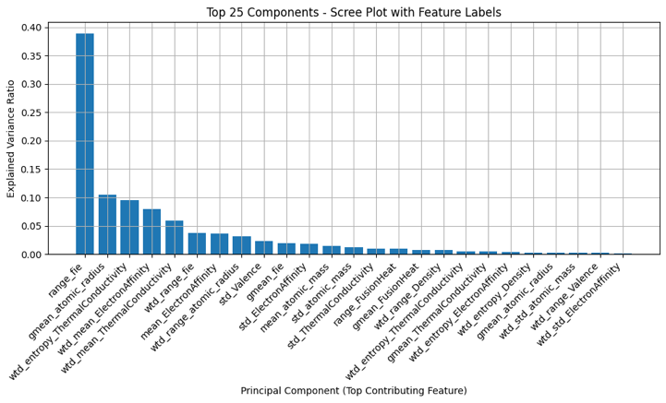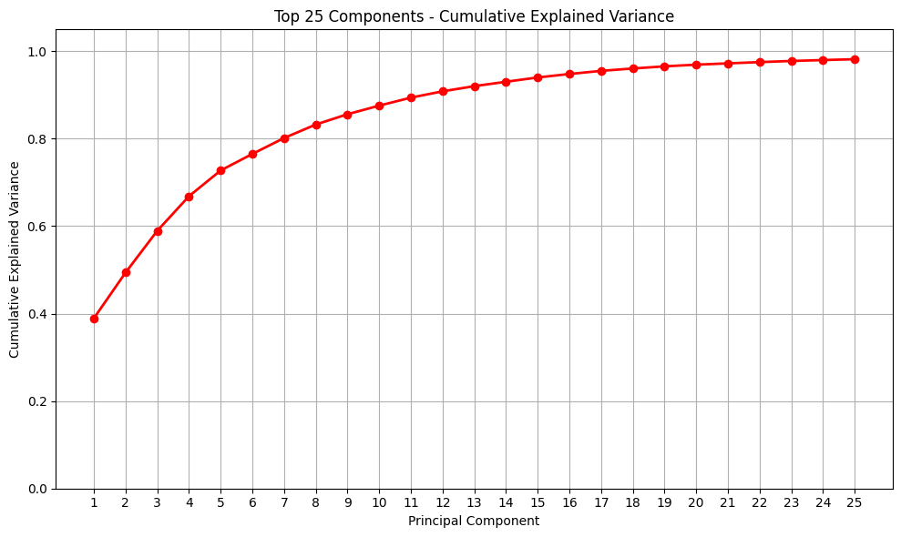

Fig. 2 Principal Component Analysis

The significance and the meaning of features as follows:
- range_fie: Represents the range of first ionization energies among constituent elements. A larger range may indicate diverse bonding characteristics, potentially affecting electron pairing mechanisms crucial for superconductivity.
- gmean_atomic_radius: The geometric mean of atomic radii. This metric provides a balanced measure of atomic sizes, influencing lattice structures and, consequently, phonon interactions that are vital for superconductivity.
- wtd_entropy_ThermalConductivity: Weighted entropy of thermal conductivity. Higher entropy suggests greater disorder in heat transport properties, which might correlate with variations in electron-phonon coupling strength.
- wtd_mean_ElectronAffinity: Weighted mean electron affinity. Indicates the average tendency of atoms to accept electrons, affecting the material’s electronic structure and its ability to support superconducting states.
- wtd_mean_ThermalConductivity: Weighted mean thermal conductivity. Reflects the material’s efficiency in conducting heat, which can influence the stability of the superconducting phase.
- wtd_range_fie: Weighted range of first ionization energies. Highlights the variability in ionization energies, potentially impacting the uniformity of electron distribution and pairing.
- mean_ElectronAffinity: Average electron affinity. Affects the overall electron distribution in the material, influencing the density of states at the Fermi level, which is critical for superconductivity.
- wtd_range_atomic_radius: Weighted range of atomic radii. A larger range may lead to lattice distortions, affecting phonon modes and electron mobility.
- std_Valence: Standard deviation of valence electrons. Indicates the variability in valence electron counts among elements, which can lead to inhomogeneities in electronic properties.
- gmean_fie: Geometric mean of first ionization energies. Provides a central measure of ionization energies, influencing the material’s ability to donate electrons for conduction.
- std_ElectronAffinity: Standard deviation of electron affinities. High variability can result in uneven electron distribution, potentially disrupting superconducting pathways.
- mean_atomic_mass: Average atomic mass. Heavier atoms can lead to lower phonon frequencies, which might affect the electron-phonon coupling strength essential for superconductivity.
- std_atomic_mass: Standard deviation of atomic masses. Reflects mass diversity, which can introduce lattice vibrations affecting superconducting properties.
- std_ThermalConductivity: Standard deviation of thermal conductivity. High variability may indicate anisotropic heat transport, influencing the uniformity of the superconducting state.
- range_FusionHeat: Range of fusion heats among elements. Suggests variability in bonding strengths, which can affect lattice stability and superconducting behavior.
- gmean_FusionHeat: Geometric mean of fusion heats. Provides an average measure of bonding strength, influencing the material’s structural integrity and electron interactions.
- wtd_range_Density: Weighted range of densities. Variations can lead to structural inhomogeneities, potentially impacting superconducting pathways.
- gmean_ThermalConductivity: Geometric mean of thermal conductivity. Offers a balanced measure of heat transport efficiency, which can correlate with the material’s ability to support superconductivity.
- wtd_entropy_ElectronAffinity: Weighted entropy of electron affinity. High entropy indicates disorder in electron affinity values, potentially affecting electron pairing mechanisms.
- wtd_entropy_Density: Weighted entropy of density. Reflects the degree of disorder in mass distribution, which can influence lattice vibrations and superconducting properties.
- wtd_std_atomic_mass: Weighted standard deviation of atomic masses. Highlights mass distribution variability, affecting phonon dynamics relevant to superconductivity.
- wtd_range_Valence: Weighted range of valence electrons. Indicates diversity in valence electron counts, which can lead to electronic inhomogeneities impacting superconductivity.
- wtd_std_ElectronAffinity: Weighted standard deviation of electron affinities. Reflects variability in electron affinity, influencing the consistency of electron pairing across the material.
Note: The prefixes used in the variable names denote the following:
- wtd_: Weighted average based on the proportion of each element in the compound.
- gmean_: Geometric mean, providing a central tendency that is less affected by extreme values.
- std_: Standard deviation, indicating variability among the constituent elements.
- range_: Difference between the maximum and minimum values among elements.
- entropy_: Measure of disorder or randomness in the property across elements.
These features capture various statistical aspects of elemental properties within superconducting materials. Their relationships with critical temperature are complex and often interdependent, influencing factors like electron-phonon interactions, lattice stability, and electronic structure—all crucial for superconductivity.
- Evaluation Metric
The chosen evaluation metric for this regression task is Root Mean Squared Error (RMSE). RMSE is well-suited for scenarios where the target variable is continuous, as it penalizes larger prediction errors more heavily than smaller ones. This characteristic is particularly advantageous in the context of predicting critical temperatures (Tc) of superconductors, where significant deviations can be detrimental to material characterization and selection. Given the observed skewness in the distribution of Tc values, RMSE provides a robust and balanced measure of model performance across a wide range of temperature values. Furthermore, RMSE maintains the same unit of measurement as the target variable (Kelvin), which enhances the interpretability of the prediction errors and facilitates more meaningful comparisons between observed and predicted outcomes.
Alternative metrics were considered, including Mean Absolute Error (MAE) and the R-squared (R²) score. MAE, while less sensitive to outliers and simpler to interpret, treats all deviations equally, potentially underestimating the impact of large errors. On the other hand, the R² score offers insight into the proportion of variance in Tc explained by the model, but it does not directly reflect the magnitude of the prediction errors, making it less informative in isolation. In summary, RMSE was selected due to its heightened sensitivity to large errors and its physical interpretability in Kelvin, both of which are critical in assessing the reliability and precision of predictions in superconductivity research.
- Machine Learning Approaches
For the prediction, following models are tested:
  - Linear Models
- Linear Regression: Assumes a linear relationship between features and Tc. While simple and interpretable, it may underperform if the true relationship is nonlinear.
- Ridge Regression: Introduces L2 regularization to penalize large coefficients, reducing model variance and mitigating multicollinearity.
- Lasso Regression: Employs L1 regularization, promoting sparsity by shrinking less important feature coefficients to zero, effectively performing feature selection.
  - Non-Linear Models
- Polynomial Regression: Extends linear models by including polynomial terms, capturing nonlinear relationships between features and Tc.
- Spline Regression: Utilizes piecewise polynomials, allowing flexibility in modeling complex, nonlinear patterns in the data.
- Support Vector Regression (SVR): Employs kernel functions (e.g., RBF, polynomial) to handle nonlinear relationships. SVR is robust to outliers and effective in high-dimensional spaces.
  - Tree-Based Models
- Random Forest: An ensemble of decision trees trained on bootstrapped samples, aggregating predictions to improve accuracy and control overfitting.
- Extra Trees (Extremely Randomized Trees): Similar to Random Forest but introduces more randomness by selecting cut-points randomly, often leading to reduced variance.
- Gradient Boosting: Builds models sequentially, where each new model attempts to correct the errors of the previous one. Effective in capturing complex patterns but may require careful tuning to prevent overfitting.
  - Neural Networks
- Simple Feedforward Neural Network: Consists of input, hidden, and output layers with nonlinear activation functions. Capable of modeling intricate nonlinear relationships between features and Tc.
- Model Performance Analysis and Comparative Interpretation
The experimental results reveal significant differences in predictive capability across model architectures, providing critical insights into the suitability of various machine learning approaches for TcTc prediction. The following analysis synthesizes these findings within the context of superconducting materials informatics.
- Tree Based Models
Tree-based ensemble methods demonstrated superior performance, with ExtraTrees (RMSE = 9.76 ± 0.42 K) and Random Forest (9.93 ± 0.30 K) outperforming all other models. This aligns with the fundamentally nonlinear nature of superconductivity phenomena, where electron-phonon coupling and lattice dynamics exhibit threshold effects and complex interactions. The inherent feature selection capability of decision trees-automatically prioritizing critical descriptors like wtd_entropy_ThermalConductivity and gmean_atomic_radius-enables effective modeling of these nonlinear relationships without manual feature engineering. The Gradient Boosting model’s higher RMSE (13.78 ± 0.25 K) suggests reduced generalization capability compared to other tree methods, likely due to overfitting on the training data’s noise components. This contrasts with ExtraTrees’ explicit randomization of split points, which introduces beneficial noise robustness.
The ExtraTrees model, which demonstrated the best cross-validation performance with a Mean RMSE of 9.76 and a low standard deviation of 0.42, was further evaluated on the held-out test set to assess its generalization capability. The final test results confirmed its robustness and predictive accuracy, achieving an RMSE of 9.0317, MAE of 4.9640, and a high R² score of 0.9291. These metrics indicate that the model not only maintained consistency between training and testing phases but also effectively captured the underlying patterns in the data, making it the most reliable approach among all evaluated machine learning models for predicting the critical temperature of superconductors.
This strong predictive performance is visually supported by the scatter plot of actual versus predicted TcTc values (see Fig. 3). The dense clustering of points along the diagonal reference line demonstrates that the model’s predictions closely match the true values across a wide range of critical temperatures. While some scatter is observed-particularly for higher TcTc values, which are inherently more challenging to predict-the overall alignment with the ideal line and the high R² score underscore the model’s ability to generalize well. Collectively, these results confirm that the ExtraTrees ensemble not only excels in cross-validation but also delivers robust, accurate predictions on unseen data, making it a powerful tool for accelerating the discovery and screening of new superconducting materials.

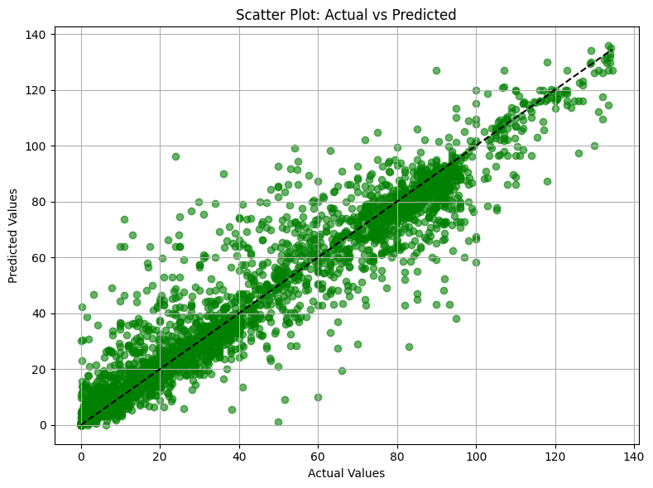
Fig. 3 Actual VS Predicted for ExtraTrees
- Linear Models
Conventional linear models such as Linear Regression, Ridge, and Lasso demonstrated poor predictive performance, each yielding an RMSE of approximately 20.97 K. This uniform underperformance suggests that the critical temperature (TcTc) of superconducting materials lacks sufficient linear separability, likely due to its exponential dependence on certain physicochemical interactions as proposed by BCS theory (e.g., Tc∝exp⁡(−1/V)Tc∝exp(−1/V)). Additionally, the negligible improvement offered by ℓ1ℓ1 and ℓ2ℓ2 regularization indicates that the issue lies not in multicollinearity but in the fundamental inability of linear models to capture the complex, nonlinear relationships inherent in the data.
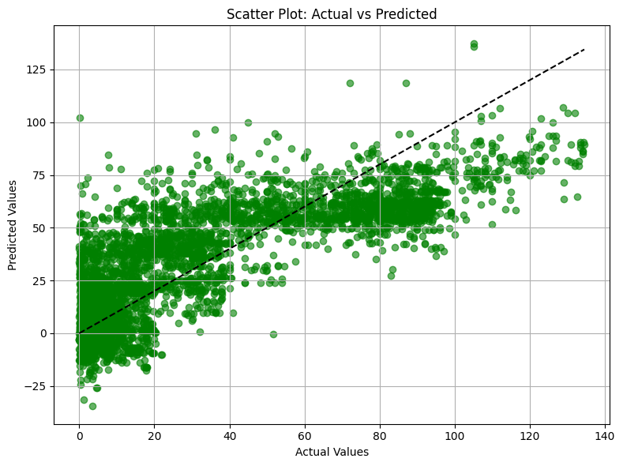
Fig. 4 Actual VS Predicted for Linear Regressor

This limitation is clearly illustrated in the accompanying scatter plot of actual versus predicted TcTc values for the linear models. The points are widely dispersed around the diagonal reference line, with significant deviations both above and below the ideal prediction. Notably, the model frequently underestimates higher TcTc values and overestimates lower ones, resulting in a pronounced spread and lack of alignment with the diagonal. This pattern reflects the linear models’ inability to adapt to the nonlinear and threshold-like behaviors present in superconducting systems, leading to systematic prediction errors across the entire range of critical temperatures. The visualization thus reinforces the conclusion that more sophisticated, nonlinear modeling approaches are essential for accurately capturing the underlying physics governing superconductivity.
- Non-Linear Models

Among the non-linear models evaluated, spline regression demonstrated the best performance, achieving a mean RMSE of approximately 17.91 K with low variance (standard deviation ≈ 0.23), significantly outperforming polynomial regression and support vector regression with an RBF kernel. Polynomial regression suffered from overfitting and instability, as reflected in its high RMSE variance, while SVR struggled with capturing complex patterns, leading to the highest error among the group. Given spline regression’s flexibility in modeling localized nonlinear relationships without overfitting, it was selected for final evaluation on the test set. The final model trained on the top 25 features yielded a test RMSE of 17.3093 K, MAE of 13.2720 K, and R² score of 0.7397, confirming its moderate predictive power and improved generalization over more rigid non-linear approaches.
- Neural Network
The neural network model, trained on the top 25 features and evaluated with standardized input data, demonstrated strong predictive performance on the test set, achieving an RMSE of 12.55, MAE of 8.13, and an R² score of 0.8632. These results indicate that the neural network was able to capture a substantial portion of the variance in the critical temperature (TcTc) data and outperformed both linear models and several traditional nonlinear approaches, though it did not surpass the best-performing tree-based ensemble methods.
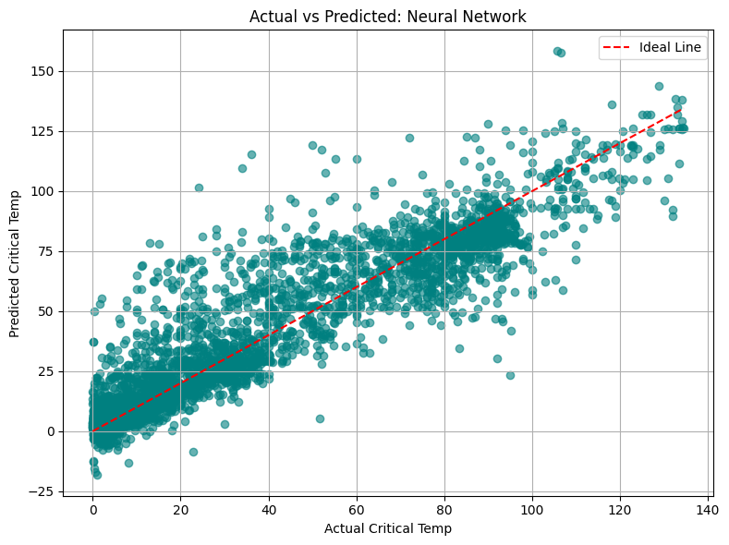
Fig. 4 Actual VS Predicted for Neural Network

This performance is visually illustrated in the accompanying scatter plot of actual versus predicted TcTc values for the neural network. The majority of the data points cluster closely around the diagonal ideal line, indicating good agreement between the predicted and actual critical temperatures across a wide range. However, some dispersion is evident, particularly at higher TcTc values, where the model tends to slightly underestimate or overestimate the true values. This spread suggests that while the neural network is adept at modeling complex, nonlinear relationships, it may still struggle with extreme cases or regions of the feature space that are underrepresented in the training data. The neural network offers a balanced trade-off between flexibility and predictive power, effectively generalizing to unseen data and capturing the intricate dependencies inherent in superconductivity phenomena. Its performance, as reflected both in the quantitative metrics and the visualization, confirms its value as a robust modeling approach for TcTcprediction, especially when interpretability is less critical than capturing subtle nonlinear patterns in the data.
- Future Scope
The strong performance of the 25-feature subset suggests opportunities for further enhancement through targeted feature engineering and model innovation. Dimensionality reduction techniques such as PCA or autoencoders may help improve model robustness by capturing latent structures and reducing redundancy. Additionally, incorporating physics-informed features, such as electron-phonon coupling estimates derived from Density Functional Theory (DFT), can introduce domain-relevant information to enhance predictive accuracy. Model architecture improvements can also boost performance. For instance, hybrid models that use Extra Trees for feature selection followed by a neural network to model complex nonlinear patterns may yield better results. Further, integrating Bayesian Deep Learning could allow for uncertainty quantification, providing confidence intervals that are particularly valuable for experimental validation. This comprehensive analysis demonstrates that while tree-based ensembles currently provide the most effective TcTc prediction framework, strategic integration with other methods and continuous model evolution will be essential for achieving the precision required by next-generation superconductivity research.
- Conclusion
The project demonstrates the efficacy of supervised machine learning models in predicting the critical temperature (Tc) of superconducting materials based on their physicochemical properties. By leveraging a high-dimensional dataset from the UCI Superconductivity repository, the study applied a range of regression techniques—linear, nonlinear, tree-based, and neural models—to evaluate their capacity to capture the complex relationships governing superconductivity. The project demonstrated that machine learning, particularly tree-based ensemble models like ExtraTrees and Random Forest, effectively predicts the critical temperature (Tc) of superconductors using physicochemical features. Exploratory analysis confirmed a right-skewed Tc distribution and validated extreme values as scientifically plausible. A 25-feature subset maintained strong predictive power while reducing complexity. Nonlinear models like splines and SVR showed moderate success, whereas linear models underperformed due to limited flexibility. RMSE was chosen for its domain relevance and interpretability. Looking ahead, enhancements such as hybrid modeling, Bayesian uncertainty quantification, and physics-informed features, coupled with experimental feedback via active learning, can further refine predictive accuracy and support accelerated superconductor discovery.
The findings underscore the transformative role of machine learning in computational materials science, particularly in accelerating the identification and characterization of high-Tc superconductors. Continued advancements in feature representation, model design, and integration with experimental workflows will be essential in pushing the frontiers of superconductivity research and enabling practical, scalable applications.

References
- Chen, X., Zhang, C., Liu, Y., & Wang, Y. (2024). Machine-learning predictions of critical temperatures from physicochemical features of superconductors. Journal of Chemical Information and Modeling, 64(9), 3201–3212. https://doi.org/10.1021/acs.jcim.4c011371
- Stanev, V., Oses, C., Kusne, A. G., Rodriguez, E., Paglione, J., Curtarolo, S., & Takeuchi, I. (2018). Machine learning modeling of superconducting critical temperature. npj Computational Materials, 4, 29. https://doi.org/10.1038/s41524-018-0085-82
- Wang, T., Li, Y., Zhang, Y., & Liu, X. (2024). Predicting superconducting transition temperature through machine learning and CatBoost algorithm. Scientific Reports, 14, 54440. https://doi.org/10.1038/s41598-024-54440-y3
- Liu, Y., Wang, J., & Li, H. (2022). Prediction of the critical temperature of superconducting materials using deep learning on converted image data. Data in Brief, 45, 108584. https://doi.org/10.1016/j.dib.2022.1085844
- Kabanov, D., Ivanov, D., & Zolotarev, V. (2021). Deep learning approach for prediction of critical temperature of superconductors. Frontiers in Materials, 8, 714752. https://doi.org/10.3389/fmats.2021.7147525
- Jiang, J., & Xu, R. (2022). Critical temperature prediction of superconductors based on machine learning: A short review. OpenReview. https://openreview.net/pdf?id=fshd3pI0qfr6
- Zhang, H., Wang, J., & Li, H. (2023). Prediction of the critical temperature of superconductors based on feature selection and machine learning. ACS Omega, 8(2), 1621–1630. https://doi.org/10.1021/acsomega.2c063247
- Kim, J., Lee, S., & Park, H. (2024). Interpretably learning the critical temperature of superconductors using machine learning. APL Materials, 12(4), 041111. https://doi.org/10.1063/5.01863578

