GitHub: <https://github.com/s-mckean52/Guildhall>

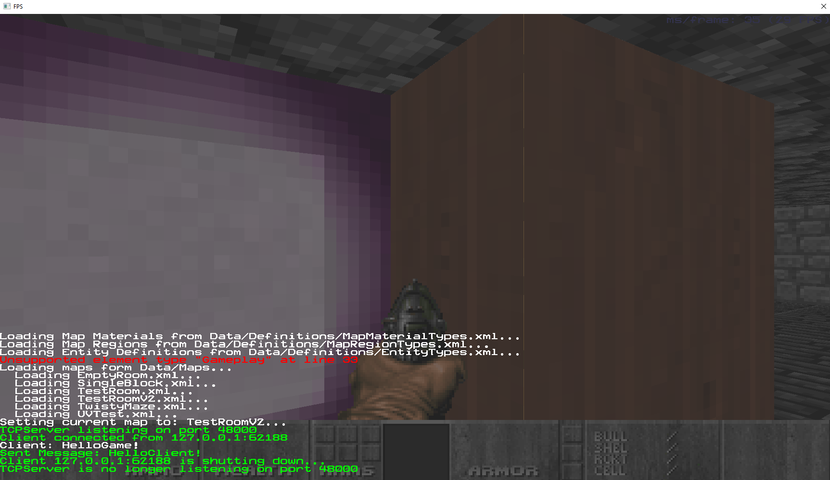Server Screenshot:

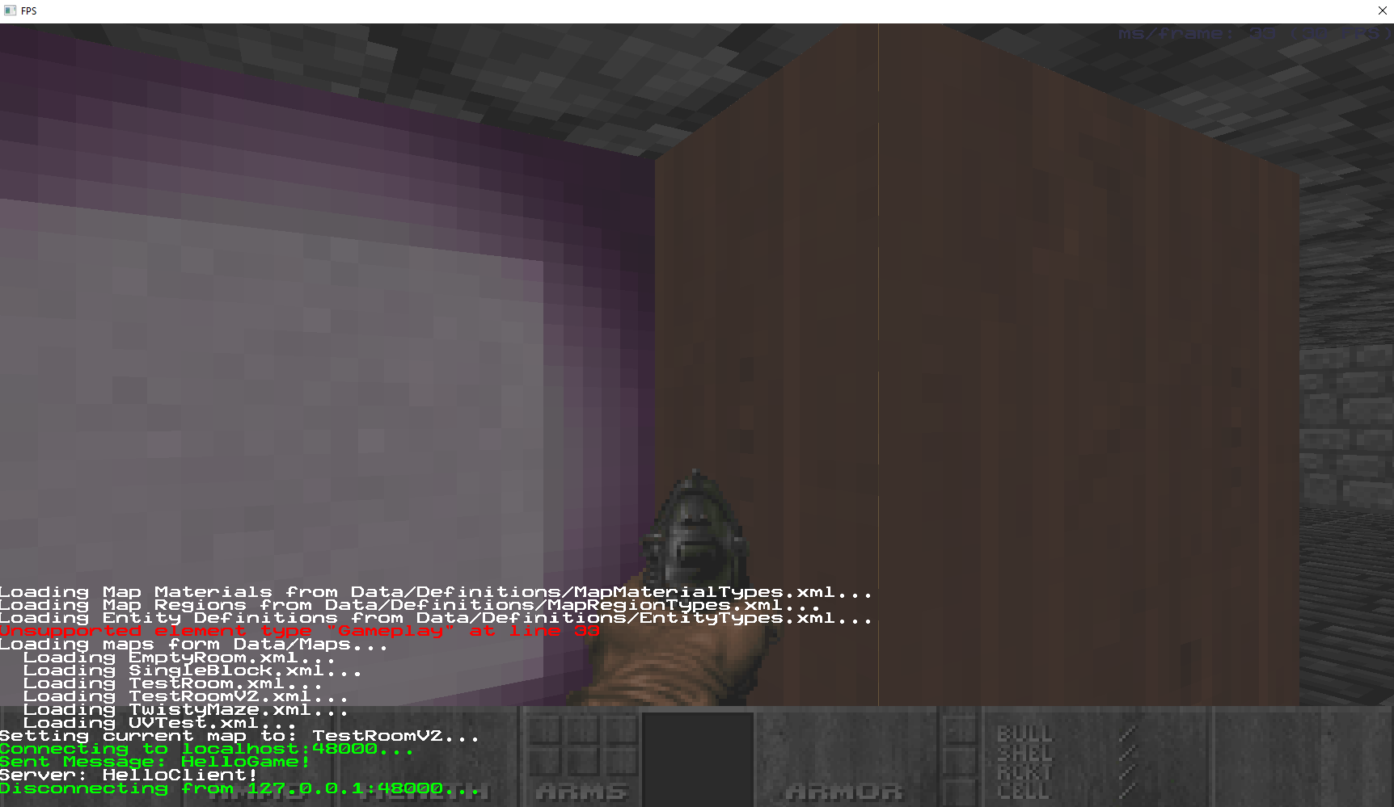Client Screenshot:

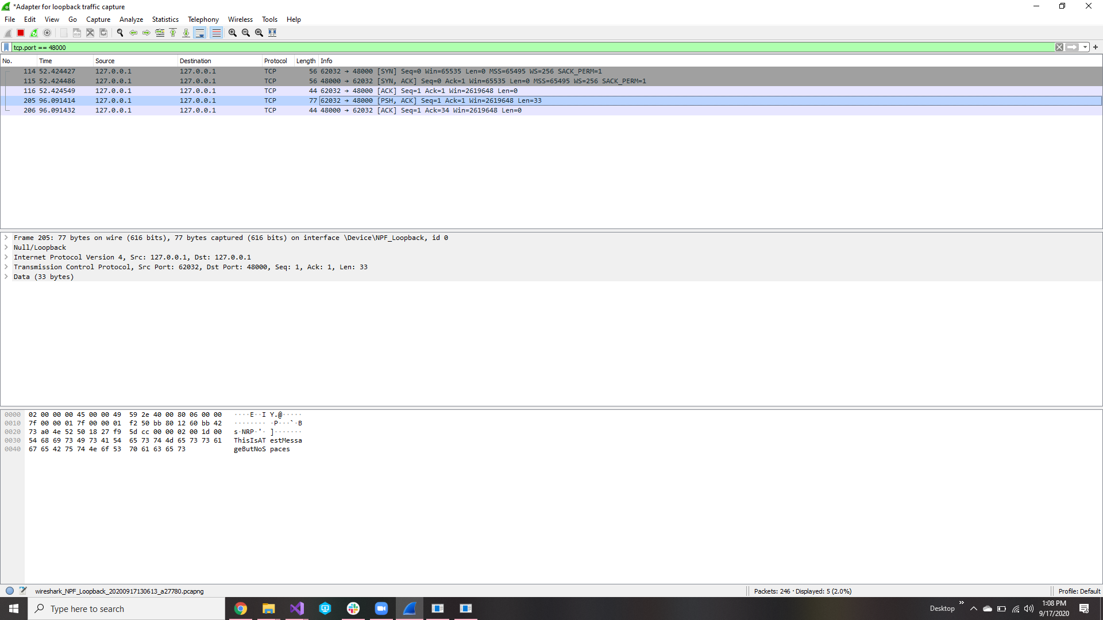WireShark Screenshot: