Project 2: Where Is It?
Locating a stationary LostBot with Detector A and Detector B
CS 01:198:440 Introduction to Artificial Intelligence — Fall 2026
Harikrishnaa Ganeshpandi
Sahas Mupharaphu
November 2026

Contents
Experimental setup 3
Range of k and α, and why they set the sensitivity 3
How k and α control sensitivity 3
Chosen ranges 4
Question 1: Knowledge-base update rules 5
Type A: the set of possible cells S 5
Type B: a probability for every cell 5
Question 2: Our strategies 6
Why the baselines waste cost 6
What the bot computes from its current knowledge 6
Final strategy (both detectors): the slides' sampled planning, sensing on the way 7
Other techniques we tried 8
Question 3: Baseline A against our Type A strategy 8
The most interesting k-regime 9
What we learned from the techniques we tried (Type A) 10
Question 4: Baseline B against our Type B strategy 11
What we learned from the techniques we tried (Type B) 12
Question 5: Most efficient k against most efficient α 12
Question 6: Free movement (cost = readings only) 13
How the strategies change 13
Results 13
Summary: what we tried and how we chose 15
Reproducing the results 15

Experimental setup
- Ships: 41×41 grids built with the team's Project 1 generator, averaging 1,101 open cells. Movement is in 4 directions. A move costs 1 and a detector reading costs ½.
- Ship size: 41×41 was the largest size for which every experiment fitted our time budget. All runs together took about 7.4 hours on a 15 W laptop CPU (Intel i7-1255U) using 6 processes.
- Trials: every reported point averages 200 trials (10 ships × 20 random start/LostBot placements). Every strategy runs on the same 200 placements with the same detector random numbers, so differences between strategies are paired comparisons, reported with 95% confidence intervals (CI).
- Tuning: strategy settings were tuned on separate seeds (3 ships × 8 placements), never on the evaluation trials.
- Distances: Detector A uses Chebyshev distance (the square of radius k); Detector B uses Euclidean distance, as specified. Movement cost uses the shortest walking distance around walls, computed once per ship.

Range of k and α, and why they set the sensitivity

How k and α control sensitivity
- k is the detection radius. A reading answers the yes/no question "is the LostBot inside the (2k+1)×(2k+1) square around me?". Small k gives a precise but local answer that is almost always NO PING; large k covers most of the ship, so the answer is almost always PING. Either way the answer is predictable and therefore uninformative. The most useful k makes PING and NO PING about equally likely.
- α is the decay rate of the ping probability with distance. As α → 0, P(ping) ≈ 1 at every distance, so the detector pings regardless of where the LostBot is. As α grows, pings become rare beyond distance 1; at d = 1 the ping is always certain (e^0 = 1). In the limit α → ∞ the detector only ever pings for the four orthogonal neighbours, so it behaves like a tiny deterministic detector. In between, a ping means "probably close", but each reading is noisy and must be combined with others.
We chose the ranges by measuring how much a first reading tells the bot, in bits, averaged over sensing positions on our ships (Figures 1 and 2).
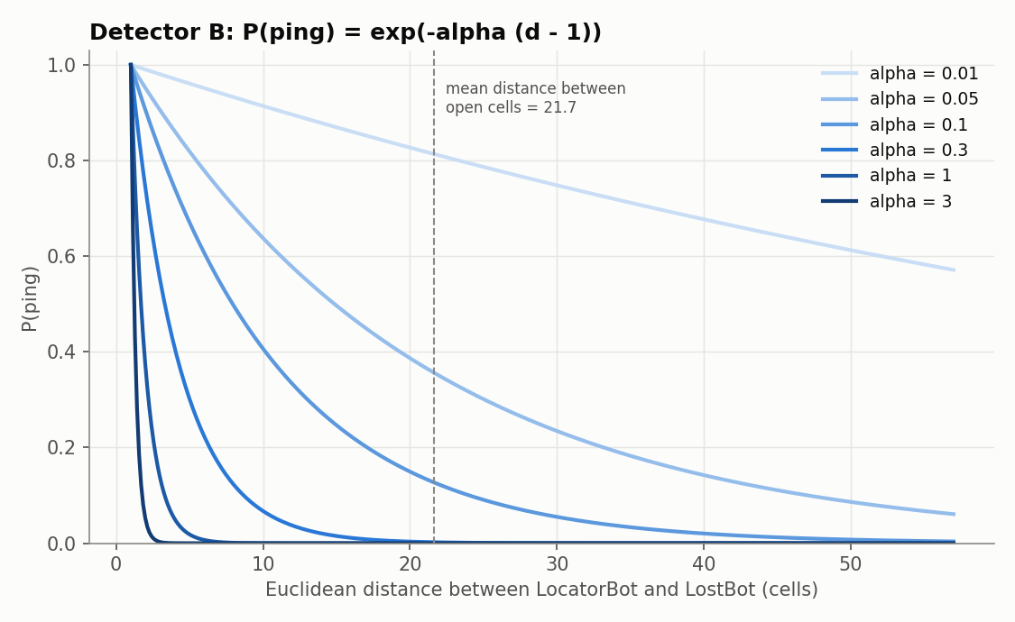
Figure 1. Detector B: probability of a ping against Euclidean distance, P(ping) = exp(−α(d−1)), for several α.

Chosen ranges
Detector A: k from 0 to 40.
- At k = 0 the detector can only report FOUND, so a reading carries about 0.01 bits. At k = 40 the square covers the whole 41×41 ship from any position, so a ping is certain and carries nothing.
- In between, the information rises to a peak of about 0.95 bits on average around k = 17–18, where the best positions give about 1 bit.
- So 0…40 covers the whole curve from useless to best to useless again; larger k adds nothing on a 41×41 ship. We tested k ∈ {0, 1, 2, 3, 4, 5, 6, 8, 10, 13, 16, 20, 25, 30, 40}.
Detector B: α from 0.01 to 3.
- Very small α makes the detector ping almost always (P(ping) averages 0.98 at α = 0.001); very large α makes it almost never ping (0.002 at α = 10). Both extremes carry almost no information.
- The peak is 0.166 bits around α ≈ 0.13. At our endpoints the information has fallen to roughly a quarter of the peak: 0.044 bits at α = 0.01 and about 0.04 bits at α = 3. Because α acts multiplicatively in the exponent, we spaced the values on a log scale: α ∈ {0.01, 0.02, 0.05, 0.1, 0.2, 0.3, 0.5, 1, 2, 3}.
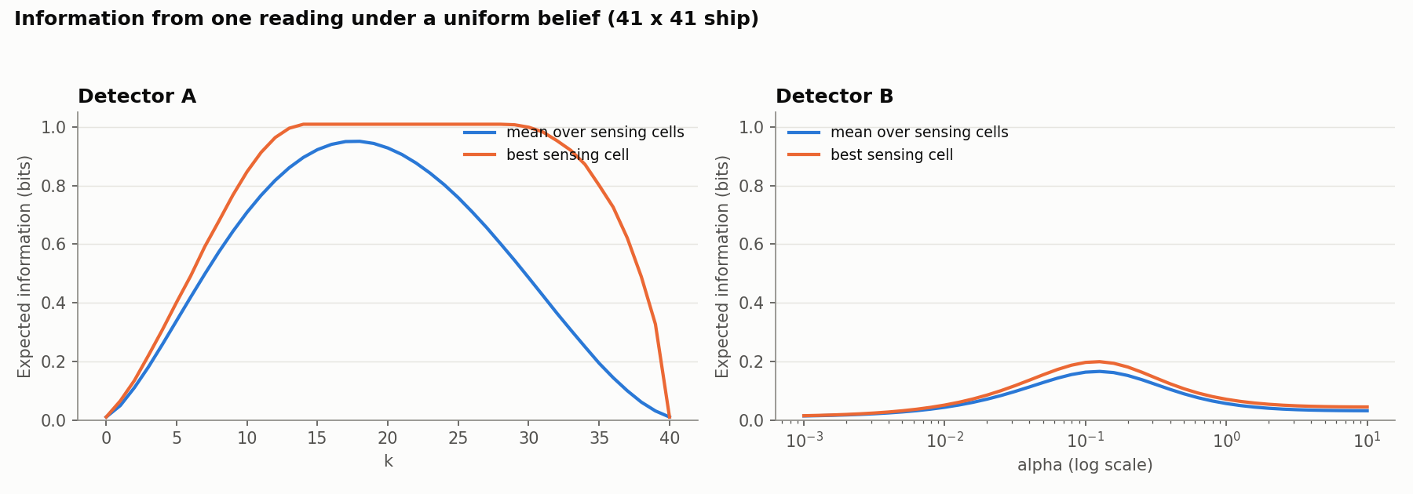
Figure 2. Expected information from a first reading against k (Detector A) and α (Detector B), averaged over sensing positions, with the best position also shown.
Detector B's best reading carries about 0.2 bits, against about 1 bit for Detector A's best. That already suggests Detector A will be the more efficient detector (Question 5).

Question 1: Knowledge-base update rules
Both bots start with no information except the map. The LostBot is placed on a cell different from the start, so every open cell except the start is initially possible, with equal probability. Let a be the cell where the LocatorBot takes a reading and b a possible LostBot cell. If the reading at a is not FOUND, the LostBot is not at a.

Type A: the set of possible cells S
Let D_k(a) be the open cells within the square of radius k around a: D_k(a) = { b : max(|row_a − row_b|, |col_a − col_b|) ≤ k }. Start with S = (all open cells) \ {start}. After a reading at a:
PING: S ← (S ∩ D_k(a)) \ {a}
NO PING: S ← S \ D_k(a) (this also removes a, since a ∈ D_k(a))
FOUND: S ← {a} (the search ends)
Why this is correct. Detector A is deterministic: given the LostBot's cell b, the outcome at a is certain (PING exactly when b ∈ D_k(a) and b ≠ a). Treating the initial belief as uniform, Bayes' rule gives P(b | outcome) ∝ P(b) · P(outcome | a, b), where the likelihood is 1 for cells consistent with the outcome and 0 otherwise. So the posterior is uniform over the cells consistent with every reading so far, which is exactly the set S kept by the rules above. The true cell is always consistent with a truthful detector, so it is never removed and S is never empty; every cell that is removed is impossible.

Type B: a probability for every cell
Start with P(b) = 1/(n − 1) for every open cell b ≠ start, where n is the number of open cells. After a reading with outcome o at a, update every cell b with Bayes' rule:
P'(b) = P(b) · L_o(a, b) / Z, Z = Σ_b' P(b') · L_o(a, b')
L_ping(a, b) = e^(−α(d(a,b) − 1)), L_noping(a, b) = 1 − e^(−α(d(a,b) − 1)), L_o(a, a) = 0
FOUND sets P to 1 at a and ends the search. Z is the probability of the observed outcome, so dividing by it makes P' sum to 1.
Why this is correct.
- It is Bayes' theorem with the handout's detector model as the likelihood: P(b | o) = P(o | a, b) P(b) / P(o), and P(o) = Σ P(o | a, b') P(b') = Z.
- Each reading is a fresh random draw that depends only on where the LostBot is, so readings are conditionally independent given b. Then P(b | o_1 … o_t) ∝ P_0(b) · Π_i L_{o_i}(a_i, b), and updating one reading at a time with the rule above gives exactly this batch posterior.
- L_o(a, a) = 0 because a non-FOUND reading at a proves the LostBot is not at a. For b ≠ a the distance is at least 1, so 0 < e^(−α(d−1)) ≤ 1 is a valid probability.
- A consequence: at distance 1 a ping is certain, so a NO PING rules out the four orthogonal neighbours exactly, as in Type A. Every other cell keeps a non-zero probability, because no single reading can rule it out.
Numerical stability. After hundreds of readings the probabilities become extremely small. We store log P, add log L_o, and renormalise with log-sum-exp (subtract the maximum before exponentiating). The NO PING term is computed as log(−expm1(−x)) so it stays accurate when x is tiny. This prevents underflow to zero, which would otherwise wrongly eliminate cells.

Question 2: Our strategies

Why the baselines waste cost
- Baseline A always walks to the nearest possible cell. It ignores where a reading would be most informative, so for small k it sweeps cell by cell, and for large k many of its readings are almost certain to PING and tell it little.
- Baseline B always walks to the single most likely cell, however far away. The most likely cell keeps changing as evidence arrives, so the bot crosses the ship again and again. It also senses only at the destination, even when a reading on the way would be almost as useful.
Both waste cost because they never weigh what a reading is likely to tell them against what it costs to get there. Our strategies make that trade-off explicitly, following the course's decision-making ideas: Bayesian belief updating, expected cost (expected utility), the value of information measured by entropy, and the slides' (RL-8) sampled planning over hypothetical LostBot locations.

What the bot computes from its current knowledge
Before each decision, the bot uses its knowledge base (S for Type A, P for Type B) to score every open cell a as a place to take the next reading. Writing p for the current belief (for Type A, p(b) = 1/|S| on S and 0 elsewhere):
- Outcome probabilities: P(FOUND | a) = p(a); P(PING | a) = Σ_{b≠a} p(b) · L_ping(a, b); P(NO PING | a) = 1 − the other two. For Type A these are counts: |S ∩ D_k(a) \ {a}| / |S| and |S \ D_k(a)| / |S|.
- Expected remaining uncertainty E[H_post | a]: the entropy (in bits) of the updated belief after each outcome, averaged over the outcomes' probabilities. For Type A this is Σ_o P(o | a) · log2 |S_o|. The difference from the current entropy is the expected information gain of reading at a.
- Expected distance still to walk E[d(a, B)] = Σ_b p(b) · d(a, b), where d is the walking distance.
All cells are scored at once: Type A counts use a summed-area table over the grid, and Type B sums use an FFT convolution of the belief with the detector's ping-probability kernel.

Final strategy (both detectors): the slides' sampled planning, sensing on the way
Each time it decides where to go next, the bot:
- Samples 64 pairs (h1, h2) of hypothetical LostBot locations from its current belief (slide 13): from S uniformly for Type A, and in proportion to P for Type B.
- Weighs each pair by renormalising the two probabilities within the pair: w1 = p(h1) / (p(h1) + p(h2)), w2 = 1 − w1 (slide 15).
- Compares the two visiting orders using the project's costs (slides 10 and 16). The second leg is only needed if the LostBot was not at the first cell:
cost(h1 → h2) = [ d(cur, h1) + ½ ] + w2 · [ d(h1, h2) + ½ ]
- Picks a destination: the cell that most often starts the cheaper order across the 64 pairs. Ties go to the nearer cell, then are broken at random.
- Chooses where to sense (slide 17, "do we have to travel all the way to a likely cell?"): among the cells on the walking route to the destination, including the current cell, it senses at the one with the lowest estimated total remaining cost
J(a) = d(cur, a) + γ · E[d(a, B)] + ½ · (2 − P(FOUND | a)) + c · E[H_post | a]
J adds the walk to a, the walking still expected afterwards, this reading plus another one unless this reading finds the LostBot, and the remaining uncertainty priced at c per bit. It is a one-step lookahead that values information by how much expected uncertainty a reading removes.
Design decisions and justifications:
- Allowed sensing cells. For Type A, a cell is allowed only if a reading there can shrink S (information gain > 0 or a ∈ S), so every reading makes progress and the search ends after at most |S| readings. For Type B, a cell is allowed only if it could hold the LostBot or c × (information gain) ≥ ½, the price of a reading. Without this, a weak detector makes re-sensing in place look cheaper than moving, and the bot can stall.
- Settings tuned per k or α on separate seeds: c ∈ {1, 3, 10, 30, 100}; γ ∈ {0, 1} for Type A, and γ = 1 for Type B (with γ < 1, re-sensing in place forever can look cheaper than walking).
- 64 sampled pairs give a stable vote while keeping each decision to a few milliseconds.
- Why it should beat the baselines. With uniform weights and no sensing on the way, the planner reduces to "go to a nearby likely cell", close to the baselines. With an uneven belief (Type B) it balances probability against distance instead of chasing the single most likely cell. Sensing on the way lets the bot buy cheap, informative readings rather than walking all the way to a destination first.
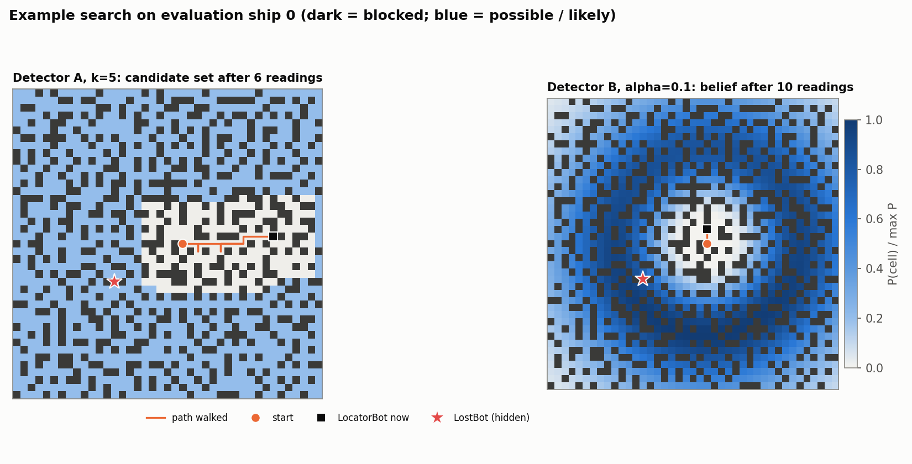
Figure 3. Example search states of the final strategies: the Type A candidate set (left) and the Type B belief heatmap (right), with the path walked.

Other techniques we tried
Following the recitation suggestions, we also implemented and measured these alternatives on the same 200 paired trials (results under Questions 3 and 4):
- Slides' planning only (A-S / B-S): steps 1–4, then walk to the destination and sense there (no sensing on the way).
- Earlier rule (A0 / B0): skip the sampled planning and sense at the cell with the lowest J anywhere on the ship.
- Simple ablations: A1 senses where information gain per unit cost is highest; B3 senses where P(a) / (cost to reach a) is highest (a classic search-theory rule).

Question 3: Baseline A against our Type A strategy
Figure 4 plots the mean discovery cost against k; each point averages 200 paired trials, and the shaded bands are 95% CIs.
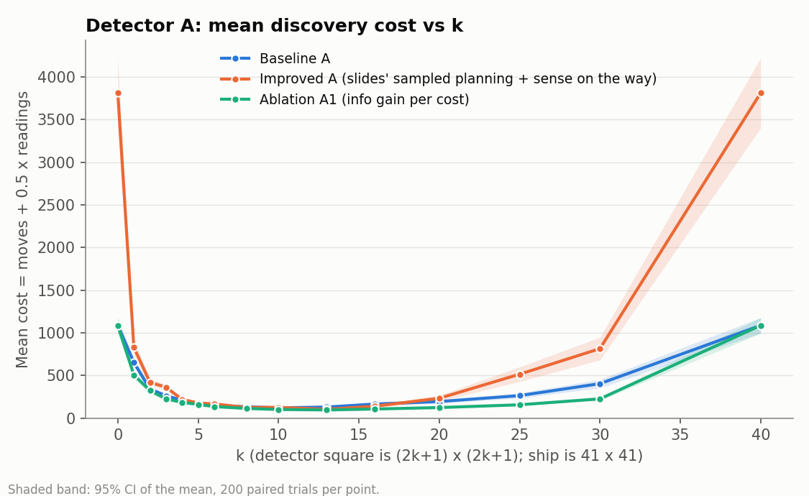
Figure 4. Detector A: mean discovery cost against k for Baseline A, our final Type A strategy and ablation A1. Shaded bands are 95% CIs over 200 paired trials.
k | 0 | 1 | 3 | 5 | 8 | 10 | 13 | 16 | 20 | 25 | 30 | 40
Baseline A | 1088 | 654 | 264 | 172 | 135 | 122 | 132 | 167 | 196 | 266 | 406 | 1088
Final A | 3810 | 831 | 363 | 180 | 128 | 128 | 105 | 142 | 234 | 516 | 816 | 3810
Saving | −250% | −27% | −38% | −5%* | +5%* | −5%* | +20% | +15% | −20% | −94% | −101% | −250%
A0 (tried) | 1088 | 589 | 276 | 166 | 111 | 95 | 82 | 91 | 105 | 156 | 220 | 1088
Mean cost (moves + ½ readings). Saving = paired saving of Final A against Baseline A; * = not statistically significant (the 95% CI includes zero).
- Baseline A is most efficient at k = 10: mean cost 121.9 (CI 112.7–131.1), made of 107.8 moves and 28.2 readings.
- Our final Type A strategy is most efficient at k = 13: mean cost 104.8 (CI 96.6–113.0; 91.1 moves, 27.3 readings), 14% below the baseline's best. At k = 13 it saves 20% (CI of the saving: 14.1–39.3 cost units) and is cheaper in 67% of the paired trials; at k = 16 it saves 15%.
- Outside k = 13–16 it does not beat the baseline: it is worse at small k, at large k, and much worse at k = 0 and 40.

The most interesting k-regime
The interesting regime is k ≈ 8–16:
- Both strategies reach their lowest cost there (k = 10 and k = 13).
- A reading there comes close to splitting the possible cells in half, so it carries close to its maximum information (about 0.9 bits on average).
- The strategies differ most there: where a reading is taken matters most when the answer is uncertain. At small k almost every reading says NO PING and every strategy is reduced to sweeping; at large k almost every reading says PING. At k = 0 and k = 40 the detector is useless and the baseline becomes a plain nearest-cell sweep, costing 1,088.

What we learned from the techniques we tried (Type A)
Technique | Best mean cost (k) | Compared with the baseline | Computation per decision†
Baseline A | 121.9 (10) | — | 0.3 ms
A-S: slides' planning only | 197.8 (10) | Worse at every k: −40% to −690% | 2.6 ms
Final: slides' planning + sense on the way | 104.8 (13) | +15–20% at k = 13–16, worse elsewhere | 8.0 ms
A0: sense at the global best J | 81.9 (13) | +18% to +46% for k = 8–30, never significantly worse | 6.8 ms
A1: information gain per unit cost | 97.9 (13) | +6% to +44% at every k from 1 to 30 | —
†Timed on one ship at k = 13, single core, Intel i7-1255U laptop.
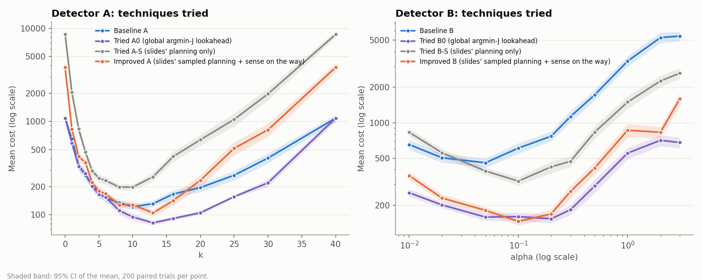
Figure 5. Techniques tried, on a log cost axis: baseline, earlier rule (A0/B0), the slides' planning alone (A-S/B-S), and the final strategy (slides' planning + sense on the way). 200 paired trials per point.
Why the slides' method struggles with Detector A. It trades off how likely each cell is against how far away it is. Under Detector A every cell in S is equally likely, so every pair has w1 = w2 = ½ and only distance matters: the cheaper order is just "nearer cell first". Two problems follow:
- Votes stay spread out. Pairs are drawn from all of S, so the winning cells scatter across the ship and the destination is a random-ish cell rather than the single nearest one. At k = 0, where readings carry no information, this costs 3.5× the baseline's nearest-cell sweep (3,810 against 1,088).
- It only scores cells that might hold the LostBot. With Detector A, the main gain is a reading from a well-placed cell that splits S in half, whether or not that cell is in S. The slides' method cannot see that; sensing on the way recovers part of it (104.8 against 197.8 for A-S), but A0 and A1, which look for the best sensing cell anywhere, do better.

Question 4: Baseline B against our Type B strategy
How we chose the α range. As explained in the range section, we picked the α values where a reading carries useful information (Figure 2) and spaced them on a log scale from 0.01 to 3, so both ends reach the regime where the detector is nearly useless (almost always or almost never pinging). Figure 6 plots cost against α on a log axis.
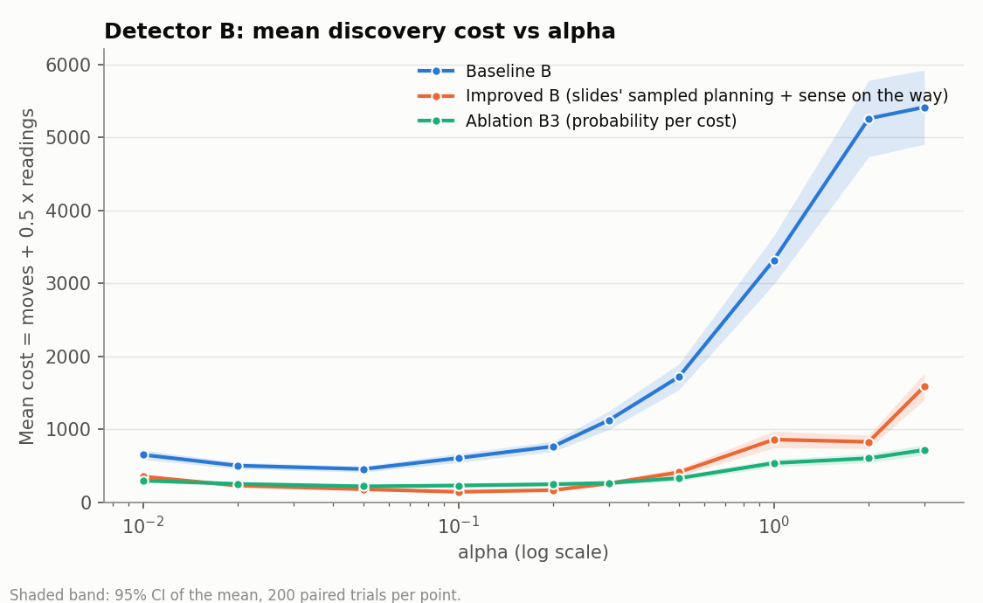
Figure 6. Detector B: mean discovery cost against α (log scale) for Baseline B, our final Type B strategy and ablation B3. Shaded bands are 95% CIs over 200 paired trials.
α | 0.01 | 0.02 | 0.05 | 0.1 | 0.2 | 0.3 | 0.5 | 1 | 2 | 3
Baseline B | 654 | 505 | 458 | 610 | 769 | 1128 | 1722 | 3323 | 5262 | 5417
Final B | 357 | 230 | 181 | 146 | 169 | 262 | 414 | 863 | 831 | 1590
Saving | 46% | 54% | 61% | 76% | 78% | 77% | 76% | 74% | 84% | 71%
Trials cheaper | 71% | 77% | 80% | 91% | 92% | 90% | 87% | 84% | 86% | 82%
B0 (tried) | 256 | 201 | 159 | 160 | 154 | 183 | 291 | 553 | 710 | 680
Mean cost (moves + ½ readings). All savings of Final B against Baseline B have 95% CIs that exclude zero.
- Baseline B is most efficient at α = 0.05: mean cost 458.2 (CI 416.6–499.8), made of 438.9 moves and 38.5 readings. Movement dominates: it walks all the way to whichever cell is currently most likely, and as the belief changes its target jumps around the ship. For large α a NO PING says almost nothing, so it walks to many single cells one after another.
- Our final Type B strategy is most efficient at α = 0.1: mean cost 146.1 (CI 135.5–156.6; 106.0 moves, 80.1 readings), 68% below the baseline's best. It beats the baseline at every α, by 46–84%, and is cheaper in 71–92% of paired trials.
- It saves by taking more, cheaper readings (80 against 39) to avoid long walks (106 moves against 439). Under Detector B the belief is uneven, so the slides' trade-off between probability and distance is exactly the right question.

What we learned from the techniques we tried (Type B)
Technique | Best mean cost (α) | Compared with the baseline | Computation per decision
Baseline B | 458.2 (0.05) | — | 0.4 ms
B-S: slides' planning only | 320.5 (0.1) | +15% to +58% for α ≥ 0.05; −27% at α = 0.01 | 2.6 ms
Final: slides' planning + sense on the way | 146.1 (0.1) | +46% to +84% at every α | 13 ms
B0: sense at the global best J | 153.7 (0.2) | +60% to +87% at every α | 16 ms
B3: probability per unit cost | 221.6 (0.05) | +50% to +89% | —

- The slides' method alone (B-S) already beats the baseline for most α, because it stops the bot chasing the single most likely cell across the ship. At α = 0.01, though, the belief is nearly flat and B-S behaves like the uninformed Type A case.
- Adding sensing on the way is what makes the method strong: 146.1 against 320.5.
- Against B0: the final strategy has the lowest single cost (146.1 at α = 0.1), but its CI overlaps B0's best (153.7, CI 141.1–166.3). B0 is cheaper at most other α, and much cheaper at α = 3 (680 against 1,590).
- Computation: about 30× the baseline per decision (13 ms against 0.4 ms), yet a whole trial still takes under 1 second.

Question 5: Most efficient k against most efficient α
 | Detector setting | Mean cost [95% CI] | Moves | Readings
Baseline A | k = 10 | 121.9 [112.7, 131.1] | 107.8 | 28.2
Baseline B | α = 0.05 | 458.2 [416.6, 499.8] | 438.9 | 38.5
Final A | k = 13 | 104.8 [96.6, 113.0] | 91.1 | 27.3
Final B | α = 0.1 | 146.1 [135.5, 156.6] | 106.0 | 80.1

Detector A at its most efficient k is more efficient than Detector B at its most efficient α, for both the baselines and our final strategies; the confidence intervals do not overlap. Across every strategy we tried, the best Type A result (A0: 81.9) also beats the best Type B result (146.1).
Why: information per reading (Figure 2).
- A Detector A reading at k ≈ 13 delivers up to about 1 bit. Its answer is certain, so it rules out a whole region permanently.
- A Detector B reading delivers at most about 0.2 bits and is noisy, so evidence must accumulate over many readings (80 against 27) and no distant cell is ever ruled out completely. Since locating the LostBot among about 1,100 cells needs about 10 bits, Detector B needs several times more readings, and more walking between them.
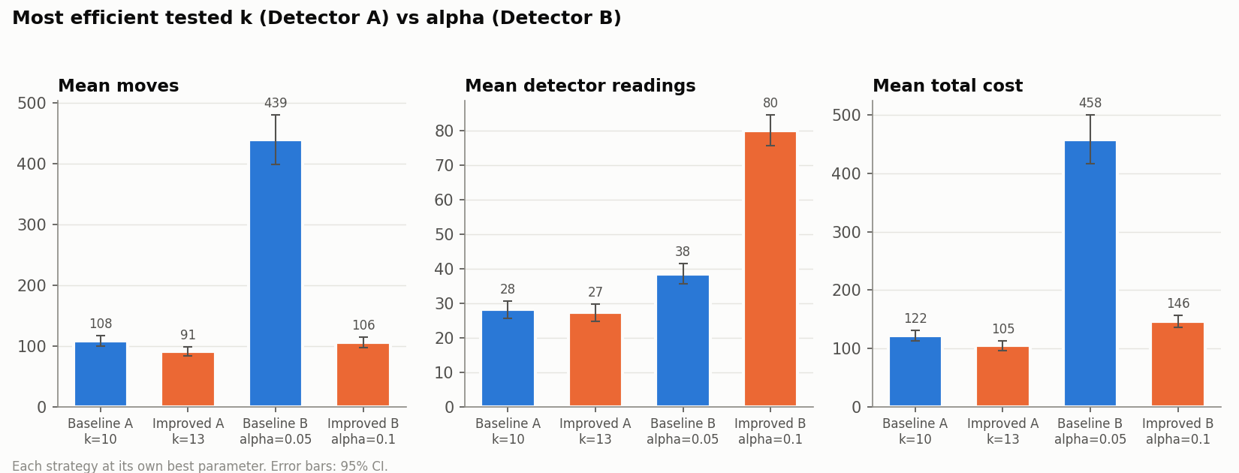
Figure 7. Each strategy at its own most efficient parameter: mean moves, readings and total cost, with 95% CIs.

Question 6: Free movement (cost = readings only)

How the strategies change
When moving is free, the distance terms vanish from every cost formula (move cost m = 0):
- In J(a), only the reading terms and the value of information remain, so the best next reading is simply the one that removes the most uncertainty.
- In the slides' pairwise comparison, cost(h1 → h2) = 1 + w2, so the more likely cell always goes first: it reduces to the slides' highest-probability-first rule (slides 7–8).
We therefore implemented free-movement strategies that sense, at each step, wherever the expected information gain is highest anywhere on the ship (distance only breaks ties):
a* = argmax_a [ H(current belief) − E[H_post | a] ]
- Type A: this is "twenty questions": choose the square that splits S as evenly as possible between FOUND, PING and NO PING. Every chosen reading shrinks S, so the search always ends.
- Type B: the FOUND outcome makes a very likely cell score well by itself; once the belief is nearly certain the highest-gain cell is the most likely one, so the strategy finishes by sensing there.
The bot still walks legal paths and its moves are still counted; they just cost nothing. All strategies were scored on the same 200 paired trials under the new cost.

Results
Mean number of readings (the free-movement cost):
k | 1 | 3 | 5 | 8 | 10 | 13 | 16 | 20 | 30
Baseline A | 182.4 | 43.4 | 25.7 | 24.2 | 28.2 | 40.1 | 63.8 | 79.7 | 190.4
Final A (Q2) | 135.2 | 74.2 | 31.7 | 21.1 | 38.7 | 27.3 | 35.1 | 51.2 | 163.2
Free-movement A | 92.1 | 22.8 | 14.3 | 11.9 | 11.2 | 11.2 | 11.2 | 11.2 | 40.9

α | 0.01 | 0.05 | 0.1 | 0.2 | 0.5 | 1 | 3
Baseline B | 79.6 | 38.5 | 31.5 | 29.1 | 47.0 | 89.6 | 162.9
Final B (Q4) | 289.0 | 141.5 | 80.1 | 81.5 | 109.1 | 159.1 | 228.0
Free-movement B | 87.5 | 35.4 | 29.3 | 28.1 | 41.3 | 74.4 | 128.5

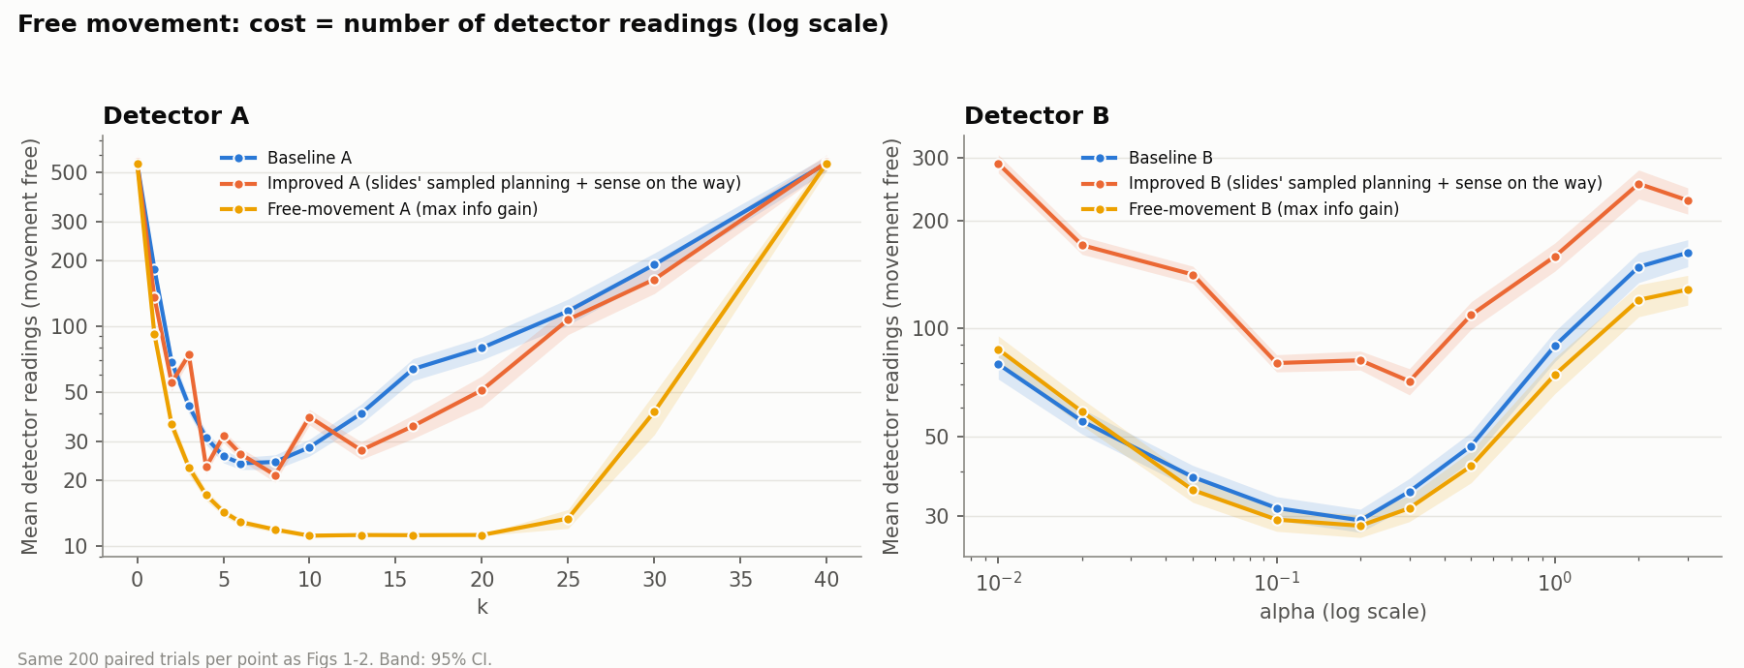
Figure 8. Free movement: mean number of detector readings against k (Detector A) and α (Detector B) for the baseline, our final strategy and the free-movement strategy.
- Type A: the free-movement strategy needs 11.2 readings (CI 11.0–11.4) for k = 10–20, against 23.8 for the baseline at its best (k = 6): roughly half the readings at small k, and 72–89% fewer at k ≥ 13. With about 1,100 open cells, locating the LostBot needs at least log2(1,100) ≈ 10.1 bits; at up to about 1 bit per reading, 11.2 readings is close to that lower bound.
- Type B: the free-movement strategy needs 28.1 readings (CI 26.1–30.2) at α = 0.2, against 29.1 for the baseline. At low α the gain is small or none (3% and not significant at α = 0.2; slightly worse at α ≤ 0.02): every reading gives at most about 0.2 bits wherever it is taken, so where to sense matters less than taking enough readings, and with free movement the baseline's "go to the most likely cell" is already close to optimal. At α ≥ 1 it saves 17–21% (significant).
- Against our previous strategies: the strategies that are best when moving costs something are poor here. Our final Type B strategy uses 71–289 readings, because it deliberately trades extra readings for fewer moves; our final Type A strategy also uses more readings than the free-movement one at every k. The cost model changes which strategy is best.
- Which detector is more efficient (tuned optimally): Detector A, at 11.2 readings (k = 10–20) against 28.1 for Detector B (α = 0.2). With free movement the best k shifts slightly larger (10–20 instead of 10–13), because the bot can always reach the cell that splits S best.

Summary: what we tried and how we chose
- Baselines (as specified): the reference point.
- Earlier rule (A0 / B0): an expected-cost score J over every sensing position. Strong for both detectors: −33% (A) and −66% (B) against the best baselines.
- The slides' method on its own (A-S / B-S): cheap (2.6 ms per decision). Useful under Detector B's uneven belief, harmful under Detector A's uniform belief.
- The slides' method plus sensing on the way (final strategies): it keeps the slides' idea of sampling hypothetical LostBot locations and comparing the expected cost of visiting orders, which works well when probabilities differ, while slide 17's sensing on the way fixes the main weakness of planning only by destination.
  - Type B: clearly better than the baseline at every α (46–84%), and tied with the best other technique at its best α.
  - Type A: better than the baseline only at k = 13–16. Our experiments show that for a uniform belief, ranking sensing positions by information gained per cost works better (A0 / A1).
- Computation: the scored strategies take 7–16 ms per decision, against under 0.5 ms for the baselines. They score every cell with fast array operations (summed-area tables and FFT convolution), and no trial took more than a few seconds.

Reproducing the results
python main.py experiment --stage all --processes 6
python main.py analyze
Results are cached in results/cache, so an interrupted run resumes where it stopped. All figures are written to results/figures (fig1 … fig8).

