Spencer Purves

CS 6760 Project Intermediate Report #1

Rule Based Models

I have made progress in a few different areas related to the goals I set forth. I have been able to make and simulate a rule based model using BioNetGen, export an SBML file of the model, and use libSBML in python to import the document and print some statistics and other things about the model. My GitHub is <https://github.com/s-n-p/RuleBasedModels> and it contains many of the files and programs I am using. It does not contain the RuleBender application but the file MM contains all the files used and produced by RuleBender including the SBML file (MM.xml).

I first wanted to make a simple rule based model using some existing software. I chose to use BioNetGen and their GUI called RuleBender. I used the simple MM model found on the first page of the Quick Reference Guide (<https://drive.google.com/file/d/0B2lPm2_GUE01X3ZaamZxUl80NTA/edit>). I was able to successfully build and simulate this simple model in RuleBender. When bionetgen.org is back online I hope to find slightly more complicated models to play with. Below are some of the results from the simple simulation of MM.

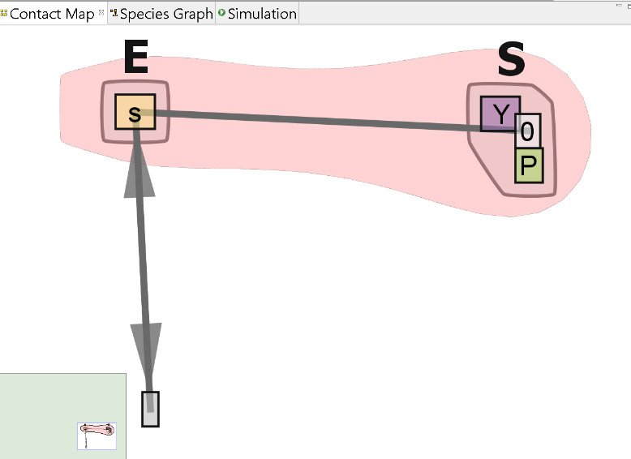

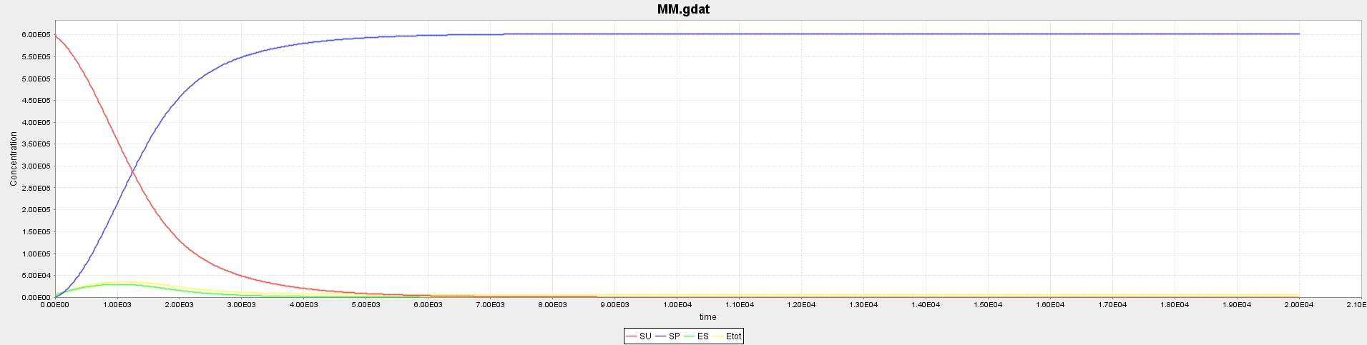

As seen in the email correspondence with Jim, I have had some problems validating the SBML file (MM.xml on my GitHub) using libSBML. The formatting of the SBML file is not accurate but I have found the writeSBMLMulti() function I need on the bioNetGen GitHub and am currently working on pulling that file into my distribution of bioNetGen. This will hopefully produce an error free SBML file that I can extract information from such as species, rules, etc. Once I am able to work with an error free SBML file and print important information I will begin constructing functions to simulate the model, most likely using regular ODE’s before I try SSA.

The combinatorial complexity of some biological circuits can become intractable. One method that has been presented to solve this synthetic biology problem is rule-based modeling. A rule based model defines a set of rules for the molecules within the biological system. For example, a molecule X could have two different binding sites with rules defining how and when it is able to bind with other molecules. The rule will define what conditions are necessary for a molecule to bind with X and at what rate the reaction happens. For example, X might bind with Y if phosphorous is present but will bind with Z when phosphorous is not present. In this way a rule-based model defines rules for how each molecule in a system interacts with other molecules. In this framework it is possible to keep track of the state of the molecule.

The ultimate goal of my project is to create software to analyze and simulate a rule-based biological model. This is an ambitious project so some time will be necessary to understanding the SBML of rule-based models and learning the Libsbml python package in addition to the coding of the model simulation. I will use the following steps to guide me:

Step 1 – Try to create a simple rule-based model using current software such as BioNetGen or Kappa. Use the softwre to simulate the biological circuit to understand how it works.

Step 2 – Export the SBML file and import it into python using the libsbml python library.

Step 3 – Become familiar with the internal libsbml methods and how to use them. One example of this is to iterate through the rules and molecules of the model and print them out.

Step 4 – This step is to implement the necessary algorithms for analysis and simulation of the model. Ideally there will be graphs produced to visualize the circuit and the activity of the molecules, similar to what we have done before. This step will become more defined as I learn more about libsbml and the sbml for rule-based models.