Floorplan think in the logic first:
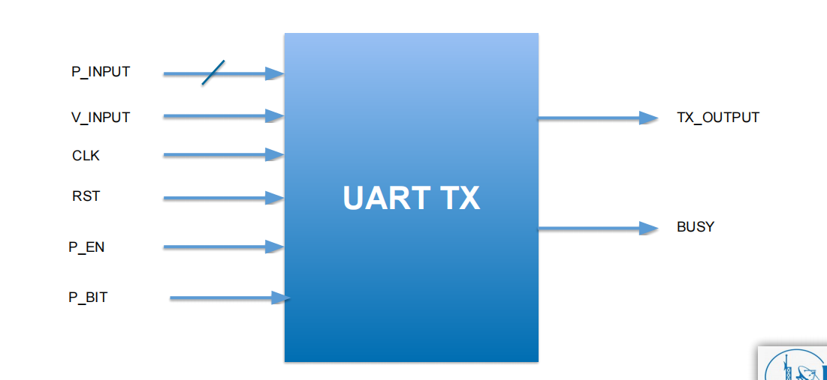
Data eneter series and out parallel with width of 8 bits

First module build :
Serializer:
Serializer do not generate start bit he is only start when fsm send it to him
Least sgnificant bit is first one serialized
Counter to count number ob bins
Sample the data only when V_input high
Busy is internal signal to determine if serializer work or not (I think it is not necessaey and should be included in FSM not serilizaer)
Positive clock edge clk and negative reset(Asynchronous Active-Low Reset)
We use parameter to be able to change it in the future
If it is valid input that is meaning we can take the data and start the serlizar process
If shift enable equal one then you should start shift the data to complete ther serilization process

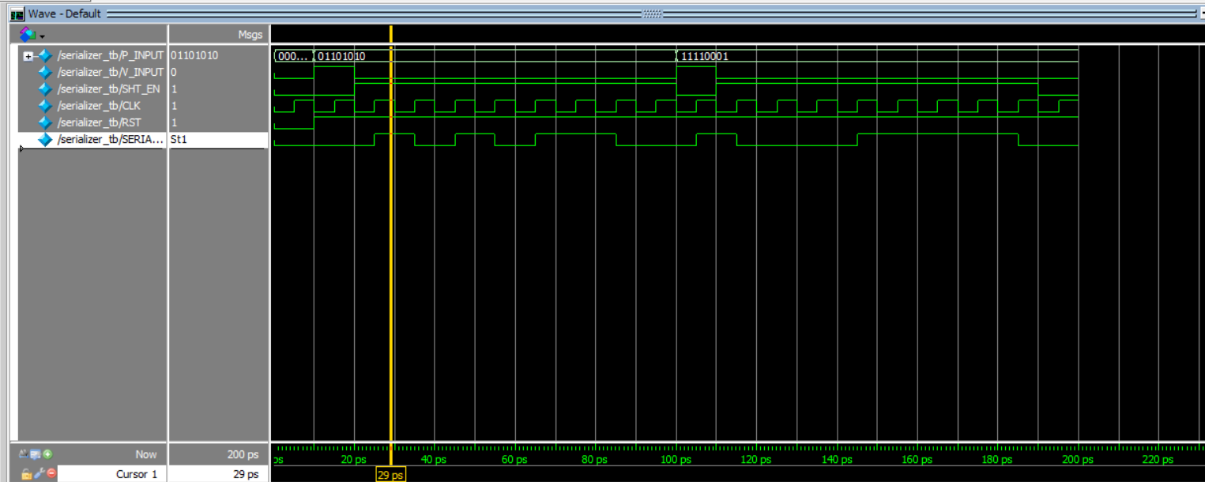
Three cases tested to make sure that serilizer works good :
Rst=0 to see all data reset
Input data with EN=1 and Valid=1 so data path correct
Input data one time when enable equal zero and one time with valid equal zero and we see that no data path that confirm that the system is working correct.

Second module:
Parity:
Parity is only module helps to know that there is an error in sending the data or not
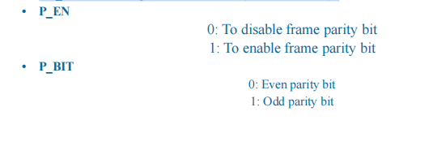

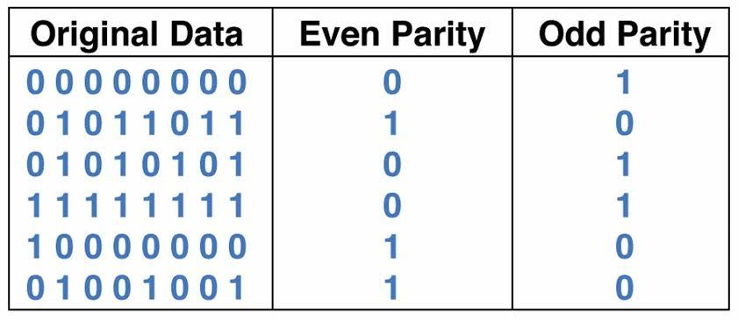

I will use this test cases

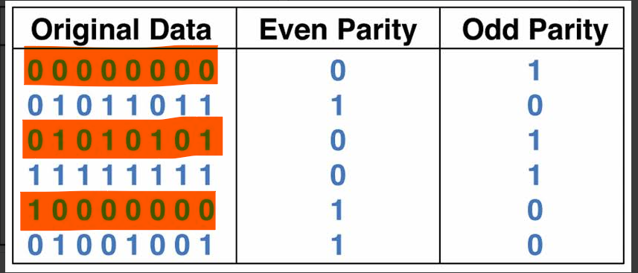

Those three cases and case with the enable=0
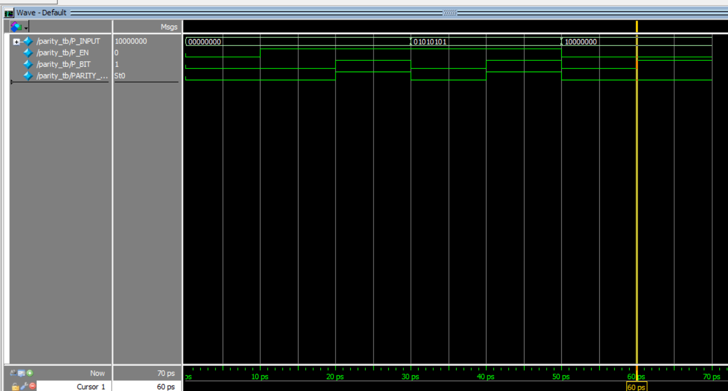

FSM:

FSM iwill control the enable for the parity and the enable for the serilizerit it will determine which one will work and when.

Moore as it willdepend on the current state do not care about the input

TX_OUTPUT is high in the IDLE case (No transmission).
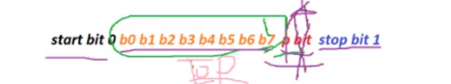

S0
IDLE
TX_OUTPUT=1
Busy=0
S4
Stop
Tx_output=1
Busy=1

MM

S1
Start
Tx_output=0
Busy=1
S2
Data
Tx_output=input data
Busy=1
S3
Parity
Tx_output=parity bit
Busy=1

S0=000
S1=001
S2=010
S3=011
S4=100

To move from S0 to S1
We should load vinput
Data valid=1

From s1 to s2 the Ck must be 1 cycle
From s2 to s3 we should wait
#error in your code you should have count bit or wait 8 cycles to make sure all data are transferred
Or you can build in Fsm code

From s3 to s4:
To go to it we should first make that parity bit is enable if enable include it if not do not include it
If yes then include the parity bit include it in this bit

Signals inputs in the FSM:
V_INPUT check the data is valid or not
P_INPUT the parallel data itself
Clk
RST
Parity bit
Parity enable

Output signals
Busy
Mux selection
And the serializar enable

For mux he should choose between those:
signal IDLE to check if you are in IDLE or not
Signal start equal one when we are in start case
Signal data=1 when serializer is work
Signal parity=1 when we are
Signal stop=1 when we are passing the stop bit

We need also
State
Next state
Bit_count to count the data
And control signals for the
Mux and serializer and parity bit

Mux module:
Willbe 4 to 1 and out the selection bit for it
Start
Stop
Parity
Or data

00 start
01 data
10parity
11stop

4 cases every case will change the mux out and they should happens after each other
If the V_input equal one that is means that we should out the start data
mux=00
busy=1
Case 2 if the enable of serilizar is 1 that is mean we are in s2 place then
Mux=01
Stop till count equal 7

Case 3 if the parity enable is 1
Then mux=11
busy=1

Case 4 if the sop is one that is meaning
mux=10
busy=1

Fsm testing case:

We are going to check this cases:
Test cases we will apply on the FSM:
Reset
Busy 0 and Busy 1
Problem faced

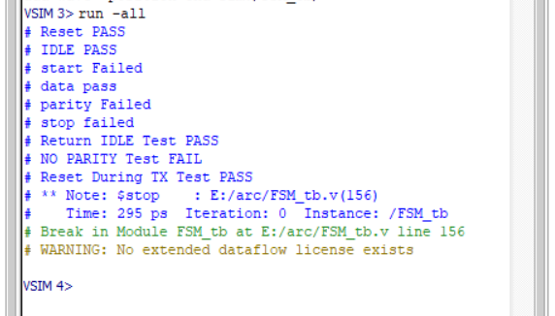
All failed approximately

Why this happens
Notes i asked the Ai because iam tried to find the errors but i failed
In this line:

if (state == S0)
BUSY <= 0;
else
BUSY <= 1;

The main problems were related to timing: BUSY was registered inside the clocked block, so it used the old state and became delayed by one clock cycle, while SHT_EN and mux_sel were combinational and changed immediately with the current state. Also, the Testbench used extra #10 delays, causing it to check PARITY and STOP after the FSM had already moved to the next state. The solution is to make BUSY combinational with the other outputs and carefully place the Testbench delays so each state is checked during its correct clock cycle. Also, P_EN must be set before starting the transmission.
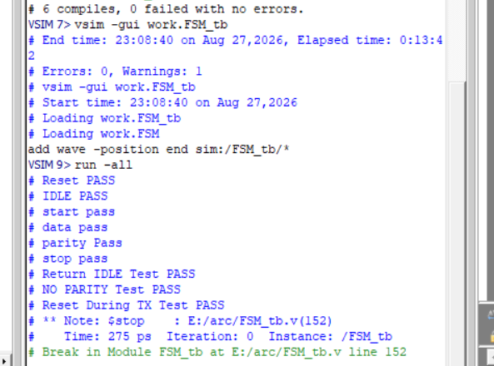

I have an error delay in clk pulse

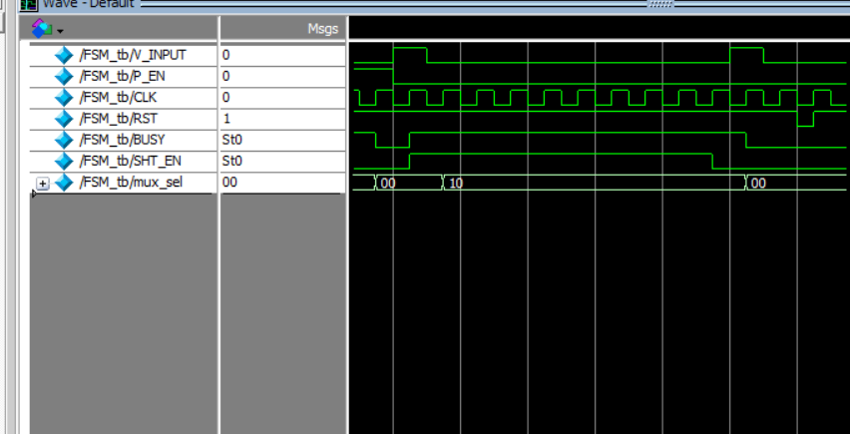

Top modules mind map:
Also i enter all the inputs and outputs for the hole UART system
Only the signals and call the modules with the signals and call them and assign the value of start and stop

UART testbench:
What cases we need to test:
RSt
My code idea
Try to send all data 00000000
Try to send all data 11111111
Send two normal bits 010101110

Try to send parity bit 0 even
Try to send parity bit 1 odd
Try to send parity enable 0
Try to send parity enable 1
Test the parity bits use this two cases
Reset mid-transmission (top level)


Test the frame in every case

Letssssssssssss go

First case first stop failed why
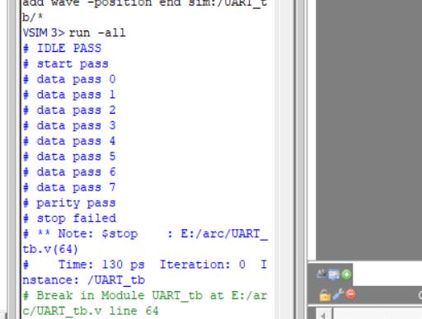

I missed one clk cycle

Test case: Test UART transmission with P_INPUT = 00000000 and parity enabled, with P_BIT = 0.

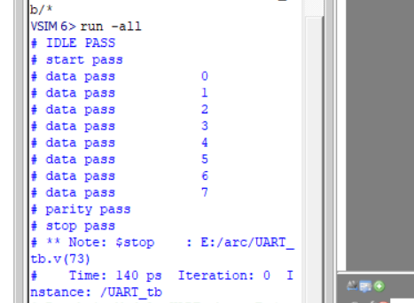
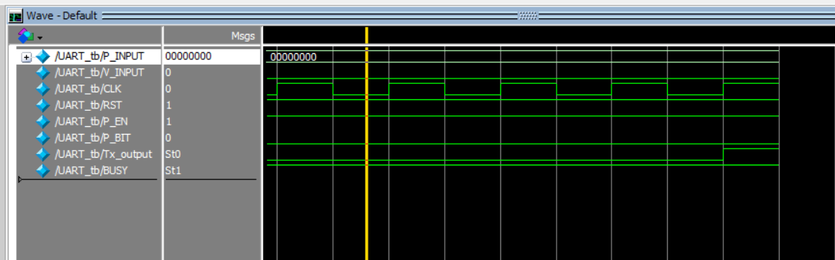

Test case: Test UART transmission with P_INPUT = 00000000 and parity enabled, with P_BIT = 1.

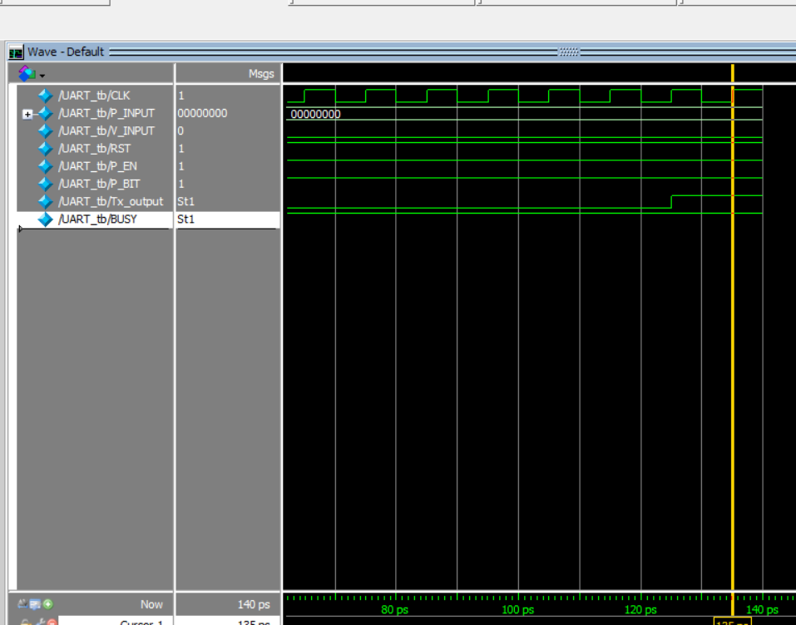

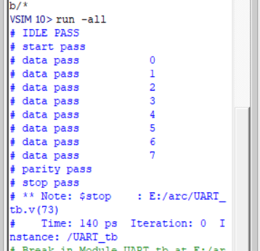

Try parity enable equal 0 with the same case

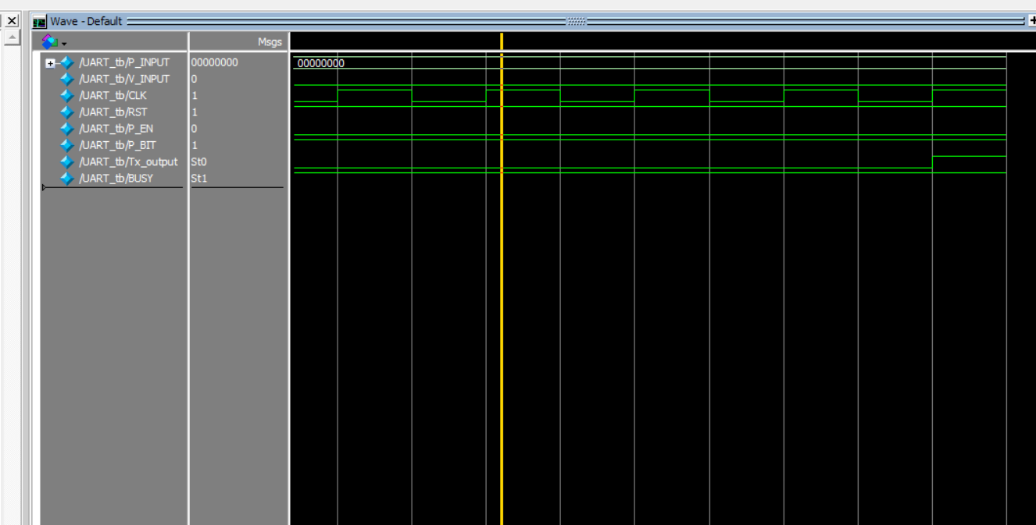

Try to change parity bit to be equal 0 to conflict with stop but still pass

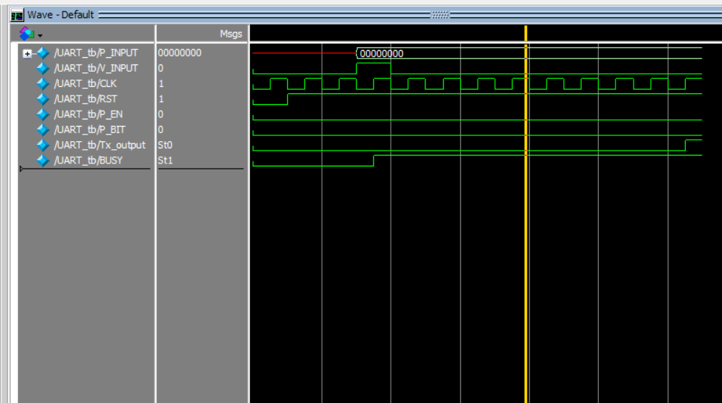

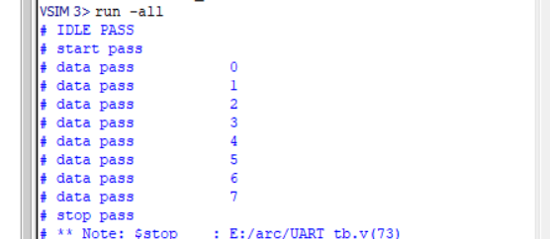

Test case: Test UART transmission with P_INPUT = 11111111 and parity enabled, with P_BIT = 0.

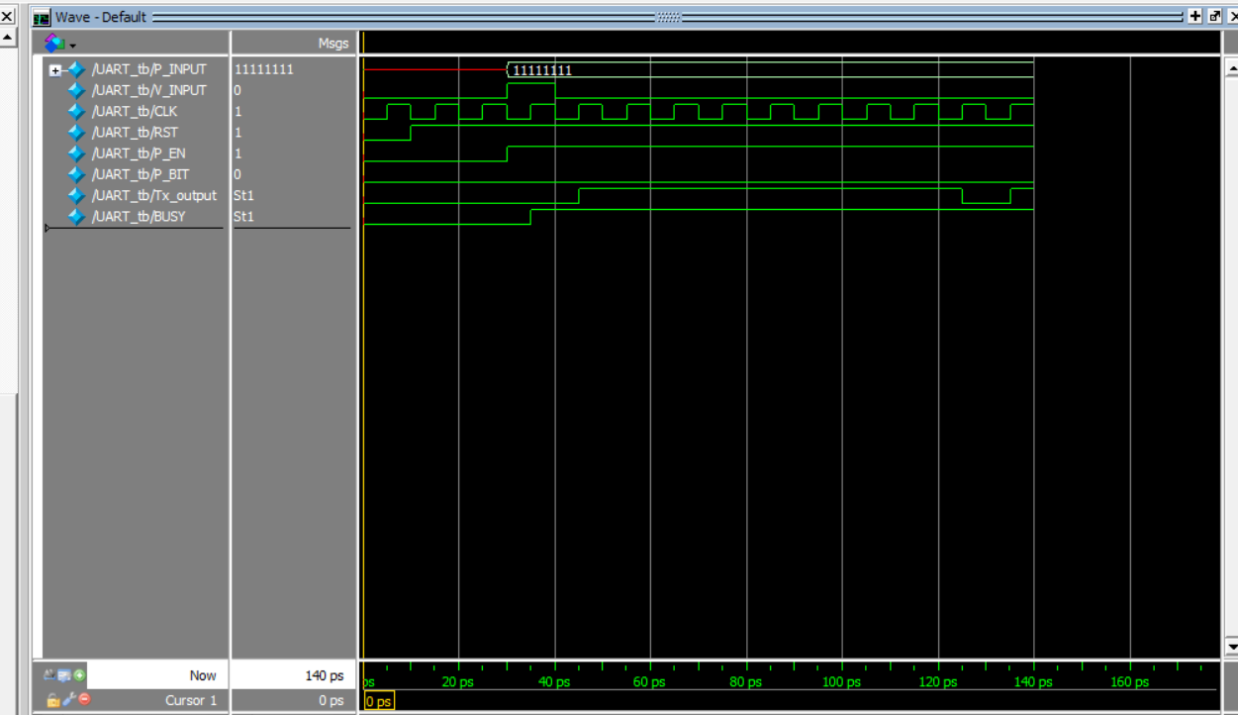

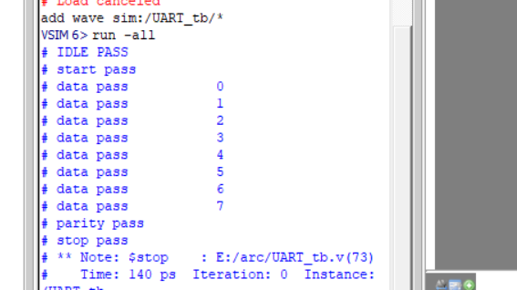

Test case: Test UART transmission with P_INPUT = 11111111 and parity enabled, with P_BIT = 1.

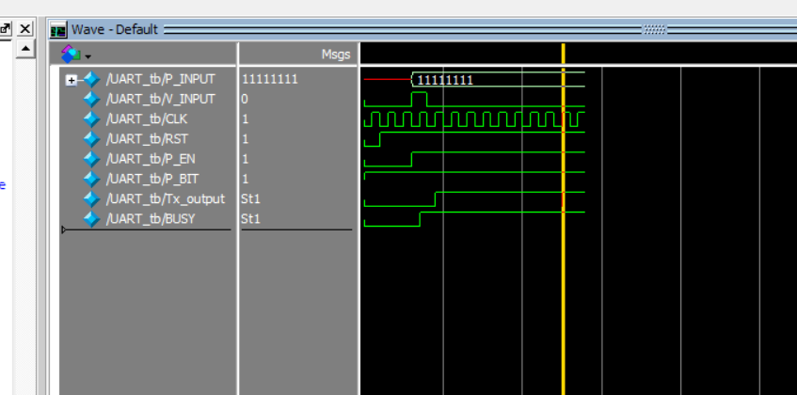

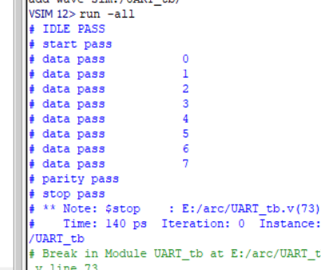

Test Case: 01011011 with Parity Enabled

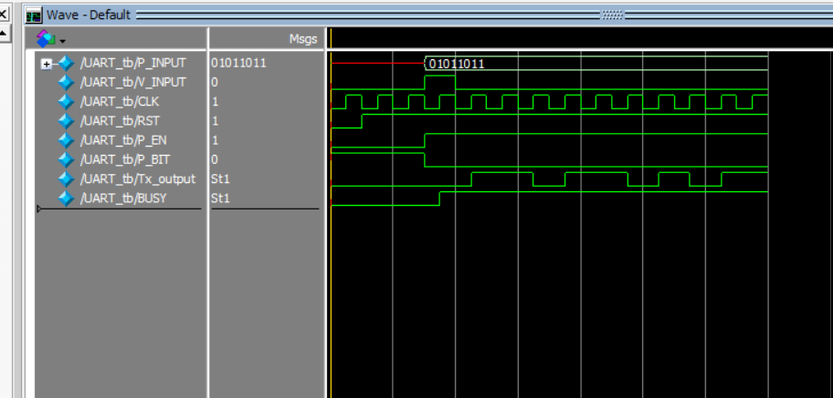

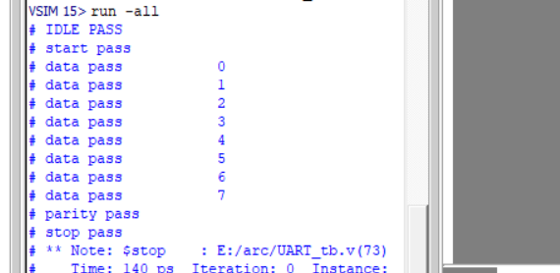

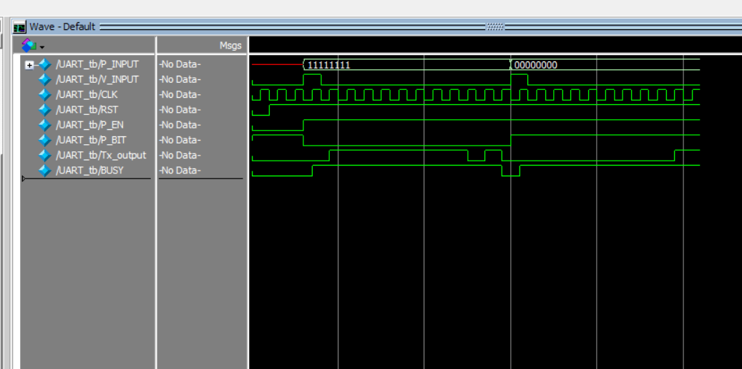

Sending two different frames:

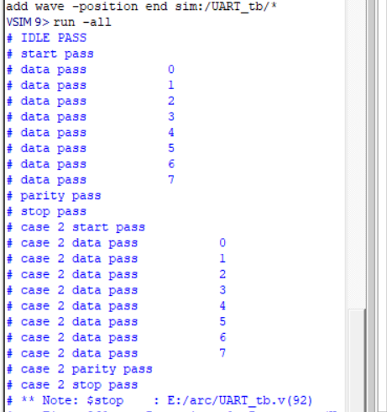

Sending two frames first fram all ones and second fram all zeros
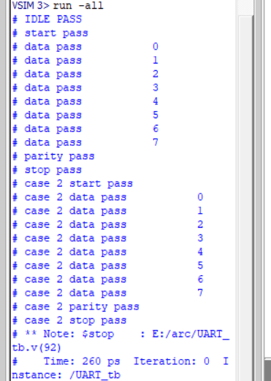

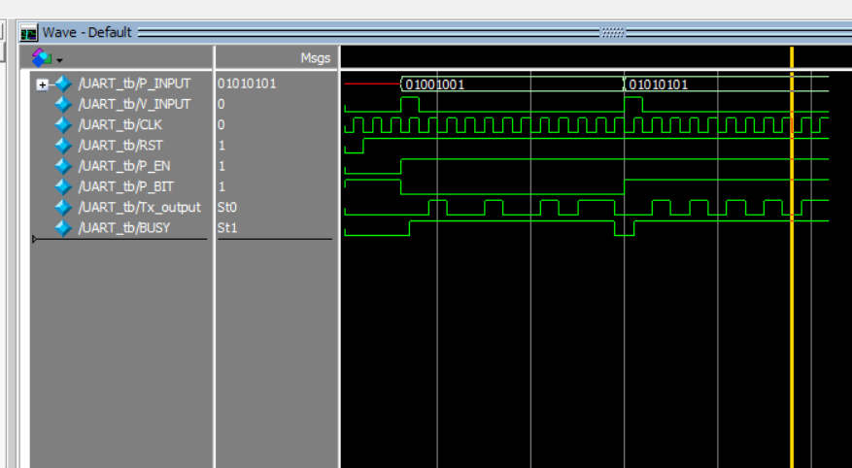

draft

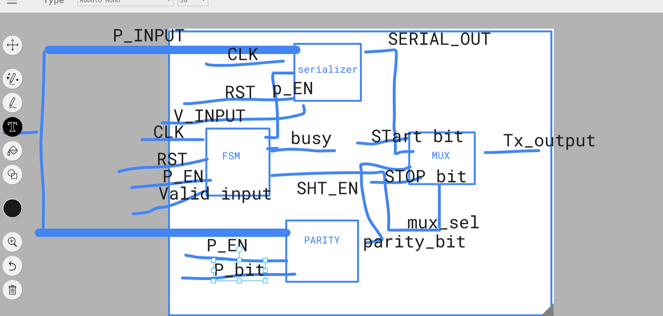

After polishing
