1. Dns

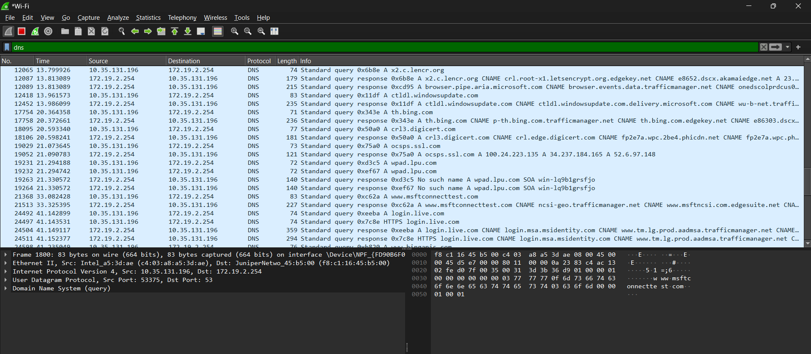

1. Dns.qry.name==[www.youtube.com](http://www.youtube.com)

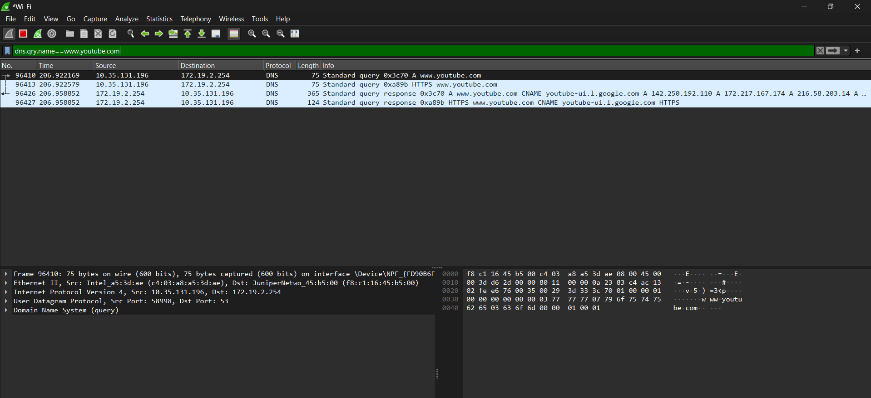

1. Dns.qry.name contains [www.youtube.com](http://www.youtube.com)

1. Tcp

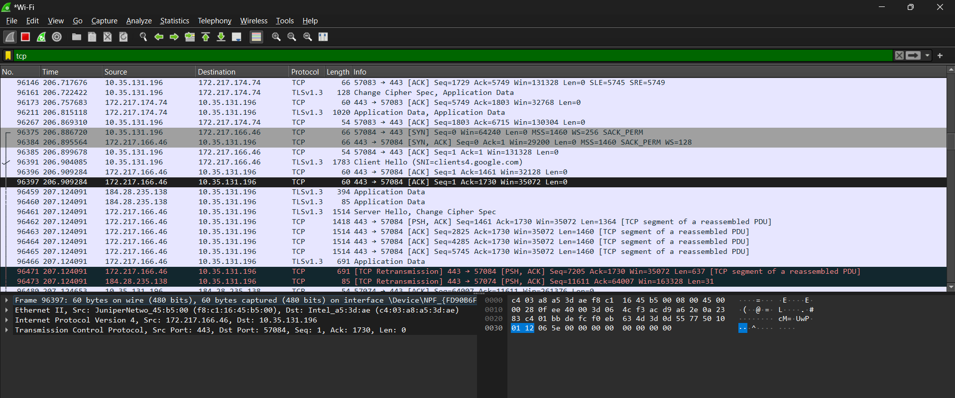

1. Udp

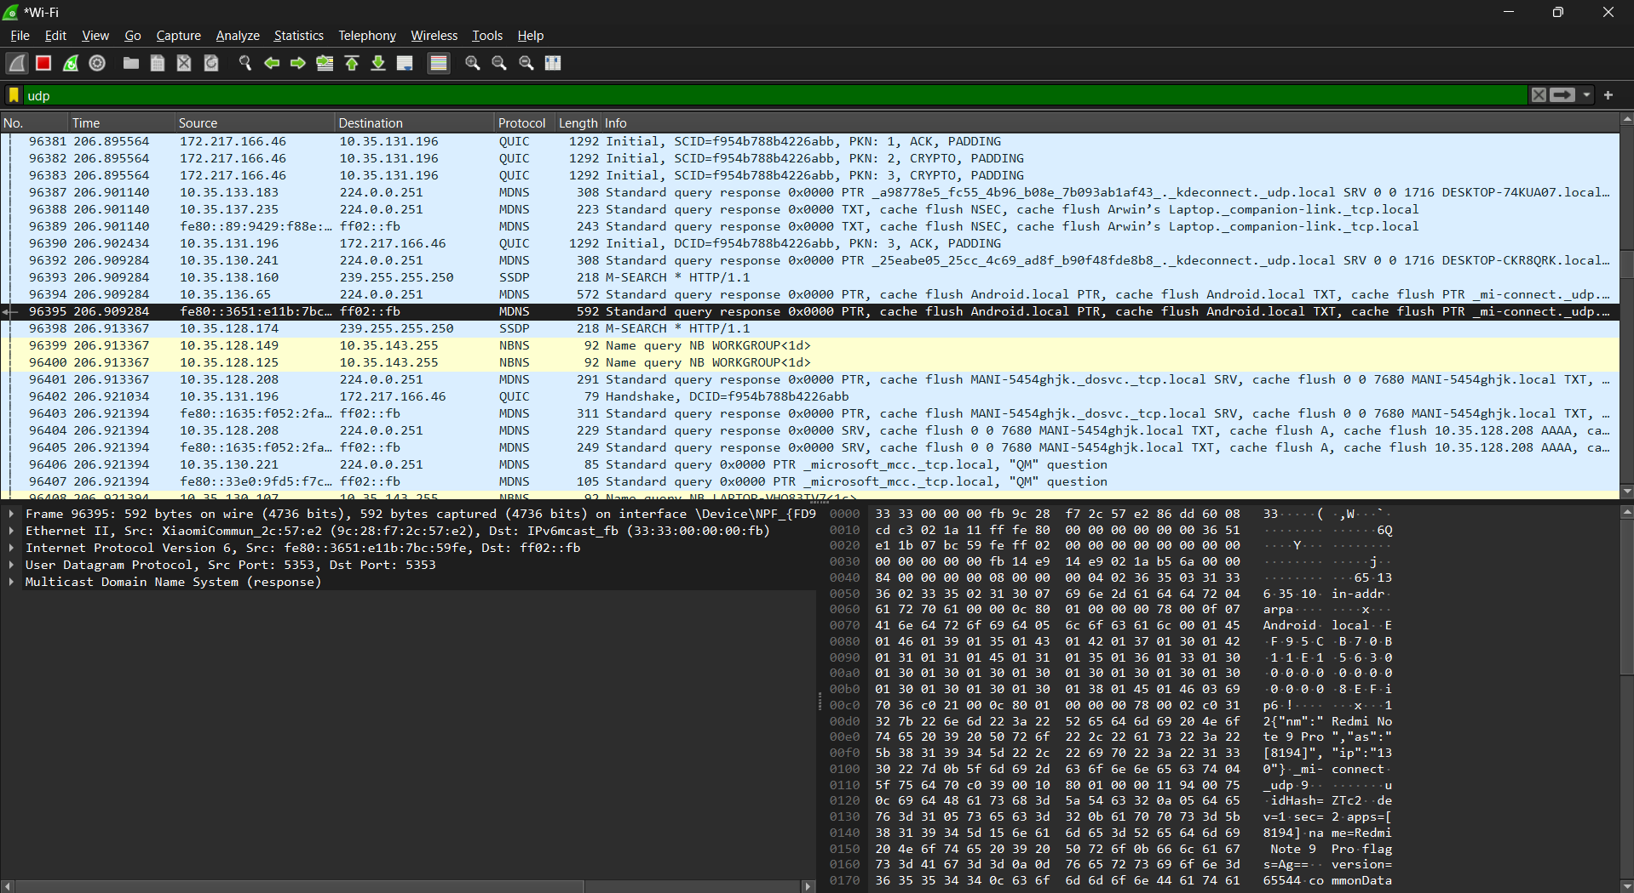

1. Icmp

1. !tcp

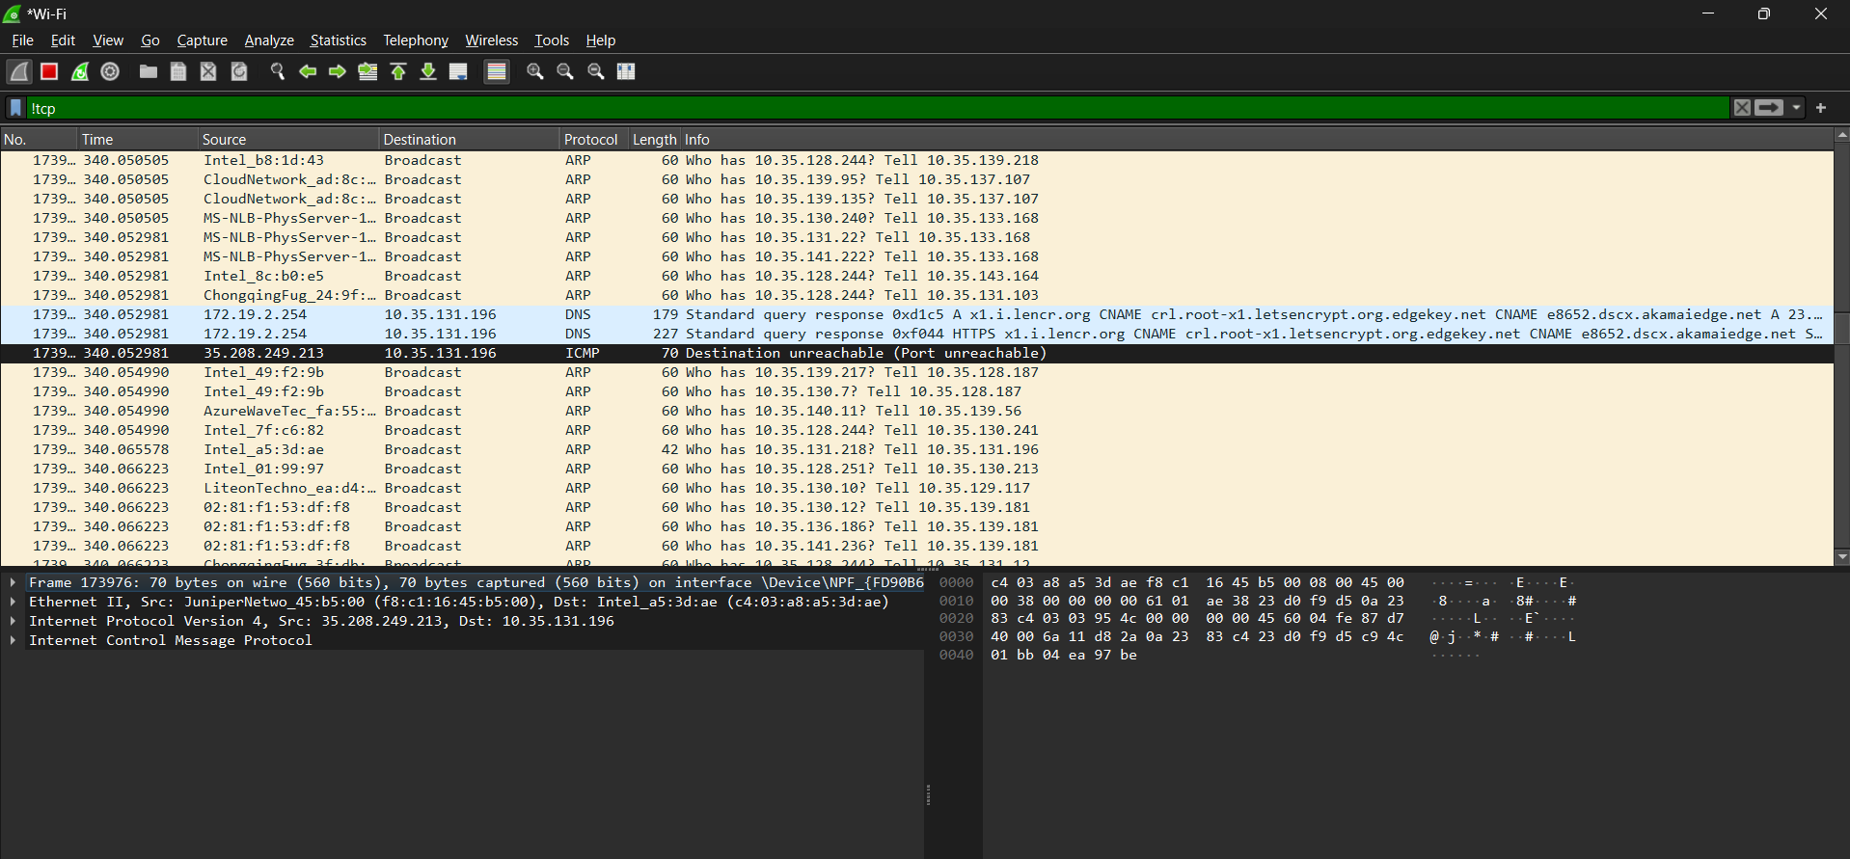

1. !dns

1. Tcp and !udp

