High Frequency Stock Price Prediction Using
Transformer Model

Omkar Singh Sandeep Odichuya
Department of Data Science Department of Data Science
Thakur College of Science & Commerce Thakur College of Science & Commerce
Mumbai,India Mumbai,India
Omkar.rsingh78@gmail.com sodichuya@gmail.com

Abstract— Stock Price Prediction is uncertain due to rapid change in financial market. The high-frequency stock price prediction using transformer model is trained on teacher-forcing approach which work properly on predicting past data values. The stock price data normalizes the past data to show short-term and long-term relationship. The result of the transformer model after training shows gives stable learning patterns and future predicted values. This result of the research paper emphasizes the importance of attention model for high-frequency data prediction and scatter plot shows the linear relationship.

Keywords— Stock price prediction, Transformer model, High-Frequency data, Time series analysis, Deep Learning.

I. INTRODUCTION

The stock price data prediction is extremely challenging and time consuming because of uncertainty of the data. The stock market every second generate millions of data and finding exact data price challenging. Even some time the machine learning and deep learning model failed to capture the different stock price data patterns and rapidly change in time series. The deep learning model have given great result on stock price prediction in last few years. The deep learning models mostly focus on the sequential data which make the prediction more accurate and effortless by training the model on sequential data. The transformer model improved in attention because of its long-range dependencies using attention mechanism. The self-attention mechanism of deep learning primarily focuses on capture the similar relationship between the different stock price patterns which make future forecast effective than traditional. The transformer model is trained and learn to identify the hidden relationship between the past and future stock price movement.

II. LITERATURE REVIEW

The stock price prediction in past years was primarily focused on the traditional statistics and machine learning mechanisms such as linear models, ARIMA models, support vector machines, and decision tree. These models were beneficial for recognizing the hidden market trends but due to limitation of handling of non-linear data it was very difficult to predict stock price.[1]

The stock prices are changes by multiple factors such market noise, high volatility or non-linear relationship in data which make models failed to generalize well [2].
Deep learning makes the task of stock price prediction effortless by the inclusion of different models, namely Artificial Neural Network, Convolutional Neural Network, and Recurrent Neural Network.[3]

In deep learning, the LSTM network helps in converting the temporal dependencies into sequential stock price data. They also handle large quantities of temporal relations. Drawbacks of using LSTM network: longer training time, limited processing, and poor performance since the management of long-range dependencies is laborious. Recent studies have been focused purely on the transformer-based architectures for stock price data prediction. The transformer model architecture with an internally based self-attention system, allows taking long-range relationship across time with no recurrence.[4]

The Transformer allows effective training with sequences of greater length and high frequency. Moreover, a number of studies demonstrated that using the Transformer architecture provides better forecasting results compared to traditional LSTM and CNN architecture when demonstrating the forecasting on multi-variable financial datasets. This reflects that the Transformer architecture is feasible in improving the stock forecasting system [5].

III. METHODOLOGY AND PROPOSED SYSTEM

The primary goal of the methodology is “to design an efficient framework for high frequency stock price prediction using a transformer-based deep learning architecture.” The complete process is divided into steps including data acquisition, processing, formation of sequences, training, and forecasting. Each step is designed with a focus on robustness, replicability, and efficient training of models on historical data towards recognizing financially relevant patterns.

The dataset researched was obtained from the Stooq financial data platform, which makes historical stock market data freely accessible. The S&P 500, Dow Jones Industrial Average (DOW), and NASDAQ Composite indices, because these benchmarks give wide coverage to overall market behaviour across many sectors. Daily closing prices were used to build a multivariate time-series dataset suitable to perform the prediction analysis [1]. Data preprocessing helps to enhance the performance of the model. First, the missing values were removed to maintain continuity in the time series.

A trend line was then calculated and subtracted from the index series to remove the trend. This is because the trend line can have values similar. This detrending helps the model concentrate on the intraday variations of the stocks, which are more relevant to forecasts at a high frequency. The detrends were then normalized to help the model train faster and converge better [2].

Further preprocessing operations generated fixed-size sequence pairs using a window method. Given an input sequence, which contains historical price data for a fixed number of timesteps, its paired sequence represents the value of the next timesteps. Hence, this sequence-to-sequence technique allows the Transformer network to efficiently extract timesteps within a sequence.

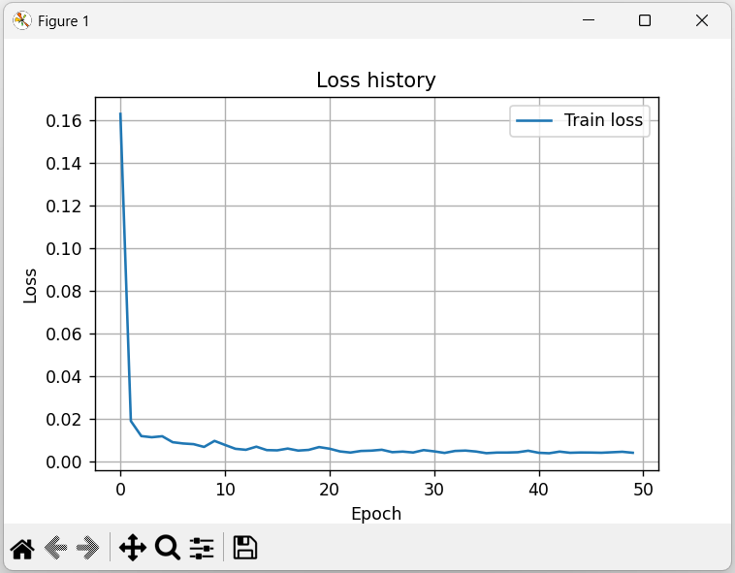

IV. TRANSFORMER ARCHITECTURE

The Transformer serves as a multilayer sequence learning model, aimed at the meaningful pattern extraction from the financial time series. An encoder-decoder-based architecture provides the fundamental architecture on which multiple layers can be stacked to progressively enrich the representation of the input. In this encoder, past stock price values are mapped to a higher-dimensional feature representation such that complicated temporal behaviors can be learned. Instead of using explicit position signals, it internally learns the sequence order through its structure.
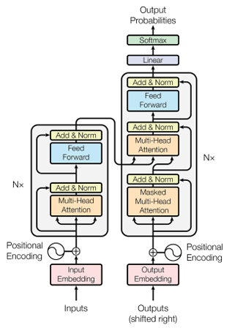
The final layer that represents the decoder produce the predictions of the stock price. As the target involves a forecasting problem, the target is a continuous number representing the stock price of the markets, and therefore the model predicts the stock prices in figures as opposed to classification. This is considered another advantage of the proposed model in being able to handle the stock markets' data, which demands rapid changes of the stock price as opposed to the traditional models used for handling the sequence data [2]; it is precise as opposed to the traditional models used for learning the particular sequence one after the other, as demonstrated by the example of the stock markets [3].

Key Mathematical Equations Used
Linear Detrending
To remove long-term market trends from stock prices:
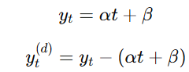
Data Normalization (Z-Score)
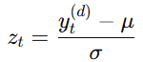
Evaluation Metrics
RMSE
MAE 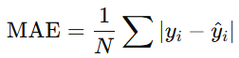
R² Score 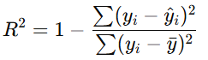

V. RESULT AND DISCUSSION

The loss history curve helps to visualize the epochs while training the stock data and progressive training process. Loss curve demonstrates transformer model training process.



The Actual and Predicted Stock Prices can be easily understood by visualization. This visualization help predict the stock price by historical data where the multiple epochs are trained by Supervised learning (Regression). The training result shows the actual vs predicted stock prices of market indices such also gives the short term/long term market trends.

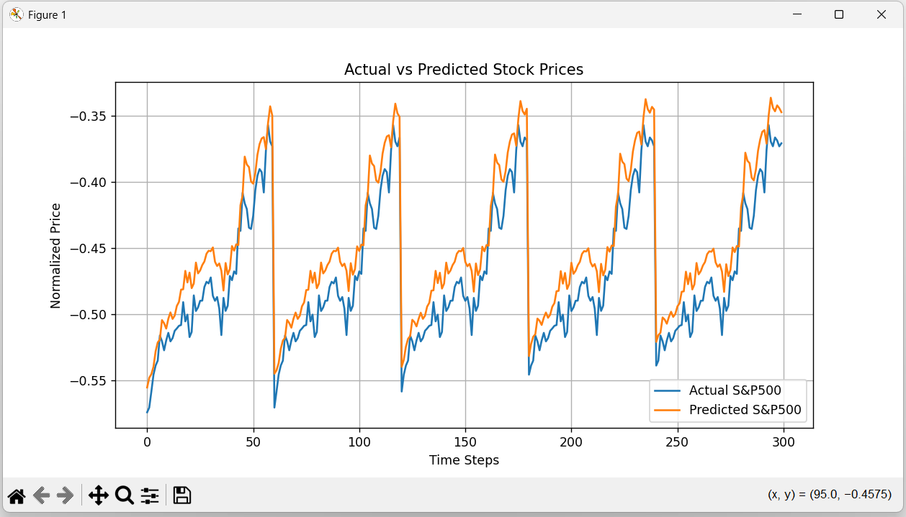

In result the predicted vs actual scatter plot shows a linear relationship. The scatter plot gives the high accuracy of the predicted task. The scatter plots of linear relationship give the actual and predicted values shows the high accuracy of the prediction task. The error metric R² small and large value verify the good performance of the Transformer model in predicting stock data with high frequency after normalization.

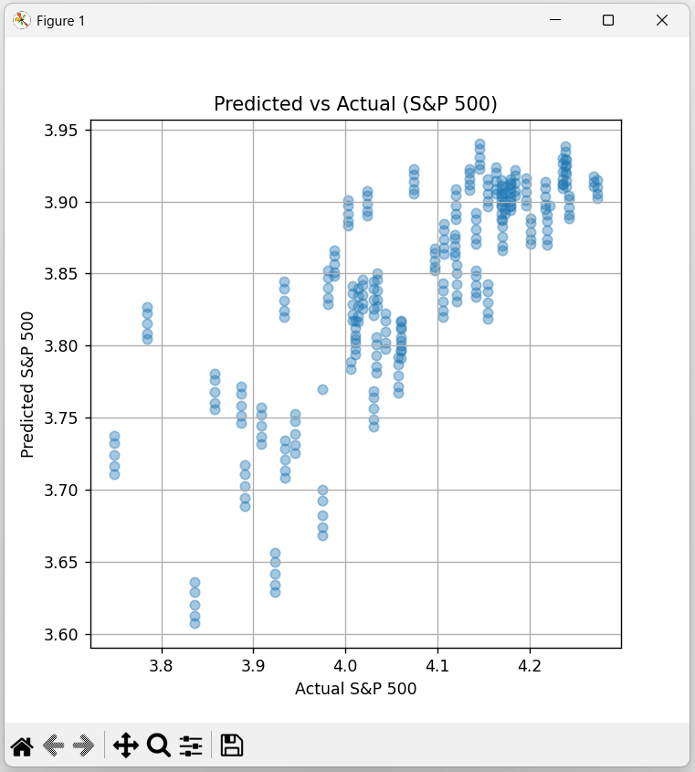

VI. REFERENCE

[1] Liu J, Lin H, Liu X, Xu B, Ren Y, Diao Y, Yang L. Transformer-based capsule network for stock movement prediction. In Proceedings of the first workshop on financial technology and natural language processing 2019 Aug (pp. 66-73).
[2] Lai S, Wang M, Zhao S, Arce GR. Predicting high-frequency stock movement with differential transformer neural network. Electronics. 2023 Jul 4;12(13):2943.
[3] Li S, Xu S. Enhancing stock price prediction using GANs and transformer-based attention mechanisms. Empirical Economics. 2025 Jan;68(1):373-403.
[4] Kabir MR, Bhadra D, Ridoy M, Milanova M. LSTM–transformer-based robust hybrid deep learning model for financial time series forecasting. Sci. 2025 Jan 10;7(1):7.
[5] Xie L, Chen Z, Yu S. Deep Convolutional Transformer Network for Stock Movement Prediction. Electronics. 2024 Oct 28;13(21):4225.

