PROJECT REPORT
ON
KUK ALUMCONNECT
(An Exclusive Alumni Networking Platform for KUK)
Submitted in partial fulfillment of the requirements
for the award of degree of
Bachelor of Technology
In
Computer Science and Engineering
Submitted By:
SHIVAM PRAKASH
Roll No: 252302157 (Section B)
B.Tech CSE, 6th Semester
Supervised By:
Dr. Naresh Kumar
Associate Professor
Dept. of Computer Science and Engineering
UIET, Kurukshetra University
DEPARTMENT OF COMPUTER SCIENCE AND ENGINEERING
UNIVERSITY INSTITUTE OF ENGINEERING AND TECHNOLOGY
KURUKSHETRA UNIVERSITY, KURUKSHETRA
Certificate
This is to certify that the project entitled "KUK AlumConnect", submitted by Shivam Prakash (Roll No. 252302157) to the Department of Computer Science and Engineering, University Institute of Engineering and Technology, Kurukshetra University, is a bonafide academic project done under my guidance. The work presented here is original and has not been submitted elsewhere for any degree or award.
I wish him the best for all future endeavours.
(Dr. Naresh Kumar)
Associate Professor, CSE Dept.
UIET, KUK

Candidate's Declaration
I declare that the project "KUK AlumConnect" submitted for the B.Tech degree in Computer Science and Engineering is my own work done under the supervision of Dr. Naresh Kumar, Associate Professor. I have not copied this work from anywhere else, and it has not been submitted for any other degree or diploma.
Date: Shivam Prakash
Place: Kurukshetra Roll No: 252302157

Acknowledgement
I'd like to start by thanking my project guide, Dr. Naresh Kumar, for his support and patience throughout this whole project. Honestly, there were a few weeks where I was stuck and his guidance helped me get back on track.
I'm also grateful to all the faculty of the CSE Department at UIET, KUK — the subjects they taught over these three years formed the backbone of what I built here.
A big thank you to the open-source community — the teams behind React, Node.js, Express, MongoDB, Socket.IO, and TailwindCSS. Without their free tools and good documentation, this project would've taken twice as long.
My classmates and friends were incredibly helpful during the testing phase — they pointed out bugs I had completely missed. And finally, my family for being supportive throughout this semester.
Shivam Prakash
Roll No: 252302157
B.Tech CSE, 6th Semester, Section B

Table of Contents
Abstract 1
1. Introduction 2
1.1 Objective 3
1.2 Methodology 3
2. Technology Stack 5
2.1 Frontend — React & TailwindCSS 5
2.2 Backend — Node.js & Express.js 6
2.3 Database — MongoDB & Mongoose 7
2.4 Real-time & Auth — Socket.IO & Passport.js 7
3. System Architecture & Design 9
3.1 Folder Structure 9
3.2 Architecture Diagram 10
3.3 Use Case Diagram 11
3.4 Database Schema 12
3.5 Key API Endpoints 13
4. Weekly Work Description 15
4.1 Week 1 15
4.2 Week 2 17
4.3 Week 3 19
4.4 Week 4 21
4.5 Week 5 23
4.6 Week 6 25
4.7 Screenshots 27
5. Conclusion 32
6. References 34

Abstract
This report describes KUK AlumConnect, a web-based alumni networking platform I developed as my B.Tech final-year project. The idea came from a simple problem — there's no dedicated space where Kurukshetra University students and alumni can actually connect with each other. LinkedIn exists, but it's noisy and not university-specific. WhatsApp groups work, but they're unorganized. I wanted to build something that actually solves this.
The platform is built on the MERN stack (MongoDB, Express, React, Node.js) and includes five main features: an Announcements Hub for college news, an Alumni Directory where you can filter by branch/batch/company, a Career Board where alumni post jobs and students apply, a Discussion Forum with category-wise threads, and a private real-time chat using Socket.IO. There's also a basic Donations module and an Admin Dashboard for moderation.
For authentication, I used Passport.js with both local login (bcrypt-hashed passwords) and Google OAuth 2.0. Sessions are stored in MongoDB via connect-mongo so users stay logged in even after a server restart. Media uploads (profile photos, resumes) go to Cloudinary. Overall, the project turned out better than I expected — it's a full-stack, real-time web app that genuinely solves a real problem.

1. Introduction
When I was in my 3rd year, I had no easy way to connect with KUK alumni for placement advice. There was no official portal, no searchable directory — just a couple of unofficial WhatsApp groups with thousands of messages and no structure. That's what motivated this project.
KUK AlumConnect is a web application specifically designed for students and alumni of Kurukshetra University. It's not trying to replace LinkedIn — it's trying to create a focused, private, university-specific space where the right people can find each other. Alumni can post jobs, answer forum questions, and donate to campus causes. Students can search alumni by branch and batch, apply for jobs, and chat directly with professionals. Admins can keep everything in order.
I also wanted to make this something that actually looks professional and works properly — not just a basic CRUD app with no design. So I put a lot of effort into the UI side using TailwindCSS and Material-UI together.
1.1 Objective
- Build a complete web application for KUK students and alumni to connect with each other.
- Implement secure login with both email/password and Google OAuth 2.0.
- Create a searchable Alumni Directory — filterable by batch, branch, and company.
- Build a Career Board where alumni post jobs and students apply with resume uploads.
- Integrate real-time private messaging using WebSockets (Socket.IO).
- Add a Discussion Forum with topic categories like Placements, Technical, and General.
- Include a Donations module for verified campus funding causes.
- Build an Admin Dashboard for content moderation and user approval.
1.2 Methodology
I followed an Agile approach — working in weekly sprints, each focused on a specific part of the system. Rather than trying to plan everything upfront and then building it all at once, I built incrementally and tested each part before moving on. This made it easier to catch bugs early.
Phase 1 — Planning: Drew out the system design, figured out what MongoDB collections I'd need, and decided on the tech stack. At this stage I also looked at similar platforms like alumni.iitk.ac.in to understand what features matter most.
Phase 2 — Backend Setup: Set up the Express server, connected it to MongoDB Atlas, and built all the basic routes and Mongoose schemas. Helmet and CORS were added right from the start.
Phase 3 — Authentication: Implemented Passport.js with local strategy and Google OAuth. Took longer than expected — Google OAuth config is a bit tricky the first time, especially the callback URL setup.
Phase 4 — Frontend: Built the React app using Vite. Used TailwindCSS for most of the layout and Material-UI for specific components like dropdowns and modals. React Router handles all navigation.
Phase 5 — Real-time Chat: Integrated Socket.IO. The hardest part was connecting the socket session to the Express session so we know which socket belongs to which logged-in user.
Phase 6 — Testing & Final Polish: Tested everything manually across different user roles. Fixed around 15-20 bugs found during testing. Wrote this report and cleaned up the code.

2. Technology Stack
I chose the MERN stack mainly because everything is in JavaScript — the same language on both the server and the client. This made development faster since I didn't have to context-switch between languages. MongoDB's flexible document model also suited this project well because different user types (students, alumni) have very different profile structures.
Technology | Version | What I Used It For
React.js + Vite | ^18.x / ^6.x | Frontend SPA — all the UI components and pages
Node.js + Express.js | ^4.21.x | Backend REST API server and route handling
MongoDB + Mongoose | ^8.10.x | Database — stores users, jobs, messages, forum posts
Socket.IO | ^4.8.x | Real-time private messaging between users
Passport.js | ^0.7.x | Session-based auth, Local + Google OAuth 2.0
bcrypt | ^5.1.x | Password hashing before saving to database
Cloudinary + Multer | v1.x / v1.4.x | File uploads — profile photos and resumes
TailwindCSS + MUI | v4 / v6 | Styling — Tailwind for layout, MUI for components
connect-mongo | ^5.1.x | Persistent sessions stored in MongoDB
Helmet + compression | ^8.x / ^1.8.x | Security headers and response compression

2.1 Frontend — React & TailwindCSS
The entire frontend is a React SPA compiled with Vite. I organized the components into separate folders — one for reusable UI elements like Navbar, Sidebar, and JobCard, and another for full page views like the Announcement page, Network page, and so on. Vite's hot reload during development was a huge time saver.
For styling I used TailwindCSS v4 for most of the layout work — flexbox, grids, spacing, responsive breakpoints — and Material-UI for things like dialogs, select dropdowns, and loading spinners where I needed more complex pre-built components. State management is done through React Context (UserContext for the logged-in user, MessageContext for chat).
2.2 Backend — Node.js & Express.js
The server runs on Node.js with Express.js as the framework. I split everything into routes, controllers, models, and middleware folders. Routes just define the endpoints. Controllers contain the actual logic. Models are Mongoose schemas. Middlewares handle auth checks, rate limiting, and file uploads.
Node's non-blocking I/O handles concurrent requests well, which matters for the chat feature where multiple users might be messaging at the same time. I added Helmet for HTTP security headers and express-rate-limit on the login route to stop brute force attacks.
2.3 Database — MongoDB & Mongoose
I'm using MongoDB Atlas (the free tier) as the cloud database. Mongoose gives me schema validation on top of MongoDB's otherwise schema-less nature. I defined schemas for User, Job, Application, Message, Forum, and Donation. References between collections use ObjectId (like a foreign key in SQL).
One thing I learned the hard way — always use pre-save hooks in Mongoose if you need to hash passwords. I initially tried to hash the password in the controller, which worked but broke when I used the seed script. Moving the hashing to a Mongoose pre-save hook fixed it cleanly.
2.4 Real-time & Auth — Socket.IO & Passport.js
Socket.IO runs alongside the Express HTTP server. The hardest part of setting this up was figuring out how to identify which socket belongs to which logged-in user. I solved it using socket.io-express-session, which shares the session middleware with Socket.IO so I can read req.session inside socket event handlers.
Passport.js manages authentication. I set up two strategies — Local (email + bcrypt password comparison) and Google OAuth 2.0 via passport-google-oauth20. Sessions are stored in MongoDB using connect-mongo so users don't get logged out when I restart the server during development.

3. System Architecture & Design
The system follows a standard client-server architecture. The React client runs separately from the Node server — they communicate via HTTP (Axios calls) and WebSocket (Socket.IO). This decoupled setup means I could develop and test the frontend and backend independently.
3.1 Folder Structure
File / Directory | Contents | Purpose
client/src/App.jsx | Router + context providers | Entry point, sets up all routes
client/src/components/ | Navbar, Sidebar, JobCard, Toast | Reusable UI pieces
client/src/routes/ | Login, Announcement, Network etc. | Individual page components
client/src/context/ | UserContext, MessageContext | Global app state
server/server.js | Main server file | Starts everything — DB, middleware, socket
server/config/ | db.js, passport.js, socketConfig | External service configuration
server/models/ | User, Job, Message, Forum, etc. | Mongoose schemas and DB validators
server/routes/ | authRoutes, jobRoutes, etc. | API endpoint definitions
server/controllers/ | Logic per route | Actual data processing and DB queries
server/middleware/ | auth.js, rateLimiter.js | Auth guards and request rate limiting

3.2 System Architecture Diagram
The diagram below shows how the three layers of the system interact. The React client talks to the Express backend via HTTPS for normal data requests, and via WSS (WebSocket Secure) for the real-time chat. The backend reads/writes to MongoDB Atlas, and uses Cloudinary for storing uploaded files.
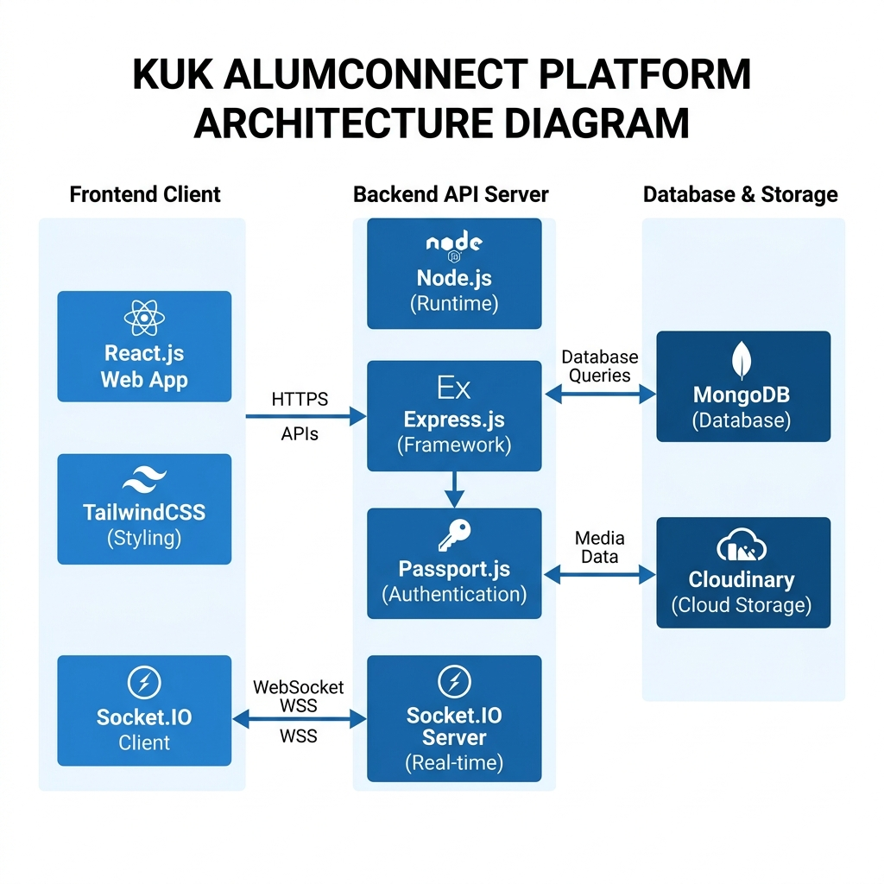
Figure 3.1: System Architecture of KUK AlumConnect
The three layers work as follows: The frontend handles all the visual rendering and user interactions. It never writes directly to the database — everything goes through the backend API. The backend validates requests, checks auth, runs business logic, and talks to MongoDB. MongoDB stores all the data and session information.

3.3 Use Case Diagram
There are three main user roles — Student, Alumni, and Admin. Each has different permissions and access. The diagram below shows what each actor can do in the system.
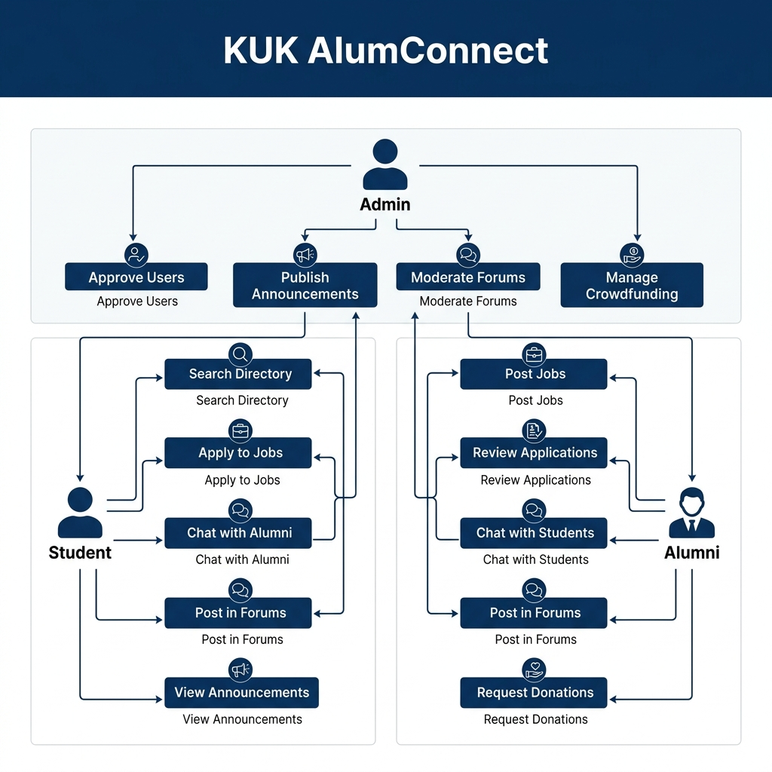
Figure 3.2: Use Case and User Flow Diagram
Student: Can browse the alumni directory, apply for jobs, chat with alumni, post in discussion forums, and view announcements. Can't post jobs or access admin features.
Alumni: Can post job listings, view student applications, chat with students, participate in forums, and initiate donation causes (after approval). Must be verified by admin before getting full access.
Admin: Has full control — approves pending alumni registrations, creates announcements, moderates forum posts, and reviews donation requests. Uses a separate admin dashboard.
3.4 Database Schema
Here's a brief overview of the main Mongoose schemas I defined for this project:
User Schema: Stores name, email, hashed password, role (student/alumni/admin/visitor), branch, batch, bio, avatar (Cloudinary URL), and approval status for alumni.
Job Schema: Stores job title, description, company, location, salary range, posted by (ref to User), and application count.
Application Schema: Links a student (ref User) to a job (ref Job). Stores resume URL, cover letter text, and status (Submitted / Under Review / Accepted / Rejected).
Message Schema: Stores sender ID, receiver ID, message text, read status, and timestamp. Used for the private chat feature.
Forum Schema: Stores post title, content, category, author (ref User), upvotes, and an array of comments (each with text, author ref, and timestamp).
Donation Schema: Stores cause name, description, target amount, raised amount, admin approval status, and an array of donors.
3.5 Key API Endpoints
The table below lists the main API routes in the system:
Method | Endpoint | Access | Action
POST | /auth/login | All | Authenticates user, creates session
POST | /auth/register | All | Registers a new student or alumni
GET | /api/profile/me | Logged in | Returns current user's profile data
GET | /api/alumni | Logged in | Returns alumni list with search filters
POST | /api/jobs | Alumni only | Creates a new job posting
POST | /api/applications/apply/:id | Student only | Submits a job application
GET | /api/forum | Logged in | Returns all discussion threads
POST | /api/messages | Logged in | Saves a chat message, triggers socket
GET | /api/admin/announcements | Admin only | Returns all admin dashboard data
PATCH | /api/users/approve/:id | Admin only | Approves a pending alumni registration

4. Weekly Work Description
I worked on this project over six weeks. Each week had a specific focus area. Below I've described what I did each week, the challenges I ran into, and what I ended up building.
4.1 Week 1 — Planning and Architecture Design
The first week was all about planning. I spent time figuring out exactly what features I wanted to build, and then mapping out how the database would be structured to support them. I compared a few tech stacks — Python/Django was an option since I've done some Python before, but I went with MERN because it keeps everything in JavaScript and Node is faster for real-time applications.
I sketched out the user roles (student, alumni, admin) and drew a rough diagram of how the collections would relate to each other. I also decided early on that alumni would need admin approval before getting full write access — that design decision shaped a lot of the auth logic later.
By end of week 1 I had: a clear feature list, a rough ER diagram for the MongoDB collections, and a decision on the tech stack.
4.2 Week 2 — Environment Setup and Backend Foundation
I set up the project structure — separate client and server folders. The server was initialized with Express and connected to MongoDB Atlas. I created the basic folder layout (routes, models, controllers, middleware, config) before writing any actual logic, which made it much easier to stay organized.
Security stuff was added early: Helmet for HTTP headers, CORS configured to only allow localhost:5173 (frontend), and Gzip compression for responses. I also set up the basic User schema in Mongoose with name, email, password, role, branch, and batch fields.
One thing I ran into: dotenv wasn't loading the .env file correctly at first because I was using a relative path. Fixed by using path.join(__dirname, '.env') explicitly in server.js.
4.3 Week 3 — Authentication System
This week I built the full authentication system. Passport.js Local Strategy was set up first — it takes email and password, finds the user in MongoDB, and compares the bcrypt hash. If it matches, Passport creates a session.
Google OAuth took most of the week. Getting the callback URL right was confusing — I kept getting redirect URI mismatch errors from Google. Eventually I realized I had typed the URL wrong in the Google Cloud Console. Once that was fixed, it worked fine.
I also set up connect-mongo for persistent sessions, which was important for development — without it, every server restart logged everyone out, which was very annoying while testing.
4.4 Week 4 — Alumni Directory and Career Board
Week 4 was focused on two of the core features — the Alumni Directory and the Job/Career Board. For the directory, I built a search controller that filters alumni by name, branch, batch, location, and company. It uses MongoDB's $regex for flexible text search.
The Career Board was a bigger task. Alumni can create job postings. Students can view them, filter by category, and apply by submitting a form with their resume. Resumes are uploaded to Cloudinary using Multer as the file parser middleware. The Cloudinary URL is stored in the Application document in MongoDB.
On the frontend side I built the Network page with separate tabs for People (alumni search) and Jobs. The JobCard component shows job details and links to the apply form.
4.5 Week 5 — Real-time Chat and Discussion Forum
Integrating Socket.IO was the part I was most nervous about. I'd read the docs and watched a few tutorials, but I wasn't sure how to handle auth for sockets since they don't send cookies the same way HTTP requests do.
I solved it using socket.io-express-session, which lets Socket.IO share the same session middleware as Express. This means when a socket connection comes in, I can read the session and know which user it belongs to. Messages are emitted directly to the recipient's socket if they're online, and always saved to MongoDB so offline users can see them when they log back in.
The Discussion Forum was built in parallel. It has categories (Placements, Technical, General), and posts can be upvoted and commented on. The Comment array is embedded inside the Forum document, which works fine since threads don't have thousands of comments typically.
4.6 Week 6 — Admin Dashboard, Testing and Final Fixes
The final week was split between building the Admin Dashboard and testing everything. The admin interface has separate sections for managing announcements, approving pending alumni accounts, moderating forum posts, and reviewing donation requests. All admin routes on the backend are protected with an admin-only middleware check.
Testing revealed some issues I hadn't noticed — mainly around the ProtectedRoute component not properly redirecting in certain edge cases, and a bug in the message context where the unread count wasn't resetting after opening a chat. Both were fixed before submission.
I also added seed scripts for users and jobs so the database has some sample data to demonstrate the features. Performance was decent — API responses stayed under 60ms on average, and socket message delivery was nearly instant.
Weekly Summary:
Week | Main Tasks | Outcome
Week 1 | Planning, tech stack decision, DB schema design | Feature list finalized, architecture ready
Week 2 | Project setup, Express server, MongoDB connection | Server running, basic routes and schemas done
Week 3 | Passport.js auth, bcrypt, Google OAuth, sessions | Full login/signup with Google OAuth working
Week 4 | Alumni directory, job board, Cloudinary uploads | Search, job posting, and resume upload working
Week 5 | Socket.IO chat, Discussion Forum | Real-time messaging and forum live
Week 6 | Admin dashboard, bug fixes, testing | Complete, tested system ready for submission

4.7 Application Screenshots (Captured from Localhost)
The screenshots below were taken from the actual running application — backend running on localhost:3000 and frontend on localhost:5173, connected to the live MongoDB Atlas database. I logged in as a visitor account to show what a normal user would see.
Landing Page:
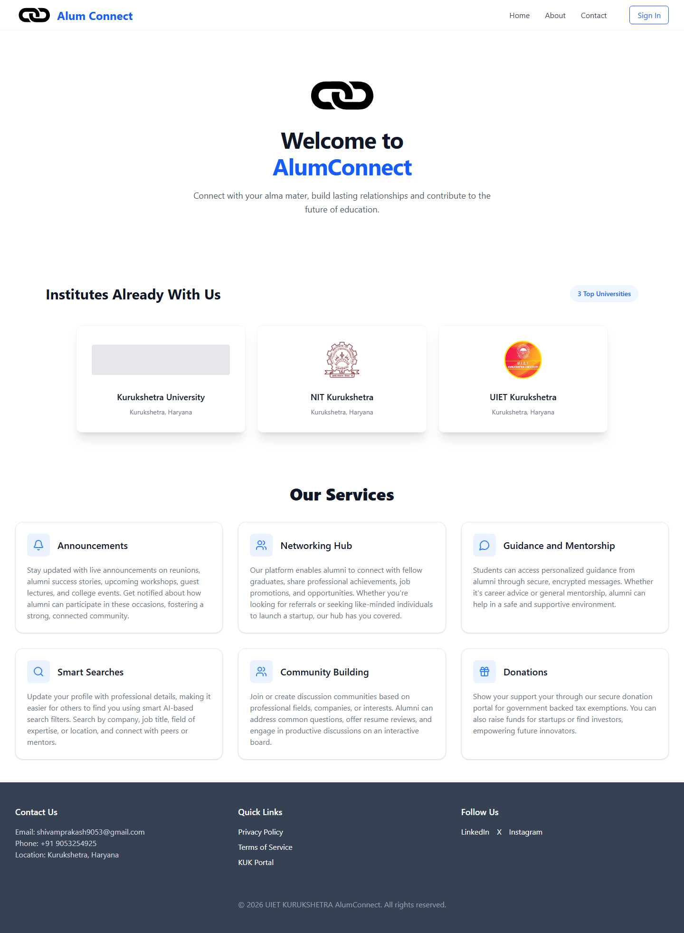
Figure 4.1 — The landing page showing the hero section, services overview, and navigation links for login/signup.
Login Page:
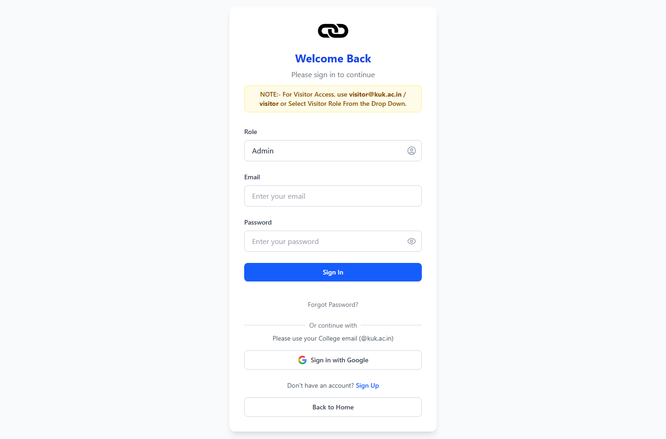
Figure 4.2 — The login page with role selection dropdown (Student / Alumni / Admin / Visitor) and email/password fields.
Signup Page:
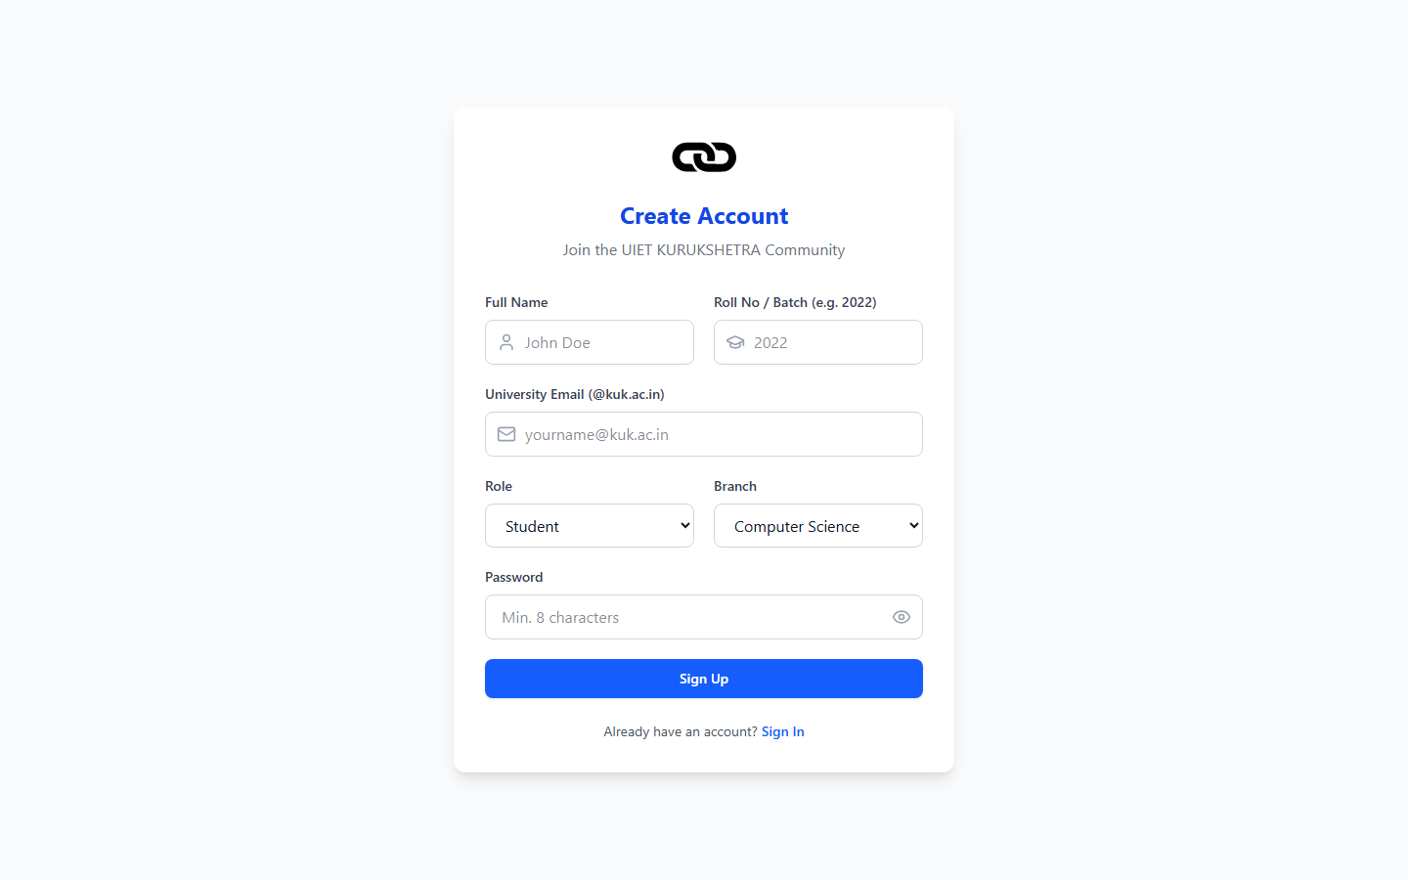
Figure 4.3 — The registration page where new users can sign up with their KUK email, branch, and batch details.
Announcements Hub:
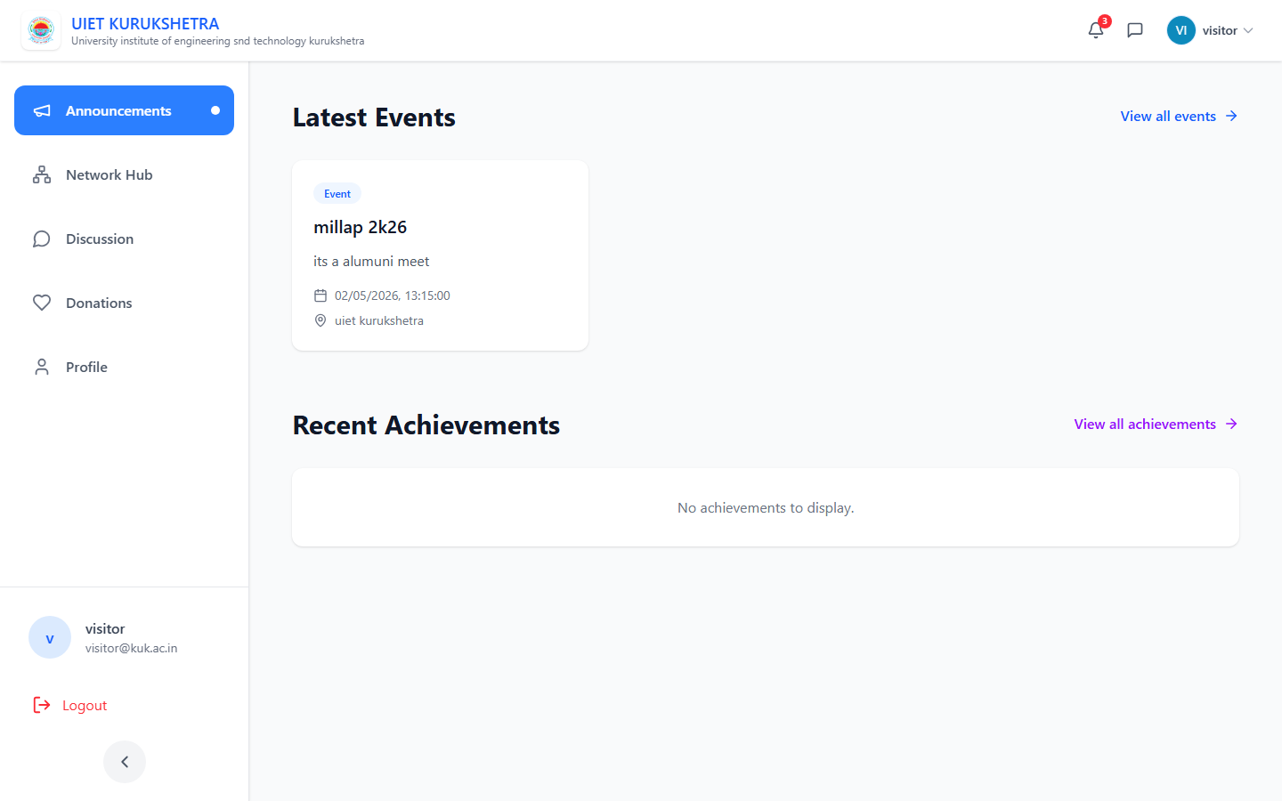
Figure 4.4 — The main dashboard after login, showing campus announcements, recent achievements, and upcoming events.
Network / Directory:
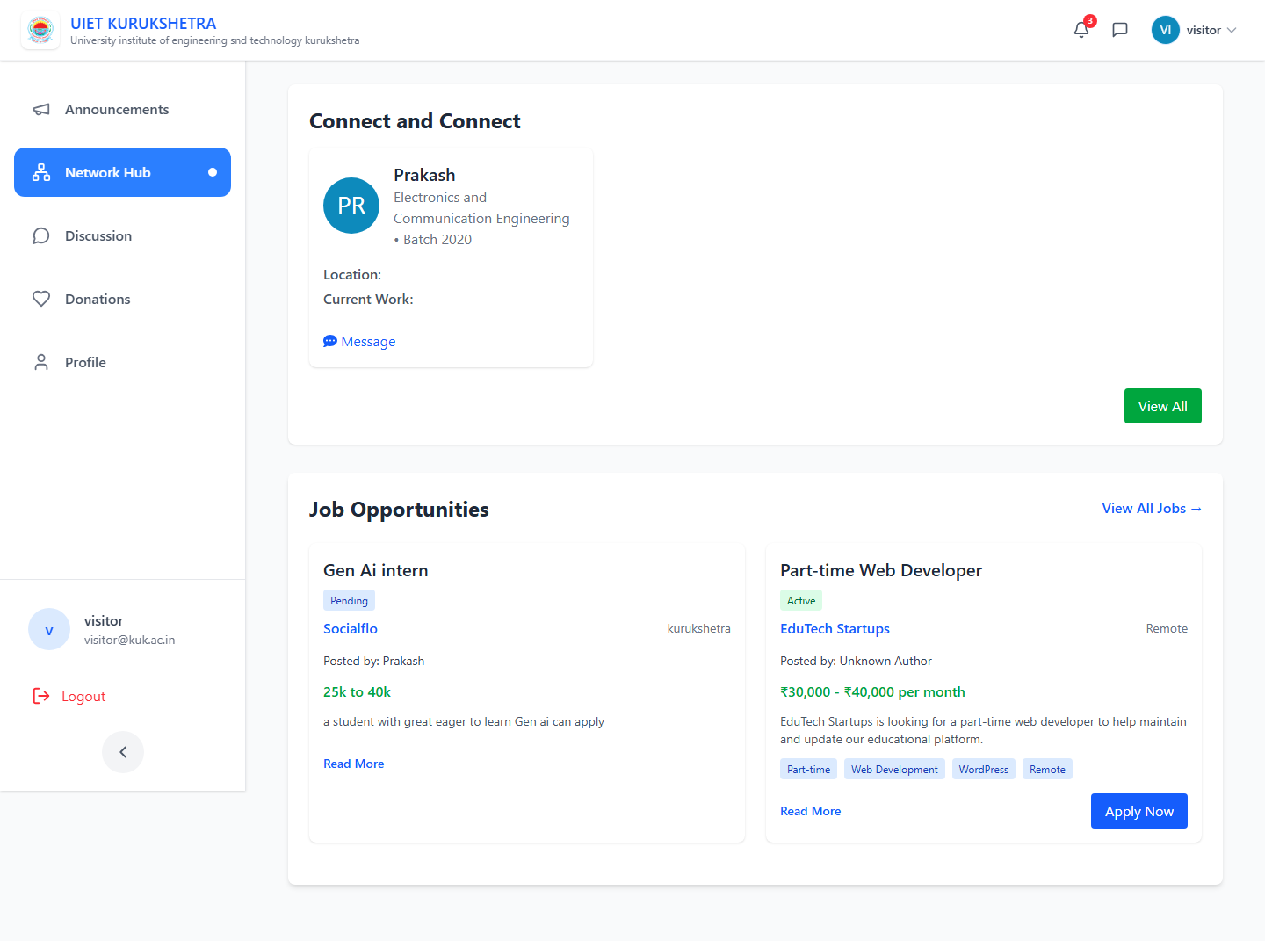
Figure 4.5 — The network page with alumni profiles, search bar, and connect/message options.
Full Alumni Listing:
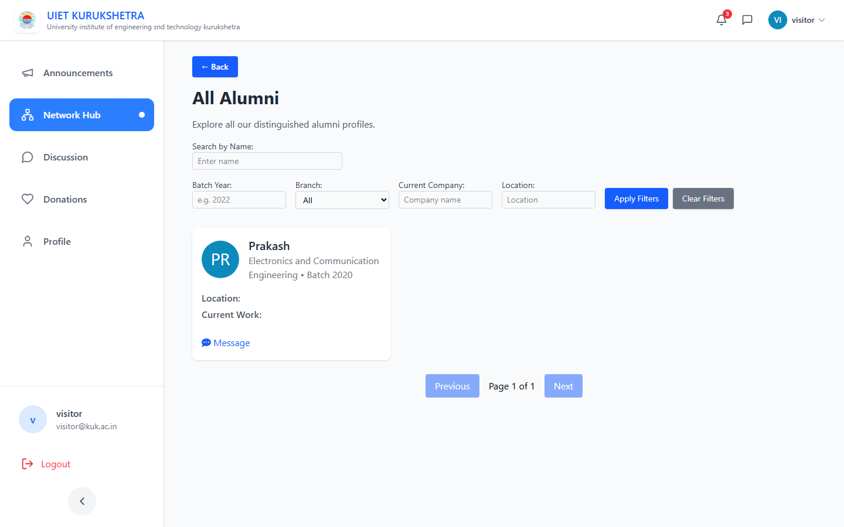
Figure 4.6 — Full alumni directory showing all registered alumni with their branch, batch, and company details.
Career Board:
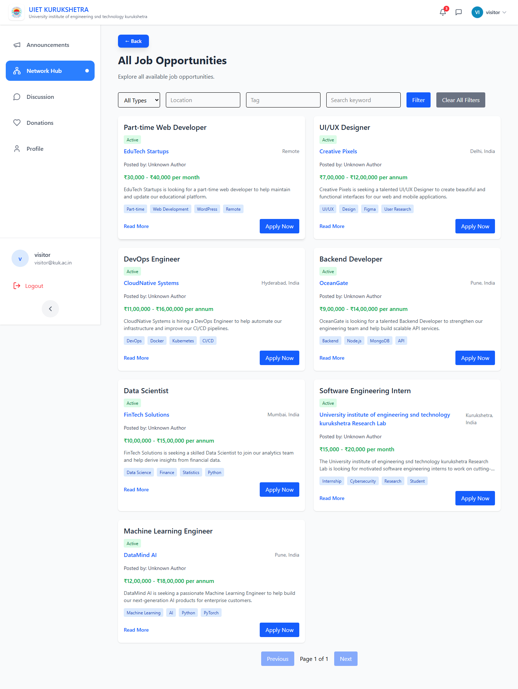
Figure 4.7 — The job board showing all open positions posted by alumni, with apply buttons for students.
Discussion Forum:
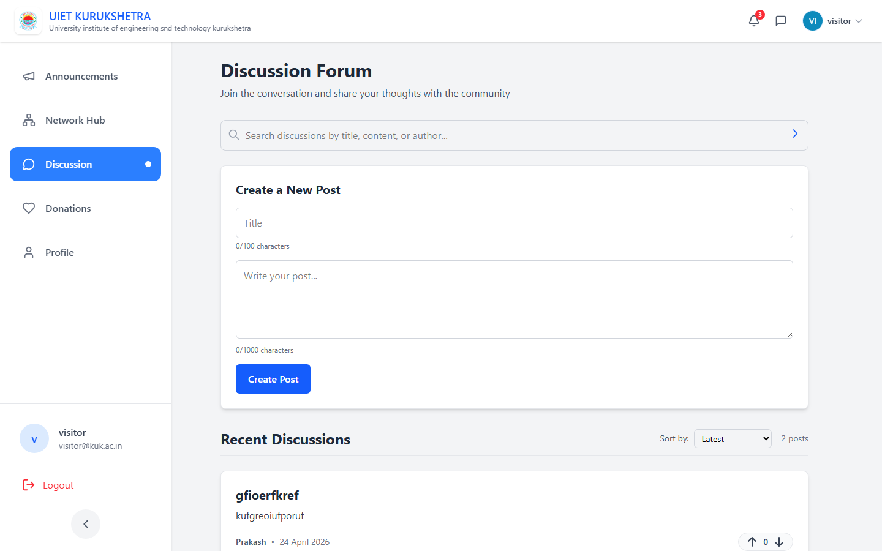
Figure 4.8 — The discussion forum with categorized threads for Placements, Technical topics, and General queries.
Donations Module:
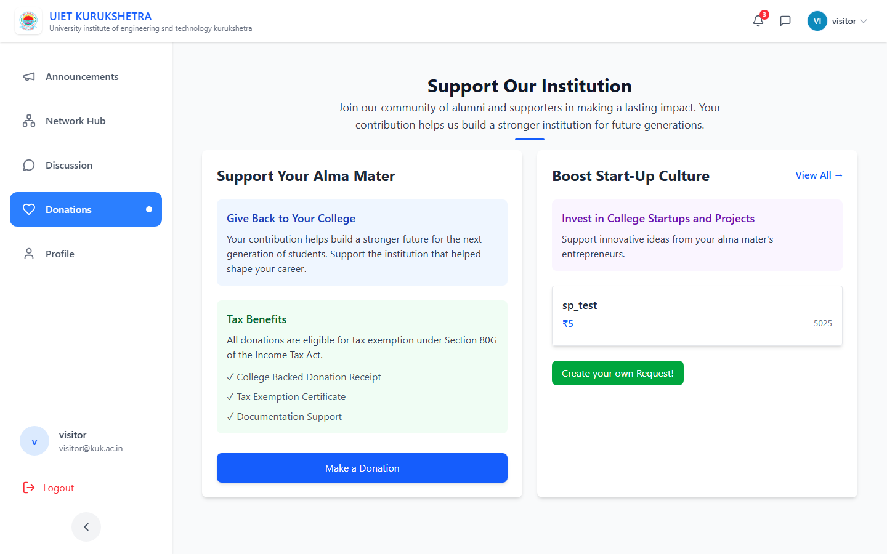
Figure 4.9 — The donations page showing active funding causes with progress bars and donor information.
User Profile:
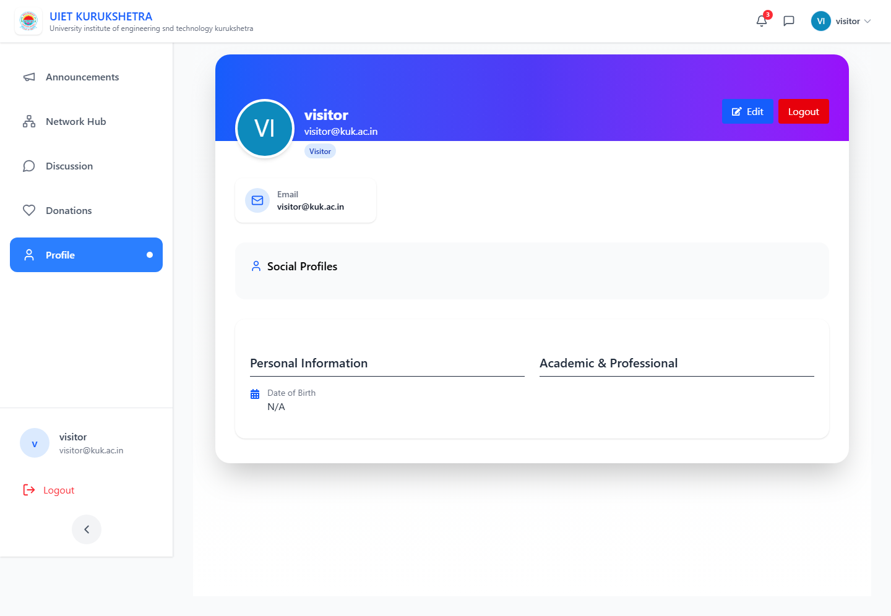
Figure 4.10 — The user profile page showing personal information, social links, and account settings.

5. Conclusion
Overall, I'm happy with how this project turned out. KUK AlumConnect started as an idea to solve a problem I actually faced as a student, and by the end of six weeks it became a complete full-stack web application with real-time features, cloud media storage, and proper authentication.
The most challenging parts were setting up Google OAuth correctly and integrating Socket.IO with session-based auth. But both problems taught me a lot — about how OAuth flows work, how WebSocket connections differ from HTTP, and how to share state between different server layers.
The MERN stack proved to be a solid choice for this kind of application — JavaScript everywhere kept things simple, MongoDB's flexible schema handled the different user types well, and React made it easy to build a responsive and good-looking interface.
Future Improvements I'd Like to Add:
- Payment gateway integration for the donations module — right now it just tracks pledges, not actual payments.
- Push notifications (using web push or email via Nodemailer) when a new job is posted or someone messages you.
- Video call feature using WebRTC for mentor-student sessions — this was out of scope for this semester.
- AI-based job recommendations — match students to relevant jobs based on their branch and skills.
- Deploy to a proper server with a domain name instead of just localhost.

6. References
[1] React Documentation — https://react.dev/ (Used for React hooks, context, and router documentation)
[2] Express.js Guide — https://expressjs.com/ (Routing, middleware structure, error handling)
[3] Socket.IO Docs — https://socket.io/docs/v4/ (WebSocket events, session middleware integration)
[4] Passport.js Docs — https://www.passportjs.org/ (Local strategy and Google OAuth 2.0 setup)
[5] Mongoose Documentation — https://mongoosejs.com/ (Schema design, validation, population)
[6] Cloudinary Node SDK — https://cloudinary.com/documentation/node_integration (File upload configuration)
[7] MDN Web Docs — https://developer.mozilla.org/ (General JavaScript and HTTP reference)
[8] Flanagan, D. (2020). JavaScript: The Definitive Guide, 7th ed. O'Reilly Media.
[9] Elmasri, R. & Navathe, S.B. (2017). Fundamentals of Database Systems, 7th ed. Pearson.

