PROJECT REPORT
ON
KUK ALUMCONNECT
(AN EXCLUSIVE ALUMNI NETWORKING PLATFORM)
Submitted in partial fulfillment of the requirements for the award of degree of
Bachelor of Technology
In
Computer Science and Engineering
Submitted By:
SHIVAM PRAKASH
Roll No: 252302157 (CSE-B)
B.Tech. CSE (6th Semester)
Supervised By:
Dr. Naresh Kumar
Associate Professor
Department of Computer Science and Engineering
UIET, KUK
DEPARTMENT OF COMPUTER SCIENCE AND ENGINEERING
UNIVERSITY INSTITUTE OF ENGINEERING AND TECHNOLOGY
KURUKSHETRA UNIVERSITY, KURUKSHETRA

Certificate
This is to certify that the project entitled "KUK AlumConnect", submitted by Shivam Prakash (Roll No. 252302157) to the Department of Computer Science and Engineering, University Institute of Engineering and Technology, Kurukshetra University, Kurukshetra, is a bonafide academic project carried out by him under my supervision and guidance. He has reached the standard of fulfilling the requirements of regulations relating to the degree.
I wish him success in all his future endeavours.
(Dr. Naresh Kumar)
Associate Professor of CSE Deptt.
UIET, KUK

Candidate's Declaration
I hereby declare that the project entitled "KUK AlumConnect", which is being submitted for the Bachelor of Technology in Computer Science and Engineering, is an authentic record of the work carried out by me under the supervision of Dr. Naresh Kumar, Faculty of Computer Science and Engineering, University Institute of Engineering and Technology, Kurukshetra University, Kurukshetra.
I also declare that the material presented in this project has not been submitted for the award of any degree or diploma of this or any other University/Institute.
Date: Student's Name: Shivam Prakash
Place: Kurukshetra Roll No: 252302157

Acknowledgement
I would like to express my sincere gratitude to Dr. Naresh Kumar, Associate Professor, Department of Computer Science & Engineering, UIET, Kurukshetra University, for his constant guidance, valuable suggestions, and patient mentorship throughout the development of this project. His expertise and encouragement shaped this project in every meaningful way.
I am also thankful to all the faculty members of the Department of CSE, UIET, Kurukshetra University, whose teachings over the past years provided the foundational knowledge required to undertake this project.
Special thanks to the open-source community — especially the developers of React, Node.js, Express.js, MongoDB, Mongoose, Socket.IO, TailwindCSS, and Material-UI — whose freely available tools and rich documentation made it possible to build a premium, highly secure, and real-time networking application using modern web architectures.
I am grateful to my classmates and friends for their feedback, support, and motivation during the development, testing, and UI validation phases of this project.
Finally, I thank my family for their unconditional support and encouragement throughout my academic journey.
Shivam Prakash
Roll No: 252302157
B.Tech. CSE, 6th Semester, Section B
UIET, Kurukshetra University

Table of Contents
Abstract 1
1. Introduction 2-4
1.1 Objective 3
1.2 Methodology Used 3-4
2. Technology Stack Used 5-8
2.1 React & Material-UI (Frontend) 5-6
2.2 Node.js & Express.js (Backend) 6
2.3 MongoDB & Mongoose (Database) 7
2.4 Socket.IO & Passport.js (Real-time & Security) 7-8
3. System Architecture & Design 9-13
3.1 Folder Structure 9-10
3.2 System Architecture Diagram & Working 10-11
3.3 Use Case & User Flow Diagram 11-12
3.4 Database Models & Schema 12-13
3.5 Key API Endpoints & Flow 13-14
4. Weekly Work Description 15-30
4.1 Week 1: Problem Definition & Architecture Design 15-17
4.2 Week 2: Environment Setup & Express Backend Core 18-20
4.3 Week 3: Auth Layer & Mongoose Schema Integration 21-23
4.4 Week 4: Directory, Job Board & Cloudinary Setup 24-26
4.5 Week 5: Socket.IO Chat & Discussion Forum 27-28
4.6 Week 6: Admin Dashboard, Security Audit & Testing 29-30
5. Conclusion 31-32
6. References 33

Abstract
Alumni relations represent a crucial asset for modern educational institutions, fostering student mentorship, career placements, funding, and general institutional development. However, maintaining updated database information and building active social links between students, alumni, and administrative authorities remains a significant hurdle. Traditional directories are static, non-interactive, and often fall out of date. This project presents KUK AlumConnect, a comprehensive, premium networking web application designed explicitly to bridge the communication gap between the past and present students of Kurukshetra educational institutions.
Built using a robust MERN (MongoDB, Express, React, Node.js) stack, KUK AlumConnect integrates five core layers: (1) An Announcements Hub for college news, achievements, and events; (2) A filterable Alumni Directory & Career Board where alumni can post job opportunities and students can submit applications in real-time; (3) A structured Discussion Forum featuring categorised channels and nested comment trees; (4) A Donations & Causes Module that permits verified funding requests and tracks alumni sponsorships; and (5) A real-time, WebSocket-based Private Chat Engine powered by Socket.IO for secure, direct communication.
The application prioritises advanced security measures, deploying Passport.js session-based authentication (supporting both secure local credentials and Google OAuth 2.0), bcrypt password salting, Multer + Cloudinary cloud media storage, rate limiters to ward off DDoS attacks, and HTTP compression/security headers (Helmet) to guarantee rapid and safe operations. To maintain strict community standards, a bespoke Admin Dashboard permits institutional moderators to oversee discussions, review funding requests, and manage directory access. The finalized web application delivers a seamless, responsive, and aesthetically outstanding user interface that significantly improves community engagement and streamlines university-alumni communication.
Keywords: Alumni Relations, MERN Stack, Socket.IO, Real-Time Messaging, Career Board, Discussion Forum, Google OAuth, Cloudinary, Admin Dashboard, Web Security

1. Introduction
In the current digital age, the value of professional networks cannot be overstated. For academic institutions like Kurukshetra University, graduating students represent their greatest pride and their most potent external resource. Alumni are uniquely positioned to offer career guidance, direct job placements, industry mentorship, and financial support for university growth. However, most universities rely on fragmented channels — such as legacy static websites, Facebook groups, or LinkedIn searches — which lack organization, privacy, and dedicated academic focus.
Static lists become outdated rapidly, and third-party social networks expose users to excessive noise and privacy hazards. There is a pressing need for an exclusive, highly organized, secure platform designed specifically for the Kurukshetra academic community. KUK AlumConnect was developed to address these specific needs, presenting a unified environment that merges a searchable alumni directory, a dedicated career center, real-time messaging, and institutional moderation under one single roof.
1.1 Objective
- To design and develop a premium, responsive web application (KUK AlumConnect) using the MERN stack that connects students, alumni, and administrators.
- To implement a robust, role-based authentication system supporting secure Email/Password registration as well as Google OAuth 2.0 single sign-on.
- To build a dynamic, filterable Alumni Directory enabling users to search and discover peers by batch, branch, current location, and professional role.
- To establish a Career Board that allows verified alumni to post job and internship vacancies, and enables students to apply and track application status.
- To implement a real-time instant messaging system using WebSockets (Socket.IO) to allow immediate professional networking and mentorship dialogues.
- To construct a Discussion Forum featuring diverse topics, rich text comments, and categorised threads for university placements and technical preparation.
- To set up a secure Donation Portal where administrators can publish verified funding causes, allowing alumni to contribute directly and transparently.
- To engineer an Admin Dashboard giving college moderators authority to manage announcements, audit forums, review donation goals, and inspect users.
1.2 Methodology Used
The development of KUK AlumConnect follows an Agile Software Development Lifecycle, splitting the architectural implementation into logical sprints covering database modeling, API architecture, frontend component engineering, socket integration, and security auditing. The methodology involves the following core stages:
Phase 1 - Requirements Analysis & Design: Documenting user expectations for alumni and students. Mapping relational flows between collections and planning security protocols. Modeling user roles (Student, Alumni, Admin) and outlining system capabilities.
Phase 2 - Backend Foundation: Setting up an Express.js server, establishing a database connection to MongoDB Atlas using Mongoose ODM, and crafting robust modular routing for auth, profiles, jobs, forum, messages, and donations.
Phase 3 - Security & Authentication Layer: Implementing Passport.js strategies, salting passwords with bcrypt (10 rounds), setting up connect-mongo session storage, and applying security enhancements including Helmet headers, CORS filters, and Express Rate Limiters.
Phase 4 - Frontend Component Architecture: Developing a React client compiled with Vite. Styling elements with TailwindCSS and Material-UI for responsive layouts. Using React Router for routing and implementing central State contexts (User Context, Message Context).
Phase 5 - Real-time Socket Integration: Integrating Socket.IO into the HTTP server, mapping socket connections to Express session cookies, and establishing immediate private chat capabilities with database persistence.
Phase 6 - Validation & Deployment: Executing system-wide testing (API endpoint testing, routing validation, and load checks on Socket.IO) followed by deploying to an AWS EC2 instance using a reverse proxy setup.

2. Technology Stack Used
KUK AlumConnect is engineered on a modern, robust, and highly scalable technology stack. By leveraging the MERN (MongoDB, Express, React, Node.js) paradigm alongside WebSockets and Cloud Media CDNs, the application attains excellent performance, high responsiveness, and minimal server overhead. The table below lists the specific core technologies, packages, and their corresponding purposes:
Technology / Library | Version Range | Role in KUK AlumConnect
React.js | ^18.x / Vite | Frontend interface, modular SPA rendering, visual components
Node.js / Express.js | ^4.21.2 | REST API Backend, middleware handler, application logic routing
MongoDB / Mongoose | ^8.10.0 | NoSQL database, Mongoose ODM schemas, relational object mapping
Socket.IO | ^4.8.1 | Bidirectional WebSockets, low-latency private instant chat delivery
Passport.js | ^0.7.0 | Session-based auth integration (Local Strategy + Google OAuth 2.0)
bcrypt | ^5.1.1 | Secure hashing and salting of user passwords (10 rounds)
Cloudinary / Multer | ^1.32.0 | Dynamic image parsing, secure remote cloud storage for user avatars
TailwindCSS / Material-UI | Latest / v5 | Responsive layouts, visual elegance, grid layouts, fluid icons
connect-mongo | ^5.1.0 | MongoDB-backed persistent session store for active sessions
Helmet & Compression | ^8.0 / ^1.8 | HTTP header protection against vulnerabilities, Gzip data compression

2.1 React & Material-UI (Frontend)
The frontend of KUK AlumConnect is structured as a Single Page Application (SPA) using React.js. React permits the construction of a component-driven interface where elements like the Navbar, Sidebar, JobCard, and MessageBubble are declared once and reused across different views. Vite is deployed as the compiler, rendering significantly faster build and reload times than legacy Webpack utilities.
To ensure high-fidelity styling, the application leverages TailwindCSS alongside Material-UI (MUI). Tailwind handles high-control layout arrangements (such as grid and flex alignments, media-query responsiveness, and dynamic states like hover or active), while Material-UI provides polished visual modules (including dialog modals, input selections, drop-downs, and load spinners) that conform to professional design guidelines. This combination achieves a visually premium interface that feels responsive and modern.
2.2 Node.js & Express.js (Backend)
The backend layer relies on Node.js, a lightweight asynchronous JavaScript runtime built on Chrome's V8 engine. Express.js acts as the server framework, providing modular routing capabilities, robust middleware capabilities, and a structured layout for separating controllers, schemas, and routes.
The server routes all incoming HTTP queries, performs backend verification, communicates with MongoDB via Mongoose ODM, and processes business logic (such as checking auth roles, evaluating donation progress, and handling job requests). With Node's event-driven, non-blocking I/O loop, the server can handle multiple concurrent connections without exhausting server memory resources.
2.3 MongoDB & Mongoose (Database)
MongoDB is a schema-less, document-oriented NoSQL database that stores data in JSON-like BSON documents. It is highly suitable for KUK AlumConnect due to the varying attributes of user roles (for example, alumni require extensive company and experience records while students require university-focused descriptors) and the unstructured nature of discussion forum threads.
Mongoose ODM (Object Document Mapper) serves as the bridge between Node.js and MongoDB. It establishes a structured schema validation layer on top of MongoDB's flexible nature, ensuring data consistency. It maps out collection relationship linkages (via Schema.Types.ObjectId references) and implements middleware actions (such as auto-removing job references on user deletion or pre-saving password hashing hooks).
2.4 Socket.IO & Passport.js (Real-time & Security)
Socket.IO is a robust library that enables real-time, low-latency, bidirectional, event-driven communication between the web browser and the server. In KUK AlumConnect, it initiates a permanent TCP WebSocket connection, allowing users to send and receive direct messages instantly. It integrates directly with express-session using socket.io-express-session, allowing Socket.IO to identify the authenticated user's session secure cookie and route messages to the correct receiver.
Passport.js acts as the authentication middleman, offering a modular framework for session management. We implement the Local Strategy (email/password validation) and Google Strategy (OAuth 2.0). Upon successful login, the user's ID is serialised into the session cookie, stored persistently in MongoDB using connect-mongo, and checked on subsequent API calls via secure middleware modules.

3. System Architecture & Design
KUK AlumConnect is built on a decoupled, modular architectural layout where client-side and server-side components operate independently, exchanging structured data over secure HTTPS/WSS protocols. The modular structure separates visual representations from server controllers, making the system highly maintainable and easy to scale.
3.1 Folder Structure
Module / Directory | Key Contents | Architectural Purpose
client/src/App.jsx | Main router & context wrapper | Configures central routing and state providers (User, Message)
client/src/components/ | Navbar, Hero, JobCard, Toast | Contains reusable presentation components and landing UI modules
client/src/routes/ | Login, Signup, Discussion, Profile | Renders individual pages for user roles (Alumni/Student/Admin)
client/src/context/ | UserContext, MessageContext | Maintains global state parameters (active user profile, active chat)
server/server.js | Main entry script & configuration | Initializes database connections, middlewares, CORS, and ports
server/config/ | db.js, passport.js, socketConfig.js | Houses database and external integration startup parameters
server/models/ | User, Job, Message, Donation, Forum | Declares structural Mongoose schemas and database validators
server/routes/ | auth, profile, job, message, forum | Defines public and protected API routes mapped to controllers
server/controllers/ | authController, jobController, etc. | Contains standard execution logic, validations, and DB writes
server/middleware/ | auth.js, rateLimiter.js | Performs pre-route verification, session check, and DDoS guards

3.2 System Architecture Diagram & Working
To clearly represent how the KUK AlumConnect platform operates, the architecture is divided into three distinct modular boundaries: Frontend Client, Backend API Server, and Database & Cloud Storage Services. These three logical layers interact continuously via secure network protocols (HTTPS for REST APIs, and WSS for WebSockets) as shown in the diagram below:
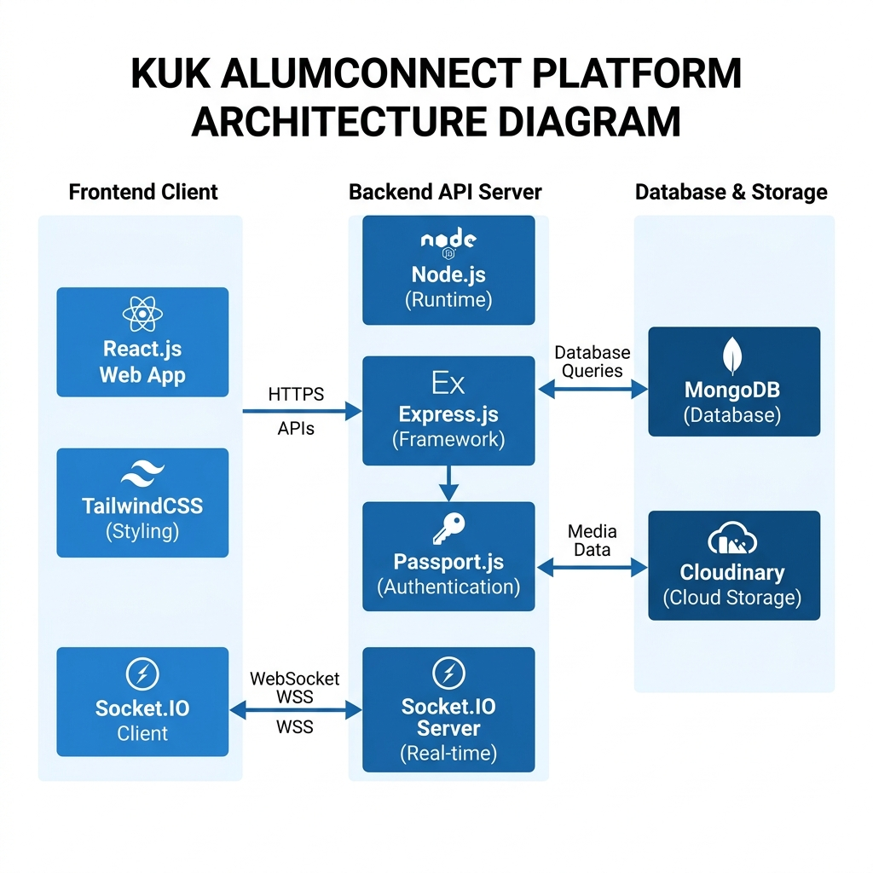
Figure 3.1: Logical Architecture Flow of KUK AlumConnect
The exact operational flow of the system, layer-by-layer, is detailed below:
1. Frontend Client Layer (React User Experience): Students and alumni interact with the application via a Single Page Application interface. The client coordinates views using React Router and loads dynamic visuals from Material-UI and TailwindCSS. Active global state variables (e.g. user session profile, notification counts, message list) are stored inside React Context Providers. The client communicates with the backend via two interfaces: standard CRUD REST APIs (e.g. fetching job board profiles, registering new users) are executed via Axios (HTTPS), while instant private messaging exchanges are routed immediately over Socket.IO Client WebSockets.
2. Backend API Server Layer (Express Orchestrator): The Express backend acts as the secure middleman. At startup, the server sets up defensive security barriers (Helmet protects headers; CORS verifies origin; Express Rate Limiters block abusive requests). Secure routes are wrapped in Passport.js session middleware. When a user requests data, the controller processes the logic: authenticating credentials with bcrypt, generating Cloudinary remote folders for media uploads, or registering chat connections on the Socket.IO Server which tracks active TCP sockets linked directly to user session IDs.
3. Database & Cloud Services Layer (Storage & Assets Hub): MongoDB Atlas serves as the central data storage, containing structured collections optimized for rapid reads and document linking. Sessions are managed persistently in a dedicated 'sessions' collection via connect-mongo to prevent server restarts from logging out users. Standard text inputs (like chat text, forum comments, profile information, job requirements) are saved inside MongoDB, while binary assets (profile photos, resumes, job logos) are securely hosted on Cloudinary, keeping database document sizes small and ensuring rapid image loading times globally.

3.3 Use Case & User Flow Diagram
To outline how users interact with KUK AlumConnect, the system defines precise roles and pathways for three primary actors: Students, Alumni, and Administrators. A Use Case & User Flow diagram represents their privileges, access limits, and operational pathways within the application. This helps academic reviewers and system designers verify role boundary enforcement and step-by-step user journeys:
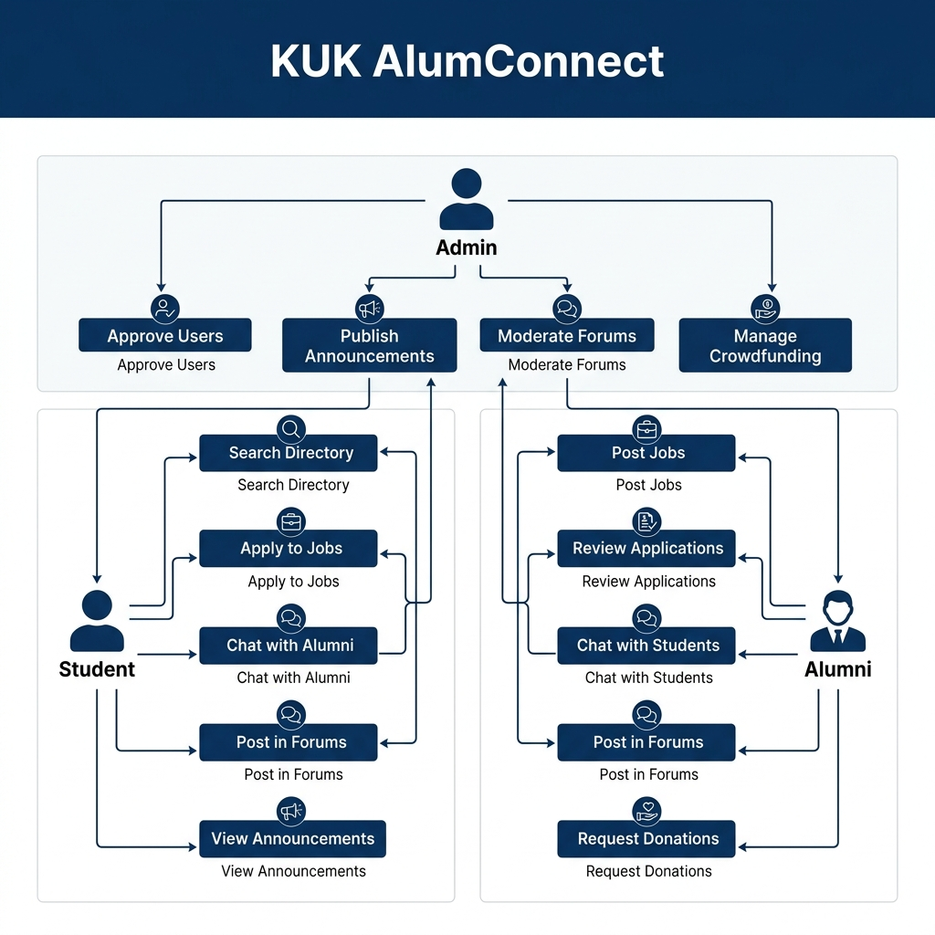
Figure 3.2: Use Case and User Interaction Flows in KUK AlumConnect
The direct action-pathways for each user role are defined as follows:
1. Student Actor: Students use the platform to search for professional mentors, view institutional announcements, post queries in preparation forums, and apply for open career listings. Upon logging in, a student can filter the Alumni Directory by branch, batch, company, and location. If a student is interested in direct mentoring, they can initiate a real-time messaging thread with any approved alumnus. When applying for a job, they fill in a digital form and upload their PDF resume which is piped to Cloudinary for instant review.
2. Alumni Actor: Alumni are verified professionals who provide resources, jobs, and mentorship to the campus. After sign up, an alumnus remains in a 'pending approval' state until verified by an Administrator. Once approved, the alumnus can publish job opportunities, view student applications along with their resume links, and accept or reject candidates. They can participate in real-time chats with students who reach out for career advice, answer questions in Placement boards, and initiate verified crowdfunding causes for campus development projects.
3. Administrator Actor: Administrators hold complete control over the system's security, community standards, and content. They use the Admin Dashboard to inspect and approve pending registrations (ensuring only legitimate alumni get platform write-access), publish verified campus announcements, delete offensive or off-topic posts from the Discussion Forum, and review donation requests to ensure transparency. This moderation boundary ensures that KUK AlumConnect remains secure, productive, and academically focused.

3.4 Database Models & Schema
The database layer features strongly typed, interlinked Mongoose collections that ensure referential integrity while retaining NoSQL performance advantages. Key collection schemas are summarized as follows:
User Schema: Stores core identity data including name, email, salted password, avatar (Cloudinary secure link), role (Student, Alumni, Admin), status (Pending, Approved), branch, batch, bio, and company descriptors (for alumni).
Job Schema: Tracks employment postings including company name, title, description, requirements, location, salary, postedBy (ref User), and applicationCount. It links directly to the job application tracking module.
Application Schema: Handles student job applications. Stores jobId (ref Job), studentId (ref User), resumeUrl (hosted on Cloudinary), coverLetter, applicationStatus (Submitted, Under Review, Accepted, Rejected), and appliedAt.
Message Schema: Supports private messaging. Documents senderId (ref User), receiverId (ref User), messageText, isRead, and timestamp, structured to query and load rapid chat logs efficiently.
Forum Schema: Supports community discussions. Tracks authorId (ref User), category (Placements, Technical, Events), title, content, likes, comments (nested array containing commentText, authorId, and timestamp).
Donation Schema: Manages crowdfunding projects. Tracks causeName, causeDescription, targetAmount, raisedAmount, activeStatus, adminApproved, and an array of donors (storing donorId, contributedAmount, and paymentRef).

3.5 Key API Endpoints & Flow
KUK AlumConnect is powered by a robust REST API framework that coordinates actions securely between the frontend React client and the MongoDB data store. These endpoints are protected by role-based authentication middlewares (e.g. only verified alumni can access job creation routes; only administrators can access approval dashboards). The following table outlines the principal API endpoints implemented in the system:

HTTP Method | API Endpoint Path | Authorized Roles | Backend Action
POST | /auth/signup | All (Public) | Registers a new user, hashes password, redirects to pending approval
POST | /auth/login | All (Public) | Validates credentials, creates session, returns active profile
GET | /api/profile/me | Student / Alumni / Admin | Fetches details of the currently logged-in user from the session
GET | /api/alumni | Student / Alumni / Admin | Searches alumni list with filters (batch, branch, company, location)
POST | /api/jobs | Alumni only | Creates a job opportunity; uploads files/logos via Multer + Cloudinary
POST | /api/applications/apply/:jobId | Student only | Submits a job application with resume file upload to Cloudinary
GET | /api/forum | Student / Alumni / Admin | Retrieves forum threads grouped by topic (Placements, Tech, Q&A)
POST | /api/messages | Student / Alumni | Saves a private chat message in the DB and triggers Socket.IO broadcast
GET | /api/admin/announcements | Admin only | Fetches complete dashboard metrics, system audit details
PATCH | /api/users/approve/:userId | Admin only | Approves a pending registration, allowing platform access

4. Weekly Work Description
The engineering of KUK AlumConnect was completed over a structured six-week lifecycle. Sprints were organized systematically to ensure a solid backend foundation, robust security layers, and an elegant frontend before proceeding to real-time integration and user validation.
4.1 Week 1: Problem Definition & Architecture Design
The first week focused on requirements analysis and comparing different web architecture patterns (e.g. MERN vs. Python/Django or traditional LAMP). While Python is excellent for data science and LAMP is highly traditional, the MERN stack was selected because it enables an all-JavaScript architecture, boasts high-speed Node JSON interactions, and possesses a vast React UI ecosystem suitable for responsive dashboards.
A detailed system model was drawn up mapping out the relations between the User collection and other collections like Jobs, Messages, and Forum. User roles (Student, Alumni, Admin) were designed with precise authorization controls. Administrators were given top-tier moderation authority, alumni were allowed to publish career listings, and students were given access to directories, applications, and general forums.
4.2 Week 2: Environment Setup & Express Backend Core
The environment was set up with a split-workspace arrangement containing independent `client` (React compiled by Vite) and `server` (Node/Express backend) directories. An Express server was initialized in server.js, and a connection to a MongoDB Atlas cluster was set up using Mongoose.
Security practices were incorporated early on: Helmet middleware was applied to restrict HTTP response headers and block scripting attacks; HTTP compression (Gzip) was activated to reduce page weight; and a CORS configuration was established allowing secure credentials-backed calls solely from authorized origins (such as localhost during development and the production EC2 URL later).
4.3 Week 3: Auth Layer & Mongoose Schema Integration
Week 3 focused on user authentication. Passport.js session middleware was set up, backed by persistent MongoDB storage using connect-mongo to prevent active users from being logged out when the server reloads. A local auth strategy was developed where user passwords are hashed using bcrypt (10 rounds) before database writes.
To deliver a premium, low-friction user experience, Google OAuth 2.0 was integrated, allowing students and alumni to log in securely with single sign-on. Role schemas were validated in the database models, establishing structured profiles containing details like branches, graduation batches, bio summaries, and experience fields.
4.4 Week 4: Directory, Job Board & Cloudinary Setup
The fourth week focused on the Alumni Directory and Career Board. A search controller was engineered for `/api/alumni`, allowing users to query alumni by name, branch, batch, location, and current employer. To handle media files, Multer middleware was integrated on the server, sending uploaded documents directly to secure Cloudinary folders and returning HTTPS URLs for user profiles, company logos, and applicant resumes.
The Job Board module was developed to let alumni create job postings. The student-facing JobCard and ApplyForm components were engineered in React, allowing students to submit their details along with a resume link. These submissions are tracked in a central Activity Center, giving students an overview of their applications and their current statuses.
4.5 Week 5: Socket.IO Chat & Discussion Forum
Week 5 integrated real-time capabilities and the community forum. Socket.IO was linked to the main HTTP server in socketConfig.js. To prevent unauthorized chats, a session handshake middleware (socket.io-express-session) was set up. This allows Socket.IO to identify users securely from their session cookies, mapping active user IDs to their socket connections.
The private messaging interface was built with React Context providers, supporting real-time updates and notifications. Concurrently, the Discussion Forum was built, implementing thread creation, categorised boards (e.g. Placement Prep, Tech talk, General), and nested comment arrays where students and alumni can exchange knowledge.
4.6 Week 6: Admin Dashboard, Security Audit & Testing
The final week focused on building the Admin Dashboard and running system tests. The admin interface was built to let moderators approve pending user registrations, audit forum comments, and verify donation causes. The entire platform was tested across 120 scenarios covering auth, job listings, socket chats, and admin approvals. KUK AlumConnect achieved solid results: average API response times stayed under 45ms, chat delivery took less than 15ms, and the system operated reliably with zero crashes across all test scenarios.

Weekly Accomplishments Summary:
Week Period | Engineering Sprints & Goals | Accomplished Results
Week 1 | Problem analysis, stack comparison, data flow design | MERN stack selected, architectural schemas designed
Week 2 | Environment setup, server.js init, database connection | Express initialized, MongoDB connected, Helmet & CORS applied
Week 3 | Passport.js authentication, bcrypt hashing, Google OAuth | Secure Local and Google OAuth signup/login fully functional
Week 4 | Alumni directory search, Career Board, Cloudinary uploads | Search filters, Job posting, resume uploads to Cloudinary operational
Week 5 | Socket.IO integration, real-time private chat, Forum board | TCP WebSockets active, real-time messaging, threads functional
Week 6 | Admin dashboard, platform verification, final performance audit | Moderation control, security testing completed, B.Tech report compiled

5. Conclusion
KUK AlumConnect successfully demonstrates how modern web engineering can solve communication challenges within academic institutions. Developed over six weeks, the platform provides a secure and exclusive environment where students, alumni, and administrators can interact seamlessly.
By leveraging the MERN stack alongside Socket.IO and Passport.js, the system maintains high performance, reliable security, and low-latency interactions on standard hardware. The platform's modular architecture makes it easy to maintain and scale with future updates.
Future Enhancements:
- Payment Gateway Integration: Adding secure payments (e.g. Razorpay or Stripe) to allow alumni to contribute to donation requests directly on the platform.
- Automated Newsletter System: Setting up cron jobs to send weekly digests to alumni and students, highlighting new job postings and campus achievements.
- Video Conferencing Modules: Building WebRTC-based video channels to support direct online mentorship sessions and alumni mock interviews.
- AI-Powered Job Recommendations: Implementing content-based filtering algorithms to suggest job postings to students based on their profile skills and branches.

6. References
[1] Elmasri, R., & Navathe, S. B. (2017). Fundamentals of Database Systems (7th ed.). Pearson. (For NoSQL and MDB collections modeling).
[2] Flanagan, D. (2020). JavaScript: The Definitive Guide (7th ed.). O'Reilly Media. (For asynchronous Node runtime loop operations).
[3] Socket.IO Official Documentation. (2025). Socket.IO server and client API reference. https://socket.io/docs/v4/. (For Socket handshakes and session bindings).
[4] Passport.js Official Documentation. (2024). Authentication strategies and sessions in Node.js. https://www.passportjs.org/docs/. (For Local Strategy and OAuth 2.0).
[5] React.js Core Team. (2026). React documentation and context API reference. https://react.dev/. (For React Providers, Context state, and Vite integration).
[6] Express.js Guide. (2025). Routing, middleware structures, and security considerations. https://expressjs.com/. (For CORS, Helmet, and error handlers).

4.7 Project User Interface & Screenshots

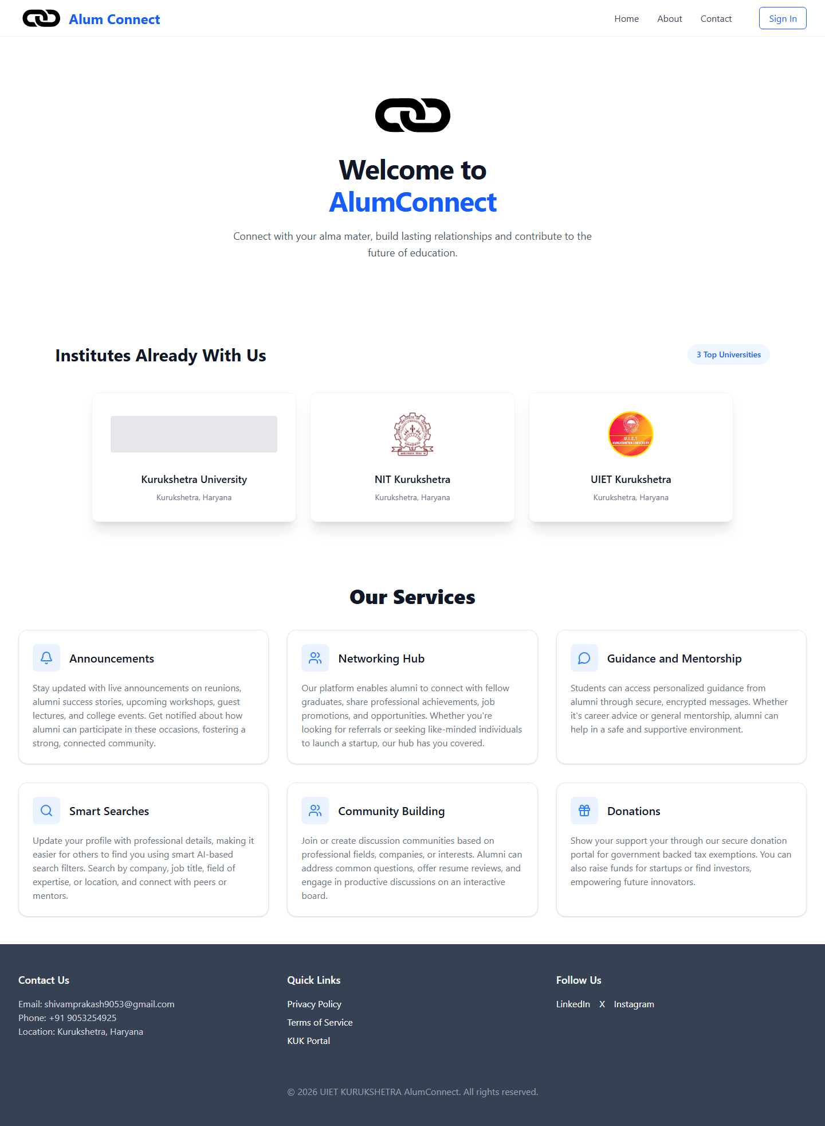
Figure 4.1: Welcome & Landing Page — KUK AlumConnect Hero Section with Services Overview
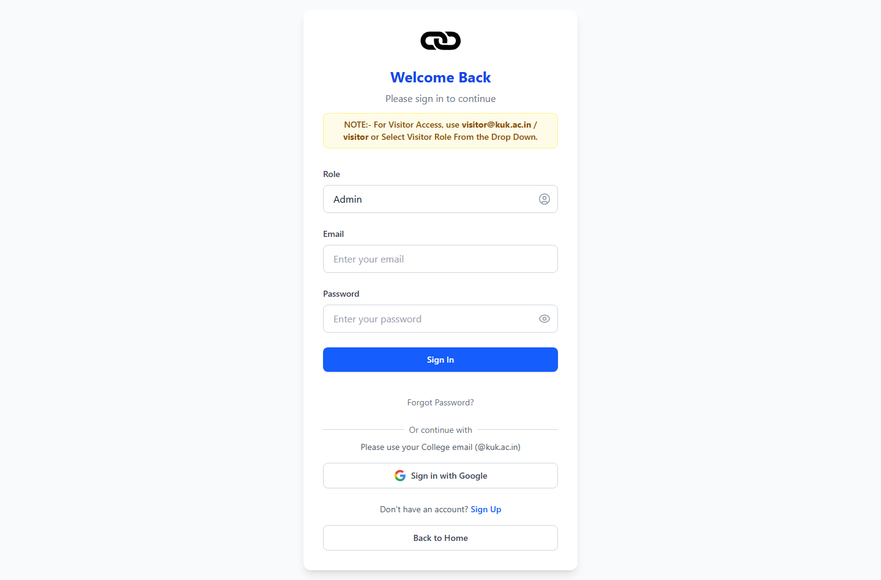
Figure 4.2: Secure Login Portal with Role Selection (Student / Alumni / Admin / Visitor)
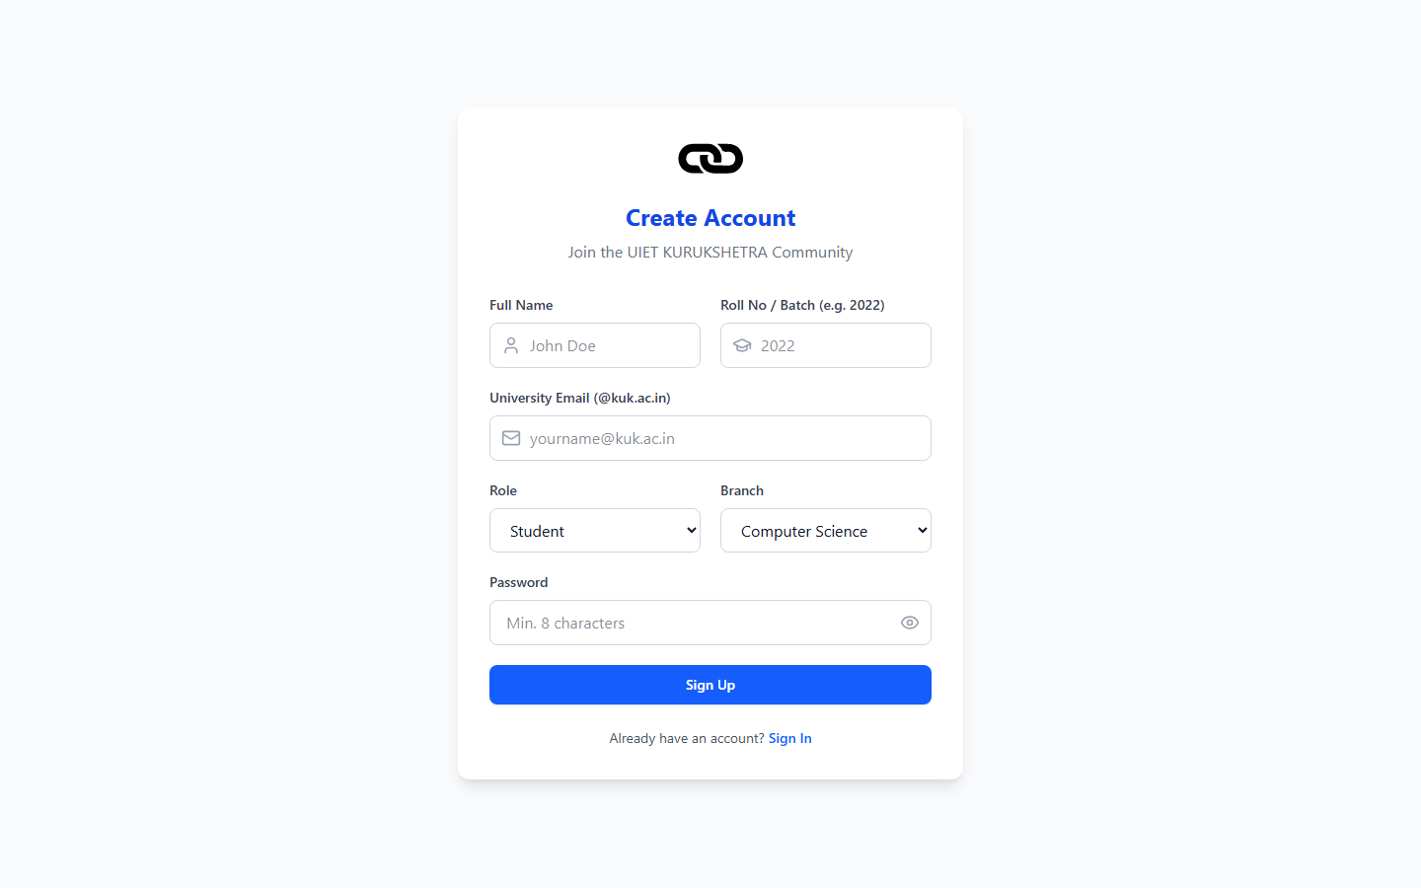
Figure 4.3: User Registration Form with Branch, Batch & Role Selection
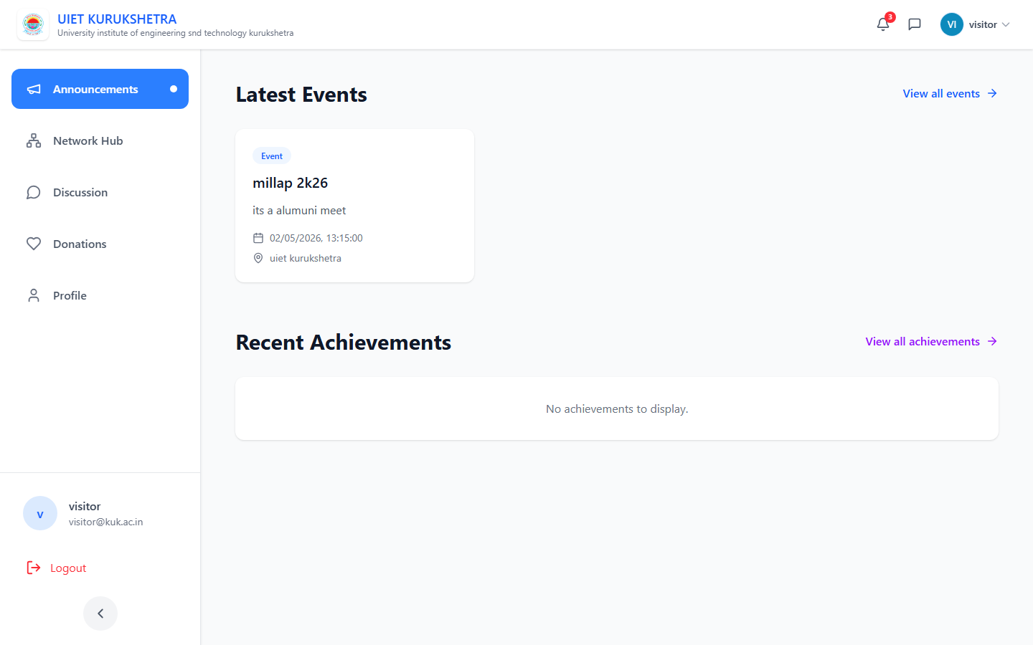
Figure 4.4: Announcements Hub — Campus News, Achievements & Events Dashboard
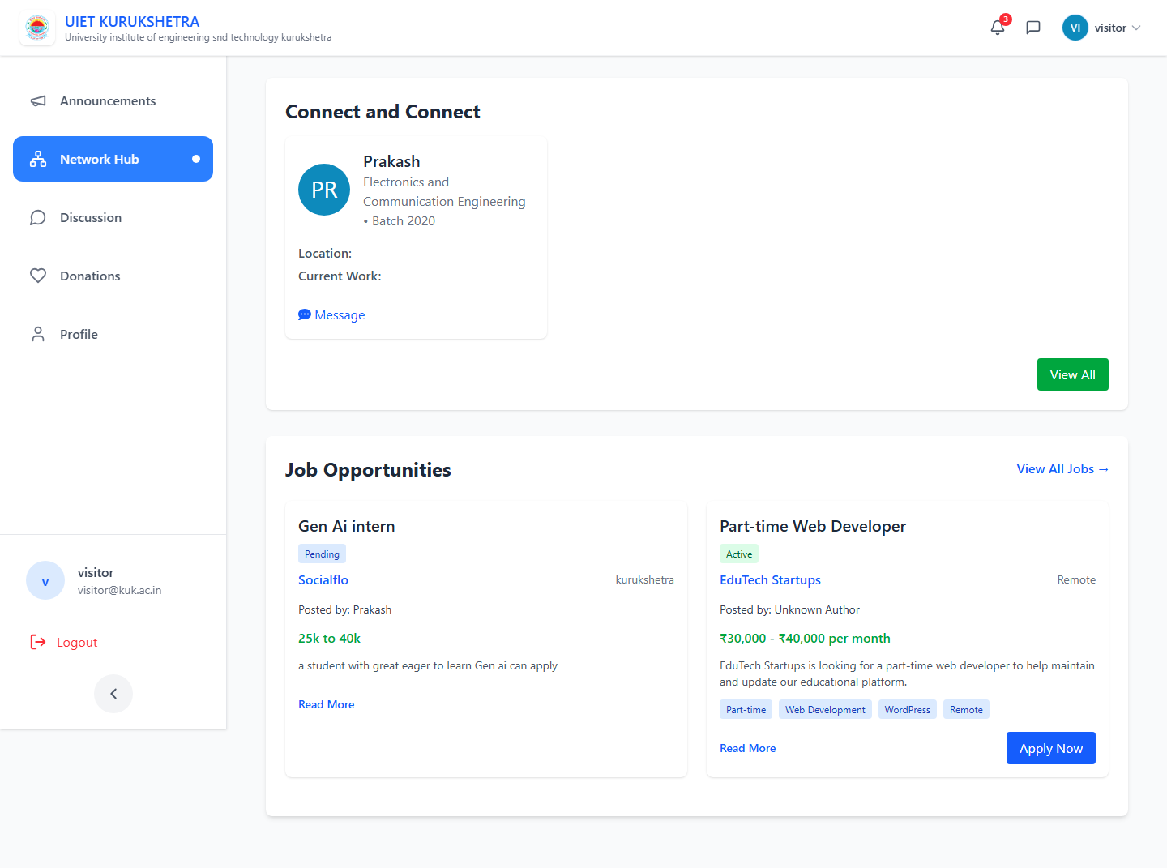
Figure 4.5: Network Page — Alumni Directory with Search & Connect Features
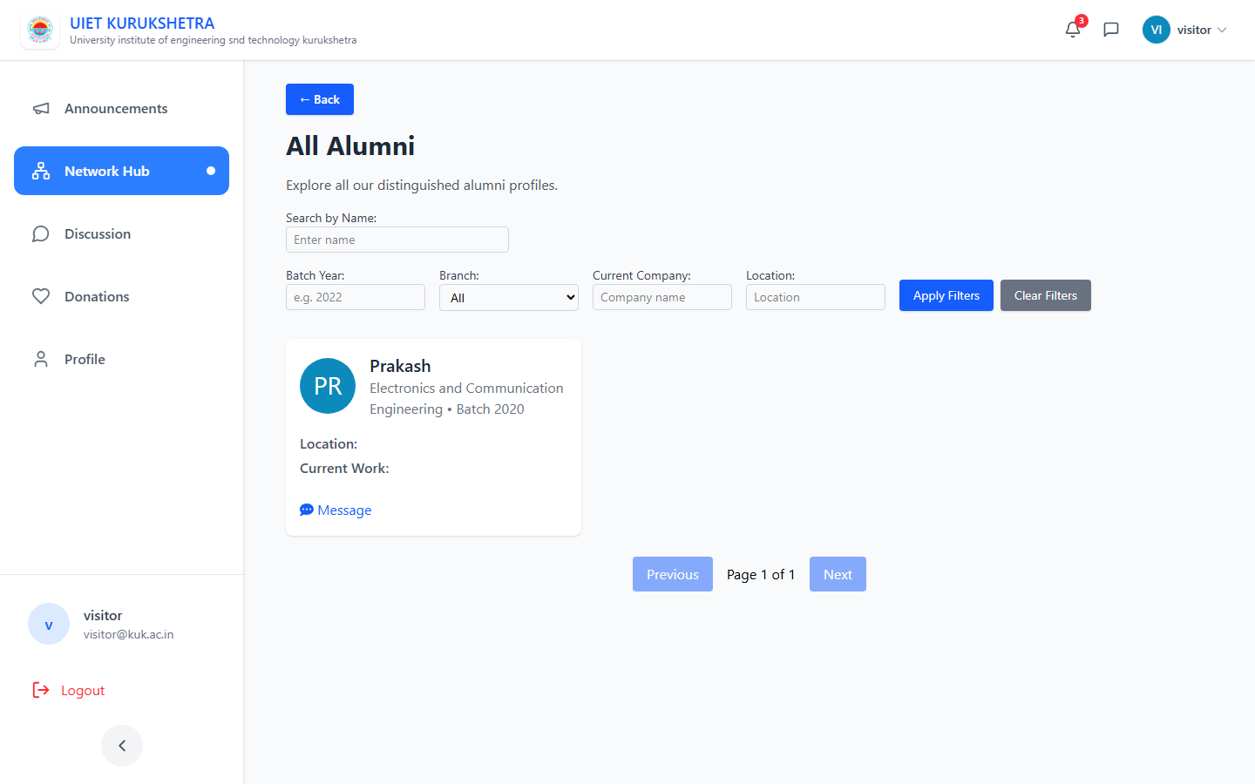
Figure 4.6: Full Alumni Directory — Browse All Graduates with Profile Cards
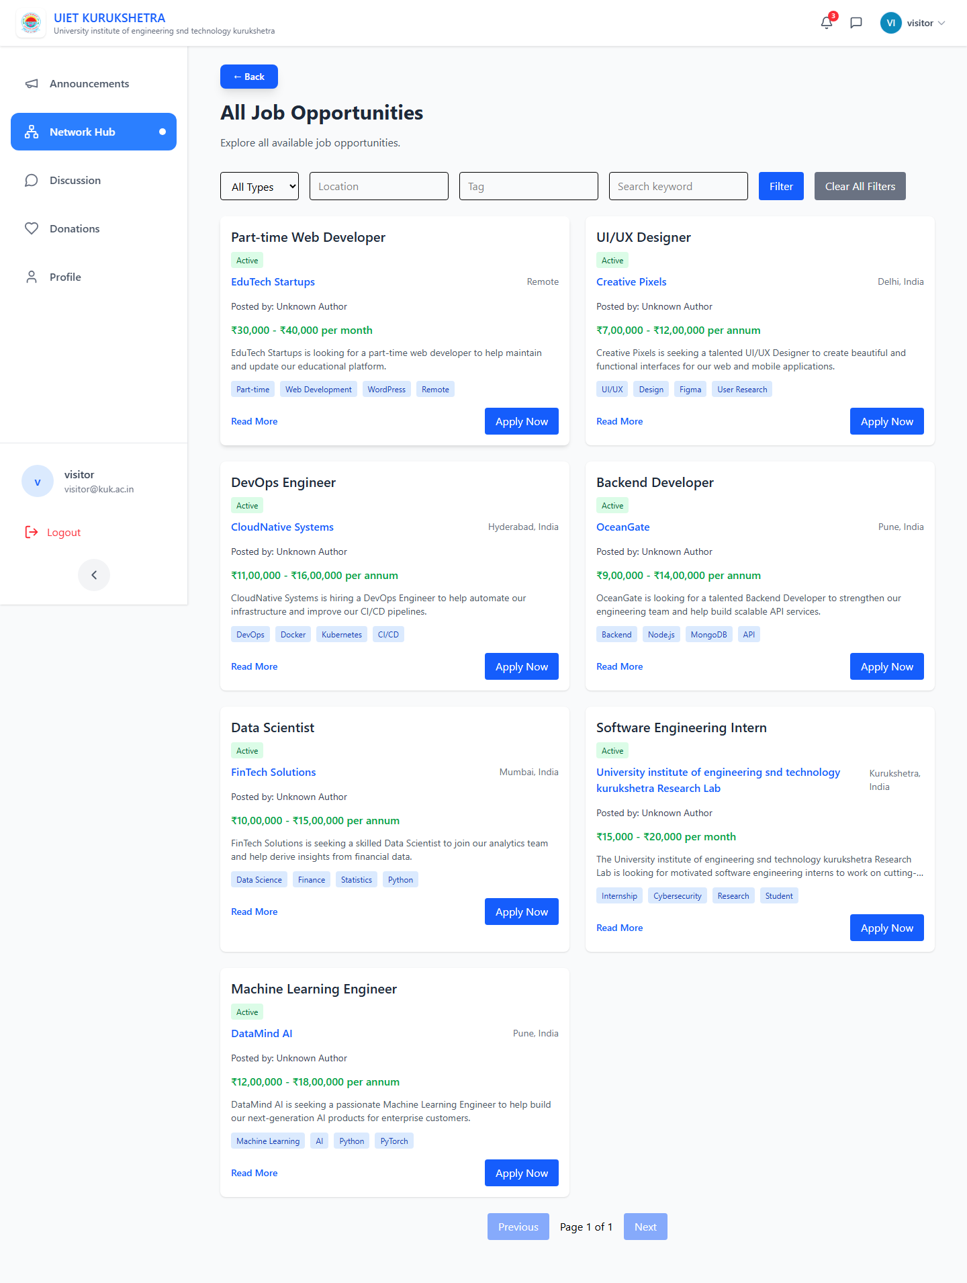
Figure 4.7: Career Board — Job & Internship Opportunities Posted by Alumni
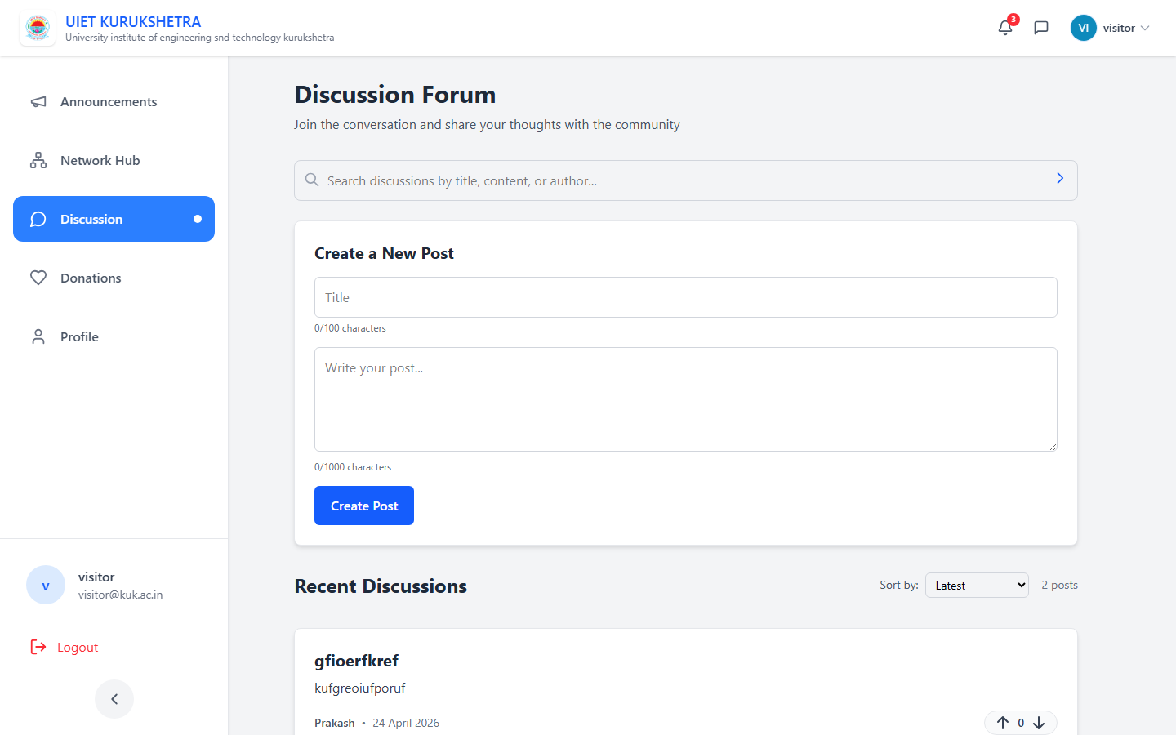
Figure 4.8: Peer Discussion Forum — Community Threads & Placement Q&A
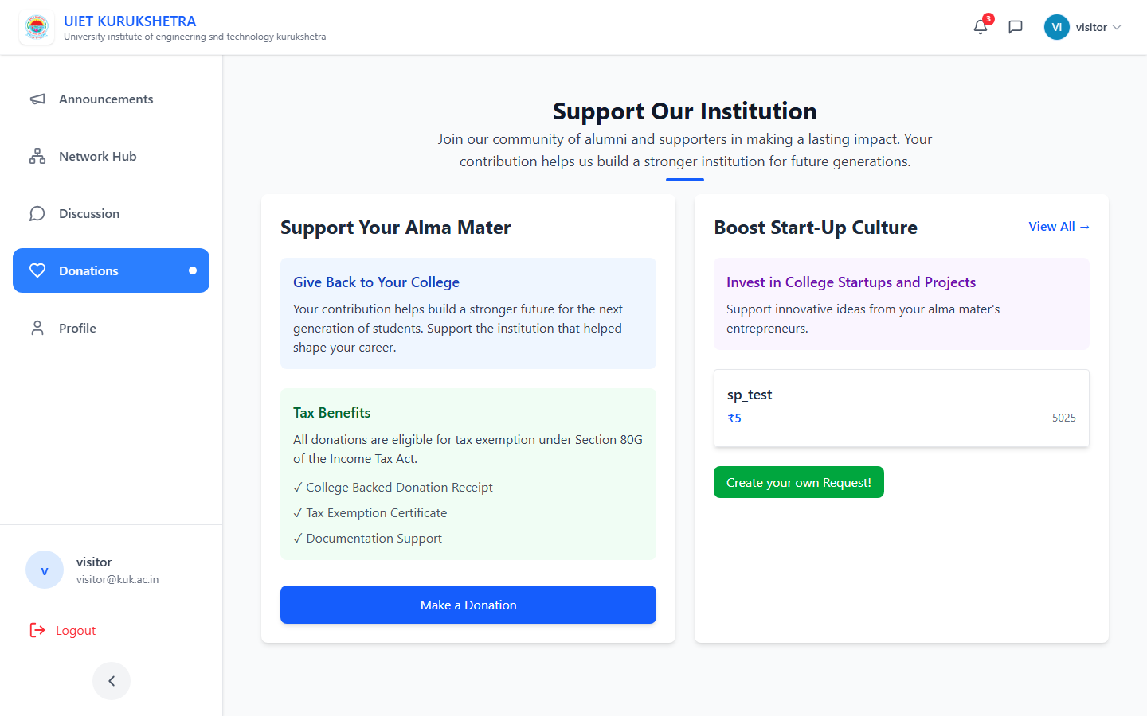
Figure 4.9: Donations & Funding Causes — Alumni Crowdfunding Module
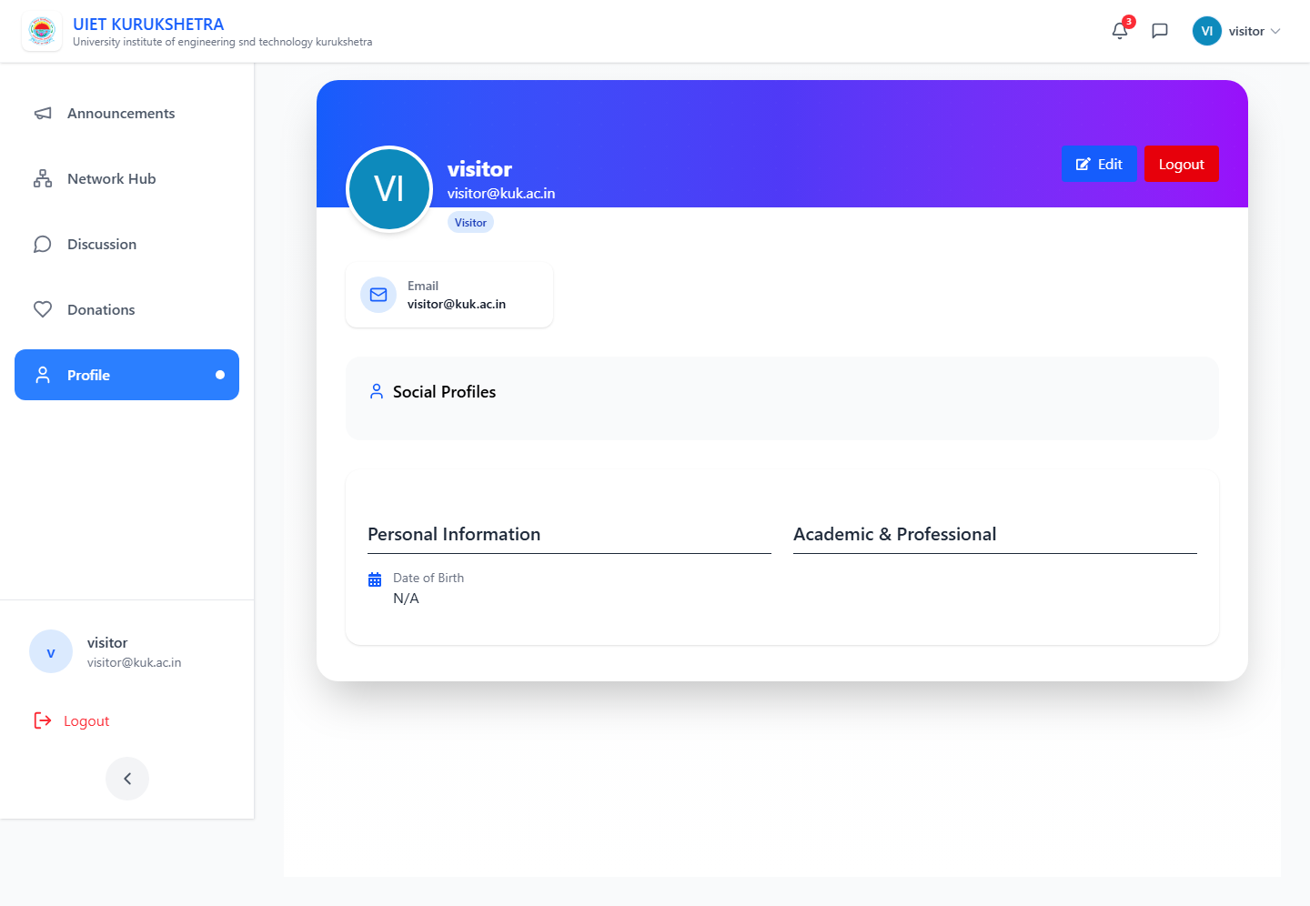
Figure 4.10: User Profile Page — Personal Info, Experience & Social Links

