trees

3 parts

left pointer data right pointer

pointer points to the next node

pointer store the address of different variable

for binary tree

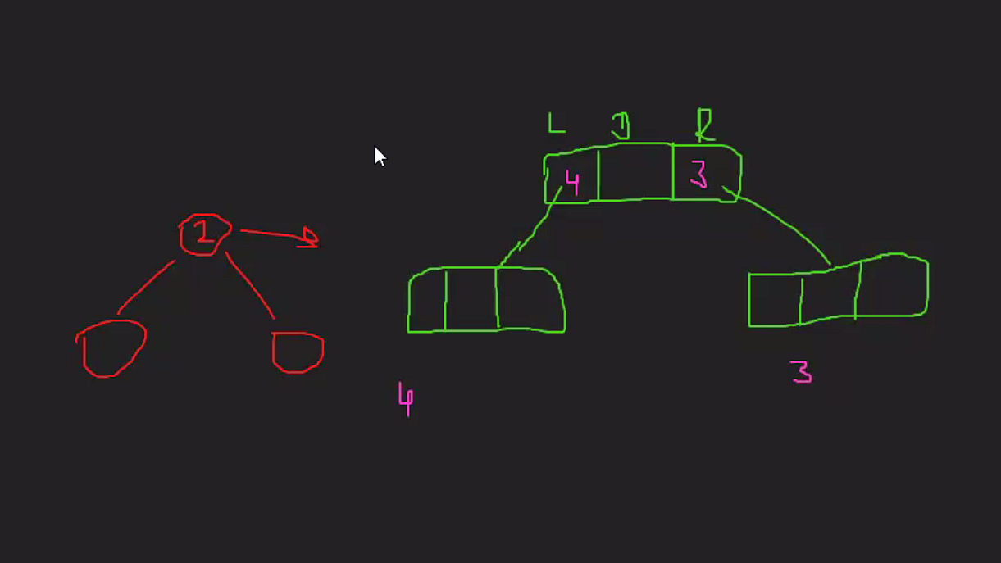

If no chil – store null at left and right child

Left child of binary tress is less than parent node

Right child is always greater than the parent child

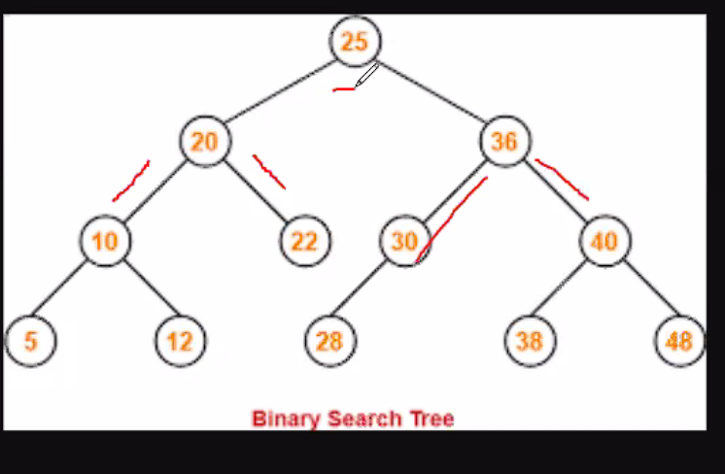

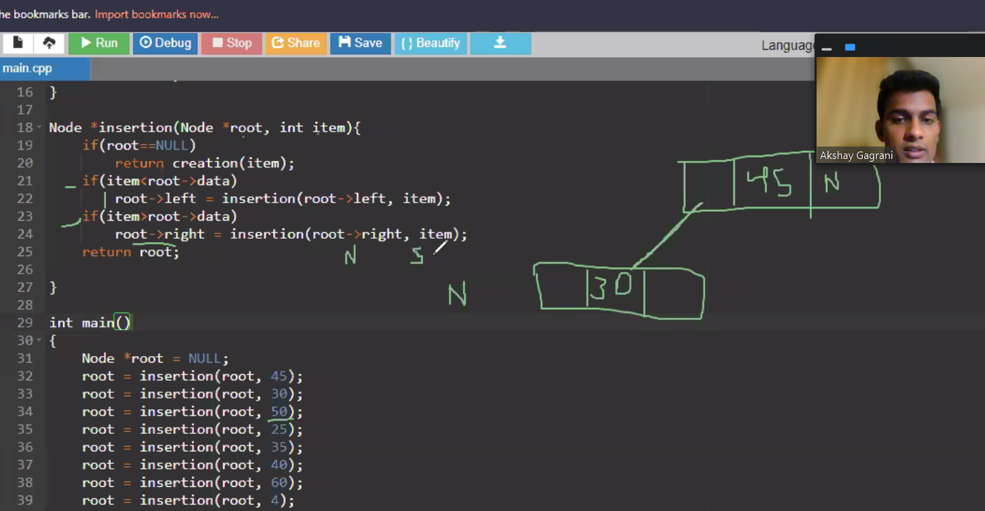

Tree traversal

Inorder is always in ascending order