AI Content Generation & Translation Tool
Architecture sketch
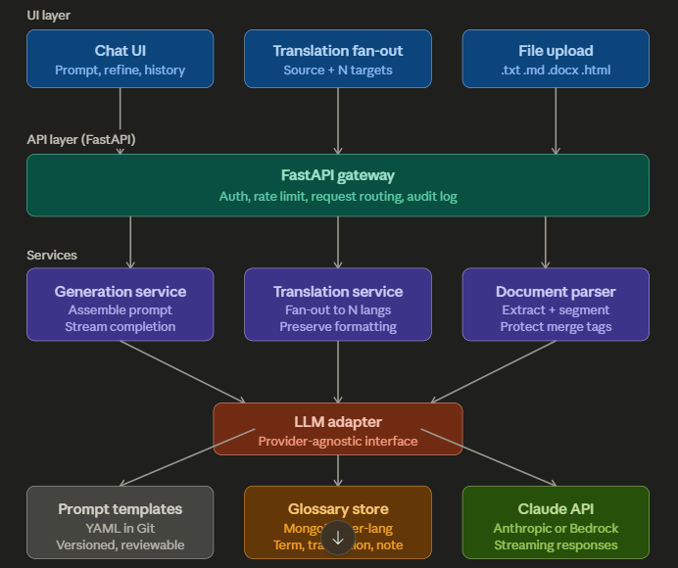
The layers, end to end
1. UI (thin React or Next.js app)
Two primary surfaces, one chat history store. The chat surface is a standard streaming chat UI with a language dropdown and a "content type" chip (article / CRM email / push / social). The translation surface is a two-pane layout: source on the left, tabbed targets on the right, each with its own regenerate and copy button. File upload is a button on the source pane that parses and pre-fills it.
2. API layer — FastAPI on EC2 (you already run this pattern)
Three endpoints is enough: POST /generate (streaming SSE), POST /translate (accepts N target languages, streams each), POST /parse-upload (returns extracted text + detected format). Auth via your existing SSO or a simple JWT if internal-only. Every request goes into an audit log (MongoDB or Postgres — who, when, prompt, output, provider, token count). This is non-negotiable for a regulated industry.
3. Services — where the value lives
Generation service: takes {prompt, language, content_type, glossary_scope}, assembles a composite prompt = system prompt from template store + injected glossary terms + user prompt, calls the LLM adapter, streams back. The assembly is the real product — the LLM call is a line of code.
Translation service: takes {source_text, target_languages, format_hints}, fans out one call per target language in parallel (asyncio.gather), each call uses the translation-specific system prompt with the target-language glossary injected. Returns a map of {lang: translation}.
Document parser: for v1, handle .txt, .md, .html, and .docx. Use python-docx for Word, BeautifulSoup for HTML. Critical trick: replace merge tags and placeholders with sentinel tokens before sending to the LLM, then swap them back after. So {{first_name}} becomes __VAR_001__ in the prompt, the LLM translates around it, and you restore it. Same for HTML tags if you're preserving structure.
4. LLM adapter — provider abstraction
One Python class with generate(messages, stream=True) and generate_structured(messages, schema). Implementations for Anthropic direct and Bedrock. This is 50 lines of code and saves you a month of refactoring in a year when procurement wants you to switch providers or add a fallback.
5. Prompt templates — YAML files in Git
Don't build an admin UI for prompts in v1. Prompts are code; code lives in Git with PR review. Structure like:
yaml
# prompts/generate_crm_email.yaml
version: 2
system: |
You are a CRM copywriter for {{brand}}, an iGaming operator...
Tone: {{tone}}. Always include responsible gambling disclaimer.
Target language: {{language}}.
Use these approved terms: {{glossary_block}}
variables: [brand, tone, language, glossary_block]
Load at startup, hot-reload on file change in dev. A/B testing and a proper prompt registry come in v2.
6. Glossary store — MongoDB collection
You're already on MongoDB. Schema:
{
_id, term_en, translations: {es: "...", it: "...", pt: "..."},
category: "promo|compliance|product", notes, do_not_translate: bool,
created_by, updated_at
}
At request time, the service loads relevant terms (by category or all) and injects them as a bulleted block into the prompt: "Always translate 'free spins' as 'giros gratis' in Spanish." Plus a flag list for do_not_translate terms (brand names, product names). A simple CRUD admin page comes later — for v1, seed it from a CSV.
7. Claude API — the commodity
Via Anthropic direct or AWS Bedrock (Bedrock keeps everything in your AWS footprint, which matters for compliance audits). Streaming on by default. Use Sonnet for generation and translation — Opus is overkill for most of this and meaningfully more expensive per token.
What to deliberately leave out of v1
Approval workflows, brand voice fine-tuning, translation memory with fuzzy matching, A/B prompt testing, analytics dashboards, direct push to Braze/Optimove, role-based permissions beyond basic auth. Each of these is a full feature — ship v1 without them, watch what people actually use, then prioritize.
Rough build effort
Assuming one engineer familiar with your stack: two weeks for API + services + LLM adapter + basic prompts, one week for the UI, one week for document parsing and the glossary seed + admin basics, one week for audit logging, auth integration, deployment on EC2/ECS and smoke-testing with the CRM team. Call it six weeks to a usable internal beta, with a 1–2 week buffer for prompt tuning once marketers start using it.

