CUSTOMER SUPPORT TICKET PRIORITY PREDICTION AND AUTOMATED ASSIGNMENT SYSTEM USING AGENTFORCE
Sree Sastha Institute of Engineering and Technology
Team ID : SWUID2026380241
Team Size : 5
Team Leader : Rajasekar S
Email id: narlarajasekar1@gmail.com
Team member : Ramya V
Email id: ramyavenkatraman208@gmail.com
Team member : Moovendhan
Email id: mmoovendhanvk@gmail.com
Team member : Mohammad Afrar I
Email id : mohammedafrar2005@gmail.com
Team member : Pavin Kumar M
Email id : pavinpavinkumar46@gmail.com

EXECUTIVE SUMMARY

We implemented a Salesforce-based Customer Support Ticket Priority Prediction and Automated Assignment System using Agentforce. The completed solution stores customer support information in a custom Support Ticket Intelligence object, retrieves the latest ticket for an Account, analyzes the ticket description, determines a High, Medium, or Low priority, and invokes backend automation for the required handling.

The automation is implemented through an Auto-Launched Flow. High-priority tickets generate an Urgent Ticket Handling task and are associated with a senior support level. Agentforce provides the conversational interface and passes the Account Name to the flow-based action. The completed workflow returns the ticket ID, calculated priority, assigned support level, and an action message.

The supplied project evidence includes the Salesforce data-flow/architecture diagrams, the implemented flow structure, and an Agentforce conversation preview demonstrating the completed interaction. The original sample describes the same core workflow and its configured fields, decisions, and outputs.

2. IDEATION PHASE

2.1 Problem Statement
User | Need | Observed Problem | Implemented Response
Support Agent | Identify critical tickets first | Manual prioritization can delay urgent cases | Automatic priority classification
Customer | Receive urgent issue handling quickly | Critical issues can wait behind lower-priority work | Priority-based handling
Support Manager | Assign the correct support level | Assignment can require manual decisions | Configured assignment logic
Support Agent | Recognize urgency in descriptions | Important urgency words can be missed | Description-based decision rules
Support Manager | Reduce SLA-related risk | Older unresolved tickets may need additional checking | Optional SLA-risk decision

2.2 Empathy Map

Think & Feel: Wants critical issues identified quickly so urgent customer problems receive attention.

Hear: Receives customer issue descriptions and support requests.

See: Ticket status, issue type, description, priority, assignment, and SLA-risk information.

Say & Do: Reviews tickets, handles assigned cases, and focuses on urgent support issues.

Pain: Manual prioritization, missed urgency signals, and delays in handling critical tickets.

Gain: Automatic priority classification, clearer assignment, urgent-task creation, and reduced manual effort.

2.3 Idea Selection

Manual ticket registers

Spreadsheet-based ticket tracking

Standalone support portal

Salesforce CRM with Agentforce

We selected Salesforce with Agentforce because the implemented design combines structured customer/ticket data, Salesforce Flow automation, and conversational AI in one workflow.

Page

3. REQUIREMENT ANALYSIS PHASE

3.1 Implemented Customer Journey

Ticket Creation → Account Identification → Latest Ticket Retrieval → Description Analysis → Priority Classification → Assignment → High-Priority Task Creation (when applicable) → Support Handling → Resolution

3.2 Functional Requirements
ID | Requirement | Implementation Status
FR-1 | Support ticket creation and management | Implemented
FR-2 | Account and Contact association | Implemented
FR-3 | Ticket description analysis | Implemented
FR-4 | Automatic priority classification | Implemented
FR-5 | High-priority Task creation | Implemented
FR-6 | Support-agent/support-level assignment | Implemented
FR-7 | SLA-breach-risk checking | Implemented as optional decision
FR-8 | Agentforce conversational analysis | Implemented

3.3 Non-Functional Requirements
Requirement | Implemented Interpretation
Usability | Clear Agentforce interaction and understandable priority messages
Reliability | Consistent classification according to configured conditions
Performance | Quick retrieval and analysis of the latest support ticket
Security | Controlled Salesforce access to customer and ticket information
Maintainability | Flow and Agentforce configuration can be updated
Scalability | Salesforce automation can support increasing ticket volumes

3.4 Data Flow

The implemented data flow is: Customer/Support Request → Account → Latest Support Ticket → Ticket Description → Description Analysis → Priority Level → High/Medium/Low Decision → Agent Assignment → High-Priority Task (if applicable) → Final Response.

Customer Support Ticket Priority Prediction

Project Title
Customer Support Ticket Priority Prediction and Automated Assignment System Using Agentforce

Problem Statement
Customer support teams receive a large number of tickets daily, but prioritization and assignment are often manual. This leads to delays in resolving critical issues and poor customer satisfaction.
There is a need for a system that:
- Automatically classifies ticket priority
- Assigns tickets to the right support agent
- Reduces response time
- Uses AI to understand urgency

User Stories
- As a Support Agent, I want tickets to be automatically prioritized so that I can focus on critical issues first.
- As a Customer, I want urgent issues to be resolved quickly so that my experience improves.
- As a Manager, I want tickets to be assigned automatically to the right team so that workload is balanced.
- As an AI Agent (Agentforce), I want to analyze ticket details and trigger automation so that manual work is reduced.

Expected Outcome
- Faster ticket resolution
- Improved customer satisfaction
- Reduced manual effort
- Intelligent ticket handling
- Better team productivity

Custom Object

Object Name
Support Ticket Intelligence

API Name
Support_Ticket_Intelligence__c

Fields
Field Label | API Name | Data Type | Description
Ticket Number | Ticket_Number__c | Auto Number | TKT-{0000}
Customer | Customer__c | Lookup (Account) | Related Account
Contact | Contact__c | Lookup (Contact) | Customer contact
Issue Type | Issue_Type__c | Picklist | Technical, Billing, General
Description | Description__c | Long Text Area | Issue details
Priority Level | Priority_Level__c | Picklist | Low, Medium, High
Status | Status__c | Picklist | New, In Progress, Resolved
Created Date | Created_Date__c | Date | Ticket date
Assigned To | Assigned_To__c | Lookup (User) | Support agent
SLA Breach Risk | SLA_Breach_Risk__c | Checkbox | Risk flag
Resolution Time (hrs) | Resolution_Time__c | Number | Time taken

Auto-Launched Flow Logic (Modified for this Project)

1. Flow Type
Auto-Launched Flow (No Trigger or called from Agentforce)

2. Variables

Input Variable
Label | API Name | Type | Input
Account Name | varAccountName | Text | Yes

Output Variables
Label | API Name | Type | Output
Account Id | varAccountId | Text | Yes
Ticket Id | varTicketId | Text | Yes
Priority Level | varPriorityLevel | Text | Yes
Assigned Agent | varAssignedTo | Text | Yes
Action Message | varActionMessage | Text | Yes

3. Step-by-Step Flow Implementation

Step 1: Get Account
Element: Get Records
- Label: Get Account
- Object: Account
- Condition:
  - Name Equals {!varAccountName}
- Sort: CreatedDate DESC
- Store: Only first record

Step 2: Assignment (Store Account Id)
Element: Assignment
- Label: Store Account Id
Set:
- varAccountId = {!Get_Account.Id}

Step 3: Get Ticket Record
Element: Get Records
- Label: Get Ticket
- Object: Support_Ticket_Intelligence__c
- Condition:
  - Customer__c Equals {!varAccountId}
- Sort: CreatedDate DESC
- Store: Only first record

Step 4: Assignment (Store Ticket Id)
Element: Assignment
- Label: Store Ticket Id
Set:
- varTicketId = {!Get_Ticket.Id}

Step 5: Decision (Analyze Description)
Element: Decision
- Label: Analyze Description
Outcomes:
High Priority
- Description contains:
  - "urgent"
  - "not working"
  - "failure"
(Use multiple conditions with CONTAINS)
Medium Priority
- Description contains:
  - "issue"
  - "slow"
  - "delay"
Default Outcome
- Low Priority

Step 6: Assignment (Set Priority Level)
High Path
- varPriorityLevel = "High"
Medium Path
- varPriorityLevel = "Medium"
Low Path
- varPriorityLevel = "Low"

Step 7: Decision (High Priority Check)
Element: Decision
- Label: Is High Priority
Condition:
- varPriorityLevel Equals "High"

Step 8: Create Task (Only High Priority)
Element: Create Records
- Object: Task
Set Fields:
- Subject = "Urgent Ticket Handling"
- WhatId = {!varTicketId}
- Priority = High
- Status = Not Started

Step 9: Assignment (Assign Agent Name)
Element: Assignment
- Label: Set Assigned Agent
Set:
- varAssignedTo = "Senior Support Agent"

Step 10: Optional SLA Check
Decision: SLA Risk
Condition example:
- If Created Date older than 2 days
Then:
- (Optional internal flag or message)

Step 11: Final Output Message
Element: Assignment
- Label: Set Final Message
Set varActionMessage:
- High: "High priority ticket detected. Assigned to senior agent."
- Medium: "Ticket marked as medium priority. Will be handled shortly."
- Low: "Tickets are low priority and queued for processing."

Step 12: Save Flow
Label Name: Support_Ticket_Intelligence
Activate the flow.

4. Final Flow Structure
Start
→ Get Account
→ Assignment (Account Id)
→ Get Ticket
→ Assignment (Ticket Id)
→ Decision (Analyze Description)
→ Assignment (Priority Level)
→ Decision (High Priority)
→ Create Task
→ Assignment (Assigned Agent)
→ Optional SLA Decision
→ Assignment (Final Message)
→ End

Flow Output:
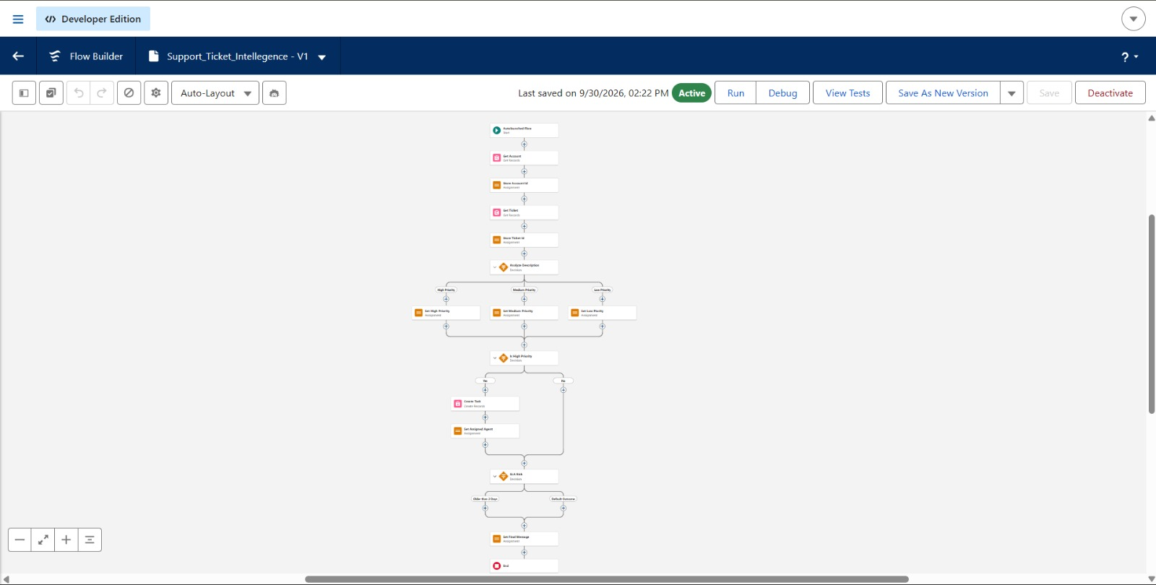
Figure 1: Flow canvas – Support Ticket Intelligence auto-launched flow
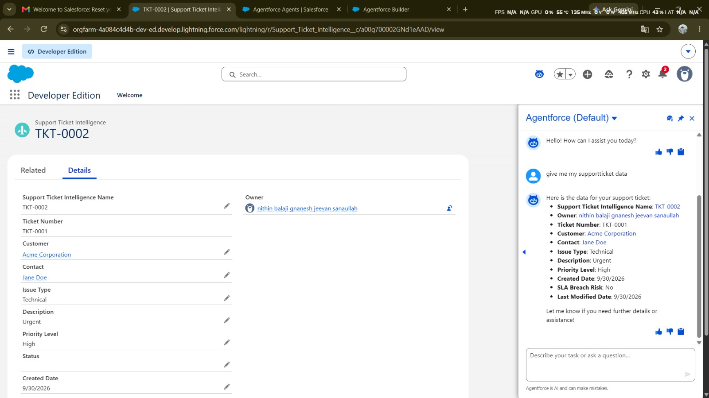
Figure 2: Ticket record TKT-0002 (High priority) with the Agentforce panel returning the same ticket data

5. Final Outcome
- Takes Account Name as input
- Fetches latest support ticket
- Analyzes description using keywords
- Sets priority automatically
- Creates task for urgent cases
- Returns output to Agentforce

Agentforce Configuration
Steps:
- Go to the Gear icon and click Salesforce Go.
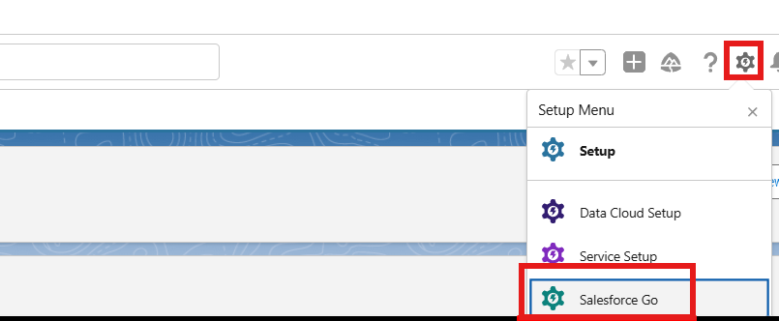
Figure 3: Setup menu – Salesforce Go
- Search Default, select Agentforce (Default) and enable it.
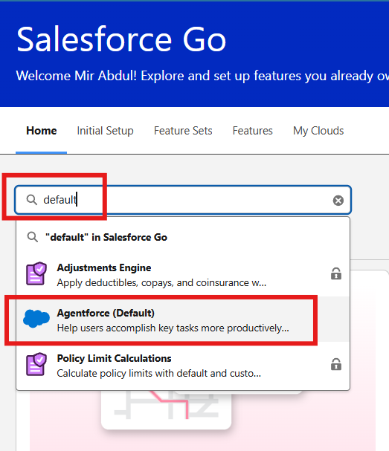
Figure 4: Salesforce Go – searching for Agentforce (Default)
- Select Get Started ⇒ Turn On ⇒ Confirm.
- Search Agents in the Quick Find box and enable the agent; you will see the Default Agent.
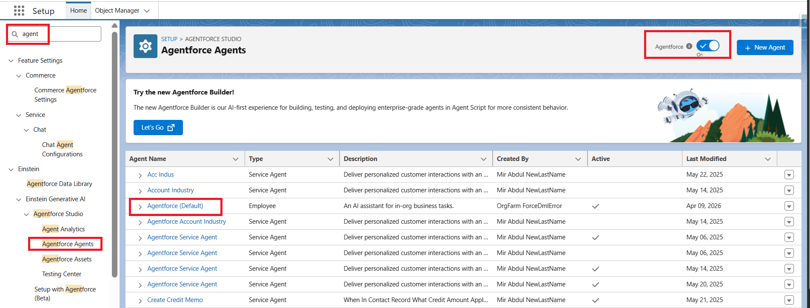
Figure 5: Agentforce Agents list with Agentforce turned on
- Select Default Agent and click Open in Builder.
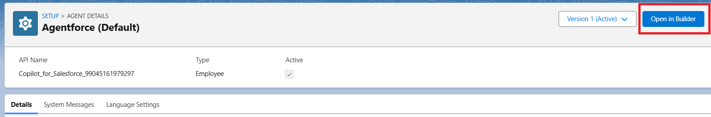
Figure 6: Agentforce (Default) – Open in Builder
- Click New to create a new subagent.
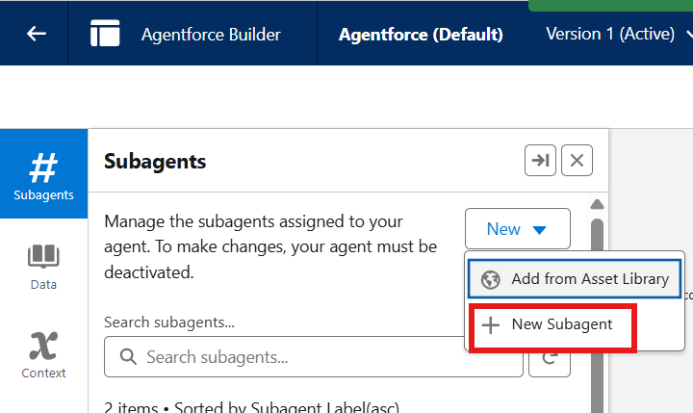
Figure 7: Agentforce Builder – New ▸ New Subagent
- Click Next.
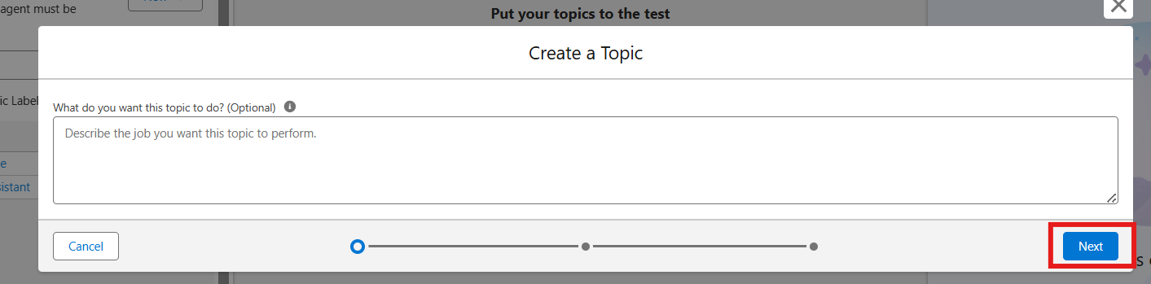
Figure 8: Create a Topic dialog

Agentforce Subagent Configuration

Name
Support Ticket Priority Analysis

API Name
Support_Ticket_Priority_Analysis

Classification Description
This topic analyzes customer support tickets to determine priority based on issue description and urgency. It handles user requests related to ticket status, issue severity, and support prioritization.

Scope
Your job is only to analyze support ticket descriptions, determine the priority level (High, Medium, Low), and trigger backend automation for task assignment. Do not handle unrelated requests such as billing, subscription management, or account updates.

Instructions
Follow these steps when this topic is triggered:
- Ask the user to provide the Account Name if not already given.
- Retrieve the latest support ticket associated with the Account.
- Read and analyze the ticket description.
- Determine priority based on keywords:
  - High Priority: contains "urgent", "not working", "failure"
  - Medium Priority: contains "issue", "slow", "delay"
  - Low Priority: if none of the above
- Set the priority level accordingly.
- If the ticket is High Priority:
  - Trigger the Auto-Launched Flow
  - Ensure a task is created for immediate handling
- Assign the ticket to the appropriate support level (e.g., senior agent for high priority).
- Return a clear response message to the user:
  - High → Inform urgent handling is initiated
  - Medium → Inform issue will be handled shortly
  - Low → Inform ticket is queued
- Do not update records directly or send emails. Use Flow for all actions.

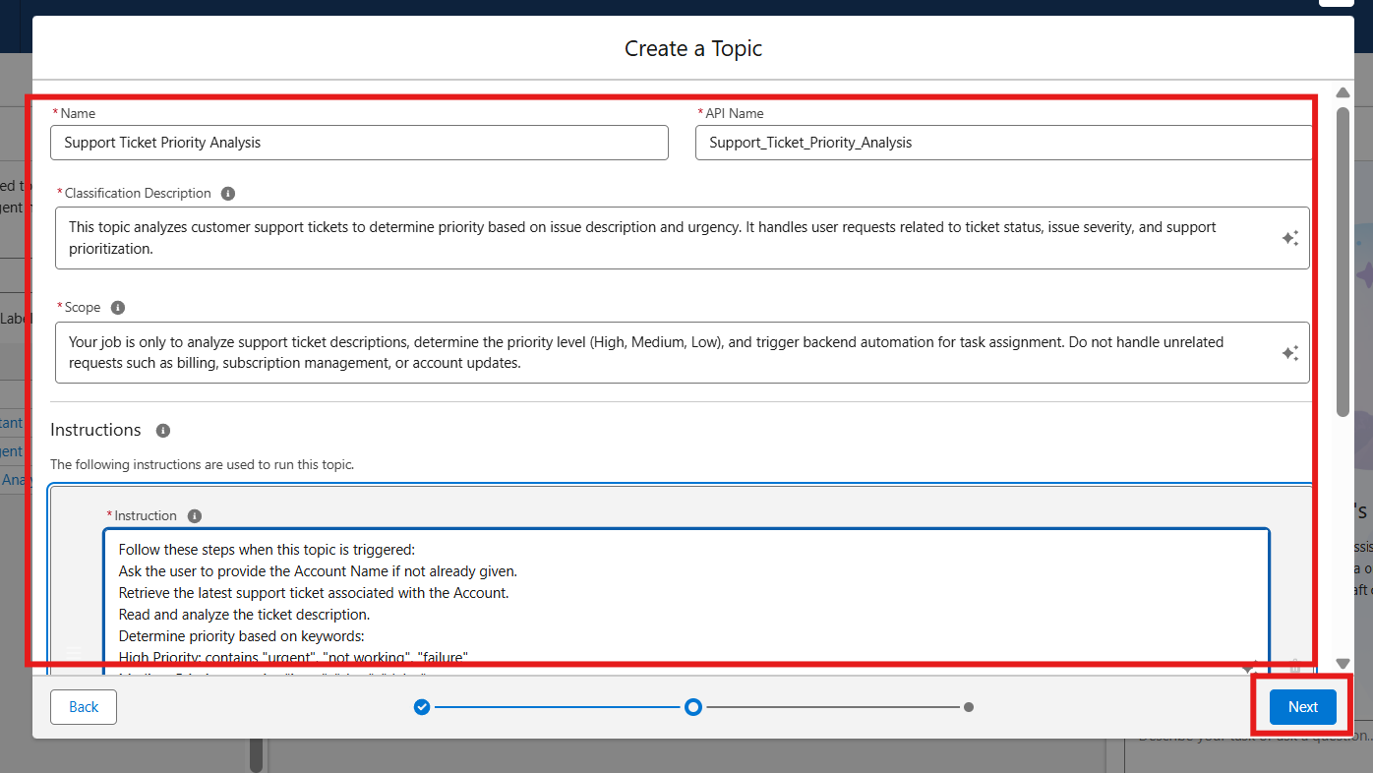
Figure 9: Create a Topic – name, description, scope and instructions
Select Topic
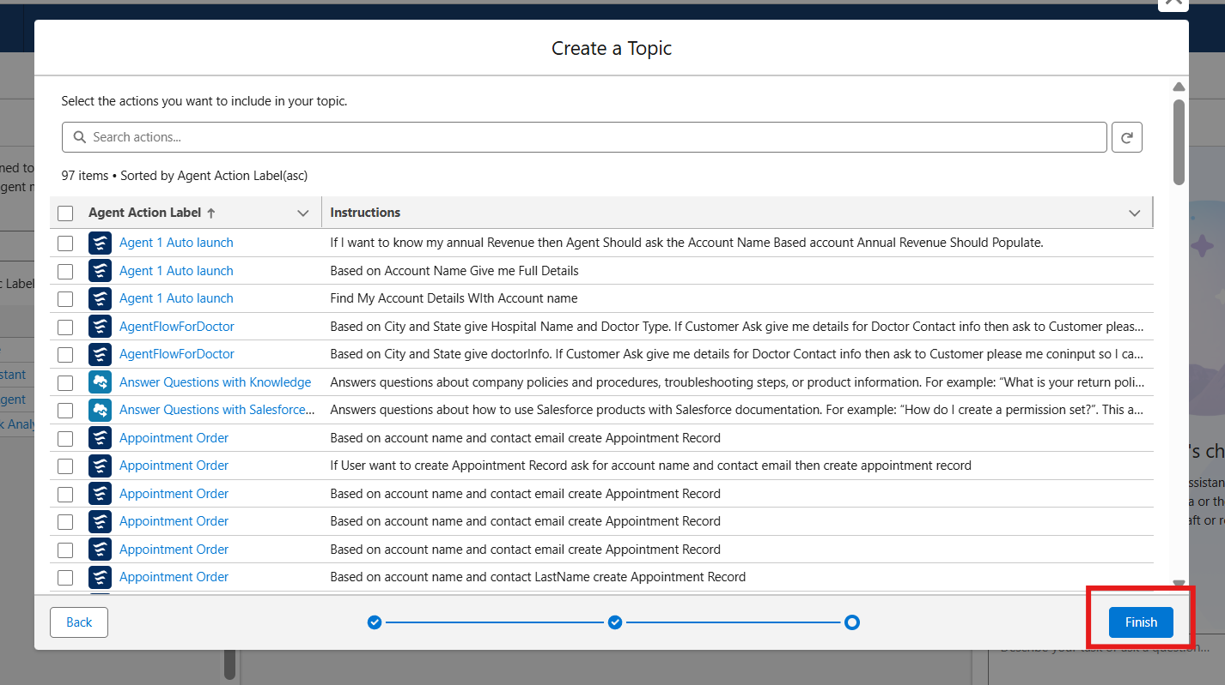
Figure 10: Create a Topic – select actions, then click Finish
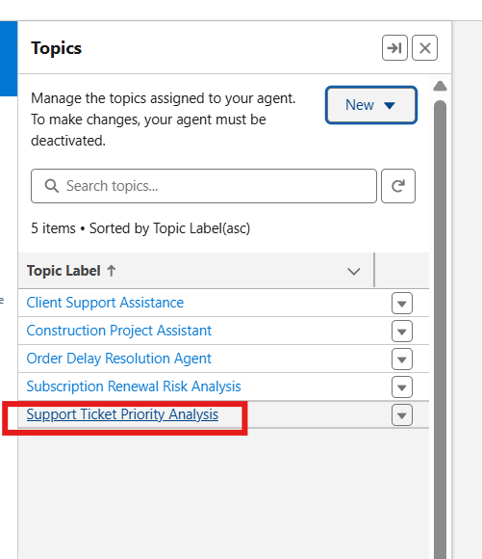
Figure 11: Topics list showing "Support Ticket Priority Analysis"

Add the Flow as an Agent Action
Open the topic, go to the This Topic's Actions tab and choose New ▸ Create New Action.
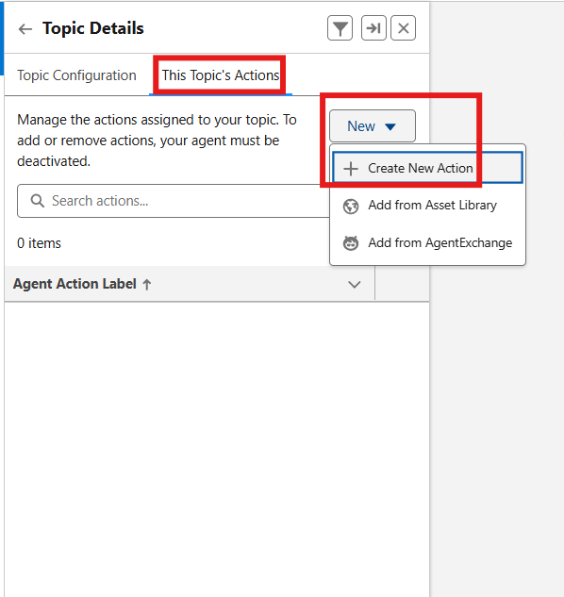
Figure 12: Topic Details – This Topic's Actions ▸ Create New Action
Set Reference Action Type to Flow and select the Support_Ticket_Intelligence flow, then click Next.
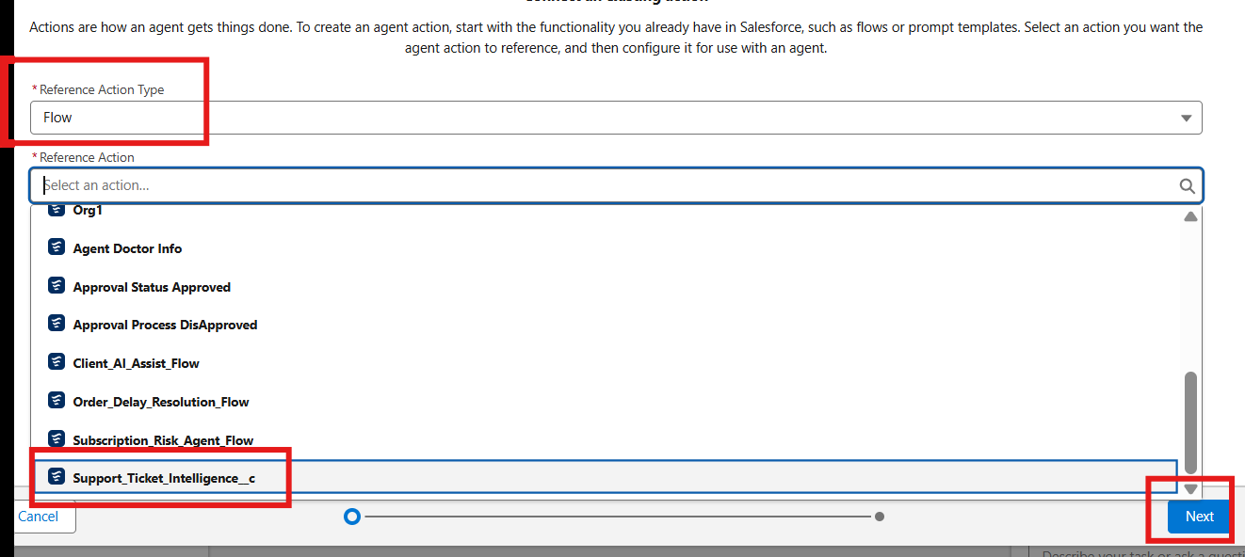
Figure 13: Reference Action Type = Flow; select the Support Ticket Intelligence flow
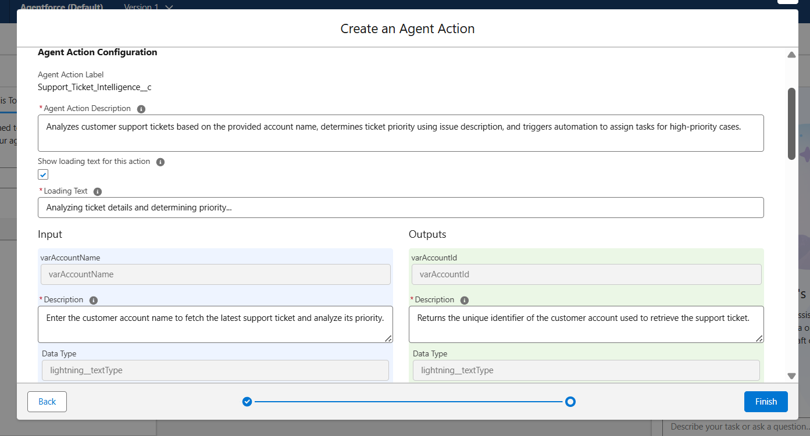
Figure 14: Create an Agent Action – configuration

Agent Action Description
Analyzes customer support tickets based on the provided account name, determines ticket priority using issue description, and triggers automation to assign tasks for high-priority cases.

Loading Text
Analyzing ticket details and determining priority...

Input

varAccountName
- Description: Enter the customer account name to fetch the latest support ticket and analyze its priority.
- Data Type: lightning__textType
- Require Input: Enabled
- Collect Data From User: Enabled

Outputs

varAccountId
- Description: Returns the unique identifier of the customer account used to retrieve the support ticket.
- Data Type: lightning__textType
- Show in Conversation: Enabled
- Output Rendering: Text

varActionMessage
- Description: Displays the final message indicating ticket priority and actions taken by the system.
- Data Type: lightning__textType
- Show in Conversation: Enabled
- Output Rendering: Text

varAssignedTo
- Description: Indicates the support agent or team assigned to handle the ticket.
- Data Type: lightning__textType
- Show in Conversation: Enabled
- Output Rendering: Text

varPriorityLevel
- Description: Represents the calculated ticket priority level (High, Medium, Low) based on issue description.
- Data Type: lightning__textType
- Show in Conversation: Enabled
- Output Rendering: Text

varTicketId
- Description: Returns the unique identifier of the support ticket analyzed by the system.
- Data Type: lightning__textType
- Show in Conversation: Enabled
- Output Rendering: Text

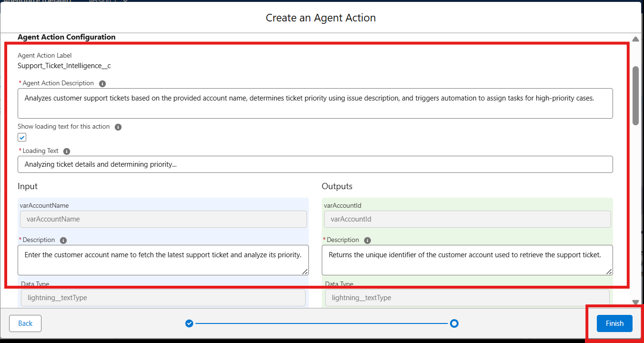
Figure 15: Agent action configuration – click Finish to save

Final Output
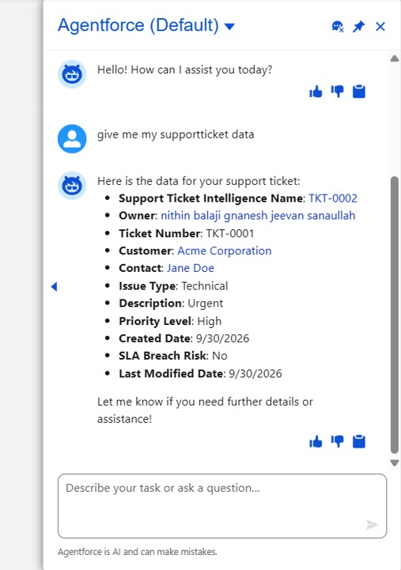
Figure 16: Agentforce (Default) – the agent returns the support ticket data
Note: If you would like to extend this scenario, you can add more variables to the flow and configure them in the agent. This will help you achieve better outputs. It’s a great way to learn.

8. ADVANTAGES & LIMITATIONS
8.1 Advantages
Automatic Ticket Prioritization – Classifies tickets as High, Medium or Low according to configured conditions.
Faster Identification of Critical Issues – High-priority cases are separated for urgent handling.
Reduced Manual Effort – Ticket analysis, priority setting, Task creation and assignment are automated.
Intelligent Ticket Handling – Agentforce provides conversational access to the backend workflow.
Automatic Urgent Task Creation – High-priority tickets create an Urgent Ticket Handling Task.
Improved Support Assignment – High-priority cases are assigned to the configured senior support level.
Conversational Support – Users can request ticket analysis through Agentforce.
SLA Risk Awareness – Older tickets can be checked using the optional SLA-risk decision.
Scalable Architecture – Additional rules, support teams, indicators and analytics can be added later.
8.2 Limitations
Keyword-Based Priority Logic – The current classification depends on configured words and conditions.
Limited Context Understanding – The configured conditions may not capture every possible urgency signal.
Dependence on Accurate Data – Correct Account, Contact and ticket information is required.
Flow Configuration Dependency – Changes to the handling logic require Flow maintenance.
Agentforce Configuration Dependency – Conversation behavior depends on correctly configured instructions and actions.
Limited Agentforce Scope – The documented subagent focuses on ticket analysis and related automation.
Limited SLA Monitoring – The current SLA check is an optional risk flag rather than a full escalation platform.
Assignment Logic Can Be Expanded – More teams and sophisticated routing rules would require additional configuration.
Advanced Analytics Are Not Yet Included – Trend and resolution-performance analytics remain future scope.
Page
9. CONCLUSION
We successfully designed and implemented a Salesforce-based Customer Support Ticket Priority Prediction and Automated Assignment System using Agentforce. The completed solution connects a custom Support Ticket Intelligence object, an Auto-Launched Flow and an Agentforce subagent to provide an end-to-end ticket-prioritization workflow.
The implementation retrieves the latest ticket for a customer Account, analyzes its description, classifies the ticket as High, Medium or Low, creates an urgent handling Task for High-priority cases, assigns the configured support level, and returns the result through Agentforce. This completed architecture addresses the project's stated goal of reducing repetitive manual handling and improving the consistency of ticket prioritization.
The supplied sample's conclusion describes the same implemented sequence—latest-ticket retrieval, description analysis, priority classification, urgent-task creation, support assignment and a conversational response. fileciteturn1file0L1-L1
10. FUTURE SCOPE
Add more priority indicators and business rules.
Use richer natural-language/context analysis instead of relying mainly on configured keywords.
Extend Agentforce outputs with additional ticket information.
Implement more sophisticated SLA monitoring, escalation and notifications.
Support multiple support teams and more advanced assignment/routing rules.
Introduce dashboards and analytics for priority trends and resolution performance.
Add additional Flow variables and Agentforce outputs for richer conversations.
Integrate historical ticket data to support more advanced priority prediction.
11. APPENDIX
A. Core Salesforce Components
Custom Object: Support Ticket Intelligence
Key Salesforce records: Account, Contact, User and Task
Auto-Launched Flow: Support_Ticket_Intellegence
Agentforce Subagent: Support Ticket Priority Analysis
Agentforce Action: Flow-based Support Ticket Intelligence action
B. Final Workflow
Start → Get Account → Store Account Id → Get Ticket → Store Ticket Id → Analyze Description → Set Priority → Check High Priority → Create Urgent Task (High only) → Set Assigned Agent → Optional SLA Risk Check → Set Final Message → End
C. Final Output Variables
Variable | Meaning
varAccountId | Unique identifier of the customer Account
varTicketId | Unique identifier of the analyzed support ticket
varPriorityLevel | Calculated High, Medium or Low priority
varAssignedTo | Configured support agent/support level
varActionMessage | Final message describing priority and action taken
D. Implementation Evidence
The supplied sample contains Salesforce screenshots and diagrams showing the data flow, solution architecture, implemented Flow, Agentforce configuration and conversation output. The key evidence used in this rewritten report is reproduced in the implementation section.

— END OF COMPLETED PROJECT REPORT —

