Architecture:

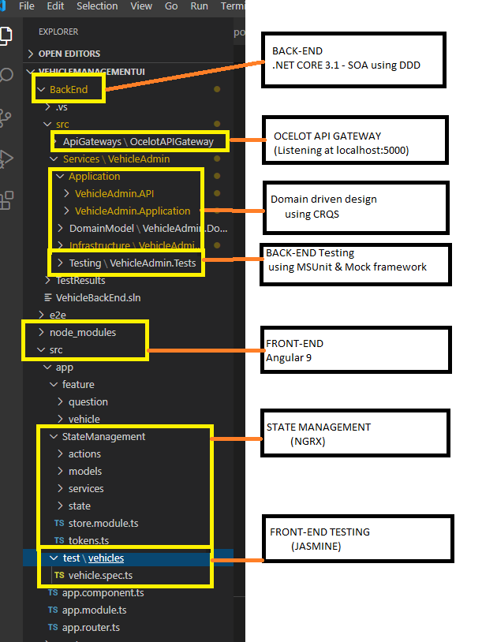

Landing Page:

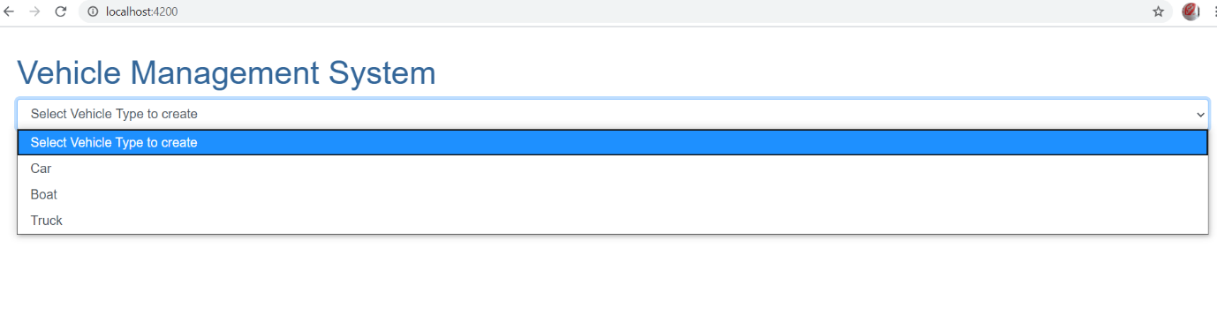

1)Add new Car by selecting Car from dropdown, loading the properties and click Add

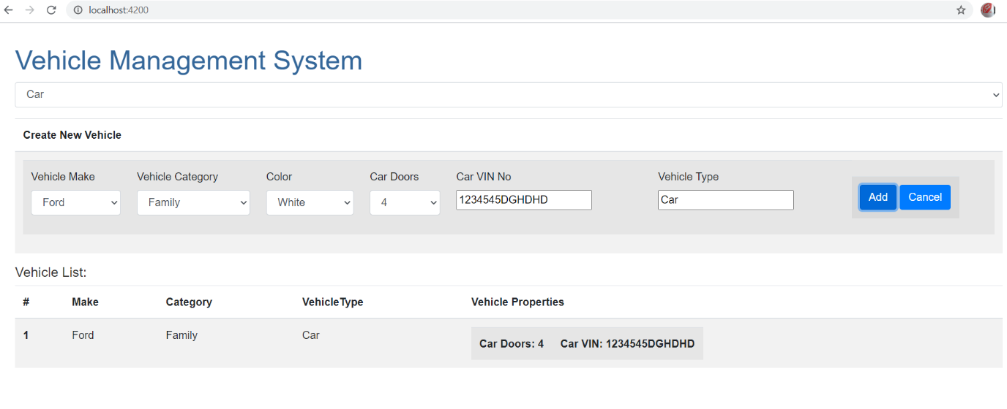

2) Add new Boat:

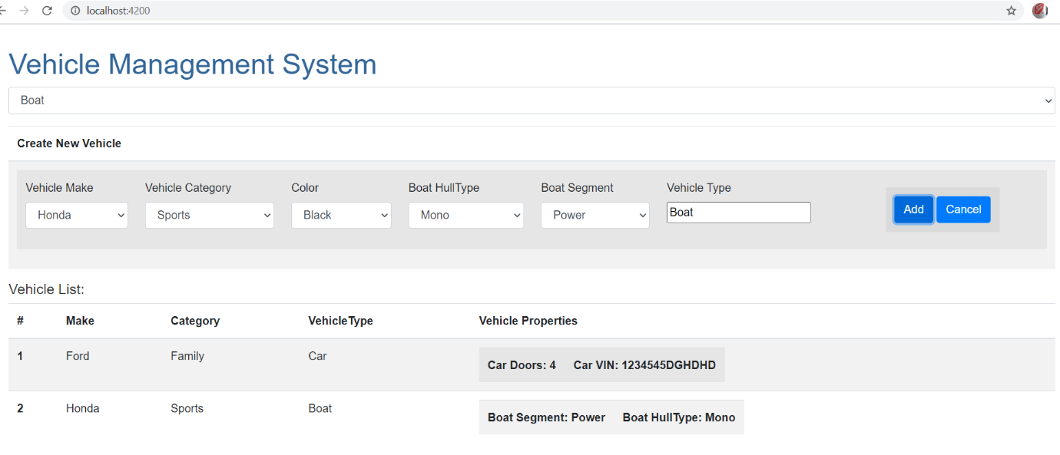

How to start: Copy project to C:\VehicleMgmt

Start Back-end

1. Start the back-end microservice Vehicles:
2. CD to C:\VehicleMgmt\BackEnd\src\Services\VehicleAdmin\Application\VehicleAdmin.API

Run: **dotnet run** and browse to <http://localhost/3000> to open

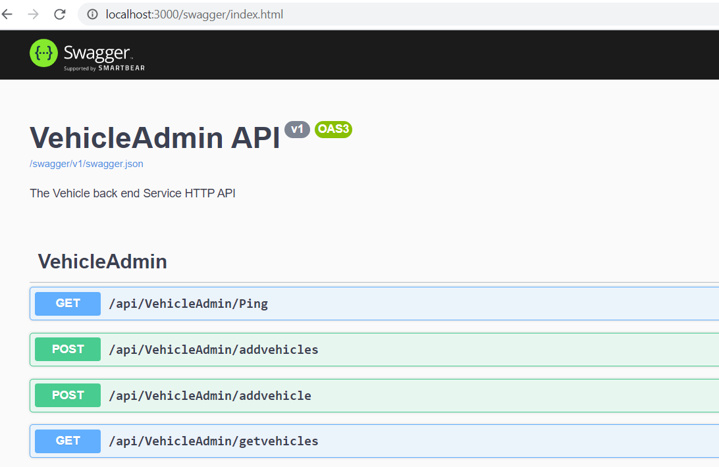

1. Start the API Gateway:
2. CD to gateway path: C:\VehicleMgmt\BackEnd\src\ApiGateways\OcelotAPIGateway

Run: **dotnet run** and browse to <http://localhost/5000> to confirm

(Notice the end-point customisation)

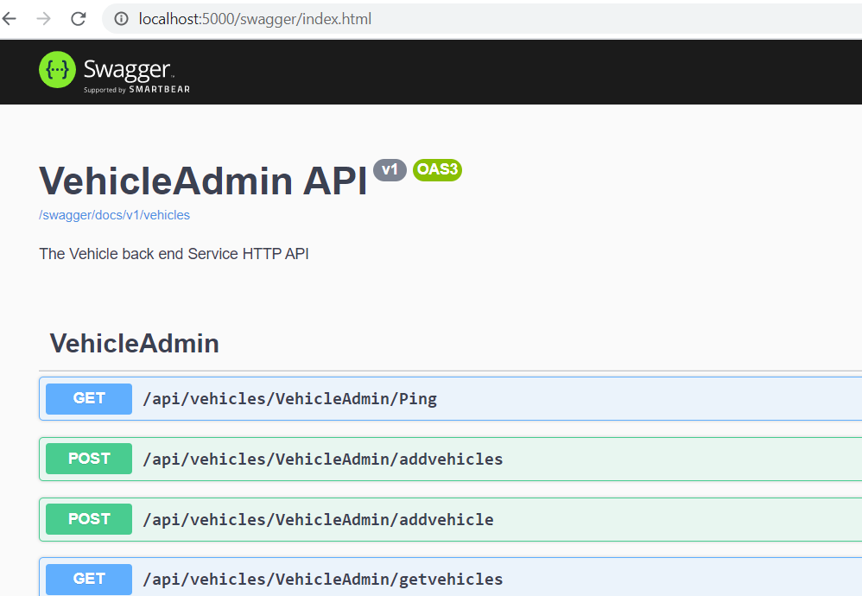

Start Front-end

1. Install modules using npm
2. CD to vehicle back-end api:

C:\VehicleMgmt

Run: **npm install**

1. Run **ng serve -o** and Browse to <http://localhost/4200> to open the site

